Tugas_Modul4

Torangto Situngkir

11/10/2020

library(dslabs)  
data(murders)  
str(murders)

## 'data.frame': 51 obs. of 5 variables:  
## $ state : chr "Alabama" "Alaska" "Arizona" "Arkansas" ...  
## $ abb : chr "AL" "AK" "AZ" "AR" ...  
## $ region : Factor w/ 4 levels "Northeast","South",..: 2 4 4 2 4 4 1 2 2 2 ...  
## $ population: num 4779736 710231 6392017 2915918 37253956 ...  
## $ total : num 135 19 232 93 1257 ...

ayam goreng {r murders}

pop <- murders$population  
 sort(pop)[[1]]

## [1] 563626

2

order(pop)[[1]]

## [1] 51

3

which.min(pop) == order(pop)[[1]]

## [1] TRUE

4

murders$state[[order(pop)[[1]]]]

## [1] "Wyoming"

5

ranks <- rank(murders$population)  
 my_df <- data.frame(name=murders$state,peringkat=ranks)

5

table(matrix(murders$region))

##   
## North Central Northeast South West   
## 12 9 17 13

6

ind = order(my_df$peringkat)  
 my_dff = data.frame(name=(sort(murders$state))[ind],Populasi = sort(murders$population),Peringkat = sort(ranks))

5

population_in_millions <- log10(murders$population)  
 total_gun_murders <- log10(murders$total)  
 plot(population_in_millions,total_gun_murders)

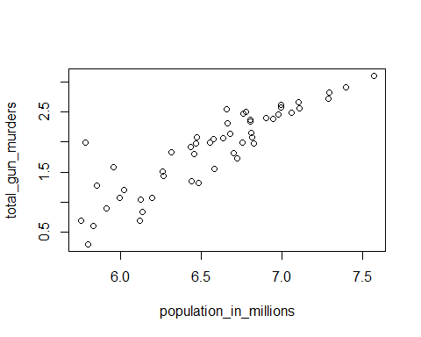

5

population <- murders$population/100000  
 hist(population)

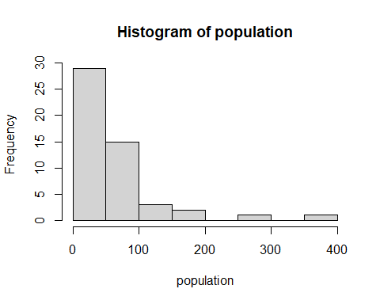

5

population <- murders$population/100000  
 boxplot(population~region,data=murders)

