RDQI Specification Design & Configuration Change Request

|  |  |
| --- | --- |
| **PROJECT NAME:** | **Canadian Compliance** |
| **BPM OWNER:** | **Deb Ellinger** |
| **BUSINESS REQUESTOR** | **Vida Cormier; Dawn Hutchins** |
| **Today’s date:** | **June 15, 2017** |
| **CR Name: *(Year. INITIALS.Program)*** | **2017.DLE.CanadianComplianceProject** |
| **Budget/Funding Approver:** | **Compliance support** |

**BACKGROUND & JUSTIFICATION OF THIS REQUEST :**

The Canadian labeling regulations have changed and the compliance deadline is December, 2021. Since the ILM project will take at least 1.5-2 years before go-live, it is recommended that we go ahead and make these changes in Meridian, so that CA can begin developing the new labeling data.

The Meridian system changes required to support label compliance are:

1. Add eight new Nutrient Rounding Rules
2. Add four new Canadian nutrition templates
3. Modify the IL Module Step 8 with a new formatting option to allow CA Regulatory users to format the IL text according to the new CA required format (examples below).

*Justification for the IL Module Step 8 customization:*

Current MDLZ Canadian labels declare the English and French Ingredient Lines (IL) in ALL CAPS, which the IL Module supports via a base-product formatting option. In Step 8, the user highlights the entire IL text and clicks a button to change the format to all CAPS.

***Current format - all CAPS***

INGREDIENTS: SUGARS (FANCY MOLASSES, BROWN SUGAR, SUGAR), WHEAT FLOUR, VEGETABLE OIL SHORTENING (SOYBEAN AND/OR CANOLA AND MODIFIED PALM OIL), LIQUID WHOLE EGG, SALT, SODIUM BICARBONATE, SPICES, ALLURA RED.

As part of the recent changes to the Canadian labeling regulations, ingredient lines on food labels must be declared in a *mixed case* format, as illustrated below. This format is not specifically supported by the base-product IL Module Step 8 options, although the user may manually edit the IL text in Step 8 to achieve the same result.

***New format - Mixed case with “Ingredients:” in bold***

**Ingredients:** Sugars (fancy molasses, brown sugar, sugar), Wheat flour, Vegetable oil shortening (soybean and/or canola and modified palm oil), Liquid whole egg, Salt, Sodium bicarbonate, Spices, Allura red.

Note that (a) The word “**Ingredients:**” must be in **bold**, (b) only the first word of each ingredient name must be capitalized, and (c) any ingredients *within parentheses* must be in all lower-case.

The Canadian Regulatory Affairs team is looking for a system solution to make the formatting of Canadian English and French ingredient lines more efficient and less time-consuming for the user. They estimate that an auto-formatting option would save the team approximately 50 staff-hours per year.

* Team generates approx. 30 CA ILs per week (15 in English & 15 in French)
* Manual formatting takes approx. 2 *extra* minutes per IL
* 2 min. * 30 IL/week * 50 working weeks/year = 3000 min/year or 50 extra staff-hours per year

**DESCRIPTION OF THE CHANGE(S) :**

1. Add eight new Nutrient Rounding Rules for the Nutrition Module:



1. Add four new nutrition templates *(NOTE: The existing CA templates must be maintained for history*):

   

1. Add the following new items to the **REF spec > Rounding** **picklist**:
   1. Canada Micro 1
   2. Canada Micro 2
   3. Canada Micro 3
   4. Canada Micro 4
   5. Canada Micro 5
   6. Canada Micro 6
   7. Canada Micro 7
   8. Canada Micro 8
2. Add the following new items to the **PROD > Label Type** **picklist**:
3. CA-NLR-100g
4. CA-NLR-Dual Format
5. CA-NLR-Simplified Format
6. CA-NLR-Standard Format

*-- continued on next page --*

1. Add a formatting option to the IL Module Step 8 which will allow the user to convert the default IL text into the required formatting for Canadian labels.

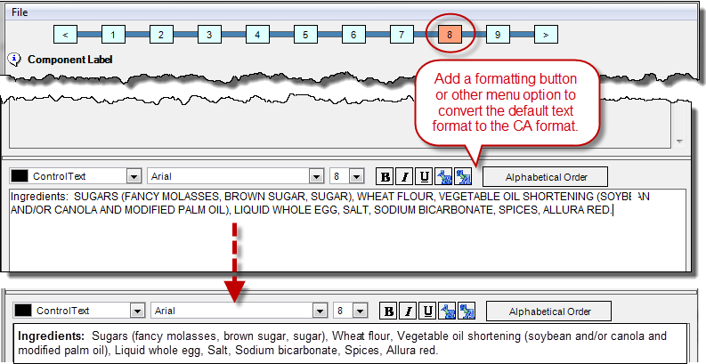

Two suggested solutions (ITS - please suggest more):

1. *[Preferred solution]* Provide one button or menu option to convert the entire IL text into the Canadian format:
   1. User highlights the text and clicks the button or selects the menu option.
   2. System does the following *in order*:
      1. Bolds “**Ingredients:**”
      2. Capitalizes the first word which follows a comma or colon.
      3. Converts all words between parentheses to all lower-case.
2. *[Alternate solution]* Allow the user to highlight the entire text and automatically re-format it so that the first word after each comma or colon is Capitalized. The user must then complete the formatting manually. Example:

*Before formatting (default Step 8 setting):*

Ingredients: SUGARS (FANCY MOLASSES, BROWN SUGAR, SUGAR), WHEAT FLOUR, VEGETABLE OIL SHORTENING (SOYBEAN AND/OR CANOLA AND MODIFIED PALM OIL), LIQUID WHOLE EGG, SALT, SODIUM BICARBONATE, SPICES, ALLURA RED.

*After executing the Mixed case formatting option:*

Ingredients: Sugars (fancy molasses, Brown sugar, Sugar), Wheat flour, Vegetable oil shortening (soybean and/or canola and modified palm oil), Liquid whole egg, Salt, Sodium bicarbonate, Spices, Allura red.

*User manually completes the formatting, using the existing* ***bold*** *and lower-case formatting buttons:*

**Ingredients:** Sugars (fancy molasses, brown sugar, sugar), Wheat flour, Vegetable oil shortening (soybean and/or canola and modified palm oil), Liquid whole egg, Salt, Sodium bicarbonate, Spices, Allura red.

**WHAT HAPPENS IF THIS CHANGE IS NOT APPROVED/IMPACT OF CHANGE REJECTION:**

CA RA users would have to make all required modifications to the label data manually, which would increase the risk of data errors, risk label non-compliance, and significantly increase the user time required to generate the correct labeling data.

**ASSUMPTIONS & CONSTRAINTS:**

n/a

**ITEMS OUT OF SCOPE:**

n/a

**EXISTING DATA & SPECIFICATION IMPACTS:**

The CA Regulatory Champion will need to version all CA REF specs to include the new rounding rules and any other changes required to support the regulation change. CA Regulatory users may need to recreate prior saved Nutrition panels, using the new REF spec versions.

**COMMUNICATIONS:**

The nutrient rounding rules and CA nutrition templates only impact CA Regulatory; this communication will be handled by the Business Leads (Vida & Dawn).

The IL Module Step 8 formatting option will only require a short communication to all Regulatory users, to alert them that this new option has been added for Canada; Deb will write the communication.

**End BPM Section Business Requirements Section**

**IDM and ITS Only**

**System Impacts:**

**This will impact current system functionality**

**PICKLISTS**

**Picklist update required**

If checked please specify picklist to be update

REF spec “Rounding” picklist

**Validation**

What are the consequences for specs already routed or Current:

No impact rounding rules will apply only to new data

**System Calculation Analysis**

☐   Net weight calculations

☐   Packed weight calculations

☐   Regulatory calculations

☐   System roll ups

**Please describe requirements if any of the above are checked:**

Click here to enter text.

**Reports**

New Report Required

Change to Existing Report

**Please describe below if new or change to existing:**

Click here to enter text.

**Security**

New user group(s) required

New access group(s) required

New workflow group(s) required

**Interfaces**

New Interface Required

Update to Existing Interface

**Describe below if new or change to existing**

Click here to enter text.

**Infosys or other 3rd Party Work**

This request will require ITS scripting and or Development/Programming

Click here to enter text.

**Frames**

**This is a change to an existing Frame. << IF Checked please select from below>>**

Choose an item.

If New property to frame, is this being validated or required or used for some other purpose such as calculations, being sent downstream or reports **Yes No**

**⮊Overall Analysis:** Please provide overall analysis and suggest solution for this Change Request.

**Document Update(s) Required**

|  |  |
| --- | --- |
| **Document** | **Owner** |
| **Test Script Doc** | **<< To be confirmed during Design Review with BPM>>** |
| **User Guide Doc** | **<< To be confirmed during Design Review with BPM>>** |
| **Business Process Guide Doc** | **<< To be confirmed during Design Review with BPM>>** |
| **Other reference document(s) – please specify if checked: Security Matrix** | **<< To be confirmed during Design Review with BPM>>** |

**Estimated IS Effort:**

**Proceed to Change Committee Review – IDM ONLY**

**Notes for Change Committee:** Click here to enter text.