# **Analysis of military spending for Germany in comparison to other NATO countries**

## Introduction/Business Problem

There are several points that are being discussed in the political German American friendship. One is the 2% target for military spending per GDP for every member country of the NATO. I would like to better understand if first of all this statement is accurate, second if Germany has met this target in the past and how are other countries (inside and outside of the NATO) dealing with this problem. Last, I would like to know if Germany will meet the target next year.

This information is relevant for the German prime minister when meeting up with the American president in December 2019. (just kidding: it is just for my own interest).

## Data Preparation

In order to analyze the above outlined business problem, three data sources are required:

1. List of NATO member countries

2. GDP per year per country in USD

3. MDS per year per country in USD

**Details:**

1: The member countries of the NATO can be found online, e.g. here: <https://www.worlddata.info/alliances/nato-north-atlantic-treaty-organization.php>

No data modification is required besides relabeling the column names and dropping of some non-relevant columns

2: The GDP data can be downloaded from the Worldbank: <https://data.worldbank.org/indicator/NY.GDP.MKTP.CD>

The data had to be modified by transpose the data set, taking out N/A, dropping not-related columns and renaming of columns.

3: The military spending data is available on kaggle: <https://www.kaggle.com/nitinsss/military-expenditure-of-countries-19602019>

The data had to be modified by transpose the data set, taking out N/A, dropping not-related columns and renaming of columns.

Last, the data had to be joined using the aligned column names Country_Names and Year. Then, the ratio of MDS (military defense spending) and GDP could be calculated.

## Methodology

First, the data is being joined and the ratio of MDS/GDP is being calculated for every country and year where data is available. Then, the data is analyzed graphically for all countries, for all NATO and all non-NATO countries and for Germany. The ratio of countries below and above the 2% target is being calculated.

Second, an ARIMA model is being used to predict the MDS/GDP for Germany for 2019.

## Results

**Visual Analysis:**

MDS/GDP for non-NATO countries:

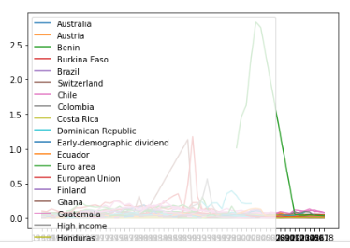

Fun Fact: The extreme outlier (green) is Myanmar which has been constantly in a Civil War – clearly identifiable from the data.

Generally: for the most countries quite stable numbers around 1 % and 3 % with a small trend downwards.

MDS/GDP for NATO- countries:

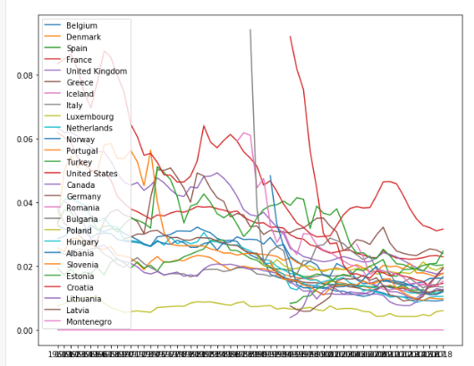

Generally: for the most countries the numbers are strongly trending downwards. The average for the last couple of years has been around 2%.

MDS/GDP for Germany:

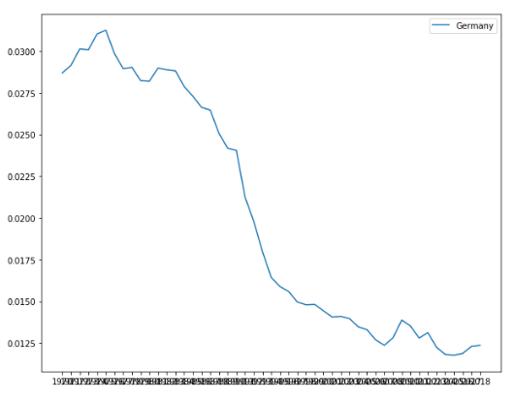

Generally: clear trend downwards. Already for several years below 2 % target.

**Statistics:**

% of countries and years above 2 % target for NATO countries:

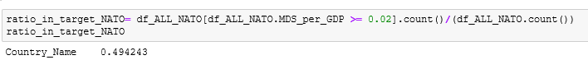

% of countries above 2 % target for 2018 for NATO countries:



% of countries and years above 2 % target for non-NATO countries:



% of countries above 2 % target for 2018 for non-NATO countries:



**Prediction:**

MDS/GDP for Germany in 2019:

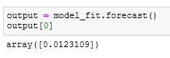

## Discussion

From the data it can be seen that almost all countries in the NATO have decreased there percentual spending on military defense. Also, the same holds true for non-NATO countries. Here, Germany is following a global trend in which you see more diverse spending culture.

Also it can be seen that other countries have now and had in the past problems with meeting the 2 % target for NATO members. Surprisingly, roughly in 50 % of the cases (country + year) the target was met – thus it seems like that the 2 % target is more a guideline/wish than an actual hard target with no actual consequences.

Further, Germany will also – based on the prediction- not meet the target of 2 % in 2019.

## Conclusion

Germany will also not meet the target of 2 % on MDS per GDP in 2019. While the American president might not be happy about this, this is in-line with a.) the general global trend and b.) the behavior of being a more desirable target than a hard target.