Chess game

### Stockfish all games

|  |  |
| --- | --- |
| Result | Amount |
| Won | 992 |
| Drawn | 1600 |
| Lost | 8 |

### Stockfish white games

|  |  |
| --- | --- |
| Result | Amount |
| Won | 698 |
| Drawn | 601 |
| Lost | 2 |

### Stockfish black games

|  |  |
| --- | --- |
| Result | Amount |
| Won | 294 |
| Drawn | 999 |
| Lost | 6 |

### Median and standard deviation for length of games

|  |  |
| --- | --- |
| Type | Value |
| Median all games | 122.0 |
| SD all games | 39.12 |
| Median white games | 117 |
| SD white games | 39.49 |
| Median black games | 122 |
| SD black games | 38.51 |

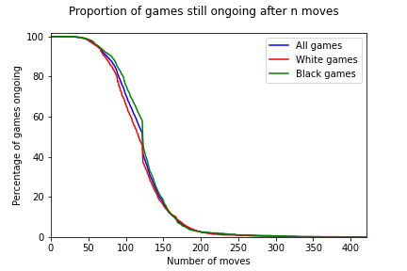

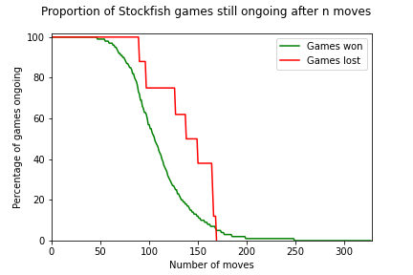

## Games played with the French opening

### Stockfish all games

|  |  |
| --- | --- |
| Result | Amount |
| Won | 52 |
| Drawn | 77 |
| Lost | 1 |

### Stockfish white games

|  |  |
| --- | --- |
| Result | Amount |
| Won | 41 |
| Drawn | 24 |
| Lost | 0 |

### Stockfish black games

|  |  |
| --- | --- |
| Result | Amount |
| Won | 11 |
| Drawn | 53 |
| Lost | 1 |

## Games played with the Sicilian opening

### Stockfish all games

|  |  |
| --- | --- |
| Result | Amount |
| Won | 238 |
| Drawn | 342 |
| Lost | 2 |

### Stockfish white games

|  |  |
| --- | --- |
| Result | Amount |
| Won | 150 |
| Drawn | 139 |
| Lost | 1 |

### Stockfish black games

|  |  |
| --- | --- |
| Result | Amount |
| Won | 88 |
| Drawn | 203 |
| Lost | 1 |

# All openings with at least 10 games played.

|  |  |  |  |
| --- | --- | --- | --- |
| Opening | White won | Draw | Black won |
| Bird's opening | 3 | 5 | 6 |
| Nimzo-Indian | 22 | 44 | 13 |
| Sicilian | 151 | 342 | 89 |
| QGA | 7 | 20 | 3 |
| QGD | 28 | 83 | 9 |
| Budapest | 9 | 17 | 0 |
| Queen's pawn game | 17 | 44 | 8 |
| French | 42 | 77 | 11 |
| Ruy Lopez | 47 | 102 | 15 |
| English opening | 20 | 56 | 12 |
| Gruenfeld | 8 | 28 | 4 |
| Reti opening | 12 | 26 | 4 |
| Caro-Kann | 36 | 75 | 11 |
| English | 43 | 93 | 17 |
| Queen's Indian | 26 | 66 | 10 |
| QGD semi-Slav | 18 | 50 | 8 |
| Petrov | 8 | 19 | 0 |
| King's Indian | 31 | 47 | 7 |
| KGA | 1 | 8 | 1 |
| Two knights defence (Modern bishop's opening) | 3 | 7 | 0 |
| Pirc | 4 | 4 | 4 |
| Catalan | 10 | 20 | 0 |
| Benoni | 2 | 8 | 2 |
| Benko's opening | 2 | 12 | 0 |
| Sicilian defence | 13 | 19 | 2 |
| Trompovsky attack (Ruth, Opovcensky opening) | 2 | 9 | 2 |
| Reti | 9 | 21 | 8 |
| Robatsch (modern) defence | 7 | 8 | 8 |
| Alekhine's defence | 5 | 6 | 1 |
| Kevitz-Trajkovich defence | 5 | 8 | 1 |
| Robatsch defence | 4 | 6 | 0 |
| Giuoco Piano | 3 | 14 | 1 |
| QGD Slav defence | 3 | 9 | 0 |
| QGD Slav | 12 | 36 | 4 |
| Queen's pawn | 5 | 8 | 2 |
| Dutch defence | 3 | 6 | 1 |
| Dutch | 4 | 9 | 1 |
| Four knights | 1 | 10 | 1 |

