Web Text Operation Documentation

Currently, the web end has only adapted avatars 1 to 4 (i.e., Alina, Aille, David, Calum) and the display of clothes corresponding to Alina and Calum. If there are changes in the personnel to be displayed in the future, please follow the following steps to make changes.

(1) Default character:

At line 498, we establish the connection with Alina (avatar1) as the initial character. If you want to change the initial character, simply replace it with the corresponding name of the desired character (e.g., Calum is avatar4).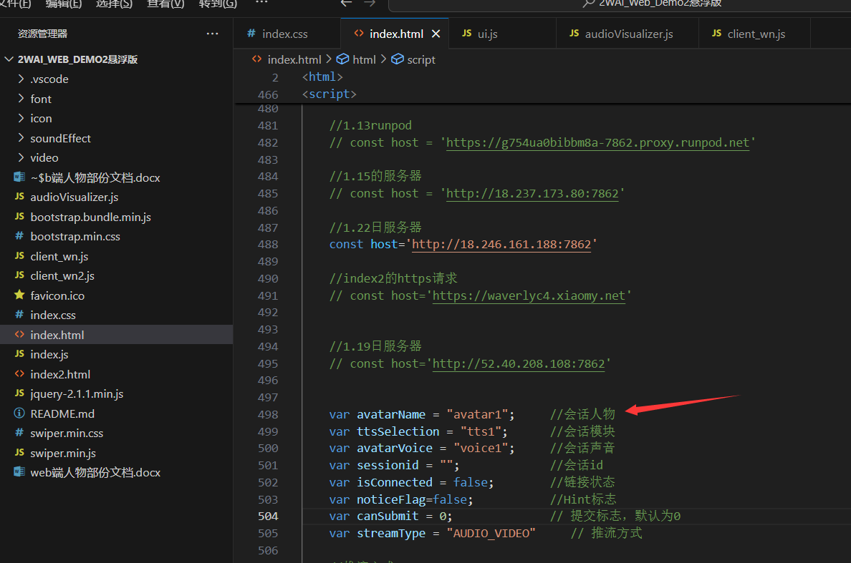

1.1

(2) Display character changes:

Starting from line 1701 is the filling of the character carousel, and options.avatars is the array of characters obtained by the request. On line 1719, we will store the requested character names into dataAvatars for subsequent character switching.

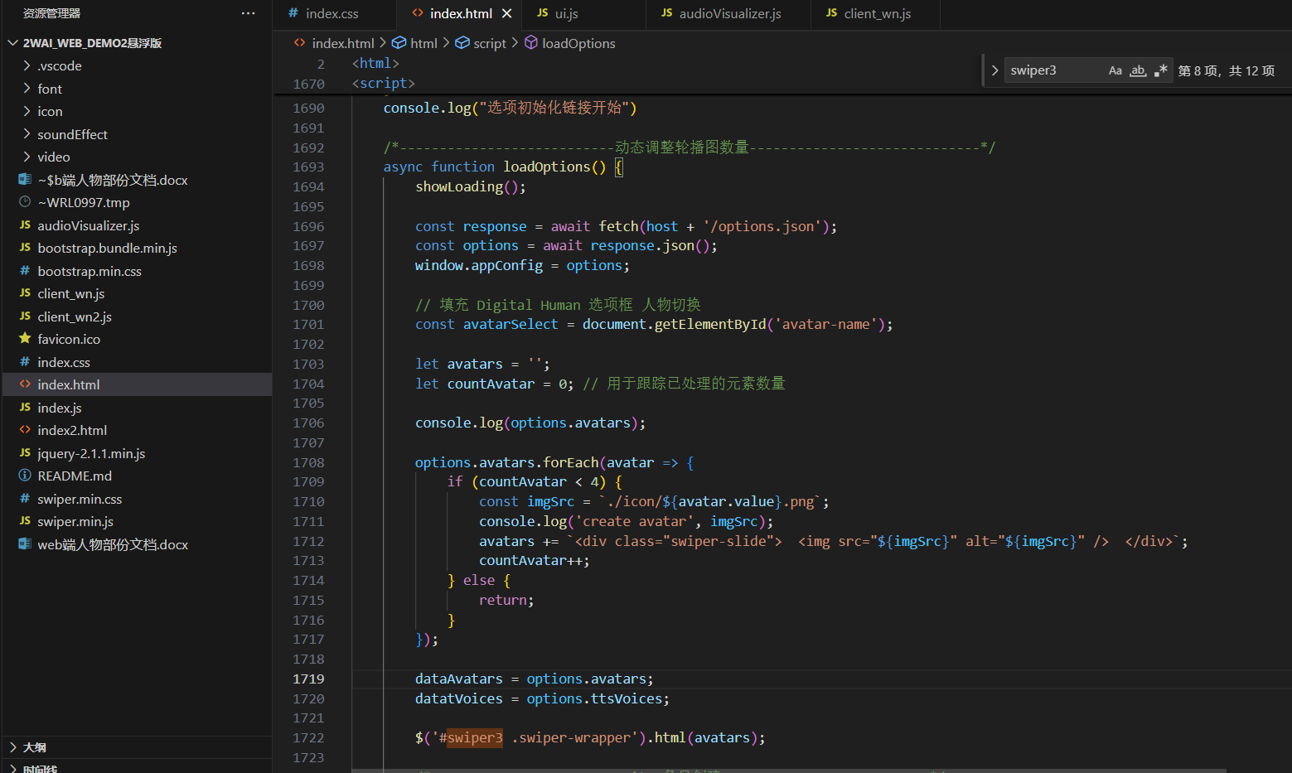

1.2

The following part is the core of displaying characters, which can be divided into two situations.

1. There is a need to change clothes.

Because changing clothes is essentially still changing characters, the following is the character information obtained by the interface: the first 1-4 are characters, while characters 5 and 8 are the clothes of characters 1 and 4.

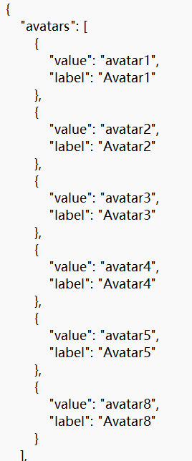

1.3

So in this case, the characters to be displayed should be limited to the first four. If it's like the situation in the above figure, there's no need to change, because it originally corresponds to this situation.

If you want to change the number of characters displayed, just replace the 4 in if (countAvatar < 4) with the number of characters you want to display.

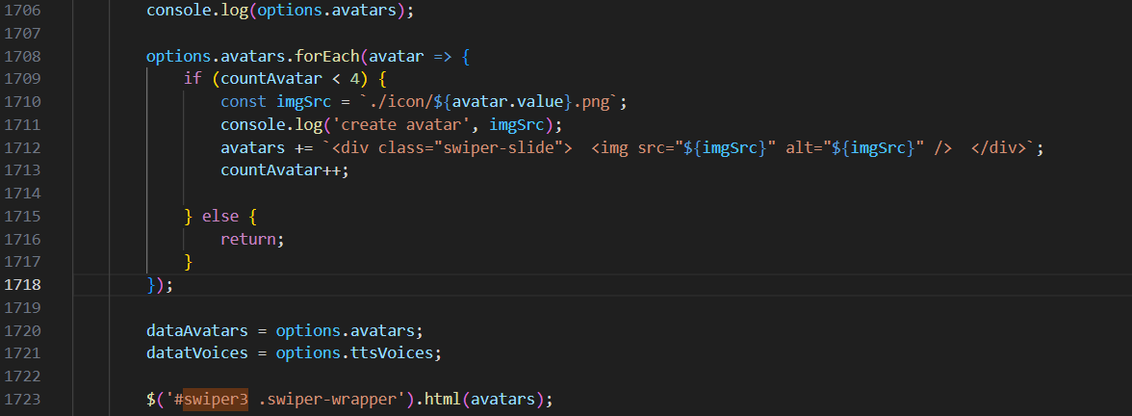

1.4

1. There is no need to change clothes.

Similarly, if there are no clothes, there is no need to limit the display. You can simply display all the characters. Therefore, you can directly remove the if...else control statement, as shown in the modified code in the figure below.

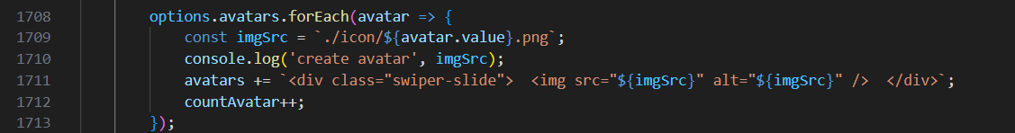

1.5

(三)The above is the display of the character carousel, and the below is the character change when switching the carousel.

①There is a need to change clothes.

len should be the number after if (countAvatar < 4) in the above.

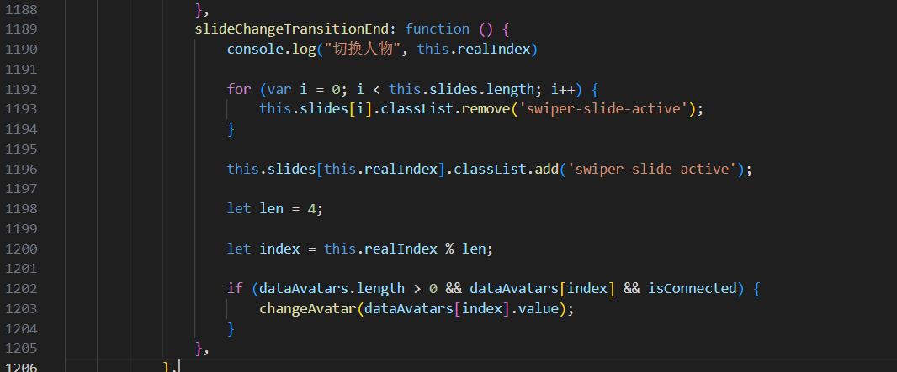

1.6

1. There is no need to change clothes.

len should be dataAvatars.length

Note: The web end should not support the display of anime characters such as Pikachu, Shakespeare, Daffy Duck, etc.

You can check which characters are obtained each time in the console. If the characters you want to display are not included, they cannot be changed in the front-end code.

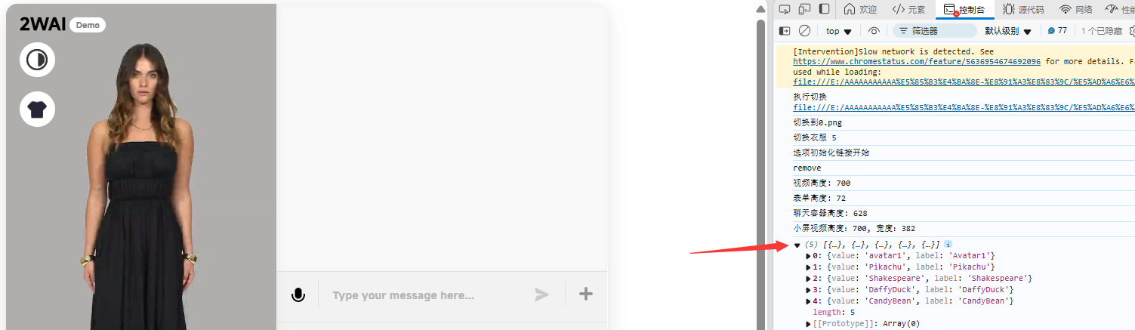

1.7