CEG5101 Modern Computer Networking
CA2: Laboratory Assignment
Anomaly-aware Routing and Blocking Controller
Design, implementation and evaluation on the CEG mesh topology (Ryu / OpenFlow 1.3 / Mininet)
Group members
Name | Student number
[Name] | [A0XXXXXXX]
[Name] | [A0XXXXXXX]
[Name] | [A0XXXXXXX]

Lecturer: Assoc. Prof. Mohan Gurusamy
ECE Department, CDE, National University of Singapore
Semester 1, AY 2026/27

1 Introduction
This report presents an anomaly-aware routing and blocking controller for the six-switch mesh network defined in ceg_mesh_topo.py. The controller, solution/anomaly_aware_controller.py, is a Ryu application for OpenFlow 1.3. It integrates the two reference programs: topology discovery and Dijkstra routing from resilient_controller.py, and EMA-based anomaly detection with source blocking from anomaly_detection.py. It then adds the parts that neither program provides: a dynamic cost for every switch-to-switch link driven by the measured load and by the anomaly state, continuous re-optimisation of the installed paths, and automatic recovery once an attack stops. These additions address the limitations listed in References A and B of the assignment: static routing costs, a purely relative detection threshold, and no rerouting after a source has been blocked.

1.1 Experimental setup
All experiments ran on Ubuntu 20.04.6 LTS under WSL2 (16 vCPU, 7 GB RAM) with Mininet 2.3.1b4, Open vSwitch 2.13.8, Ryu 4.34 (Python 3.8.10), hping3 3.0.0-alpha-2 and iperf 3.7. Every quantitative result in this report comes from one complete automated run, solution/results/run4, produced by solution/run_experiment.py with its default parameters. The script starts the controller, builds the topology with TCLinks, waits until all 11 inter-switch links have been discovered, and confirms full connectivity with pingall (0 % loss). It then drives the traffic shown in Table 1.
Table 1. Timeline of the evaluated run (time 0 = start of the baseline phase).
Phase | Time (s) | Traffic
Baseline | 0 – 30.1 | Legitimate h1→h6 flow only, plus normal background pings
Scenario a | 30.1 – 60.1 attack  60.1 – 90.2 recovery | hping3 --icmp --flood h2→h3, loads link s2–s3
Scenario b | 90.2 – 120.2 attack  120.2 – 150.3 recovery | hping3 --icmp --flood h2→h6, loads link s2–s6
Scenario c | 150.3 – 180.3 attack  180.3 – 210.4 recovery | hping3 --icmp --flood h5→h6, loads link s5–s6
Throughout | 0 – 210.4 | h1→h6: iperf3 UDP 5 Mbit/s (1200-byte datagrams) and ping every 0.1 s.  Normal traffic for the baselines: ping every 1 s on h2→h3, h2→h6, h5→h6, h3→h4 and h4→h1.

A constant-rate UDP flow is used for the legitimate traffic because it exposes loss and throughput directly; TCP would retransmit and back off and so hide short losses. The 10 Hz ping on the same pair gives per-packet loss and the round-trip time, and the RTT reveals every path change. The following data were recorded:
- Controller logs, every 2 s: link_costs.csv (rate, utilisation, anomaly flag, cost and normalised cost of each link), sources.csv (rate, baseline, threshold and state of each source IP), paths.csv (path and path cost of each installed flow) and events.csv (ANOMALY, BLOCK, REROUTE and UNBLOCK events).
- Host measurements: the iperf3 server report every 1 s (throughput and UDP loss of h1→h6), and the timestamped ping output (ping -D) of h1→h6.
- Data-plane evidence: the h1→h6 path traced once per second from the installed OpenFlow rules, interface packet counters once per second, and full flow-table dumps before, during and after each scenario.

2 Task 1: Topology in MiniEdit
The topology of ceg_mesh_topo.py was rebuilt in MiniEdit (Figure 1) and saved as solution/miniedit.mn. It contains six Open vSwitch switches s1–s6 with OpenFlow 1.3 enabled, six hosts h1–h6 (10.0.0.1–10.0.0.6, one per switch), and 17 TCLinks: six host links and 11 switch-to-switch links. Every link has bw = 40 Mbit/s and the delay given in the topology file. A remote controller c0 points to 127.0.0.1:6633. With Ryu started as ryu-manager --observe-links anomaly_aware_controller.py and the network run from MiniEdit, ovs-vsctl show reports is_connected: true for every bridge. The controller log grows to "Topology: 6 switches, 11 links", which means LLDP discovered every inter-switch link.
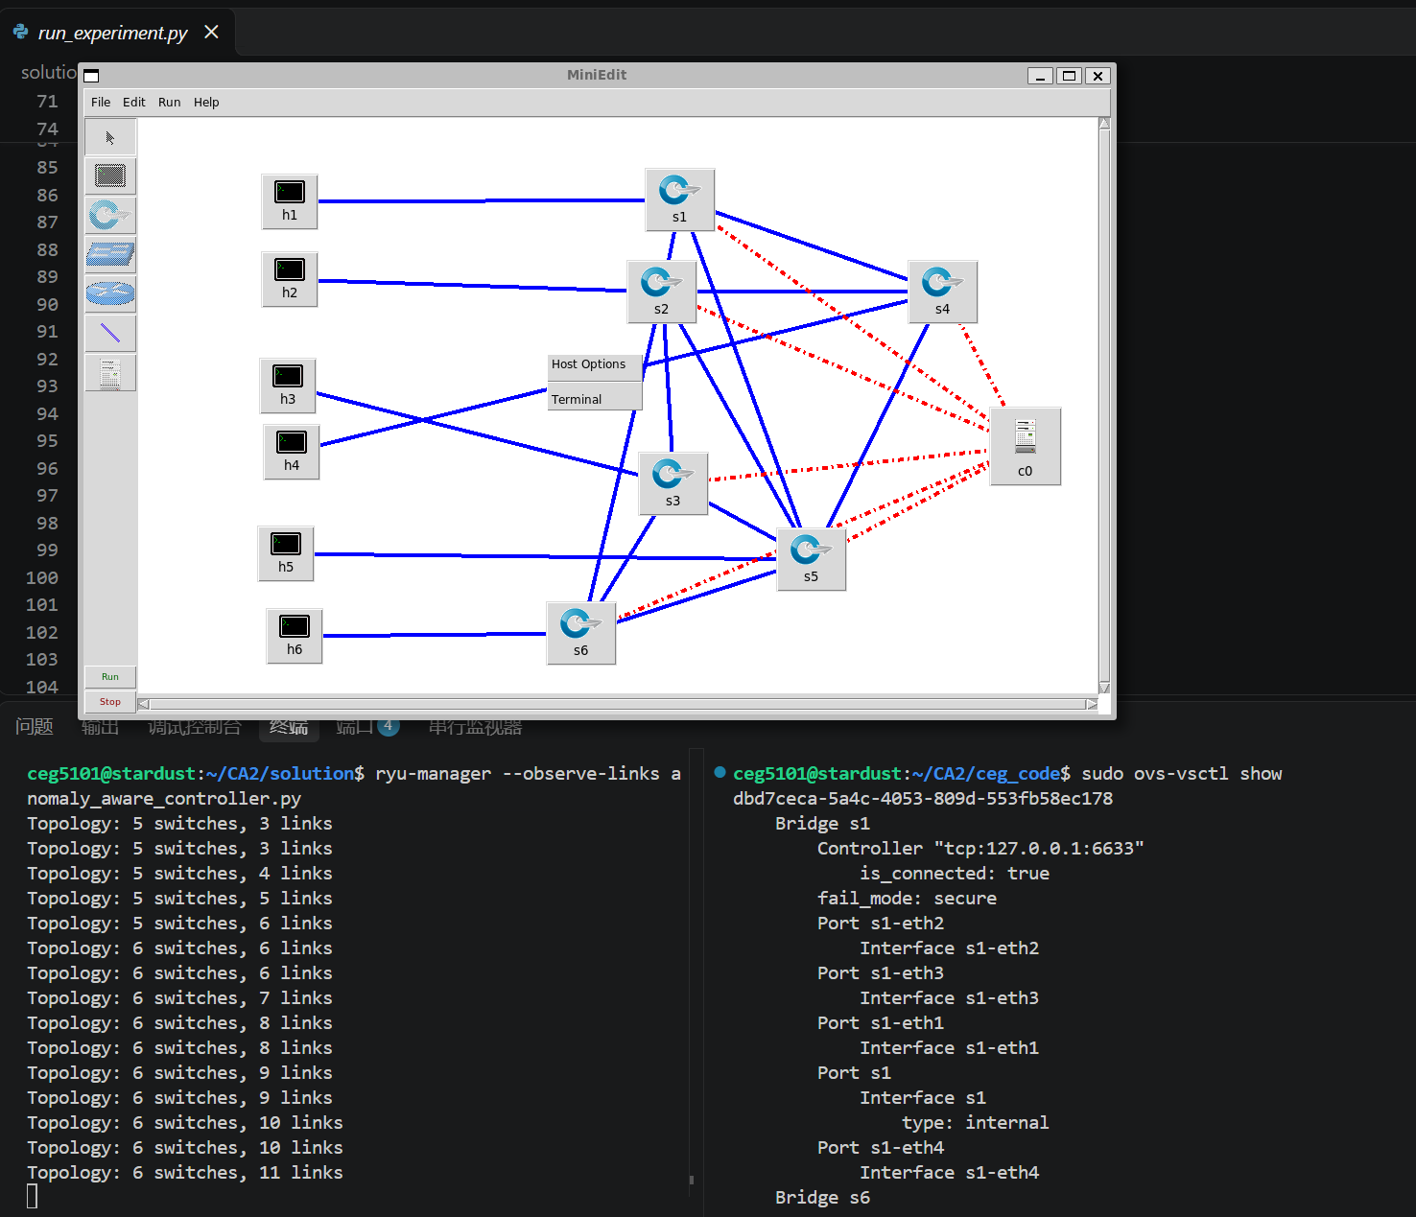
Figure 1. The mesh topology running in MiniEdit (top). Bottom left: the Ryu controller log reaching 6 switches and 11 links. Bottom right: ovs-vsctl show with the bridge connected to the controller.
Figure 2 redraws the topology with the parameters used by the routing logic. The assignment defines C⁰_{ij} as "the original link cost from the provided controller". resilient_controller.py has a predefined table (s1–s2 = 5, s2–s3 = 10, s1–s4 = 20, s2–s4 = 8, plus s3–s4 = 15, which is not a link in this mesh) and a default cost of 10 for every other link, so these are the C⁰ values used (Table 2). The controller can instead set C⁰ equal to the link delay (CA2_COST_MODE=delay); Section 8 discusses the consequences of that choice. With these costs the h1→h6 flow initially takes s1–s2–s6 (cost 15), and the next-best path is s1–s5–s6 (cost 20).
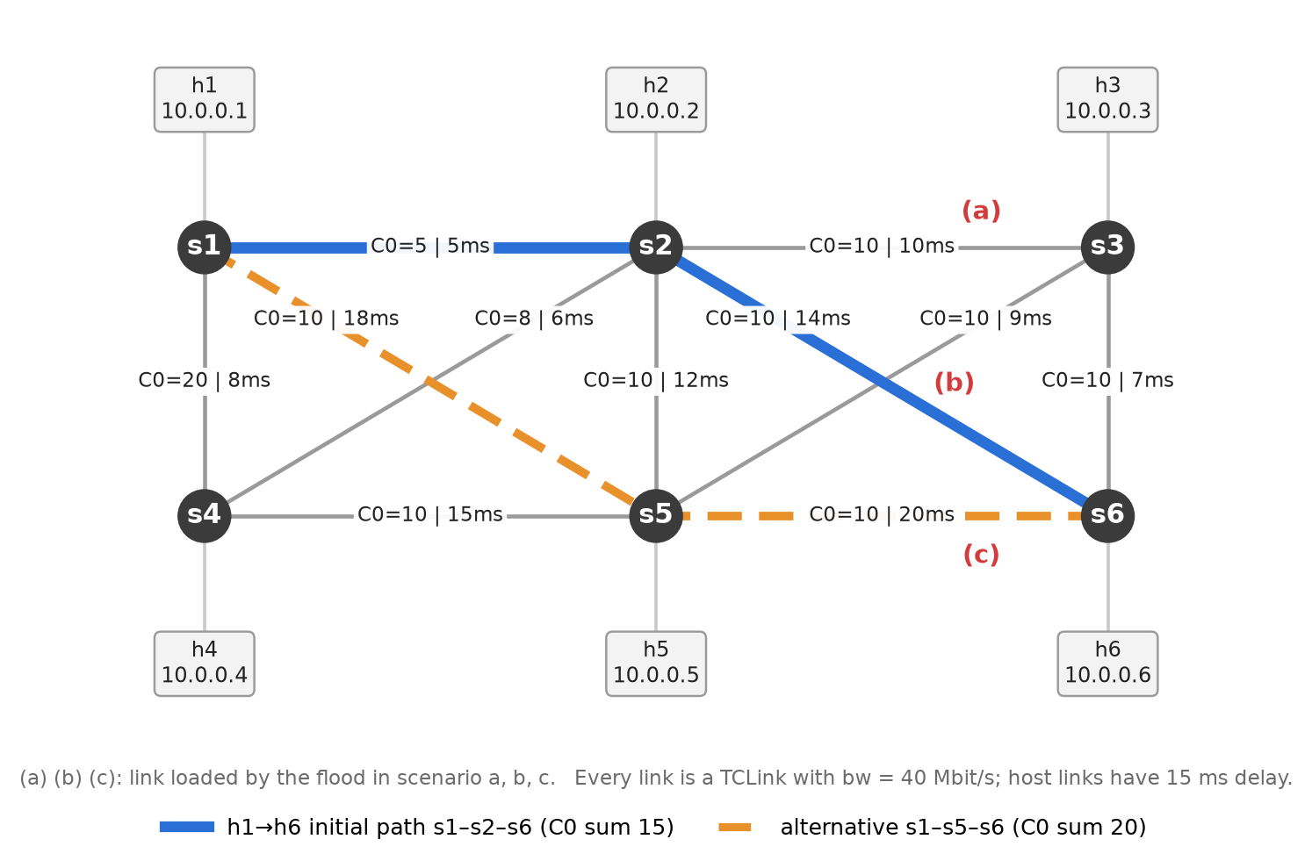
Figure 2. Switch-level view with the base cost C0 and the delay of each link. Blue: initial h1→h6 path. Orange: its cheapest alternative. Red labels: the link loaded by the flood in each scenario.
Table 2. Switch-to-switch links (host links: 40 Mbit/s, 15 ms).
Link | Delay (ms) | Bandwidth | C⁰ (from resilient_controller.py) | Role in the experiment
s1–s2 | 5 | 40 Mbit/s | 5 (predefined) | h1→h6 initial path
s2–s3 | 10 | 40 Mbit/s | 10 (predefined) | flooded in scenario a
s1–s4 | 8 | 40 Mbit/s | 20 (predefined)
s2–s4 | 6 | 40 Mbit/s | 8 (predefined)
s2–s6 | 14 | 40 Mbit/s | 10 (default) | h1→h6 initial path; flooded in scenario b
s1–s5 | 18 | 40 Mbit/s | 10 (default) | h1→h6 alternative path
s5–s6 | 20 | 40 Mbit/s | 10 (default) | h1→h6 alternative path; flooded in scenario c
s4–s5 | 15 | 40 Mbit/s | 10 (default)
s2–s5 | 12 | 40 Mbit/s | 10 (default)
s3–s6 | 7 | 40 Mbit/s | 10 (default)
s3–s5 | 9 | 40 Mbit/s | 10 (default)

3 Controller Design Overview
Figure 3 shows the structure of the controller. A monitoring loop runs every 2 s and carries out the detection and routing logic of Tasks 2–4 in a fixed order. Event handlers deal with new hosts, new flows and link failures as they occur.
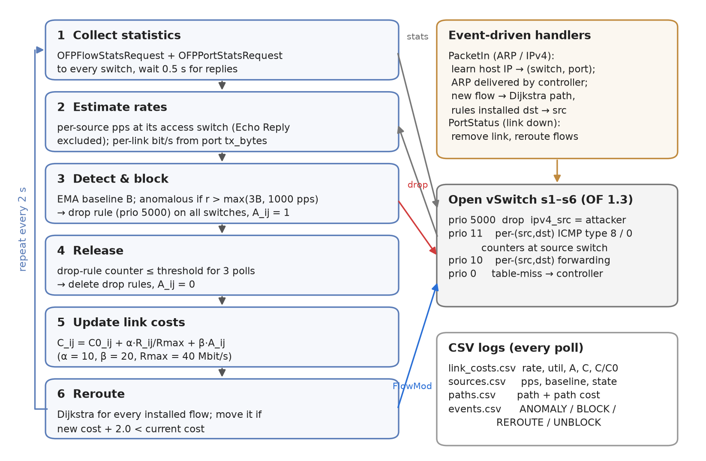
Figure 3. Control loop and OpenFlow rule layout of anomaly_aware_controller.py.
- Explicit per-pair forwarding. Instead of MAC learning, every (source IP, destination IP) pair gets its own priority-10 rule on each switch of its Dijkstra path. Each pair therefore has an explicit path that can be moved on its own, and the rule counters give per-flow rates.
- Host learning and ARP. Host locations are learned from ARP and IPv4 packet-ins that arrive on host-facing ports, i.e. ports that are not part of an LLDP-discovered link. The controller delivers ARP itself: it sends the packet straight to the target's port if the target is known, and otherwise floods it only to host-facing ports. This replaces the MST flooding of the reference controller and cannot cause a broadcast storm in the meshed topology.
- Rule priorities and cookies. Drop rules for blocked sources (5000) override everything. Typed ICMP counters (11) sit just above forwarding (10), and the table-miss rule (0) sends packets to the controller. Each rule type has its own cookie, so statistics replies can be classified and stale rules removed when a switch reconnects.
- Robust link state. Link failures are taken from OpenFlow PortStatus messages. LLDP "link deleted" events are ignored because LLDP probes can time out on a congested link that is still up, and a flood would otherwise appear to "remove" the very link it is congesting.

4 Task 2: Traffic Monitoring, Anomaly Detection and Source Blocking

4.1 Traffic monitoring
Every 2 s the controller sends an OFPFlowStatsRequest and an OFPPortStatsRequest to all switches. It waits 0.5 s for the replies and then evaluates them. The rate of a source IP is the packet-count increase of its flows divided by the elapsed time, measured only at the source's access switch. The reference anomaly_detection.py keeps a separate baseline for every (switch, IP) pair, so a flow that crosses three switches is measured three times. Measuring at the ingress gives exactly one value per host, taken at the point where the block later takes effect.
Echo Replies are excluded from the source rate. Section 4.2 explains why and how.

4.2 Avoiding false blocking of the victim
Problem. An ICMP flood makes the victim answer every request, so the victim sends Echo Replies back to the attacker at the same rate as the flood. A detector that counts every IPv4 packet by its source address therefore sees two "anomalous" sources: the attacker and the victim. The first version of our controller did exactly this and blocked h3 together with h2 in scenario a. In scenarios b and c the victim is h6, the destination of the legitimate flow. Blocking h6 drops every packet h6 sends, including the ping replies and iperf3 control traffic of the h1→h6 session, so the detector would cut the very traffic it is meant to protect.
First attempt. The second version kept one counter per source and, within each poll, subtracted the Echo Requests a host had received from the Echo Replies it had sent. This still blocked the victim from time to time. OpenFlow statistics replies arrive from each switch asynchronously, so a request and its reply are often counted in different polls (and once the attacker is blocked, the remaining replies have no requests to cancel them). Same-poll cancellation is therefore unreliable.
Final design. The controller now separates the two message types in the data plane. For each (source, destination) pair it installs two extra rules on the source's access switch, at priority 11, just above the forwarding rule. They match ICMP type 8 (Echo Request) and type 0 (Echo Reply) and use the same output port as the forwarding rule, so forwarding is unchanged but each type has its own packet counter. The source rate is the sum of all counters except the Echo Reply counter. Echo Requests and all non-ICMP traffic are still counted, so a host that floods with requests, UDP or anything else is still detected. Because the classification is done per rule rather than by matching requests to replies, the asynchronous arrival of statistics no longer matters. Link load (Task 3) is measured from port counters and still includes the replies, so the cost of a link carrying a reply stream is not understated.
Table 4. Evolution of the source-rate measurement.
Version | Source rate counts | Outcome
1 | all IPv4 packets from the source | victim (h3 / h6) blocked together with the attacker
2 | all IPv4 packets minus Echo Requests received in the same poll | victim still blocked at times: requests and replies fall into different polls
3 (final) | all IPv4 packets except Echo Replies, using typed per-rule counters | only the attacker blocked in all three scenarios of run4

Evidence from run4. During the first second of scenario a, h3 sent 41,311 Echo Replies per second into s3, yet its measured source rate stayed at 1.0 pps (its background ping) and it was never flagged. The same holds for h6 in scenarios b and c. The design has one limit, discussed in Section 8: a flood made only of Echo Replies would not count against its sender.

4.3 EMA baseline and anomaly threshold
For each source s with measured rate r_{s} (packets/s), the baseline B_{s} and threshold T_{s} are
B_{s} ← 0.3 · r_{s} + 0.7 · B_{s} T_{s} = max(3 · B_{s} , 1000 pps)
and the source is anomalous if r_{s} > T_{s}. Three design decisions refine the reference detector:
- Compare first, then update. Each sample is tested against the baseline before it is folded in, and an anomalous sample never updates the baseline. Otherwise a sustained flood would raise its own baseline (baseline poisoning) until it no longer looked anomalous.
- Absolute floor of 1000 pps. Background pings give baselines of 1–2 pps, so 3 × B alone would be only 3–6 pps, and a pingall or an ARP burst would trigger a block. The floor is far above any normal ping traffic yet about 60 times below the observed flood rate (≈ 63k pps). For h1, which carries the 5 Mbit/s flow, the relative term dominates (T = 1574 pps).
- Warm-up. A source must have three samples (6 s) before it can be flagged, so the first, unrepresentative sample cannot trigger a block.
Listing 1. Detection step for one source (from _check_anomalies).
threshold = max(THRESHOLD_MULT * stats['baseline'], MIN_ANOMALY_PPS) # max(3B, 1000)
if stats['samples'] >= WARMUP_SAMPLES and pps > threshold:
self._block_ip(ip, pps, stats['baseline'], flow_pps, now) # baseline left untouched
else:
stats['baseline'] = EMA_ALPHA * pps + (1 - EMA_ALPHA) * stats['baseline'] # alpha = 0.3
stats['samples'] += 1

Table 3. Source baselines learned from normal traffic, just before the first attack (t = 29.3 s).
Source | h1 | h2 | h3 | h4 | h5 | h6
Rate (pps) | 523.9 | 2.0 | 1.0 | 1.0 | 1.0 | 0.0
EMA baseline (pps) | 524.8 | 1.98 | 0.99 | 1.00 | 0.99 | 0.02
Threshold (pps) | 1574 | 1000 | 1000 | 1000 | 1000 | 1000

4.4 Blocking and release
When a source is flagged, the controller installs on all six switches a rule matching eth_type=IPv4, ipv4_src=<attacker> with an empty action list (drop), priority 5000 and its own cookie. This is the same firewall rule as in the reference code. Packets from a blocked source that reach the controller are also discarded. Because the rule exists on the attacker's access switch, the flood is dropped at its first hop. The drop rule's packet counter at that switch then keeps measuring the attacker's rate. Once this rate stays at or below the threshold for three consecutive polls, the drop rules are deleted and the source is released. Requiring three quiet polls stops a source from being released during a brief pause in the attack.

4.5 Results and verification
Table 5. Detection and blocking in run4.
Scenario | Attacker → victim | Detected after flood start | Rate at detection | Baseline / threshold | IPs blocked | Drop-rule counter at ingress (13.8 s into block)
a | h2 → h3 | 1.24 s | 5,708 pps | 1.98 / 1000 pps | 10.0.0.2 only | s2: 883,740 pkts
b | h2 → h6 | 1.22 s | 4,124 pps | 1.99 / 1000 pps | 10.0.0.2 only | s2: 854,260 pkts
c | h5 → h6 | 1.20 s | 17,147 pps | 1.00 / 1000 pps | 10.0.0.5 only | s5: 854,559 pkts

In every scenario only the attacker was blocked, at the first poll after the flood began (about 1.2 s). The rate at detection is lower than the true flood rate because the flood started part-way through the 2-s measurement interval. The drop-rule counters show the real rate, about 62–64k pps. Three independent observations confirm that the anomalous traffic is no longer forwarded:
- Drop-rule counters (Listing 2). Almost every flood packet matches the drop rule on the attacker's ingress switch. The other switches count zero, apart from the next-hop switch, which caught packets already in flight on the link when the rule was installed (s3: 23,076 in a; s6: 1,344 in b and 1,035 in c).
- Interface counters. In scenario a, s2 receives 44,357 → 57,679 → 63,579 packets/s from h2 in the first three seconds. Its transmission towards s3 falls from 43,893 to 15,501 and then to 1 packet/s. For the rest of the attack s2 receives about 63,700 packets/s from h2 while s2→s3 carries about 1 packet/s and s3→h3 about 2 packets/s (background traffic only). Scenarios b and c show the same pattern (s2→s6 and s5→s6 fall to ≈ 1 packet/s).
- Victim-side links. Once blocked, the links that carried the flood return to their normal load. The controller's utilisation of s2–s3, s2–s6 and s5–s6 decays to 0 (Section 5.3).
Listing 2. Drop rules in the flow tables during scenario a (excerpt of run4/flows_during_a.txt; table and byte fields omitted).
s1: cookie=0xca20002, duration=13.774s, n_packets=0, priority=5000,ip,nw_src=10.0.0.2 actions=drop
s2: cookie=0xca20002, duration=13.780s, n_packets=883740, priority=5000,ip,nw_src=10.0.0.2 actions=drop
s3: cookie=0xca20002, duration=13.785s, n_packets=23076, priority=5000,ip,nw_src=10.0.0.2 actions=drop
s4: cookie=0xca20002, duration=13.791s, n_packets=0, priority=5000,ip,nw_src=10.0.0.2 actions=drop
s5: cookie=0xca20002, duration=13.797s, n_packets=0, priority=5000,ip,nw_src=10.0.0.2 actions=drop
s6: cookie=0xca20002, duration=13.803s, n_packets=1, priority=5000,ip,nw_src=10.0.0.2 actions=drop

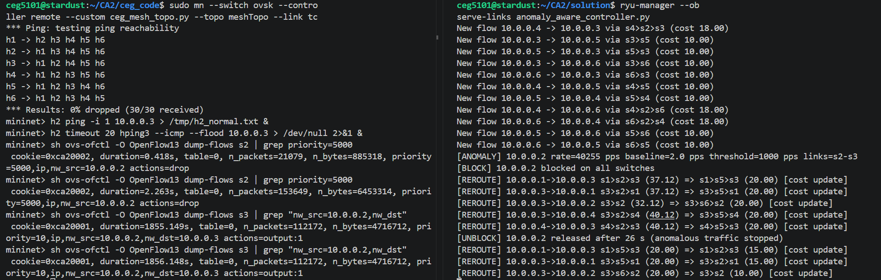
Figure 4. Manual run of scenario a. Left: Mininet CLI with pingall, the baseline ping, the flood and two queries each of the s2 drop rule and the s3 forwarding rule. Right: controller log with detection, blocking, rerouting and release of h2.
Figure 4 repeats scenario a by hand, following the Task 2 procedure: pingall (0 % loss), a 1-s ping from h2 to h3 to build the baseline, then hping3 --icmp --flood from h2 to h3 for 20 s. The controller reports [ANOMALY] 10.0.0.2 rate=40255 pps baseline=2.0 pps threshold=1000 pps links=s2-s3 followed by [BLOCK] 10.0.0.2 blocked on all switches. No other address is blocked; in particular the victim 10.0.0.3 is not. The flows that crossed s2–s3 (h1↔h3, h3→h2, h3↔h4) are then rerouted via s5 or s6. During the flood, the drop rule on s2 counts 21,079 and then 153,649 packets 1.85 s later (about 71k packets/s), while the h2→h3 forwarding rule on s3 stays at 112,172 packets in both queries. The flood is therefore dropped at the ingress switch and no longer forwarded towards h3. After the flood ends, h2 is released ("released after 26 s") and the rerouted flows return to their original paths.

5 Task 3: Dynamic Link-Cost Update

5.1 Cost model
Every 2 s, each switch-to-switch link (i, j) receives the cost of Reference C:
C_{ij}(t) = C⁰_{ij} + α · u_{ij}(t) + β · A_{ij}(t), u_{ij}(t) = min(1, R_{ij}(t) / R^{max}_{ij})
- Current rate R_{ij}(t). Taken from the tx_bytes port counters at both ends of the link. Each direction's rate (8·Δbytes/Δt) is smoothed with weight 0.5 on the newest sample, and the busier direction is used, since a link is as congested as its busier direction. Port counters include every packet (data, replies, control traffic), so they measure the real load, not just the flows the controller installed.
- Reference rate R^{max}_{ij} = 40 Mbit/s, the TCLink bandwidth of every link.
- Base cost C⁰_{ij}, the static cost of the provided controller (Table 2).
- Anomaly flag A_{ij}(t). When a source is blocked, every link on the installed path of each of its flows that carries at least 20 % of its rate is set to 1. The flag stays at 1 while the source is blocked and is cleared when it is released. The 20 % share selects the flood flow and ignores the attacker's low-rate background flows, so only links that actually carried the attack are penalised. In run4 the flagged links were exactly s2–s3, s2–s6 and s5–s6.
- Normalised cost C_{ij}/C⁰_{ij} equals 1 on an idle, clean link and reaches at most 1 + (α + β)/C⁰ = 4 for C⁰ = 10. It is the quantity plotted in Figure 5.
Listing 3. Cost update (simplified from _update_costs).
for u, v in links: # every switch-to-switch link, once
fwd, rev = self.link_rate.get((u, v), 0.0), self.link_rate.get((v, u), 0.0)
utilisation = min(1.0, max(fwd, rev) / LINK_CAPACITY_BPS) # R / Rmax, Rmax = 40 Mbit/s
anomaly = 1 if (u, v) in anomaly_links else 0 # A_ij from blocked sources
cost = self.base_cost[(u, v)] + COST_ALPHA * utilisation + COST_BETA * anomaly
self.graph[u][v] = self.graph[v][u] = cost # weights used by Dijkstra

5.2 Choice of α and β
- α = 10. A saturated link costs C⁰ + 10, i.e. about twice a default link. Load alone can move traffic, but only under substantial congestion. For h1→h6, load on s2–s6 alone would trigger a reroute when 6.3 + 10 + 10·u > 20 + 2, i.e. at u > 0.57 (≈ 23 Mbit/s). The 2.0 margin is the rerouting hysteresis of Section 6.1, so ordinary fluctuations do not move flows.
- β = 20. β is larger than the cost difference between the primary and alternative paths in this topology (for h1→h6: 20 − 15 = 5). A link with an active anomaly is therefore always avoided when an alternative exists. Unlike removing the link, the penalty is finite: if the flagged link is the only way to a destination, it is still used, so connectivity is preserved as the assignment requires.

5.3 Results
Table 6. Dynamic cost of the flooded links (release time measured from the end of the flood).
Scenario | Link | C⁰ | Cost before (norm.) | Peak util. | Peak cost (norm.) | While blocked (norm.) | After release
a | s2–s3 | 10 | 10.00 (1.00) | 0.089 | 30.89 (3.09) | 30.00 (3.00) | 10.00 at +7.2 s
b | s2–s6 | 10 | 11.30 (1.13) | 0.200 | 32.00 (3.20) | 30.00 (3.00) | 10.00 at +7.2 s, then 11.09
c | s5–s6 | 10 | 10.00 (1.00) | 0.076 | 30.76 (3.08) | 30.00 (3.00) | 10.00 at +7.2 s

Figure 5 (Section 7) plots these costs against time. Four observations follow:
- The load term and the anomaly term act on different time scales. At the first poll after the attack begins, both terms rise and the cost jumps to 30.8–32.0. The drop rule removes the flood from the link in the same poll, so the measured load then decays geometrically because of the smoothing (s2–s6: u = 0.200, 0.174, 0.087, 0.044, …). The β term, however, holds the cost at 30.0 (normalised 3.0) until the source is released. This plateau is the controller's memory of the attack.
- The peak load is modest because the flood is blocked quickly. In the first second the flood pushed about 44k packets/s (≈ 15 Mbit/s with 42-byte frames, u ≈ 0.37) onto s2–s3. It lasted only about 1.2 s of a 2-s window, however, so the smoothed sample peaks at 0.09. A flood is handled by detection and the β term. The α term is meant for sustained congestion caused by legitimate traffic.
- The load term follows the legitimate traffic. Before scenario b, s2–s6 is at 1.13 and s1–s2 at 1.26 because they carry the 5 Mbit/s h1→h6 flow (u = 0.13). When the flow moves away, s1–s5 rises from 1.00 to 1.13, and after the flow returns, s2–s6 climbs back towards 1.13 (11.09 six seconds after the release).
- Costs recover automatically. The drop rule keeps counting the attacker. Once three polls in a row see no anomalous traffic, the source is released 7.2 s after the flood stops (one poll that still contains the end of the flood plus 3 × 2 s). A_{ij} is then cleared and the link returns to C⁰ in the same poll, in all three scenarios.

6 Task 4: Rerouting of Legitimate Traffic

6.1 Routing and rerouting mechanism
- Path computation. Dijkstra's algorithm (from resilient_controller.py) runs on the graph weighted by the current C_{ij}(t). A new flow is routed when its first packet arrives.
- Periodic re-optimisation. After every cost update the controller recomputes the best path of every installed flow and moves the flow only if the new path is cheaper by more than a margin of 2.0. This hysteresis prevents flapping between near-equal paths. In particular, a flow does not bounce back just because its own load has made its new path slightly more expensive. Flows of blocked sources are not rerouted.
- Make-before-break installation. Rules are written from the destination switch back towards the source, so a packet never reaches a switch that has no rule yet. A rule whose output port changes is modified in place (OFPFC_MODIFY_STRICT, which keeps its counters for rate measurement). Rules on switches that are no longer on the path are deleted last.
Listing 4. Reroute decision for one installed flow (from _reroute_flows).
best = self.dijkstra(src_host.dpid, dst_host.dpid) # under the current dynamic costs
current_cost, best_cost = self._path_cost(flow['path']), self._path_cost(best)
if best_cost + REROUTE_MARGIN < current_cost: # hysteresis, margin = 2.0
self._install_path(src_ip, dst_ip, best) # dst-to-src, MODIFY where possible
self._event('REROUTE', ...)

6.2 Initial state of the h1→h6 flow
Before any anomaly, h1→h6 follows s1 → s2 → s6 → h6, both according to the controller and as traced from the switches' flow tables. Its path cost is 15 from C⁰ alone, or 17.59 including its own load (s1–s2 = 6.30, s2–s6 = 11.30). During the baseline it delivers 5.00 Mbit/s with 0 % UDP loss and 0 % ping loss, and its RTT is 98.5 ms, matching 2 × (15 + 5 + 14 + 15) ms of link delays. Table 7 lists the candidate paths and their costs in each phase. The chosen path is always the cheapest one in its column.
Table 7. Cost of the h1→h6 candidate paths at the first poll after each attack is detected (baseline: t = 25 s). Bold: the selected path.
h1→h6 path | C⁰ sum | Baseline | Scenario a | Scenario b | Scenario c
s1–s2–s6 | 15 | 17.59 | 17.60 | 38.30 | 17.59
s1–s5–s6 | 20 | 20.00 | 20.00 | 20.00 | 40.57
s1–s2–s3–s6 | 25 | 26.30 | 47.03 | 26.30 | 26.30
s1–s2–s5–s6 | 25 | 26.30 | 26.30 | 26.30 | 46.87
s1–s5–s3–s6 | 30 | 30.00 | 30.00 | 30.00 | 30.00

6.3 Behaviour in each scenario
Table 8. Requirements a–f of Task 4 for each scenario (times relative to the start of the flood unless stated).
Requirement | Scenario a: h2→h3, s2–s3 | Scenario b: h2→h6, s2–s6 | Scenario c: h5→h6, s5–s6
a. Load and cost of the link | u 0 → 0.089; C 10 → 30.89, then 30.00 | u 0.13 → 0.200; C 11.30 → 32.00, then 30.00 | u 0 → 0.076; C 10 → 30.76, then 30.00
b. Detected and blocked | h2 at +1.24 s; only h2 blocked | h2 at +1.22 s; only h2 blocked | h5 at +1.20 s; only h5 blocked
c. h1→h6 rerouted? | No: s2–s3 is not on its path; 17.60 < 20.00 | Yes, at +1.22 s: s1–s2–s6 (38.30) → s1–s5–s6 (20.00); data plane at +1.8 s | No: the penalty falls on the alternative path (40.57); 17.59 is still cheapest
d. Path before / during | s1–s2–s6 / s1–s2–s6 | s1–s2–s6 / s1–s5–s6 | s1–s2–s6 / s1–s2–s6
d. Throughput during (mean / min) | 5.00 / 4.99 Mbit/s | 4.99 / 4.67 Mbit/s | 5.00 / 4.99 Mbit/s
d. Packet loss during | UDP 0 %; ping 0 / 311 | UDP 34 datagrams, all before the block (0.21 %); ping 0 / 309 | UDP 0 %; ping 0 / 311
e. Connectivity kept? | Yes, no ping lost | Yes, no ping lost | Yes, no ping lost
f. Recovery | h2 released 7.2 s after the flood; s2–s3 back to 10; h1→h6 never moved | h2 released 7.2 s after the flood; s2–s6 back to 10; h1→h6 back on s1–s2–s6 in the same poll (data plane +7.8 s) | h5 released 7.2 s after the flood; s5–s6 back to 10; h1→h6 never moved

Scenario a (link s2–s3). The flagged link is not on the h1→h6 path. That path stays the cheapest (17.60 against 20.00), so the controller correctly leaves the flow untouched: its throughput, loss and RTT do not change at all. The controller does reroute every flow that did cross s2–s3: h1→h3 and h3→h1 move from s1–s2–s3 (37.03) to s1–s5–s3 (20.00), and h3→h2, h3→h4 and h4→h3 move onto paths via s5. Rerouting is therefore selective. A flow moves only when its own path cost changes.
Scenario b (link s2–s6, shared with h1→h6). This is the case the assignment targets. At the first poll after the flood starts (+1.22 s), h2 is blocked, s2–s6 is flagged, and the h1→h6 path cost rises to 6.30 + 32.00 = 38.30. Dijkstra picks s1–s5–s6 (20.00) over s1–s2–s3–s6 (26.30), and the flow is moved in the same poll. h6→h1, h6→h2, h4→h6 and h6→h4 are moved as well. During the attack, the h1→h6 flow's own load raises the new path to 22.57, while the next-best path s1–s2–s3–s6 costs 25.01. The 2.44 gap exceeds the margin, so the path stays stable for the whole 36 s. When h2 is released, s2–s6 drops to 10, s1–s2–s6 becomes 15.00 against 22.59 for the current path, and the flow returns in the same poll. The only loss of the entire run occurred in this scenario: 34 UDP datagrams, all in the ≈ 1.2 s before the block took effect (analysed in Section 7.3).
Scenario c (link s5–s6). This flood hits the alternative path rather than the active one. s1–s5–s6 rises to 40.57 while the active path s1–s2–s6 stays at 17.59, so h1→h6 is not moved. The only flow rerouted is h6→h5 (s6–s5 → s6–s3–s5). The scenario also shows that the costs keep the controller ready for a combined failure: if s2–s6 were degraded at the same time, the next choice would be s1–s2–s3–s6 (26.30), not the flagged s1–s5–s6.

7 Task 5: Performance Evaluation
Figures 5–7 are the three required plots. Figure 8 adds the RTT, which makes path changes visible. Grey bands mark the three floods, and dotted lines mark the two reroutes of h1→h6 in scenario b. Table 9 summarises each phase.
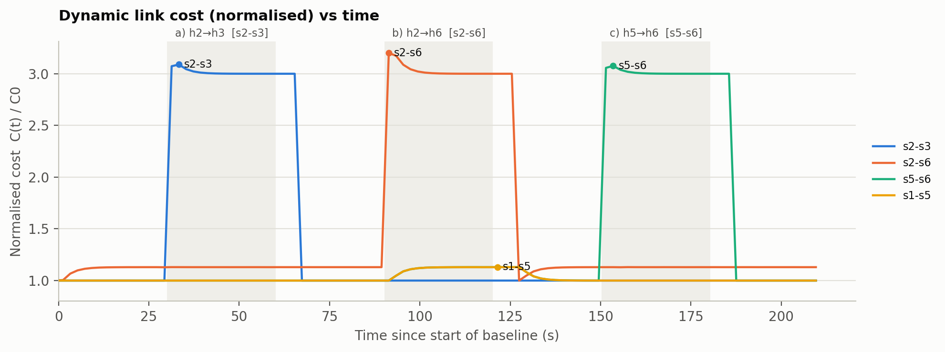
Figure 5. Dynamic link cost (normalised, C(t)/C0) against time for the flooded links and for s1–s5, which carries h1→h6 during scenario b.
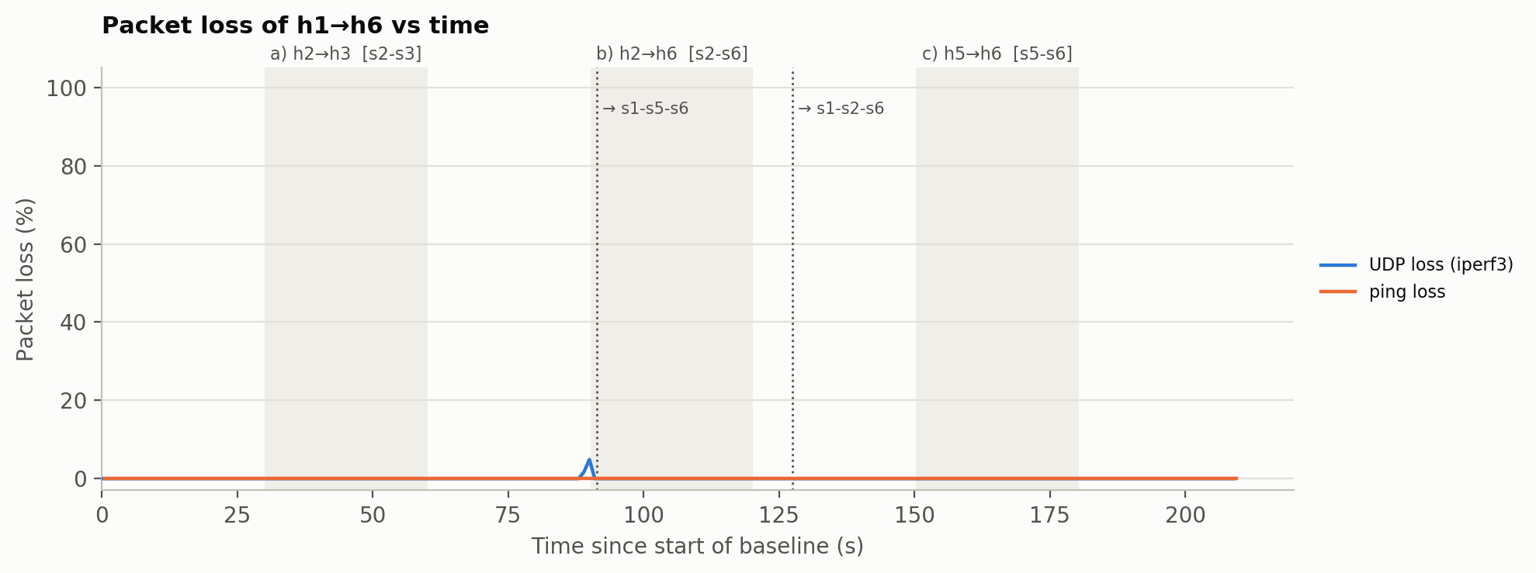
Figure 6. Packet loss of h1→h6 against time: UDP loss per iperf3 interval and ping loss per second.
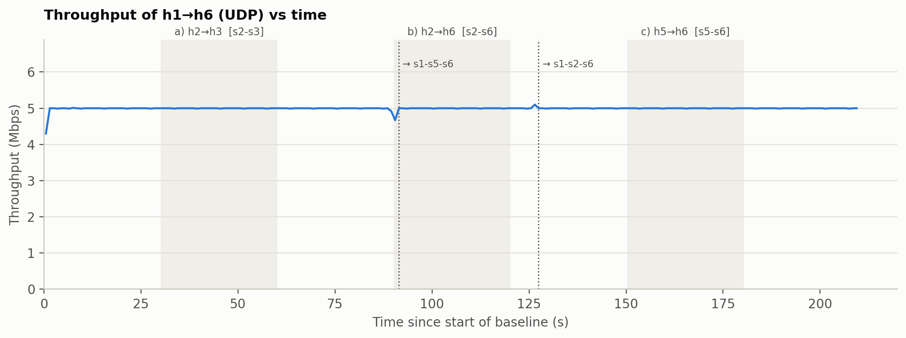
Figure 7. Throughput of the h1→h6 UDP flow against time.
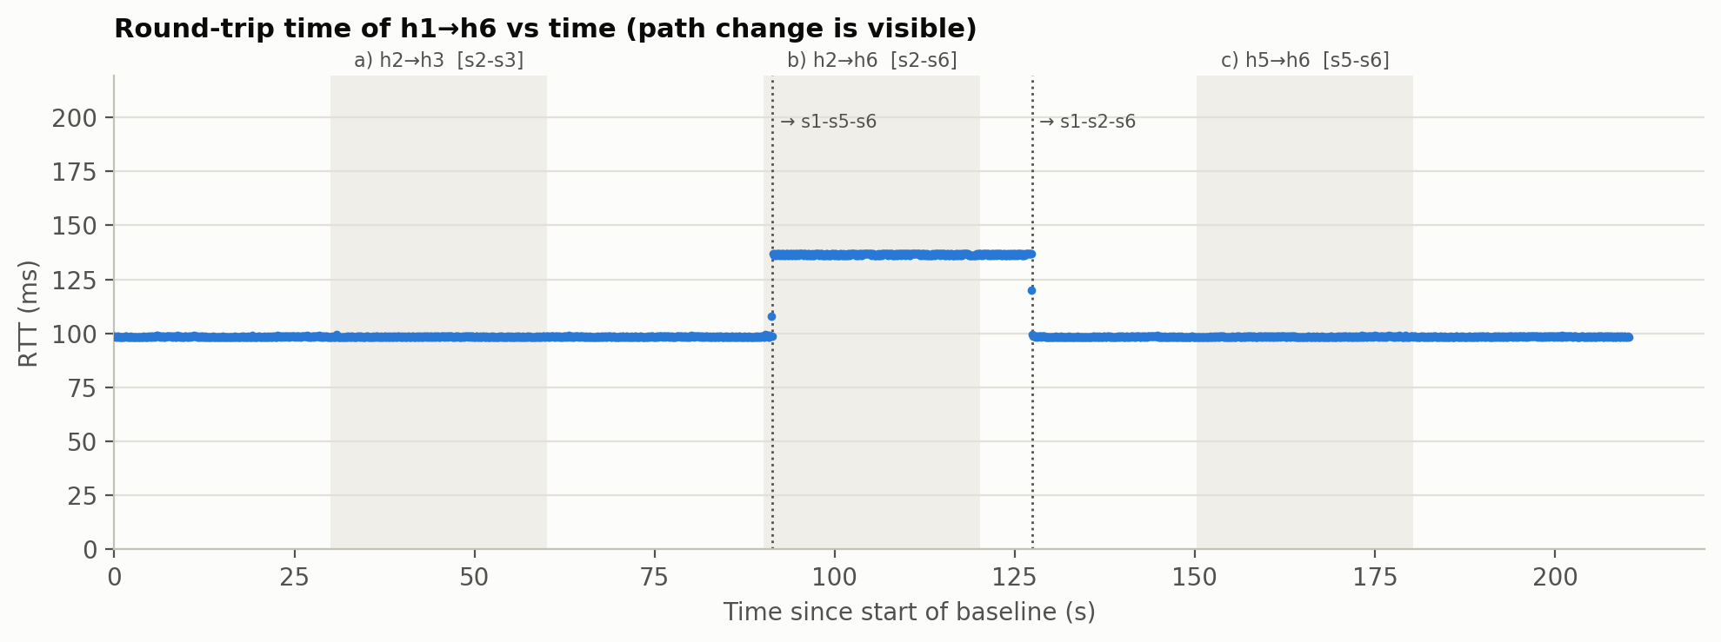
Figure 8. Round-trip time of h1→h6 (ping every 0.1 s). The step to 137 ms is the move to s1–s5–s6.
Table 9. h1→h6 before (10 s to 1 s before the flood), during the flood, and after it (10–20 s after the flood). *136.6 ms once on s1–s5–s6.
Scenario | Phase | h1→h6 path | Throughput mean / min (Mbit/s) | UDP loss | Ping loss | RTT mean
a | before | s1–s2–s6 | 5.00 / 4.99 | 0 % | 0 / 90 | 98.6 ms
a | during | s1–s2–s6 | 5.00 / 4.99 | 0 % | 0 / 311 | 98.5 ms
a | after | s1–s2–s6 | 5.00 / 4.99 | 0 % | 0 / 100 | 98.5 ms
b | before | s1–s2–s6 | 5.00 / 4.99 | 0 % | 0 / 90 | 98.5 ms
b | during | s1–s5–s6 from +1.2 s | 4.99 / 4.67 | 0.21 % (34 datagrams) | 0 / 309 | 133.9 ms*
b | after | s1–s2–s6 | 5.00 / 4.99 | 0 % | 0 / 100 | 98.5 ms
c | before | s1–s2–s6 | 5.00 / 4.99 | 0 % | 0 / 90 | 98.5 ms
c | during | s1–s2–s6 | 5.00 / 4.99 | 0 % | 0 / 311 | 98.5 ms
c | after | s1–s2–s6 | 5.00 / 4.99 | 0 % | 0 / 100 | 98.6 ms

7.1 Routing cost
Before any anomaly, only links that carry the legitimate flow sit above 1: s1–s2 at 1.26 and s2–s6 at 1.13. During each flood, the cost of the flooded link jumps to 3.08–3.20 at the first poll, then relaxes to a 3.00 plateau as the load term decays to zero and the anomaly term remains (Section 5.3). After the flood the link returns to 1.00 within 7.2 s. The other links react only to the traffic that is moved onto them: s1–s5 rises to 1.13 while it carries h1→h6 in scenario b. The cost thus captures both components the assignment asks for: current load and anomaly state.

7.2 Path selection
The h1→h6 path changes exactly when a penalised link lies on it (scenario b) and stays put when the penalised link is elsewhere (a, c). Figure 8 shows the change: the RTT steps from 98.5 ms to 136.6 ms at +1.2 s and returns at release. The single intermediate samples (108 ms and 120 ms) belong to probes in flight during the switch. The 38 ms increase is the price of the detour. s1–s5 (18 ms) and s5–s6 (20 ms) have the controller's default C⁰ = 10 even though they are the slowest links in the mesh, so the cost metric does not reflect delay. Section 8 discusses this trade-off.

7.3 Packet loss
Of 2,102 ping probes, none was lost during the whole run, and of 109,255 UDP datagrams, 34 (0.031 %) were lost. All 34 were lost in the first ≈ 1.2 s of scenario b, between the start of the flood and the installation of the drop rule. During that window the flood shares two links with the legitimate flow: s2–s6, which rerouting can avoid, and the victim's access link s6→h6, which it cannot, because h6 is the destination of both flows. Diagnostic counters sampled every second during the run show that the egress queue of s6-eth1 (towards h6) dropped 760 packets between 89.5 s and 91.5 s (and otherwise only 18, at the onset of scenario c, without any UDP or ping loss), while h6's UDP receive-buffer errors stayed at 0. The loss therefore happened in the network queue in front of the victim, not in the receiving host. This explains why rerouting and blocking are both needed. Rerouting protects legitimate traffic on shared transit links, but only blocking at the attacker's ingress relieves the victim's own access link. Figure 6 shows this loss in the 89–91 s bins because iperf3's 1-s reporting grid lags the experiment clock by about 0.5 s, as the server starts its interval timer only after the test set-up. The interface counters show no flood traffic before 90.2 s. The return to s1–s2–s6 at 127.4 s lost no packets, and the queue drops on s6-eth1 fully account for the loss around the first switch at 91.4 s. This is consistent with the make-before-break rule installation.

7.4 Throughput
The legitimate flow keeps its full 5.00 Mbit/s in every phase. The only dip is the 4.67 Mbit/s interval that contains the loss described above. One interval at the return to s1–s2–s6 reads 5.10 Mbit/s (531 datagrams instead of 521). When the flow moves from the 68 ms path back to the 49 ms path, datagrams sent on the new, shorter path overtake those still in flight on the old one, so two streams arrive in the same interval. iperf3 accordingly reports 15 out-of-order datagrams for the whole run: reordering at the path switch, not loss.

8 Discussion and Limitations
- Detection latency is bounded by polling. With a 2-s poll the worst-case detection delay is about 2.5 s; here it was 1.2 s. Until then the flood reaches the victim, which caused the only loss of the run. Shorter polling, or OpenFlow meters that rate-limit each access port in the data plane, would shrink this window at the cost of more control traffic.
- Fixed absolute floor. The 1000-pps floor removes false positives from low-rate baselines but must be tuned to the network. A low-and-slow attack, or a distributed attack in which every source stays below the floor, would not be detected. Detection is also per source IP, so a spoofing attacker could evade an IP block. Blocking by access port would be more robust.
- Scope of the Echo-Reply exclusion. Excluding replies prevents the victim from being blocked, but a flood consisting only of Echo Replies (e.g. a reflection attack) would not count against its sender. Its load would still raise the link costs through the α term.
- Coarse blocking. The whole source IP is blocked, including its legitimate traffic (h2's background pings are also dropped during scenarios a and b). Blocking only the offending protocol or destination would reduce this collateral damage.
- The base cost does not encode delay. Following the assignment, C⁰ comes from the provided controller, where most links share the default cost of 10. The detour in scenario b therefore adds 38 ms of RTT. With the delay-based option (CA2_COST_MODE=delay), h1→h6 would start on s1–s2–s6 (cost 19) and during scenario b would move to s1–s2–s3–s6 (5 + 10 + 7 = 22, RTT ≈ 104 ms) instead of s1–s5–s6 (38). This is a calculation from the cost model; run4 used the controller costs.
- Conservative anomaly memory. A_{ij} stays at 1 for as long as the source is blocked, although the flood is already dropped at the ingress. This keeps legitimate traffic away from links that an attacker is targeting (useful if the attacker changes address), but it also keeps h1→h6 on the longer path for about 37 s. A decaying anomaly term would trade some of that safety for a faster return.
- Emulation environment. All switches, hosts and the controller share one virtual machine. In run4 the controller kept a regular 2.00 s polling period throughout (2.001–2.008 s between samples), but on a weaker host a flood can compete with the controller for CPU and delay its reaction.

9 Conclusion
The integrated controller meets the objectives of CA2 on the CEG mesh topology. It learns per-source EMA baselines from normal ping traffic and detects each ICMP flood at the first poll after it starts (1.2 s). It blocks only the attacker, never the victim, thanks to the separate Echo-Reply counters, and drops the flood at the attacker's first hop. The dynamic cost C = C⁰ + α·R/R^{max} + β·A reflects both the measured load and the anomaly state. The resulting rerouting is selective: in the scenario where the attack shares a link with the legitimate h1→h6 flow, the flow moves to s1–s5–s6 in the same poll in which the attacker is blocked, and in the other two scenarios it correctly stays on its path. Throughout all three attacks the legitimate flow kept 5.00 Mbit/s and lost no ping probe. Its only loss, 0.031 % of UDP datagrams, occurred on the victim's access link before the block took effect. Once each attack stopped, the source was released, the link cost returned to C⁰, and the original path was restored automatically within 7.2 s.

Appendix A Controller parameters
Table 10. Parameters at the top of anomaly_aware_controller.py.
Parameter | Value | Purpose
POLL_INTERVAL / STATS_WAIT | 2.0 s / 0.5 s | monitoring period / wait for statistics replies
EMA_ALPHA | 0.3 | weight of the newest sample in the baseline (as in anomaly_detection.py)
THRESHOLD_MULT / MIN_ANOMALY_PPS | 3.0 / 1000 pps | anomaly threshold max(3·B, 1000 pps)
WARMUP_SAMPLES | 3 | samples before a source can be flagged
RECOVERY_POLLS | 3 | quiet polls before a blocked source is released
HEAVY_FLOW_SHARE | 0.2 | flows with ≥ 20 % of the attacker's rate mark their links (A = 1)
COST_ALPHA / COST_BETA | 10 / 20 | weights of the load and anomaly terms
LINK_CAPACITY_BPS (R^{max}) | 40 Mbit/s | TCLink bandwidth
LOAD_SMOOTHING | 0.5 | weight of the newest link-rate sample
REROUTE_MARGIN | 2.0 | hysteresis for moving an installed flow
DROP / ICMP counter / FWD priority | 5000 / 11 / 10 | OpenFlow rule priorities

Appendix B Files and reproduction
Table 11. Submitted files.
File | Content
solution/anomaly_aware_controller.py | integrated controller (Tasks 2–4)
solution/miniedit.mn | MiniEdit topology (Task 1)
solution/run_experiment.py | automated experiment: topology, traffic, attacks, measurements
solution/summarize_run.py, plot_results.py, run_data.py | per-scenario summary and the plots of Section 7
solution/results/run4/ | raw data of the evaluated run (controller CSVs, iperf3, ping, flow tables)

Listing 5. Commands used to reproduce the results.
# automated run (about 4 minutes), results in results/run4
cd ~/CA2/solution && sudo python3 run_experiment.py --out results/run4
python3 summarize_run.py results/run4 > results/run4/summary.md
python3 plot_results.py results/run4
# manual run - terminal 1 (in solution/), then terminal 2 (in ceg_code/)
ryu-manager --observe-links anomaly_aware_controller.py
sudo mn --switch ovsk --controller remote --custom ceg_mesh_topo.py --topo meshTopo --link tc

