

Merged

Author: Kirky DeLong, Sardis Harward and Antonia Harward
Last Modified: January 2010
Version: 10

Overview 5
Service Broker Requirements 5
iLab Process Agents 5
Grants and Qualifiers 6
Resource Mapping 6
Installing iLab Servers 8
Requirements 8
iLab Installation Directory 8
.NET 2.0 Framework 9
What is a GUID 9
Building from the SDK 10
Opening the Visual Studio Project 10
Installing from the Pre-built Binaries 11
General Installation Process 11
iLabs Installation Check List 12
iLab Service Broker 13
Service Broker Web Site 13
Create the Database 15
Grant Access to the Database 15
Service Broker Database Scripts 16
Web.Config 19
Update the Database Name 20
Update Email Addresses 20
Update Default Passkey 20
Web.Config Parameters to be aware of: 21
Testing Your Service Broker Installation 21
Self-Registration Fields 22
iLab Service Broker Self Registration 22
Error Messages 24
Experiment Storage Service (ESS) 24
ESS Web Site 24
Create the Database 25
Grant Access to the Database 25
ESS Database Scripts 25
Web.Config 27
Update the Database Name 28
Update Default Passkey 28
Web.Config Parameters to be aware of: 28
Test the Experiment Storage Service: 28
Self-Registration Fields 28
ESS Self Registration 29
Userside Scheduling Services (USS) 31
USS Web Site 31
Create the Database 31
Grant Access to the Database 31
USS Database Scripts 32
Web.Config 33
Update the Database Name 34
Update Default Passkey 34
Web.Config Parameters to be aware of: 35
Test the Scheduling Services: 35
USS Self Registration 35
Labside Scheduling Service 36
LSS Web Site 36
Create the Database 37
Grant Access to the Database 37
LSS Database Scripts 38
Web.Config 39
Update the Database Name 40
Update Default Passkey 40
Web.Config Parameters to be aware of: 40
Test the Scheduling Services: 40
LSS Self Registration 41
Time Of Day Lab Server 42
TimeOfDay Web Site 42
Create the Database 43
Grant Access to the Database 43
TOD Database Scripts 44
Web.Config 45
Update the Database Name 46
Update Default Passkey 46
Web.Config Parameters to be aware of: 47
Test the Time Of Day Server: 47
TOD Self Registration 47
Bootstrapping 49
Users and Groups 49
Process Agents 51
Service Broker 52
Experiment Storage Service (ESS) 53
Userside Scheduling Server (USS) 55
Labside Scheduling Server (LSS) 56
Time Of Day Lab Server (LS) 57
Time Of Day Lab Client 58
Lab Client Record 58
Client Loader Script 59
Associate the Lab Server 59
Associate the ESS and USS 60
Associate Groups 61
Create a Test User 61
Group Membership 61
Setup Time Of Day Experiment 62
Manage USS 62
Manage LSS 63
Running the Time Of Day Experiment 65
Setting Up Batched Experiments 67
Create a Batched Lab Server Record 67
Create a Lab Client Record 68
Client Loader Script 68
Associate the Lab Server 69
Associate the ESS 69
Associate Groups 70
Check Grants 70
MIT Certificate 71
Running the Experiment 71
Lab Client 72
Troubleshooting 73
Grants 73

Overview
This document describes the steps necessary to get an iLab Service Broker and Process Agents installed and functioning correctly in the single domain scenario. This document also contains instructions on how to install and configure the Time Of Day Interactive Experiment (to test your iLab Service Broker), and instructions for configuring a batched experiment.

Service Broker Requirements
You should have already installed and configured one or more computers to run the iLab Service Broker and Process Agents. This document will assume that you have at least one Service Broker installed and configured. Since the iLab architecture uses web services you can run all servers on a single machine or each service on a separate machine. See iLab document “iLabs Service Broker Machine Build Operating System and Database Install Guide” for instructions on installing and configuring the operating system and database. This document can be downloaded from the http://icampus.mit.edu/iLabs/Architecture/Downloads/default.aspx website.
- Windows 2003 Server Enterprise Edition
- SQL Server 2000 with Service Pack 3a
- Visual Studio.NET 2005 Professional and Library
It is also assumed that your computer(s) are connected to the Internet and have valid IP addresses and domain names. In order for the web services in iLab Architecture to communicate with each other, the service will need to communicate over the Internet. This document does not address network connectivity issues. Please contact your local systems administrator to make sure that your computer(s) are connected to the Internet and can communicate with each other correctly.
This document assumes that you are using Windows 2003 Server Enterprise Edition and SQL Server 2000 Enterprise with Service Pack 3a. There is a help document called “iLabs Service Broker XP notes.doc” with some configuration suggestions and notes about installing the iLab Service Broker under Windows XP with SQL Server Express. This document is not an install guide but a set of notes about the issues that can arise when installing under Windows XP with Microsoft SQL Express. We recommend and support the use of Windows 2003 Server Enterprise Edition and SQL Server 2000 Enterprise with Service Pack 3a.

iLab Process Agents
A process agent in the iLab architecture is a web service that implements the ProcessAgent interface. A process agent can be a web service or a web server. In addition to having the physical machines correctly installed and configured, you will need to have downloaded and installed the code or pre-built iLab services.
In the iLab architecture there are four types of services described; iLabServiceBroker ( ISB), Experiment Storage Server (ESS), User Scheduling Server (USS),Lab Scheduling Server (LSS), Interactive Lab Server (ILS), Batch Lab Server (BLS). This bootstrapping guide will assume that your iLab domain will have one iLab Service Broker and at least one of each of the servers. Also included in this release is a test ILS and experiment called the Interactive Time Of Day Experiment, designed to confirm that the Service Broker and its components are installed correctly. The Interactive Lab Server (ILS) with LabVIEW is not configured in this document but under a separate document called iLabs InteractiveLabServer with LabVIEW Setup and Configuration.
- iLab Service Broker (ISB)
- Experiment Storage Server (ESS)
- User-side Scheduling Server (USS)
- Lab-side Scheduling Server (LSS)
- Interactive Time of Day Experiment (TOD)
- Interactive Lab Server (ILS) with LabVIEW (this server is not configured in this document, but under a separate document called iLabs InteractiveLabServer with LabVIEW Setup and Configuration.
One important item to remember about Process Agents is that services (USS, ESS, and LSS) can have only one Administration group, but may have many Management groups.

Grants and Qualifiers
Grants are the permissions given to an agent (either a group or user). Qualifiers are the resources (services or servers) that Agents are allowed to perform actions on.
Grants have three parts: Group, Function, and Qualifier.
- Groups
- Functions are the permissions or TicketType that a group has on a particular qualifier.
- Qualifiers are resources or resource mappings.

Resource Mapping
- Resources such as scheduling and storage are associated with clients, process agents or groups.
- Resource Mappings are resource associations with one key to many values.
- Authorizations come from the Grant table not the Resource Mapping table.
- In the case of a single domain, resource mappings will be used to map client -> USS, client -> LSS and LS -> LSS. Mapping_id’s are unique. TicketTypes needed for each resource are stored in the grants information.

Map_ID | KeyType | KeyValue (DB) | ValueType | ValueValue (DB)
11 | “client” | Client_object (client_id) | “ResourceType” | “ESS”
 |  |  | “ProcessAgent” | ESS_Object (pa_id)
 |  |  | “TicketType” | “Manage Experiment”
12 | “client” | Client_object (client_id) | “ResourceType” | “USS”
 |  |  | “ProcessAgent” | USS_Object (pa_id)
 |  |  | “TicketType” | “Schedule session”
13 | “LabServer” | LS_Object (pa_id) | “ResourceType” | “LSS”
 |  |  | “ProcessAgent” | LSS_Object (pa_id)
 |  |  | “TicketType” | “Manage LS”

Installing iLab Servers
Currently, there is only one version of the iLab’s distribution files that can be downloaded from http://icampus.mit.edu/iLabs/architecture/ website:
The standard distribution contains both the SDK and a pre-built set of web sites ilab_Project_Release_2.zip. If you want to use the pre-built services use the builds directory. If you intend to set up a development environment with full source code, use the code in the services directory for compiling. Note: Visual Studio 2005 is the recommended install, since you will need to build the local installation.

Requirements
You should have the following software already installed and configured before you begin to set up the iLab Service Broker.
- Windows 2003 Server Enterprise
- SQL Server 2000 or 2005
- Microsoft .Net 2.0 Framework
- Visual Studio.NET 2005 Professional and Library (optional, but required for compiling the SDK version)
The installation and configuration of the server computers is described in the iLabs Service Broker OS and Database Install Guide.

iLab Installation Directory
- Create a folder called iLabs (typically on the D drive)
- Unzip the iLabs Distribution archive ilab_Project_Release_2.zip into this folder.
  - Right-click on the zip file
  - Select Extract All…
  - Click Next>
  - If you are using ilab_Project_Release_2.zip, edit the directory to so that it simply reads “D:\iLabs” if you installed on the D drive. You can install the code in the directory of your choice. For notation purposes, this document will use \*local_path*\ to represent the directory on your local computer where the code is installed.
  - Click Next>
  - Click Finish
The structure of the new iLab directories includes the following (there may be other directories).
\iLabs\Builds – Precompiled versions.
\iLabs\Database – Database scripts and models.
\iLabs\Documents – Install documents.
\iLabs\LabView – LabView interface and support.
\iLabs\Libraries – ProcessAgent, ServiceBroker and Ticketing libraries.
\iLabs\Projects\iLabProject – the Visual Studio solution file
\iLabs\Services – The individual service’s code

If you are using the pre-built version, you will need the Builds, Database and Documents directory. If you are using the SDK version, you will need all the directories except the Builds directory.

.NET 2.0 Framework
The iLabs Architecture needs the .NET 2.0 framework to be installed. This is not installed when you installed Windows Server 2003.
Download the Microsoft .NET framework from http://www.microsoft.com/downloads/ there should be a link to the .NET Framework Version 2.0 Redistributable Package (x86).
This document assumes that you will be installing each service separately or on separate machines. This document is organized by service.
If you are installing all the services on a single machine, a more efficient way to set up the services is by activity; i.e., all the databases at once. This document is not configured to follow this method, but you can use the included checklist to install by activity.

What is a GUID
A Globally Unique Identifier or GUID is a special type of identifier used in software applications in order to provide a unique string for referencing. It is typically a string of letters and numbers separated by hyphens. iLab uses GUIDs to ensure the Process Agent IDs are unique. Since Process Agents such as the Service Broker, Experiment Storage Service, User-Side Scheduling and Lab-Side Scheduling exchange credentials, it is very important that their identifiers be unique. This ensures the correct service is accessed when needed.
There are several free, on-line, easy to use GUID generators available, or you can use the GUID generator provided with Visual Studio .NET. If you have installed Visual Studio.NET 2003, GuidGen.exe is available in the C:\Program Files\Microsoft Visual Studio.NET 2003\Common7\Tools directory. To create a GUID, select Registry Format, Click the Copy button, and paste the resulting GUID between the quote marks following the value field. Edit out the bracket and hyphen characters ({-}). On pages that require a GUID assigned to the pages subject, a utility button is displayed to generate a new GUID. Use this utility only if the object’s GUID has not been generated by another method.
BUG: The Service Broker GUID needs to be 35 characters or less due to some legacy code in the batched architecture. If you enter a GUID into the web.config file directly, please make sure that it is less than 35 characters long including dashes and underscores.

Building from the SDK
Most developers prefer to run from their own compiled versions of the software. To do this you will need to use the SDK version of the iLab software located in the Services directory, if not, please use the pre-built version located in the Builds directory.

To build the files locally you must first create virtual directories for each of the services as defined in the solution file. The different site directories are located in the Services directory of the iLabs installation.

- http://localhost/ExperimentStorage
- http://localhost/iLabServiceBroker
- http://localhost/InteractiveTimeOfDay
- http://localhost/LabSideScheduling
- http://localhost/UserSideScheduling
- http://localhost/InteractiveLabServer
- http://localhost/ilab_WSDLl

Opening the Visual Studio Project
Now, create the Visual Studio project.
- Start->Run->Microsoft Visual Studio.NET 2005- Microsoft Visual Studio.NET 2005
- Click on the Projects tab
- Click Open Project
- Browse to \*local_path*\iLabs\projects\ iLabProject_wLabView.sln
- Click OK
- Wait while Visual Studio loads the code. If you get an error message saying that VS cannot find the directory, browse to the location where the code in question currently resides.
- Do a Test Build: Build->Build Solution. If it builds without errors, your installation is a success. There may be a few warnings.
Note: You cannot develop in Visual Studio against a website that is running SSL. If you have problems, check to make sure that SSL is not turned on in web.config.
Problems under XP
- Under the virtual directory properties, make sure that Default.aspx is in the documents section
- Make sure that the .NET framework is installed
- Run the .Net framework-iis installation aspnet_regiis.exe from the command prompt (C:\WINDOWS\Microsoft.NET\Framework)
There is a help document titled “iLabs Service Broker XP notes.doc” with some configuration and notes about installing the iLab Service Broker under Windows XP with SQL Server Express. This is not an install guide, but notes about the issues that can arise when installing under Windows XP with Microsoft SQL Express.

Installing from the Pre-built Binaries
If you do not want to build the project locally, please use the pre-built version of the code included in the distribution’s Builds directory. To use the pre-built version, when creating the virtual directories, set the directory location to the Builds directory for each service rather than the services directory.

General Installation Process
A more detailed description of each installation process will follow. Each service installation will follow the same general process:
- Create a virtual directory
- Create the database (tables and stored procedures)
- Edit Web.config file as necessary
- Complete self-registration
After a service is installed the Service Broker needs to create a trusted relationship with the service. This is done in the bootstrapping section of this document.
URGENT: This document assumes that you have compiled the iLab architecture and will be using the Services directory for the IIS virtual directories and editing the web.config files. If you are using the pre-compiled version in the Builds directory you will need be aware and make the necessary changes so that the IIS virtual directories point to the correct prebuilt locations and that you edit the correct web.config files.

iLabs Installation Check List
iLab Service Broker
- Create Virtual Web Site
- Create Database
- Database Permissions
- Database Process Agent scripts
- Database Ticketing scripts
- Database Interactive Service Broker scripts
- Edit Web.Config file
- Test service
- Register domain services
Experiment Storage Server
- Create Virtual Web Site
- Create Database
- Database Permissions
- Database Process Agent scripts
- Database ESS scripts
- Edit Web.Config file
- Test service
- ESS self registration
UserSide Scheduling Service
- Create Virtual Web Site
- Create Database
- Database Permissions
- Database Process Agent scripts
- Database USS scripts
- Edit Web.Config file
- Test service
- USS self registration
LabSide Scheduling Service
- Create Virtual Web Site
- Create Database
- Database Permissions
- Database Process Agent scripts
- Database LSS scripts
- Edit Web.Config file
- Test service
- LSS self registration
Interactive Time Of Day Server
- Create Virtual Web Site
- Create Database
- Database Permissions
- Database Process Agent scripts
- Edit Web.Config file
- Test service
- ToD self registration

iLab Service Broker

Service Broker Web Site
First, create a virtual directory in IIS.
- Right-Click on My Computer
- Click Manage
- Expand Services and Applications
- Expand Internet Information Services
- Expand Web Sites
- Expand Default Web Site
- Right-click on Default Web Site
- Select New->Virtual Directory
- Click Next to start the Virtual Directory Creation Wizard
- In the Alias box, type iLabServiceBroker
- Click Next
- Click the Browse button and navigate to the location where your Service Broker code is located. The path should resemble \*local_path*\iLabs\Services\ iLabServiceBroker directory. In addition, there is a second set of precompiled builds located in \*local_path*\iLabs\Builds\iLabServiceBroker. Use the Service directory if you compiled the code yourself and the builds directory to use the pre-build versions.
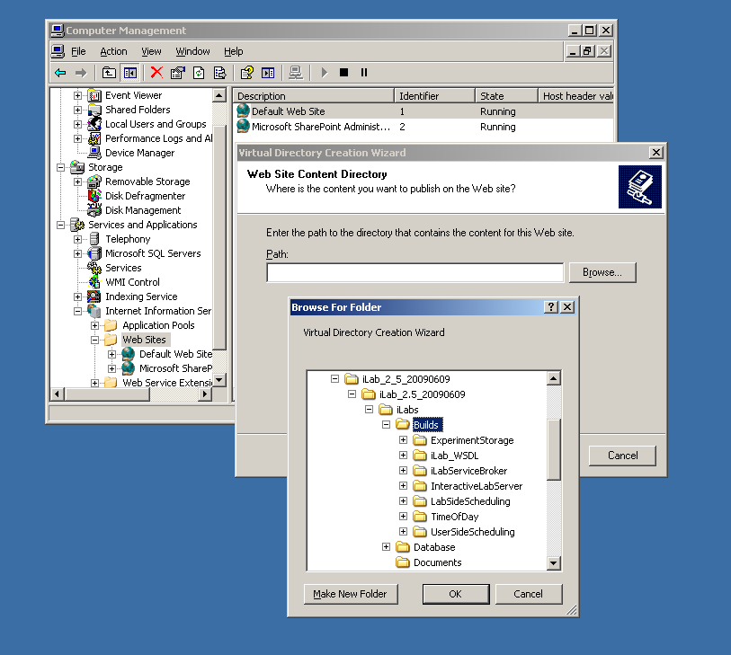

For notational purposes we will use \*local_path*\ to represent the directory on your local computer where the code is unzipped.

- Click Next
- Access Permissions: make sure you check the Run Scripts, Execute and Read permission boxes
- Click Next
- Click Finish
- You should see the Service Broker site listed under the Default Web Site
- Right click on the iLabServiceBroker website and select Properties
- Select the ASP.NET tab
- Use the pull-down list for the ASP.NET version and select 2.0.xxx. Where xxx is the current release version.
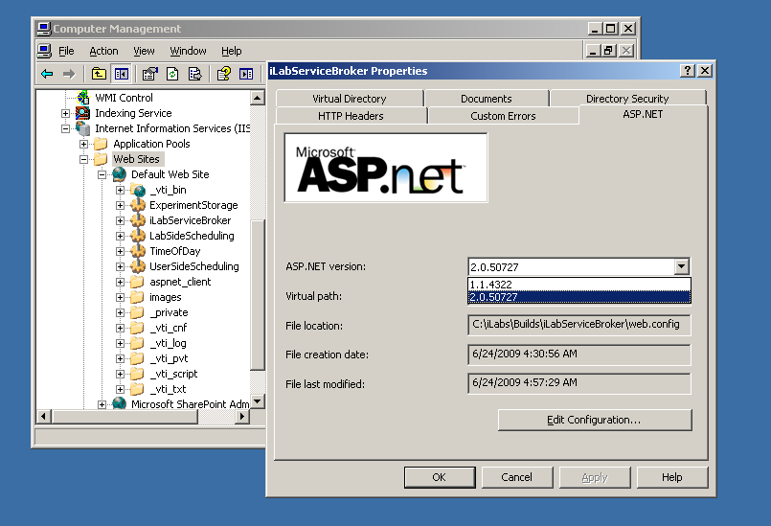
- Select OK and close the properties window
- Close the Computer Management Window
This document assumes that you will be installing each service separately or on separate machine. This document is organized by service.
If you are installing all the services on a single machine, a more efficient way to set up the services is by activity; i.e., all of the virtual directories at once. This document is not configured to follow this method, but you can use the included checklist to install by activity.

Create the Database
First, create the database.
- Start-> Enterprise Manager
- Console Root->Microsoft SQL Servers->SQL Server Group->(local)->Databases
- Right-Click on Databases
- New Database…
- Name: ilab_ISB (This is the default. You can use any name you would like but you must update the web.config file to use the different name)
- Click OK

Grant Access to the Database
- Expand the Security folder in Enterprise Manager.
- Right-click Logins, select New Login…
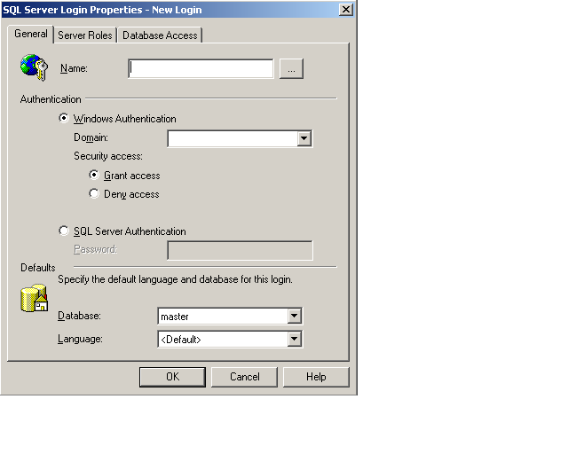
- In the Name box, type NT AUTHORITY\NETWORK SERVICE
  - Note: if you already have a login for NT AUTHORITY\NETWORK SERVICE, double-click on it and continue with the next step. If you are installing under Windows XP, please check the Windows XP notes guide for the proper security name to use.
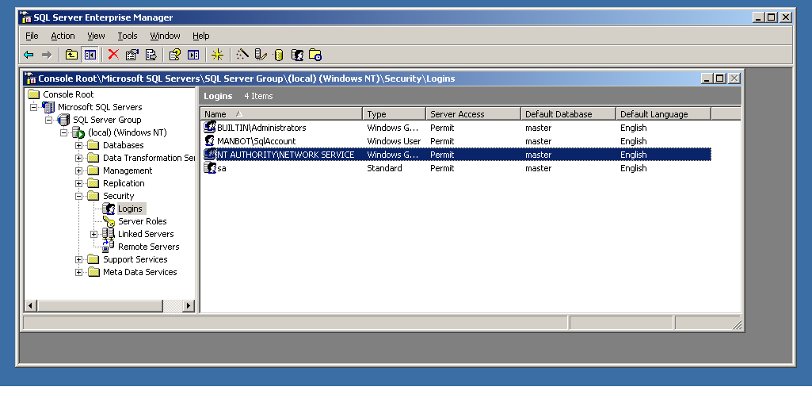
- Click the Database Access tab
- Check the box next to ilab_ISB (or the database name you used above)
- In the box below, click the box next to db_owner
- Click OK

Service Broker Database Scripts
For each Process Agent created (ISB, USS, LSS, ESS, and TOD), you will need to run Process Agent scripts that are generic for all process agents, and specific scripts for the particular Process Agent you are creating. The generic process agent scripts are in a directory called ProcessAgent and specific database scripts will be in named directories, for example ServiceBroker.
This document contains two ways to run the database scripts for Microsoft SQL server; from within the SQL Query Analyzer or from the loader scripts that are in the DB_Scripts directory. The preferred method of creating a new service database is to use Method 2: Using the SQL loader scripts. If you are just updating a stored procedure and not the database, it is best to use the SQL Query analyzer. We include Method1: Using the SQL Query Analyzer for your information.
NOTE: the SQL loader scripts do not work under Windows XP with SQL Express – if you are using Windows XP and SQL Express you will need to use the SQL Query Analyzer.
Do NOT attempt both methods – choose one.
METHOD 1: Using the SQL Query Analyzer:
- Expand Databases
- Select the ilab_ISB database (or what you named it) in Enterprise Manager.
- On the menu bar, select Tools -> SQL Query Analyzer
- In Query Analyzer, click File->Open…
- Browse to database scripts directory typically (\*local_path*\iLabs\ Database\DB_Scripts\ProcessAgent)
- In the ProcessAgent directory select and open the ProcessAgentTables.sql
This directory contains the database scripts for all of the Process Agents. You will set up and run the ProcessAgent database scripts before running the service-specific database scripts. This is important because there is a key from the iLab Service Broker foreign to the Process Agents table.
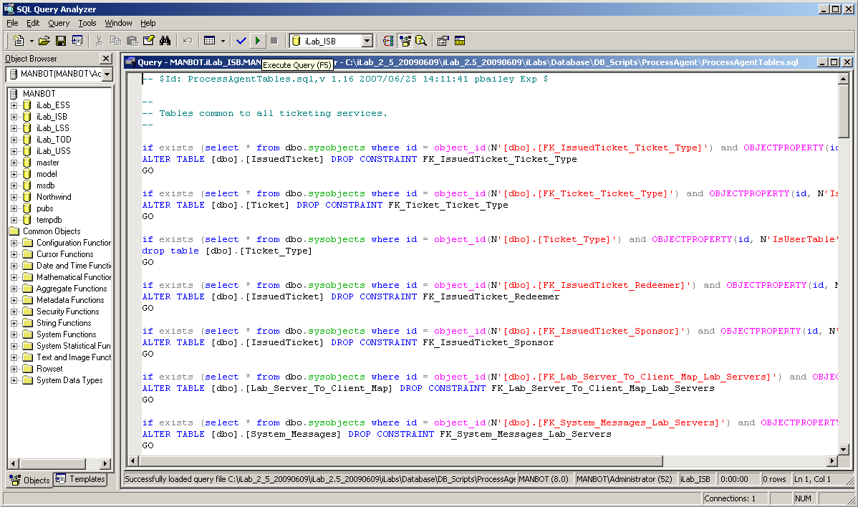
- Again make sure the correct database, ilab_ISB, is the selected database in the dropdown menu at the top of the window. *This is very important because the scripts will be installed in the database specified by this pull-down menu.
- Click the green triangle “play” button to run the script
- You should see a message: “The command(s) completed Successsfully.”
- Follow the same procedure, File → Open, to open and run the ProcessAgentProcedures.sql script.
- You should see the same message: “The command(s) completed Successsfully.”
- Open and run the SetDefaultsPA.sql script.
- You should see several messages: “1 row(s) affective.” and “Checking Identity Information ….”.
Next, set up and run the Interactive Service Broker-specific database scripts (typically located in \*local_path*\iLabs\ Database\DB_Scripts\ServiceBroker).
- In Query Analyzer, click File->Open…
- Browse to database scripts directory, typically (\*local_path*\iLabs\ Database\DB_Scripts\ServiceBroker)
- Open and run the TIssuerTables.sql script.
- Open and run the TIssuerProcedures.sql scripts.
- Open and run the ServiceBrokerCoreTables.sql script.
- Again you should see the message: “The command(s) completed Successsfully.”
- Open and run ServiceBrokerCoreProcedures.sql, as above
- Open and run ServiceBrokerCoreDefaultValues.sql as above
- You should see several messages: “1 row(s) affective.” and “Checking Identity Information ….”.
- Close SQL Query Manager and Enterprise Manager
METHOD 2: Using the SQL loader scripts:
- Open a Command Prompt window. Start -> Programs -> Accessories -> Command Prompt.
- A DOS window should open.
- Change the directory to the DBscripts directory.
- Type: “cd \*local_path*\iLabs\ Database\DB_Scripts\”
- Type: “LoadISB ilab_ISB” where ilab_ISB is the name of your database.
- You should see something similar to the following with your directory path and database name.
D:\iLabsInteractive\iLabs_NET20\iLabs\Database\DB_Scripts>loadISB iLab_ISB
D:\iLabsInteractive\iLabs_NET20\iLabs\Database\DB_Scripts>echo populating iLab_ISB
populating InteractiveSB InteractiveSB
D:\iLabsInteractive\iLabs_NET20\iLabs\Database\DB_Scripts>call ISB_tables.bat iLab_ISB
D:\iLabsInteractive\iLabs_NET20\iLabs\Database\DB_Scripts>echo InteractiveSB Tables: ilab_ISB
InteractiveSB Tables: ilab_ISB
D:\iLabsInteractive\iLabs_NET20\iLabs\Database\DB_Scripts>isqlw -E -d ilab_ISBeSB -i .\Ticketing\ProcessAgentTables.sql -o isbBuild0.log
D:\iLabsInteractive\iLabs_NET20\iLabs\Database\DB_Scripts>isqlw -E -d ilab_ISB -i .\Ticketing\SetdefaultsTicketing.sql -o isbBuild1.log
D:\iLabsInteractive\iLabs_NET20\iLabs\Database\DB_Scripts>isqlw -E -d ilab_ISB
-i .\Ticketing\TIssuerTables.sql -o isbBuild2.log
D:\iLabsInteractive\iLabs_NET20\iLabs\Database\DB_Scripts>isqlw -E -d ilab_ISB
-i .\InteractiveSB\ServiceBrokerCoreTables.sql -o isbBuild3.log
D:\iLabsInteractive\iLabs_NET20\iLabs\Database\DB_Scripts>isqlw -E -d ilab_ISB
-i .\InteractiveSB\ServiceBrokerCoreDefaultValues.sql -o isbBuild4.log
D:\iLabsInteractive\iLabs_NET20\iLabs\Database\DB_Scripts>call ISB_procedures.bat ilab_ISB
D:\iLabsInteractive\iLabs_NET20\iLabs\Database\DB_Scripts>echo InteractiveLS Procedures: ilab_ISB
InteractiveLS Procedures: ilab_ISB
D:\iLabsInteractive\iLabs_NET20\iLabs\Database\DB_Scripts>isqlw -E -d ilab_ISB -i .\Ticketing\ProcessAgentProcedures.sql -o isbBuild1.log -r
D:\iLabsInteractive\iLabs_NET20\iLabs\Database\DB_Scripts>isqlw -E -d ilab_ISB -i .\Ticketing\TIssuerProcedures.sql -o isbBuild4.log -r
D:\iLabsInteractive\iLabs_NET20\iLabs\Database\DB_Scripts>isqlw -E -d ilab_ISB -i .\InteractiveSB\ServiceBrokerCoreProcedures.sql -o isbBuild6.log -r

Web.Config
An overview of editing the web.config
Web.config is a text file containing configuration information in an XML format. It resides in the root of the Service Broker web site (typically in the \*local_path*\iLabs\Services\iLabServiceBroker directory). Web.config.template ships with this release.
If this is a new installation of the Service Broker, delete any existing copy of the Web.Config file. Copy web.config.template and paste the file into the same directory. Rename the copy “web.config” and edit it using notepad.
There are two ways to configure a service: editing the web.config file for that service directly using a program such as notepad, or using the self-registration webpage supplied as part of the installation package. Please note that not all fields can be configured using the self-registration webpages; there are certain fields that can only be edited in the web.config file. Also, changes made on the self-registration pages are not updated in the web.config file.
<?xml version="1.0"?>
<configuration xmlns="http://schemas.microsoft.com/.NetConfiguration/v2.0">
<!-- This area contains the Services specific configuration properties YOU MUST SET THESE-->
<appSettings>
<!--
Interactive ServiceBroker Web.Config -->

<!--
ProcessAgent required Keys -->
<!-- THE FOLLOWING MUST BE SET FOR ALL SERVICES, used to define the service -->
<!-- The following keys specify the WebService required Values -->
<!-- They are used by the SelfRegistration page to generate the ProcessAgent's
Bootstrap ProcessAgent Record, which must be created before installing domain credientials -->

<add key="serviceType" value="SERVICE BROKER"/>
<!-- The name of the Service displayed for the user, please change -->
<add key="serviceName" value="Default iLab ServiceBroker"/>
<!-- This Service's GUID You must supply a vaild GUID, see createGUID.exe, may be any string, 50 characters or less. -->
<add key="serviceGUID" value=""/>
<add key="codebaseURL" value="http://localhost/iLabServiceBroker"/>
<add key="serviceURL" value="http://localhost/iLabServiceBroker/iLabServiceBroker.asmx"/>
<add key="defaultPasskey" value="Let me in!"/>

<!-- the database connection information
NOTE: You Must set the database catalog to the database name that you created as part of the instalation process -->
<add key="sqlConnection" value="data source=(local);initial catalog=iLab_ISB;Integrated Security=SSPI" />

<!-- Optional path and filename for application log. The directory must exisit & be writeable to the IIS worker process -->
<add key="logPath" value=""/>

<!-- ServiceBroker Specific Keys -->
<!-- Cookie support for applets needed for .Net 2.0. This should only need to be changed if you host more than one SB per machine -->
<add key="isbAuthCookieName" value="isbAuth" />

<!-- CHANGE THIS TO LOCAL ADDRESS: email address where help requests are sent -->
<add key="supportMailAddress" value="ilab-comment@mit.edu"/>
<!-- CHANGE THIS TO LOCAL ADDRESS: default email address where requests for membership in a group are sent.
If the group has a contact address mail will be sent to that address -->
<add key="registrationMailAddress" value="your_email@your_machine.edu"/>
<add key="genericFromMailAddress" value="your_email@your_machine.edu"/>

<!-- email address where bug reports are sent, this for the centralized bug tracking system at MIT.
Append a local mail address if you want to also recieve bug reports ( comma delimited ) -->
<add key="bugReportMailAddress" value="ilab-bug@mit.edu"/>
<add key="bugReportOptions" value="System-wide error,Login,Group Issues,Grant Issues,UserInterface,Business logic"/>
<add key="helpOptions" value="General Help,Logging In,Running Lab,Page Specific Help"/>

……………………………………..

Update the Database Name
Update the database connection variable in the web.config file to use the name you chose when you created the database. Note the default database name is set to ilab_ISB. If you used a different database name, update the catalog value in the key. This name MUST match the name of your database exactly including capitalization.
<add key=”sqlConnection”
value="data source=(local);initial catalog=ilab_ISB;Integrated Security = SSPI" />

Update Email Addresses
Do not forget to update the email address keys or else users will encounter errors when registering and sending bugs.
<add key="supportMailAddress" value=" your_email@your_machine.edu " />
<add key="registrationMailAddress" value=" your_email@your_machine.edu " />
<add key="genericFromMailAddress" value="your_email@your_machine.edu"/>

Update Default Passkey
The default Pass Key is a simple string used by process agents to exchange credential information the first time only. This can be any string you would like. We recommend that you not change this.

<add key="defaultPasskey" value="" /> Set to “Let me in!” by default

Web.Config Parameters to be aware of:
There are several other parameters that you should be aware of in web.config, for example, bugreportMailAddress which is the email address that bug reports will be sent to.
serviceType | SERVICE BROKER (do not change this)
serviceName | A default name - should be changed in selfRegister (later)
serviceGuid | Must be created in selfRegister (later)
codebaseURL | SB application URL, change to DNS name in selfRegister (later)
serviceURL | SB’s service URL, change to DNS name in selfRegister (later)
defaultPassKey | Initial Passkey for credential exchange
sqlConnection | Database name, default ilab_ISB
bugReportingMailAddress | Enter a local email address or leave ilab-bug@mit.edu you may add comma delimited additional addresses
supportMailAddress | Enter a local email address
registrationMailAddress | Enter a local email address
genericFromMailAddress | Enter a local email address
NOTE: In the following steps it is best to use the fully qualified URLs in this document rather than localhost. localhost is good for testing but not for web service registrations. Make sure to use fully qualified URLs for registration. It is also important that your registration URLs be consistent. Do not mix the use of fully qualified URLs, localhost and IP addresses within a single service setup. Mixing registration URLs will cause problems with web service communications.

Testing Your Service Broker Installation
- Open Internet Explorer
- Browse to http://localhost/iLabServiceBroker/iLabServiceBroker.asmx
- The iLab Service Broker service description page should be displayed
- Browse to http://localhost/iLabServiceBroker
- Log in as follows:
  - Username: SuperUser
  - Password: ilab
Using the http://localhost is a good way to test your service installation, but you should also test with the fully qualified URLs in this document. The iLab architecture is designed to use fully qualified URLs, and unexpected things can happen when using localhost.
- Browse to http://machinename.edu/iLabServiceBroker/iLabServiceBroker.asmx
- The iLab Service Broker service description page should be displayed
- Browse to http:// machinename.edu /iLabServiceBroker
- Log in as follows:
  - Username: SuperUser
  - Password: ilab

Self-Registration Fields
Most of the setup information like the serviceName, serviceGUID and codebaseURL will now be entered in the Service Broker self-registration page when you first login to the Service Broker. This is the preferred method, but you can also enter the information into the web.config file and it will be loaded into the self-registration page for you to check.
NOTE: Currently, changes made in the self-registration page are not updated in the web.config file.

Each Service Broker and Process Agent must have a unique GUID (Globally Unique Identifier) which will identify this particular Service Broker to all lab servers and Process Agents. This GUID will be supplied to the Lab Server(s) administrator so that the Lab Server can be configured to communicate with this Service Broker. We use a GUID produced on the Service Broker's machine with all the '-', '{', and '}' characters stripped out. You can generate your own GUID and enter it in the web.config, or use the “Generate GUID” button on the Service Broker’s self registration page and then remove the hyphens (this is the preferred method).

BUG: The Service Broker GUID needs to be 35 characters or less due to some legacy code in the batched architecture. If you enter a GUID into the web.config file directly, please make sure that it is less than 35 characters long including dashes and hyphens.

iLab Service Broker Self Registration
In order for process agents to exchange credentials, their information needs to be entered into the Process Agents table. There is a self-registration web service included with each process agent. You cannot register a process agent until after you have created and edited the corresponding web.config file.
- Open Internet Explorer
- Browse to http://machinename.edu/iLabServiceBroker/
- Login as SuperUser
- Click on the “Services & Clients” tab
- Click on the “Self Registration” tab in the sub-menu
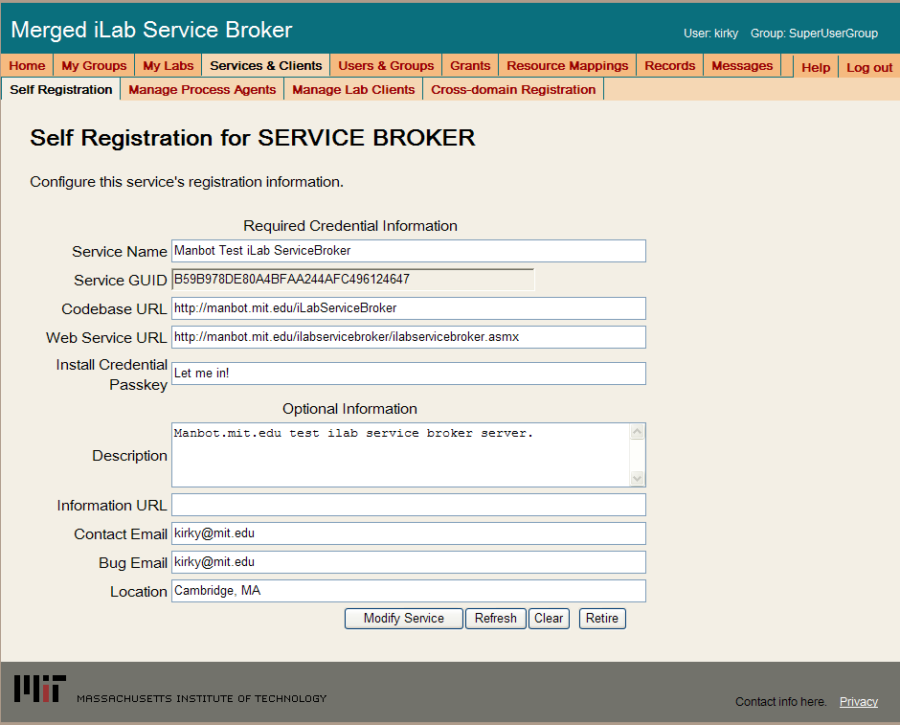
- Modify Service Name, CodeBase & Webservice URLs as needed. Please make sure that the Service Name is unique. Be sure to use fully qualified URLs.
  - Codebase URL: http://machinename.edu/iLabServiceBroker
  - Web Service URL: http://machinename.edu/iLabServiceBroker/iLabServiceBroker.asmx
- If necessary, use the “Create GUID” button to generate a new GUID and remove the hyphens.
BUG: The Service Broker GUID needs to be 35 characters or less due to some legacy code in the batched architecture. If you used the “Create GUID” button to generate the GUID, please remove the hyphens “-“ from the GUID before saving.
- Update the optional fields (Description, Information URL, Contact Email, Bug Email and Location) as needed.
- Click the Save Service button
NOTE: Currently, changes made in the self-registration page are not updated in the web.config file.
Please be aware that there are certain fields that can not be configured from the Service Broker self-registration page. For example, the default passkey for registering process agents such as the ESS can only be edited in the web.config file. Similarly, configuring email addresses for bugs and notices can also only be edited in the web.config file. Please see the section on the web.config for more information.

Error Messages
When testing your installation of the Service Broker you may see one of the following error messages:
- “Cannot open database requested in login 'ilab_ISB'. Login fails. Login failed for user 'NT AUTHORITY\NETWORK SERVICE'.”
- Edit the web.config and enter the correct database name.
- “The page cannot be displayed. You have attempted to execute a CGI, ISAPI, or other executable program from a directory that does not allow programs to be executed.” The Virtual Directory in IIS does not have the correct permissions. Remove the virtual directory and recreate it with the correct permissions.
- In the System News and Messages section of the login page you may see one of the following messages:
  - An Administrator needs to edit web.config and add a value for registrationMailAddress. This is the default email address where requests for membership in a group are sent.
  - An Administrator needs to add a value for supportMailAddress. This is the email address where help requests are sent.
To remove error or warning messages from the System News and Message area,
- Login as SuperUser
- Select the Messages tab from the top menu
- Click on the system bullet in the message type area
- Select a message to delete and click remove.

Experiment Storage Service (ESS)

ESS Web Site
First, create a virtual directory in IIS.
- Right-Click on My Computer (renamed to your computer name)
- Click Manage
- Expand Services and Applications
- Expand Internet Information Services
- Expand Web Sites
- Expand Default Web Site
- Right-click on Default Web Site
- Select New->Virtual Directory
- Click Next to enter the Virtual Directory Creation Wizard
- In the Alias box, type ExperimentStorage
- Click Next
- Enter \*local_path*\iLabs\Services\ExperimentStorage in the Directory box (or click the Browse button, and navigate to the location where the code is located.) If you are using the pre-built code, please use the “Builds” directory, \*local_path*\iLabs\Builds\iLabServiceBroker.
- Click Next
- Access Permissions: make sure you check the Run Scripts, Execute and Read permission boxes
- Click Next
- Click Finish
- You should see the ExperimentStorage site listed under the Default Web Site
- Right click on the ExperimentStorage website and select Properties
- Select the ASP.NET tab
- Use the pull-down list for the ASP.NET version and select 2.0.xxx. Where xxx is the current release version.
- Select OK and close the properties window
- Close the Computer Management Window

Create the Database
First, create the database.
- Start-> Enterprise Manager
- Console Root->Microsoft SQL Servers->SQL Server Group->(local)->Databases
- Right-Click on Databases
- New Database…
- Name: ilab_ESS (You can use any name you would like but you must update the web.config file if you change the default name)
- Click OK

Grant Access to the Database
- Expand the Security folder in Enterprise Manager.
- Double-click on the NT AUTHORITY\NETWORK SERVICE under Logins.
- Click the Database Access tab
- Check the box next to ilab_ESS (or the database name you used above)
- In the box below, click the box next to db_owner
- Click OK

ESS Database Scripts
This document contains two ways to run the database scripts for Microsoft SQL server; from within the SQL Query Analyzer or from the loader scripts that are in the DB_Scripts directory. The preferred method of creating a new service database is to use Method 2: Using the SQL loader scripts. If you are just updating a stored procedure and not the database, it is best to use the SQL Query analyzer. We include Method1: Using the SQL Query Analyzer for your information.
NOTE: the SQL loader scripts do not work under Windows XP with SQL Express – if you are using Windows XP and SQL Express you will need to use the SQL Query Analyzer.
Do NOT attempt both methods – choose one.
METHOD 1: Using the SQL Query Analyzer:
- Start-> Enterprise Manager
- Console Root->Microsoft SQL Servers->SQL Server Group->(local)->Databases
- Expand Databases
- Select the ilab_ESS database (or what you named it) in Enterprise Manager.
- On the menu bar, select Tools -> SQL Query Analyzer
- In Query Analyzer, click File -> Open…
- Browse to \*local_path*\iLabs\ Database\DB_Scripts\ProcessAgent
Every service must have its own Process Agent information. These tables should exist before the service-specific tables are added to the database.
- In the ProcessAgent directory select and open the ProcessAgentTables.sql
- Make sure the correct database is the selected database in the dropdown menu at the top of the window- *This is very important, because the scripts will be installed in the database specified by this pull-down menu.
- Click the green triangle “play” button to run the script
- You should see a message: “The command(s) completed Successsfully.”
- Follow the same procedure, File→Open, to open and run the ProcessAgentProcedures.sql script.
- You should see the same message: “The command(s) completed Successsfully.”
- Open and run the SetDefaultsPA.sql script.
Next, set up and run the ESS database script.
- In Query Analyzer, click File -> Open…
- Browse to database scripts directory typically \*local_path*\iLabs\ Database\DB_Scripts\ESS
- In the ESS directory select and open the Ess_Tables.sql
- Make sure the correct database is the selected database in the dropdown at the top, then click the green triangle “play” button to run the script
- You should see the message: “The command(s) completed Successsfully.”
- Follow the same procedure to open and run the Ess_Procedures.sql script.
- Again, you should see the message: “The command(s) completed Successsfully.”
- Close SQL Query Manager and Enterprise Manager
METHOD 2: Using the SQL loader scripts:
- Open a Command Prompt window. Start -> Programs -> Accessories -> Command Prompt.
- A DOS window should open.
- Change the directory to the DBscripts directory.
- Type: “cd \*local_path*\iLabs\ Database\DB_Scripts\”
- Type: “LoadESS ilab_ESS” where ilab_ESS is the name of your database.
- You should see something similar to the following with your directory path and database name.
D:\iLabsInteractive\iLabs_NET20\iLabs\Database\DB_Scripts>loadESS ilab_ESS
D:\iLabsInteractive\iLabs_NET20\iLabs\Database\DB_Scripts>echo populating ESS ilab_ESS
populating ESS ESSdb
D:\iLabsInteractive\iLabs_NET20\iLabs\Database\DB_Scripts>call ESS_tables.bat ilab_ESS
D:\iLabsInteractive\iLabs_NET20\iLabs\Database\DB_Scripts>echo creating ESS Tables: ilab_ESS
creating ESS Tables: ilab_ESS
D:\iLabsInteractive\iLabs_NET20\iLabs\Database\DB_Scripts>isqlw -E -d ilab_ESS -i .
\Ticketing\ProcessAgentTables.sql -o essBuild.log
D:\iLabsInteractive\iLabs_NET20\iLabs\Database\DB_Scripts>isqlw -E -d ilab_ESS -i .
\Ticketing\SetdefaultsTicketing.sql -o essBuild.log
D:\iLabsInteractive\iLabs_NET20\iLabs\Database\DB_Scripts>isqlw -E -d ilab_ESS -i .
\ESS\Ess_tables.sql -o essBuild.log
D:\iLabsInteractive\iLabs_NET20\iLabs\Database\DB_Scripts>call ESS_procedures.ba
t ilab_ESS
D:\iLabsInteractive\iLabs_NET20\iLabs\Database\DB_Scripts>echo Creating StoredPr
ocedures ESS: ESSdb
Creating StoredProcedures ESS: ilab_ESS
D:\iLabsInteractive\iLabs_NET20\iLabs\Database\DB_Scripts>isqlw -E -d ilab_ESS -i .
\Ticketing\ProcessAgentProcedures.sql -o essBuild.log
D:\iLabsInteractive\iLabs_NET20\iLabs\Database\DB_Scripts>isqlw -E -d ilab_ESS -i .
\ESS\ESS_Procedures.sql -o essBuild.log
D:\iLabsInteractive\iLabs_NET20\iLabs\Database\DB_Scripts>

Web.Config
An overview of editing the web.config.
Web.config is a text file containing configuration information in an XML format, residing in the root of the ESS Services web site (typically in the \*local_path*\iLabs\Services\ExperimentStorage directory). Web.config.template ships with this release. If a web.config already exists, please delete it. Copy web.config.template and paste the file into the same directory. Rename the copy “web.config” and edit it using notepad. Please be sure to use only fully qualified URLs
NOTE: Currently, changes made in the self-registration page are not updated in the web.config file.

Update the Database Name
Update the database connection variable in the web.config file to use the name you chose when you created the database. Note the default database name is set to ilab_ESS. If you used a different database name, update the catalog value in the key.
<add key=”sqlConnection”
value="data source=(local);initial catalog=ilab_ESS;Integrated Security = SSPI" />

Update Default Passkey
The default Pass Key is a simple string used by process agents to exchange credential information the first time only. This can be any string you would like. We recommend that you not change this.

<add key="defaultPasskey" value="ESS" />

Web.Config Parameters to be aware of:
serviceType | EXPERIMENT STORAGE SERVER – Do not Change
serviceName | ESS unique name for this service
serviceGuid | ESS GUID - Set during self Registration (later)
codebaseURL | ESS application URL - Set during self Registration (later)
serviceURL | ESS’s service URL - Set during self Registration (later)
defaultPassKey | Initial Passkey for credential exchange
sqlConnection | Database Connection string;

Test the Experiment Storage Service:
- Open Internet Explorer
- Browse to http://localhost/ExperimentStorage/ExperimentStorage.asmx
Using the http://localhost is a good way to test your service installation, but you should also test with the fully qualified URLs in this document. The iLab architecture is designed to use fully qualified URLs, and unexpected things can happen when using localhost.

Self-Registration Fields
Most of the setup information like the serviceName, serviceGUID and codebaseURL will now be entered in the self-registration page. This is the preferred method, but you can also enter the information into the web.config file and it will be loaded into the self-registration page for you to check.

<?xml version="1.0"?>

<configuration>
<configSections>
</configSections>
<appSettings>
<!-- Experiment Storage Service Web.Config -->

<!-- ProcessAgent required Keys -->
<add key="serviceType" value="EXPERIMENT STORAGE SERVER"/>
<add key="serviceName" value="Default ESS"/>
<add key="serviceGUID" value=""/>
<add key="codebaseURL" value="http://localhost/ExperimentStorage"/>
<add key="serviceURL" value="http://localhost/ExperimentStorage/ExperimentStorage.asmx"/>
<add key="defaultPasskey" value="ESS"/>
<add key="sqlConnection" value="data source=(local);initial catalog=iLab_ESS;Integrated Security=SSPI"/>

<!-- Optional path and filename for application log. The directory must exisit & be writeable to the IIS worker process -->
<add key="logPath" value=""/>
……………………………………..

Each Process Agent must have a unique GUID (Globally Unique Identifier) which will identify this particular Process Agent to all lab servers. This GUID will be supplied to the Lab Server(s) administrator so that the Lab Server can be configured to communicate with this Service Broker. We use a GUID produced on with all the '{', and '}' characters stripped out. You can generate your own GUID and enter it in the web.config or use the “Generate GUID” button on the Service Broker’s self registration page (this is the preferred method).

BUG: The Service Broker and process agent GUIDs needs to be 35 characters or less due to some legacy code in the batched architecture. If you used the “Create GUID” button to generate the GUID, please remove the hyphens “-“ from the GUID before saving.

ESS Self Registration
In order for process agents to exchange credentials, their information needs to be entered into the Process Agents table. There is a self-registration web service included with each process agent. You cannot register a process agent until after you have created and edited the corresponding web.config file.
KNOWN BUG: Currently, there is no CSS associated with the Experiment Storage self-registration page.

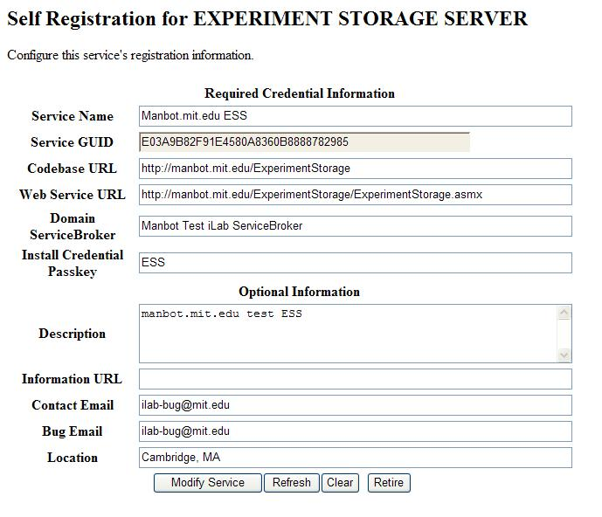
- Open Internet Explorer
- Browse to http://machinename.edu/ExperimentStorage/selfRegistration.aspx
- Modify ESS Service Name, CodeBase & Webservice URLs as needed. Please make sure that the Service Name is unique.
  - Codebase URL: http://machinename.edu/ExperimentStorage
  - Web Service URL: http://machinename.edu/ExperimentStorage/ ExperimentStorage.asmx
- If necessary, use the “Create GUID” button to generate a new GUID. Please remove the ‘-‘ from the GUID.
BUG: The Service Broker GUID needs to be 35 characters or less due to some legacy code in the batched architecture. If you used the “Create GUID” button to generate the GUID, please remove the hyphens “-“ from the GUID before saving.
- Update the optional fields (Description, Information URL, Contact Email, Bug Email and Location) as needed.
- Click the Save Service button
NOTE: Currently, changes made in the self-registration page are not updated in the web.config file.

Userside Scheduling Services (USS)

USS Web Site
First, create a virtual directory in IIS.
- Right-Click on My Computer (renamed to your computer name)
- Click Manage
- Expand Services and Applications
- Expand Internet Information Services
- Expand Web Sites
- Expand Default Web Site
- Right-click on Default Web Site
- Select New->Virtual Directory
- Click Next to enter the Virtual Directory Creation Wizard
- In the Alias box, type UserSideScheduling
- Click Next
- Enter \*local_path*\iLabs\Services\UserSideScheduling in the Directory box (or click the Browse button, and navigate to the location where your Service Broker code is). If you are using the pre-built code, please use the builds directory.
- Click Next
- Access Permissions: make sure you check the Run Scripts, Execute and Read permission boxes
- Click Next
- Click Finish
- You should see the UserSideScheduling site listed under the Default Web Site
- Right click on the UserSideScheduling website and select Properties
- Select the ASP.NET tab
- Use the pull-down list for the ASP.NET version and select 2.0.xxx. Where xxx is the current release version.
- Select OK and close the properties window
- Close the Computer Management Window

Create the Database
First, create the database.
- Start-> Enterprise Manager
- Console Root->Microsoft SQL Servers->SQL Server Group->(local)->Databases
- Right-Click on Databases

- New Database…
- Name: ilab_USS (You can use any name you would like but you must update the web.config file if you change this name)
- Click OK

Grant Access to the Database
- Expand the Security folder in Enterprise Manager.
- Double-click on the NT AUTHORITY\NETWORK SERVICE under Logins
- Click the Database Access tab
- Check the box next to ilab_USS (or the database name you used above)
- In the box below, click the box next to db_owner
- Click OK

USS Database Scripts
This document contains two ways to run the database scripts for Microsoft SQL server; from within the SQL Query Analyzer or from the loader scripts that are in the DB_Scripts directory. The preferred method of creating a new service database is to use Method 2: Using the SQL loader scripts. If you are just updating a stored procedure and not the database, it is best way is to use the SQL Query analyzer. We include Method1: Using the SQL Query Analyzer for your information.
NOTE: the SQL loader scripts do not work under Windows XP with SQL Express – if you are using Windows XP and SQL Express you will need to use the SQL Query Analyzer.
Do NOT attempt both methods – choose one.
METHOD 1: Using the SQL Query Analyzer:
- Start-> Enterprise Manager
- Console Root->Microsoft SQL Servers->SQL Server Group->(local)->Databases
- Expand Databases
- Select the ilab_USS database (or what you named it) in Enterprise Manager.
- On the menu bar, select Tools -> SQL Query Analyzer
- In Query Analyzer, click File -> Open…
- Browse to \*local_path*\iLabs\Database\DB_Scripts\ProcessAgent
Every service must have its own Process Agent information. These tables should exist before the service-specific tables are added to each database.
- In the ProcessAgent directory select and open the ProcessAgentTables.sql
- Make sure the correct database is the selected database in the dropdown menu at the top - *This is very important, because the scripts will be installed in the database specified by this pull-down menu.
- Click the green triangle “play” button to run the script
- You should see a message: “The command(s) completed Successsfully.”
- Follow the same procedure, File→Open, to open and run the ProcessAgentProcedures.sql script.
- You should see the same message: “The command(s) completed Successsfully.”
- Open and run the SetDefaultsPA.sql script.
Next, set up and run the USS database script.
- In Query Analyzer, Click File -> Open…
- Browse to database scripts directory typically \*local_path*\iLabs\ Database\DB_Scripts\Scheduling
- In the Scheduling directory select and open the USS_Tables.sql
- Make sure the correct database is the selected database in the dropdown at the top, then click the green triangle “play” button to run the script
- You should see the message: “The command(s) completed Successsfully.”
- Follow the same procedure to open and run the USS_Procedures.sql script.
- Again you should see the message: “The command(s) completed Successsfully.”
- Close SQL Query Manager and Enterprise Manager
METHOD 2: Using the SQL loader scripts:
- Open a Command Prompt window. Start -> Programs -> Accessories -> Command Prompt.
- A DOS window should open.
- Change the directory to the DBscripts directory.
- Type: “cd \*local_path*\iLabs\ Database\DB_Scripts\”
- Type: “LoadUSS ilab_USS” where ilab_USS is the name of your database.
- You should see something similar to the following with your directory path and database name.
D:\iLabsInteractive\iLabs_NET20\iLabs\Database\DB_Scripts>loadUSS Ilab_USS
D:\iLabsInteractive\iLabs_NET20\iLabs\Database\DB_Scripts>echo loading USS: USSdb
loading USS: Ilab_USS
D:\iLabsInteractive\iLabs_NET20\iLabs\Database\DB_Scripts>call USS_tables.bat USSdb
D:\iLabsInteractive\iLabs_NET20\iLabs\Database\DB_Scripts>echo USS Tables: Ilab_USS
USS Tables: Ilab_USS
D:\iLabsInteractive\iLabs_NET20\iLabs\Database\DB_Scripts>isqlw -E -d Ilab_USS -i .
\Ticketing\ProcessAgentTables.sql -o ussBuild.log
D:\iLabsInteractive\iLabs_NET20\iLabs\Database\DB_Scripts>isqlw -E -d Ilab_USS -i .
\Ticketing\SetdefaultsTicketing.sql -o ussBuild.log
D:\iLabsInteractive\iLabs_NET20\iLabs\Database\DB_Scripts>isqlw -E -d Ilab_USS -i .
\Scheduling\USS_Tables.sql -o ussBuild.log
D:\iLabsInteractive\iLabs_NET20\iLabs\Database\DB_Scripts>call USS_procedures.bat Ilab_USS
D:\iLabsInteractive\iLabs_NET20\iLabs\Database\DB_Scripts>echo USS Procedures: USSdb
USS Procedures: Ilab_USS
D:\iLabsInteractive\iLabs_NET20\iLabs\Database\DB_Scripts>isqlw -E -d Ilab_USS -i .
\Ticketing\ProcessAgentProcedures.sql -o lssBuild.log
D:\iLabsInteractive\iLabs_NET20\iLabs\Database\DB_Scripts>isqlw -E -d Ilab_USS -i .
\Scheduling\USS_Procedures.sql -o lssBuild.log
D:\iLabsInteractive\iLabs_NET20\iLabs\Database\DB_Scripts>

Web.Config
An overview of editing the web.config
Web.config is a text file containing configuration information in an XML format, residing in the root of the USS Services web site (typically in the \*local_path*\iLabs\ Services\ UserSideScheduling directory). Web.config.template ships with this release. If the web.config file already exists, delete it. Copy web.config.template and paste the file into the same directory. Rename the copy “web.config” and edit it using notepad.
NOTE: Currently, changes made in the self-registration page are not updated in the web.config file.
<?xml version="1.0"?>
<configuration>
<appSettings>
<!--
LabSideScheduling Web.Config -->

<!--
ProcessAgent required Keys -->
<!-- THE FOLLOWING MUST BE SET FOR ALL SERVICES, used to define the service -->
<!-- The following keys specify the WebService required Values -->
<!-- They are used by the SelfRegistration page to generate the ProcessAgent's
Bootstrap ProcessAgent Record, which must be created before installing domain credientials -->
<!-- The Service Type - Do Not Change -->
<add key="serviceType" value="SCHEDULING SERVER"/>
<!-- The name of the Service displayed for the user, please change -->
<add key="serviceName" value="Default UserScheduling Server"/>
<!-- This Service's GUID You must supply a vaild GUID, see createGUID.exe, may be any string, 50 characters or less. -->
<add key="serviceGUID" value=""/>
<add key="codebaseURL" value="http://localhost/UserSideScheduling"/>
<add key="serviceURL" value="http://localhost/UserSideScheduling/UserScheduling.asmx"/>
<add key="defaultPasskey" value="USS"/>

<!-- the database connection information
NOTE: You Must set the database catalog to the database name that you created as part of the instalation process -->
<add key="sqlConnection" value="data source=(local);initial catalog=iLab_USS;Integrated Security=SSPI"/>
……………………………………..

Update the Database Name
Update the database connection variable in the web.config file to use the name you chose when you created the database. Note the default database name is set to ilab_USS. If you used a different database name, update the catalog value in the key.
<add key=”sqlConnection”
value="data source=(local);initial catalog=ilab_USS;Integrated Security = SSPI" />

Update Default Passkey
The default Pass Key is a simple string used by process agents to exchange credential information the first time only. This can be any string you would like. We recommend that you not change this.

<add key="defaultPasskey" value="USS" />

Web.Config Parameters to be aware of:
ServiceType | SCHEDULING SERVER – Do not Change
service Name | USS unique name – Change in selfRegister (later)
serviceGuid | USS GUID - Set in selfRegister (later)
codebaseURL | USS’s applicaiton URL – Change in selfRegister (later)
serviceURL | USS’s service URL– Change in selfRegister (later)
DefaultPassKey | Initial Passkey for credential exchange
sqlConnection | Database name – default ilab_USS

Test the Scheduling Services:
- Open Internet Explorer
- Browse to http://localhost/UserSideScheduling/UserScheduling.asmx
Using the http://localhost is a good way to test your service installation, but you should also test with the fully qualified URLs in this document. The iLab architecture is designed to use fully qualified URLs, and unexpected things can happen when using localhost.
Self Registration
Most of the setup information like the serviceName, serviceGUID and codebaseURL will now be entered in the self-registration page. This is the preferred method, but you can also enter the information into the web.config file and it will be loaded into the self-registration page for you to check. Make sure to use fully qualified URLs in the self-registration page.
Each Process Agent must have a unique GUID (Globally Unique Identifier) which will identify this particular Process Agent to all lab servers. This GUID will be supplied to the Lab Server(s) administrator so that the Lab Server can be configured to communicate with this Service Broker. We use a GUID produced on with all the '{', and '}' characters stripped out. You can generate your own GUID and enter it in the web.config or use the “Generate GUID” button on the Service Broker’s self registration page (this is the preferred method).

USS Self Registration
In order for process agents to exchange credentials, their information needs to be entered into the Process Agents table. There is a self-registration web service included with each process agent. You cannot register a process agent until after you have created and edited the corresponding web.config file.
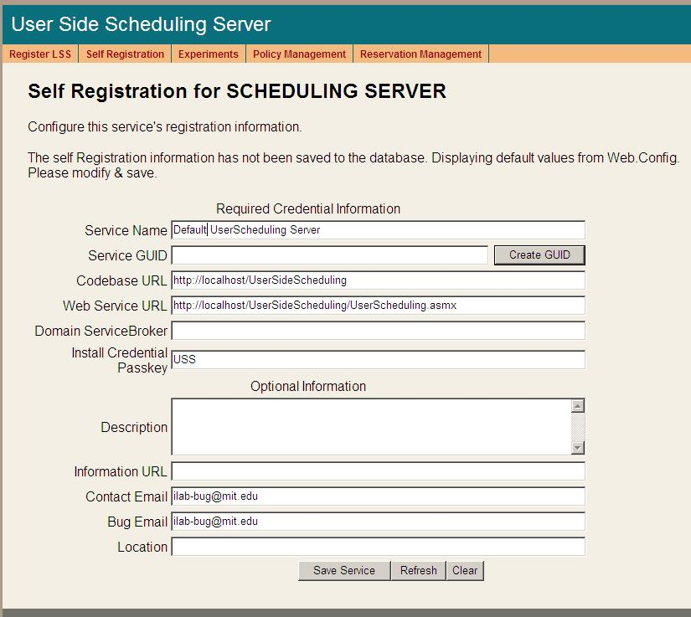
- Open Internet Explorer
- Browse to http://machinename.edu/UserSideScheduling/selfRegistration.aspx
- Modify the USS Service Name, CodeBase & Webservice URLs as needed. Please make sure that the Service Name is unique. Make sure to use fully qualified URLs.
  - Codebase URL: http://machinename.edu/UserSideScheduling
  - Web Service URL: http://machinename.edu/UserSideScheduling/UserScheduling.asmx
- If necessary, use the “Create GUID” button to generate a new GUID
BUG: The Service Broker GUID needs to be 35 characters or less due to some legacy code in the batched architecture. If you used the “Create GUID” button to generate the GUID, please remove the hyphens “-“ from the GUID before saving.
- Update the optional fields (Description, Information URL, Contact Email, Bug Email and Location) as needed.
- Click the Save Service button
NOTE: Currently, changes made in the self-registration page are not updated in the web.config file.

Labside Scheduling Service

LSS Web Site
First, create a virtual directory in IIS.
- Right-Click on My Computer (renamed to your computer name)
- Click Manage
- Expand Services and Applications
- Expand Internet Information Services
- Expand Web Sites
- Expand Default Web Site
- Right-click on Default Web Site
- Select New->Virtual Directory
- Click Next to enter the Virtual Directory Creation Wizard
- In the Alias box, type LabSideScheduling
- Click Next
- Enter \*local_path*\iLabs\Services\LabSideScheduling in the Directory box (or click the Browse button, and navigate to the location where your Service Broker code is). If you used the pre-built code please use the builds directory.
- Click Next
- Access Permissions: make sure you check the Run Scripts, Execute and Read permission boxes
- Click Next
- Click Finish
- You should see the LabSideScheduling site listed under the Default Web Site
- Right click on the LabSideScheduling website and select Properties
- Select the ASP.NET tab
- Use the pull-down list for the ASP.NET version and select 2.0.xxx. Where xxx is the current release version.
- Select OK and close the properties window
- Close the Computer Management Window

Create the Database
First, create the database.
- Start-> Enterprise Manager
- Console Root->Microsoft SQL Servers->SQL Server Group->(local)->Databases
- Right-Click on Databases
- New Database…
- Name: ilab_LSS (You can use any name you would like but you must update the web.config file if you change this name)
- Click OK

Grant Access to the Database
- Expand the Security folder in Enterprise Manager.
- Double-click on the NT AUTHORITY\NETWORK SERVICE under Logins
- Click the Database Access tab
- Check the box next to ilab_LSS (or the database name you used above)
- In the box below, click the box next to db_owner
- Click OK

LSS Database Scripts
This document contains two ways to run the database scripts for Microsoft SQL server; from within the SQL Query Analyzer or from the loader scripts that are in the DB_Scripts directory. The preferred method of creating a new service database is to use Method 2: Using the SQL loader scripts. If you are just updating a stored procedure and not the database, it is best way to use the SQL Query analyzer. We include Method1: Using the SQL Query Analyzer for your information.
NOTE: the SQL loader scripts do not work under Windows XP with SQL Express – if you are using Windows XP and SQL Express you will need to use the SQL Query Analyzer.
Do NOT attempt both methods – choose one.
METHOD 1: Using the SQL Query Analyzer:
- Start-> Enterprise Manager
- Console Root->Microsoft SQL Servers->SQL Server Group->(local)->Databases
- Expand Databases
- Select the ilab_LSS database (or what you named it) in Enterprise Manager.
- On the menu bar, select Tools -> SQL Query Analyzer
- In Query Analyzer, click File -> Open…
- Browse to database scripts directory typically \*local_path*\iLabs\ Database\DB_Scripts\ProcessAgent
Every service must have its own Process Agent information. These tables should exist before the service-specific tables are added to each database.
- In the ProcessAgent directory select and open the ProcessAgentTables.sql
- Make sure the correct database is the selected database in the dropdown menu at the top - *This is very important, because the scripts will be installed in the database specified by this pull-down menu.
- Click the green triangle “play” button to run the script
- You should see a message: “The command(s) completed Successsfully.”
- Follow the same procedure, File→Open, to open and run the ProcessAgentProcedures.sql script.
- You should see the same message: “The command(s) completed Successsfully.”
- Open and run the SetDefaultsPA.sql script.
Next, set up and run the LSS database scripts, typically located in \*local_path*\iLabs\ Database\DB_Scripts\Scheduling.
- In Query Analyzer, click File -> Open…
- In the Scheduling directory select and open the LSS_Tables.sql
- Make sure the correct database is the selected database in the dropdown at the top, then click the green triangle “play” button to run the script
- You should see the message: “The command(s) completed Successsfully.”
- Follow the same procedure to open and run the LSS_Procedures.sql script.
- Again, you should see the message: “The command(s) completed Successsfully.”
- Close SQL Query Manager and Enterprise Manager
METHOD 2: Using the SQL loader scripts:
- Open a Command Prompt window. Start -> Programs -> Accessories -> Command Prompt.
- A DOS window should open.
- Change the directory to the DBscripts directory.
- Type: “cd :\*local_path*\iLabs\ Database\DB_Scripts\”
- Type: “LoadLSS ilab_LSS” where ilab_LSS is the name of your database.
- You should see something similar to the following with your directory path and database name.
D:\iLabsInteractive\iLabs_NET20\iLabs\Database\DB_Scripts>loadLSS LSSdb
D:\iLabsInteractive\iLabs_NET20\iLabs\Database\DB_Scripts>echo populating LSS LSSdb
populating LSS LSSdb
D:\iLabsInteractive\iLabs_NET20\iLabs\Database\DB_Scripts>call LSS_tables.bat LSSdb
D:\iLabsInteractive\iLabs_NET20\iLabs\Database\DB_Scripts>echo LSS Tables: LSSdb
LSS Tables: LSSdb
D:\iLabsInteractive\iLabs_NET20\iLabs\Database\DB_Scripts>isqlw -E -d LSSdb -i .
\Ticketing\ProcessAgentTables.sql -o lssBuild.log
D:\iLabsInteractive\iLabs_NET20\iLabs\Database\DB_Scripts>isqlw -E -d LSSdb -i .
\Ticketing\SetdefaultsTicketing.sql -o lssBuild.log
D:\iLabsInteractive\iLabs_NET20\iLabs\Database\DB_Scripts>isqlw -E -d LSSdb -i .
\Scheduling\LSSCreateTableScript.sql -o lssBuild.log
D:\iLabsInteractive\iLabs_NET20\iLabs\Database\DB_Scripts>call LSS_procedures.bat LSSdb
D:\iLabsInteractive\iLabs_NET20\iLabs\Database\DB_Scripts>echo LSS Procedures: LSSdb
LSS Procedures: LSSdb
D:\iLabsInteractive\iLabs_NET20\iLabs\Database\DB_Scripts>isqlw -E -d LSSdb -i .
\Ticketing\ProcessAgentProcedures.sql -o lssBuild.log
D:\iLabsInteractive\iLabs_NET20\iLabs\Database\DB_Scripts>isqlw -E -d LSSdb -i .
\Scheduling\LSSstoreprocedure.sql -o lssBuild.log
D:\iLabsInteractive\iLabs_NET20\iLabs\Database\DB_Scripts>

Web.Config
An overview of editing the web.config
Web.config is a text file containing configuration information in XML format, residing in the root of the LSS Services web site (typically in the \*local_path*\iLabs\ Services\LabSideScheduling directory). Web.config.template ships with this release. If a web.config file already exists, please delete it. Copy web.config.template and paste the file into the same directory. Rename the copy “web.config” and edit it using notepad.
NOTE: Currently, changes made in the self-registration page are not updated in the web.config file.

<?xml version="1.0"?>
<configuration xmlns="http://schemas.microsoft.com/.NetConfiguration/v2.0">
<appSettings>
<!--
LabSideScheduling Web.Config -->
<!--
ProcessAgent required Keys -->
<!-- THE FOLLOWING MUST BE SET FOR ALL SERVICES, used to define the service -->
<!-- The following keys specify the WebService required Values -->
<!-- They are used by the SelfRegistration page to generate the ProcessAgent's
Bootstrap ProcessAgent Record, which must be created before installing domain credientials -->

<add key="serviceType" value="LAB SCHEDULING SERVER"/>
<!-- The name of the Service displayed for the user, please change -->
<add key="serviceName" value="Default LabScheduling Server"/>
<!-- This Service's GUID You must supply a vaild GUID, see createGUID.exe, may be any string, 50 characters or less. -->
<add key="serviceGUID" value=""/>
<add key="codebaseURL" value="http://localhost/LabSideScheduling"/>
<add key="serviceURL" value="http://localhost/LabSideScheduling/LabScheduling.asmx"/>
<add key="defaultPasskey" value="LSS"/>

<!-- the database connection information
NOTE: You Must set the database catalog to the database name that you created as part of the instalation process -->
<add key="sqlConnection" value="data source=(local);initial catalog=iLab_LSS;Integrated Security=SSPI"/>
……………………………………..

Update the Database Name
Update the database connection variable in the web.config file to use the name you chose when you created the database. Note the default database name is set to ilab_LSS. If you used a different database name, update the catalog value in the key.
<add key=”sqlConnection”
value="data source=(local);initial catalog=ilab_LSS;Integrated Security = SSPI" />

Update Default Passkey
The default Pass Key is a simple string used by process agents to exchange credential information the first time only. This can be any string you would like. We recommend that you not change this.

<add key="defaultPasskey" value="LSS" />

Web.Config Parameters to be aware of:
ServiceType | LAB SCHEDULING SERVER –Do Not Change
serviceName | LSS unique name – change in selfRegister (later)
serviceGuid | This is the LSS’s Guid – change in selfRegister (later)
codebaseURL | LSS application URL – change in selfRegister (later)
serviceURL | LSS’s service URL
DefaultPassKey | Initial Passkey for credential exchange
sqlConnection | Database name – default ilab_LSS

Test the Scheduling Services:
- Open Internet Explorer
- Browse to http://localhost/LabSideScheduling/LabScheduling.asmx
Using the http://localhost is a good way to test your service installation, but you should also test with the fully qualified URLs in this document. The iLab architecture is designed to use fully qualified URLs, and unexpected things can happen when using localhost.
Self Registration

Most of the setup information like the serviceName, serviceGUID and codebaseURL will now be entered in the self-registration page. This is the preferred method, but you can also enter the information into the web.config file and it will be loaded into the self-registration page for you to check. Use fully qualified URLs.

Each Process Agent must have a unique GUID (Globally Unique Identifier) which will identify this particular Process Agent to all lab servers. This GUID will be supplied to the Lab Server(s) administrator so that the Lab Server can be configured to communicate with this Service Broker. We use a GUID produced on with all the '{', and '}' characters stripped out. You can generate your own GUID and enter it in the web.config use the “Generate GUID” button on the Service Broker’s self registration page (this is the preferred method).

LSS Self Registration
In order for process agents to exchange credentials, their information needs to be entered into the Process Agents table. There is a self-registration web service included with each process agent. You should not self register a process agent until after you have created and edited the corresponding web.config file.
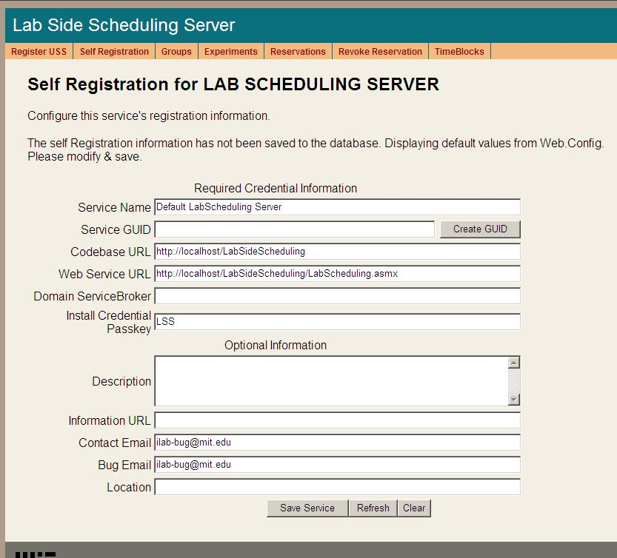
- Open Internet Explorer
- Browse to http://localhost/LabSideScheduling/selfRegistration.aspx
- Modify Service Name, CodeBase & Webservice URLs as needed. Please make sure that the Service Name is unique. Be sure to use fully qualified URLs.
  - Codebase URL: http://machinename.edu/LabSideScheduling
  - Web Service URL: http://machinename.edu/LabSideScheduling/LabScheduling.asmx
- If necessary, use the “Create GUID” button to generate a new GUID
BUG: The Service Broker GUID needs to be 35 characters or less due to some legacy code in the batched architecture. If you used the “Create GUID” button to generate the GUID, please remove the hyphens “-“ from the GUID before saving.
- Update the optional fields (Description, Information URL, Contact Email, Bug Email and Location) as needed.
- Click the Save Service button
NOTE: Currently, changes made in the self-registration page are not updated in the web.config file.

Time Of Day Lab Server

TimeOfDay Web Site
First, create a virtual directory in IIS.
- Right-Click on My Computer (renamed to your computer name)
- Click Manage
- Expand Services and Applications
- Expand Internet Information Services
- Expand Web Sites
- Expand Default Web Site
- Right-click on Default Web Site
- Select New->Virtual Directory
- Click Next to enter the Virtual Directory Creation Wizard
- In the Alias box, type TimeOfDay
- Click Next
- Enter \*local_path*\iLabs\Services\TimeOfDay in the Directory box (or click the Browse button, and navigate to the location where your Service Broker code is). If you used the pre-built code, please use the builds directory.
- Click Next
- Access Permissions: make sure you check the Run Scripts, Execute and Read permission boxes
- Click Next
- Click Finish
- You should see the TimeOfDay site listed under the Default Web Site
- Right click on the TimeOfDay website and select Properties
- Select the ASP.NET tab
- Use the pull-down list for the ASP.NET version and select 2.0.xxx. Where xxx is the current release version.
- Select OK and close the properties window
- Close the Computer Management Window

Create the Database
First, create the database.
- Start-> Enterprise Manager
- Console Root->Microsoft SQL Servers->SQL Server Group->(local)->Databases
- Right-Click on Databases
- New Database…
- Name: ilab_TOD (You can use any name you would like but you must update the web.config file if you change this name)
- Click OK

Grant Access to the Database
- Expand the Security folder in Enterprise Manager.
- Double-click on the NT AUTHORITY\NETWORK SERVICE under Logins
- Click the Database Access tab
- Check the box next to ilab_TOD (or the database name you used above)
- In the box below, click the box next to db_owner
- Click OK

TOD Database Scripts
This document contains two ways to run the database scripts for Microsoft SQL server; from within the SQL Query Analyzer or from the loader scripts that are in the DB_Scripts directory. The preferred method of creating a new service database is to use Method 2: Using the SQL loader scripts. If you are just updating a stored procedure and not the database, it is best to use the SQL Query analyzer. We include Method1: Using the SQL Query Analyzer for your information.
NOTE: the SQL loader scripts do not work under Windows XP with SQL Express – if you are using Windows XP and SQL Express you will need to use the SQL Query Analyzer.
Do NOT attempt both methods – choose one.
METHOD1: Using the SQL Query Analyzer:
- Start-> Enterprise Manager
- Console Root->Microsoft SQL Servers->SQL Server Group->(local)->Databases
- Expand Databases
- Select the ilab_TOD database (or what you named it) in Enterprise Manager.
- On the menu bar, Select Tools -> SQL Query Analyzer
- In Query Analyzer, Click File->Open…
- Browse to database scripts directory typically (\*local_path*\iLabs\ Database\DB_Scripts\ProcessAgent)
Every service must have its own Process Agent information. These tables should exist before the service-specific tables are added to each database.
- In the ProcessAgent directory select and open the ProcessAgentTables.sql
- Make sure the correct database is the selected database in the dropdown at the top - *This is very important, because the scripts will be installed in the database specified by this pull-down menu.
- Click the green triangle “play” button to run the script
- You should see a message: “The command(s) completed Successsfully.”
- Follow the same procedure, File→Open, to open and run the ProcessAgentProcedures.sql script.
- You should see the same message: “The command(s) completed Successsfully.”
- Open and run the SetDefaultsPA.sql script.
- Close SQL Query Manager and Enterprise Manager
For the Time Of Day Server, there are no process agent-specific database scripts that need to be run.
METHOD 2: Using the SQL loader scripts:
- Open a Command Prompt window. Start -> Programs -> Accessories -> Command Prompt.
- A DOS window should open.
- Change the directory to the DBscripts directory.
- Type: “D:” to change the disk if you need to
- Type: “cd :\*local_path*\iLabs\ Database\DB_Scripts\”
- Type: “LoadTOD ilab_TOD” where ilab_TOD is the name of your database.
- You should see something similar to the following with your directory path and database name.
D:\iLabsInteractive\iLabs_NET20\iLabs\Database\DB_Scripts>loadTOD Ilab_TOD
D:\iLabsInteractive\iLabs_NET20\iLabs\Database\DB_Scripts>echo populating TOD TODdb
populating TOD Ilab_TOD
D:\iLabsInteractive\iLabs_NET20\iLabs\Database\DB_Scripts>call TOD_tables.bat TODdb
D:\iLabsInteractive\iLabs_NET20\iLabs\Database\DB_Scripts>echo populating TOD TODdb
populating TOD Ilab_TOD
D:\iLabsInteractive\iLabs_NET20\iLabs\Database\DB_Scripts>isqlw -E -d Ilab_TOD -i .
\Ticketing\ProcessAgentTables.sql -o TODBuild.log
D:\iLabsInteractive\iLabs_NET20\iLabs\Database\DB_Scripts>isqlw -E -d Ilab_TOD -i .
\Ticketing\SetdefaultsTicketing.sql -o TODBuild.log
D:\iLabsInteractive\iLabs_NET20\iLabs\Database\DB_Scripts>call TOD_procedures.bat Ilab_TOD
D:\iLabsInteractive\iLabs_NET20\iLabs\Database\DB_Scripts>echo TOD Procedures: TODdb
TOD Procedures: Ilab_TOD
D:\iLabsInteractive\iLabs_NET20\iLabs\Database\DB_Scripts>isqlw -E -d Ilab_TOD -i .
\Ticketing\ProcessAgentProcedures.sql -o TODBuild.log
D:\iLabsInteractive\iLabs_NET20\iLabs\Database\DB_Scripts>loadTOD Ilab_TOD
D:\iLabsInteractive\iLabs_NET20\iLabs\Database\DB_Scripts>echo populating TOD TODdb
populating TOD Ilab_TOD
D:\iLabsInteractive\iLabs_NET20\iLabs\Database\DB_Scripts>call TOD_tables.bat TODdb
D:\iLabsInteractive\iLabs_NET20\iLabs\Database\DB_Scripts>echo populating TOD TODdb
populating TOD Ilab_TOD
D:\iLabsInteractive\iLabs_NET20\iLabs\Database\DB_Scripts>isqlw -E -d Ilab_TOD -i .
\Ticketing\ProcessAgentTables.sql -o TODBuild.log
D:\iLabsInteractive\iLabs_NET20\iLabs\Database\DB_Scripts>isqlw -E -d Ilab_TOD -i .
\Ticketing\SetdefaultsTicketing.sql -o TODBuild.log
D:\iLabsInteractive\iLabs_NET20\iLabs\Database\DB_Scripts>call TOD_procedures.bat Ilab_TOD
D:\iLabsInteractive\iLabs_NET20\iLabs\Database\DB_Scripts>echo TOD Procedures: TODdb
TOD Procedures: Ilab_TOD
D:\iLabsInteractive\iLabs_NET20\iLabs\Database\DB_Scripts>isqlw -E -d Ilab_TOD -i .
\Ticketing\ProcessAgentProcedures.sql -o TODBuild.log
D:\iLabsInteractive\iLabs_NET20\iLabs\Database\DB_Scripts>

Web.Config
An overview of editing the web.config
Web.config is a text file containing configuration information in XML format, residing in the root of the InterctiveTimeOfDay web site (typically in the \*local_path*\iLabs\ Services\InteractiveTimeOfDay directory). Web.config.template ships with this release. If a web.config already exists, please delete it. Copy web.config.template and paste the file into the same directory. Rename the copy “web.config” and edit it using notepad. Use only fully qualified URLs in the web.config file.
NOTE: Currently, changes made in the self-registration page are not updated in the web.config file.

<?xml version="1.0"?>
<configuration>
<appSettings>
<!--
Interactive TimeOfDay Web.Config -->

<!--
ProcessAgent required Keys -->
<!-- THE FOLLOWING MUST BE SET FOR ALL SERVICES, used to define the service -->
<!-- The following keys specify the WebService required Values -->
<!-- They are used by the SelfRegistration page to generate the ProcessAgent's
Bootstrap ProcessAgent Record, which must be created before installing domain credientials -->

<add key="serviceType" value="LAB SERVER"/>
<!-- The name of the Service displayed for the user, please change -->
<add key="serviceName" value="Default TimeOfDay Server"/>
<!-- This Service's GUID You must supply a vaild GUID, see createGUID.exe, may be any string, 50 characters or less. -->
<add key="serviceGUID" value=""/>
<add key="codebaseURL" value="http://localhost/TimeOfDay"/>
<add key="serviceURL" value="http://localhost/TimeOfDay/TimeOfDayWebService.asmx"/>
<add key="defaultPasskey" value="TOD"/>

<!-- the database connection information
NOTE: You Must set the database catalog to the database name that you created as part of the instalation process -->
<add key="sqlConnection" value="data source=(local);initial catalog=iLab_TOD;Integrated Security=SSPI"/>

Update the Database Name
Update the database connection variable in the web.config file to use the name you chose when you created the database. Note the default database name is set to ilab_TOD. If you used a different database name, update the catalog value in the key.
<add key=”sqlConnection”
value="data source=(local);initial catalog=ilab_TOD;Integrated Security = SSPI" />

Note: there is an mistake in the web.config file in the release … check the database name in the web.config file and make sure that the database name you used to create the database matches exactly including capitalization.

Update Default Passkey
The default Pass Key is a simple string used by process agents to exchange credential information the first time only. This can be any string you would like. We recommend that you not change this.

<add key="defaultPasskey" value="TOD" />

Web.Config Parameters to be aware of:
serviceType | LAB SERVER – Do Not Change
serviceName | Lab Server unique name – Change in selfRegistration
serviceGuid | This is the LSS’s Guid name – Set in selfRegistration
codebaseURL | Lab Server URL – Change in selfRegistration
serviceURL | Lab Server’s service URL – Change in selfRegistration
DefaultPassKey | Initial Passkey for credential exchange
sqlConnection | Database name – default ilab_TOD

Test the Time Of Day Server:
- Open Internet Explorer
- Browse to http://localhost/TimeOfDay/TimeOfDayWebService.asmx
Using the http://localhost is a good way to test your service installation, but you should also test with the fully qualified URLs in this document. The iLab architecture is designed to use fully qualified URLs, and unexpected things can happen when using localhost.
Self Registration
Most of the setup information like the serviceName, serviceGUID and codebaseURL will now be entered in the web service self-registration page. This is the preferred method, but you can also enter the information into the web.config file and it will be loaded into the self-registration page for you to check.

Each Process Agent must have a unique GUID (Globally Unique Identifier) which will identify this particular Process Agent to all lab servers. This GUID will be supplied to the Lab Server(s) administrator so that the Lab Server can be configured to communicate with this Service Broker. We use a GUID produced on with all the '{', and '}' characters stripped out. You can generate your own GUID and enter it in the web.config or use the “Generate GUID” button on the Service Broker’s self registration page (this is the preferred method).

TOD Self Registration
In order for process agents to exchange credentials, their information needs to be entered into the Process Agents table. There is a self-registration webservice included with each process agent. You cannot register a process agent until after you have created and edited the corresponding web.config file.
- Open Internet Explorer
- Browse to http://localhost/TimeOfDay/selfRegistration.aspx
- Modify Service Name, CodeBase & Webservice URLs as needed. Please make sure that the Service Name is unique. Be sure to use fully qualified URLs.
  - Codebase URL: http://machinename.edu/TimeOfDay
  - Web Service URL: http://machinename.edu/TimeOfDay/ TimeOfDayWebService.asmx
- If necessary, use the “Create GUID” button to generate a new GUID
BUG: The Service Broker GUID needs to be 35 characters or less due to some legacy code in the batched architecture. If you used the “Create GUID” button to generate the GUID, please remove the hyphens “-“ from the GUID before saving.
- Update the optional fields (Description, Information URL, Contact Email, Bug Email and Location) as needed.
- Click the Save Service button
NOTE: Currently, changes made in the self-registration page are not updated in the web.config file.
KNOWN BUG: Currently, there is no CSS associated with the Time Of Day Interactive Experiment self-registration page.

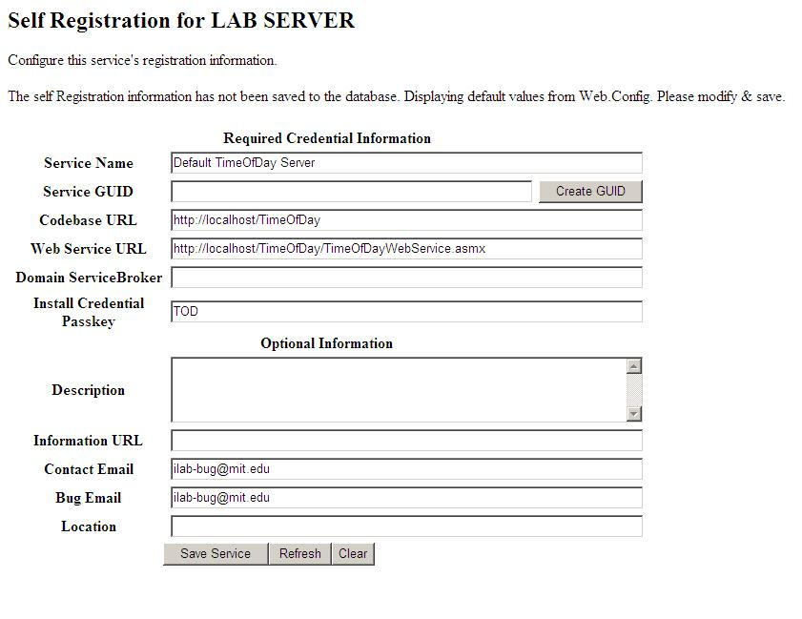

Bootstrapping
Bootstrapping is the process of enabling the various iLab services to recognize each other and exchange credentials.
This initial bootstrapping process will assume that you are logged into the iLab Service Broker as a SuperUser and that all servers are in the same domain. To manage the USS and LSS directly, you will need to be logged in as the correct management group – not as SuperUser
This document will set up and configure the different services for the Service Broker, and configure the Time Of Day (TOD) test lab.
NOTE: This document assumes that you will replace your computer’s name and fully qualified URL where ever you see “machinename.edu”.
NOTE: Before beginning the bootstrapping process, any and all current security patches and internet browser updates must be downloaded and installed.

Users and Groups
At the time of installation, the database script creates one default user and group called “SuperUser”. This user is the Service Broker’s administrator and has full permissions. Any user added to this group will also have full administration permissions on the Service Broker.
In addition to the SuperUser group, you will need administrator groups for Process Agent services such as the USS and LSS, and a management group for each user group. Members of the administration groups will have SuperUser permissions on the specified Process Agent; typically these are the lab or department administrators. Members of the management groups will have control over a particular group of students; typically these are the class TAs.
Create an administrator group for administering the Userside Scheduling Server (USS) called USS_admin
- Navigate to http://machinename.edu/ilabservicebroker
- Log in as SuperUser
- Click on the Users & Groups tab on the main menu of the Service Broker.
- In the sub-menu, select the Administer Groups tab.
- Click on the Add Service Admin Group button. A popup window should appear.
- Enter the Group Name “USS_admin”.
- Enter a Description, “Administration group for the USS”.
- Enter the administrator’s contact email address.
- This service does not need a request group, so do not click on Need Request group.
- This is a Administer group, so you do not need to add or change the Direct Group Membership area.
- Click on the Save Changes button. The new group should be listed on the Administer Groups page.
Create an Administrator group for administering the Labside Scheduling Server (LSS) called LSS_admin
- On the Administer Groups page, click on the Add Service Admin Group button. A popup window should appear.
- Enter the Group Name “LSS_admin”.
- Enter a Description, “Administration group for the LSS”.
- Enter the administrator’s contact email address.
- Click on the Save Changes button. The new LSS_admin group should be listed on the Administer Groups page.
Create a management group for managing the Lab Server (LS) configurations on the Labside Scheduling Server (LSS). In our case we will be managing the Time Of Day Lab Server configuration on the LSS, but this group will manage all the Lab Servers using this LSS.
- On the Administer Groups page, click on the Add Service Admin Group button. A popup window should appear.
- Enter the Group Name “Manage_LS_on_LSS”.
- Enter a Description, “Managers group for managing the Lab Servers using the LSS”.
- Enter the administrator’s contact email address.
- Click on the Save Changes button. The new group should be listed on the Administer Groups page.
Create a management group for managing the Time Of Day users group on the Userside Scheduling Server (USS)
- On the Administer Groups page, click on the Add Service Admin Group button. A popup window should appear.
- Enter the Group Name “Manage_Users_on_USS”.
- Enter a Description, “Managers group for managing the Time of Day lab users on the USS”.
- Enter the administrator’s contact email address.
- Click on the Save Changes button. The new group should be listed on the Administer Groups page.
Create a group for users of the Time Of Day Experiment
- On the Administer Groups page, click on the Add Group button. A popup window should appear.
- Enter the Group Name “Experiment_Group”.
- Enter a Description, “User Experiment Group for running and testing Experiments”.
- Enter the administrator’s contact email address.
- The Time Of Day Interactive Lab service does not need any additional groups, so do not click on Need Request group or Need course Staff Group.
- Click on the Save Changes button. The new Experiment_Group group should be listed on the Administer Groups page.
- Next, we need to give this group permission to create and store experiments. Click on the Edit button for the Experiment_Group. A popup window will appear.
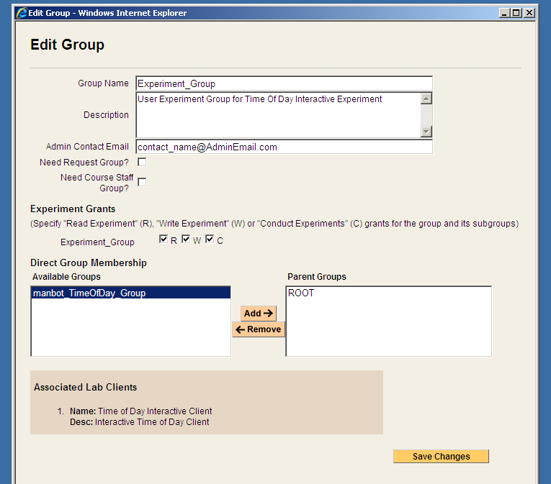
- In the Experiment Grants area under Experiment_Group click on the R, W and C boxes.

Process Agents
Process Agents are services (web servers or web service calls) that that the Service Broker can use. Setting up a new Process Agent is a two step process. We have tried to automate this process as much as possible to eliminate the need for human data entry. For each Process Agent (except the Service Broker) you will need to contact the Process Agent administrator via email and get the web services URL and an initial passkey. With these two items (web services URL and passkey) you should be able to install domain credentials.

Service Broker
The Service Broker Information page can be found on the Service Broker Information tab in the Service & Clients sub-menu. This page provides the self-Registration function for the iLab Service Broker. Initially, this information is retrieved from the Service Broker’s web.config file. On this page, you can create a new GUID for the Service Broker, if needed, and edit the defaults for serverName, serviceURL, applicationURL.
If you have already modified the defaults in the Service Broker’s web.config file, you can use this page to make sure the information is correct. Remember all URLs must be fully qualified including protocol and actual host DNS name or IP address. These variables that used for all communication between this service and all other services.
This information is used to create process agent credentials and can not be changed once an external process agent is registered. Note: If you are developing and all services will reside on the development machine you may leave the machine name as localhost but this is not recommended. We recommend using fill qualified URLs at all times.
If you have not already done so, register the Service Broker.
Add Service Broker’s Information to the Process Agents table.
- Click on the Service Broker Information tab.
- Modify Service Name, CodeBase & Webservice URLs as necessary. Please be sure that the Service Name is unique. Be sure to use fully qualified URLs.
  - Codebase URL: http://machinename.edu/iLabServiceBroker
  - Web Service URL: http://machinename.edu/iLabServiceBroker/iLabServiceBroker.asmx
- If necessary, use the “Create GUID” button to generate a new GUID and remove the hyphens.
BUG: The Service Broker GUID needs to be 35 characters or less due to some legacy code in the batched architecture. If you used the “Create GUID” button to generate the GUID, please remove the hyphens “-“ from the GUID before saving.

- Click on the Save Changes button to add the Service Brokers credentials to the Process Agents table.
Next, complete the Service Broker information in the Process Agent’s table
- Click on the Services & Clients tab
- Click on the Manage Process Agents tab
- Use the Services pull-down menu to select the Service Broker.
- Enter your University Name and Service Broker name into the description field, if it is not already entered.
- Enter a URL for service information in the info_URL box, if available
- Enter a contact email into the correct box.
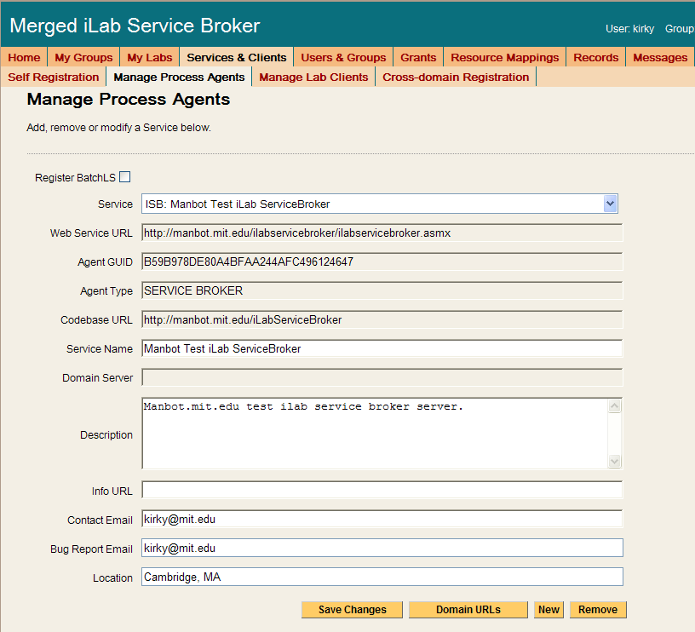
- Click Save Changes. You should see a green box at the top of the page stating that the record has been modified.
For the Service Broker, there are no additional Domain URLs that need to be entered. Changes made from the Manage Process Agents page will NOT be reflected in the web.config file.

Experiment Storage Service (ESS)
To add the Experiment Storage Service to the Service Broker, you will need the web service URL and an initial passkey for the ESS. This should be exchanged via email if you are not the owner of these services. For this document, we will assume that you are the administrator for all services and that you will be using the default initial passkey values.
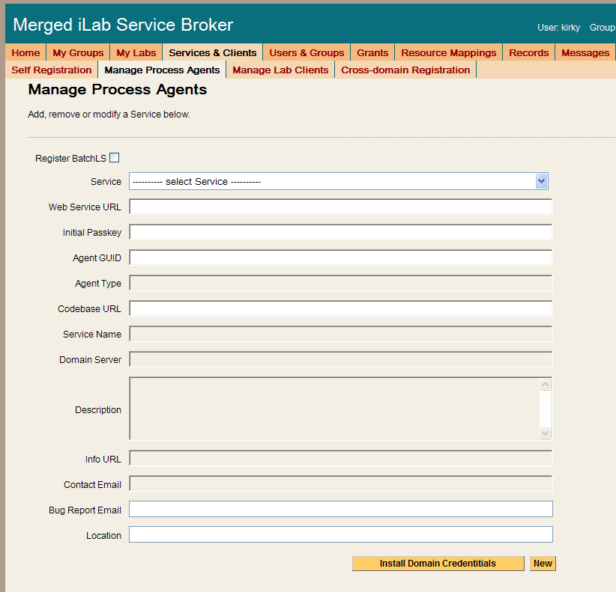
Add the ESS to the Service Broker and exchange credentials.
- Click on the Manage Process Agents page.
- Enter ESS info (web services URL & passkey) into the correct fields. Default Web Services URL: http://machinename.edu/ExperimentStorage/ExperimentStorage.asmx Default Passkey: ESS
- Click on the Install domain credentials button.
- A register web service call is made using the web services URL and initial passkey to get the Process Agent’s information and credentials.
- You should see a green message bar at the top of the page stating that a “Relationship has been created and saved.”
Complete the information record for the ESS.
- You can use the description area to make notes about the process agent as needed. Make any other necessary changes to fields like info URL, contact email, bug email, and location.
- For the ESS, you do not need to select an Admin Group pull down list.
- Click Save Changes. You should see a green box at the top of the page stating that the record has been successfully updated.
The ESS does not need to have any Domain URLs entered.

Userside Scheduling Server (USS)
To add the User-side Scheduling Service to the Service Broker, you will need the web service URL and an initial passkey for the USS. This should be exchanged via email if you are not the owner of these services. For this document, we will assume that you are the administrator for all services and that you will be using the default initial passkey values.
Add the USS to the Service Broker and exchange credentials.
- Click on the Manage Process Agents tab
- Enter USS info (web services URL & passkey) into the correct fields. Default Web Services URL: http://machinename.edu/UserSideScheduling/UserScheduling.asmx
- Default Passkey: USS
- Click on the Install domain credentials button.
- A register web service call is made using the web services URL and initial passkey, to get the process Agents information and credentials.
- You should see a green message bar at the top of the page stating that a “Relationship has been created and saved.”
Associate the USS Administration Group with the USS.
- Still on the “Manage Process Agents” page, select the “USS_admin” group from the Admin Group pull down list. (This is the administrator group that will manage the USS that was created earlier.)
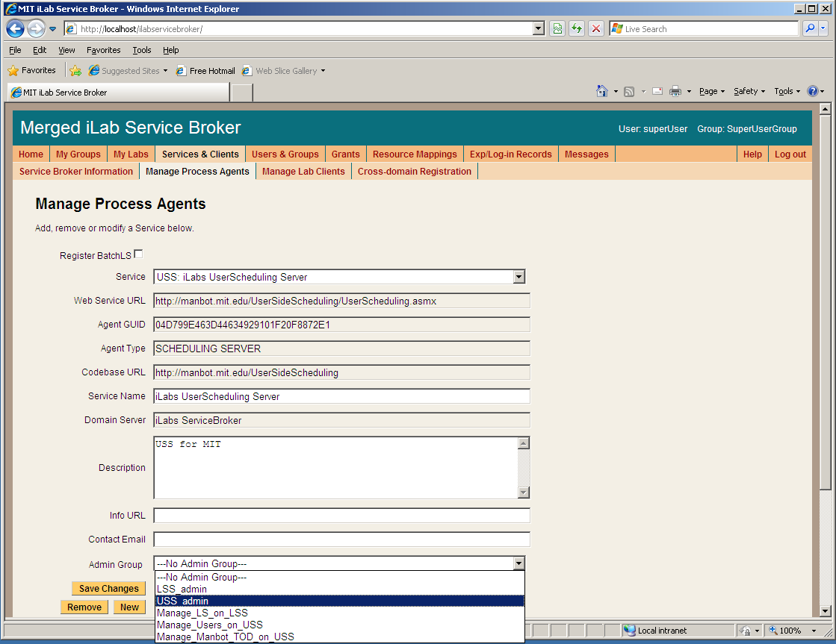
- You can use the description area to make notes about the process agent as needed. Enter “USS for your_university name” into the description area.
- Click Save Changes. You should see a green message bar at the top of the page stating that the record has been successfully modified.
Domain URLs are needed for administering and managing the USS. These URLs are automatically generated and entered into the database. To check the domain URLs:
- Click on the Domain URLs button. The domain URLs will be displayed in the Existing URL area.
- For the USS, there should be three domain URLs. Administer_USS, Manage_USS_Group, and Schedule_Session
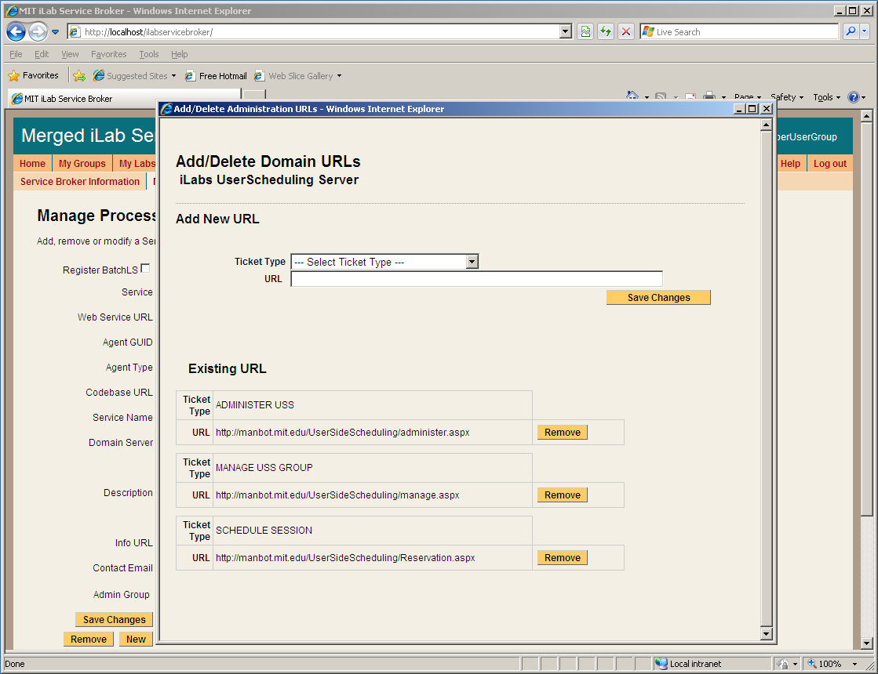
- Close the Domain URLs popup window.

Labside Scheduling Server (LSS)
To add the Labside Scheduling Service to the Service Broker, you will need the web service URL for the LSS and an initial passkey. This should be exchanged via email if you are not the owner of these services. For this document, we will assume that you are the administrator for all services and that you will be using the default initial passkey values.
Add the LSS to the Service Broker and exchange credentials.
- Click on the Manage Process Agents tab
- Enter LSS info (web services URL & passkey) into the correct fields.
- Default Web Services URL: http://machinename.edu/LabSideScheduling/LabScheduling.asmx
- Default Passkey: LSS
- Click on the Install domain credentials button.
- A register web service call is made using the web services URL and initial passkey, to get the process Agents information and credentials.
- You should see a green message bar at the top of the page stating that a “Relationship has been created and saved.”
Associate the LSS Administration Group with the USS.
- Select the “LSS_admin” group from the Admin Group pull down list. (This is the administration group that will manage the LSS.)
- You can use the description area to make notes about the process agent as necessary. Enter “LSS for your_university name” into the description area.
- Click Save Changes. You should see a green message bar at the top of the page stating that the record has been successfully updated.
Domain URLs are needed for administering and managing the USS. These URLs are automatically generated and entered into the database. To check the domain URLs:
- Click on the Domain URLs button. The domain URLs will be displayed in the Existing URL area.
- For the USS, there should be two domain URLs: Administer_LSS and Manage_Lab.
- Close the Domain URLs popup window.

Time Of Day Lab Server (LS)
To add the Lab Server to the Service Broker, you will need the web service URL and an initial passkey for the Lab Server. This should be exchanged via email if you are not the owner of these services. For this document, we will assume that you are the administrator for all services and that you will be using the default initial passkey values.
Add the ToD Lab Server to the Service Broker and exchange credentials.
- Click on the Manage Process Agents tab
- Enter LS info (web services URL & passkey) into the correct fields.
- Default Web Services URL: http://machinename.edu/TimeOfDay/TimeOfDayWebService.asmx
- Default Passkey: TOD
- Click on the Install domain credentials button.
- A register web service call is made using the web services URL and initial passkey, to get the process Agents information and credentials.
- You should see a green message bar at the top of the page stating that a “Relationship has been created and saved.”
Associate the LSS and management group with this Lab Server.
- Select the LSS to associate with this Lab Server from the pull-down list
- Select a Management group (Manage_LS_on_LSS) from the pull-down list
- Click the Associate button
The Lab Server does not need an Admin Group nor does it have any Domain URLs entered.

Time Of Day Lab Client

Lab Client Record
Create a Time Of Day Lab Client record.
- Click the Manage Lab Clients tab.
- Lab Client Name: Time Of Day Interactive Client
- Click the Make Guid button to generate a new GUID for this client. GUIDs can not be changed once the client record is saved.
- Version: 1.5
- Short Description: Interactive Time Of Day Client
- Long Description: Interactive Time Of Day Client with elephant image.
- Contact First Name: Your Name
- Contact Last Name: Your Name
- Contact Email: your@email_address
- Click on the box next to Needs Scheduling
- Click on the box next to Needs ESS
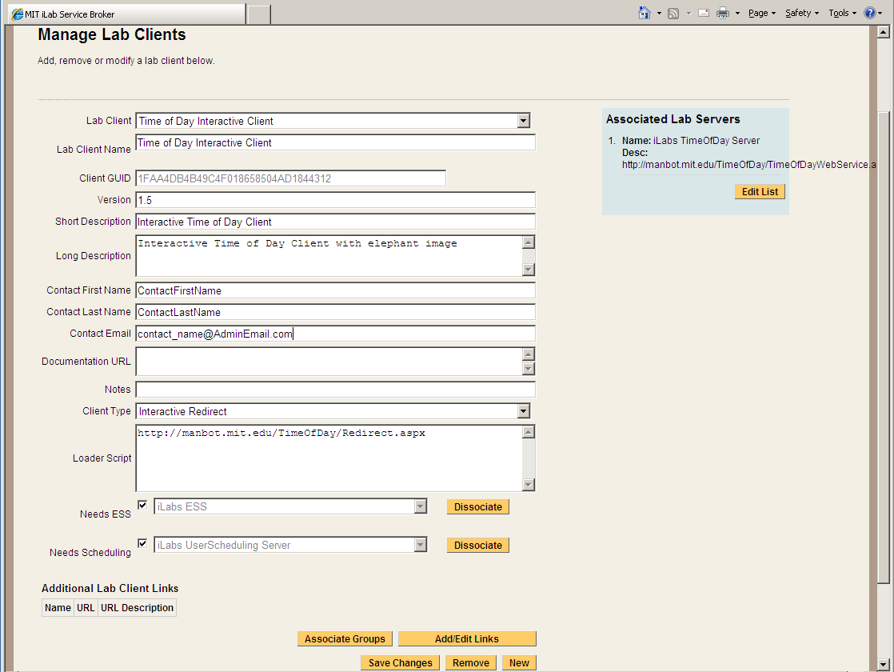

Client Loader Script
The Time Of Day Interactive Client is an HTML redirect client. Make sure to use fully qualified URLs.
Set up the Client loader scripts.
You should still be on the Manage Lab Clients page.
- On the Time Of Day Interactive Clients page, select “Interactive Redirect” from the Client Type pull-down list.
- Enter the redirect URL “http://machinename.edu/TimeOfDay/Redirect.aspx” into Loader Script area.
- Click Save Changes
- You should see a green message bar at the top of the page stating that the record has been modified.

Associate the Lab Server
You should still be on the Manage Lab Clients page.
Associate the Time Of Day Lab Server with the Time Of Day Client.
- Click the Edit List button under Associated Lab Servers in the upper right column. A popup window will appear.
- In the popup window, notice the Time Of Day Server web service URL in the left hand box labeled Available Lab Server.
- Select the Time of Day Lab Server web service URL so it is highlighted, then select the Add >> button.
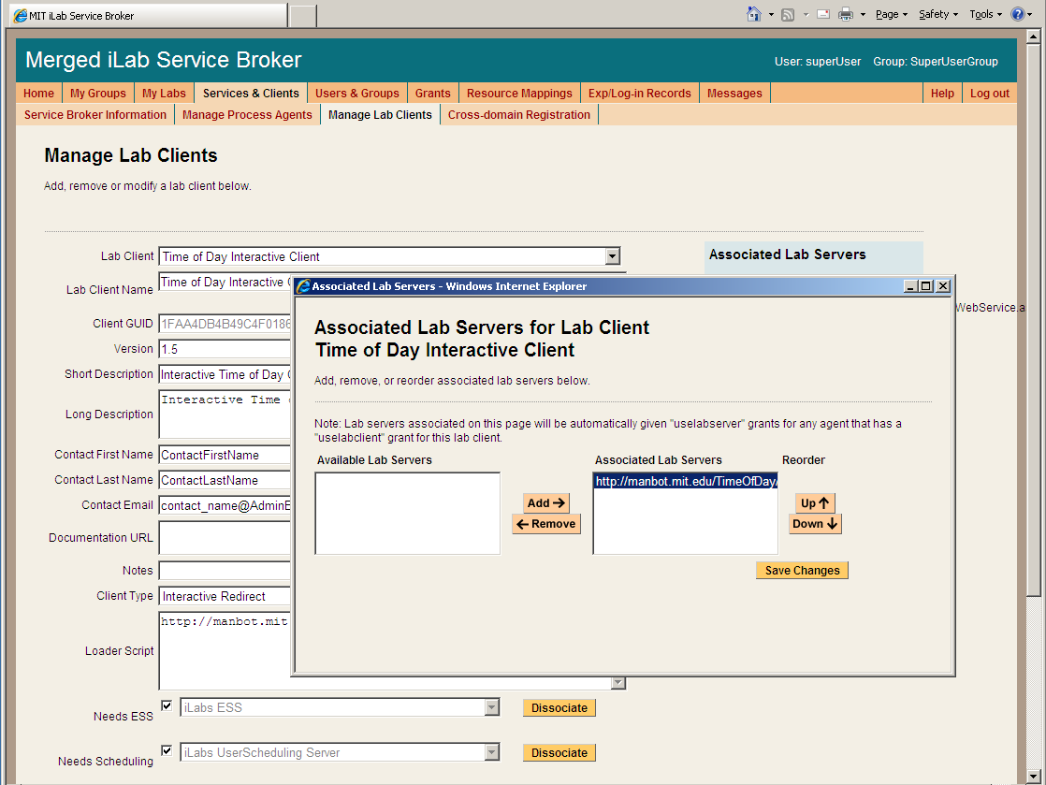
- Click the Save Changes.
- The Time Of Day Lab server should now appear in the blue box labeled Associated Lab Servers.

Associate the ESS and USS
The Time Of Day experiment uses both the USS and the ESS. Before the experiment can be run, the USS and the ESS must be associated with the client.
- From the Manage Lab Clients page, use the Needs ESS pull-down list to select which ESS this client will use.
- Click the Associate button.
- You should see a green message bar at the top of the page stating that the record has been successfully associated.

- Use the Needs Scheduling pull-down list to select which USS this client will use.
- Click the Associate button.
- You should see a green message bar at the top of the page stating that record has been successfully associated.

Associate Groups
Associate the Time Of Day Interactive client with the user and management groups.
- Click the Associate groups button at the bottom of the Manage Lab clients page.
- The Time Of Day interactive client should already be selected.
- The associated services (USS, ESS, Lab Server) should contain the correct information.
- Select the group that will use this client. In this case, select the Experiment_Group from the pull-down list.
- Use the pull-down list to select the management group for the Experiment_Group. In this case, select the Manage_Users_on_ USS group.
- Click the Save Changes button. The associated groups and manager should now be listed.
- A green bar should appear at the top of the window indicating a successful update.
- Close the popup window and return to the Manage Lab Clients Page.

Create a Test User
You will need a new user for testing.
Create a test user.
- Click the Users & Groups Tab.
- Click the Manage Users tab.
- Enter the user information for a test account. Use any username, information and password that you want.
- Select the Save Change button.
- A green bar at the top of the page should indicate that you have successfully created a new user.

Group Membership
Now that there is a test user, it needs to be given the correct group memberships. For testing purposes, the user needs to be part of five groups.
Add the user to the LSS_admin, Manage_LS_on_LSS, USS_admin, Manage_Users_on_USS, and Experiment_Group groups.
- Click the Group Membership Tab.
- In the left hand “Users and Groups” tree, click the + sign next to the NewUserGroup.
- You should see your test user listed.
- Click on your test username to highlight it.
- In the right side “Target Groups” tree, select LSS_admin group
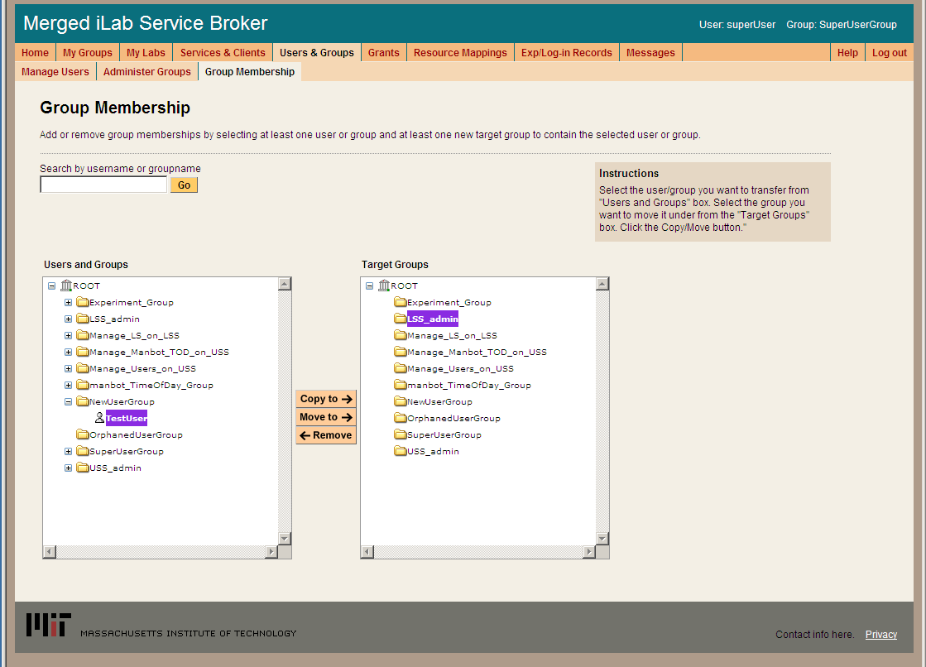
- Click on the Move To -> button
- In the left hand “Users and Groups” tree, the test user should now appear under the LSS_admin Group.
- Click on the test username under the LSS_admin group
- Click on the right side “Target Groups” tree, select Manage_LS_on_LSS group
- This time select the Copy To -> button.
- Repeat this process and copy the test user to the Manage_Users_on_USS group, the USS_admin group, and the Experiment_Group.
- You should now be in 5 groups.

Setup Time Of Day Experiment
Log out of the SuperUser account and log in as your test user.

Manage USS
Manage the TimeOfDay users on the USS
- Select Manage_Users_on_USS as your group.
- In the Service Administration page, use the – Select Process Agent - pull down list to select your USS.
- Click the USS Manage Group button
- The User Side Scheduling Server should load.
- Click on the Policy Management tab.
- Use the pull down list to select the Experiment
- The group should automatically fill in.
- Enter the Minimum Time Required: 1
- Enter the Maximum Reservation Time: 5
- Click the Save Changes button
- Click the Back to Service Broker tab.
- Click on the My Groups tab.

Manage LSS
Manage the TimeOfDay server on the LSS
- Select Manage_LS_on_LSS as your group.
- In the Service Administration page, use the – Select Process Agent - pull down list to select your LSS.
- Click the Manage Lab button
- The Lab Side Scheduling Server should load.
- Click on the Experiment tab.
- Select the Lab Client “TimeOfDay Interactive Client, 1.5” from the list on the left.
- The client information should automatically populate the fields.
- Update the fields as follows:
- Enter Minimum Time (min): 1
- Enter Prepare Time (min): 0
- Enter Recover Time (min): 0
- Enter Early Arrive Time (min): 0
- Click the Save Changes button.

- Click on the TimeBlocks tab.
- Click New.
- Use the Lab Server Resource pull down list to select your Time of Day Server.
- In Recurrence Type: select Single Block
- In the Date Span field, use the calendar icons to set the Begin Date and End Date.
- Set the Quantum to 1
- Leave the Start Time set to 12:00 AM
- Leave the End Time set to 12:00 AM
- Click Save
- In the TimeBlock tab, select the time block you just created.
- In the left column of the Select Experiment block, select the TimeOfDay Interactive Client
- Click on the Permit button
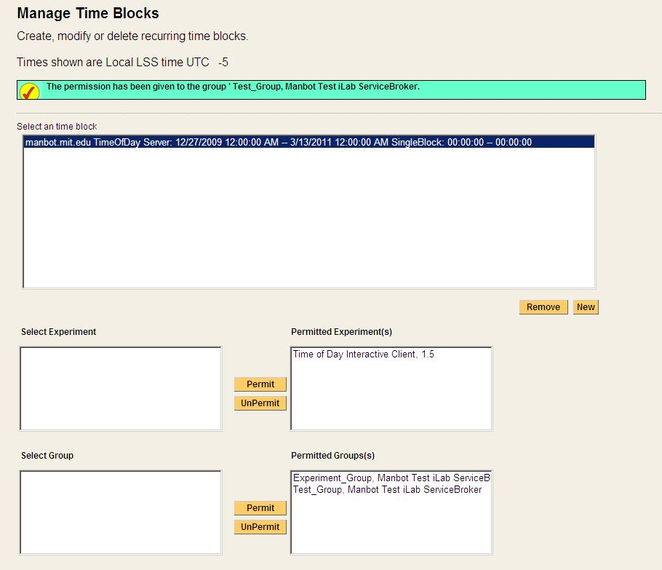
- A green bar at the top of the page should state that permissions have been granted to the experiment.
- In the left column of the Select Group block, select the Experiment_Group
- Click on the Permit button
- A green bar at the top of the page should state that permissions have been granted to the group.
- Click the Back to Service Broker tab.
- Click on the My Groups tab.
The following experiment is just for confirmation of a clean install, no administration or configuration is needed.

Running the Time Of Day Experiment
Make sure that you have logged out of the SuperUser account and log in as your test user.
Scheduling and Running the Time of Day Experiment
- Select Experiment_Group as your effective group.
- From the My Labs page, click on the Schedule/Redeem Session button.
- In the scheduling window, the highlighted date should be set to today.
- Click on today’s date in the calendar area – if your browser has popup blocker turned on, you will need to hold the ctrl-key down and click on the date.
- In the scheduling popup window, the available times are identified in green and the reserved times are red. Click on the first green area.
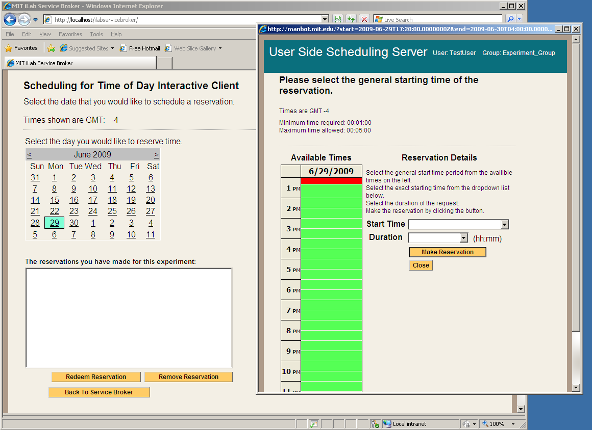
- In the Reservation Details area, use the Start Time pull down to select your start time and the Duration pull down to select your reservation length. In this case select 5 minutes for your duration.
- Click on the Make Reservation button.
- You will see a message in a green bar at the top of the window that says “The reservation is confirmed successfully”.
- Click on the Close button
- The reservation should appear in the reservation window.
BUG: There is an occasional issue in the Firefox browser and the reservation does not automatically appear in the reservations box area. Use the “Back to Service Broker” button, then the Schedule/Redeem Session button. Your reservation should appear. This is an inconsistent bug and has not been tracked down yet.

- Click on the reservation to highlight it.
- Click on the Redeem Reservation button.
- Depending on the computers clock a small green bar may appear at the top of the page letting you know how long until the reservation is valid. If this happens, wait the allotted time and click the Redeem Reservation button again.
- On the My Labs page, click the Launch Client button.
- The Time Of Day Interactive Lab Client will load. (not very exciting)
- Click on the Get Time of Day Button.
- The date and time is returned and a blob is stored in the database with the Date and Time.
  - Click the Request Blob Access button to see the elephant image with the Date and Time stamp. (Cute Elephant!)
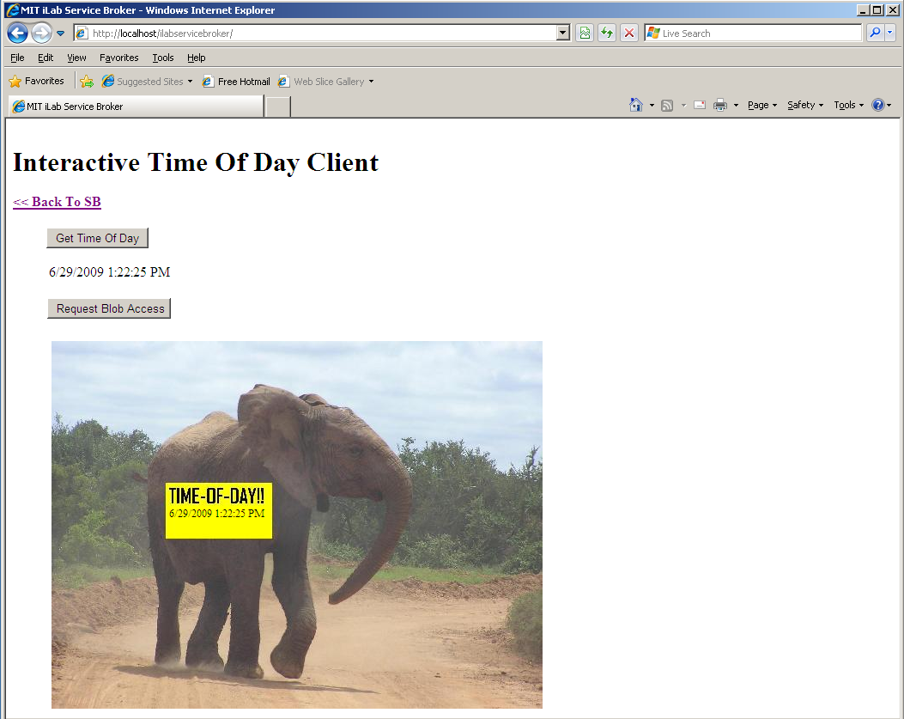
- Use the << Back To SB link to return to the Service Broker.

Setting Up Batched Experiments
In this example, we will be setting up the MIT Microelectronics Weblab experiment, but the process is the same when setting up any batched experiment. Unlike the interactive services, in batched experiment registration there is no automatic registration process.
Before beginning the registration process for a batched experiment, you will need to contact the experiment administrator and make arrangements to use the experiment. In this case, please email Jim Hardison (weblab@mit.edu). Please be sure to include the following information in your email:
- The name of your Service Broker
- Your Service Broker’s GUID
- Your Service Broker’s web service URL
- An incoming passcode (this can be a GUID or just a password string)
- Contact information
The Lab server administrator, in this case, Jim, will use this information to create a Service Broker account on the lab server for you to use. He will send you back an outgoing passcode that you will need to create the lab server entry on your service broker.

Create a Batched Lab Server Record
- Log in to the Service Broker as SuperUser.
- Navigate to Services & Clients on the top navigation bar
- On the Manage Process Agents page, click on the New button at the bottom of the page to clear the page form.
- Click on the Register Batched LS box at the top of the form. Notice that the Agent type has been entered as BATCH LAB SERVER
- Enter the following information into the web form:
  - Web Service URL: This is the location of the Lab Server’s web service. Type https://weblab2.mit.edu/services/WebLabService.asmx
  - Agent GUID: a7aa3c00d7404c63858ff4832b4217ed
  - Incoming Passcode (this is the passcode you sent to Jim)
  - Outgoing passcode (this is the passcode that Jim sent to you)
  - Codebase URL: https://weblab2.mit.edu
  - Service Name: Microelectronics WebLab 6.1
  - Description: The MIT microelectronics device characterization weblab Lab Server.
  - Lab Info URL: http://weblab.mit.edu
  - Contact Email: weblab@mit.edu
- Click the Register Lab Server button
- You should see a green message bar at the top of the page that says: “Lab Server Microelectronics WebLab 6.1 has created and saved”
Passcodes: Passcodes are the strings used by the batched Lab Server to communicate with the Service Broker. Passcodes are only used in Batched labs. Passcodes are not the same as passkeys specified in the web.config files.

Create a Lab Client Record
- From the Servers & Clients menu, click the Manage Lab Clients Tab from the submenu.
- If needed, click on the New button at the bottom of the page to clear the page form.
- Enter the following information into the web form:
  - Lab Client Name: MIT Microelectronics WebLab Client
  - Click on the Make GUID button.
  - Version: 6.1
  - Short Description: MIT Microelectronics WebLab Graphical applet
  - Long Description: The standard MIT Microelectronics WebLab Graphical applet configured to interface to the WebLab 6.1 server.
  - Contact First Name: Jim
  - Contact Last Name: Hardison
  - Contact Email: weblab@mit.edu
  - Documentation URL: http://weblab2.mit.edu/docs/weblab/v6.1/manual/index.htm
  - Client type: Batched Applet
  - Check the Needs ESS check box.
- Click Save Changes
- You should see a green message bar at the top of the page that says: “Lab Client WebLab Client has been added.”

Client Loader Script
This is crucial part of the Lab Client Record, responsible for the following:
- Name and location of the Client (a Java applet compiled into a Jar archive)
- The URL of the Service Broker’s web service. This web service contains “passthrough” methods. The Lab Client will invoke a passthrough method on the Service Broker, which will in turn invoke a corresponding method (one with exactly the same name) on the Lab Server.
- The GUID (a.k.a. Lab Server ID) of the Lab Server that the Service Broker will communicate with when its passthrough methods are called.
- Copy the loader script from the example below, and paste it into the Loader Script box on the Manage Lab Clients page
- Replace the text that reads [YOUR HOST NAME HERE] with your host name (e.g. “somemachine.myschool.edu”).
- Click the Save Changes button at the bottom of the screen when finished.
- You should see a green message bar at the top of the page that says “Lab Client WebLab Public Client has been modified”
<APPLET
height=1 width=1 archive="http://weblab2.mit.edu/client/v6.1.3g/signed_Weblab_Graphical.jar" code="weblab.client.graphicalUI.GraphicalApplet"
>
<PARAM NAME="initial_focus" VALUE="false">
<PARAM NAME="serviceURL" VALUE="http://ilab.mit.edu/ServiceBroker/Services/ServiceBrokerService.asmx">
<PARAM NAME="labServerID" VALUE="a7aa3c00d7404c63858ff4832b4217ed">
<PARAM NAME="helpURL" VALUE="http://weblab2.mit.edu/docs/weblab/v6.1/manual/index.htm">
</APPLET>

- Click Save Changes
- You should see a green message bar at the top of the page: “Lab Client WebLab Client has been updated.”
Note: If you intend to log in from a browser on the Service Broker machine using “localhost” in the URL, you must specify localhost as the host in the serviceURL parameter. If you intend to log on from a remote machine, you must change the serviceURL parameter in the loader script to contain machine’s external URL. Leaving “localhost” in the applet tag when logging in remotely using the real hostname is a common cause of failure. In that case, the WebLab client will return a “failed to load lab configuration” error message.

Associate the Lab Server
You should still be on the Manage Lab Clients page.
- Associate the Microelectronics WebLab Batched Lab Server with the MIT Microelectronics WebLab Client.
- Click the Edit List button under Associated Lab Servers in the upper right column. A popup window will appear.
  - In the popup window, notice the Microelectronics WebLab web service URL in the left hand box labeled Available Lab Server.
  - Select the Microelectronics WebLab web service URL so it is highlighted, then select the Add >> button.
- Click the Save Changes.
- The MIT Microelectronics Lab server should now appear in the blue box labeled Associated Lab Servers.

Associate the ESS
- The MIT Microelectronics Experiment uses only the Experiment Storage Server (ESS). Before the experiment can be run, the ESS must be associated with the client.
  - From the Manage Clients page, use the Associate ESS pull-down list to select which ESS this client will use.
  - Click on the Associate button.

Associate Groups
- Associate the Microelectronics WebLab client with a user group.
  - Click on the Associate groups button at the bottom of the Manage Lab clients page.
  - The Microelectronics WebLab client should already be selected.
  - The associated services (USS and Lab Server) should contain the correct information.
  - Select the group that will use this client. In this case, select the Experiment_Group from the pull-down list.
  - Batched experiments do not need a management group.
- Click on the Save Change button. The associated groups should now be listed.
- A green message bar should appear at the top of the page indicating a successful update.
- Close the popup window and return to the Manage Lab Clients Page.

Check Grants
The authorization mechanism in iLabs requires that there be a grant to use each resource controlled by iLabs. For our sample lab to work, we will need our WebLab Group to have a “useLabServer” grant on the Microelectronics WebLab 6.1 Lab Server, and a “useLabClient” grant on the WebLab Public Client. The useLabServer grant was just created, when the Microelectronics WebLab 6.1 Lab Server was associated with the WebLab Group. We’ll see how that looks on the Grants page.
- On the top navigation bar, click Grants
- In the Users and Groups box on the left, click once on Experiment Group
- In the Functions box in the middle, click once on useLabServer
- Beneath the Qualifiers box on the right, there are three buttons. Click on View Grant
- In the Qualifiers box, the entry for Microelectronics WebLab 6.1 Server should now be red.
- Making sure that Experiment Group is still selected in the Users and Groups box, click once on useLabClient in the Functions box
- In the Qualifiers box, click once on MIT Microelectronics WebLab Client
- Click the View Grant button
- If you click the View Grant button with Experiment Group and useLabClient selected, the MIT Microelectronics WebLab Client should turn red, indicating that the grant already exists.
- If not, click the Add Grant button
- You should see a green message bar at the top of the page that says: “The grant {WebLab Group, useLabClient, WebLab Public Client} was successfully added.”
- If you click the View Grant button with Experiment Group and useLabClient selected, the MIT Microelectronics WebLab Client should turn red.

MIT Certificate
The WebLab web service runs over a Secure Sockets (SSL) connection. Therefore, your Service Broker is required to have the MIT Certification Authority certificate installed in its Trusted Root Certification Authority store. Here is how to obtain and install the certificate:
- Go to http://ist.mit.edu/services/certificates
- In the right-hand column, click on Get MIT CA (Certificate Authority)
- Save the file mitca.cer to your hard drive
- Create a Certificate Microsoft Management Console (MMC) Snap-in. Start->Run…mmc
- File->Add/Remove Snap-In
- Click the Add… button
- Select Certificates
- Click the Add… button
- Select Computer account
- Click Next>
- Select Local Computer
- Click Finish
- Click Close
- Click OK
- Expand Certificates (Local Computer)
- Right-click Trusted Root Certification Authorities
- All Tasks->Import…
- Next>
- Browse to the location where you saved mitca.cer
- Select mitca.cer, and click Open
- Next>
- Make sure Place all certificates in the following store is selected, and that Trusted Root Certification Authorities appears in the box. If it does not, click the Browse button and correct it.
- Next>
- Finish
- OK
- The Certificates console is a handy thing to keep on your machine. To save it so that you can open it without having to add the Certificate snap-in again, click File->Save As, type Certificates.msc in the box, and click Save. It should now appear as an option in Start->All Programs->Administrative Tools
- Close the Certificate MMC Console.
- Reboot the machine

Running the Experiment
- Log in to the Service Broker as the user you created
- Following login you should see the My Labs page, which should contain one Lab Client, the WebLab Client (Note: if you are a member of more than one group, you will have to select the WebLab Group link first before you get to this page)
- Click the Launch Lab button
  - Note: if you do not see the Launch Lab button, check the following:
    - User is in the WebLab group
    - WebLab group has useLabServer grant on the Microelectronics 6.1 Lab Server
    - Weblab Group has useLabClient grant on the WebLab Public Client
- A Warning – Security box should pop up. Click Yes
- A new screen – the Java Client - should load
  - If the screen does not load, check the Java Console Messages. In the system tray, at the lower right near the clock, look for the Java icon (a blue and red steaming coffee cup). Right-click on the icon, and select Open Console
  - Scroll down and look at the messages. If there is a problem, chances are that either the client classes didn’t load properly into the virtual machine (in which case there will be a stack trace), or that there was something wrong with a parameter on one of the Web Service calls. In that case, look at the SOAP messages from the Web Service calls that have been passed from the client to the Service Broker, along with the responses. If you see the term “SOAP Fault” in a response, that should point to the problem.

Lab Client
- If everything is working, you should see a rudimentary circuit diagram in the upper window. If things are not configured correctly, you will get a message that says Failed to Retrieve Lab Configuration. If that happens, check to make sure the following is done:
  - MIT Certificate is on your machine
  - Lab Server GUID is correct on the Lab Server record
  - Service Broker ID is in the correct place in web.config
  - Service Broker ID is correct and has been keyed into the WebLab Administrative Interface by the WebLab Administrator
  - Lab Client Loader script has the correct serviceURL
  - Lab Client Loader script has the correct Lab Server ID (should be the same as the Lab Server GUID in the Lab Server record
- For information on how to submit experiments to Weblab, please see http://weblab.mit.edu

Troubleshooting

Grants
Currently, the bootstrapping process does not automatically give the managers of the LSS the correct permissions to manage the lab server on the LSS. This will be fixed in the next release.
- Give the Managers of the LSS permission to manage the LS.
  - Click on the Grant tab in the main menu.
  - In the Users & Groups tree on the left side, click on Manage_LS_on_LSS group to highlight it.
  - Under functions, click on Manage Lab.
  - Under Qualifiers, select the resource mapping between the Interactive Lab Sever and the LSS; Look for a resource mapping where the Process Agent: ILS and the ResourceType: LSS
  - Click the Add Grant button.
  - A green message bar should appear at the top of the screen indicating a successful update.

  - Note: You may get this error message: “Unable to find script library ‘/aspnet_client…WebUIValidation.js’ If you see this, do the following:
  - Open a command prompt with Start->Run-CMD
  - Type CD\Windows\Microsoft.NET\Framework\v1.1.4322
  - Type aspnet_regiis –c
  - You should see a message that says “Start copying the ASP.NET client side script files for this version (1.1.4322.0)…Finished copying the ASP.NET client side script files for this version (1.1.4322.0)”
  - Type Exit to close the command prompt
  - Click OK on the “Unable to find script library” error message

Web.config issue
There is a problem with the specified service’s web.config file. Please delete the current web.config file from the service’s directory and copy the web.config.template to create a new web.config file.
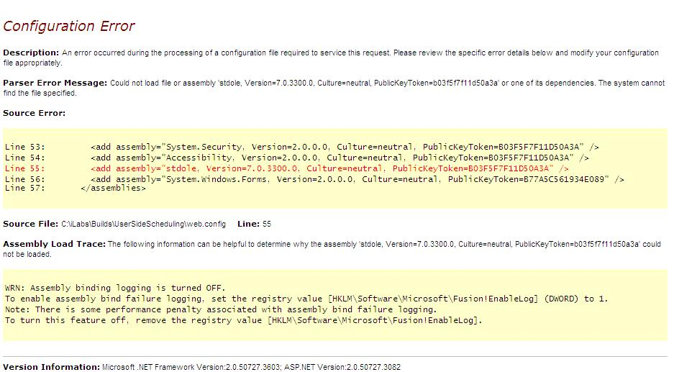

Incorrect Password
Incorrect password was supplied when trying to install domain credentials. Check the web.config file for the service or the database for the correct password.
