Power BI Best Practices for Development, Visualizations, Performance
written by Scott Murray August 22, 2022 0 comments
Problem
Microsoft Power BI is used by more and more data professionals each day. Just like with any tool, there are good practices and bad practices. In this article, we will look at things you should know in order to make the best use of Power BI for your reporting needs on-premises as well as in the Azure and AWS clouds.
Solution
As Microsoft Power BI has grown and matured over the past five years or so, certain practices have surfaced that provide a rich and successful report consumer experience. This tip will discuss several best practices, some practices will be rooted in common sense solutions, while others will not seem as clear, common, or obvious. Some of the practices will even permeate to design work you for additional tools such as SQL Server Reporting Services or even other reporting and dashboard tools.
As with any best practice, there will be variations in opinion, so be sure to review the opinion of other well-versed writers on Power BI. However, generally, you will find several common threads throughout these practices.
Getting started with Power BI Desktop begins by downloading Power BI Desktop from Microsoft’s website. A tip called Power BI – How to Download and Get Started is a great first read to get you moving with Power BI Desktop. We will also use the WideWorldImportersDW database from GitHub as a basis for our data sources.
Best Practice #1: Prepare and Know the Data
The first best practice to follow when using Power BI is to use “finely curated” data. All too often, a BI designer will immediately dive into developing the dashboard without first checking the data being used as the data sources and if data sets are in a state suitable for Power BI. As we all know, some data come to the dashboard designer as a fine-grained end product with a detailed data dictionary and maybe even a well-documented data model. Of course, the availability of those items is often the exception and not the standard order of business in many organizations. Thus, as the report and dashboard designer, it behooves you to get to know both structure and content of the data being used.
Note: It is recommended to check out this tip, SQL Server Database Diagram Tool in Management Studio, for the SQL Server version of database diagrams. Additionally, see this tip, SQL Server Database Diagram Index was Outside the Bounds of the Array, if you are running into an error with the Management Studio diagrams.
To understand the context of the data, the following are helpful ideas to consider:
- Discuss the data, its purpose, and its source with the business/data owner
- Determine the quality, timeliness, accuracy, and privacy of the data
- Determine the valid values and metrics for many of the common fields
- Ask the business/data owner to prototype a report for you
- Determine the uses of the dashboard – real-time, data analytics, statistics, trending, etc.
- Determine who will be using the dashboard – the view for the CFO would likely be very different from the view of a sales executive
- Determine if interactions and drill down are needed
Next, you will want to learn about the technical specifications of the data, including:
- If primary and foreign keys are set up, which will assist with relationships
- If appropriate data types are used, and, if not, determine what the appropriate data should be
- What are the data sizes
- How the data can be imported into Power BI, including appropriate drivers/sources in Power BI
- The level and grain of the needed data
- The performance of the data imports/queries
One area open for discernment centers on whether your business logic should reside in the database or in Power BI. This is up to the organization’s philosophy and whether you envision Power BI as the main business processes tool or if the database will handle that item.
Certainly, there are other ramifications surrounding data knowledge and structure, but these items are the first steps to creating a great dashboard.
Best Practice #2: DAX or M
Within Power BI, there are multiple ways to complete a task or process, with the decision centering on whether you would use M in the Power Query Editor.
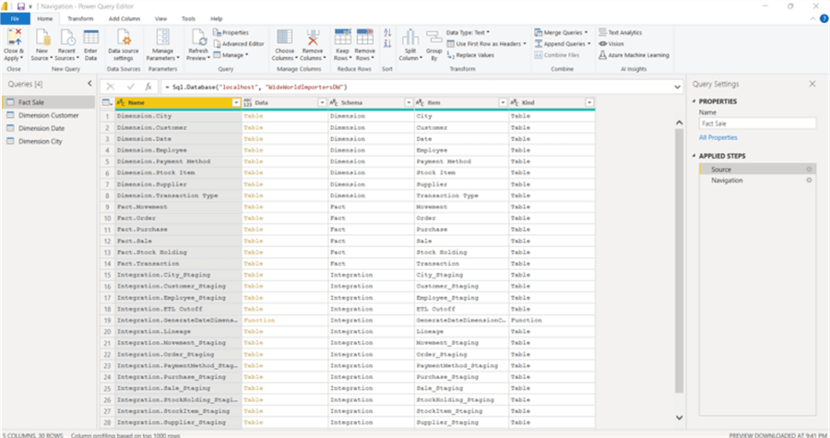
Alternately, many similar tasks can be completed in the Design grid, specifically using DAX formulas and the Modeling tab. A few DAX items will be covered later in this tip.
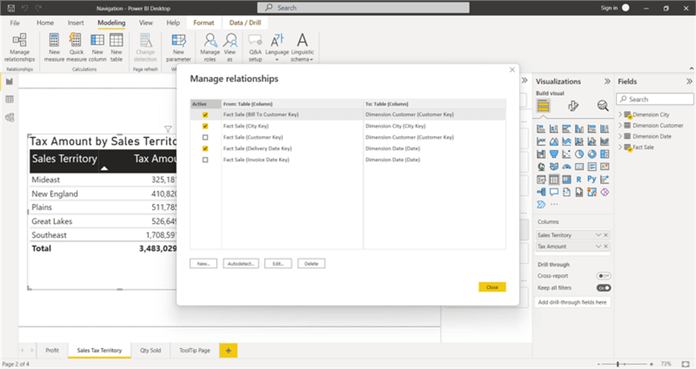
Generally, the decision is dependent on the data and its structure. For instance, if two tables need to be appended together, then that process should be handled in the Query Editor. Likewise, if joins need to be completed with some complexity or involve multiple fields, that should often occur in the Query Editor. However, if the joins are simple, then that process can usually be completed in the Manage Relationship area of the design grid modeling tab.
The best practice here is to create a data set/data source as nimble as possible in the Query Editor/M option. This method means a smaller data size, likely faster load/import time, and the ability to take advantage of query folding. On the other hand, if you need to perform row-by-row calculations or create dynamic-type calculations, DAX is often the better option for completing those tasks.
Best Practice #3: Choose Visuals Wisely in Apps
Ever heard the phrase, “Just because you can, does not mean you should.”? Dealing with visuals, a dashboard or report designer is telling a story. No one likes a confusing story, especially in most corporate or government organizations. Yet, all too often, a well-meaning but inappropriate set of visuals is created to convey specific information about a set of data. Unfortunately, using a visual not designed to convey a specific story can easily lead to confusion or misunderstanding by the report viewer.
Here is a list of several tips that can help in deciding which visual is best in a particular situation:
- Correlation Analysis using Correlation Plot in Power BI Desktop
- Power BI Key Influencers Visual
- Power BI Visual Interactions
- Power BI Small Multiples Visual Example
- Power BI Pulse Charts
- How to Increase the Vertical Orientation of Power BI Report Page
- Analyze Interrelationships with Chord Diagram Visualization in Power BI Desktop
Of course, there are additional helpful tips available in this area, including Story Telling with Data.
Best Practice #4: Performance is Key in Apps
Performance is a critical component of the dashboard experience. As such, a Power BI designer needs to know the best ways to speed up performance on a dashboard.
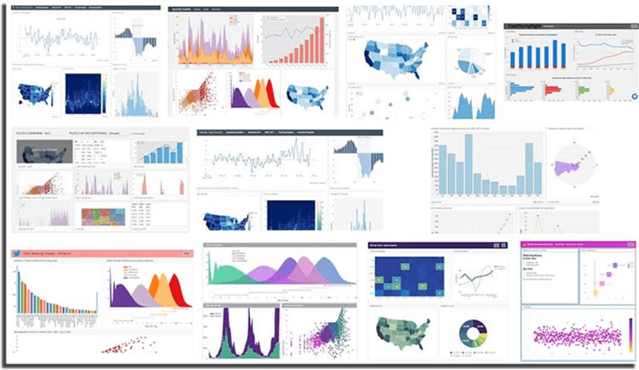
Image source: http://dev3lop.com/wp-content/uploads/2018/01/plotly-data-visualization-dashboard-example-1.jpg
Several practices can assist with keeping performance at its peak and that starts with planning the dashboard’s design, meaning a report designer should limit the number of individual visuals and other objects on a dashboard. Including too many visuals and other objects, such as slicers, can slow down initial views and refreshes after a slicer or filter is changed. If either of these views takes more than 10 to 30 seconds, maybe up to a minute, it is likely too long to wait between initial viewing or refreshes of the dashboard. Report consumers expect dashboards to be fully interactive. Due to the interactive nature, the expectation is often that changes will occur in seconds, not minutes. The more visuals on a report tab, the longer the refresh will take of those visuals.
An idea to address this type of issue is instead of having copious amounts of cards on the dashboard, rather consolidate all the cards into a single table or matrix. This will decrease the refresh time by many multiples.
Likewise, limiting the number of calculated columns and measures that use DAX can also improve the performance of the dashboard itself. Reminder: a calculated column happens on every row. If these calculations are moved to the Query Editor and M, the calculation time will occur when the data set is loaded in the Query Editor (on the online service refresh).
Finally, attempt to limit the level of detail shown initially. Set the grain for the graphics appropriately and at the highest level available. If drill down or drill through is needed for further detail, it can easily be added to the visual through filters and slicers on top of regular drill through actions. See these tips for some ideas on how to best use drill down and drill through techniques:
- Power BI Drill Through Example
- Data Exploration, Drill Down, and Analysis Using Decomposition Tree in Power BI Desktop
Best Practice #5: Security in the Design
Most database professionals, including data engineers, analysts, and scientists, are well aware of the ramifications and impacts security has on our job duties, design efforts, and development work. We need to be continually monitoring the best practices in this area. For Power BI, Row Level Security is one of the deeper layers to restrict access to data based on the setup of the security roles. Through the user of roles (see below), dynamic or static, data access can be restricted to only those authorized to access the data on a Power BI report.
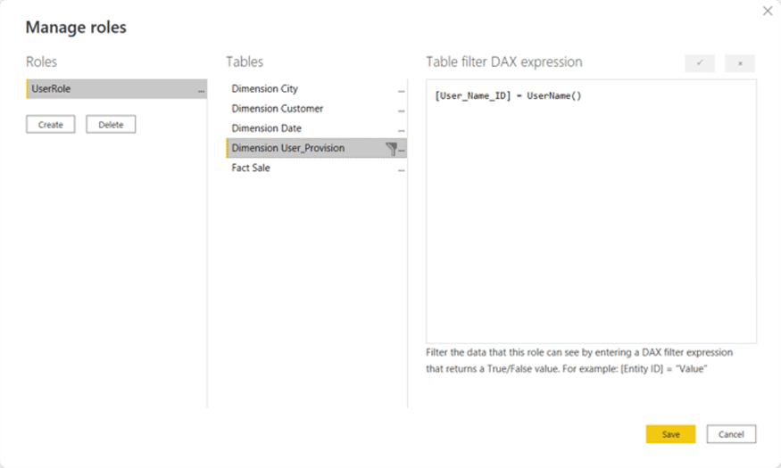
Here are two tips that can help get the security set up and working for your organization:
- Power BI Row Level Security
- Power BI Table Based Row Level Security
In addition to providing restricted access at the data set level, Power BI also offers the opportunity to control access at the workspace level on the Power BI Service. Workspaces are somewhat like a file directory; however, this level of access limits users from seeing the note dashboards in a particular workspace.
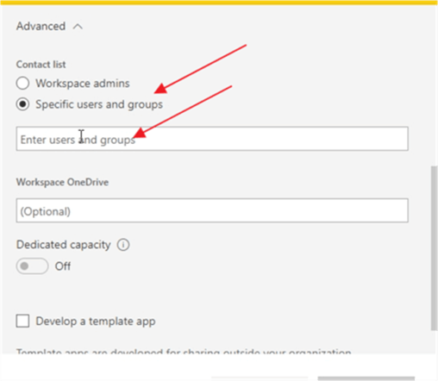
Here is an article that dives deep into setting up the workspace security: Power BI Workspace Permissions and Roles.
Best Practice #6: Dashboard Visual Flow
Although some folks would say this item is not important for most Power BI users and consumers, they need to follow the flow of the story the dashboard is telling. This means using appropriate colors and, more importantly, placing the most significant visual in the appropriate location. In western cultures, where one reads left to right, that means putting the most crucial visual in the upper left corner of the dashboard.
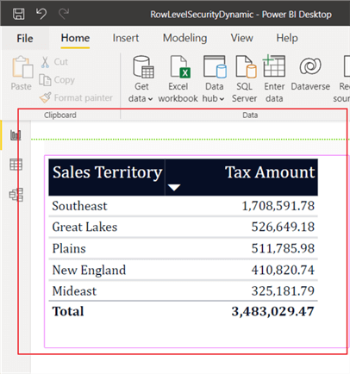
As visuals become less critical to the user or are tangents to the vital visual, they should be placed to the right and downward, as shown below. In other cultures, reading occurs from right to left, so dashboard visuals should be created to flow in that direction. Ultimately all these items are to benefit the dashboard consumer.
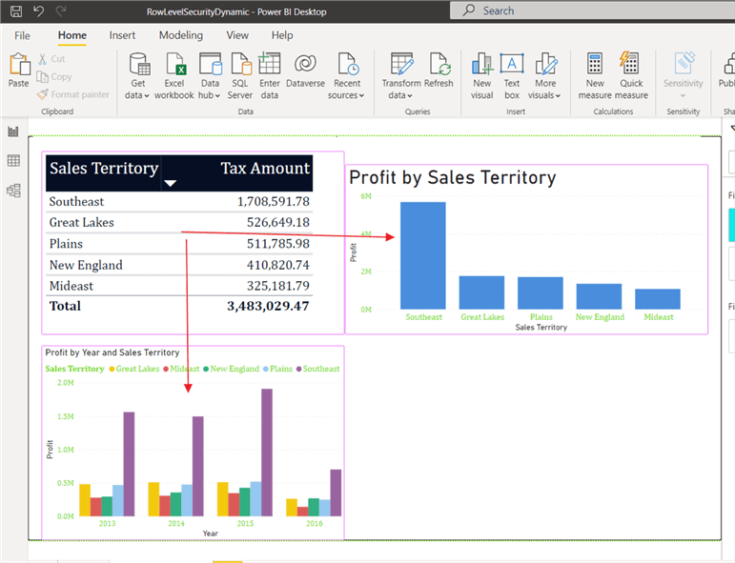
Other ways to help with telling the story on the Power BI dashboard include:
- Using a standard theme on all reports
  - Power BI Layouts and Themes
- Using appropriate formatting on visuals
  - Power BI Table, Matrix, and Chart Formatting
  - Power BI Dynamic Conditional Formatting
  - Power BI Conditional Formatting for Matrix and Table Visuals
- Setting up appropriate report page sizes
  - How to Increase the Vertical Orientation of Power BI Report Page
- Creating reports for mobile apps (iOS and Android), if needed
  - Power BI Mobile New Development Features
Conclusion
Power BI continues to be a go-to tool for dashboard and business intelligence development. As this growth continues, it would be wise to establish both community and organizational best practices that can be followed. In this tip, we covered some of the basic best practices that can be used in Power BI development.
Power BI Key Influencers Visual
written by Scott Murray April 18, 2019 0 comments
Problem
What is the Power BI Key Influencer Visualization and how should I use it?
Solution
As Power BI continues to grow and features are added, new Microsoft developed visuals are being added. The Key Influencer Visual is actually not a custom visual developed outside of Microsoft, but is one of the normal visuals added to the default visual pick list. Of course there are plenty of custom visuals that you can choose from (see these tips for some great examples: Power BI Custom Infographics or Creating Custom Maps to Display Data with Power BI or Power BI Desktop Custom Visualization), but we are here to talk about the Key Influencer visual.
The Key Influencer Visual takes the next step toward detailed analytics within a visual by analyzing the selected data set, fields, and measures, and assigning specific “influence values” to input fields. This visual is progressing from a simple view of the data to integrating Microsoft AI features and analysis processing to produce a reporting set of values that are likely to influence a particular value. Furthermore, the behind the scenes work comes from Microsoft Artificial Intelligence infrastructure. Specifically, the visual uses machine learning to run regression analysis on the data to model the influencer and segmentation data. It is looking to identify, based on the selected category values, which values influence the designated metric being evaluated. The evaluation ranks the categories from most influential to least influential. Furthermore, the evaluation performs a second set of analysis in order to create distinct segments which group the various categories into segments of influence. These segments create a “picture” of the most common categories that are grouped together to produce a significant result in the metric being evaluated. I am sure going through the below example will assist with seeing the power of this new visual.
Before we get into an example, you need to be sure to download the latest version of Power BI desktop from: https://powerbi.microsoft.com/en-us/get-started/. The download and install process has changed, in that it now uses the Microsoft Store to complete the install. For those wanting the more traditional download and install method, you can still use this site: https://powerbi.microsoft.com/en-us/desktop/. Additionally, we will be using the AdventureWorks 2016 database as a basis for our data sources; this database can be downloaded from GitHub at: https://github.com/Microsoft/sql-server-samples/releases/tag/adventureworks.
What the Power BI Influencer Visual Can Do!
Depending on the version of Power BI Desktop that you are using, you may need to enable the Key Influencer feature in order to leverage its use. To enable this feature, navigate to File > Options and Settings > Options; then, click on the Preview features in the left menu, and finally as shown below, check the Key Influencer visual option.
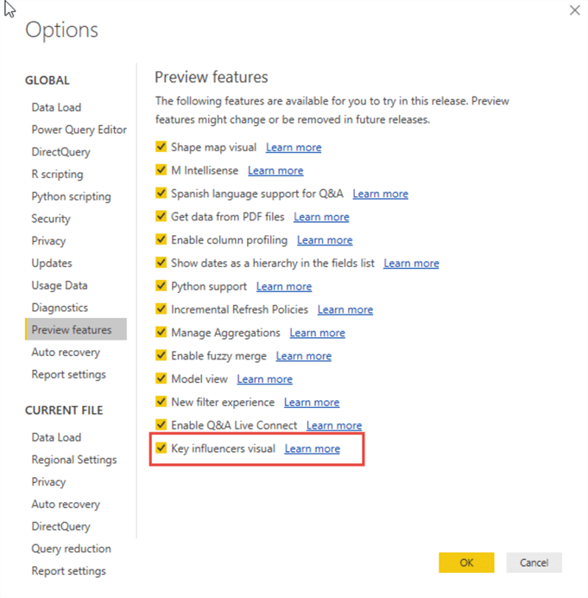
Once enabled, the new Key Influencer visual is now available in the gallery.
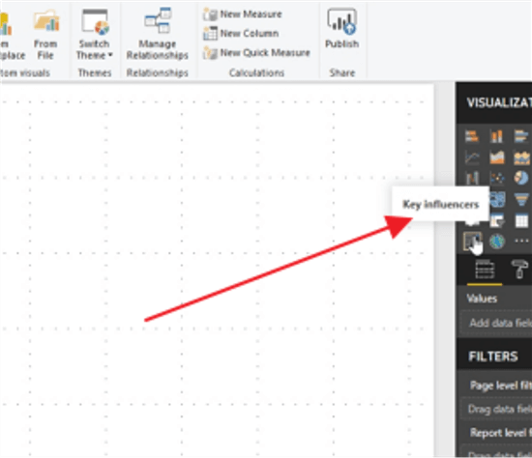
Prior to diving into an example, we need to complete some setup work. For this tip, we will be using the AdventureWorks2016 database as our data source (take a look at these tips Querying SQL Server Data with Power BI Desktop or Connect to on-premises data sources with Power BI Personal Gateway as some examples for connecting to various data sources).
As shown in the below screen print, we add the Production schema tables from the AdventureWorks2016 database to our data model in the Power Query Editor. For this example, no particular transformations other than a few columns renames (to add spaces between words) were completed on the data. Once the tables are added, go ahead and select the Close and apply button in the upper left corner of the toolbar.
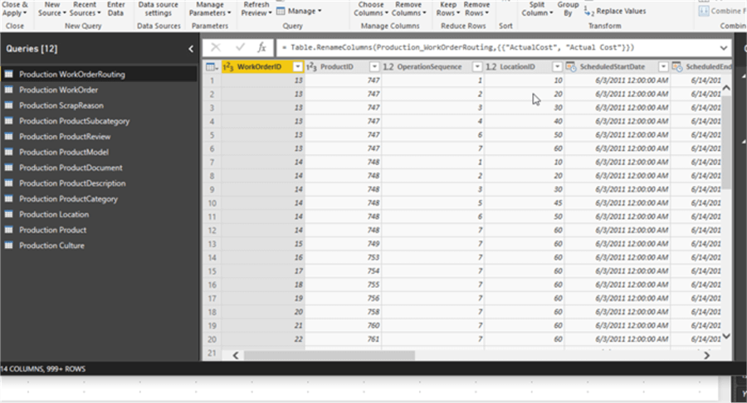
We are now ready to start designing our Key Influencer visual, and thus we must decide which value will be analyzed within the visual. As of this writing, only category type fields can be evaluated within the visual. In the below example, the Size field from the Product table is used; note that even though this field is numeric, it is categorical in nature and not continuous (currently the Key Influencer visual does not support analyzing continuous values).
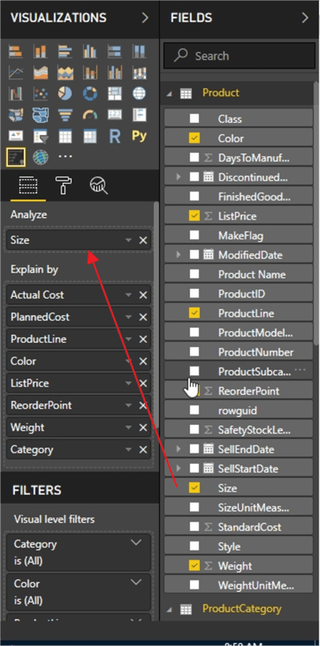
After setting the metric to be analyzed, the fields that could affect the analyze field are then added to the Explain by list. As shown below, we can add values from multiple, related, tables to the Explain by list of values. Thus, we are suspecting that the following items influence the Size of a product:
- Actual Cost
- Planned Cost
- Product Line
- Color
- List Price
- Reorder Point
- Weight
- Category
As the list of possible influencers is selected and added to the Explain by list, we do need to keep in mind that these items must be related to the Analyze field and that they also must be at the same level of aggregation. If they are not, then you will need to transform the data to get it to the same level.
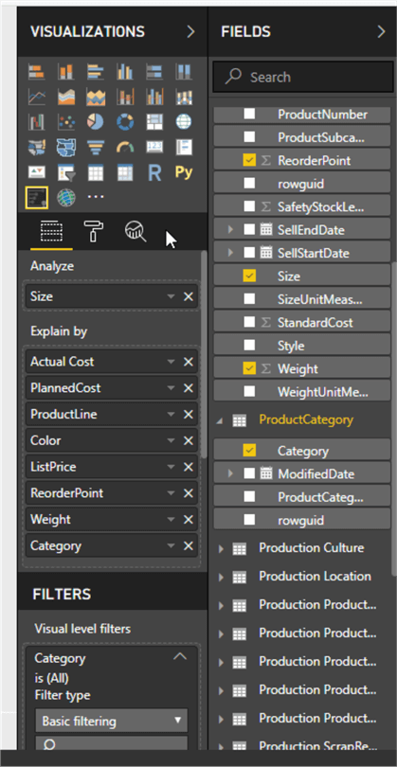
Now, we are ready for the processing to begin! Before we review the processing and more so the results, it would be a good refresher for everyone to know that the analysis being performed is regression based. Additionally, if too few values exist for a particular Explain by value or the value list is too broad (even though they are known values, but there are many different values…. namely the cardinality of the data is very high), the analysis may not work for a particular set of Explain by values. Of course, the larger the dataset and the larger the number of Explain by values, the longer processing may take. Finally, normal report and page filters can also be implemented.
Let us first look at the Key Influencer tab, shown below, now that processing on our data is complete. You will notice in the upper left corner just below the title and tabs, is the selection drop down for deciding what value is being examined. For this example, we are looking at what influences the size of the product to be 62 (remember 62 is considered a categorical value). As we can see from the results, the key values influencing the size to be 62 are, in order of most influential to least influential:
- Product Line of R
- Color of Red
- Product Line of T
- Color of Blue
- Category of Bike
- Category of Components
- Color of Black
- List Price up to $906
You will also notice that not all the fields selected in the Explain by list are shown which indicates that either that particular field did not contain any influencers, or the influence was too low to be considered. Also, note that multiple values from the same field can be influencers as noted with the product line and color in this example.
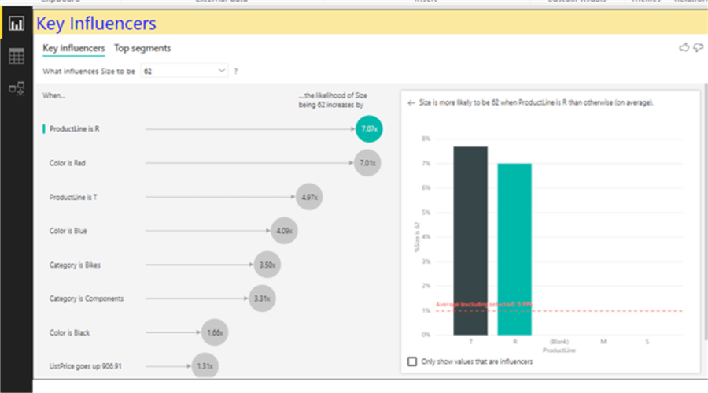
Furthermore, drilling into the actual details in the above analysis, it shows that having a product line of R is 7.07 more likely to produce a size of 62. Selecting one of the influencers lines on the left side of the chart, will activate that value for detailed analysis chart on the right side as shown in the above screen print. The bar chart on the right side actually shows us a comparison of the designated Explained by value with other values for the same field. In the above example, we see that a Prod R is roughly 6% more likely than the average to produce a size of 62. You may also notice that T has a higher likelihood of indicating a size of 62, but because product line T has many fewer values, its influence is also less.
On the right side you will also notice that there is a bar that shows the key influential value (aqua in color) along with all the other available values for that particular field (black), and then finally an average line is displayed (in red). The average line is the average of all the values except for the main key influence metric that is selected from the left side.
One option that is available on the right-side key influence visual is a checkbox, below the bar / column charts, that allows you to only use those values that are influencers. It will basically ignore all the remaining values that have absolutely no influence on the selected category value as notated below.
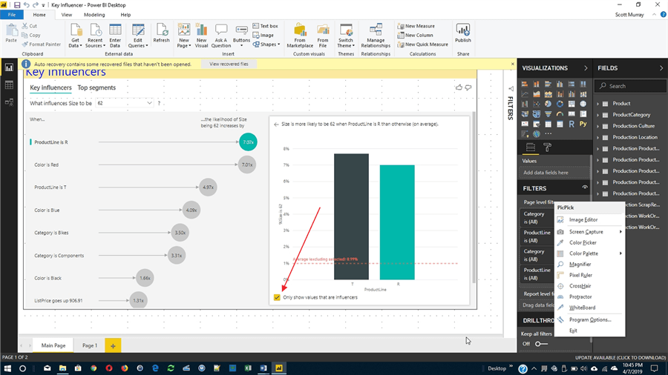
As you continue to work with the key influencer tools, you will quickly notice that in addition to being able to select an individual item that you’re looking at, you can also add filters which allow you to even further subdivide the list that is being analyzed. For the below example, the filter is activated to only show categories of bikes; the analysis in the visual reprocesses and produces new results based on this feature.
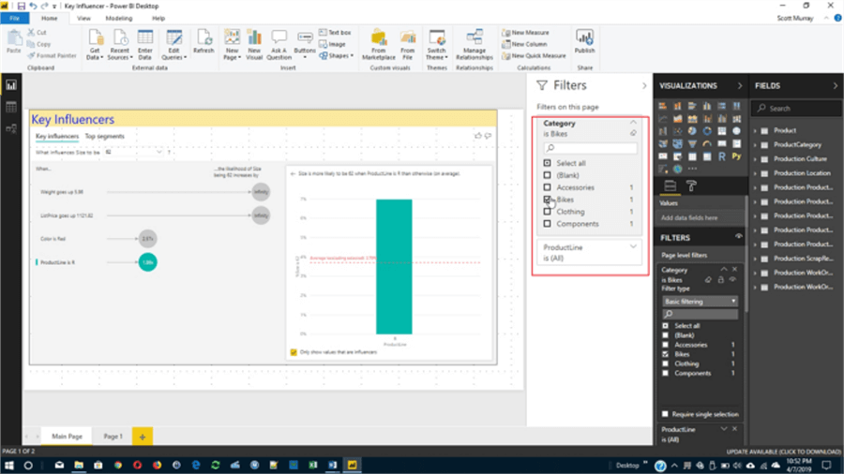
Next, we are going to move on to the second tab which is the Top segments tab. The top segments tab allows a visual consumer to actually look at values, when combined as a group, that have a key influence on the particular to be analyzed. Thus, for instance, as a visual consumer is looking through a particular set of fields and values, we can see what combinations have a strong impact on the analyzed value (size in our example). Therefore, in essence what is happening is a group of values are all banded together. As you are looking at these different segment groups, you will notice that certain influencers have a stronger value when combined; in the top segments visual, the size of the circle \ bubble shows you not only the influence but also the strength of that particular influence. As shown in the below example, the size of the circle shows the number of records that make up that particular set (you will need to know your data to know those values are valid and worthy of further review). Furthermore, the percentage listed inside the circle shows the percentage of value to be analyzed that makes up total population (as does the height of the bubble on the bubble chart).
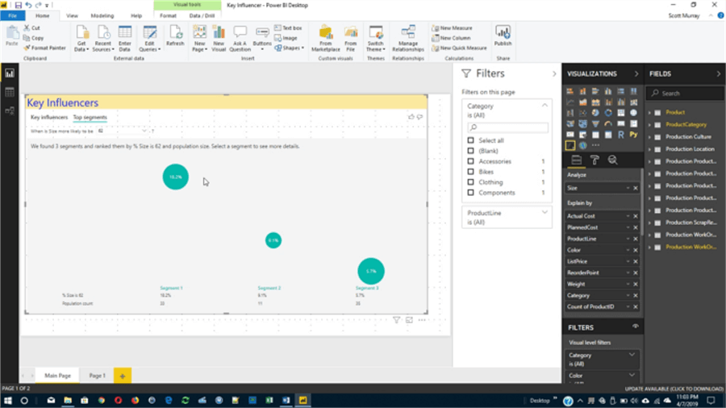
The segmentation tab actually uses similar methodologies to the main key influencer tab, in that it is using a regression analysis to determine those values that make up this particular set are indeed key influencers. Clicking on an individual bubble opens a segment detail window, as illustrated in the subsequent screen print. This detail provides data for each of the category values that make up the segment, such as list price and weight in the below example. The detail visual also provides for the percentage of the total population of values this segment represents both within the particular metric value and as a whole (whole population).
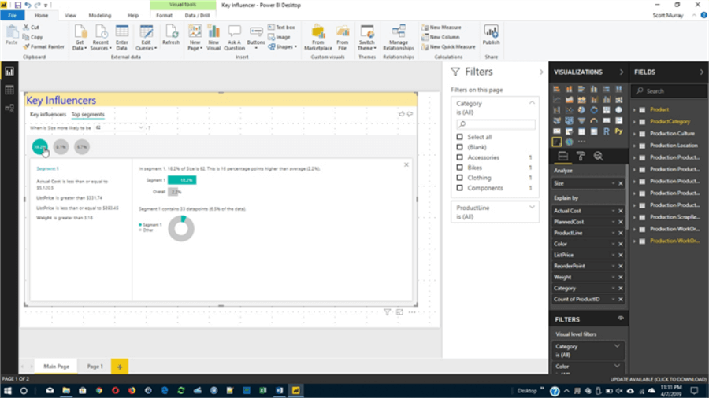
Hopefully you can see these new visuals represent a very direct and exceptional step forward for data analytics within Power BI. As more visuals are developed, these “influential” visuals will continue to proliferate.
Power BI Visual Interactions
written by Scott Murray April 7, 2017 0 comments
Problem
How can I adjust the interactions that take place between different visuals on a Power BI report page?
Solution
Power BI provides neat interactive features which allows for easy navigation and filtering with a click of the mouse. However, there are times when all these interconnected features are not conducive to the goals of a Power BI report. Fortunately, the Power BI developers added the ability to customize and turn on and off the connection between visuals on a report. Currently the default interactions for any page report is one of two variations, all depending on the type of visualization involved. Some of the visuals default to a filter functionality where as other visuals use the highlight method. The filtering method is often not desired when you have a high level or rollup visual such as a Card.
So, let us get started with discussing the options available for interactions on a page; you need to do a few things to get everything setup for access to Power BI. First, you need to go to the Power BI web site and sign up to access Power BI. Note that you must use a work or school address to sign up for Power BI. Next, you need to download the Power BI Desktop (PBID) tool. Once you have your account setup and your Power BI Desktop application installed, you are ready to start working with Power BI!
Controlling Interactions
We will use the Wide World Importers databases, which is freely available from Microsoft, as the basis for our data. We will not go into all the details here ( feel free to review both this tip, Querying SQL Server Data with Power BI Desktop, and this tip, Power BI Data Import and Export with Excel, for details on retrieving data from a SQL Server or Excel dataset), but our first step is to load the Sales tables using the Get Data functionality. We will use these tables as the source for our visualizations. Next, as shown below, we add 4 visualizations to our page:
- A Treemap with customer category and outstanding balance
- A card with total outstanding balance
- A cross tab with customer name, transaction amount, and tax amount
- A clustered bar chart with postal code and quantity
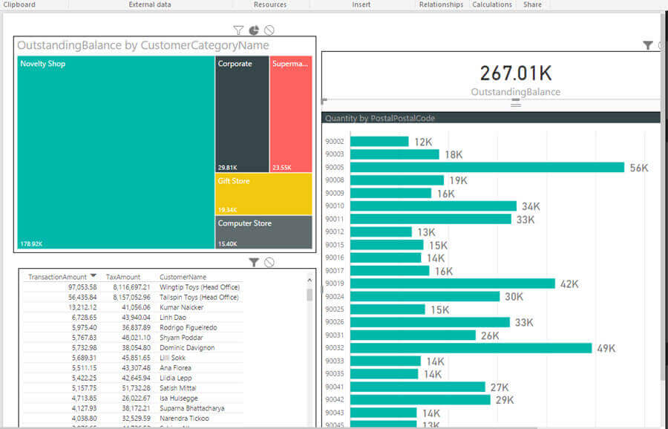
On our newly created page, if we select the Postal Code 90005 from the Quantity by Postal Code visual, you will see that both the cross tab and bar chart are filtered to just Postal Code 90005 whereas the Treemap visual utilizes the highlight method.
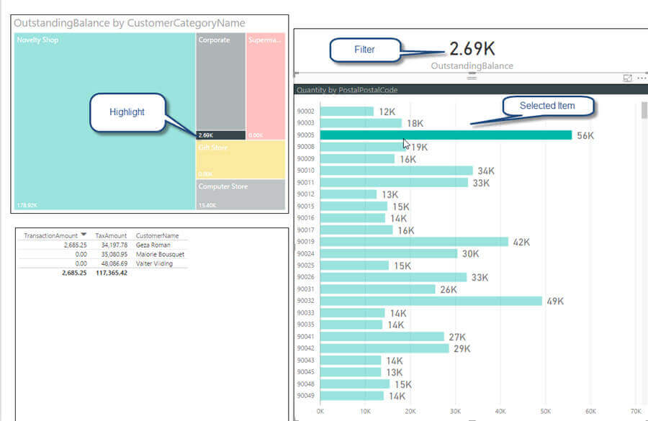
We actually may not want, for instance, for the Card visual to be filtered when other visualization’s objects and values are selected and clicked. In order to make this change, we need to use the Edit Interactions button on the Format Tab of the ribbon in Power BI Desktop.
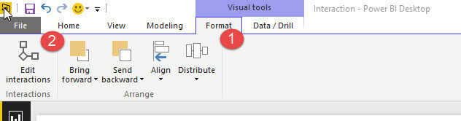
Once you click the Edit interactions button, you can now edit the interactions between the different visuals by selecting the “originating” visual for the interactions. Thus, as shown in the below screen print, the Outstanding Balance by Customer Category Name visual is selected as the originating visuals and there for you are deciding what should occur with the other visuals when you click on an object within the Outstanding Balance by Customer Category Name visual. You will notice that all the other visuals have either two or three symbols activated in the upper right corner of the visual. These symbols are as a follows:
- Funnel – this symbol indicates that the visual will be filtered
- Circle with Slash – this symbol indicates that no filtering will occur
- Pie with slice offset – this symbol indicates that the visual will use highlighting
When an option is selected, it will be filled in with black coloring. Thus, in the below screen print, all three of the other visuals on the report page will be filtered when a value / area is selected on the Outstanding Balance by Customer Category Name visual.
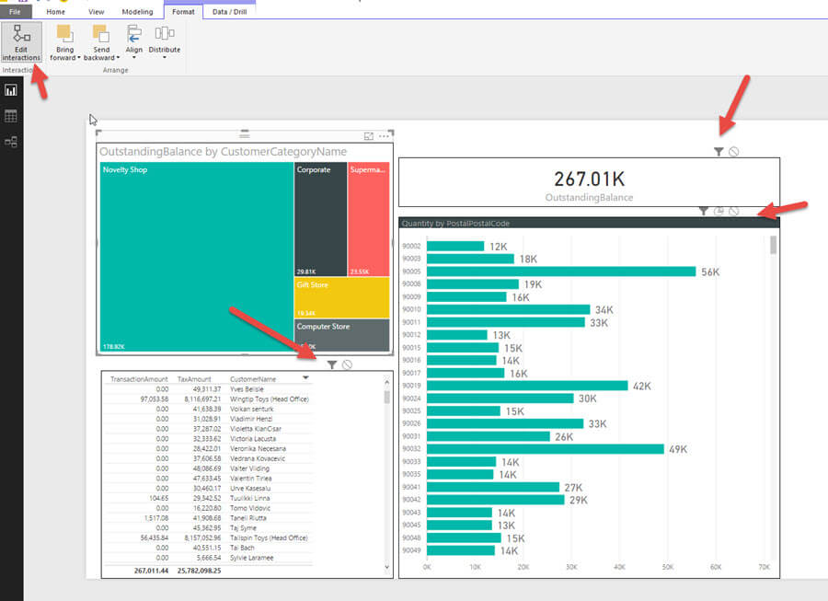
As illustrated next, the three other visuals now interact differently from the default. The card visual will now not be affected by selections on the Outstanding Balance by Customer Category Name visual. The bar chart will be highlighted when one or more items are selected while the cross tab will remain filtered.
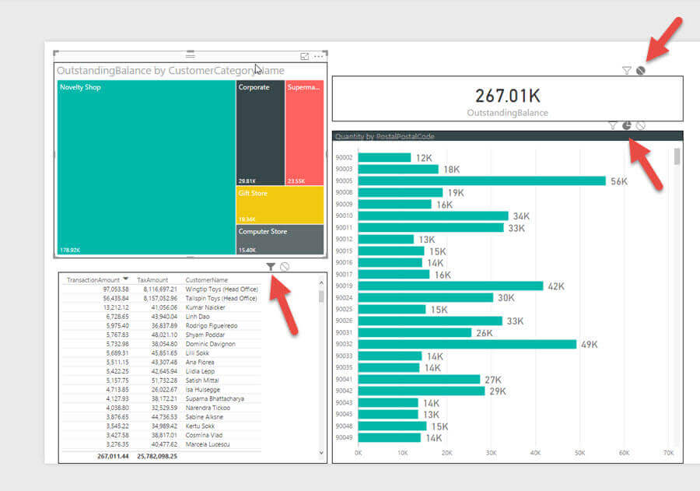
Now, as shown below, when one of the boxes is selected on the Treemap visual, the card visual does not change, the Quantity by Postal Code visual highlights the impacted postal codes, and the cross tab is still being filtered.
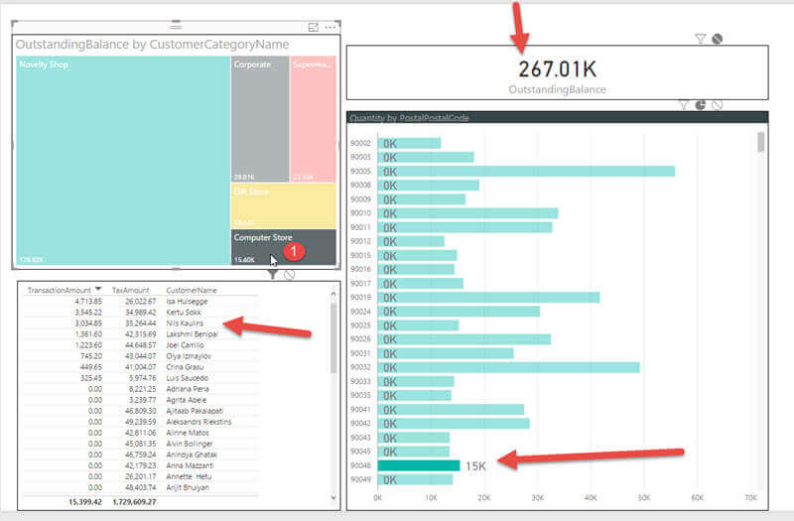
This customization of the interactions does come with a few caveats. First, as noted in the below screen prints, certain visualizations including the cross tab and card visuals do not have allow selection and interaction (they cannot be the “originating” visual for the interaction), but they can respond to interaction and be changed based on other objects. Additionally, these same visuals only allow filtering or no action, while the highlighting option is not available.
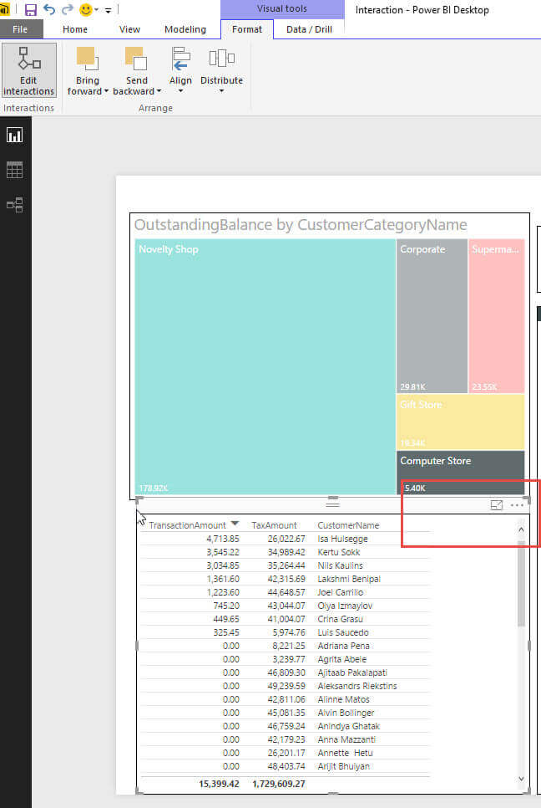
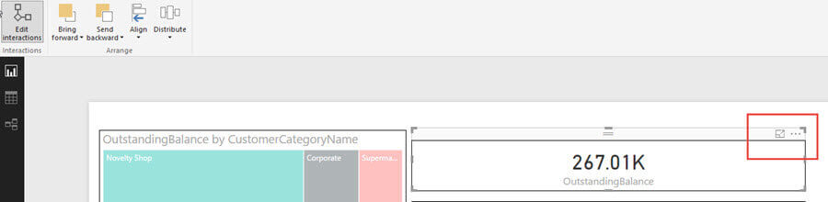
Finally, the interaction between visuals is not automatically two way. For instance, we have been adjusting the interaction for the Treemap visual. For the other visuals on the report page, we would need to adjust their interaction in a similar way if we want them to behave different from the default interactions for each visual. As such, the interaction can be:
- No-way – no interaction between visuals
- One-way – interaction occurs from one visual to another, but not in the reverse direction
- Two-way – interaction occurs between one visual and another in both directions
Conclusion
Interactions between the visuals on a Power BI Report are one of the features that make Power BI very attractive in the Dashboard marketplace. With a click here and a click there, you can easily drill into specific details that are present on a set of visualizations. However, there are also times when you would want to customize how the visuals interact; fortunately, Power BI gives you the ability to set the interaction functionality that will be used on specific visuals. The options include no action, highlighting, or filtering. However, some visuals, such as cross tab, can only be on the receiving end of the interaction and do not allow for customization of its interaction.
Power BI Small Multiples Visual Example
written by Scott Murray February 12, 2021 1 comment
Problem
Power BI has a new feature which is the Power BI Small Multiples visual. In this article we cover how to enable this feature and also walk through an example of how to use this in a Power BI report.
Solution
Power BI has extensive contextual highlighting built into dashboards by default as noted in this Power BI tool tip. Furthermore, using filters and slicers allows for drill down and criteria limits
Similar functionality has been a main stay feature in SQL Server Reporting Services – SSRS for many years as outlined in this tip about putting a chart within a textbox of a matrix. Within Power BI, this functionality takes the name of Small Multiples as generally the charts will be smaller in size (they do not have to be small necessarily), so you can include many and sundry slices of the data. It is a lot like having a legend, but instead of different colors for each item in the legend, you have a different chart for each item. To be honest, I have been anxiously awaiting this feature for some time as it is often requested by my report consumers. I am so glad it is now in Preview, and based on the latest Power BI blog, it will be a work in progress for several updates.
Before we display the advantages and some of the caveats of small multiples, be sure to download the latest version of Power BI desktop. Additionally, we will be using the WideWorldImportersDW database as a basis for our data sources; this database can be downloaded from GitHub. If you need a refresher on bringing data into Power BI please see this tip about querying data.
Power BI Small Multiples Visual Example
Our first step is to enable this preview feature in the Report Options by clicking on File in the tool bar and the Options and settings and then Options.
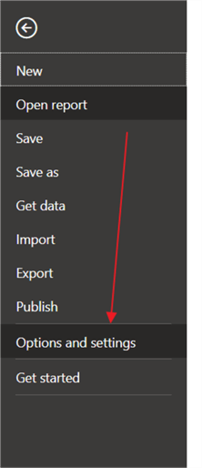
Next, check the box next to the Small Multiples (2) option to enable this feature for use in the report. Notice that the Share feedback option is available here, and Microsoft is actively seeking feedback on this feature.
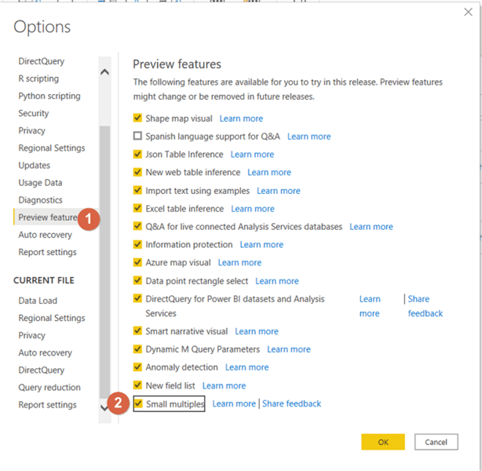
Next, we can create a simple dashboard tab with a column chart, a matrix, and a line chart. As with any new feature and especially one that is still in preview mode, several limitations still constrain the full potential of the small multiples functionality. This feature currently only works for 4 visuals at the present time: line charts, bar charts, column charts, and area charts (note some folks combine bar and column charts). I would expect more visuals to come online as releases are completed over the next several iterations of updates.
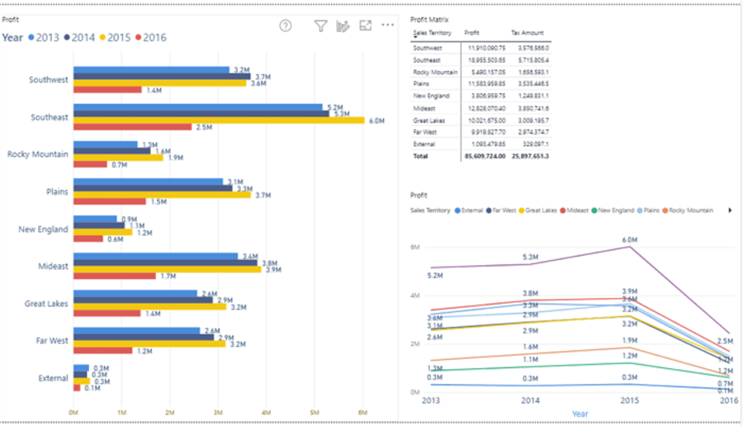
Creating a small multiple visual starts with adding the requested chart to the design grid first. Thus, using the bar chart shown on the left side of the above illustration, we will create new set of small multiples based on the sales territory field. This process is accomplished by dragging the Sales Territory field to the Small multiples well under visualizations, as shown next.
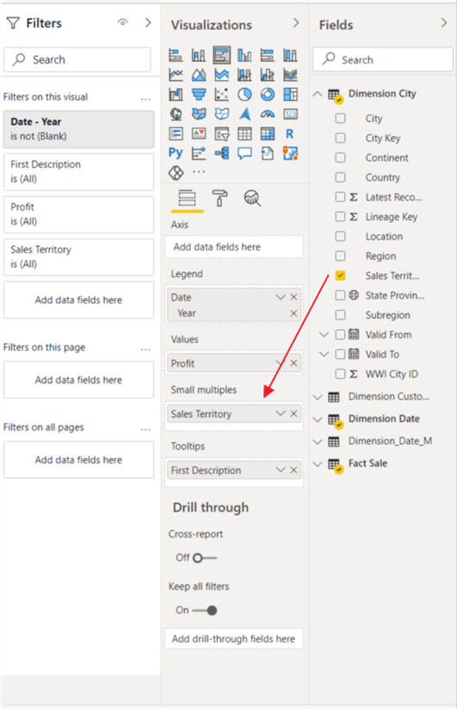
Now, as shown below, our column chart displays a separate chart for each Sales Territory within the main visual.
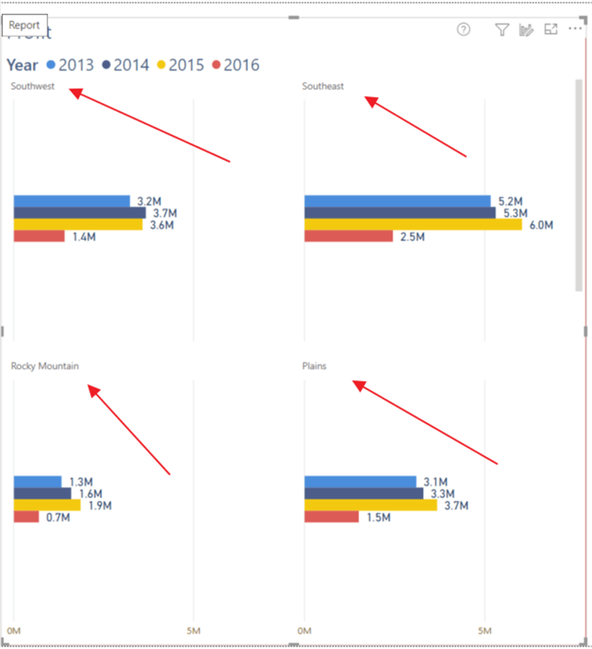
Cross filter continues to work as shown below. Southwest is selected in the matrix and the small multiple charts highlights the Southwest chart while dimming the other sales territory small multiples charts.
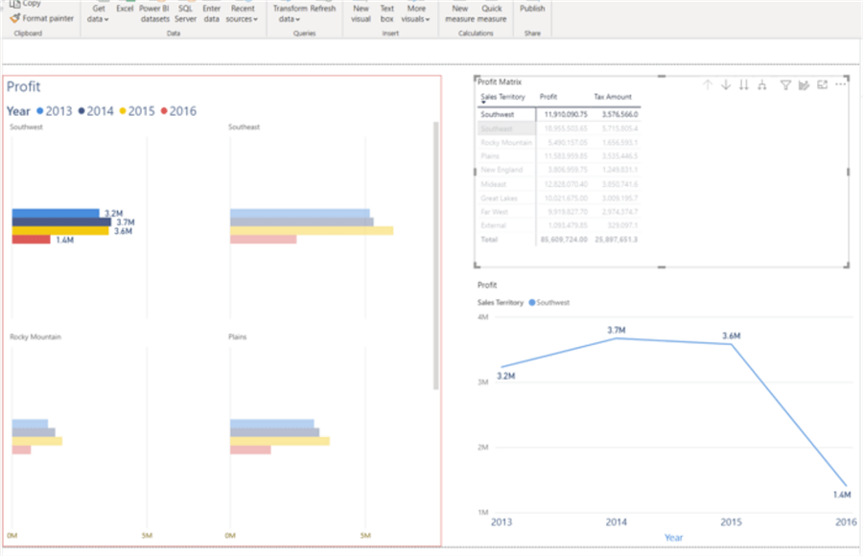
The same highlighting occurs when selecting both a territory and year from the line chart. Also, clicking on the legend or title in the small visuals will actually cross highlight the related values in the other visuals on the report page.
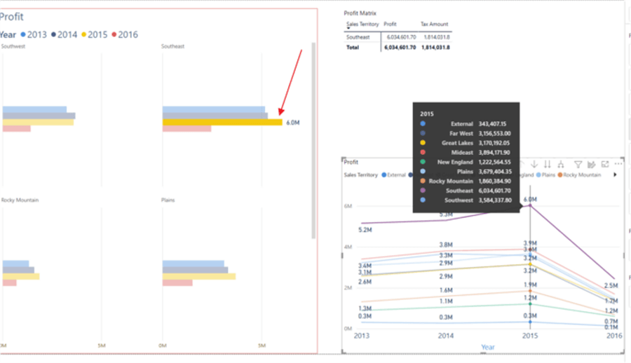
You will also notice the current functionality defaults number of visuals per row is 2; similarly, the default number or rows is 2 (2×2). Thus, if the size of the overall visuals is shrunk, as illustrated below, the 2×2 format is retained with a smaller size for each multiple. To see the additional small multiples visuals, you would need to scroll downward.
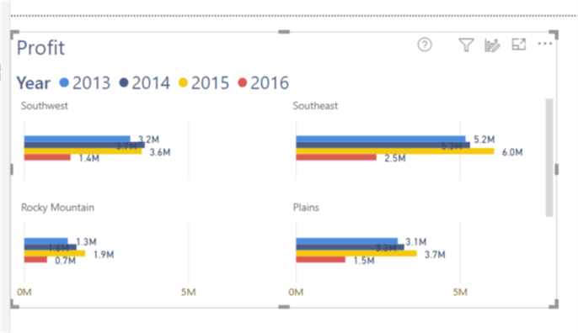
Fortunately, we can change that default 2×2 view to allow for a set number of columns. In the below screen prints, we adjust the grid to now show 3 visuals wide by 3 visuals tall. The current limit is 6×6.
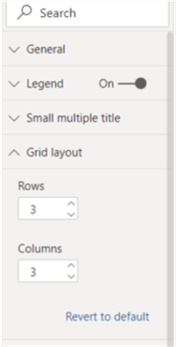
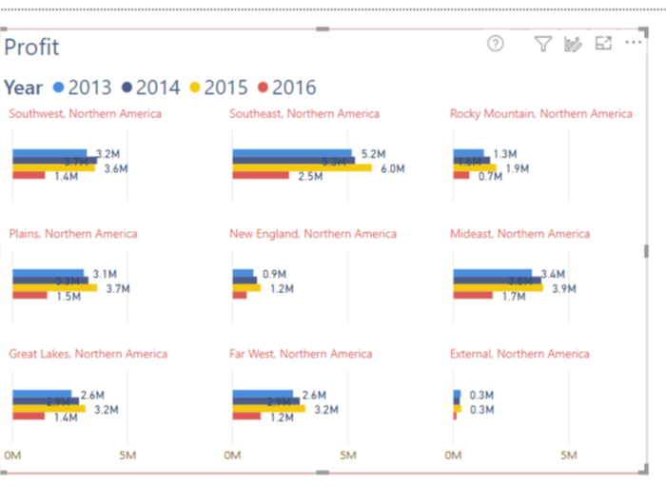
The small multiple category values can also extend beyond a single dimensional value. As illustrated subsequently, the small multiple category is a combination of Sales Territory and SubRegion.
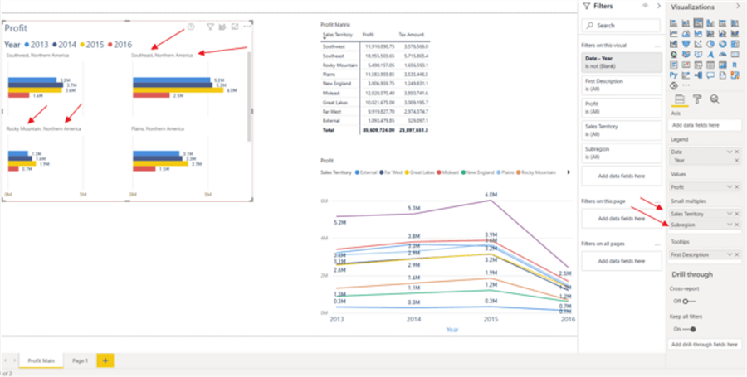
When small multiple values are added, additional formatting options are presented in the formatting pane including adjusting the title format. The title was changed to red in the below example.
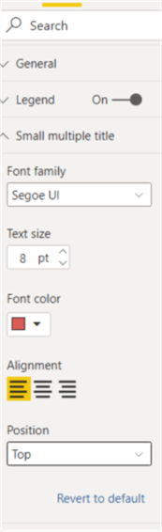
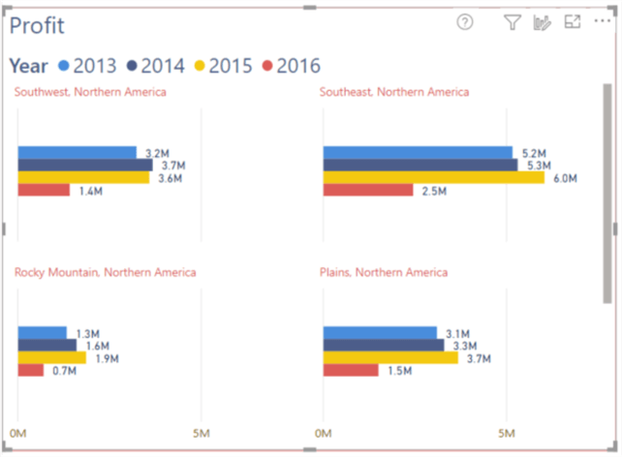
We can similarly use small multiples on a line chart. This functionality definitely reminds me of sparklines used in SSRS or even Excel and is illustrated below.
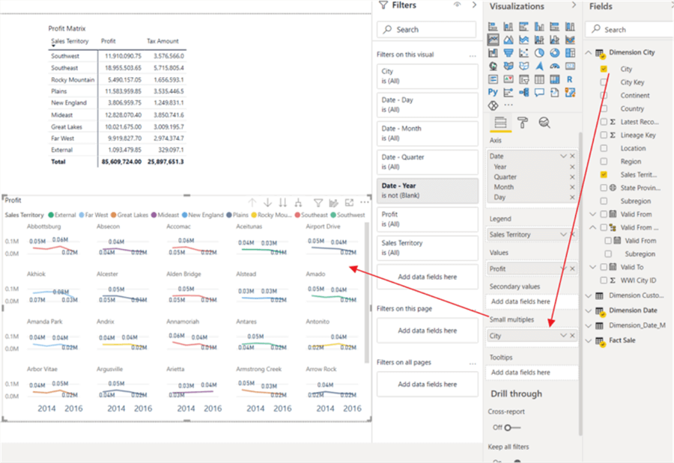
Tool tips allow you to quickly drill into the distinct values used on the line chart.
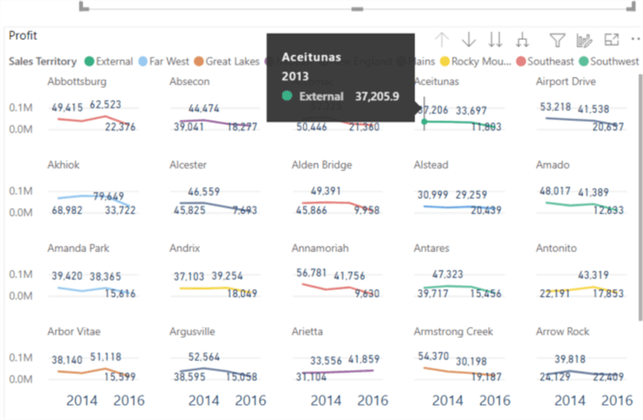
Caveats when using Power BI Small Multiples
Some of the other current caveats when using small multiples, for now, include:
- The ability to add them on the Power BI Service is not available
- Several formatting options are limited, disabled, or not available including:
  - Analytics pane
  - Background color
  - Padding and grid lines between the small multiples
  - Text wrapping on headers
  - Zoom slider
  - Concatenated labels and total labels
- Continuous X axis is not available
- Visuals beyond, bar, column, line and area charts are not available for use in small multiples, but combo charts and scatter charts are on the roadmap for the next set of releases
- Sorting by measure values is not currently available
- Rectangle select is not available
Even with these limitations, the new small multiples feature is a giant step in the correct direction to expand functionality in Power BI. It quickly provides the ability to show the same chart for multiple categorical values in one single and simple design. As this feature continues to expand, it will only enhance the abilities of report designers to quickly generate needed charts for report consumers.
Power BI Pulse Charts
written by Scott Murray March 15, 2018 0 comments
Problem
What are Power BI Pulse Charts and how are they used? Can you provide a step by step example on how to get started with Power BI Pulse Charts?
Solution
One of the neat features of Power BI is the proliferation of various visualizations. Between the default visuals available upon install plus all the custom visualizations that have been created and available in the Microsoft store, the variety of visual solutions is ever growing. The pulse chart is one of those charts that excels at telling a story, a story with visual cues and animation. Pulse charts act like a “moving” pulse monitor you may see in a hospital, so thus the name Pulse. As an added benefit, the pulse chart provides an auto-run option which automatically starts the animation for the chart. Furthermore, “highlighted” events can enhance the animation by creating a temporary pause to highlight a particular event or events.
Implementing a Pulse Chart in Power BI
Since the pulse chart is a custom visualization we first must import it into Power BI. It can be downloaded from the Microsoft app store at: https://appsource.microsoft.com/en-us/product/power-bi-visuals/WA104381006?src=office&tab=Overview. Of course, you will want to download Power BI Desktop if you have not already done so: https://powerbi.microsoft.com/en-us/desktop/.
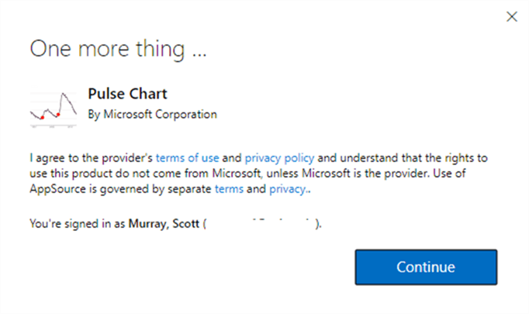
You will want to download the visual to your local machine.
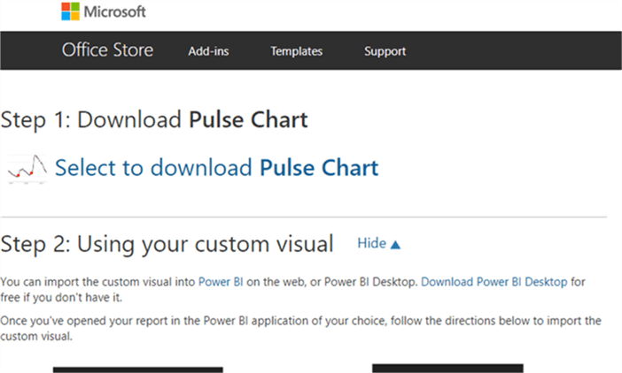
After starting Power BI Desktop, you will need to import the newly downloaded custom visual into the visualization gallery.
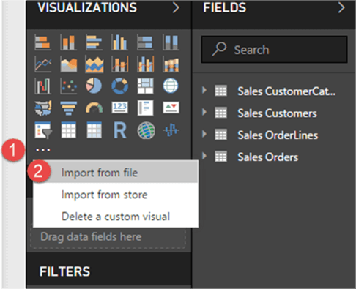
As an alternative, the Pulse Chart visual can be imported directly using the Import from store option.
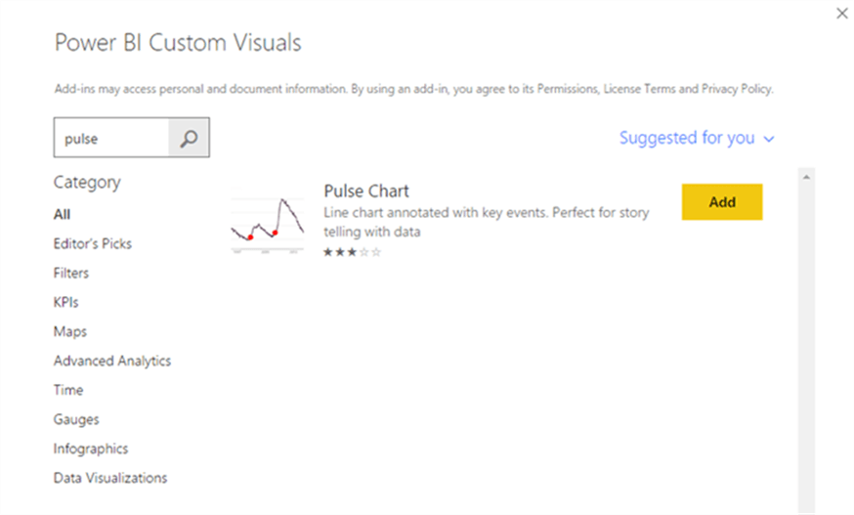
Now we are ready to use the Pulse chart. Our first step is to import some time series data into Power BI. I am using a data set which shows attendance figures from Major League Soccer (MLS) matches. This type of data is perfect as it shows a data measure over a time series. For this exercise, we will show the maximum attendance per day (to emphasize when record attendance was achieved).
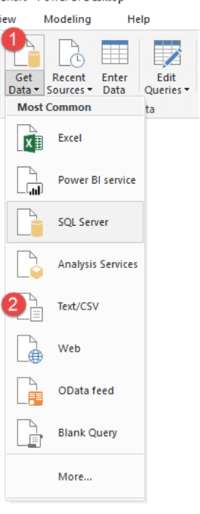
Next, we will load the attendance data into the data model.
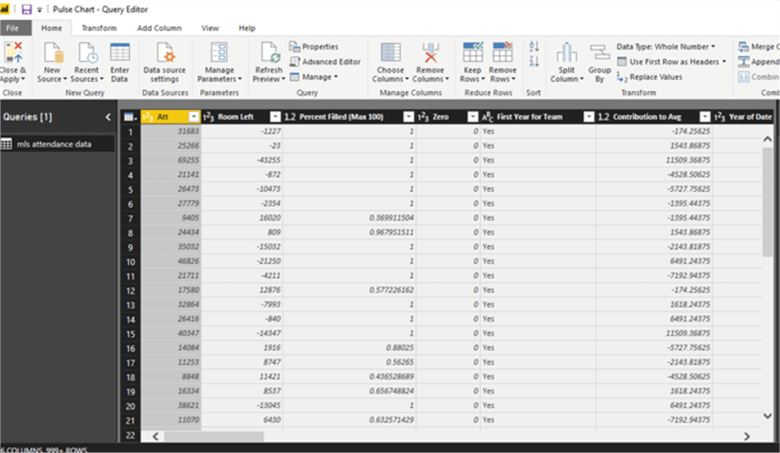
The Att (attendance) field will be used as the main measure while the Date field will be used for the x-axis. We will also add an event field to the data set which we will employ later to highlight special records in MLS history. More to come on that item. To get back to the design window from the data model, you would want to select to Close & Apply.
Now that we have a prepared dataset, the Pulse Chart is now ready to be setup. We have several items that will need to be added to the chart. The first step in setting up the Pulse chart is to select the chart from the chart gallery and drag it onto the design grid.
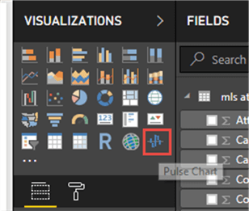
Next, we begin to add the data items.
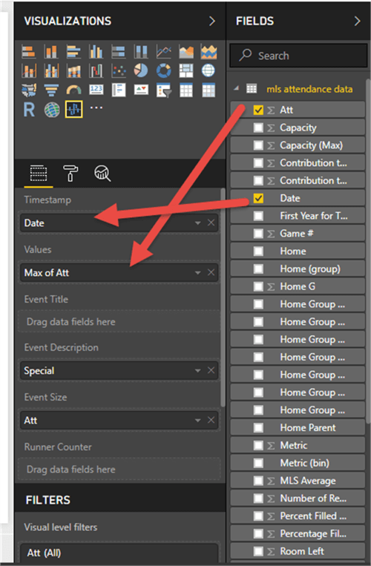
For the Timestamp field, we will add the MLS match Date field. The TimeStamp field is really the x axis for the chart. Next, the Att / Attendance field is added to the Values area; this figure is the total attendance per match. Since we want to show the highest attendance event per day, the maximum attendance value for matches on that day is used. This value becomes the y value for the chart.
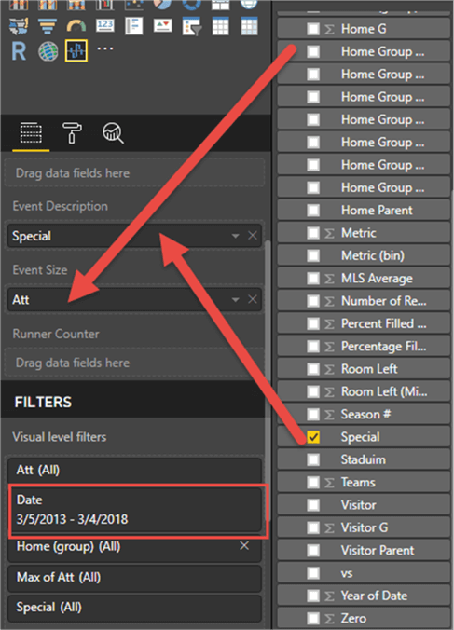
We next add the Special field to the Event field. The Event field shows the value to the Event field and the Att / attendance value to the Event Size field. This item is one of the neat features of a Pulse Chart. The event field is used to highlight a particular special item at a particular time; the event size will emphasize the attendance value at the event occurrence on the chart.
One last item that was added to the Pulse Chart is a filter; we will limit the chart to just 3/5/2013 to 03/04/2018.
So on an initial pass, we have the following result for our chart. As you can tell, it does need some work to get the formatting and aesthetics in a better format.
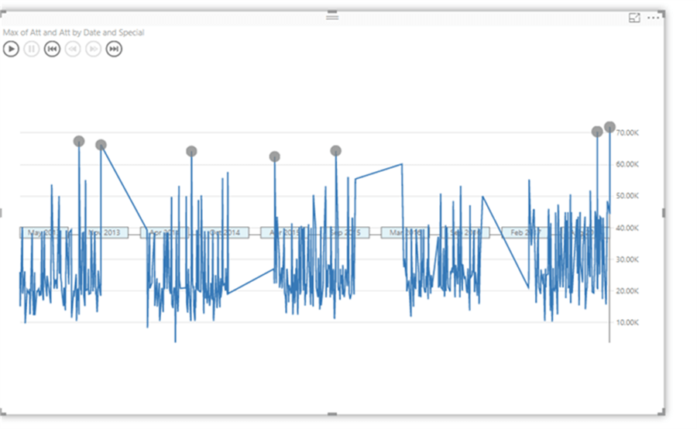
Our first formatting steps are to adjust the color of series, changing it to red and then turning the gap property off. Turning off the gap property allows the graph to flow and be connected between one year of matches and the next.
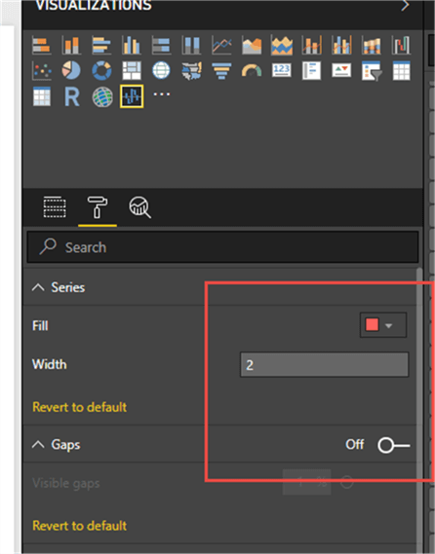
Now the Popup formatting is set; this particular set of properties sets the formatting of the Popup areas. This Popup will display the details from the event setting; in our example that would be the “Special” field. These properties control the look of the popup box (sort of like a tool tip) and include items like the font size and color, the background color and the size of the overall popup box.
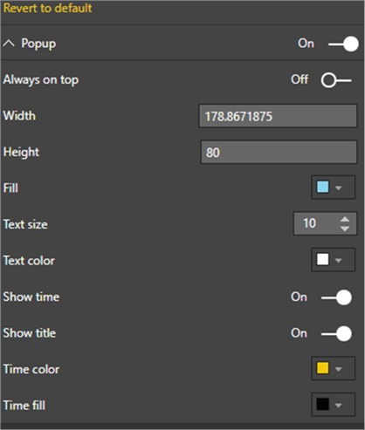
The next set of options controls the size of the circle that show when an Event takes place.
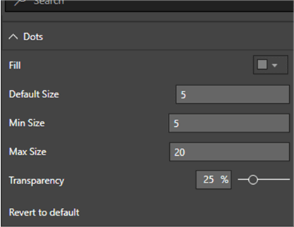
The X and Y axis properties control the coloring and location of the x and y axis on the chart. You may have noticed on the original chart, the x axis was centered horizontally. Based on the number values to chart, moving it to the bottom of the chart was a better option.
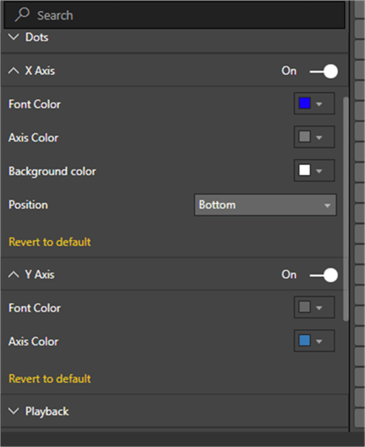
The subsequent option to be set is the playback properties; this list of properties controls how fast the “pulse” line will play across the screen and whether the playback occurs automatically or not. Furthermore, the pause option tells Power BI how long to stop and display the popup when an event occurs. Finally, the button color controls the color of the play, pause, forward and backward buttons which appear in the upper left corner of pulse chart grid.
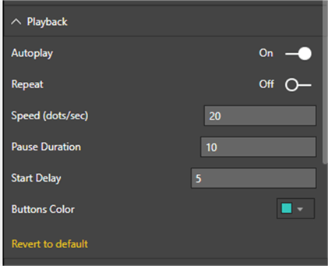
The Title and Background formatting options are self-explanatory, and control how the tiles appear on the chart and whether a background color should be used to enhance the visual.
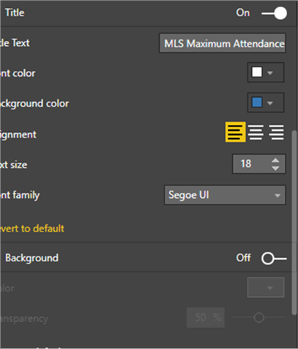
The last 3 options control: 1) the lock aspect of the chart for sizing purposes, 2) the border color and 3) the general location and size of the chart.
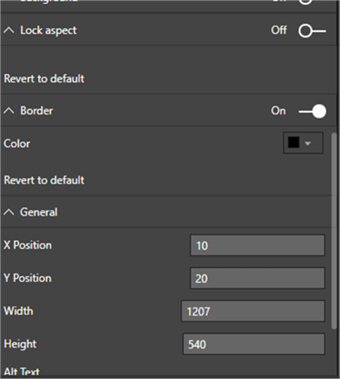
So now that we have completed our formatting for the chart, we are ready to “play it” by clicking the play button. The chart starts at the left side and begins drawing the red line. When the chart gets to an “event”, the playback pauses, and the popup box is displayed as illustrated in the first screen print below. The chart pauses for the time frame we specified above, and then begins drawing again. When the drawing gets to the next event, as shown in the second screen print, the next event is displayed in the popup.
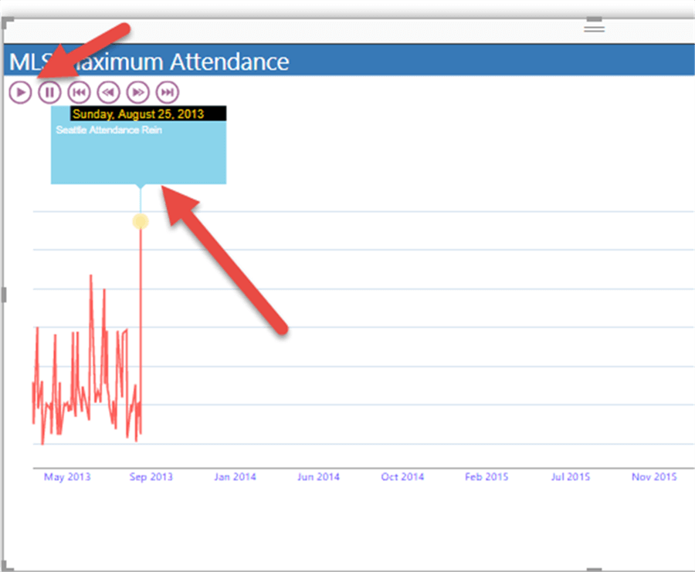
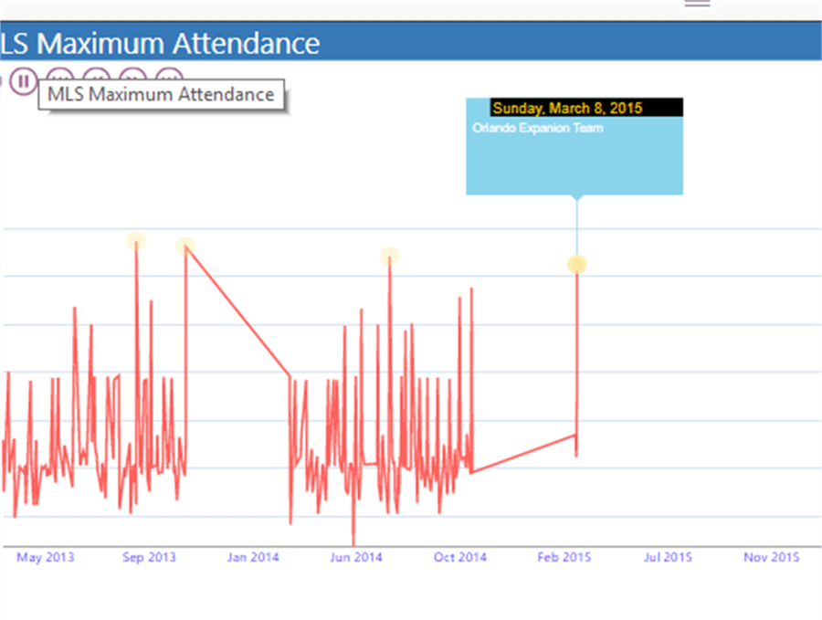
This process continues until the chart drawing reaches the end data for the data set. If set in the playback options, the chart will automatically replay the drawing again from the left side.
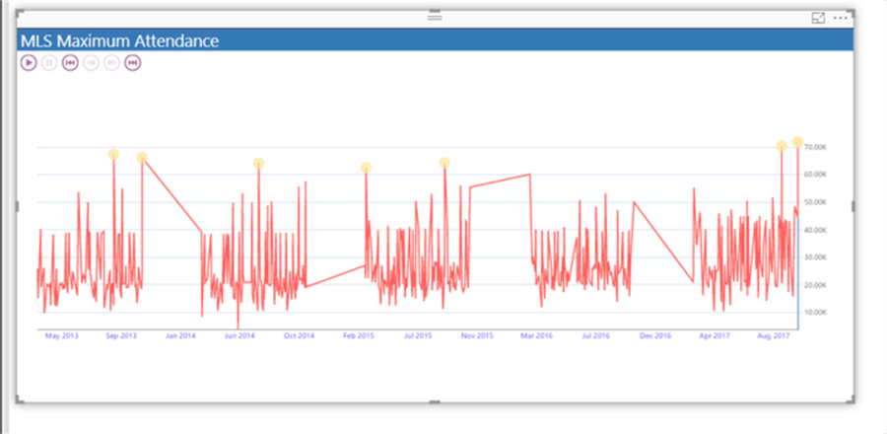
Furthermore, each dot can be clicked on to display the event appearing at that point in time.
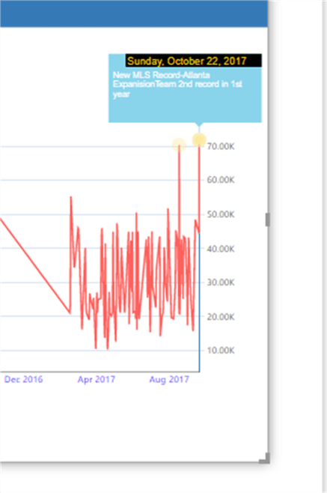
Once you are satisfied with your new chart, you would need to publish this report to the PowerBi.com online service to display for others.
Increase Power BI Canvas Size
written by Kenneth A. Omorodion June 23, 2022 0 comments
Problem
By default, a Power BI report page canvas orientation has a size of 16:9. This can become challenging when you need to include more visuals or details in a single report page. Power BI has a way to re-configure the canvas settings of the page to allow it to have an increased Portrait Orientation depending on your requirement so that you can more space to add your visuals. Let’s look at how this can be done in Power BI Desktop.
Solution
I understand that most Power BI developers already know how to configure this easily, but from experience I can guarantee you that not everyone knows how to do this, particularly those new to Power BI. Hence, I have put in a detailed step-by-step to configure this in Power BI Desktop as follows.
To demonstrate this, lets first look at the two diagrams below and understand what we are trying to achieve.
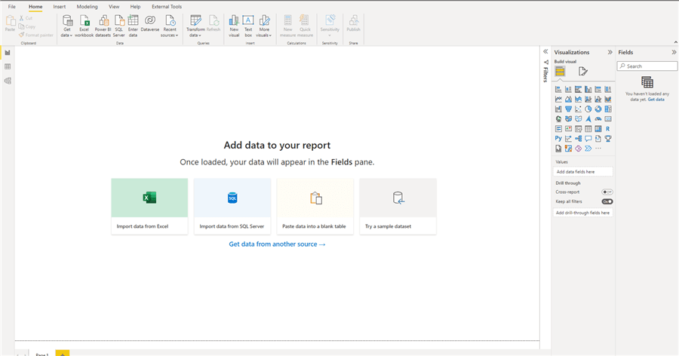
The diagram above shows the default page view of a Power BI Desktop report. The canvas size for this default view is 16:9. So you would be limited in how much information/visuals you can add on this page.
There are options to change this view, but in this article, we are just interested in increasing the vertical orientation to ensure there is more space for more visuals. The diagram below shows what we are trying to achieve.
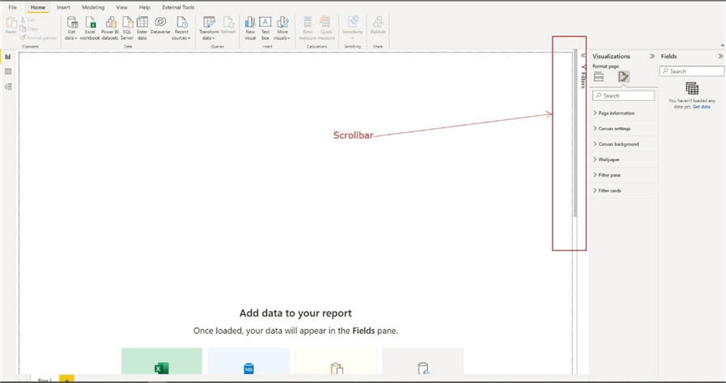
From the diagram above, you can now observe that on the right side of the page there is now a scroll bar to scroll to the bottom of the page vertically, thereby increasing the size of the page to allow for more visuals/information for this page.
So how was the increased portrait orientation achieved? Let’s look at this step-by-step.
Step 1: Go to Format section within the Visualizations pane of the page as seen in the diagram below.
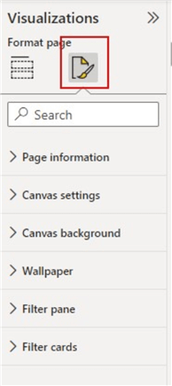
Step 2: Change the page canvas type to “Custom” as seen in diagram below.
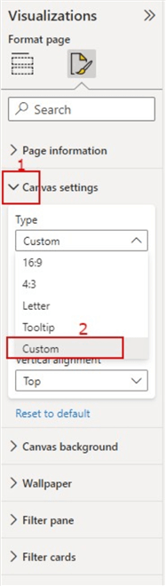
Step 3: Change the default Canvas Settings height from 720 px to a desired height. In this demo I have just multiplied the default value of 720 px by 2, you can always increase or decrease accordingly. See diagram below.
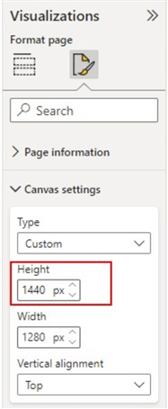
Step 4: Change the vertical alignment to “Middle”. This just ensures the page is aligned to the middle of the page rather than to the top. This can be optional though. See diagram below.
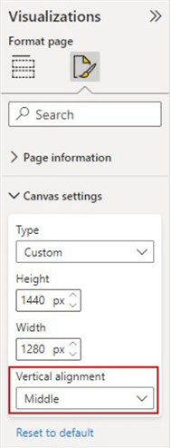
Your page orientation should now look like the diagram below.
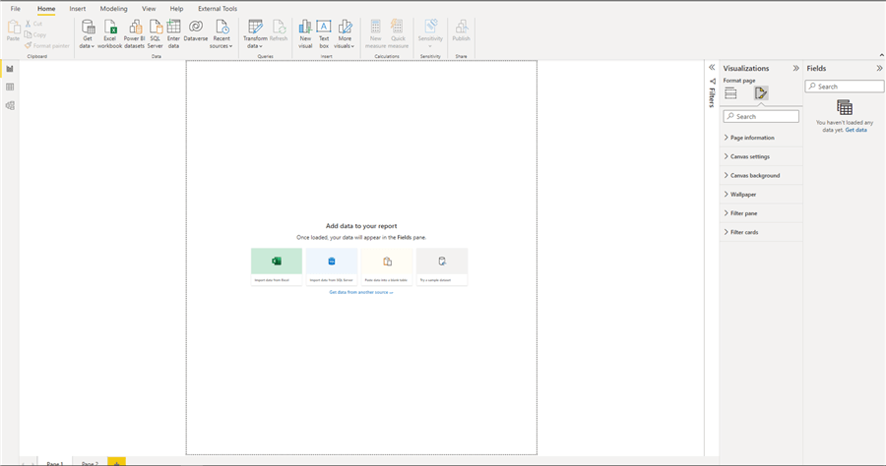
I can imagine someone saying that does not look like what we expect. Yes, you are right, there is still one more step left as detailed below.
Step 5: Change the Page View to either “Actual Size” or “Fit to Width”. To do this, navigate to the “View” tab on the Power BI Desktop ribbon, then click on the drop-down on the “Page View” and then select which one suits your requirement best. That’s all! See diagram below on how to do this.
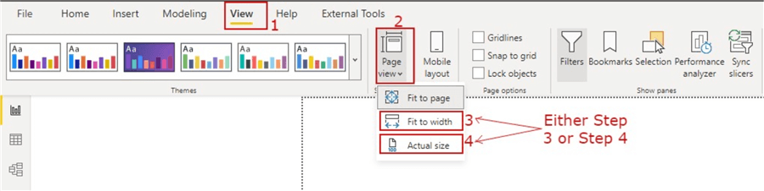
Summary and Considerations
Note that this only affects the current page you have configured it on, if you need to have extended page size on other pages you might need to either duplicate this current page or configure it separately on the other pages as required.
Analyze inter-relationships with chord diagram visualization in Power BI Desktop
written by Siddharth Mehta April 6, 2018 0 comments
Problem
A matrix is generally one of the most common and connected forms of datasets where each item shares a common set of comparable attributes. The more the data is connected, the more it becomes complex to inter-analyze in a comparative manner. There are different visualizations to represent flow or relationships in a dataset like Graphs, Trees, and Sankey Charts. Most of these visualizations are efficient at representing unidirectional relationships. Consider a scenario where employees from different companies are joining competitor companies. An employee from Facebook may join Google, an employee from Google may join Apple, and employees from Apple may join Facebook as well as Google. So, there is an inward as well as outward relationship between each company. A specialized diagram suited to represent bi-directional inter-relationships in data matrices is required. In this tip we will learn how to visualize such data using Power BI Desktop using a chord diagram visualization.
Solution
Chord diagrams are available in Power BI Desktop from the Power BI Visuals Gallery, which can be used for visualizing matrix data with inter-connected relationships.
Before we understand the details of the chord diagram, we need a real-life dataset which can be used to simulate the problem in question. World Bank publishes many public datasets that can be used for the problem in question. One such dataset is the remittance datasets. People work in foreign countries and they send part of their earnings to their home country, which is generally known as remittance. All the countries have inward and outward remittances, where each country receives foreign exchange as well as local currency is being remitted out to other countries. You can download the remittance datasets from here.
Below is how the world outward remittance dataset looks.
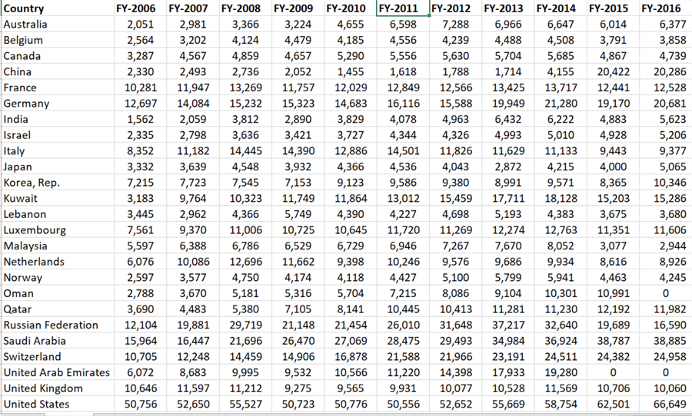
These are the top 25 countries in terms of outward remittances from 2006 till 2016. I have transformed this matrix into a simpler form for easy consumption in our report. This can be easily done using Excel. To quickly get started, you can download this curated and transformed dataset from here.
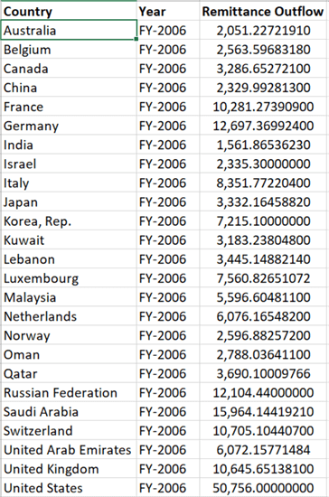
Building a Chord Diagram Visualization with Power BI
In order to study the inter-relationship in this dataset in a comparative manner, we would visualize this dataset on a chord diagram in Power BI Desktop. It is assumed that Power BI Desktop is installed on the development machine.
Step 1
The first step is to download the chord diagram from here, as it is not available by default in Power BI Desktop. Chord diagram is ideal for visualizing comparing similarities between different entities, relationships and proportions in a dataset.
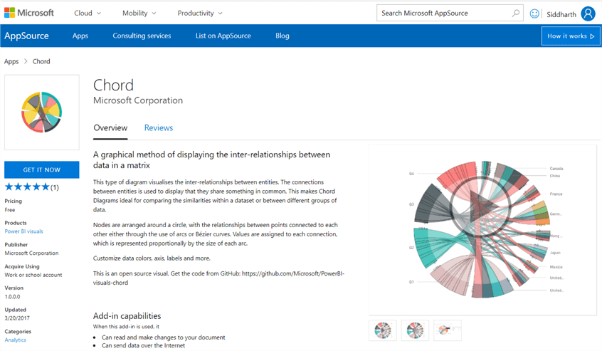
Step 2
After downloading the chord diagram control, open Power BI Desktop. You can click on the ellipsis in the visualization tab and select “Import from file” menu option. This will open a dialog box to select the visualization package file, to add the visualization in Power BI. Select the downloaded file and it should add the chord diagram to Power BI Desktop visualizations gallery.
Step 3
Click on the chord diagram and that would add it on the reports layout. Enlarge the control to occupy the screen space and it should look as shown below.
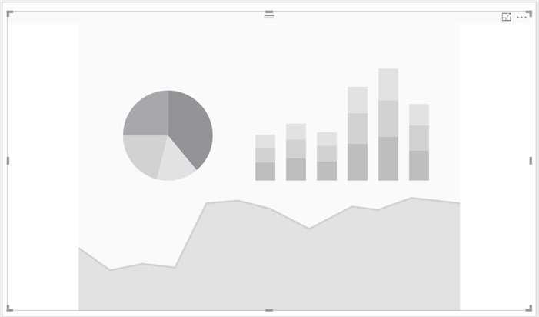
Step 4
Now that we have the visualization, it is time to populate data. Click on the Get Data menu and select Excel as shown below.
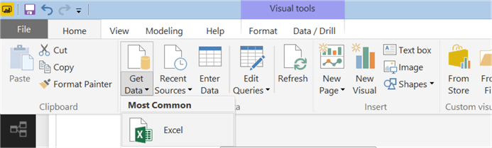
Step 5
Navigate and point to the Excel file that you would have downloaded earlier. After you select it, you would be able to preview the data as shown below. Select Sheet2 and load the data.
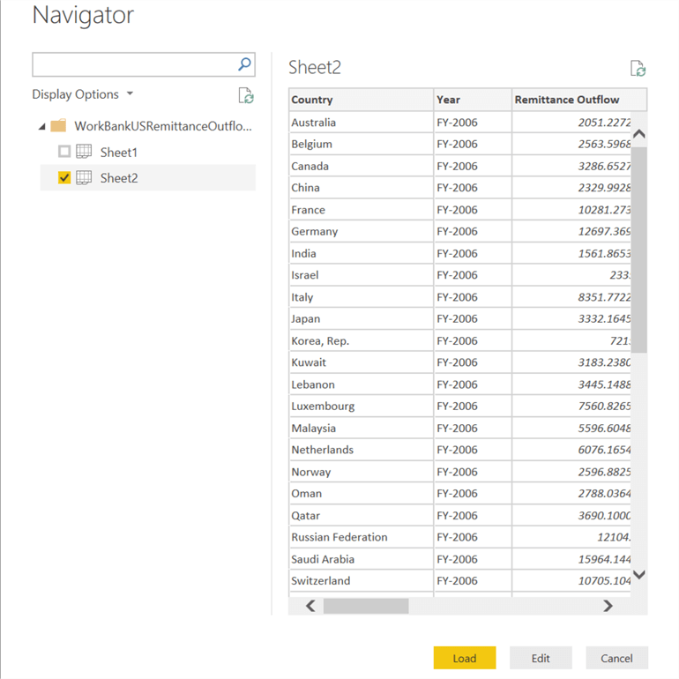
Step 6
After loading the data, the data model should look as shown below.
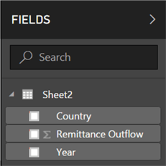
Step 7
Select the control on the report layout, add Country to source, Year to destination and Remittance Outflow to values section. This should bring up the chord diagram as shown below. The matrix we are dealing with is large and as you can see the diagram becomes extremely complex and almost illegible. At this point we can derive that the larger blocks represent the total outward remittance from the entire world in a fiscal year. Also all the top 25 countries listed have outward remittance.
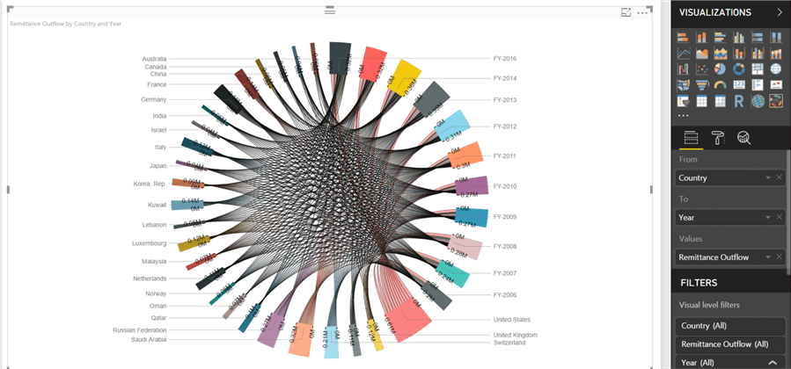
Step 8
As every country has outward remittance in each fiscal year, the volume of relationships is at its maximum. So, to make the diagram legible let’s focus on the remittance in the latest 3 years. For the same navigate to the visual filters and filter the year as shown below. This will remove the rest of the years from the diagram, reducing the volume of relationships shown on the diagram. The three biggest blocks or arcs represent the total of the fiscal year. Each of the other arcs represent the total of each country. And the connection arcs show the volume of remittance by each country in each year.
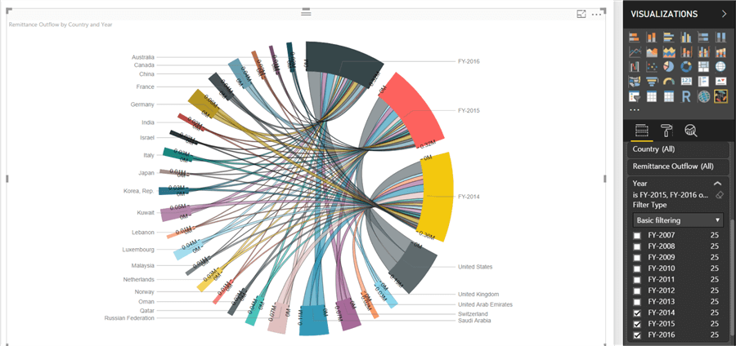
Step 9
Each legend has an axis associated with it. If you carefully study the yellow, red and black blocks, you can read 0M and 0.3M at different ends for example in the yellow block. This shows the total range of remittance. If you hover your mouse, you will also be able to see the value as shown below.
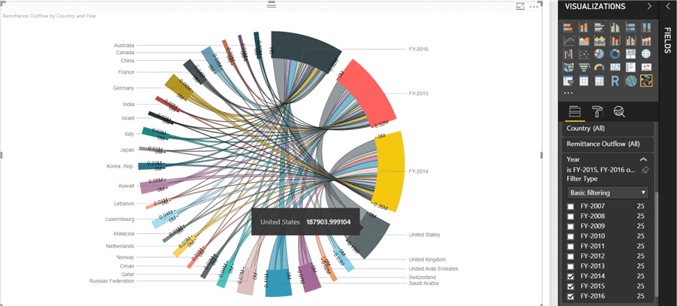
Step 10
Let’s reduce the volume of relationships further by limiting the top 10 countries in the dataset. From the visual filters, and apply the filter on country fields as Top 10. This would change the diagram as shown below. It’s easier to make out that United States, Saudi Arabia, Russia and Switzerland have the maximum outward remittance in the world.
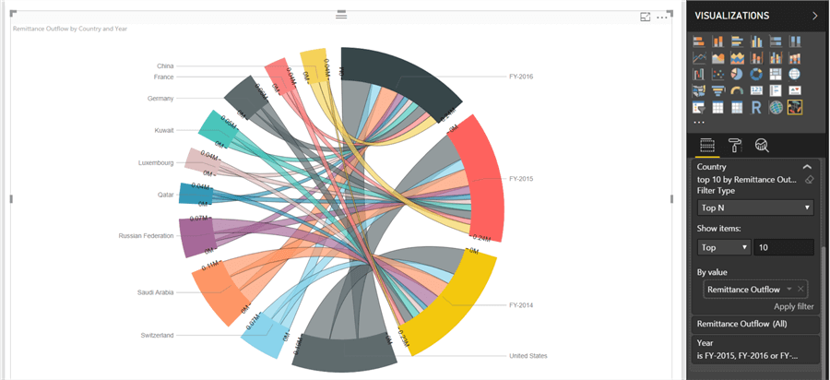
Step 11
Click on the United States block and it will highlight the connecting arcs. You can compare that the outward remittances are almost similar in all the three fiscal years. Also, its higher as compared to the rest of the world. This is also a common pattern for most of the other countries too.
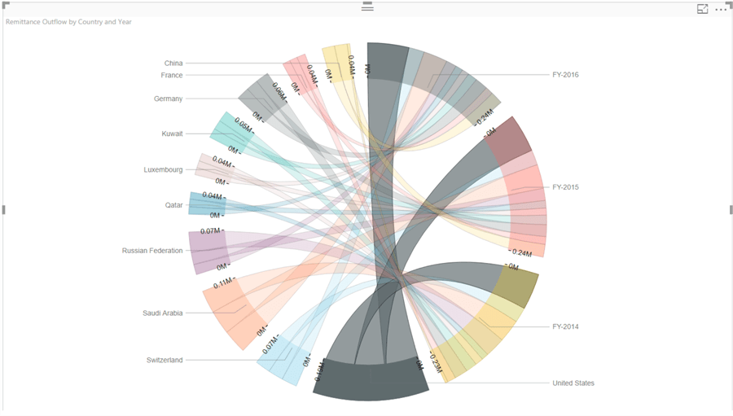
Step 12
But this may not be true for all the countries. If you select China as shown below, you would find that the outward remittance from China in 2014 was very low compared to rest of years and compared to the rest of the world. This means outward remittances grew in the past 2 years, which could mean change in geo-politics or government policies. This could be an observation of interest for analysts. The breadth of the connection arcs and legend arcs is proportional to the relative values in the dataset, making it convenient to compare any value in the entire dataset just with a glance.
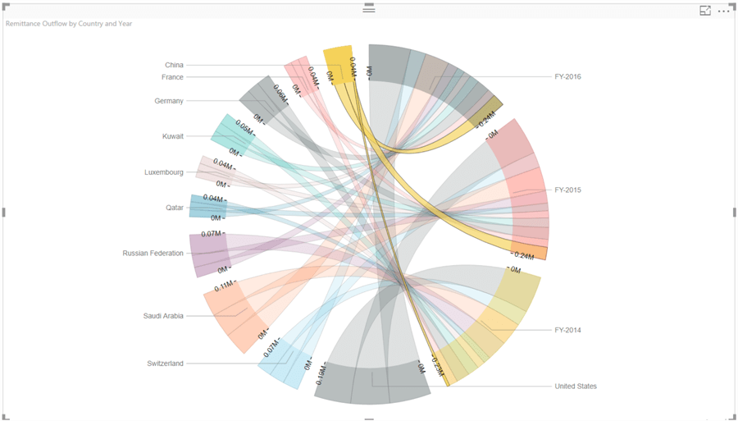
Step 13
With such a large variety of colors overlaying over one another through connecting arcs, it can be confusing at times. Let’s say we intend to show only the top 3 countries in one color and rest all in one common color, to emphasize on the top 3 countries versus rest of the world. To customize the colors, navigate to the format options tab and set the Show All options to On in the data colors section. It will show all the colors used for each legend and provide the option to customize the same.
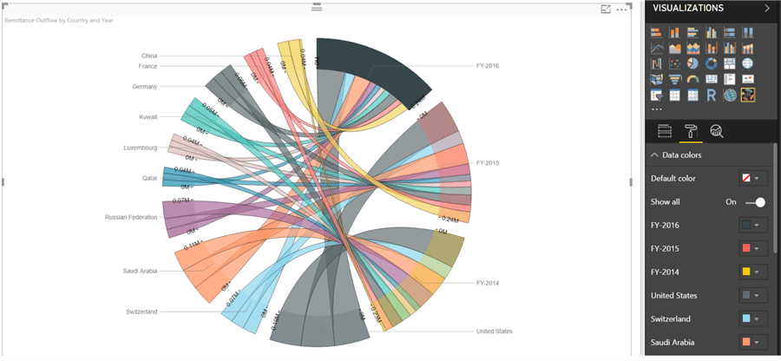
In this way, we can use a Chord diagram to study the inter-relationships and proportions in a matrix format dataset with Power BI Desktop.

