i-Telex

Communication Specification

Content

1 Content 3
2 Communication between i-telex stations 4
2.1 Basic characteristics 5
2.2 Packet types 5
2.2.1 Heartbeat packet 6
2.2.2 Direct dial packet 6
2.2.3 Baudot data packet 6
2.2.4 Communication end packet 7
2.2.5 Communication reject packet 7
2.2.6 Acknowledge packet 7
2.2.7 Version packet 7
2.2.8 Self test packet 8
2.2.9 Self test reply packet 8
2.2.10 Remote configuration packet 8
2.3 Examples 9
3 Communication between i-telex station and subscriber server 11
4 Grundlagen der Kommunikation im i-Telex-Netz 12

Pictures

Abbildung 1: i-Telex im Internet 12

Tables

Table 2: Packet types and codes 4

Content
This document describes the communication used at the IP port of the i-telex system.

There are basically two channels:

- The communication between two i-telex users (station). This is subject of chapter 2.
- The communication between the calling i-telex user (station) and the i-telex subscriber server, which is performed to get the IP address of the called station. This is subject of chapter 3.

Communication between i-telex stations
i-telex stations try to enable stations to simply interconnect two telexes thru the internet. The Protocol is TCP based and follows the same rules as the normal telex does.

It may be reflected by a state machine with the states “disconnected”, “connected unknown”, “connected proposed”, “connected” “texting ascii”, “texting baudot”, and “disconnected baudot”.
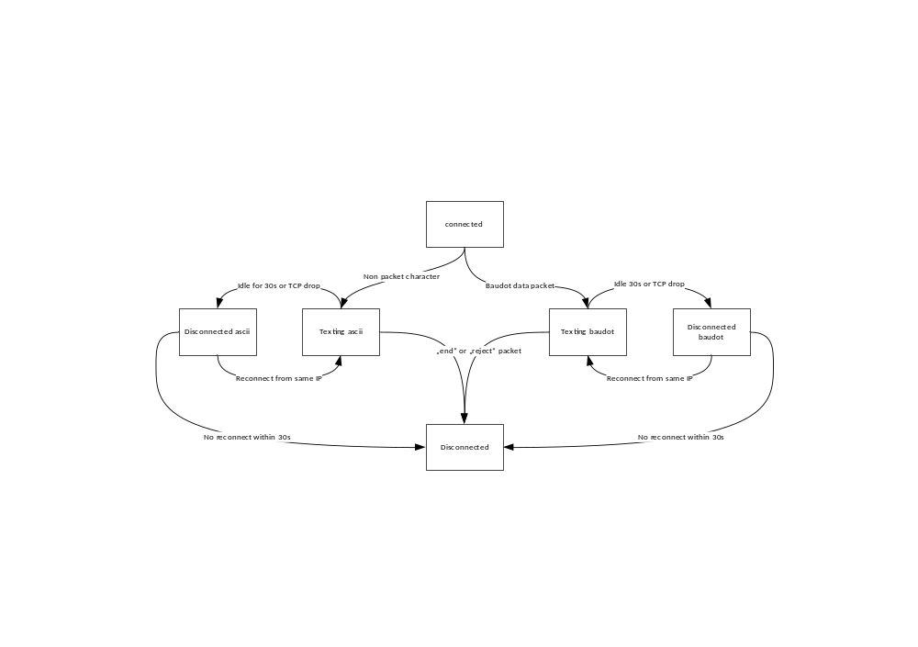
Figure 1: state diagram of an i-telex host

In the state disconnected the i-telex service waits for incoming connects on the designated TCP port.

As soon as there is an incoming TCP connect the state changes to conected. In the connected phase state the following packets are allowed: “Version”, “Direct dial”, “remote config”, “selftest”, “reject”, “end” and plain ascii characters.

When in connected state the first packet not starting with a character in the range 0x00 to 0x09 and 0x10 to 0x1F triggers the “texting ascii” state. In this state all characters sent will be interpreted as pure ASCII transmission to be sent to the telex.

When in “connected” or “texting ascii” state and a “baudot data” packet is received the state machine changes to “texting baudot”. In this mode either a “baudot data”, “acknowledge”, or “heartbeat” packet must be sent at least every 15s. If no packet is received for more than 30s the TCP connection should be dropped and changed to the “disconnected baudot” state.

When in a “texting baudot” state a “reject” or “end” end package returns the i-telex service to the disconnected state and terminates the tcp session.

In the state “disconnected baudot” the connection waits for a connect from the very same IP address as before. All other connects to the connected telex will be rejected. If a connection from the same IP arises the previous state is restored. If there is no subsequent connection within 30s the state changes to disconnected.

When in “texting ascii” state a termination of the tcp session changes the state to “disconnected”.

Basic characteristics
The communication is based on the TCP protocol. The port can be chosen individually, the existing systems use port 134.

The transmitted data is symmetric, i.e. the caller and the called stations use the same data protocol.

The transmitted data is organized in “packets”. Each packet consists of:
- 1 byte command
- 1 byte data length
- n byte data

Exception: In texting ASCII state, the byte codes 0A, 0D, 20-7E and A0 to FF (hex) are treated as plain ascii resp. ISO 8859-1 codes if they are not part of the data block as specified above.

A TCP packet may consist of one or more data packets and / or ASCII data.

If a station receives a packet with unknown command code, the packet should be discarded. The length byte determines where the next packet starts.

Is the data length of a received packet is higher than allowed the extra data must be discarded.

In “texting baudot” state at least every 15 seconds a packet should be sent (either a “baudot data”, “heartbeat” or an “acknowledge”, see below).

The calling station may close the existing connection and open it again within 30 seconds without any influence to the communication handshake.

Packet types
The following table gives an overview over all (so far) defined packet types:

Command  (hex) | Use | Version | Data | Allowed data length (decimal)
00 | Heartbeat | 1 | None | 0
01 | Direct dial | 1 | Local number | 1
02 | Baudot data | 1 | Baudot codes | 1 to 254
03 | End | 1 | None | 0
04 | Reject | 1 | Cause of rejection | 0 to 20
06 | Acknowledge | 1 | Number of received and processed baudot codes or ascii characters | 1
07 | Version | 1 | Version number | 1 to 20
08 | Self test | 1 | random payload | 2 to 254
09 | Remote config | 1 | PIN + sub command + config data | 3 to 254
Table 1: Packet types and codes

Heartbeat packet
This packet type is used for periodic transmission if nothing else is to transmit. The receiver awaits periodic data to check if the connection is stable or not. Instead of this packet also the acknowledge packet is preferred (if applicable). There is no reponse packet to be sent for a heartbeat packet. The heartbeat packet may be used while in “connected” or in “texting baudot” state.
- Example: 00 00
- Meaning: nothing to do

Direct dial packet
This packet is used to address a specific teleprinter, if the called station has more than one connected printer. The (one and only) data byte is the internal dial number of the “extension”. If a non-existing extension number is transmitted, the called station SHOULD use the main machine. Another option in case of an invalid extension is to send a “reject” packet and subsequently drop the TCP connection
- Example: 01 01 22 (hex)
- Meaning: try to connect the local printer with extension number 34 (decimal).

Baudot data packet
With a “baudot data” packet the “real” data is transferred. The baudot data (5 data bits; LSB is the last bit transmitted; MSB is the first transmitted bit) are paddet with zero bits to 8 bits. The length may be up to 254 byte.
- Example: 02 07 1F 01 10 14 01 02 08 (hex)
- Meaning: print <Ltrs> T E S T <CR> <LF>
Regarding the interpretation of the serial data it is important to know, that the first data bit sent by the teleprinter is interpreted as the most significant bit (bit 4) and the last bit send as last significant bit (bit 0). See the letter “T” sent as code 01.
The data is buffered at the receiving i-telex station. To prevent a buffer overflow, the sender SHOULD NOT cause a condition in which there are more than 254 bytes unacknowledged (See the following chapter 2.2.6).

Communication end packet
This packet indicates a normal termination of a connection (“hang-up”). The receiving station should switch off the printer and should await a close of the TCP connection.
- Example: 03 00 (hex)
- Meaning: connection will be closed

Communication reject packet
This packet indicated an abnormal termination, for example a busy sign or an error message. The receiving station should close the connection. The data within this packet consists of ascii codes.
- Example: 04 03 6F 63 63 (hex)
- Meaning: the called station is momentary in use.

The following reject codes are defined, but other codes may be used.

Code  (ASCII) | Code (hex) | Meaning
occ | 6F 63 63 | Occupied by another call
abs | 61 62 73 | i-telex station temporarily disabled
na | 6E 61 | Not allowed (called extension is not allowed for external connections)
nc | 6E 63 | Not connected (called extension is temporarily switched off)
der | 64 65 72 | Derailed (the i-telex station works not properly)
Table 2: Reject codes

Acknowledge packet
Using this packet the station indicates the number of baudot characters (as received by the baudot data packet, see 2.2.3 or by ascii characters) which were received since establishing the connection. This packet may be used to slow down connection if sender sends too fast. The use of this packet type is recommended but not mandatory.
- Example: 06 01 51 (hex)
- Meaning: currently 81 (decimal) baudot codes / characters have been processed by the printer since last acknowledge.
If the number of processed codes exceeds 255, the counting starts at 0 again.

Version packet
Using this packet the connected stations can handle out which version of the i-telex protocol is supported. Currently, there is only version 1 defined, but in future there may be enhanced versions. If a station receives a version packet with a version number it can handle, the station has to “answer” with a version packet including the same version number as received. If the station does not support that version it has to respond with a version packet including a version number it supports. Caution: It may occur that this “proposal” is again denied by the “original” station and another (“lower”) version will be handled out.
The version number is the first byte in the data block. The data block may contain further information, but this info is currently not relevant regarding the protocol. It may be used in future to signal available protocol extensions.
- Example: 07 05 01 35 32 34 00 (hex)
- Meaning: protocol version 1, additional info “524” (ascii code).

Self test packet
This packet is used like a “ping” signal to determine if the connection to the world wide web is working, especially regarding the port-forwarding for “incoming calls”.
- Example: 08 02 45 6B (hex)
- Meaning: ping signal with random number 6B45 (hex).
Note: The self test is performed by sending this data packet to itself (to check if a known public IP address is still routed to the i-telex-station performing this test).
So if any implementation has no need to perform the check, there is no need to implement the functionality for sending or receiving the self test package.

Remote configuration packet
This packet is only used for i-telex internal functions. It can be discarded.

Examples
The following example shows the data exchange in a standard connection.
A is the calling station, B is the called station.
A → B  (hex) | B → A  (hex) | Meaning
07 05 03 38 37 35 00 01 01 22 |  | A calls B with protocol version 3 and extension number 34 (decimal) in the “B” side.
 | 07 01 02 | B replys that this station only supports protocol version 2 or lower.
07 01 01 |  | A replies that it wants to use the basic protocol (e. g. if it supports only versions 3 and 1)
 | 07 01 01 | B confirms the use of protocol version 1
02 07 1F 01 10 14 01 02 08 06 01 00 |  | A sends text “test” with CR and LF to B and also states that no baudot data was received yet
 | 06 01 02 | B states that the local printer is running but only two characters had been printed yet.
06 01 00 |  | A sends acknowledge of zero processed codes (and maybe waits for B to process the data)
 | 06 01 07 | B states that 7 codes were processed.
00 00 |  | Alternative for sending “acknowledge” is “heartbeat”.
 | 02 02 02 08 | B sends itself <CR> <LF>.
06 01 02 |  | A states that <CR> <LF> were sent to the printer.
 | 06 01 07 | B repeats “7 codes processed”
06 01 02 |  | obviously at the moment nobody wants to send anything
 | 03 00 | B announces the close of the connection
Table 3: Complete example

After the announcement of a connection close the opposite station may disconnect the TCP connection immediately.

The following example is simplified for a connection, where only the sender transmits data to be printed.
A → B  (hex) | B → A  (hex) | Meaning
07 01 01 |  | A calls B with protocol version 1
 | 07 01 01 | B confirms the use of protocol version 1
02 07 1F 01 10 14 01 02 08 |  | A sends text “test” with CR and LF to B
 | 06 01 02 | B states that the local printer is running but only two characters had been printed yet.
00 00 |  | A sends “heartbeat” (should occur each 2 seconds or alternatively as a reply to each packet received from B
 | 06 01 07 | B states that 7 codes were processed.
00 00 |  | A sends “heartbeat”
 | 06 01 07 | B repeats “7 codes processed”
03 00 |  | A announces the close of the connection
Table 4: Simplified example

Communication between i-telex station and subscriber server
This chapter describes the necessary data exchange between the i-telex stations and the i-telex “nameserver”. The communication is based on the TCP protocol. The port which is used is 11811.
The following section is broadly incomplete. Only the relevant part of the protocol for the client has been documented.

Basic characteristics
Every Packet has the same outline:
- Packet type (1 byte)
- Length (1 byte)
- Data (length bytes)
- Multiple byte integer values are sent with the most significant byte first (big endian).

Packet types
Command  (hex) | Use | Version | Data | Allowed data length (decimal)
0x01 | Client_update | 1 | <Call-number 4b> <PIN 2b> <Port 2b> | 8
0x02 | Address_confirm | 1 | <IPAdr 4b> | 4
0x03 | Peer_query | 1 | <Call-number 4b> <Version 1b> | 5
0x04 | Peer_not_found | 1 | - no data - | 0
0x05 | Peer_reply_v1 | 1 | <Call-number 4b> <Name 40b> <Flags 2b> <Type 1b> <Addr 40b> <IPAdr 4b> <Port 2b> <Extension 1b> <DynPin 2b> <Date 4b> | 100
0x08 | Acknowledge | 1 | - no data - | 0
0x09 | End_of_List | 1 | - no data - | 0
0x0a | Peer_search | 1 | <Version 1b> <Search pattern 40b> | 41
Table 2: Packet types and codes

Client_update
This packed is used by a client to (if necessary) update the own IP address stored at the subscriber list. (a very simplified version of a “Dynamic DNS Server”).
Details TBD

Address_confirm
This packet is sent by the server as a reply to a Client_update packet.
Details TBD.

Peer_query
This packet is sent by the client to query a subscriber server for contact details of a subscriber number
The data is structured as following:
- 4 byte call-number: The (unique) number of the peer as a 32 bit integer value
- 1 byte version number: The highest version ID supported by the client. But currently the server support only version 1.

- Example: 03 05 00 34 AA 16 01 (hex)
- Meaning: get the details of the peer with the number 3451414 with reply format version 1.
When sending this packet to a subscriber server the subscriber server replys either with a peer_not_found or a peer_reply_v1.

Peer_not_found
This packet is a possible reply to peer_query or peer_search packtes. It is sent if the requested peer cannot be found or the result set of a peer search is empty.
- Example: 04 00 (hex)
- Meaning: unable to find requested peers

Peer_reply_v1
This packet is the standard reply to a peer_query or peer_search packet, if the version number is 1 or the server does not support higher versions.
The data is structured as following:
- 4 byte call-number: The (unique) number of the peer as a 32 bit integer value
- 40 byte name: The “long” identification of the peer (as shown in the subscriber list), coded in ASCII resp. ISO 8859-1.
- 2 byte flags: Special “attributes” of the peer, encoded as a bit-masks in a 16 bit integer value:
  - Bit 0 (mask 0x01): always 0
  - Bit 1 (mask 0x02): always 0
- 1 byte type: connection type of the peer:
  - 0: peer was deleted from the list
  - 1: peer able to support the “texting baudot” protocol, accessible by a host name (known by official DNS servers)
  - 2: peer able to support the “texting baudot” protocol, accessible by a given IP address (IPv4)
  - 3: peer only supporting “ascii texting” (or a standard telnet client), accessible by a host name (known by official DNS servers)
  - 4: peer only supporting “ascii texting” (or a standard telnet client), accessible by a given IP address (IPv4)
  - 5: same as 2, but IP address may change frequently
  - 6: not a real peer, but an “official” email address.
- 40 byte host name:
  - if “type” is 1 or 3: host name of the peer, encoded in ASCII resp. ISO 8859-1.
  - if “type” is 6: email address, encoded in ASCII resp. ISO 8859-1.
  - Invalid for other “types”.
- 4 byte IP address:
  - if “type” is 2, 4 or 5: IP address of the peer, coded as a 32 bit integer value.
  - Invalid for other “types”.
- 2 byte port number:
  - If “type” is 1 to 5: port to be used for the connection (standard 134), coded as a 16 bit integer value.
  - Invalid for other “types”.
- 1 byte extension:
  - if “type” is 1, 2 or 5: desired extension ID (see chapter 2.2.2) or 0 if this entry is assigned to the main machine of the subscriber.
  - Invalid for other “types”.
- 2 bytes PIN: always 0
- 4 byte date: Timestamp of the last change of this entry, encoded as a 32 bit integer value “unix time” (seconds since 1970-01-01 00:00:00)

Acknowledge
This packet has to be sent by the client after the reception of a Peer_reply_v1 packet to request the next entry. Only to be used if the request was initiated by a Peer_search packet.
Details TBD.

End_of_List
This packet is sent by the server either after a Peer_search packet or Acknowledge packet to indicate that all enties matching the requested name pattern were already transmitted.
Details TBD

Peer_serach
This packet is sent by the client to query a subscriber server for contact details matching a given “name”.
Details TBD

Grundlagen der Kommunikation im i-Telex-Netz

Fs
Fsg
iTx
Router
PC
Nameserver
Internet
i-Telex-Teilnehmerserver
Teilnehmer A:
Fs
Fsg
iTx
Router
PC
Teilnehmer B:
Datenpaket von A an B mit Zieladresse
23.64.83.115
Port 134
23.64.83.115
Port 134
192.168.1.15
Port 134
192.168.0.52
192.168.1.15
23.64.83.115
27.100.32.99
Legende:
interne IP-Adr.
externe IP-Adr.
Fs:Fernschreiber
Fsg:Fernschaltgerät
iTx:TelexPhone mit i-Telex-Karte
PC:Personal Computer
23.64.83.115
Port 134
Abbildung 1: i-Telex im Internet

This bit is used only internally as a flag for „private“ entries which are not subject to be reported by a query.
This bit is used only internally as a flag for „hidden“ entries which will be synchronized between the subscriber servers but not listed in a query.
This data is used for the synchronisation communication between the subscriber servers.

