Music’s Effect on Affect

Toria Davenport

Appalachian State University

**Music’s Effect on Affect**

**Introduction**

Music has virtually always been an important feature in the lives of most humans. It holds an incredible cultural importance— one can learn a plethora of information about a group of people by simply listening to their music. Cultural ideas and ideals themselves are often passed down through music. One cannot study the history of mankind without examining the constant prevailing presence of music. It has a presence in political revolutions (“The Star-Spangled Banner,” “La Cucaracha”), in social revolutions (“We Shall Overcome” by Pete Seeger), and even on the battlefront itself. Despite this, the immense influence of music often goes unrecognized. Most people are aware that music is used for entertainment purposes, but they do not comprehend just how deeply it can impact them. The music that one listens to has the potential to completely change how they experience life itself. Music-- with an immense variety of influences such as perception, past experiences, taste, and more-- has a more profound effect on human emotions and psyche than most people understand.

**Background**

Before observing the particularities of music’s effect on humans, one must first be aware of the basics of its composition and how humans physically perceive it. Music is defined as “the science or art of ordering tones or sounds in succession, in combination, and in temporal relationships to produce a composition having unity and continuity” (“Music”). The first main property of music to understand is the difference between it and simple noise. Slamming a door may not be regarded as music, while a quartet of cellos likely would. This is because music is composed of “notes,” not just regular sounds. Notes are different than other sounds because “every musical note is made up of a ripple pattern that repeats itself over and over again” (Powell, 2010). Other noises are more of a sudden burst of sound waves than a continuous pattern. Voices and instruments are not the only things that can produce notes. According to Powell, “anything which vibrates or disturbs the air in a regular way between twenty and 20,000 times will produce a note. High-speed motorbike engines or dentists’ drills produce notes” (Powell, 2010). The 7 basic notes used in music are “A, B, C, D, E, F, and G,” each with a “sharp” (slightly higher) or a “flat” (slightly lower) version. This classification is to provide a common system of interpreting and producing music between musicians and across cultures. Each note has a corresponding frequency (rate of repetition of the soundwave pattern). For example, an “A” corresponds to 110Hz (Powell, 2010). A note producing a frequency of 220Hz would also be an “A.” This is called an octave. The notes are the same, but one is twice as high as the other, producing twice the frequency. An octave higher than the second “A” would be 440Hz, and so on (Powell, 2010).

Combinations of three or more notes are called “chords,” and multiple chords played in a row are called “harmony” (Powell, 2010). Some chords produce a beautiful sound, whilst others are almost uncomfortable to listen to. This generally has to do with frequency. Two notes that are an octave apart sound good together because the brain can barely distinguish the differences in frequency. Notes that are either 1 ½ times lower or higher than the other also sound good together. Basically, if the frequencies have a simple and complementary relationship, two notes will be pleasing to the ear when played together (Powell, 2010). Two notes that are too close together in frequency sound cacophonous because of the effect that the wavelengths create. Instead of a gentle swell, the two notes combined create “an unpleasant, wobbly ‘WaWaWaWaWaWa’ sound as the volume goes up and down” (Powell, 2010). This applies to combinations of more than two notes as well. If one combines all of these concepts-- notes, chords, harmony, and complementary frequencies-- a basic understanding of music emerges.

So how do humans physically interpret the successional vibrations that are called music? First, the vibrations must hit the ear. There are three main parts: the pinna (outer ear), the meatus (auditory canal), and the tympanic membrane (eardrum) (Butler, 1992, p. 37-38). The pinna “collects” the sound, then it travels through the meatus to the tympanic membrane, which vibrates at the same frequency of the musical note. The vibrations are then transmitted to the ossicles, three small bones (the malleus, the incus, and the stapes) which amplify the vibrations (Butler, 1992, p. 37-38). From there, the fluid in the cochlea (snail shaped bone) carries the vibrations to the basilar membrane. Based on the frequency of the vibration, different parts of the basilar membrane are excited. These areas then send signals to respective parts of the auditory nerve (Butler, 1992, p. 37-38). In Figure 1, one can find an image of the cerebral auditory pathways. The signals from the vibrations start in the auditory nerve. From there, they move to areas in the cerebral cortex. These areas include the cochlear nucleus, which in turn sends the signal to the superior olivary nucleus (Baldwin, 2012, p. 40). Eventually—*finally*— the signals arrive at the auditory cortexes (in each hemisphere).

**How?**

Now, how does music influence human emotion? First, some of the emotional responses to music are natural, evolutionary, and mainly unchanged by outside factors. For example,

We often find an increase in volume exciting. This excitement can prompt the usual physical reactions of increased heart rate and adrenaline production. This is because the human subconscious links an increase in sound volume (people shouting, lions roaring) with possible danger. (Powell, 2010)

However, some responses to music are more “learned.” According to Powell, “[many people] associate slow violins accompanying a piano with romance. We do this simply because we have been taught to do so from film music and TV perfume commercials” (Powell, 2010). Thus, people associate certain music types with certain emotions because they are commonly used to convey these emotions in media. Finally, a third way through which music impacts emotions is the notes themselves. According to Powell, “[m]usic composed in major keys sound more self-confident and generally happier than music composed in minor keys” (Powell, 2010). The major scale contains seven notes (two added to the pentatonic scale). With these additions, there are more than twice the amount of possible combinations. All of these notes have complementary frequencies, so they sound “good and strong” together; thus, songs in major keys sound “complete and confident” (Powell, 2010). Minor keys, on the other hand, lack a few key notes of the major scale and are substituted with other, less complementary ones (See Figures 3 and 4). Thus, minor keys typically sound “less satisfied” (Powell, 2010). People also associate minor keys with sadness because they are typically used to portray that emotion. A succinct summary of the particular emotions that certain types of music may evoke comes from “The Social Psychology of Music.” According to the authors:

Excitement is produced by music in the major mode, that is fast, of medium pitch, uneven rhythm, dissonant harmony, and loud volume. Tranquility is produced by music in the major mode, slow tempo, medium pitch, flowing rhythm, consonant harmony, and soft volume. Happiness is induced by the major mode, fast tempo, high pitch, flowing rhythm, consonant harmony, and medium volume. Serious music is in major mode, slow with low pitch, firm rhythm, consonant harmony, and medium volume. Sadness is produced by the minor mode, slow tempo, low pitch, firm rhythm, and dissonant harmony. (Hargreaves and North, 1997, p. 75)

Further research on the biological and natural backings of emotional responses to music have been done by music therapists. Researchers in this profession measure variations in brain activity and physiological factors in order to assess emotional reactions (Miller, 2011).

**In Action**

In practice, there are many different examples and uses for music’s effect on emotions. For instance, psychiatric disorders such as anxiety, depression, bipolar disorder, personality disorders, and mood disorders, all can potentially be treated using music. Firstly, therapists “can use the emotional language of music to help clients become more aware of their feelings and thoughts, or to promote discussion, social interaction, or insights” (David, Gfeller, and Thaut, 1999, p. 108). In this case, if a person was struggling with figuring out why they are having trouble in their relationships, their therapist may play a song that relates to their situation in order to spark thoughts and discussion. Sometimes a song can articulate an emotion that a client has not quite yet gotten a grasp of. Along these lines, sometimes playing an instrument or composing music are practiced in music therapy sessions. These activities can help music therapists assess their clients as they “often [...] will exhibit the same sorts of behaviors (both healthy and maladaptive) that they show in other aspects of their lives. For example, during group singing, a shy and withdrawn client may find it very difficult to take initiative and select a favorite song” (David, Gfeller, and Thaut, 1999, p. 109). Music can also be utilized in therapy sessions to allow high-strung clients to take some time to relax and enjoy themselves. This can similarly be applied to everyday life. Sometimes just putting on a playlist and relaxing can be an extremely rewarding experience.

Three additional prominent types of music therapy include “supportive, activity-oriented music therapy,” “reductive, insight- and process- oriented music therapy,” and “reconstructive, analytically and catharsis-oriented music therapy” (David, Gfeller, and Thaut, 1999, p. 111-113). The first therapeutic method “[promotes] healthy behavior and participation” (David, Gfeller, and Thaut, 1999, p. 111). Though it may seem simple, the musical activities in these sessions encourage fruitful interaction between clients and participation in group activities, something that people with various conditions may struggle greatly with. The second type uses music to allow clients to “[gain] insight into feelings and behaviors, and reorganizing values and behavioral patterns” (David, Gfeller, and Thaut, 1999, p. 112). Therapists may ask clients to choose a song that reflects how they are feeling, and in turn they will have a deeper discussion about the feelings and the root cause. Finally, the third type of music therapy is designed to “uncover, relive, or resolve subconscious conflicts, such as traumas experienced as far back as early childhood, that continue to hamper personality development” (David, Gfeller, and Thaut, 1999, p. 113). In this type of therapy, music is used as a “trigger” for clients to remember past events or past conflicts.

According to Eric B. Miller, music therapy can also be used for stress disorders, anxiety disorders, and addiction. For stress and anxiety disorders, the amygdala-- part of the brain that regulates fear and aggression-- is stimulated by music in a way that calms the client (Miller, 2011). Sometimes, listening to music is the main event. Other times, a therapist may use music as background noise to enhance their session (Miller, 2011, p. 140-141). Music therapy can also be utilized to assist in the treatment of addiction. Type 1 addicts- those who “seek anxiety reduction” through drug use-- are instead “taught to reduce stress via the powerful vehicles of music accompanied by progressive relaxation suggestions and guided imagery (Bonny 1978), active listening and music appreciation, mediation and simply playing music” (Miller, 2011, p. 171). Conversely, Type 2 addicts-- those who seek increased sensory stimulation-- are taught that “excitement and stimulation can be achieved without drugs through active involvement in music, dance or other creative art forms” (Miller, 2011, p. 171). Clients are also taught that the improvisational practices that they perform in music therapy sessions can be applied to everyday situations, making life itself exciting. According to Miller, “when this ability is incorporated into daily life, living itself becomes the excitement sufficient to satisfy a craving for stimulation” (Miller, 2011, p. 171). These are just a few of the plethora of practices that music therapists utilize to treat addiction and anxiety.

Outside of the clinical context, these principles can still be seen in action. A 2014 study examined the musical behaviors of patients in a hospital. Entitled “Emotion Modulation in Psychiatric Patients Through Music,” this study observed 180 psychiatric patients and 430 healthy patients. The researchers sent a questionnaire to all of the patients in order to assess the frequency and reason behind their music usage. The results of the study are as follows:

[...] patients with mental disorders use music more for emotional modulation than healthy controls. In particular, patients with substance abuse and those with personality disorders used music mainly for cognitive problem solving and reduction of negative activation [...]. Patients suffering from schizophrenia and personality disorders more often applied music for relaxation than subjects of the reference group. (Gebhardt, Kunkel, and Georgi, 2014)

The researchers also found a correlation between “music usage for emotion modulation” and “degree of severity of the psychiatric disorder” (Gebhardt, Kunkel, and Georgi, 2014). All of these results imply that, consciously or not, people may naturally use music as a form of self-therapy, especially those with mental disorders.

**For Fun: Outside Influences**

It is also helpful to consider some outside factors that affect responses to music. Not everyone is going to react to a song in the exact same way. For example, how familiar a person is with a particular song or genre may influence their emotional responses to it. A 2009 study measured the differences in reactions elicited by familiar and unfamiliar music (Ali and Peynircioǧlu, 2010). The researchers studied psychology students at an American university. Through three different experiments, each with varying degrees of familiarity, they found that “familiarity increases the intensity of emotional responses to music, but only when the stimuli were made highly familiar through en masse repetitions [...] rather than interspersed repetitions” (Ali and Peynircioǧlu, 2010). These results were the same for happy, sad, calm, and angry music, so they likely do not depend on the particular emotion elicited. A similar study, entitled “Predicting Music Appreciation with Past Emotional Responses to Music,” had results comparable to those of the aforementioned experiment. The results found in this study “suggest that young adults who have had past emotional experience with classical music are more responsive to the expressive qualities of classical music and are more willing to listen to this style of music on their own time” (Woody and Burns, 2001). This is yet another example of how one’s past experiences with a certain song or type of music can influence later responses.

Again, two people may not have the exact same emotional responses to the same piece of music-- individual differences (like personality) also come into play. A theory proposed by Hansen and Hansen (1991) suggests that “people gravitate towards particular music styles according to their self-concepts and their perception of social reality” and that “listening to different types of music helps shape attitudes and personality” (Hargreaves and North, 1997, p. 38). In this case, the music that people listen to is both a product of and an influencer of their personality. It has also been suggested that extraversion and introversion have an impact on responses to music. According to “The Social Psychology of Music,” “extroverts prefer solid, weighty, vivid, vigorous, emotional, and sensational music, whereas that preferred by introverts might well be more intellectually restrained, mystical, deep, and introspective” (Hargreaves and North, 1997, p. 38). While this certainly does not apply to every extravert or every introvert, it is a prime illustration of how individual differences may also come into play regarding responses to music.

Two other outside factors that influence responses to music are music taste and the music industry. Music tastes are often formed based on social influences. For example, “people’s musical tastes may reflect a tendency to listen to, and to enjoy, the same music as is listened to by other people they like, or with whom they seek to identify” (Hargreaves and North, 1997, p. 151). For instance, it is possible that someone who hears a certain song is more likely to respond positively to it because their friends enjoy it. This can be out of admiration, or as a way to establish their place in a certain social group. Another social influence on music taste is age. A teenager’s parents are likely to listen to music that was popular when they were younger, whilst their child is more likely to listen to music that is currently popular. Henceforth, if a song from the 1970’s came on, a parent may have a stronger emotional response to it than their child because of their age group and their associations between the song and the time that it is from. Finally, the music industry is another factor that influences responses to music. What the people who work in the music industry choose to (and not to) popularize may impact personal reactions to music. The music industry has the ability to control what music people are exposed to most often, nearly forcing familiarity with certain songs. As discussed previously, familiarity can strongly impact emotional responses to music. However, in recent years, the phenomenon of music taste “massification” seems to have declined (Hargreaves and North, 1997, p. 154). Apparently, “contemporary, ‘post-industrial’ society is characterized by a variety of specialized media catering for the needs of a large number of specific taste cultures, and [...] the mass media have declined in size and importance (Maisel 1973)” (Hargreaves and North, 1997, p. 154). Thus, though the media have historically been able to heavily influence music taste and responses, the impact held by the media is generally lower in today’s society.

One outside factor that may have a surprisingly lesser influence on responses to music than expected is culture. A 1999 study found that emotional responses to music may be universal (in theme, not intensity) across cultures (Balkwill and Thompson, 1999). In the study, 30 “Western” subjects listen to Hindi music and were asked to identify the emotions conveyed by the music. The results were that “Western listeners were sensitive to intended emotions in Hindustani ragas, even though they were unfamiliar with the tonal system and the raga-rasa system of conveying moods within that tonal system” (Balkwill and Thompson, 1999). This implies that intended emotional responses to music may be elicited by music of a different culture as well, though the intensity changes with familiarity. These results also support the fact that certain sounds tend to inherently elicit certain emotional responses.

**Limitations/Conclusion**

Though music has these far-reaching effects on emotions and psychological well-being, people oftentimes overestimate or underestimate its influence. Regarding overestimations, some people believe that music can practically control one’s behavior. It is a fairly common misconception that music genres such as “screamo” or “heavy metal” cause extremely violent behavior. In one scenario, people even blamed Marilyn Manson’s aggressive-sounding music for the mass shooting at Columbine High School in 1999. Marilyn Manson himself responded to these people blaming music for the violence in a Rolling Stone article, stating, “[it] is sad to think that the first few people on earth needed no books, movies, games, or music to inspire cold-blooded murder” (Marilyn Manson, 1999). In other words, if entertainment-- his type of music, in this case-- is the reason that murders are committed, then why were they committed before his time? He goes on to say that the issue has more to do with scapegoating than anything else. People blame the music that others listen to for deviant behavior because it is easier than accepting that the person behaves that way of their own volition. Marilyn Manson’s music, like many other types, is designed to show people who do not fit in that they are not alone; it is not designed to promote cold-blooded killing (Marilyn Manson, 1999).

On the other end of the spectrum, some people underestimate the effects of music. Amongst these are those who believe that music education should be taken out of the school curriculum, citing that it is unnecessarily expensive and can distract from more “important” subjects (Negatives of Music in School). While it is true that music education can be quite costly, if people understood all of the aforementioned potential effects of music, they would also understand that this cost is justifiable. Additionally, studies have shown that music participation can actually be beneficial to academic success. Students who take music classes have been found to have better math skills (Graziano, Peterson, and Shaw, 1999), higher SAT scores (The College Entrance Examination Board, 2001), and more (Blankenbehler).

In summary, an increased awareness of the possibilities of music’s effects on human emotion and psyche can be invaluable to a person’s life. While music is certainly not a cure-all, and no two people experience it in exactly the same way, it is important to keep in mind that it is far more significant than a simple entertainment method. Seeing music as purely amusing detracts from the full experience of listening to and creating it. If more people truly understood the extent of the impact that music has and can have on us, they could use it for the betterment of their daily lives and emotional well-being due to its cathartic, therapeutic, and emotion-regulating properties.

References

Ali, S., & Peynircioǧlu, Z. (2010). Intensity of emotions conveyed and elicited by familiar and

unfamiliar music. *Music Perception: An Interdisciplinary Journal,* *27*(3), 177-182.

doi:10.1525/mp.2010.27.3.177

Baldwin, C. L. (2012). *Auditory cognition and human performance: Research and applications.*

Boca Raton, FL: Taylor & Francis Group, LLC.

Balkwill, L., & Thompson, W. (1999). A cross-cultural investigation of the perception of

emotion in music: Psychophysical and cultural cues. *Music Perception: An*

*Interdisciplinary Journal,* *17*(1), 43-64. doi:10.2307/40285811

Blankenbehler, G. Common myths [web log comment]. Retrieved from

<http://www.brillkids.com/teach-music/blankenbehler-review.php#reference>.

Butler, D. (1992). *The musician’s guide to perception and cognition.* New York, NY: Schirmer

Books.

Davis, W., Gfeller, K., & Thaut, M. (1999). *An introduction to music therapy: Theory and*

*Practice.* (n.p.): The McGraw-Hill Companies.

Gebhardt, S., Kunkel, M., & Georgi, R. (2014). Emotion modulation in psychiatric patients

through music. *Music Perception: An Interdisciplinary Journal,* *31*(5), 485-493.

doi:10.1525/mp.2014.31.5.485

Hargreaves, D. J., & North, A. C. (Eds.). (1997). *The social psychology of music*. New

York:Oxford University Press.

Manson, Marilyn. (24 June 1999). *Columbine: Whose fault is it?* Retrieved from

<https://www.rollingstone.com/culture/news/columbine-whose-fault-is-it-19990624>

McDaniel, J. Negatives of music in school [web log comment]. Retrieved from

<https://classroom.synonym.com/negatives-music-school-8136295.html>

Miller, E. B. (2011). *Bio-guided music therapy: A practitioner's guide to the clinical*

*integration of music and biofeedback*. Philadelphia: Jessica Kingsley Publishers.

Music. (n.d). In *Merriam Webster online.* Retrieved from

<https://www.merriam-webster.com/dictionary/music>

Powell, J. (2010). *How music works: The science and psychology of beautiful sounds, from*

*Beethoven to the Beatles and beyond*. New York, N.Y.: Little, Brown and Company.

Woody, R., & Burns, K. (2001). Predicting music appreciation with past emotional responses

to music. *Journal of Research in Music Education,* *49*(1), 57-70. Retrieved from

<http://www.jstor.org/stable/3345810>

Appendix

Figure 1:

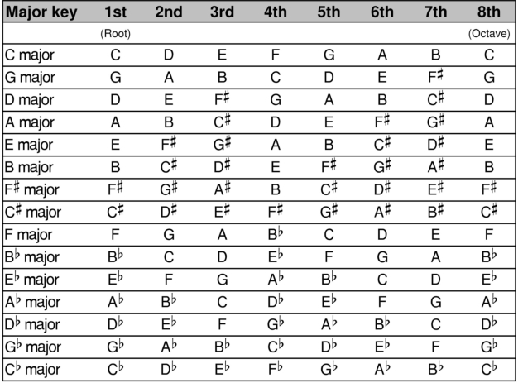

<http://www.guitar-book.com/key-signatures.htm>

Figure 2:

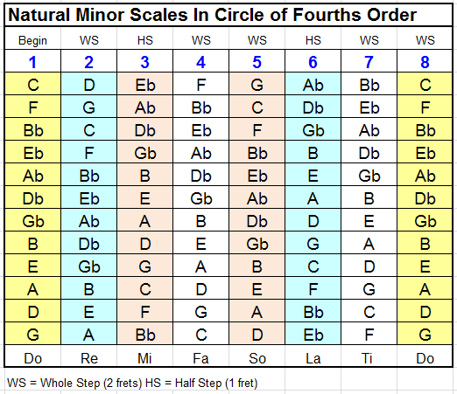

<http://www.pinsdaddy.com/major-and-minor-scales-bass_PrHufolSyMoyiDYRYWmLVxiHqaR%7CkLcaCypFTqUhtVM/>

Figure 3:

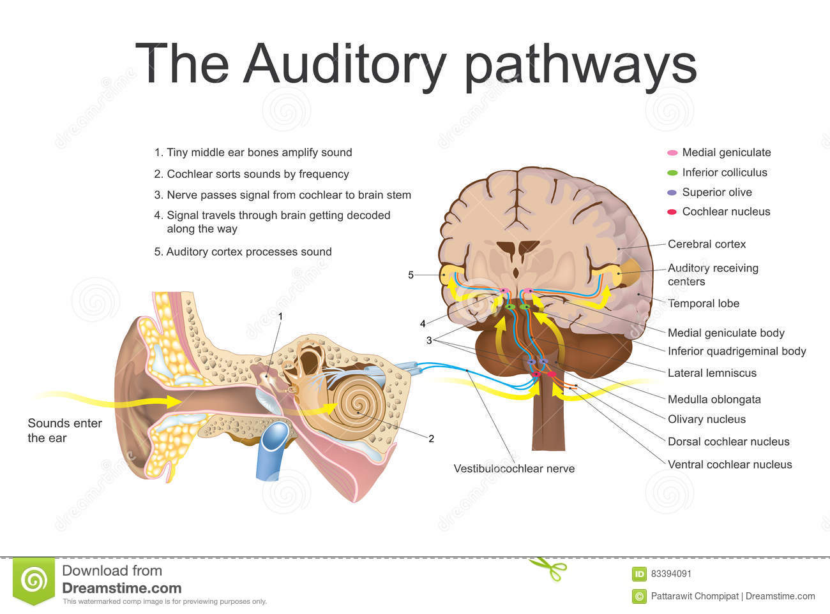

<https://www.dreamstime.com/stock-illustration-auditory-pathways-system-sensory-system-sense-hearing-includes-both-sensory-organs-ears-image83394091>