Victoria Bartolotta  
CSC 341 Database  
Fall 2019  
Course Project

**Application domain:**

The Reptile Cabin is a small reptile boarding business located in Willimantic, CT. The Reptile Cabin offers daycare and overnight boarding for pet reptiles. Some pets they accept include bearded dragons, leopard geckos, chameleons, turtles, snakes, Chinese water dragons, crested geckos, and other reptiles. A list of acceptable reptile species is available, even if that specific species has never been to The Reptile Cabin before. Reptile name, environment type, and high and low temperatures are also kept in the database. Customers can leave specific notes and information about their pets, if needed. The Reptile Cabin keeps track of their customer and pet information, including customer name, phone number, and address. Customer information is needed so the pet owner can be contacted in case of emergency or if any questions come up. Necessary information about the pet includes name, reptile species, and owner (customer) information. Reptile age is also recorded but not necessary.

The store keeps track of which pets are overnight and which are just reptile daycare. The end of a visit is initiated when a customer comes to pick up their pet and payment is due. Customers pay for the services when they pick up their pet at the end of their stay and the date / time of payment is recorded. Each pet visit is kept track of in the system so the business can see how often people bring their pets and serves as a transaction record. A visit is initiated when a customer makes a reservation to bring their pet into The Reptile Cabin. Each visit includes the start date and estimated time of pet drop-off, and when the pet parent is returning to pick-up their reptile with an estimated time of arrival.

**Reporting requirements:**

Reward Program

The Reptile Cabin wants to keep track of which customers have brought their pets in multiple times for overnight boarding. A list consisting of the customer name, pet name, and phone number must be created to keep track of these customers for special rewards and promotions.

Most Frequent Reptile

The owner of The Reptile Cabin is interested in keeping track of which reptile types are most common customers. In order to do this, a list is made with the most common reptile type and the number of this type of pet that are brought into the shop.

Current Pets

Management is responsible for creating a list of the pets that are staying overnight and just there for reptile daycare. The list consists of reptile name, species, visit type (overnight or daycare), high and low temperature, owner name, owner phone number, estimated pick up date and time, and any comments or special requests from the customer. Pets being picked up last will be displayed first.

**ER Diagram:**

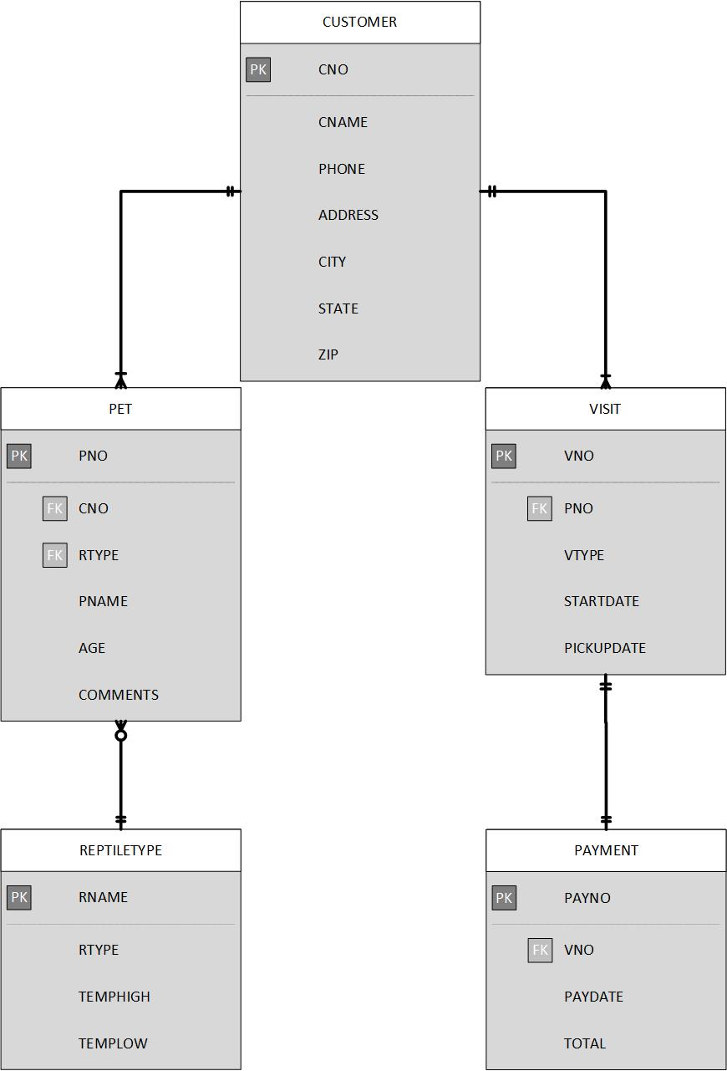

**Data dictionary:**

|  |  |  |  |  |  |
| --- | --- | --- | --- | --- | --- |
| **Table** | **Column** | **Data Type** | **Required** | **Description** | **Example** |
| CUSTOMER | CNO | CHAR(3) | Y | Primary key of table, customer ID #. | 009 |
| CUSTOMER | CNAME | VARCHAR2(30) | Y | Customer name. | John Smith |
| CUSTOMER | PHONE | VARCHAR2(10) | Y | Customer phone number. | 860-555-7755 |
| CUSTOMER | ADDRESS | VARCHAR2(30) | Y | Customer address. | 15 Walnut St |
| CUSTOMER | CITY | VARCHAR2(20) | Y | City of customer address. | Willimantic |
| CUSTOMER | STATE | CHAR(2) | Y | State of customer address. | CT |
| CUSTOMER | ZIP | CHAR(5) | Y | Zip code for customer address. | 06226 |
| PET | PNO | CHAR(3) | Y | Primary key of table, pet ID #. | 011 |
| PET | CNO | CHAR(3) | Y | Pet owner # number. Relationship to CUSTOMER table. | 009 |
| PET | RTYPE | VARCHAR2(20) | Y | Reptile type. Relationship to REPTILETYPE table. | Leopard gecko |
| PET | PNAME | VARCHAR2(20) | Y | Reptile name. | Waffles |
| PET | AGE | CHAR(2) | N | Pet’s approximate age. | 03 |
| PET | COMMENTS | VARCHAR2(150) | N | Any comments about pet. | Only eats live crickets |
| REPTILETYPE | RNAME | VARCHAR2(20) | Y | Primary key of table, reptile species name. | Bearded dragon |
| REPTILETYPE | RTYPE | VARCHAR2(9) | Y | Reptile environment type: desert or tropical. | Desert |
| REPTILETYPE | TEMPHIGH | CHAR(3) | Y | Highest ideal daytime temperature for reptile species. (°F) | 110 |
| REPTILETYPE | TEMPLOW | CHAR(3) | Y | Lowest ideal daytime temperature for reptile species. (°F) | 080 |
| VISIT | VNO | CHAR(3) | Y | Primary key of table, visit ID #. | 007 |
| VISIT | PNO | CHAR(3) | Y | Pet ID #, relationship to PET table | 011 |
| **Table** | **Column** | **Data Type** | **Required** | **Description** | **Example** |
| VISIT | VTYPE | VARCHAR2(9) | Y | Visit type: overnight or daycare. | overnight |
| VISIT | STARTDATE | DATE | Y | Visit start date: scheduled date for pet drop off and time. | 01-JAN-2019 11:45 |
| VISIT | PICKUPDATE | DATE | Y | Pet pickup date at end of visit and estimated time. | 01-JAN-2019 06:30 |
| PAYMENT | PAYNO | CHAR(3) | Y | Primary key of table, payment ID #. Signals end of visit. | 015 |
| PAYMENT | VNO | CHAR(3) | Y | Visit ID #, relationship to VISIT table. | 007 |
| PAYMENT | PAYDATE | DATE | Y | Date and time of payment. | 31-OCT-2018 05:45 |
| PAYMENT | TOTAL | CHAR(3) | Y | Total cost of visit. ($) | 125 |

**Tables:**

Underlined – Primary key

Italicized – Foreign key

1. CUSTOMER – contains personal information about Reptile Cabin customers. (Customer ID #, customer name, address, city, state, zip, phone number)
2. PET – personal information about customer’s pets brought into the business. (Pet ID #, *customer ID #, reptile type,* pet name, age, comments)
3. REPTILETYPE – information about reptile species accepted at the Reptile Cabin. (Species name, species type [desert / tropical], high temperature, low temperature)
4. VISIT – contains information about pet’s visit at the Reptile Cabin. Visit is initiated when customer creates reservation to bring pet in. (Visit ID #, *pet ID #,* visit type [overnight / daycare], scheduled drop off date/scheduled drop off time, estimated pickup date/estimated pickup time)
5. PAYMENT – all information about payment for visit. Customer initiates end of visit by completing payment at time of pet pickup. (Payment #, *visit ID #*, date of payment/time of payment, total cost of visit)