**PROTOTYPE TECHNOLOGY**

**FOR**

**FUTURE HCI**

**TRISTAN JOHN P. GIRAO**

**BSCS - 3B**

**JOSIE CALFOFORO**

**INSTRUCTOR**

**EMERGING PROTOTYPE TECHNOLOGIES**

**FOR**

**HUMAN-COMPUTER INTERACTION (HCI)**

1. **Projection or Virtual Keyboard**

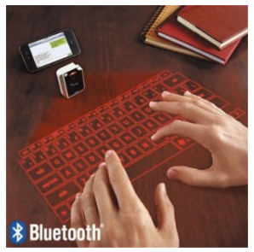

*(http://html.rhhz.net/GJZDHYJSJZZ/20170102.htm)*

**-** Just like traditional keyboard, projection or virtual keyboard human interaction is needed to make this technology work. However, the key difference is that a virtual keyboard doesn’t have a physical keyboard itself but rather the keys are being projected into any flat and smooth surface. Whenever the user tap the projected keys, virtual keyboard has a camera and scanner to capture if a finger is on a projected key and which key was tapped. Then it is processed to be as an input.

1. **Brain signal capturing headset**

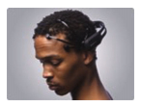

*(http://html.rhhz.net/GJZDHYJSJZZ/20170102.htm)*

**-** Also known as EEG headset, electroencephalography (EGG) is a method used to monitor brain electrical activity. It is mostly used for medical purposes like epilepsy, etc and diagnosing/understanding mental states.

1. **Virtual fitting room**

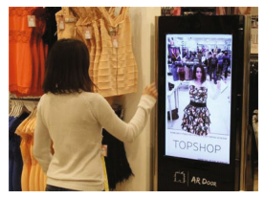

*(http://html.rhhz.net/GJZDHYJSJZZ/20170102.htm)*

- It is a technology that is detecting the shape of a person. Then the captured data is processed into an image which the user can overlap it with a virtual clothing. To fit clothes just like in normal way but virtually.

1. **Smart Glass -**

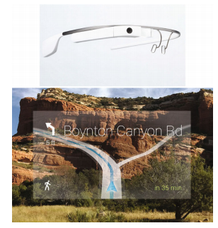

*(http://html.rhhz.net/GJZDHYJSJZZ/20170102.htm)*

Smart glass is using the technology called augmented reality, where virtual and physical objects coincide. Also the users can communicate with the system by voice commands, gesture commands to perform any system-built features.

1. **Ultrasound/Ultrasonic fingerprint sensor -**

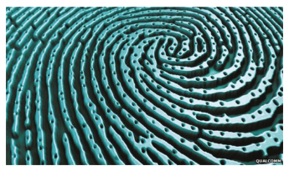

*(http://html.rhhz.net/GJZDHYJSJZZ/20170102.htm)*

Using a transmitter and a receiver the device transmits an ultrasonic pulse towards the finger that is placed over the scanner of the device. A sensor/scanner the serves as the receiver captures the returning pulses and detect the mechanical stress to be processed as a fingerprint.

1. **Nervous system or brain controlled robotics**

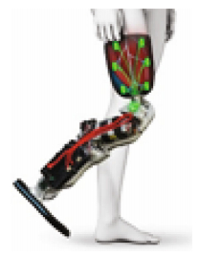

*(http://html.rhhz.net/GJZDHYJSJZZ/20170102.htm)*

**-** This technology is using brain-computer interaction (BCI) strategy to work. BCI works almost the same as EEG headset, inputs from BCI that carrying informative neural features, is being captured and recorded by electrodes. Then by using algorithms these inputs are translated into command to control a device.

1. **Bio Stamp**

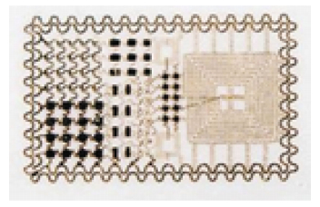

*(http://html.rhhz.net/GJZDHYJSJZZ/20170102.htm)*

**-** Bio Stamp is a monitoring device that real-time checks the user’s health holistically. Such as body temperature, heart rate, exposure to UV rays, hydration, and etc. Because of its very thin electronic mesh design, the user won’t even feel a thing while it is on the skin of a person as it stretch and bend with the skin.

1. **Closed Loop Insulin Delivery System**

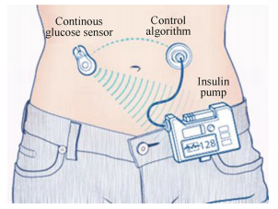

*(http://html.rhhz.net/GJZDHYJSJZZ/20170102.htm)*

**-** Referred as artificial pancreas, is an emerging treatment for a person that has type 1 diabetes. It checks the sugar level of a person in real-time. And if the sugar level is goes abnormal, the device injects insulin inside the body of the patient without any human assist.

1. **Real-time natural language translation tools**

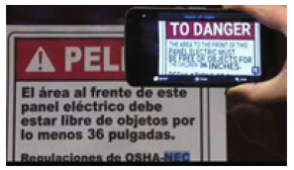

*(http://html.rhhz.net/GJZDHYJSJZZ/20170102.htm)*

**-** It is a device that translates the text or speech from a certain language to the desired language. With the use of different artificial intelligence technologies and machine-learning algorithms, the device’s AI is finding the pattern from the text or speech it is supposed to translate. And translate it to the language it thinks what the message means.

1. **Bionic Contact Lens**

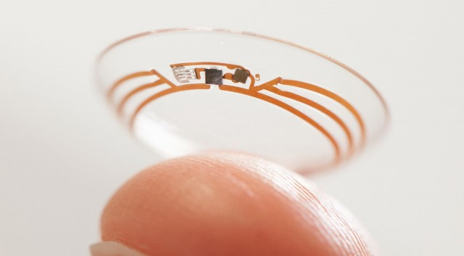

*(https://www.extremetech.com/extreme/180571-google-invents-smart-contact-lens-with-built-in-camera-superhuman-terminator-like-vision-here-we-come)*

**-** This lens is being inserted into the eyes which gave the user whatever ability the device offers. It is even said that with this device a person can see as better as 3x than 20/20 vision.