Untitled

catoro

Tuesday, April 28, 2015

Here are the first few lines of data

## country continent year lifeExp pop gdpPercap  
## 1 Afghanistan Asia 1952 28.801 8425333 779.4453  
## 2 Afghanistan Asia 1957 30.332 9240934 820.8530  
## 3 Afghanistan Asia 1962 31.997 10267083 853.1007  
## 4 Afghanistan Asia 1967 34.020 11537966 836.1971  
## 5 Afghanistan Asia 1972 36.088 13079460 739.9811  
## 6 Afghanistan Asia 1977 38.438 14880372 786.1134

All data

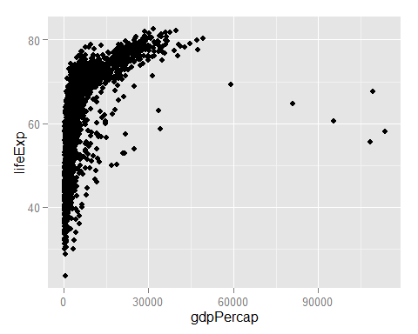

This gapminder data has 1704 and 6 columns

A summary of the GDP growth for Chile

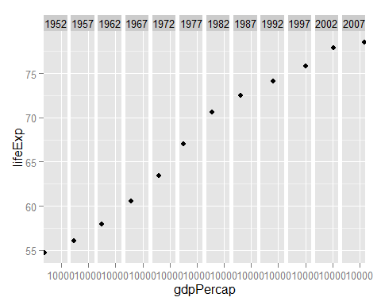

I get that the avg life for Chile is 67.4309167 or 67.4