Strategy Refinement — Bake-off Findings & Recommendation
GSD2T Asset Management · ESADE Asset Management · internal research memo
All performance SIMULATED, monthly, 2002–2026, net of 15 bps trading costs, GROSS of fund fees. Sharpe is excess-of-risk-free. IS = in-sample 2002–2015; OOS = out-of-sample 2016–2026.

1. Objective
The team asked two questions: (a) can we put the de-risked 'cash' sleeve to work, and (b) are there weighting or signal changes that improve risk-adjusted performance while keeping a defensible, literature-backed narrative. We ran two controlled bake-offs on the live monthly engine, holding everything else fixed and changing one design choice at a time, and judged each on out-of-sample Sharpe (not in-sample, to avoid rewarding overfitting).

2. Test 1 — Variant bake-off (how we found V1)
Starting from the current strategy (V0: equal-weight top-quartile momentum, macro overlay, cash sleeve), we tested four ideas: a productive defensive sleeve, inverse-volatility weighting, an asymmetric overlay (less cash in calm regimes), and different concentration levels.
Variant | CAGR | Vol | Sharpe | Max DD | Alpha (t) | IS Shp | OOS Shp | Cash
V0 Baseline (current) | 12.3% | 10.9% | 1.03 | -26% | +3.7% (3.9) | 0.98 | 1.09 | 34%
V1 Defensive sleeve | 14.9% | 11.9% | 1.15 | -21% | +6.3% (4.8) | 1.16 | 1.14 | 34%
V2 Inverse-vol weighting | 10.1% | 9.8% | 0.94 | -25% | +2.2% (2.4) | 0.94 | 0.94 | 34%
V3 Asymmetric overlay | 15.6% | 13.8% | 1.05 | -28% | +4.9% (3.6) | 1.03 | 1.08 | 17%
V4a Concentration q=0.10 | 15.1% | 13.4% | 1.05 | -29% | +4.9% (3.7) | 0.99 | 1.13 | 34%
V4b Concentration q=0.33 | 11.8% | 10.3% | 1.05 | -26% | +3.5% (4.0) | 1.01 | 1.09 | 34%
V5 Combined (asym+iv+def) | 14.3% | 13.1% | 1.01 | -24% | +4.5% (2.9) | 1.05 | 0.96 | 17%
S&P 500 (SPY) | 10.0% | 15.1% | 0.65 | -51% | — | 0.40 | 0.97 | 0%
Findings:
- V1 Defensive sleeve is the clear winner. Instead of holding cash when the overlay de-risks, the sleeve earns a Treasuries+gold basket (TLT/GLD, IEF early). It beats the baseline on every metric — higher return (14.9% vs 12.3%), higher Sharpe (1.15 vs 1.03), SMALLER drawdown (−21% vs −26%) — and improves both in- and out-of-sample. In equity crashes (2008, 2020) Treasuries rally exactly when stocks fall, adding convexity.
- Inverse-vol weighting hurts: it lowers both return and Sharpe (0.94). Momentum returns concentrate in higher-volatility winners, which risk-parity weighting tilts away from. Rejected.
- Asymmetric overlay & concentration raise return by holding less cash / concentrating, but drawdown worsens and Sharpe barely moves (~1.05). Return dials, not free lunches — they trade away the risk differentiator.
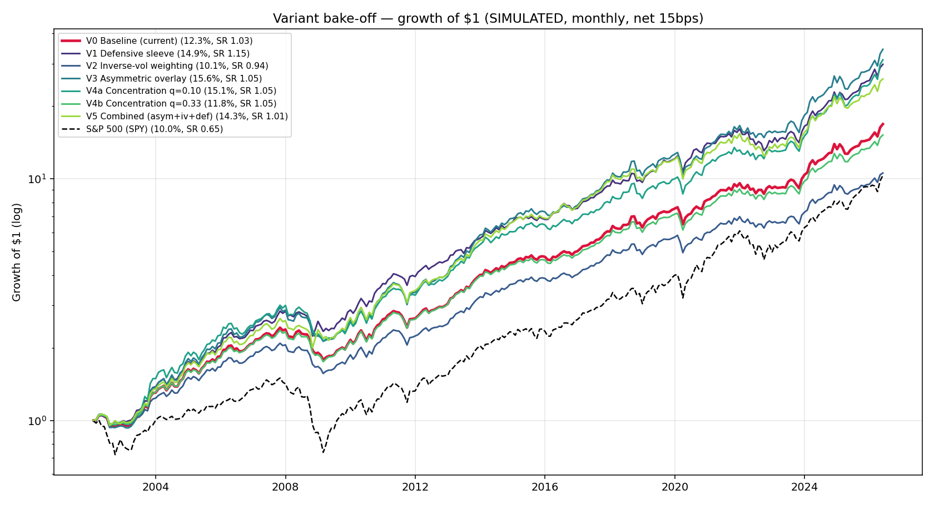
Test 1 — growth of $1 across variants (SIMULATED). V1 in red.

3. Test 2 — Improvements bake-off (layered on V1)
We then tried to improve on V1 with four literature-backed enhancements, judged on out-of-sample Sharpe: risk-managed momentum (Barroso & Santa-Clara 2015), volatility targeting (Moreira & Muir 2017), a defensive (low-beta) momentum tilt (Betting-Against-Beta), and a quality-momentum composite. Note: true fundamental quality needs point-in-time data, so we used an honest price-based quality proxy (low volatility + return stability) and label it as such.
Variant | CAGR | Vol | Sharpe | Max DD | Alpha (t) | IS Shp | OOS Shp | Cash
V1 Defensive (reference) | 14.9% | 11.9% | 1.15 | -21% | +6.3% (4.8) | 1.16 | 1.14 | 34%
W1 Risk-managed momentum | 13.9% | 11.4% | 1.12 | -20% | +6.6% (4.2) | 1.13 | 1.11 | 43%
W2 Volatility targeting | 13.5% | 11.3% | 1.10 | -21% | +6.4% (4.2) | 1.12 | 1.08 | 43%
W3 Defensive-mom tilt | 13.6% | 10.9% | 1.14 | -19% | +5.8% (4.1) | 1.21 | 1.05 | 34%
W4 Quality-momentum (proxy) | 13.4% | 11.0% | 1.12 | -19% | +5.3% (4.0) | 1.18 | 1.05 | 34%
W5 Combined (RM+qual+def) | 12.5% | 10.6% | 1.07 | -20% | +5.7% (3.5) | 1.13 | 1.01 | 43%
S&P 500 (SPY) | 10.0% | 15.1% | 0.65 | -51% | — | 0.40 | 0.97 | 0%
Findings — none of the enhancements beats V1 out-of-sample, and that is a useful result:
- V1 has the highest out-of-sample Sharpe of every variant (1.14). No enhancement improves it.
- Risk-managed momentum & vol targeting are redundant with the macro overlay, which already de-grosses in stress. A second volatility-based scaler just de-risks twice — average cash rises 34%→43% and returns fall with no Sharpe gain.
- The low-beta tilt & quality proxy overfit: better in-sample (IS Sharpe 1.21 / 1.18) but worse out-of-sample (1.05 / 1.05) — the textbook in-sample-up / out-of-sample-down signature. Rejected.
- The combined variant (stacking everything) is the worst of the enhanced set — complexity actively hurt.
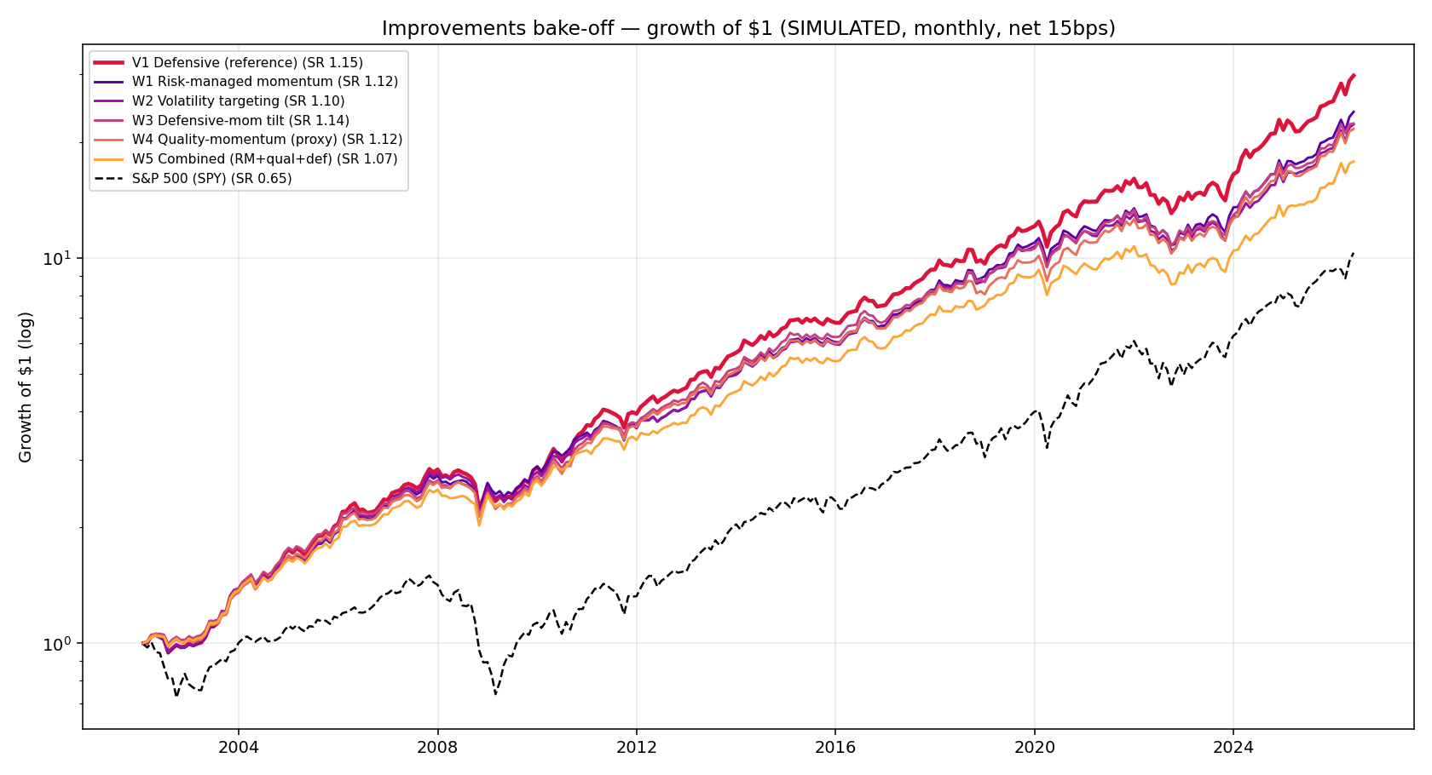
Test 2 — enhancements layered on V1 (SIMULATED). V1 reference in red.

4. Recommendation
Adopt V1 (defensive sleeve) as the flagship and stop layering.
- V1 is a strict improvement on the current strategy and strengthens the narrative: we rotate into convexity (Treasuries + gold), not idle cash, when the overlay de-risks.
- No further enhancement survives out-of-sample, so the parsimonious design is the right one. We tested the standard literature additions and kept the simple version by evidence, not by default — a credibility point for the pitch, and direct evidence of anti-overfitting discipline.
- Fundamental quality (ROE/profitability) is the only idea not tested 'for real'; given the price proxy already overfit, we do not expect it to change the verdict, and it would require a Bloomberg fundamentals pull.

5. Honest caveats on V1 (to disclose)
- The headline alpha (+6.3%) is overstated: our FF5+Momentum model has no bond/gold factor, so the defensive sleeve's returns appear as alpha. The honest wins are the Sharpe and drawdown improvements.
- Regime dependence: the sleeve relies on bonds+gold being defensive. 2022 broke that (bonds fell with stocks), though V1's out-of-sample period — which includes 2022 — still beats the baseline. Gold diversifies this risk. Part of the historical benefit came from a multi-decade bond tailwind that will not fully repeat.
- Returns are net of trading costs but gross of fund fees and taxes; investor-net is lower.
Disclaimer: Fictional pitch for the ESADE Asset Management course. Not investment advice. All performance is simulated; past performance does not indicate future results.

