Before you start:

Our program requires Microsoft Message Queuing (MSMQ) in order to run programs that you make using our software. Follow these simple steps to ensure that our program runs smoothly on your computer.

To install Message Queuing 4.0 on Windows 7 or Windows Vista

1. Open **Control Panel**.
2. Click **Programs** and then, under **Programs and Features**, click **Turn Windows Features on and off**.
3. Expand Microsoft Message Queue (MSMQ) Server, expand Microsoft Message Queue (MSMQ) Server Core, and then select the check boxes for the following Message Queuing features to install:
   * MSMQ Active Directory Domain Services Integration (for computers joined to a Domain).
   * MSMQ HTTP Support.
4. Click **OK**.
5. If you are prompted to restart the computer, click **OK** to complete the installation.

Getting started:

1. Open the Executables\Programinator.exe file
2. 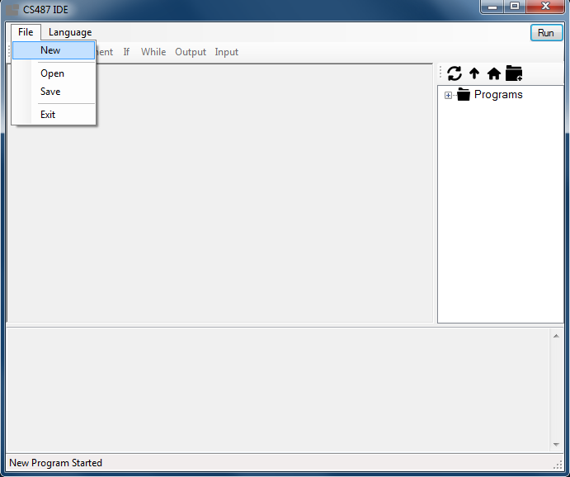To start a new program select File > New
3. This will bring up a window to let you choose the file location to save your program as well as let you select a language. To set a file location click on the ellipses button.

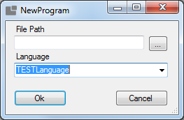

1. After you have selected a file location, choose from one of the three language options and select “Ok”.

The Basics:

Let’s start our first program by performing some simple operations.

1. First let’s create a variable. To create a variable, select the Variable button from the toolbar or press Ctrl+V.

* This will bring up a window where you can specify the name of your variable and select what kind of data type you would like your variable to be.
* Specify a name for your variable, select Integer from the data type menu and select Accept.

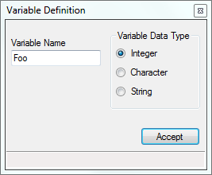

1. Next, let’s assign a value to your integer variable.

* Select the assignment button from the toolbar or press Ctrl+A.
* The assignment window lets you assign values to your variables as well as perform math operations with your variables.
* To assign a number value to your variable, type a number in the ‘Assign’ field and then select your variable name from the drop down list in the ‘To’ field and click ‘Accept’.

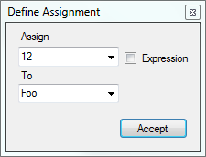

1. Now, let’s use the Assignment window to do some arithmetic with your variable.
   * Begin by opening the assignment window (Ctrl+A).
   * Now this time instead of inputting an integer into the Assign field, click the ‘Expression’ checkbox.

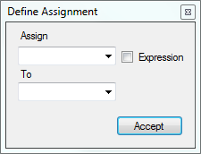

* This will bring up the expression definition window.

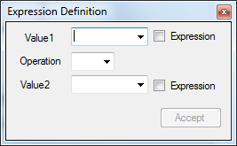

* Here is where you can perform complex expressions using the variables you have created.
* To manipulate your variable, type a number in the Value1 field in which you want to use to add to your existing variable.
* Use the dropdown operation field to select the ‘+’ for addition.
* Lastly, choose your variable from the dropdown in the Value2 field in order to add the value in the Value1 field to your variable and then click Accept.

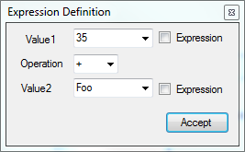

* + This will bring you back to the Assignment window.

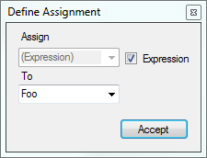

* + Now, you can assign the expression you just created to any variable you have made previously. In this example we have added 35+Foo and we are going to assign it back into our Foo variable so that Foo now equals 47.

1. Next, let’s output our variable Foo.
   * First click on the Output button on the toolbar or press Ctrl+O.
   * The output window allows you to output messages and variables.
   * To output your variable, select variable from the left and then select the variable you want to output with the dropdown box on the right and click ‘Accept’.

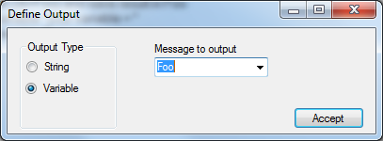

1. Now that we have a simple program finished, let’s try to run our program
   * To run your program simply click the ‘Run’ button in the top right of the program

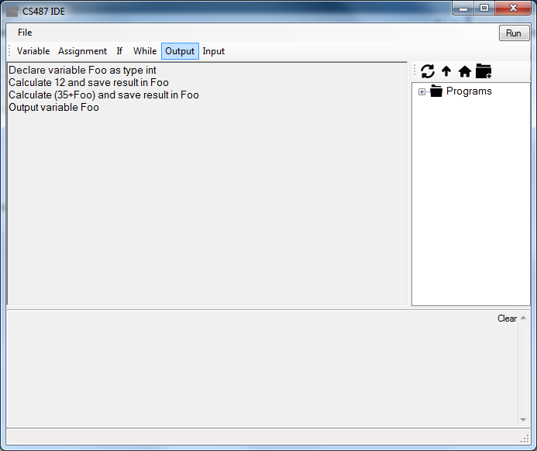

* + Any output in your program will be displayed in the console box whenever you run your program.

Congratulations! You have created your first simple program.

Advanced Operations:

Now that we have covered a few of the basic features, let’s go over some of the more advanced features in the program.

1. First let’s create an ‘If’ statement.
   * To start an ‘If’ statement, click on the ‘If’ button on the toolbar or press Ctrl+B to bring up the If statement window.

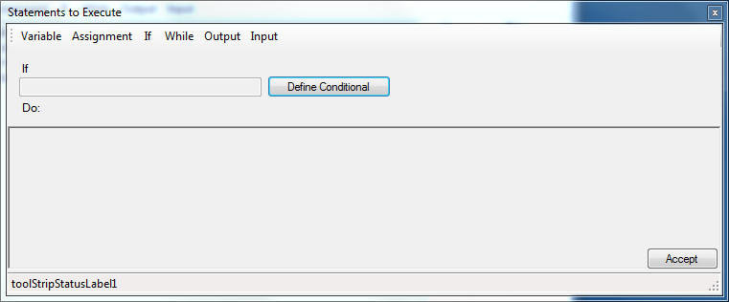

* + In the If statement window, click ‘Define Conditional’ to open up the ‘define conditional’ window.
  + In the define conditional window, you can create a condition in which your if statement will execute. To do this, select your variable in the first field, then select an operator in the second field, and finally choose a number or variable for your last field and click ‘Accept’.

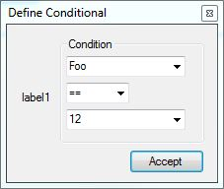

* + This will return you back to the If statement window where your condition will be filled in.
  + Now you can choose what the program will do when the condition is met. The if statement window acts just like the main program window in that it lets you choose any of the main program options to execute during your if statement. This is where you can make your programs really complex.

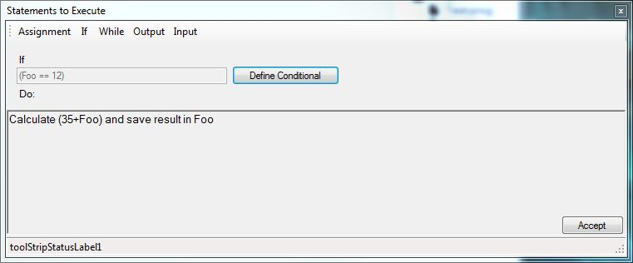

1. Now, let’s try a while loop.
   * To start a while loop click the ‘While’ button or press Ctrl+L to bring up the while loop window.
   * While loops are made exactly like if statements. The only difference is that whatever you put in the ‘Do’ field will keep running until the conditional statement isn’t satisfied.
2. The last button on the toolbar is the ‘Input’ button. This button allows you to ask the user for an input and you can store this as a variable and use it in your program.
   * To open the input window, click the ‘Input’ button or press Ctrl+I.

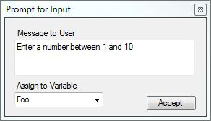

* + In the ‘Message to User’ field, you can instruct the user to input a certain value or string and then you can assign the value to a variable you’ve made previously.

Editing your program:

* + At any point during your program creation you can edit and change different aspects of your program simply by clicking on the section you’d like to change in the main window. This will bring up corresponding window and allow you to make changes. When you’re finished just click to accept to save the changes.

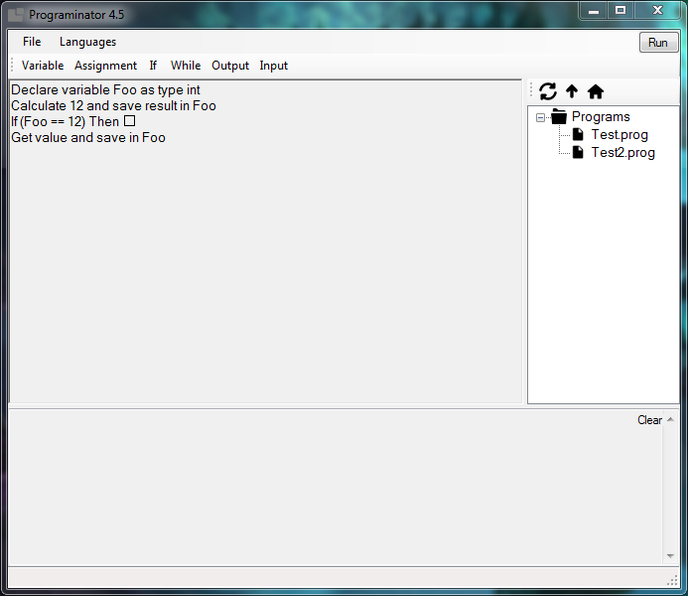

Languages:

* + If you select the ‘Languages’ button from the toolbar, you’ll be able to customize the program to make different buttons available to the user and even change the hotkeys of the different buttons.

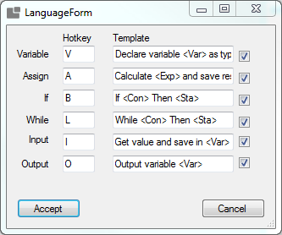

Saving and Loading :

* + The Save option can be found by clicking the ‘File’ button on the toolbar. This will let you save your current program as a .prog file. To resume working on any of your previously made programs, click ‘File’, select ‘Open’ and then find the project you wish to open and select ‘Accept’.