

**Department of Agriculture**

**Regional Feild Unit XIII**

**Online Performance Evaluation System (OPES)**

User Guide/Manual

Version 1.0

01 March 2016

**Table of Contents**

Introduction to OPES.....................................................................................

User Log-in.................................................................................................

Home Page..........................................................................

**Introduction to OPES**

Welcome to OPES!

The Online Performance Evaluation System (OPES) is an information system capable to evaluate the performance of ________________________________________________________.

OPES provides a method for measuring the banner’s performance, identifying strenghts and areas for improvement through a realtime user interface showing a graphical presentation of the current status of MFOs Accomplishment Report.

Exporting the table to PDF and Excel format are also supported in the system.

The link to access the Online Performance Evaluation System is:

<http://opes.caraga.da.gov.ph>

After clicking on this link, please provide the log-in credentials.

**User Log-in**

1. Log-in to the OPES at <http://opes.da.gov.ph>
2. Enter the appropriate information into the **Username** feild.
3. Enter the desired information into the **Password** feild.
4. Click the **Sign In** button.

*There is no sign-up page only the system administrator can register an account. For user account requests or inquiries, you may contact us via email at* ***helpdesk-opes@gmail.com***

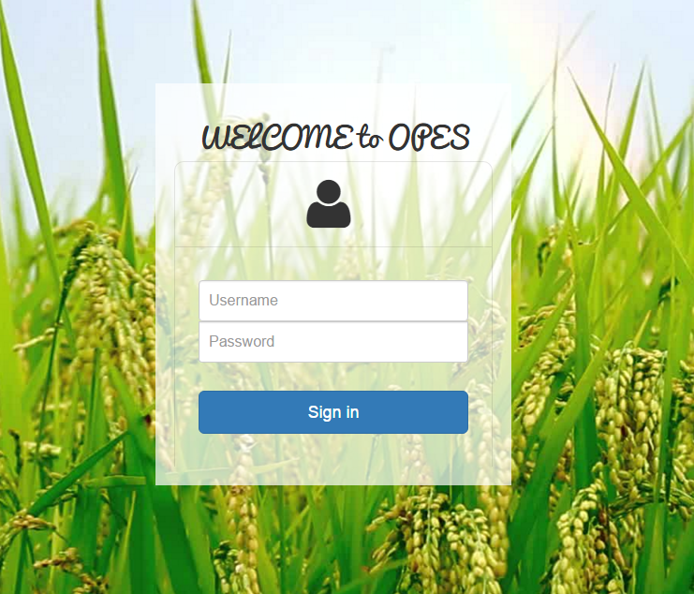

**Home Page**