LAB 1: Cloud services concepts. Introducing Microsoft 365

Contents

How to use the Lab Guides 2

Introduction to LAB 1 2

Exercise 1: Create a new tenant 2

Exercise 2: Subscribe for a trial and assign a license 7

# How to use the Lab Guides

The lab guides in this training are designed to be completed in class or at home. This means that depending on your time and availability, you can accomplish the tasks in each lab either after the corresponding module, use it as a homework or split it for class/homework as you wish. Important is that you are finished with each lab before the date of the next module.

# Introduction to LAB 1

In this first LAB, you will create a new Office/Microsoft 365 tenant, subscribe for a trial subscription and will assign a license to yourself.

# Exercise 1: Create a new tenant

1. Create an email address to associate with your tenant and make sure your phone is close to you for the verifications that will be needed.   
   Note: It is a good practice to take notes of the tenant details like email address(es), tenant name and others (not the passwords, of course)
2. Go to this URL: <https://account.azure.com/organization>

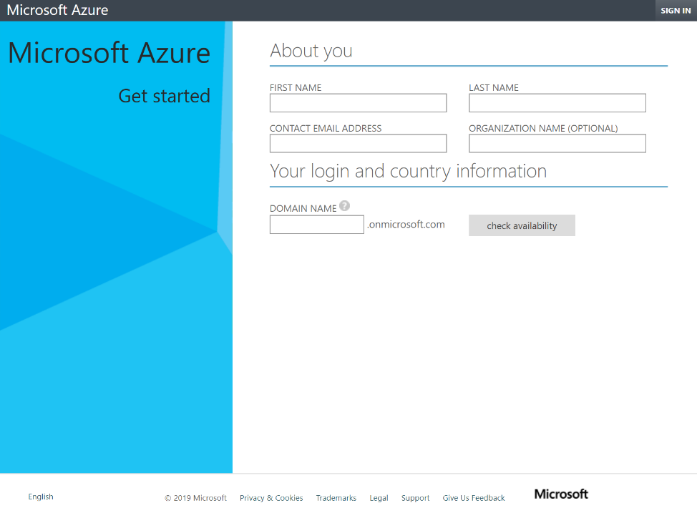

1. Fill in the required data to create your tenant.

Here is an important thing to mention - the DOMAIN NAME section is in the format: ***something*.onmicrosoft.com**. The *something* part should be unique. The second part is always **onmicrosoft.com**. This way, your tenant/domain name will be unique and your users (initially) will be in the format **user@something.onmicrosoft.com**.   
(We will add custom domains and users associated with them in the second module)

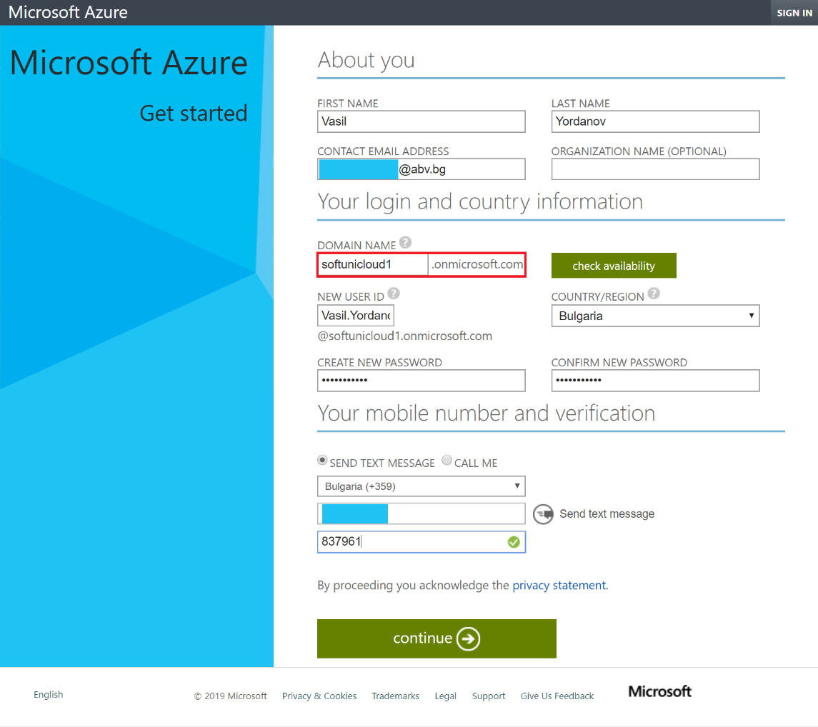

Verify your phone number and click Continue

1. What happened now is that your tenant has been created but the wizard opens a new window (see the screenshot below) to subscribe for Azure services. You should already now (from the presentation) the relation between Azure and Office/Microsoft 365 – you only want Office/Microsoft 365 tenant, which means that you are still going to use Azure Active Directory, but you do not need these Azure services now, so please just close that window.

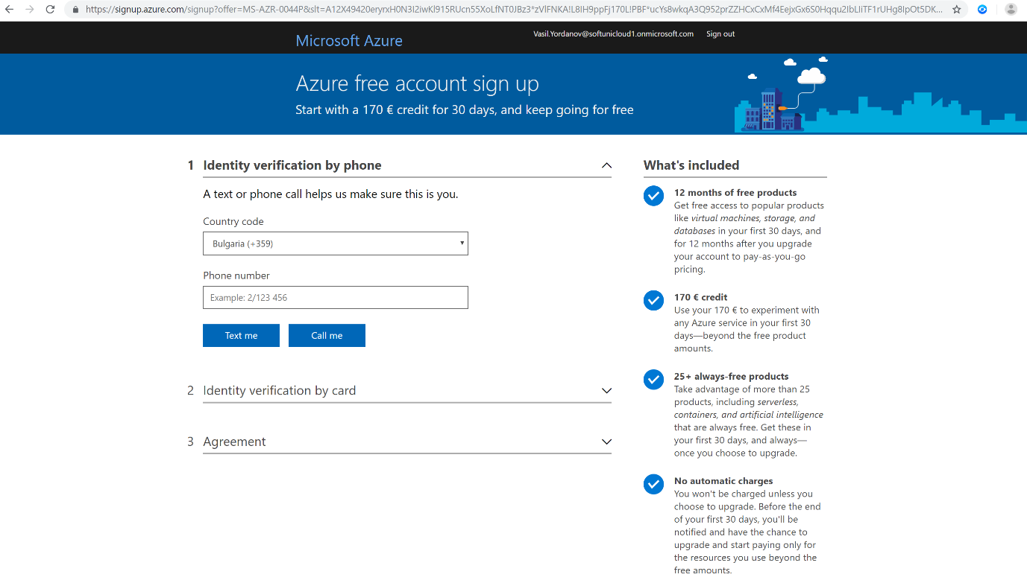

1. Log in to <https://portal.office.com> and enter the account you created in the previous step

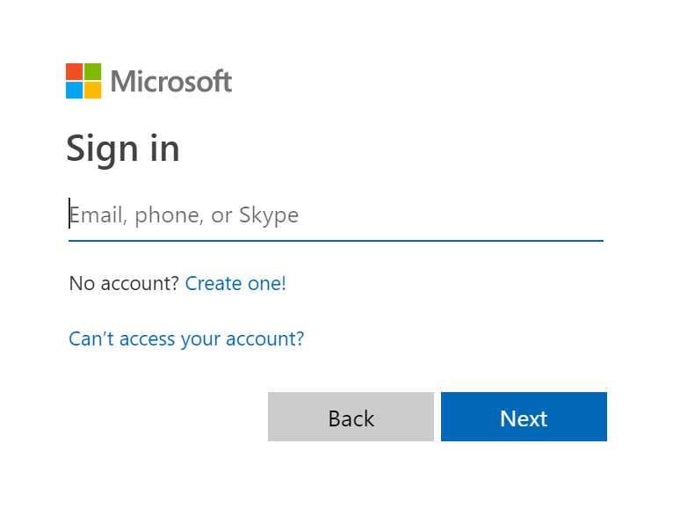

1. Congratulations! You are now logged in your new tenant. Click Admin. If you see a Welcome to the Microsoft 365 Admin Center pop-up message, click on Skip

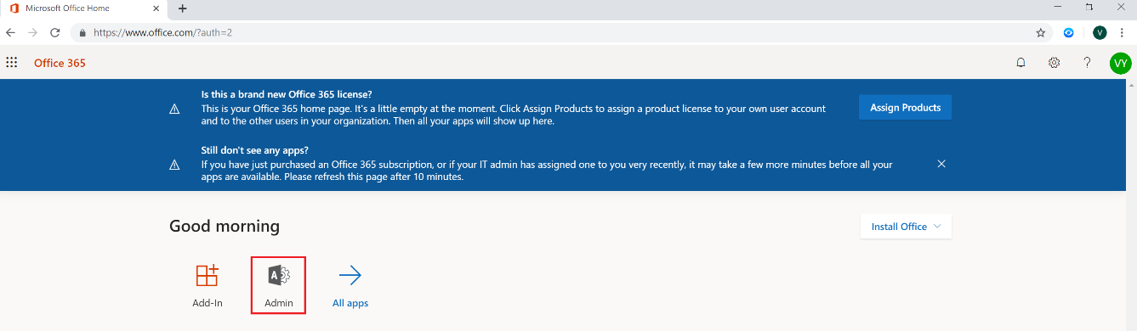

1. From the navigation menu on the left side, click on Users -> Active Users. You should see a single user, the one that you have created previously in the form, with status “Unlicensed”

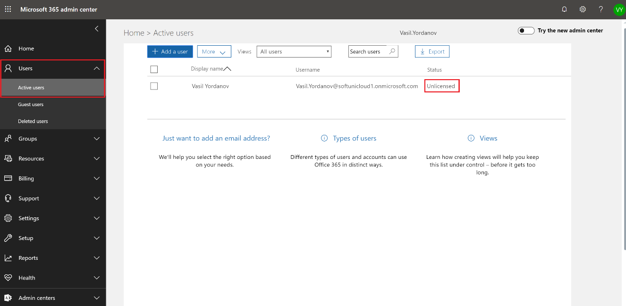

1. Click on this user and observe the fields Username, Product licenses and Roles. Note that this user does not have any licenses and in the same time it is has the highest possible privilege – **Global administrator**

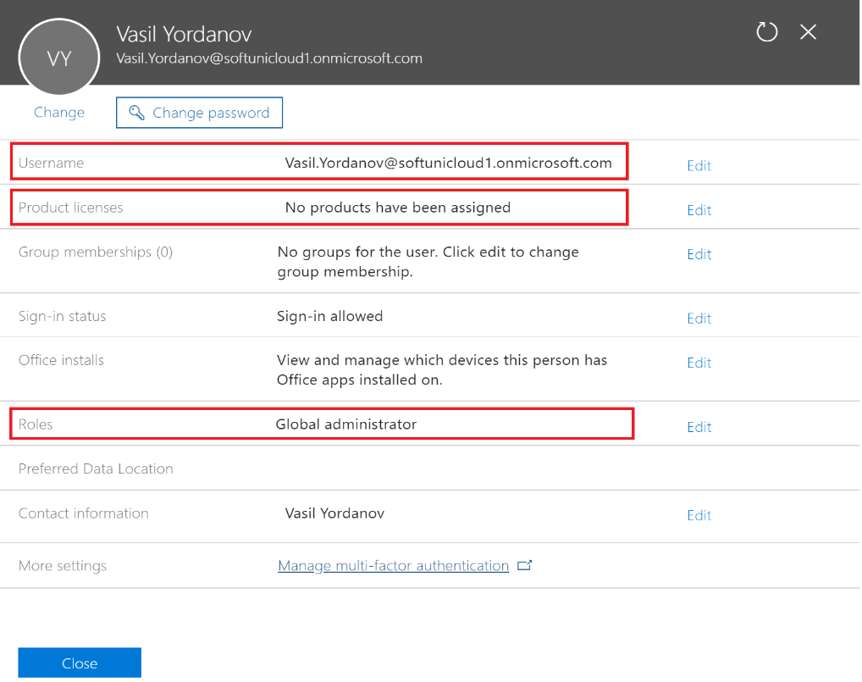

Note: There is a slider in the upper left corner, saying Try the new admin center which gives you slightly different interface. Please turn this ON. The screenshots and instructions from now on will be based on the new admin center

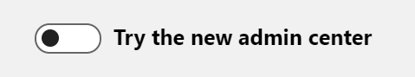

# Exercise 2: Subscribe for a trial and assign a license

Now we have our tenant but we need to assign licenses for our users so they can start using the services offered by Office/Microsoft 365. In order to be able to assign licenses, we first need a subscription. We will add a trial subscription for **Microsoft 365 E5**.

1. In the left navigation menu, Go to Billing -> Purchase services and find **Microsoft 365 E5**. Then click in the Microsoft 365 E5 box

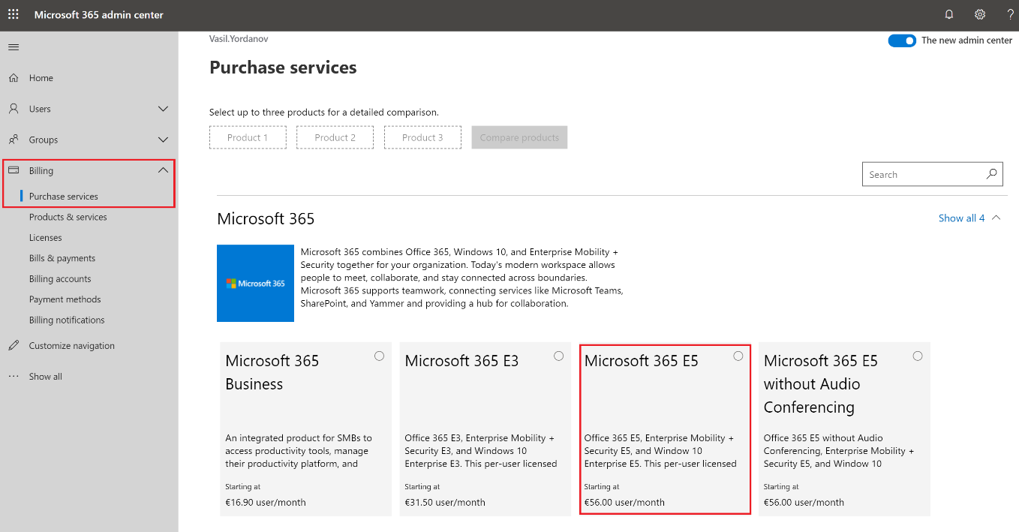

1. You can have a look at what is included in this subscription. Click on the Get free trial button

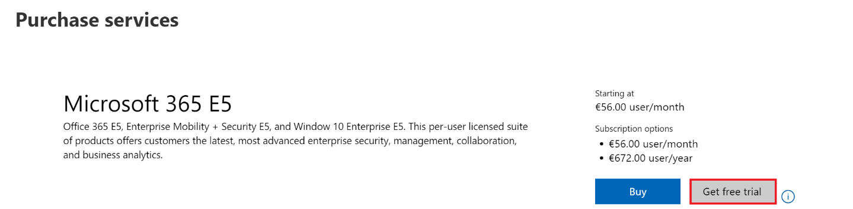

Note: This trial includes a maximum of 25 licenses for a term of 1 month

1. Confirm with a message to your phone and click what you are asked to start your trial. Finally, in the order receipt section, click Continue

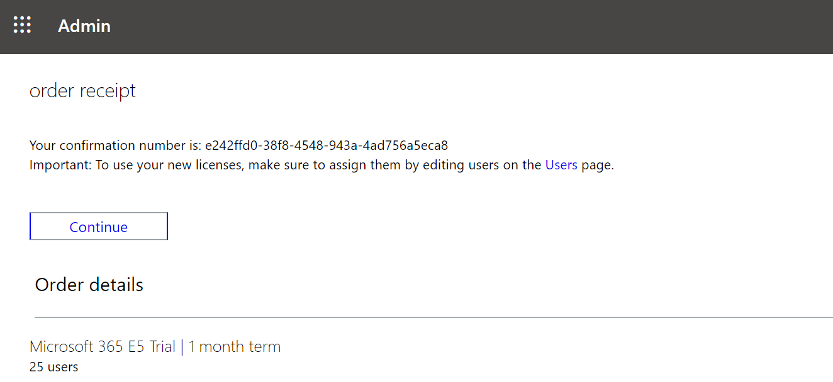

1. You can confirm the successful subscription by going to Billing -> Products & services and look into your subscription details – you can see the number of licenses (free/used) and the expiration date

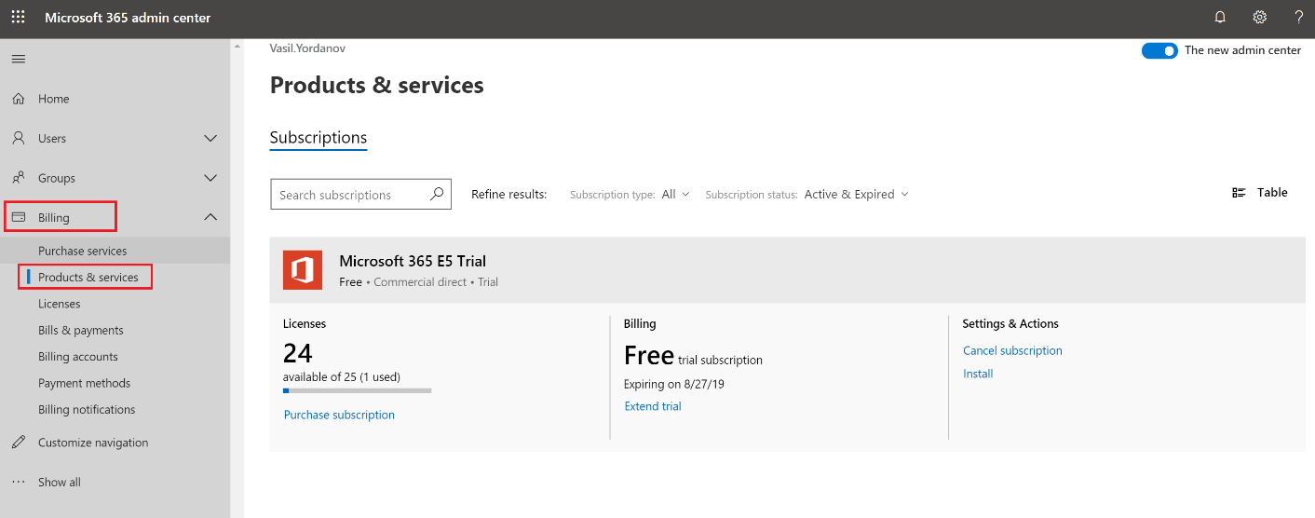

Note: As you can see, the trial subscription is valid for a month. Since the duration of this training is more than a month, we have two options:

1. To create another tenant with trial subscription when this one expires (and possibly migrate the resources)
2. To extend your trial. This option extends with one more month and requires providing your credit/debit card information – it will not charge you, it just needs your card details. Please note that after the extended period finishes, the portal may automatically charge you for the next billing period, so it is important to remove your credit/debit card information from the payment methods before this moment. Please do not extend your trial at this moment and do not put any payment information, this can be done later in the course.
3. Assign a license to yourself.   
   As you remember, your user did not have a license. There is a chance that while adding the subscription, a license (**Microsoft 365 E5**) was automatically assigned to your user, so first check this – go again to Users -> Active Users and see if you are already assigned a license, like on the picture below

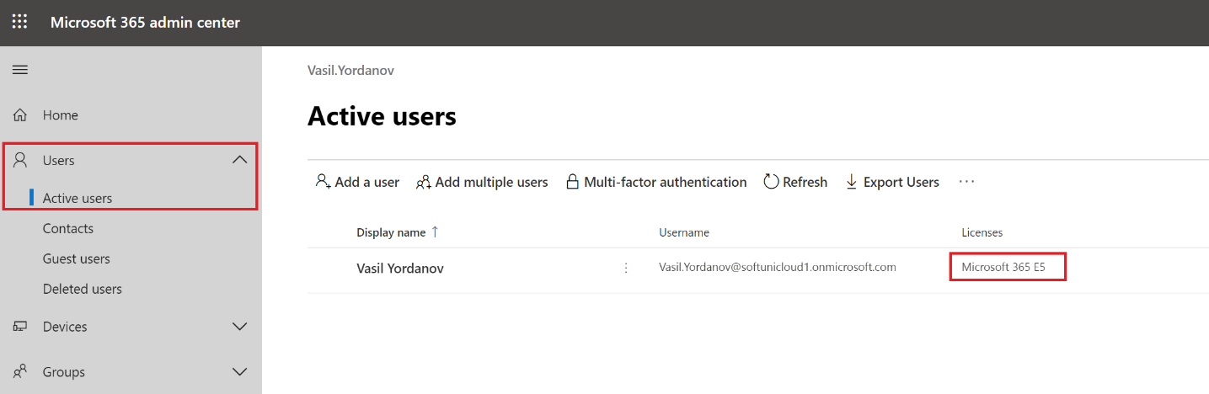  
  
If not, assign it manually. Go to Users -> Active users and click on the username of the user in your tenant. Then go to Licenses and Apps section, select your location and assign one of the **Microsoft 365 E5** licenses by clicking the checkbox. Then save your changes

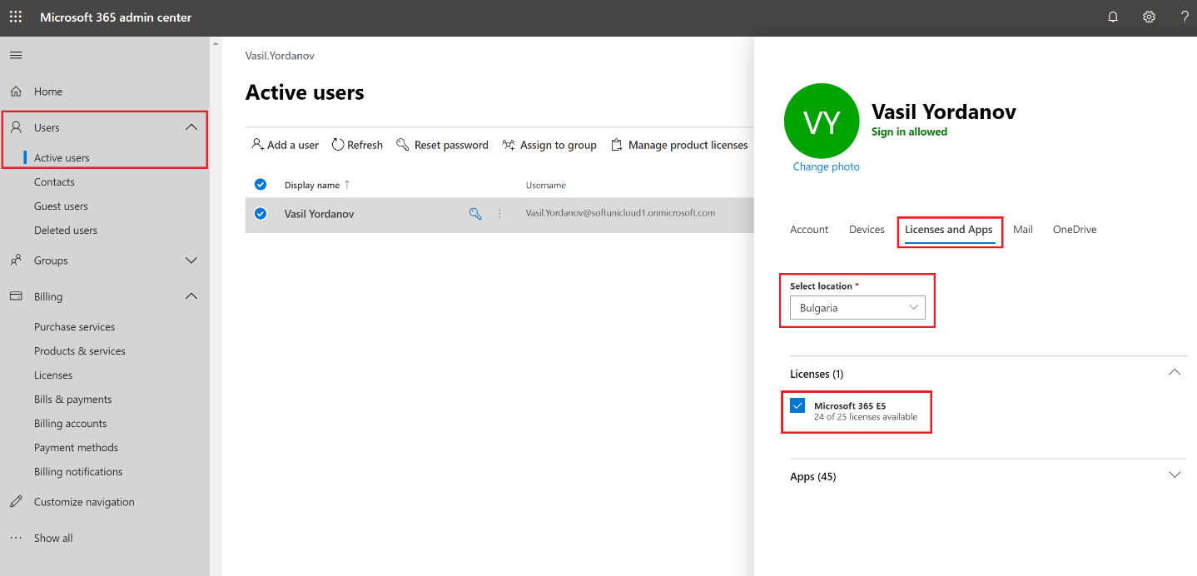

1. Test your license.  
   When you assign a license to a user account, it may take a while (several minutes) for the user’s mailbox to be built. In this situation, since you are assigning a license to yourself, you need to sign out and sign in again to reflect these changes. Because of this:
   1. Sign out from the upper right corner and close your browser
   2. Open your browser again, go to <https://portal.office.com> and sign in with your username and password.

Have a look into your home page now. It is different, because it has all these apps (Outlook, OneDrive, Word, Excel, etc.). This means that your license is applied correctly, and you can use the services now. Also, pay attention that you still have the Admin icon available – this is because you are still a Global administrator for your tenant

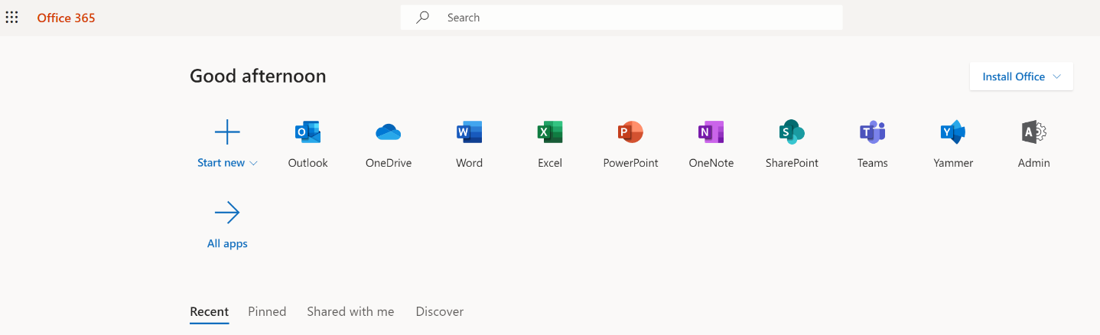

1. Configure your time zone and test the Outlook app  
   Click on the **App launcher** button (the “dots”) in the upper left corner and select Outlook:

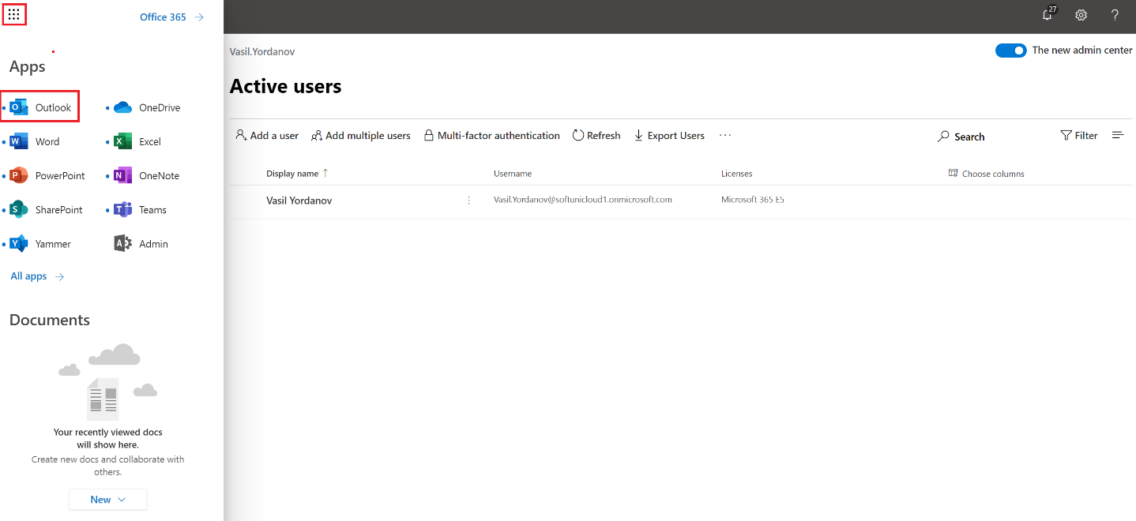

Then choose your desired display language and time zone:

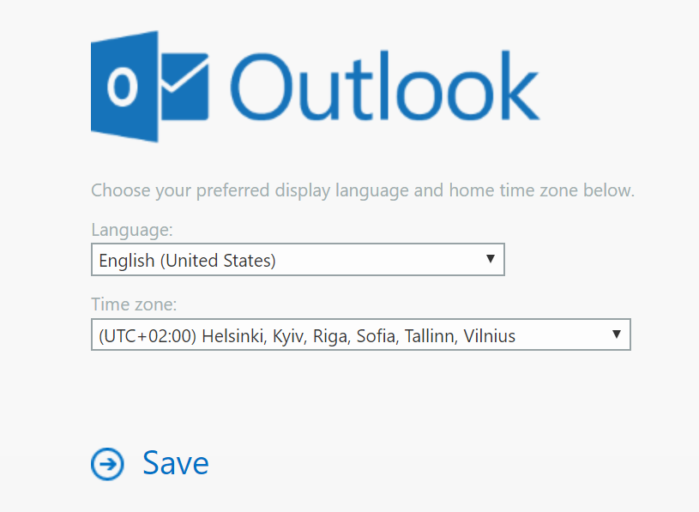

When done, explore your WEB Outlook and try sending “from” and “to” your email account. Remember that at this point, your email address is in the format **user@something.onmicrosoft.com**

Note: For security reasons, it is not a best practice to log in and use the Office/Microsoft 365 services as a user while this user is a global administrator in the same time. Later in the course, when you add a custom domain in the tenant and create different users, you can change this.

You have completed LAB 1.