CalbayogGO: WEB-BASED TRAVEL APP

A Capstone Project
Presented to

The Faculty of the College of Computing and Information Sciences
NORTHWEST SAMAR STATE UNIVERSITY
Calbayog City

In Partial Fulfillment
of the Requirements for the Degree
BACHELOR OF SCIENCE IN INFORMATION TECHNOLOGY

By

JEO B. FUENTEBLANCA

REYMALYN G. AGARAO

VENCENT CASTILLO

JASON L. DEGUZMAN

MAY 2024

TABLE OF CONTENTS
Title |  | Page
Title Page |  | i
Table of Contents |  | ii
List of Tables |  | iii
List of Figures |  | iv
CHAPTER 1 | INTRODUCTION | 1
 | Project Context | 1
 | Purpose and Description | 2
 | Objectives | 3
 | Scope and Limitations | 4
CHAPTER 2 | REVIEW OF RELATED LITERATURE/SYSTEMS | 5
CHAPTER 3  CHAPTER 4  CHAPTER 5 | TECHNICAL BACKGROUND  METHODOLOGY, RESULTS, DISCUSSION  Requirement Analysis  Requirements Documentation  Design of Software, System, Product, and/or Processes  Implementation Results  RECOMMENDATIONS | 14  22  23  24  32  50  57
REFERENCES  APPENDICES | - Relevant Source Code  - Users Guide  - Certificate of Proofreading  - Certificate of Originality  - Certificate of Acceptance  - Curriculum Vitae | 58  61  75  92  94  96  98

LIST OF TABLES

Table No | Table Name | Page
1 | Software Requirements of CalbayogGO: Web-Based Travel App | 14
2 | Hardware Requirements of CalbayogGO: Web-Based Travel App | 16
3  4  5  6  7  8  9  10  11  12  13  14 | Human Resource Requirements of CalbayogGO: Web-Based Travel App  Functional Requirements for Users  Functional Requirements for Admin  Non-Functionalities Requirements of CalbayogGO: Web-Based Travel App  Data Dictionary of Announcements Table of CalbayogGO: Web-Based Travel App  Data Dictionary of Contents Table of CalbayogGO: Web-Based Travel App  Data Dictionary of Users Table of CalbayogGO: Web-Based Travel App  Data Dictionary of Content Images Table of CalbayogGO: Web-Based Travel App  Data Dictionary of Ratings Table of CalbayogGO: Web-Based Travel App  Data Dictionary of Favorite List Table of CalbayogGO: Web-Based Travel App  Data Dictionary of Favorite List Places Table of CalbayogGO: Web-Based Travel App  Data Dictionary of Login History Table of CalbayogGO: Web-Based Travel App | 18  25  28  31  42  43  45  46  47  48  48  49

LIST OF FIGURES
Figure No | Figure Name | Page
1  2  3  4  5  6  7  8  9  10  11  12  13  14  15  16  17  18  19  20  21 | Gantt Chart of CalbayogGO: Web-Based Travel App  System Architecture of CalbayogGO: Web-Based Travel App  Context Diagram of CalbayogGO: Web-Based Travel App  Data Flow Diagram of CalbayogGO: Web-Based Travel App  Functional Decomposition Diagram of CalbayogGO: Web-Based Travel App  Entity Relationship Diagram of CalbayogGO: Web-Based Travel App  Establish a Comprehensive Database Management System to Manage and Update Content Seamlessly.  Incorporate Map Search to Navigate Certain Location.  Integrate a Travel Tracking Feature to Monitor User Activities.  Provide a Feedback System to Monitor User Feedback.  How to Install and Run the Xampp.  How to Set Up the Application and Database.  Registration and Login of the User.  Content Display and Navigation.  Managing Favorites.  Map Navigation.  User Profile.  Login Phase of Administrator.  User Management.  Content Management.  Announcement Management. | 20  22  34  36  38  40  51  53  54  55  76  77  79  80  82  84  86  88  89  90  90

CHAPTER 1

INTRODUCTION

Project Context
Tourism plays an important role in the Philippine economy. The country boasts of rich natural beauty in its many spectacular beaches, sunny weather and rich biodiversity. More than that, the Philippines’ unique and complex culture, as exemplified by its people, cuisine and lifestyle, attracts many people to visit the country. The Department of Tourism reported a rise in tourism arrivals in Samar areas, with PHP 857.59 million in 2015, PHP1.19 billion in 2016, PHP1.16 billion in 2017, and PHP1.63 billion in 2018 (Amazona, 2020). In 2022, 112,138 travelers were recorded, with 990 foreign travelers and 111,148 domestic travelers (tourism.gov.ph, 2022). Calbayog City, a key tourist destination, promotes and markets various attractions like Tarangban Falls, Malajog Beach, and the Calbayog Zipline. Tourism serves as a foundation for the socio-economic structure of the city, contributing to its local economy, cultural preservation, and overall development. However, challenges such as limited transportation options, unclear signage, and lack of accessible information hinder the maximization of its tourism potential.
Recognizing the importance of effective promotion, accessibility, and information dissemination, the project "CalbayogGO: WEB-BASED TRAVEL APP" aims to create a web-based travel application for travelers to promote tourism in Calbayog City. By providing a centralized platform offering detailed information on attractions, accommodations, transportation, and dining options, the app seeks to enhance the tourist experience while promoting local businesses and boosting the city's economic growth.
The envisioned CalbayogGO app will serve as an indispensable guide for travelers, offering directions, convenience, and ease of navigation through the city's diverse offerings. By showcasing local establishments and attractions, the app aims to broaden their exposure, attract a wider audience, and contribute significantly to the city's overall development and cultural preservation. Embracing technology, the project aims to create a vibrant, user-centric platform that elevates the way travelers interact with Calbayog City, positioning it as a premier destination for exploration and discovery.

Purpose and Description
In response to the expanding tourist business in Samar and the issues experienced by travelers in Calbayog City, the "CalbayogGO: WEB-BASED TRAVEL APP" intends to modernize the tourism experience. With the city's tourist industry acting as a major component of its socio-economic structure, the initiative attempts to harness the power of technology to promote local companies, increase cultural preservation, and encourage economic growth.
The "CalbayogGO: WEB-BASED TRAVEL APP" is a web-based travel app designed to promote Calbayog City's cultural and natural attractions while supporting local businesses. The app aims to provide a structured and convenient way for travelers to explore the city's offerings, especially during the peak summer season. It features GPS tracking for directions and detailed information, transportation options, and attractions.
The app aims to simplify travel logistics and enrich the traveler's experience, contributing to the city's economic prosperity and solidifying its position as a premier destination. The app aims to provide a user-centric and informative platform that enhances the traveler's experience and contributes to the city's economic prosperity.

Objectives
The primary goal of the "CalbayogGO: WEB-BASED TRAVEL APP" project is to develop a comprehensive and user-friendly cross-platform application. The main objectives include:
- Establish a Comprehensive Database Management System to Manage and Update Content Seamlessly.
- Incorporate Map Search to Navigate Certain Location.
- Integrate a Travel Tracking Feature to Monitor User Activities.
- Provide a Feedback System to Monitor User Feedback.

Scope and Limitations
The "CalbayogGO: WEB-BASED TRAVEL APP" project aims to develop a comprehensive and user-friendly cross-platform application, enriching the visibility and accessibility of tourism-related information in Calbayog City.
The app will feature detailed information about attractions, transportation options, dining options, and other relevant data to offer users a comprehensive guide to Calbayog City's tourism offerings that incorporate GPS technology for directions with a structured database system to store and manage the vast array of information within Calbayog City.
However, the project's success depends on widespread distribution and user adoption across different platforms. The effectiveness of the web-app relies on consistent internet access, and the tracking of the infrastructure of local businesses relies on the data that has been given to us by the Tourism Office. Areas with poor connectivity may experience limitations in utilizing certain features. Unforeseen technological faults or glitches may occur during the app's usage. Additionally, continuous monitoring and updates will be conducted to address any unforeseen technological faults or glitches, ensuring the app's reliability and functionality.

CHAPTER 2

REVIEW OF RELATED LITERATURE/SYSTEMS

Included in this chapter are the concepts, methods, completed thesis, and a generalized conclusion. The materials that are included in this chapter aid in familiarizing readers with information that is important to and similar to the current study.
In a study conducted by (M. A. Pavel, et.al, 2021) created a tour planner application to simplify tour planning for individual users based on their budget and travel duration preferences. The application serves as a personalized travel guide, offering detailed information about tourist spots, including weather, transportation, accommodation options, and local guides. This literature review is relevant to the study "CalbayogGO: WEB-BASED TRAVEL APP" as it explores the development of a web-app aimed at enhancing the tourism experience for travelers. The goals of the proposed travel app are aligned with the emphasis on user reviews, comprehensive information about tourist attractions, and personalized tour planning. This study focuses on personalized tour planning features, which can inspire the inclusion of customizable itineraries and budget management tools in the CalbayogGO app. Insights from this study can inform the design of personalized tour planning functionalities within CalbayogGO, enhancing user satisfaction and convenience.
In a study conducted by (Smirnov et.al, 2015) introduces TAIS, an intelligent mobile guide app that makes recommendations for tourist sites based on the user's preferences and current location. Using smart space technology and the Smart-M3 information sharing platform, the application pulls in real-time attractions from Wikipedia, Wikivoyage, and Panoramio, among other online sources. TAIS is a flexible tool for tailored travel advice because of its architecture, which enables scalability and integration of new data sources and services. The concept of TAIS aligns with the objectives of the proposed “CalbayogGO: WEB-BASED TRAVEL APP”. Both applications aim to enhance the tourist experience by providing personalized recommendations and information about attractions. While TAIS focuses on recommending attractions based on user preferences and location, the Travel App can offer similar features tailored to the unique offerings of Calbayog City. TAIS offers personalized tourism recommendations, real-time information extraction, and scalability, making it suitable for the proposed Travel App, which can enhance functionality and adapt to evolving user needs in Calbayog City. TAIS emphasizes smart space technology and real-time data integration, offering insights into advanced features that can enhance user experience in the CalbayogGO app. Concepts from this study can guide the implementation of intelligent recommendation systems and real-time data integration within CalbayogGO, ensuring relevant and up-to-date information for travelers.
In a study conducted by (Ferrara et al., 2021) is to explore the impact of digital technologies on tourism, particularly in the realm of cultural tourism, where immersive and interactive experiences are increasingly sought after. The study focuses on the connections between tourism, cultural heritage, and information and communication technologies (ICT), aiming to assess how tourism applications influence customers' intentions to visit a destination. The research is conducted through the case study of Smart Marca, a mobile tourism app designed to promote cultural tourism in the Fermo area of the Marche Region, Italy. This study is highly relevant to the proposed “CalbayogGO: WEB-BASED TRAVEL APP”. The study demonstrates the significant influence of mobile apps on tourists' intentions to visit destinations, emphasizing the importance of features such as perceived usefulness and ease of use. By leveraging these insights, CalbayogGO can enhance its effectiveness in promoting tourism in Calbayog City by focusing on user-friendly design and providing valuable and immersive experiences for tourists. Additionally, the study highlights the importance of understanding customer preferences and attitudes toward mobile apps, which can inform the development and marketing strategies of the Travel App to attract tourists effectively. This study focuses on immersive experiences and user perceptions, offering insights into designing engaging features that can differentiate CalbayogGO from other tourism apps. Findings from this study can inform the development of immersive and user-friendly features within CalbayogGO, enhancing tourist engagement and satisfaction.

This study conducted by (Kato et al., 2020) was to design, develop, operate, and evaluate a sightseeing spot recommendation system aimed at efficiently supporting tourists while considering their visiting frequencies. The system integrated social networking services (SNSs), Web-geographic information systems (GIS), and recommendation systems to provide personalized recommendations to users with varying visiting frequencies. Two recommendation methods, namely knowledge-based recommendation and collaborative recommendation methods, were adopted to tailor recommendations to individual user preferences. This study highlights the importance of a “CalbayogGO: WEB-BASED TRAVEL APP”. The app aims to enhance tourists' experiences by providing personalized recommendations based on their preferences and visiting frequency. The app's effectiveness is highlighted by its positive reception and the high usage of mobile devices, particularly smartphones, emphasizing the need for optimization to cater to modern tourists' preferences and behaviors. This study integrates social networking services and recommendation methods, offering insights into leveraging social data for personalized recommendations in the app. Techniques from this study can guide the implementation of social data integration and recommendation algorithms within CalbayogGO, enhancing the app's ability to cater to individual user preferences.
In a study conducted by (Fuchs et al., 2021) using Google Maps data to monitor cultural tourism and analyze travelers' experiences. It uses the Google Places API to extract and visualize locations categorized into heritage, arts, religious sites, and natural heritage. The demand-side analytics use user-generated content analysis to understand travelers' experiences. The findings are visualized using Tableau software, providing insights into travelers' perceptions and preferences. The study acknowledges limitations, but suggests future research could incorporate adjectives from UGC data and analyze spatial behavior using association rule analysis and sequential pattern mining. This study offers valuable insights into leveraging digital platforms like Google Maps for tourism research and monitoring. The methodologies and findings presented align with the objectives of the “CalbayogGO: WEB-BASED TRAVEL APP”, particularly in terms of understanding tourist preferences, analyzing user-generated content, and visualizing cultural tourism assets. The study's emphasis on real-time monitoring and analytics using inexpensive data sources underscores the potential applicability of similar approaches in the development and enhancement of the Travel App, providing a data-driven approach to promoting tourism in Calbayog City. This study focuses on spatial behavior analysis and user-generated content, offering insights into leveraging data visualization techniques within our web-app. Methodologies from this study can inform the integration of data visualization and user-generated content analysis features within CalbayogGO, enriching the app's analytical capabilities.

In a study conducted by (Abbasi-Moud, et. al, 2021) presents a novel tourism recommendation system that uses user reviews on social networks to provide personalized recommendations. The system uses advanced techniques like preprocessing, semantic clustering, and sentiment analysis to understand tourists' preferences. It also extracts features of attractions from aggregated reviews. The system uses semantic comparison to match user preferences with attraction features and integrates contextual information to filter unsuitable suggestions. The system, developed using Python and evaluated on TripAdvisor, shows improved f-measure criterion. The literature and CalbayogGO is highly related to each other. The app uses user-generated content and advanced recommendation techniques to guide tourists through Calbayog City's attractions. It emphasizes personalization and contextual relevance, enhancing tourists' experiences by offering tailored recommendations. The insights presented in this paper could inform the development of similar recommendation features within the app, ultimately improving its effectiveness in promoting tourism in Calbayog City. This study emphasizes semantic comparison and contextual relevance, offering insights into implementing sophisticated recommendation algorithms in the web-app, CalbayogGO. Techniques from this study can guide the development of advanced recommendation features within CalbayogGO, improving the app's ability to deliver tailored suggestions based on user preferences.

In a study conducted by (Nan X, et. al, 2022) that personalized tourism recommendation systems have revolutionized travel information access, offering context-aware solutions. To improve efficiency and accuracy, a collaborative mining and filtering process (CMFP) is introduced. This process uses collaborative data analysis from global and personal travel data, expenditure records, and other relevant information. It uses knowledge-based transfer learning to process large volumes of data, ensuring timely and accurate recommendations. The CMFP uses context-based analysis to generate tailored travel recommendations. The filtering phase extracts contextual data to update the knowledge base, ensuring recommendations align with users' preferences and current travel contexts. Performance metrics include accuracy, data handling rate, mining time, and overhead. This study presents a collaborative mining and filtering process (CMFP) for developing a travel app. It uses data analysis techniques and knowledge-based transfer learning to provide personalized travel recommendations. The performance of the CMFP can inform the refinement of recommendation algorithms, ensuring high-quality recommendations for users. The concepts and methodologies discussed contribute to the enhancement of the app's functionality and performance. This study emphasizes context-based analysis and knowledge transfer learning, offering insights into leveraging collaborative data analysis for personalized recommendations in CalbayogGO. Techniques from this study can guide the development of advanced recommendation algorithms within the web-app, enhancing the app's ability to generate tailored travel suggestions based on user preferences and contextual data.
The research discussed in this paper delves into recommender systems (RSs), specifically tailored for the tourism industry, focusing on their capability to meet the unique needs of tourists through personalized information and recommendations. The study introduces a novel RS approach that addresses the particular constraints and requirements of the tourism sector, aiming to provide recommendations that closely align with tourists' real needs. The findings highlight the strengths and potential improvements in RS design, particularly in the context of tourism (Massimo. D., 2022). For the Travel App aimed at promoting tourism in Calbayog City, this study is highly relevant. The insights provided could guide the development of a more sophisticated recommendation engine that not only suggests activities and destinations based on generic popularity but also incorporates individual preferences and historical data to offer personalized travel experiences. Implementing such advanced RS features in the Calbayog tourism app could significantly enhance user satisfaction and engagement, thereby boosting tourism in the area. This study likely provides insights into designing sophisticated recommendation engines that consider individual preferences and historical data, contributing to the effectiveness of personalized recommendations in our study. Findings from this study can inform the development of a robust recommendation engine within CalbayogGO, ensuring accurate and relevant travel recommendations for users based on their interests and behavior.
In a research paper conducted by (Alghobari, et. al., 2021) that introduces the Location-Aware Personalized Traveler Assistance (LAPTA) system, which utilizes modern mobile app technologies and recommender systems to aid tourists in making informed decisions about destinations and activities based on their unique preferences. Unlike traditional recommender systems that often rely on general customer ratings, LAPTA integrates user-specific data with real-time geographic positioning (GPS) to provide tailored travel recommendations. Integrating a similar personalized and location-aware recommendation system could attract more tourists by simplifying their planning process and enhancing their visiting experience. Such a system could tailor suggestions to individual tastes and interests, potentially increasing tourist satisfaction and engagement. This could be particularly beneficial for a location like Calbayog, where personalized experiences could highlight lesser-known attractions and encourage deeper exploration of the area. This study likely highlights the integration of location-based services and user-specific data, offering insights into optimizing location-aware features within CalbayogGO. Concepts from this study can guide the implementation of location-aware and personalized recommendation features in CalbayogGO, enhancing user engagement and navigation experiences.
In a study conducted by (B.A. Nugroho, et. al., 2019) focuses on developing a mobile application designed to aid tourists in navigating the city of Kediri by providing optimized tour routes to various attractions. The need for such a system arises from Kediri’s status as a transit city with growing tourist potential. The application employs the Traveling Salesman Problem (TSP) approach, coupled with dynamic programming techniques, to determine the most efficient routes connecting multiple tourist sites. The application built for this study is targeted for Android devices, which are widely used, thereby increasing accessibility for tourists. The testing phase of the application confirmed its functionality, with the dynamic programming method effectively identifying optimal routes. The Web-app aimed at promoting tourism in Calbayog City, this study is highly relevant. Implementing a similar system could enhance the tourist experience by simplifying navigation through optimized routes, thus encouraging more extensive exploration of the area's attractions. This study emphasizes the use of algorithms like the Traveling Salesman Problem (TSP) for route optimization, offering insights into designing efficient navigation features within the app. Techniques from this study can inform the implementation of optimized route planning and navigation functionalities in CalbayogGO, ensuring travelers can efficiently explore Calbayog City's attractions with minimal logistical challenges.
In a study conducted by (Dickinson et. al., 2012) explore the transformative role of smartphones in tourism and travel. With their advanced computational power and widespread use, smartphones have become indispensable tools for tourism, influencing the way people navigate transport networks and engage in travel. The authors conducted a review of smartphone applications to evaluate their current functionalities within the domestic tourism domain. Their findings highlight the diverse range of uses, from navigation to travel planning, and suggest areas where significant future developments may occur. On a conceptual level, the study examines how smartphones mediate travel experiences and their potential to foster more collaborative and adaptive travel decisions, contributing to sustainable tourism practices. Additionally, the article identifies emerging research challenges related to these evolving dynamics.
In a study conducted by Huang et. al., (2017) discuss how smart tourism technologies, such as travel websites, social media, and smartphones, have become essential tools for planning trips and improving travel satisfaction. Their study looks at how travelers use these technologies and what factors encourage or discourage their use. They found that the features of these tools encourage both exploration (trying new things) and exploitation (using them efficiently), but concerns about privacy and security can limit their use. Exploring new features enhances the overall travel experience, while efficient use focuses more on improving transaction satisfaction.
The Internet and mobile technology have greatly changed how people plan and experience travel. By 2015, there were 3.2 billion Internet users, 4.4 billion mobile users, and 1.9 billion smartphone users worldwide. These technologies have become key to helping tourism businesses stay competitive and making travel easier for tourists. Most people now search for travel information, book trips, and make payments online. Even while traveling, smartphones and the Internet give easy access to useful information. The term "smart tourism" refers to how these technologies work together to make travel smoother and more connected.
According to Wörndl, W., and Herzog D., (2020), smartphones and other mobile devices have become the primary means of accessing information for an increasing number of people, especially among travelers. The rapid rise in mobile technology usage has significantly impacted the tourism industry, with travelers relying on mobile applications for a variety of purposes, such as trip planning, navigation, booking accommodations, and discovering attractions. Mobile applications for e-tourism have gained immense popularity in recent years due to their convenience, accessibility, and ability to provide real-time information. These apps allow travelers to access essential services and information on the go, making it easier for them to plan and manage their trips seamlessly. Wörndl and Herzog (2020) highlight the importance of understanding the underlying technologies and concepts that support mobile applications in the context of e-tourism. This includes a wide range of technologies, from GPS and location-based services to cloud computing and big data analytics, which enable personalized experiences and improve the overall travel experience. The authors emphasize that the development of these applications requires a deep understanding of user needs, the integration of innovative technologies, and the ability to offer flexible, dynamic services that cater to the diverse and ever-changing demands of modern travelers. By incorporating these technologies, mobile applications are transforming how travelers interact with their destinations and enhancing the efficiency and enjoyment of the tourism experience.
According to Meiliana et. al., (2017), smartphone technology has become an essential part of modern life. Initially designed for telecommunication, smartphones now serve a wide range of functions, including information search, entertainment, work support, data storage, photography, and navigation. With their widespread use, smartphones have become integral tools that improve convenience and efficiency in both personal and professional activities. This study aims to leverage smartphone technology by developing a mobile application. In the current mobile landscape, Android, iOS, and Windows Phone are the most widely used platforms. Notably, in six ASEAN countries, Android-based devices are the most popular due to their accessibility, affordability, and variety of apps, making Android the dominant platform in the region.

CHAPTER 3
TECHNICAL BACKGROUND

In this chapter, the researchers discussed the technology that needs to be used in the development of the proposed system. The system to be made must specify software, hardware, peopleware, and network during the process to come up with the expected output. To be able get the system needs, the following requirements will help in obtaining the information during the development of the system.
Software Requirements
Table 1 below outlines the specific software requirements for the project that the researchers used in developing the CalbayogGO web-app. Their descriptions and software, and specifications are clearly stated and detailed.

Table 1

Software Requirements of CalbayogGO App

Software | Specifications | Descriptions
PHP | Programming Language | The preferred programming language for developing the CalbayogGO web app for sending and receiving data from users, as well as for the web app's security.
JavaScript  HTML/CSS | Programming Language  Web Development  Tools | The developer chose JavaScript to develop an interactive web application that can handle asynchronous data communication and also has security features necessary for our web app.  Essential tools for creating visually appealing, accessible web apps. HTML provides structure and content; CSS styles the layout. Both tools are important for the development process.
MySQL  XAMPP | Database  Local Host Server | Embedded database for storing, securing and managing the traveler’s information and records of tourist arrivals as well as all relevant data in Calbayog City.  The developer used XAMPP as a local host server because it provides an all-in-one solution for testing and debugging the web app.
Visual Studio Code  FIGMA | IDE  Web-Based Design  Tool | The developer uses Visual Studio in coding the web app, as it has a user-friendly interface and is customizable with the integration of tools and services, making it a preferred IDE by the developer.  The designer used FIGMA to design the prototype's functionalities, as it enables the designer to simulate user interaction and identify and address usability issues before development begins.

The CalbayogGO web app is developed using PHP for data transactions and security, while JavaScript is used for user interaction and dynamic behavior. HTML and CSS are used for the front end, while MySQL is used for data storage and management. XAMPP is used for local development and testing, offering a simple, all-in-one solution. Visual Studio Code is chosen as the Integrated Development Environment (IDE) due to its versatility and wide range of extensions. Figma is used for design and prototyping of the app's interface, allowing for precise design work and interactive prototyping. These technologies form a cohesive and integrated development environment optimized for the CalbayogGO web app, ensuring a robust, scalable, and user-friendly platform. The CalbayogGO web app is designed to be both functional and visually appealing, with a focus on user experience and scalability.

Hardware Requirements
Table 2 below outlines all the hardware requirements that will be used in developing the CalbayogGO web app. Their descriptions and hardware, and specifications are clearly stated and detailed.

Table 2
Hardware Requirements of CalbayogGO App

Hardware | Specifications | Descriptions
Laptop/Computer | AMD Ryzen 3 7320U with Radeon Graphics 2.40 GHz, RAM: 8.00 GB, Storage: 256GB. | The processor has a base clock speed of 2.40 GHz; it can handle efficient performance for heavy tasks and more demanding applications. It includes 8.00 GB of RAM, which can handle multitasking, and has 256 GB of storage.
 | .

The computer is equipped with an AMD Ryzen 3 7320U processor, featuring Radeon Graphics. The processor has a base clock speed of 2.40 GHz, delivering efficient performance for both everyday tasks and more demanding applications. It includes 8.00 GB of RAM, providing ample capacity for multitasking and smooth operation across various applications. For storage, the system offers a 256GB solid-state drive (SSD), ensuring fast boot times, quick application launches, and ample space for essential files and programs. This combination of CPU power, RAM, and storage makes the system well-suited for both personal and professional use, capable of handling a range of tasks from document processing to multimedia entertainment.

Human Resource Requirements
Table 3 shows the different role of Human Resources in developing the proposed system, outlining the diverse responsibilities and contributions of each team member involved in the project. Here’s a detailed description of the roles included in Table 3:
Table 3
Human Resource Requirements of CalbayogGO App

Human Resource | Description
Programmer | The programmer is tasked with coding and maintaining the technical aspects of the system. They are responsible for writing code, troubleshooting any issues, and ensuring the system functions smoothly. Additionally, they may need to update the system and implement new features as required.
Researcher | The researcher's role involves exploring relevant internet studies to identify gaps and areas for improvement within the system. They gather information and investigate how the system can be made more efficient and effective by staying informed about advancements and best practices in the field.
Team Leader  Designer  Users | The leader guides and coordinates the team to achieve common goals effectively. They provide direction, support, and motivation to team members, ensuring everyone is aligned and working together efficiently towards project success.  The designer is responsible for crafting the visual aspects of the web application, including creating mockups to visualize the system interfaces. They conduct user testing and gather feedback to refine and adjust the design before finalizing the product for launch.  The users are the individuals who interact with the system to perform various tasks. Their feedback is crucial for continuously improving the user experience and enhancing the functionality of the system based on their suggestions and preferences.

The system's development involves several roles, including a programmer, researcher, team leader, designer, and users. The programmer is responsible for coding, troubleshooting, and maintaining the system's operational efficiency. The researcher conducts extensive internet-based studies to identify gaps and areas for enhancement. The team leader guides the project, fostering a collaborative environment and ensuring communication flows effectively. The designer creates mockups and collects user feedback to refine the design. Users provide valuable insights into user experience, usability, and functionality, which are then used to tailor the system to meet real-world needs and preferences.

Gantt chart
The Gantt chart is shown in Figure 1. It provides a thorough Gantt chart that serves as a visual picture of the timeline for the researchers' actions throughout the course of the research. This carefully crafted chart delineates the various stages of the research process, each accompanied by a specific time range, to support efficient planning and execution.

PHASES | 2024
PHASES | MARCH |  |  |  | APRIL |  |  |  | MAY |  |  |  | JUNE |  |  |  | JULY |  |  |  | AUGUST |  |  |  |  | SEPTEMBER |  |  |  |  | OCTOBER |  |  |  |  | NOVEMBER |  |  | DECEMBER
PLANNING
ANALYSIS
SYSTEM DESIGN
DEVELOPMENT
TESTING

Figure 1. Gantt Chart of CalbayogGO: WEB-BASED TRAVEL APP

Figure 1 presents a Gantt chart that illustrates the research process, highlighting the stages and time ranges of the researchers' actions. The planning phase, which begins in March, involves defining the project scope, goals, and timelines, ensuring alignment among team members. The analysis phase, which begins in April, focuses on gathering and prioritizing requirements, allowing for thorough study and identification of key areas of inquiry. The design and development phase, which continues through May, involves creating software design and specs through fast testing and user feedback loops. This iterative approach allows for real-time feedback to improve the prototype, ensuring the final product meets user standards and functional requirements. The development phase, which begins in June and runs through November, involves coding, unit testing, and system integration, ensuring the app's optimal performance and functionality. The testing phase, which takes place between November and December, is the last line of defense before launch, ensuring the CalbayogGO web app meets requirements and functions smoothly across various devices and platforms. In summary, Figure 1 provides a comprehensive roadmap for the researchers' actions and time range, providing a holistic view of the research process and the meticulous planning and execution needed to achieve the project's goals effectively.

CHAPTER 4
METHODOLOGY, RESULTS, DISCUSSION

In developing the CalbayogGO web-based travel app, the researchers utilized iterative development, adaptable requirements, and prototyping to meet all project objectives, with flexibility to accommodate necessary adjustments. The Rapid Application Development (RAD) methodology guided the process, enabling the team to collect requirements concurrently with system development. This approach allowed the researchers to integrate feedback and make adjustments throughout the project.
The development process was organized into multiple structured phases, each with key steps. The planning phase, which started in March, involved defining the project scope, goals, and timeline to align the team and ensure a shared understanding of objectives and expected outcomes.
The analysis phase began in April, concentrating on gathering and prioritizing system requirements. During this phase, the researchers identified the critical features and components necessary for the CalbayogGO application to function effectively. This helped the team focus on key development areas and capture all essential requirements.
The design and development phases kicked off in May and extended over several months, during which rapid prototyping and user feedback loops were employed. This iterative approach allowed for continuous refinement, with user input incorporated to improve functionality and user experience.
The development phase, running from June to November, involved coding, unit testing, and integration of system components to ensure smooth operation and dependable functionality.
The final phase, testing, took place in November and included rigorous assessments to verify that the application met all functional and performance standards. During this phase, the CalbayogGO app was tested across various platforms to ensure a consistent user experience. A Gantt chart was used to outline the project timeline, helping the team stay on schedule and complete all deliverables on time.

Requirement Analysis
The researchers interviewed a representative from the Calbayog City Tourism Office to gather insights into the desired features and functionality of the proposed system. Through these interviews, the researcher collected valuable information regarding the expectations and requirements for the CalbayogGO: WEB-BASED TRAVEL APP. This feedback helped the researcher form a clear understanding of the system’s essential functionalities, operational flow, and conceptual framework, ensuring that the design aligned with the needs and goals of the local tourism office.

Requirements Documentation
Requirements documentation outlines both the functional and non-functional requirements that guide the development process and ensures the project meets its objectives. The primary goal of the system is to establish informative platform that enhances the traveler's experience and contributes to the city's economic prosperity. This optimization reduces complexity for all users, saving time and effort and ensures a smooth, user-friendly experience for both users and admins.

Functional Requirements
The functional requirements served as the foundation for the design of the CalbayogGO system, specifying the tasks the system needed to perform to function effectively and deliver value to users. These specifications described the application's input processing, task execution, and output generation in response to user actions. The functional requirements for CalbayogGO determined the important features and functionalities required for users to plan vacations, investigate tourist possibilities, and obtain vital Calbayog City information. The researchers sought to limit the possibility of delays or system problems, decrease misconceptions, and expedite the development process by precisely outlining these needs.

Table 4
Functional Requirements for User

Functions | Description
Registration | Allows new users to register by providing necessary personal details for profile and content access.  Input: Username, Email, Password, Confirm Password.  Output: "Registration Successful" confirmation message.
Login/Logout | Enables users to securely log in and out of their accounts.  Input: Username/Email and Password.  Output: Access to the user dashboard upon successful login; session terminated upon logout.
Profile Management  Favorites Management  Map and Location Services  Content Viewing  Upload Images  Announcement  Rating & Review | Allows users to view and update their personal profile information.  Input: Updated profile details (e.g., Name, Email, Profile Picture).  Output: "Profile Updated Successfully" confirmation.  Let users add or remove content from their favorites for quick access later.  Input: Content or location selected as favorite.  Output: Favorite list updated with selected content or location.  Enables users to view and interact with a map to find nearby locations or points of interest.  Input: Location filters or search queries.  Output: Map with highlighted points of interest based on filters.  Displays content relevant to the user's interests or preferences.  Input: Selected category or search term.  Output: List of content items based on selection.  Allows users to upload media, such as images or documents, to the platform.  Input: Media file upload.  Output: "Upload Successful" confirmation and availability of uploaded media in user account.  Provides updates and important information to users, such as upcoming events, news, or special notices.  Input: Announcement content (e.g., event details, dates, news updates).  Output: Notification or message displayed to users, with acknowledgment upon reading (e.g., "Announcement Read" status).  Allows users to provide feedback on locations, content, or services by submitting ratings and written reviews.  Input: Rating (e.g., 1-5 stars) and review text.  Output: Submission confirmation, with the rating and review visible to other users and factored into overall ratings.

Table 4 detailed the functional requirements for the CalbayogGO: WEB-BASED TRAVEL APP, emphasizing key features aimed at improving user experience and engagement. The Registration feature collected user information, including username, email, and password, to enable account creation, profile management, and confirmation upon successful signup. The Login/Logout feature provided secure account access and logout, ensuring the security of user sessions. Profile Management allowed users to view and update their personal details, ensuring that profile information remained accurate and up-to-date. Favorites Management enabled users to save preferred content or locations, creating a personalized list for easy access. The Map and Location Services feature allowed users to explore nearby points of interest via an interactive map. The Content Viewing function facilitated access to various resources and information within the system, enhancing usability. The Announcement feature kept users informed about relevant news, updates, and upcoming events. The Rating & Review feature enabled users to rate and review locations or content, fostering feedback and engagement. Finally, the Upload Media function allowed users to add images or other media to their profiles, enriching content and supporting an interactive platform experience.

Table 5
Functional Requirements for Admin

Functions | Description
Login/Logout | A functional requirement where admin can access the system.  Input: Admin Username and Password.  Output: Admin interface will be accessed.
Dashboard Access | Provides administrators with an overview of key metrics and system information, offering insights into user activity, content engagement, or system status.  Input: None (view-only for analytics).  Output: Dashboard displaying current statistics and metrics.
User Management  Analytics & Reporting  Content Management  Announcement Management | Enables administrators to manage user accounts, allowing them to add, edit, or delete user details, as well as manage user-generated content, including ratings and reviews.  Input: User details (e.g., username, email, permissions), rating and review content.  Output: Updated user information, with the option to modify or delete user ratings and reviews to maintain content quality and compliance.  Allows administrators to view and generate reports on system usage, user engagement, or content interaction to support data-driven decisions.  Input: Report parameters (e.g., date range, content type).  Output: Detailed analytics and downloadable reports.  Administrators can manage platform content, allowing for the addition, modification, or removal of informational content relevant to users.  Input: Content details (e.g., text, images, videos).  Output: Updated content available on the platform for users to access.  The system allows administrators to create, update, or delete announcements to keep users informed of important updates and events.  Input: Announcement content (e.g., title, description, date).  Output: Announcements displayed to users on the platform.

Table 5 details the functional requirements for admins within the CalbayogGO: WEB-BASED TRAVEL APP, highlighting its core capabilities. The Login/Logout feature grants administrators secure access to their accounts, allowing them to enter the admin dashboard and utilize administrative controls. User Management enables administrators to add, edit, or delete user accounts, as well as moderate user-generated content like ratings and reviews, ensuring content quality and platform compliance. Through the Dashboard Access function, administrators gain a complete view of key metrics, including user activity, content engagement, and system performance, providing quick insights into platform usage. The Analytics & Reporting feature allows administrators to create detailed reports on user interactions, content popularity, and overall system activity, which can be customized and downloaded for in-depth analysis, facilitating data-driven decision-making. Content Management empowers administrators to create, edit, or delete informational content, keeping the platform relevant and up-to-date for users. Announcement Management enables administrators to post and update announcements, ensuring users are informed about significant updates, news, and events. Finally, the Media Moderation feature provides administrators with tools to review and oversee user-uploaded media, maintaining platform standards and ensuring content appropriateness for all users.

Non-Functional Requirements
Non-functional requirements are the criteria that define the quality attributes and performance characteristics of a system rather than its specific functionalities. While functional requirements specify what the system should do, non-functional requirements outline how well the system performs those functions. The non-functional requirements for the CalbayogGO: WEB-BASED TRAVEL APP focus on essential quality attributes to ensure user satisfaction, operational effectiveness, and platform reliability. These requirements provide a strong foundation for a responsive, secure, and scalable system that can adapt to future needs and consistently deliver a positive user experience.

Table 6
Non-Functionalities Requirements of CalbayogGO: WEB-BASED TRAVEL APP

Non-Functionalities | Description
Performance | The system can respond quickly without slowing down.
Usability | The interface is intuitive, user-friendly, and accessible on both desktop and mobile devices.
Security | Robust security measures, such as data encryption, secure logins, and role-based access control, protect sensitive information and prevent unauthorized access.

Table 6 outlines the non-functional requirements of the CalbayogGO: WEB-BASED TRAVEL APP, detailing essential attributes that support system efficiency and reliability. The Performance requirement ensures that the system can respond quickly without slowing down, maintaining optimal speed even during high usage. Usability focuses on providing an intuitive, user-friendly interface that is accessible on both desktop and mobile devices, facilitating ease of access for all users. Security is critical, incorporating robust measures such as data encryption, secure logins, and role-based access control to protect sensitive information and prevent unauthorized access.

Design of Software, System, Product, and/or Processes
This phase presented the design of the CalbayogGO: WEB-BASED TRAVEL APP, focusing on the development of the software, system architecture, and core features. It served as a conceptual model that outlined the application's structure, behavior, and essential characteristics, acting as a detailed blueprint for the implementation process. During this design phase, the researchers defined the system components, data flow, and interactions, ensuring that the system aligned with both functional and non-functional requirements.

System Architecture
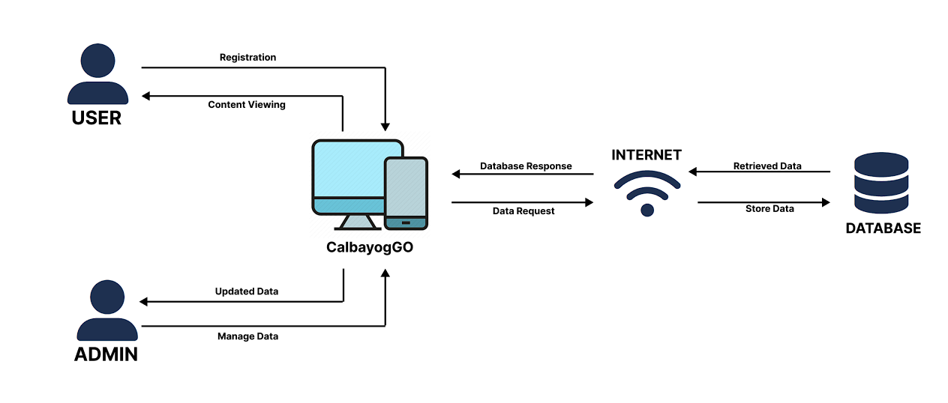
The system architecture for the CalbayogGO: WEB-BASED TRAVEL APP provides a structured framework that organizes the development process and clarifies how the system operates. The design created by the researcher allows for a clearer visualization of the system architecture.
Figure 2. System Architecture of CalbayogGO: WEB-BASED TRAVEL APP
Figure 2 shows how users and admins interact with the CalbayogGO Web-Based Travel App through their respective devices connected to an online server via Wi-Fi. Users access the platform through mobile devices, enabling them to sign up, log in, and interact with various features of the travel app. Admins access the platform via desktops, where they manage users, content, reviews, and announcements. All actions and data requests are directed to the online server, which processes these requests and returns the necessary responses to ensure data synchronization across both user and admin interfaces. The online server acts as a central hub, managing the flow of information and maintaining the system's integrity and functionality. The architecture of the CalbayogGO Web-Based Travel App ensures seamless interactions between users and administrators, providing a stable platform for managing travel-related information effectively.

Process Model
A process model is a conceptual framework that represents the sequence of a system within a particular process. It serves as a guiding framework that helps ensure the project is well-organized, systematically executed, and successfully completed. Using various diagrams, such as context diagrams, data flow diagrams, and functional decomposition diagrams, helps the researcher easily determine how the system works effectively for the users.

Context Diagram
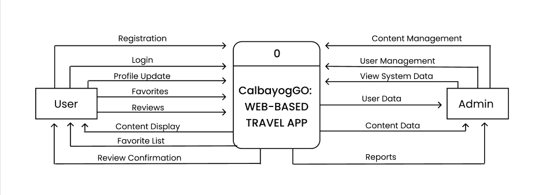
In software design and modeling, a context diagram represents the interaction between the system and its users, assisting researchers in defining and clarifying the software system's constraints. This is also known as a Level 0 Data Flow Diagram (DFD), as it depicts the entire system as a single process that interacts with external entities. Figure 3 will show the Context Diagram of the CalbayogGO Web-Based Travel App, illustrating how the system interacts with it’s users and administrators.
Figure 3. Context Diagram of CalbayogGO: WEB-BASED TRAVEL APP
Figure 3 represents the context diagram of the CalbayogGO: Web-Based Travel App. This diagram shows two main actors interacting with the system: Users and Admins. The system itself is labeled as "0" in the center, representing the core process of the travel app. Based on the context diagram, Users initiate interactions by inputting their details for Registration and Login. Once registered and logged in, users can access additional features within the system, such as updating their Profile, adding items to their Favorites, submitting Reviews, and viewing Content Display. Users can also manage a Favorite List and receive Review Confirmation feedback from the system after posting a review. These interactions ensure that users have a personalized and engaging experience on the platform. Admins interact with the system by managing critical functions through the Content Management and User Management features. They have access to User Data and Content Data to monitor and maintain the quality of the platform. Additionally, admins can View System Data and generate Reports to analyze user engagement and content performance. Admin actions, such as managing announcements, reviews, and content, help ensure the system remains up-to-date and relevant for all users.

Data Flow Diagram
A Data Flow Diagram (DFD) illustrates how a system processes data through various inputs and outputs, focusing on the flow of information—specifically where data originates, where it is directed, and how it is stored. This type of diagram is particularly valuable for researchers and data analysts, as it provides a clear understanding of how data moves within the system. Figure 4 presents the Data Flow Diagram of the CalbayogGO: Web-Based Travel App, showing the flow of data between users, admins, and system processes, enabling a structured overview of data interactions and storage within the application.
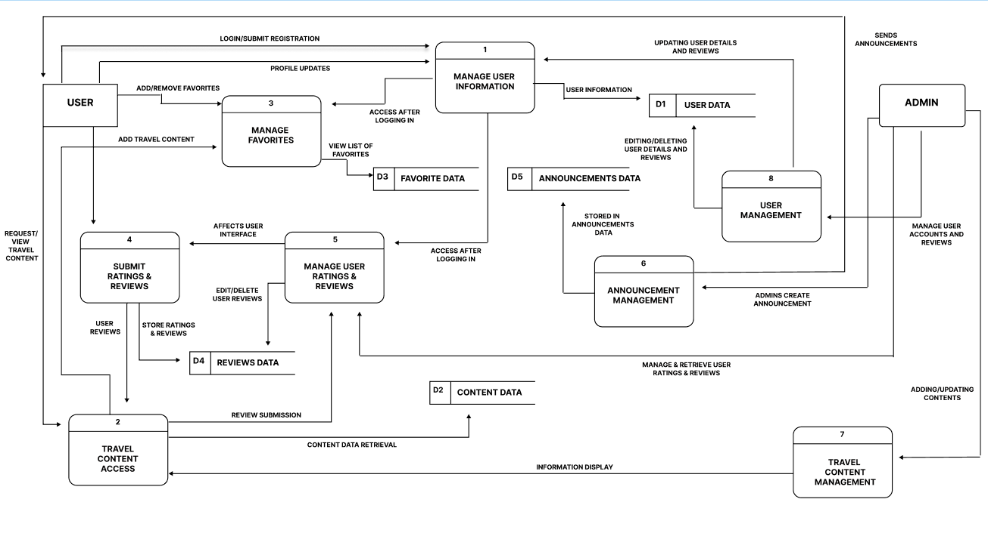
Figure 4. Data Flow Diagram of CalbayogGO: WEB-BASED TRAVEL APP
Figure 4 illustrates the Data Flow Diagram of the CalbayogGO: Web-Based Travel App, showing how users and admins interact with processes like user information management, travel content updates, favorites, and reviews, with data stored and retrieved from various databases to ensure smooth and consistent data flow throughout the system.

Functional Decomposition Diagram
A Functional Decomposition Diagram illustrates how the organization will operate within the system. This diagram helped the researchers understand how each actor in the organization contributes to the system's functionality. It includes the primary function or project and all necessary sub-tasks required for successful completion. Figure 5 illustrate the Functional Decomposition Diagram of CalbayogGO: Web-Based Travel App.

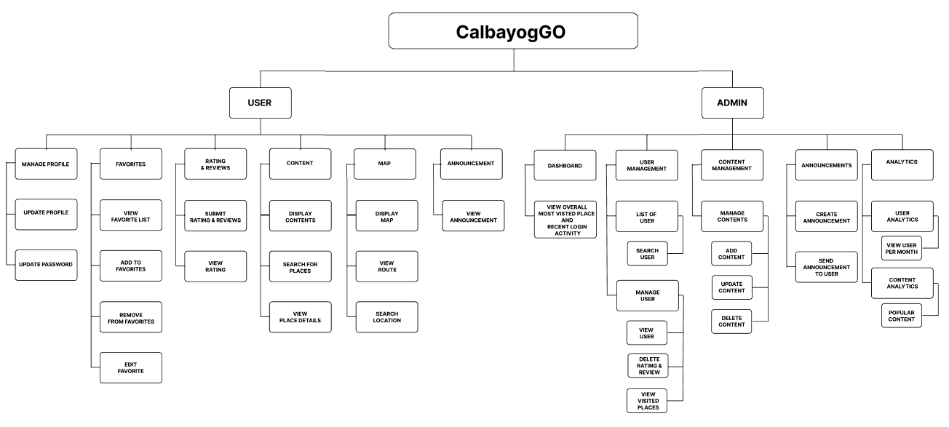
Figure 5. Functional Decomposition Diagram of CalbayogGO: WEB-BASED TRAVEL APP
Figure 5 represents the graphical representation of the functional decomposition diagram of the CalbayogGO: Web-Based Travel App, providing a detailed view of its key functionalities. In the system, users have multiple capabilities, including managing their accounts, viewing and interacting with favorite places, submitting and viewing ratings and reviews, and accessing content. Users can also explore the map to find routes and locations, as well as view announcements made by the admin. The admin section has various responsibilities, such as managing the dashboard, user management, and content management. Admins can create and send announcements to users and use analytics to gain insights into user activities and content engagement. This ensures effective content delivery and helps monitor platform usage. Furthermore, the admin manages user profiles, sports categories, and reports, ensuring smooth platform operation and data organization.

Data Model
To determine what data is needed to work the activities in the system. The researchers created data model such as entity relationship diagram (ERD) together with its dictionary. These diagrams helped the researchers see and categorize the data needed to make the system work effectively. Figure 6 illustrates the Entity Relationship Diagram of CalbayogGO: Web-Based Travel App.

Entity Relationship Diagram (ERD)
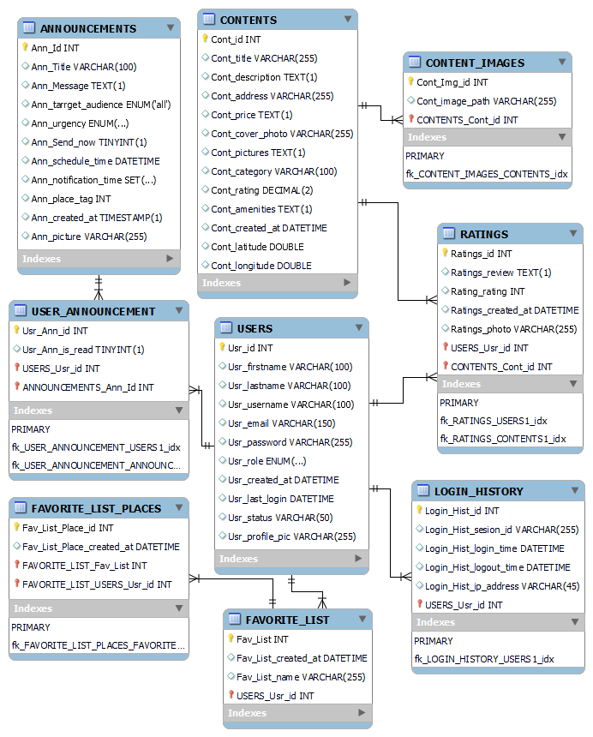
Entity-Relationship Diagram (ERD) serves as a foundation tool for visualizing and structuring the database architecture. It allows to you to map out the relationship between key data entities relevant to the project.
Figure 6. Entity Relationship Diagram of CalbayogGO: WEB-BASED
TRAVEL APP
Figure 6 outlines the entities in the CalbayogGO: Web-Based Travel App system. These entities form a crucial part of the system, with each entity representing specific characteristics that contribute to the data flow. The connections between them are referred to as relationships. As shown in the diagram, the Announcements entity allows the admin to create announcements, which are then linked to User Announcement to track whether users have read them. The Users entity plays a central role in the system, connecting to various other entities such as Ratings, Favorite List, and Login History. Users can rate contents, add places to their favorite list, and maintain a record of their login history. The Contents entity represents the information about various places, and it links to Content Images for storing related images, as well as Ratings for collecting user reviews. Users can view the details of each content and rate them based on their experience. The Favorite List allows users to create lists of their favorite places, with each list connected to specific Contents through Favorite List Places. This relationship helps users keep track of their preferred locations. The Admin is responsible for creating announcements and managing content, user details, and reports. Announcements are sent to users, and the relationship between announcements and users is tracked to ensure effective communication. Overall, these interconnected entities ensure seamless data management within the CalbayogGO system, enabling admins, users, and content to interact effectively, thus enhancing the overall user experience.

Data dictionary
The data dictionary gives researchers precise information about each table, which is critical for creating the CalbayogGO: Web-Based Travel App. Table 8 shows the Data Dictionary of Sport Selection Status History Table Athlete Registration and Management System.
Table 7
Data Dictionary of Announcements Table of CalbayogGO: WEB-BASED TRAVEL APP

Field Name | Data Type | Key | Null | Description
Ann_Id  Ann_Title  Ann_Message  Ann_target_audience  Ann_urgency  Ann_Send_now  Ann_schedule_time  Ann_notification_time  Ann_place_tag  Ann_created_at  Ann_picture | INT  VARCHAR(100)  TEXT  ENUM  ENUM  TINYINT(1)  DATETIME  SET  INT  TIMESTAMP  VARCHAR(255) | Primary  Key | No  No  No  Yes  Yes  Yes  Yes  Yes  Yes  Yes  Yes | Unique identifier for announcements.  Title of the announcement.  Content of the announcement message.  Target Audience for the announcement.  Urgency level of the announcement  Indicator if the announcement is sent now  Scheduled time for sending the announcement  Notification times for the announcement  Associated place tag  Creation timestamp of the announcement  Path to the announcement picture

Table 7 outlines the field name, data type, description, key, and null status for each column in the Announcements table. This table stores all the data for announcements, including details such as the title, message, audience, urgency, and schedule. It shows that this table has 11 fields: Ann_Id, Ann_Title, Ann_Message, Ann_target_audience, Ann_urgency, Ann_Send_now, Ann_schedule_time, Ann_notification_time, Ann_place_tag, Ann_created_at, and Ann_picture.
Table 8
Data Dictionary of Contents Table of CalbayogGO: WEB-BASED TRAVEL APP

Field Name | Data Type | Key | Null | Description
Cont_id  Cont_title  Cont_description  Cont_address  Cont_price  Cont_cover_photo  Cont_pictures  Cont_category  Cont_rating  Cont_amenities  Cont_created_at  Cont_latitude  Cont_longitude | INT  VARCHAR(100)  TEXT  VARCHAR(255)  TEXT  TINYINT(1)  TEXT  VARCHAR(100)  DECIMAL(2)  TEXT  DATETIME  DOUBLE  DOUBLE | Primary  Key | No  No  No  Yes  Yes  Yes  Yes  Yes  Yes  Yes  Yes  Yes  Yes | Unique identifier for content.  Title of the content  Description of the content.  Address related to the content  Price information for the content  Path to the cover photo of the content  Additional pictures related to the content.  Notification times for the announcement  Average rating for the content  Amenities available for the content  Creation timestamp of the content  Latitude coordinate of the content  Longitude coordinate of the content

Table 8 outlines the field name, data type, description, key, and null status for each column in the Contents table. This table stores all the content data, including information such as the content title, description, address, price, and category. The table contains 13 fields: Cont_id, Cont_title, Cont_description, Cont_address, Cont_price, Cont_cover_photo, Cont_pictures, Cont_category, Cont_rating, Cont_amenities, Cont_created_at, Cont_latitude, and Cont_longitude.
Table 9
Data Dictionary of Users Table of CalbayogGO: WEB-BASED TRAVEL APP

Field Name | Data Type | Key | Null | Description
Usr_id  Usr_firstname  Usr_lastname  Usr_username  Usr_email  Usr_password  Usr_role  Usr_created_at  Usr_last_login  Usr_status  Usr_profile_pic | INT  VARCHAR(100)  VARCHAR(100)  VARCHAR(100)  VARCHAR(150)  VARCHAR(255)  ENUM  DATETIME  DATETIME  VARCHAR(50)  VARCHAR(255) | Primary  Key | No  No  No  No  No  No  No  Yes  Yes  Yes  Yes | Unique identifier for content.  First name of the user  Last name of the user  Username of the user  Email address of the user  Encrypted password of the user  Role of the user (e.g., admin, user)  Timestamp when the user was created  Timestamp of the user’s log in  Status of the user (e.g., active, inactive)  Path to the profile picture of the user

Table 9 outlines the field name, data type, description, key, and null status for each column in the Users table. This table stores user data, including personal information, account details, and profile picture paths. The table has 11 fields: Usr_id, Usr_firstname, Usr_lastname, Usr_username, Usr_email, Usr_password, Usr_role, Usr_created_at, Usr_last_login, Usr_status, and Usr_profile_pic.

Table 10
Data Dictionary of Content Images Table of CalbayogGO: WEB-BASED TRAVEL APP

Field Name | Data Type | Key | Null | Description
Cont_img_id  Cont_img_path  CONTENTS_Cont_id | INT  VARCHAR(255)  INT | Primary  Key  Foreign Key | No  No  No | Unique identifier for content images.  Path to the content image  Identifier for associated content

Table 10 outlines the field name, data type, description, key, and null status for each column in the Content Images table. This table stores images related to the contents, including their paths and associated content IDs. The table consists of 3 fields: Cont_img_id, Cont_image_path, and CONTENTS_Cont_id.

Table 11
Data Dictionary of Ratings Table of CalbayogGO: WEB-BASED TRAVEL APP
Field Name | Data Type | Key | Null | Description
Ratings_id  Ratings_review  Rating_rating  Ratings_created_at  Ratings_photo  USER_Usr_id  CONTENTS_Cont_id | INT  TEXT  INT  DATETIME  VARCHAR(255)  INT  INT | Primary  Key  Foreign Key  Foreign Key | No  Yes  No  Yes  Yes  No  No | Unique identifier for content.  Review text provided by the user  Rating value provided by the user  Timestamp when the rating was created  Path to the photo associated with the rating  Identifier for associated user  Identifier for associated content
Table 11 outlines the field name, data type, description, key, and null status for each column in the Ratings table. This table stores user reviews and ratings, including the review text, rating value, and associated user and content IDs. It has 7 fields: Ratings_id, Ratings_review, Rating_rating, Ratings_created_at, Ratings_photo, USERS_Usr_id, and CONTENTS_Cont_id.

Table 12
Data Dictionary of Favorite List Table of CalbayogGO: WEB-BASED TRAVEL APP

Field Name | Data Type | Key | Null | Description
Fav_List_id  Fav_List_created_at  Fav_List_name  USERS_Usr_id | INT  DATETIME  VARCHAR(255)  INT | Primary  Key  Foreign Key | No  Yes  No  No | Unique identifier for favorite list.  Timestamp when the favorite list was created  Name of the favorite list.  Identifier for the user who owns the list.
Table 12 outlines the field name, data type, description, key, and null status for each column in the Favorite List table. This table stores information about users' favorite lists, including the list name and creation timestamp. It contains 4 fields: Fav_List_id, Fav_List_created_at, Fav_list_name, and USERS_Usr_id.
Table 13
Data Dictionary of Favorite List Places Table of CalbayogGO: WEB-BASED TRAVEL APP

Field Name | Data Type | Key | Null | Description
Fav_List__Place_id  Fav_List_Place_created_at  FAVORITE_LIST_Fav_list  CONTENTS_Cont_id | INT  DATETIME  INT  INT | Primary  Key  Foreign Key  Foreign Key | No  Yes  No  No | Unique identifier for favorite list places  Timestamp when the place was added to list  Identifier for associated favorite list.  Identifier for associated content
Table 13 outlines the field name, data type, description, key, and null status for each column in the Favorite List Places table. This table stores information about the places added to users' favorite lists, including the creation timestamp and associated content and list IDs. It has 4 fields: Fav_List_Place_id, Fav_List_Place_created_at, FAVORITE_LIST_Fav_List, and CONTENTS_Cont_id,
Table 14
Data Dictionary of Login History of CalbayogGO: WEB-BASED TRAVEL APP

Field Name | Data Type | Key | Null | Description
Login_Hist_id  Login_Hist_Session Id  Login_Hist_login_time  Login_Hist_logout_time  Login_Hist_ip_address  USERS_Usr_id | INT  VARCHAR(255)  DATETIME  DATETIME  VARCHAR  INT | Primary  Key  Foreign Key | No  Yes  No  Yes  Yes  No | Unique identifier for login history.  Session identifier for the login session.  Timestamp of user login  Timestamp of user login  IP address used during the session  Identifier for associated user.
Table 14 outlines the field name, data type, description, key, and null status for each column in the Login History table. This table stores login history information, including login and logout timestamps, session IDs, and IP addresses. The table consists of 6 fields: Login_Hist_id, Login_Hist_session_id, Login_Hist_login_time, Login_Hist_logout_time, Login_Hist_ip_address, and USERS_Usr_id.

Implementation Results
This phase evaluated whether the outcomes of the CalbayogGO web-based travel app aligned with the study's specific objectives. The primary objective of this study was to establish a comprehensive database management system to manage and update content seamlessly. The second objective focused on incorporating a map search feature to navigate specific locations. The third objective was to integrate a travel tracking feature to monitor user activities, and the final objective was to provide a feedback system to monitor user feedback effectively.
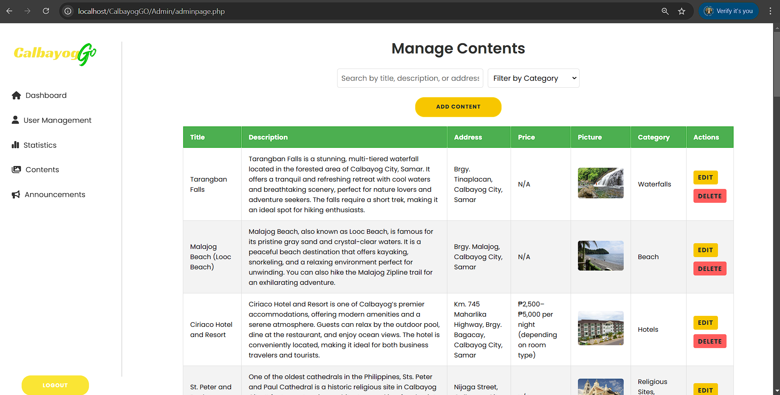
1. Establish a comprehensive database management system to manage and update content seamlessly.

This is the interface for managing content for CalbayogGO: WEB-BASED TRAVEL APP. Within the content table, it has a display of a comprehensive list of content entries with columns for: title, description, address, price, picture, category, and the actions for editing and deleting a specific content.
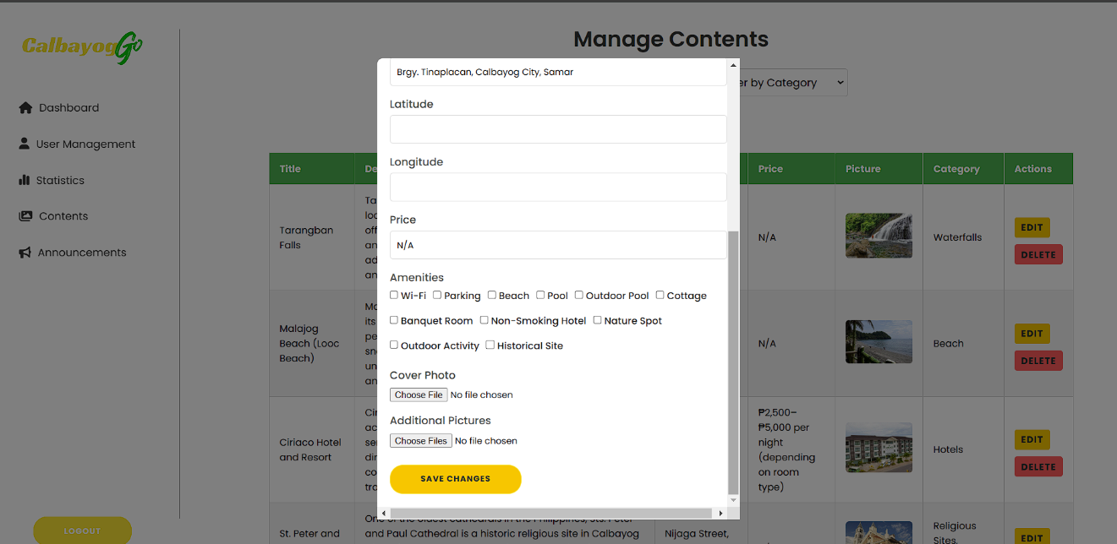
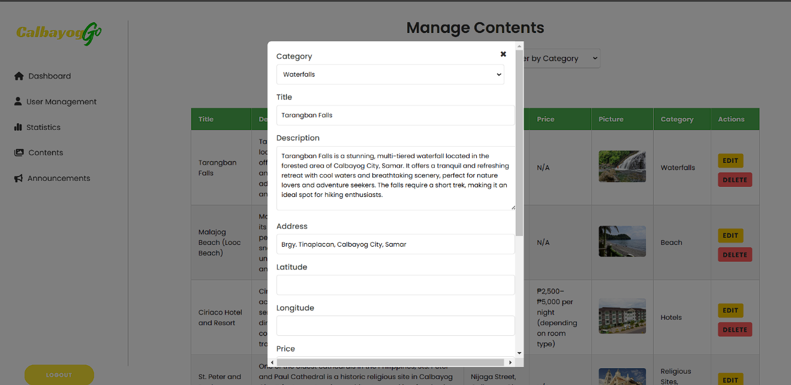

This is the modal for editing a specific content, it is crucial to have this function in order for the content to have an accuracy if it has an error in details that is been discovered or it had been changed, relevance if information may become outdated, flexibility if the content may require to be adjusted in different situations, consistency to follow the standard format, optimization for better clarity of the content.
Figure 7: Establish a comprehensive database management system to manage and update content seamlessly.
Figure 7 shows the first objective of CalbayogGO: Web Based Travel App. The design and functionality of the "Manage Contents" page effectively fulfill the objective by giving the admin a user-friendly way to add, update, and manage content, contributing to an organized and rich user experience for travelers.

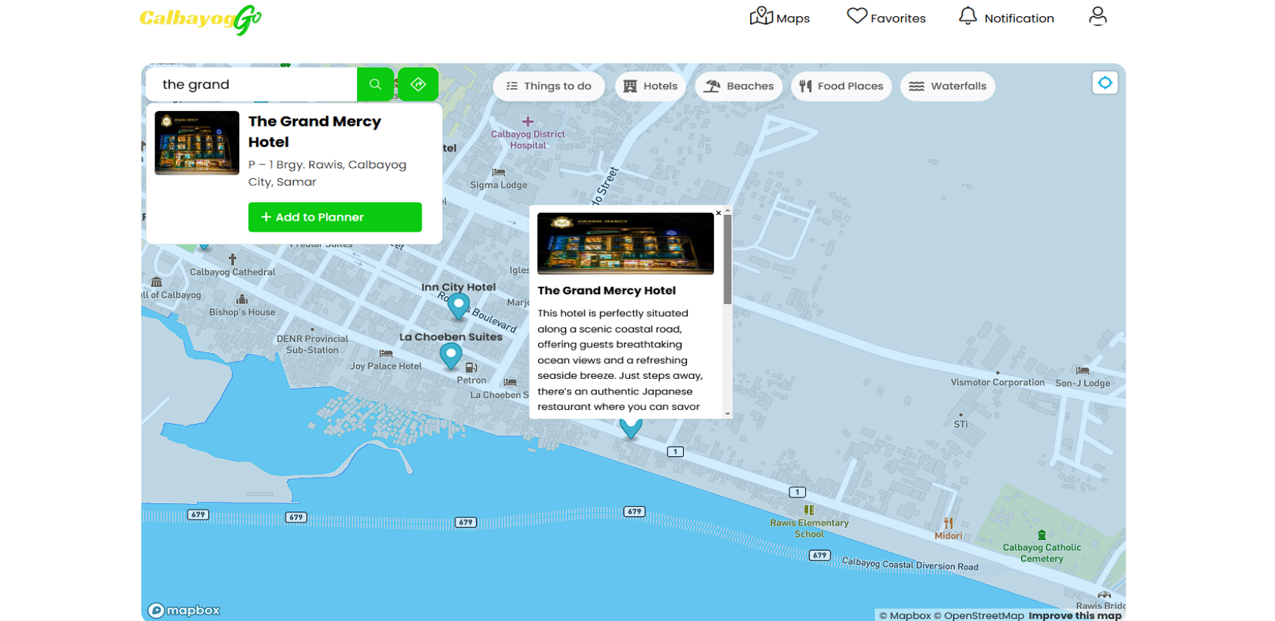
2. Incorporate Map Search to Navigate Certain Location.

Figure 8: Incorporate Map Search to Navigate Certain Location.
Figure 8 shows that it successfully achieved the second object of The CalbayogGO: Web Based Travel App. This implementation effectively fulfills the second objective by providing an interactive and intuitive way for users to search and navigate locations. Upon selecting a location, the map centers on it and displays a marker with details. Users can add location to their travel planner. The feature integrates with planner for seamless route creation.

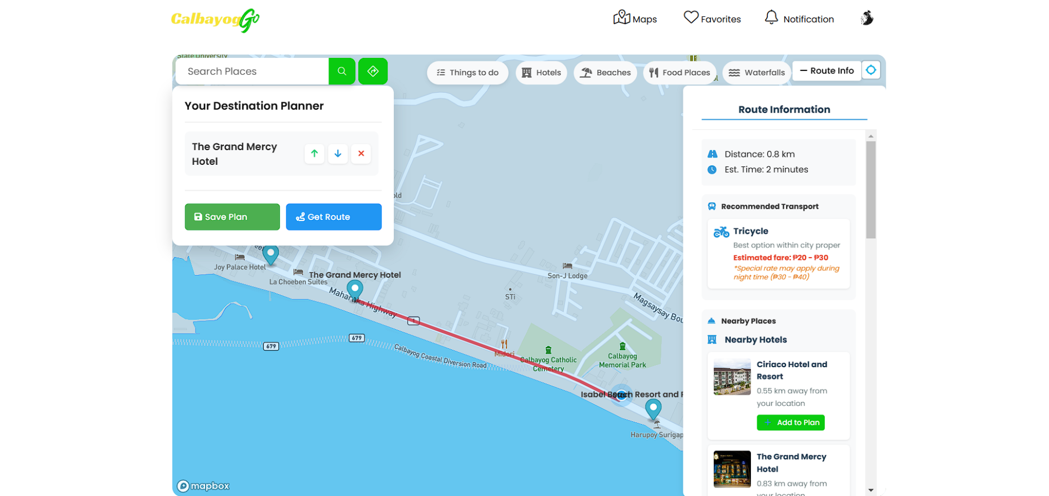
3. Integrate a Travel Tracking Feature to Monitor User Activities.

Figure 9: Integrate a Travel Tracking Feature to Monitor User Activities.
Figure 9 shows that the third object is to integrate a map for tracking and monitor the user activities. The researcher implements a geolocation services to accurately track the user’s location using the Mapbox API, followed by developing a user interface to display tracked activities on a map. A backend system with PHP and MySQL was set up to manage and store location data, destination, and timestamps.
The results were a functional travel-tracking feature enabling users to view their travel history, see their routes, and get location-based recommendations.

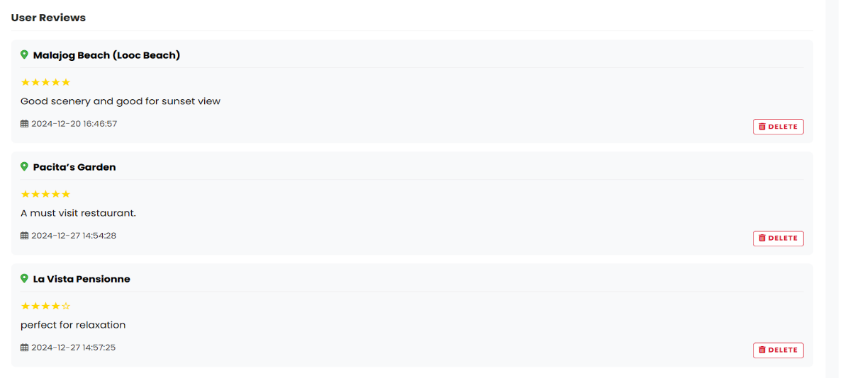
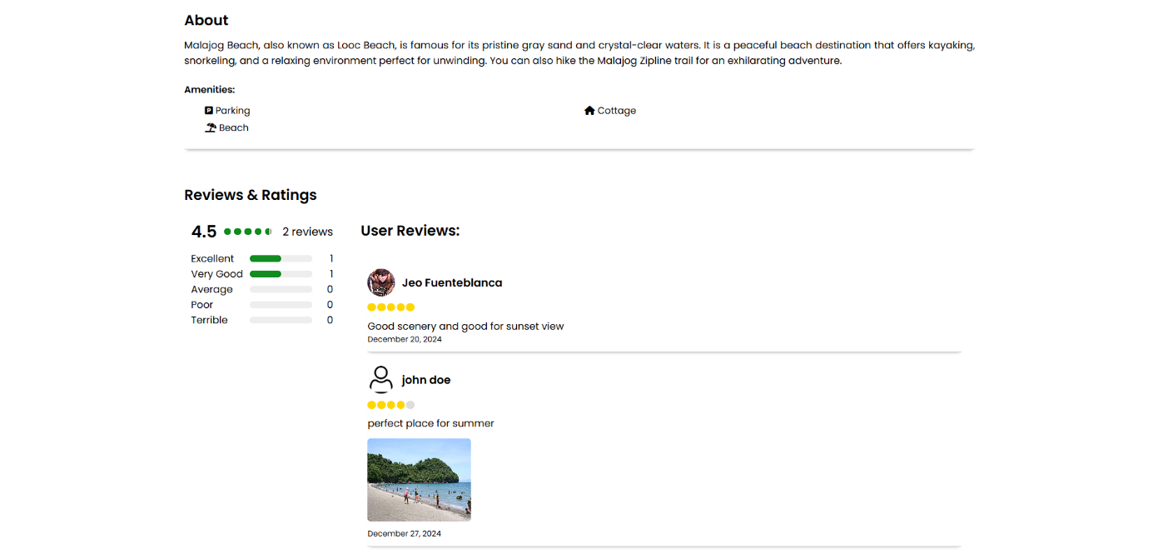
5. Provide a Feedback System to Monitor User Feedback
Figure 10: Provide a Feedback System to Monitor User Feedback.
Figure 10 shows the last objective of the developed system, focusing on the implementation of creating a user-friendly interface for submitting ratings, reviews, and photos, with backend support via PHP and MySQL for data handling. The reviews were displayed in a simple manner, with star ratings and photo thumbnails, making it easy for other user to read and engage with the reviews.
The implementation of the feedback system was greatly improved to the system, which showed how user feedback methods can be used effectively to improve user experience and provide useful insights for future improvement.

CHAPTER 5

RECOMMENDATIONS

Additional functions and interface enhancements can be added to improve the system's performance. Furthermore, implementing real-time notifications to alert users about nearby points of interest or upcoming destinations on their travel routes would make the system more user-friendly and engaging. Moreover, the researchers recommend developing an offline tracking capability to ensure functionality without an internet connection.
The study suggests that improving the map search functionality, adding advanced search filters to refine results based on criteria such as distance, rating, and category, enhancing the search input with autocomplete suggestions for a better user experience. Expanding the feedback system involves implementing a moderation system to ensure the quality of relevance of reviews, allowing users to interact with feedback by liking, commenting, or reporting views.
Lastly, the researchers recommend making the tourism of Calbayog City the beneficiary to ensure the accuracy of detailed information about the tourist attractions and other places within Calbayog City. Additionally, they advise future researchers to be open-minded in their capstone projects, as outcomes may differ from expectations. They also recommend sharing findings with peers and colleagues who can help improve the system.

REFERENCES

Abbasi-moud, Z., Vahdat Nejad, H., & Sadri, J. (2021). Tourism recommendation
system based on semantic clustering and sentiment analysis. Expert Systems with Applications, 167, 114324. https://doi.org/10.1016/j.eswa.2020.114324
Alghobari, Mohanad & Muneer, Amgad & Fati, Suliman. (2021). Location-Aware Personalized Traveler Recommender System (LAPTA) Using Collaborative Filtering KNN. Computers, Materials and Continua. 64. 10.32604/cmc.2021.016348.
Amazona, R. (2020, March 10). DOT asks Samar areas to send tourism reports. Philippine News Agency. https://beta.tourism.gov.ph/news_and_updates/dot-lauds-samar-lgu-vax-drive-for-tourism-workers/
Dickinson, J. E., Ghali, K., Cherrett, T., Speed, C., Davies, N., & Norgate, S. (2012). Tourism and the smartphone app: Capabilities, emerging practice and scope in the travel domain. Current Issues in Tourism, 17(1), 84–101. https://doi.org/10.1080/13683500.2012.718323
Huang, C. D., Goo, J., Nam, K., & Yoo, C. W. (2017). Smart tourism technologies in travel planning: The role of exploration and exploitation. Asia Pacific Journal of Tourism Research, 22(7), 751–764. https://doi.org/10.1080/10941665.2017.1331505
Ismail, N. A., Nizam, S. F., Yuen, S. C., Hasan, L., Mohamed, S. E., Leng, W. Y., & Allah, K. K. (2021). User-centred design and evaluation of web and mobile-based travelling applications. International Journal of Advanced Computer Science and Applications, 12(1), 15–22.
Ferrara, C., Pierdicca, R., Balestra, M., Mignani, C., Frontoni, E., & Cavicchi, A. (2021). ICTS and mobile applications for promoting tourism destinations: The case of smart marca app. Tourism & Management Studies, 16(1), 229-245.
Fuchs, M., Eberle, T., & Höpken, W. (2021, January 19-22). Using Google Maps data for tourism real-time monitoring and analytics: The case of cultural tourism, Sweden [Paper presentation]. 28th ENTER Conference e-Tourism: Development Opportunities and Challenges in an Unpredictable World, [DIGITAL].
Kato, Y., & Yamamoto, K. (2020). A sightseeing spot recommendation system that takes into account the visiting frequency of users. ISPRS International Journal of Geo-Information, 9(7), 411. https://doi.org/10.3390/ijgi9070411
Massimo, D., & Ricci, F. (2022). Building effective recommender systems for tourists. AI Magazine, (2), 209-224. https://doi.org/10.1002/aaai.12057
Meiliana, I., Irmanti, D., Hidayat, M. R., Amalina, N. V., & Suryani, D. (2017). Mobile smart travelling application for Indonesia tourism. Procedia Computer Science, 116, 556–563. https://doi.org/10.1016/j.procs.2017.10.059
Nan, X., Kanato, K., & Wang, X. (2022). Design and implementation of a personalized tourism recommendation system based on the data mining and collaborative filtering algorithm. Computational Intelligence and Neuroscience, 2022, 1424097. https://doi.org/10.1155/2022/1424097
Nugroho, B. A., Izzah, A., & Widyastuti, R. (2019). Development of Android application for city tour recommendation system based on dynamic programming. In 2019 International Conference on Sustainable Information Engineering and Technology (SIET) (pp. 240-245). Institute of Electrical and Electronics Engineers (IEEE). doi: 10.1109/SIET48054.2019.8986055
Pavel, M. A., Rana, M., Roman, A. A., Hassan, Y., & Khan, R. (2021). Android application for tourism planning in Bangladesh. In 2021 IEEE 19th Student Conference on Research and Development (SCOReD) (pp. 1-5). IEEE.
Philippine Department of Tourism. (2022). Regional Travelers 2022 [PDF]. Retrieved from tourism.gov.ph
Smirnov, A., Kashevnik, A., Ponomarev, A., Shchekotov, M., & Kulakov, K. (2015, July). Application for e-Tourism: Intelligent mobile tourist guide. In 2015 IEEE International Conference on Intelligent Agents (IIAI) (Vol. 1, pp. 40-45). IEEE.
Wörndl, W., & Herzog, D. (2020). Mobile applications for e-tourism. In Z. Xiang, M. Fuchs, U. Gretzel, & W. Höpken (Eds.), Handbook of e-tourism (pp. 1–17). Springer. https://doi.org/10.1007/978-3-030-05324-6_17-1




- User Signup

<!DOCTYPE html>
<html lang="en">
<head>
<meta charset="UTF-8">
<meta name="viewport" content="width=device-width, initial-scale=1.0">
<title>Document</title>
<link rel="stylesheet" href="libs/admin.css">
<link rel="stylesheet" href="libs/responsive.css">
<link rel="preconnect" href="https://fonts.googleapis.com">
<link rel="preconnect" href="https://fonts.gstatic.com" crossorigin>
<link href="https://fonts.googleapis.com/css2?family=Poppins:ital,wght@0,100;0,200;0,300;0,400;0,500;0,600;0,700;0,800;0,900&display=swap" rel="stylesheet">
<link rel="stylesheet" href="https://cdnjs.cloudflare.com/ajax/libs/font-awesome/6.5.2/css/all.min.css" integrity="sha512-SnH5WK+bZxgPHs44uWIX+LLJAJ9/2PkPKZ5QiAj6Ta86w+fsb2TkcmfRyVX3pBnMFcV7oQPJkl9QevSCWr3W6A==" crossorigin="anonymous" referrerpolicy="no-referrer" />
<style>
.signup {
margin: 0;
padding: 0;
display: flex;
align-items: center;
justify-content: center;
background-color: #fff;
}

.sign-up-form {
text-align: center;
width: 100%;
max-width: 400px; /* Limits the form width */
}

.input-group {
position: relative;
margin-bottom: 10px; /* Added margin bottom for spacing */
}

.input {
padding: 10px;
width: 100%;
box-sizing: border-box;
outline: none;
border: 1px solid;
max-width: 400px;
border-radius: 5px;
}

.placeholder {
position: absolute;
top: 10px;
left: 8px;
font-size: 14px;
padding: 0px 5px;
color: #666;
transition: 0.3s;
pointer-events: none;
}

.input:focus + .placeholder, .input:not(:placeholder-shown) + .placeholder {
top: -10px;
left: 10px;
font-size: 12px;
background-color: #fff;
padding: 0 5px;
}

.toggle-password {
position: absolute;
right: 10px;
top: 50%;
transform: translateY(-50%);
cursor: pointer;
}

.signup-succ-message {
padding: 10px;
margin-top: 15px;
border-radius: 5px;
display: none; /* Hide by default */
}

.signup-succ-message.success {
color: #155724;
background-color: #d4edda;
border: 1px solid #c3e6cb;
}

.signup-succ-message.error {
color: #721c24;
background-color: #f8d7da;
border: 1px solid #f5c6cb;
}

.already {
justify-content: center;
}

.already a {
color: #0acb10;
}

.right-link {
color: #0acb10;
}

.error-message {
color: #ff4d4d;
font-size: 14px;
margin-top: 10px;
text-align: center;
padding: 5px;
border: 1px solid #ff4d4d;
border-radius: 5px;
background-color: #ffe6e6;
}
</style>
</head>
<body class="login">
<div>
<form method="POST" action="Data/signup.php" class="sign-up-form">
<img src="images/CalbayogGO.png" alt="logo">
<h2>Sign Up</h2>
<div class="between">
<div class="input-group">
<input type="text" id="firstname" name="firstname" class="input" required>
<label for="firstname" class="placeholder">Firstname</label>
</div>
<div class="input-group">
<input type="text" id="lastname" name="lastname" class="input" required>
<label for="lastname" class="placeholder">Lastname</label>
</div>
</div>
<div class="input-group">
<input type="email" id="email" name="email" class="input" required>
<label for="email" class="placeholder">Email</label>
</div>
<div class="input-group">
<input type="text" id="username" name="username" class="input" required>
<label for="username" class="placeholder">Username</label>
</div>
<div class="input-group">
<input type="password" id="password" name="password" class="input" required>
<label for="password" class="placeholder">Password</label>
<i class="fa-sharp fa-regular fa-eye-slash toggle-password" onclick="togglePasswordVisibility('password')"></i>
</div>
<div class="input-group">
<input type="password" id="confirm-password" name="confirm-password" class="input" required>
<label for="confirm-password" class="placeholder">Confirm Password</label>
<i class="fa-sharp fa-regular fa-eye-slash toggle-password" onclick="togglePasswordVisibility('confirm-password')"></i>
</div>
<div id="message-container" class="signup-succ-message"></div>
<div class="already">
<a href="user-login.php">Sign In</a>
</div>
<button type="submit">Sign Up</button>
</form>

</div>
<script src="script.js"></script>
<script src="https://code.jquery.com/jquery-3.6.0.min.js"></script>
<script>
function togglePasswordVisibility(inputId) {
const input = document.getElementById(inputId);
const icon = input.parentElement.querySelector('.toggle-password');

if (input.type === "password") {
input.type = "text";
icon.classList.remove("fa-eye-slash");
icon.classList.add("fa-eye");
} else {
input.type = "password";
icon.classList.remove("fa-eye");
icon.classList.add("fa-eye-slash");
}
}

$(document).ready(function() {
$('.sign-up-form').on('submit', function(event) {
event.preventDefault(); // Prevent the form from submitting traditionally

const formData = $(this).serialize(); // Serialize form data for AJAX submission

$.ajax({
url: 'Data/signup.php',
type: 'POST',
data: formData,
success: function(response) {
const messageContainer = $('#message-container');

// Show the message
if (response.status === 'success') {
messageContainer.removeClass('error').addClass('success').text(response.message).fadeIn();
$('.sign-up-form')[0].reset(); // Optional: Reset form fields after successful signup
} else {
messageContainer.removeClass('success').addClass('error').text(response.message).fadeIn();
}

// Hide the message after a few seconds
setTimeout(() => {
messageContainer.fadeOut();
}, 5000); // Adjust the time as needed
},
error: function() {
const messageContainer = $('#message-container');
messageContainer.removeClass('success').addClass('error').text("An error occurred while processing your request. Please try again.").fadeIn();

// Hide the message after a few seconds
setTimeout(() => {
messageContainer.fadeOut();
}, 5000);
}
});
});
});

</script>
</body>
</html>

- Map
<?php
include 'includes/header.php';
?>
<div id="map"></div>
<div class="recommendations-btn-container">
<button class="things-to-do-btn">
<i class="fas fa-list-check"></i> Things to do
</button>
</div>
<div class="category-filters">
<button class="filter-btn" data-category="Hotels">
<i class="fas fa-hotel"></i> Hotels
</button>
<button class="filter-btn" data-category="Beach">
<i class="fas fa-umbrella-beach"></i> Beaches
</button>
<button class="filter-btn" data-category="Food Place">
<i class="fas fa-utensils"></i> Food Places
</button>
<button class="filter-btn" data-category="Waterfalls">
<i class="fas fa-water"></i> Waterfalls
</button>
</div>
<div class="things-to-do-panel">
<div class="things-header">
<h3><i class="fas fa-list-check"></i> Things to do in Calbayog</h3>
<button class="close-panel"><i class="fas fa-times"></i></button>
</div>
<div class="recommendations-container"></div>
</div>

<script>
const userIsLoggedIn = <?php echo isset($_SESSION['user_id']) ? 'true' : 'false'; ?>;
let plannerDestinations = [];

// Function to add destination to planner with coordinates and description
function addDestination(title, id, latitude, longitude, description) {
const isDuplicate = plannerDestinations.some(destination =>
destination.title === title && destination.latitude === latitude && destination.longitude === longitude
);

if (!isDuplicate) {
if (!description) {
alert("Description is required for this destination!");
return;
}
plannerDestinations.push({ title, id, latitude, longitude, description });
updatePlannerUI();
}
}

// Function to update the planner UI
function updatePlannerUI() {
const plannerContainer = document.querySelector('.planner-container');
plannerContainer.innerHTML = '';
plannerDestinations.forEach(destination => {
const destinationElement = document.createElement('div');
destinationElement.className = 'planner-destination';
destinationElement.innerHTML = `
<h4>${destination.title}</h4>
<p>${destination.description}</p>
<button onclick="removeDestination(${destination.id})">Remove</button>
`;
plannerContainer.appendChild(destinationElement);
});
}

// Function to remove a destination from the planner
function removeDestination(id) {
plannerDestinations = plannerDestinations.filter(destination => destination.id !== id);
updatePlannerUI();
}

// Function to load planner data from the server
function loadPlanner(userId) {
if (userId) {
$.ajax({
url: 'load_planner.php',
type: 'GET',
data: { userId: userId },
success: function (response) {
const result = JSON.parse(response);
if (result.success) {
const serverPlanner = JSON.parse(result.plannerDestinations);
// Merge server and local planner data (avoid duplicates)
plannerDestinations = [
...serverPlanner,
...plannerDestinations.filter(
(local) =>
!serverPlanner.some(
(server) =>
server.id === local.id &&
server.latitude === local.latitude &&
server.longitude === local.longitude
)
),
];
updatePlannerUI();
}
},
error: function (xhr, status, error) {
console.error('Error loading planner:', error);
},
});
}
}

// Function to save planner data to the server
function savePlanner(userId) {
if (userId) {
$.ajax({
url: 'save_planner.php',
type: 'POST',
data: {
userId: userId,
plannerDestinations: JSON.stringify(plannerDestinations)
},
success: function (response) {
const result = JSON.parse(response);
if (result.success) {
console.log('Planner saved successfully.');
} else {
console.error('Error saving planner:', result.message);
}
},
error: function (xhr, status, error) {
console.error('Error saving planner:', error);
},
});
}
}

// Function to filter destinations by category
function filterDestinations(category) {
const filteredDestinations = plannerDestinations.filter(destination => destination.category === category);
updatePlannerUI(filteredDestinations);
}

// Event listener for category filter buttons
document.querySelectorAll('.filter-btn').forEach(button => {
button.addEventListener('click', function() {
const category = this.getAttribute('data-category');
filterDestinations(category);
});
});

// Event listener for the "Things to do" button
document.querySelector('.things-to-do-btn').addEventListener('click', function() {
document.querySelector('.things-to-do-panel').classList.toggle('visible');
});

// Event listener for the close button in the "Things to do" panel
document.querySelector('.close-panel').addEventListener('click', function() {
document.querySelector('.things-to-do-panel').classList.remove('visible');
});

// Function to show all images in a modal
function showAllImages(images) {
const modal = document.createElement('div');
modal.className = 'image-modal';
modal.innerHTML = `
<div class="modal-content">
<span class="close-modal">&times;</span>
${images.map(image => `<img src="uploads/${image}" alt="Review Photo" class="modal-image">`).join('')}
</div>
`;
document.body.appendChild(modal);

// Close modal on click
modal.querySelector('.close-modal').addEventListener('click', function() {
document.body.removeChild(modal);
});
}

// Function to initialize the map
function initializeMap() {
mapboxgl.accessToken = 'YOUR_MAPBOX_ACCESS_TOKEN';
const map = new mapboxgl.Map({
container: 'map',
style: 'mapbox://styles/mapbox/streets-v11',
center: [124.609, 12.067],
zoom: 12
});

// Add navigation controls to the map
map.addControl(new mapboxgl.NavigationControl());

// Add markers for planner destinations
plannerDestinations.forEach(destination => {
new mapboxgl.Marker()
.setLngLat([destination.longitude, destination.latitude])
.setPopup(new mapboxgl.Popup().setHTML(`<h4>${destination.title}</h4><p>${destination.description}</p>`))
.addTo(map);
});
}

// Call the loadPlanner function when the page is loaded (if userId is available)
document.addEventListener('DOMContentLoaded', function() {
const userId = <?php echo isset($_SESSION['user_id']) ? $_SESSION['user_id'] : 'null'; ?>;
if (userId) {
loadPlanner(userId);
}
initializeMap();
});
</script>

- Display Contents
<?php
// Fetch and display content details
include 'includes/db.php';

$contentId = $_GET['id'];
$sql = "SELECT * FROM contents WHERE id = ?";
$stmt = $conn->prepare($sql);
$stmt->bind_param("i", $contentId);
$stmt->execute();
$result = $stmt->get_result();
$content = $result->fetch_assoc();
$stmt->close();
?>

<!DOCTYPE html>
<html lang="en">
<head>
<meta charset="UTF-8">
<title><?php echo htmlspecialchars($content['title']); ?></title>
<link rel="stylesheet" href="styles.css">
<script src="https://code.jquery.com/jquery-3.6.0.min.js"></script>
</head>
<body>
<div class="content-container">
<h1><?php echo htmlspecialchars($content['title']); ?></h1>
<p><?php echo htmlspecialchars($content['description']); ?></p>
<button onclick="addToPlanner('<?php echo htmlspecialchars($content['title']); ?>', <?php echo $content['id']; ?>, <?php echo $content['latitude']; ?>, <?php echo $content['longitude']; ?>)">Add to Planner</button>
</div>

<div id="ratingModal" class="modal">
<div class="modal-content">
<span class="close">&times;</span>
<h2>Rate this Content</h2>
<form id="ratingForm">
<label for="rating">Rating:</label>
<input type="number" id="rating" name="rating" min="1" max="5" required>
<label for="review">Review:</label>
<textarea id="review" name="review" required></textarea>
<button type="submit">Submit</button>
</form>
</div>
</div>

<div id="successMessageModal" class="modal">
<div class="modal-content">
<span class="close-success">&times;</span>
<p>Thank you for your feedback!</p>
</div>
</div>

<script>
document.addEventListener('DOMContentLoaded', function () {
// Handle form submission
document.getElementById('ratingForm').addEventListener('submit', function (event) {
event.preventDefault();

const formData = new FormData(this);
fetch('submit-rating.php', {
method: 'POST',
body: formData
})
.then(response => response.json())
.then(data => {
if (data.success) {
document.getElementById('ratingModal').style.display = 'none';
document.getElementById('successMessageModal').style.display = 'block';
} else {
alert(data.message);
}
})
.catch(error => console.error('Error:', error));
});

// Close the success message modal
document.querySelector('.close-success').addEventListener('click', function () {
document.getElementById('successMessageModal').style.display = 'none';
});

// Close the rating modal when the close button is clicked
document.querySelector('.close').addEventListener('click', function () {
document.getElementById('ratingModal').style.display = 'none';
});
});

function addToPlanner(title, id, latitude, longitude) {
// Create the destination object
const destination = {
title: title,
id: id,
latitude: latitude,
longitude: longitude
};

// Get the existing planner data from local storage
let planner = JSON.parse(localStorage.getItem('plannerDestinations')) || [];

// Check for duplicates
const isDuplicate = planner.some(
(item) => item.id === id && item.latitude === latitude && item.longitude === longitude
);

if (!isDuplicate) {
// Add the new destination to the planner
planner.push(destination);
localStorage.setItem('plannerDestinations', JSON.stringify(planner)); // Save to local storage
alert('Destination added to planner!');
} else {
alert('This destination is already in your planner.');
}
}

// Function to display all reviews for the content
function displayReviews(contentId) {
fetch(`get-reviews.php?content_id=${contentId}`)
.then(response => response.json())
.then(data => {
const reviewsContainer = document.querySelector('.reviews-container');
reviewsContainer.innerHTML = '';
data.reviews.forEach(review => {
const reviewElement = document.createElement('div');
reviewElement.className = 'review';
reviewElement.innerHTML = `
<strong>${review.username}</strong>
<div class="review-rating">${'★'.repeat(review.rating)}</div>
<p>${review.review}</p>
`;
reviewsContainer.appendChild(reviewElement);
});
})
.catch(error => console.error('Error:', error));
}

// Call the displayReviews function when the page is loaded
document.addEventListener('DOMContentLoaded', function () {
const contentId = <?php echo $content['id']; ?>;
displayReviews(contentId);
});
</script>
</body>
</html>

- Profile
<?php
include 'includes/header.php';
include 'includes/db.php';

if (!$isLoggedIn) {
header('Location: login.html');
exit();
}

if (isset($_SESSION['user_id'])) {
$userId = $_SESSION['user_id'];

$sql = "SELECT * FROM users WHERE id = ?";
$stmt = $conn->prepare($sql);
$stmt->bind_param("i", $userId);
$stmt->execute();
$result = $stmt->get_result();

if ($result->num_rows > 0) {
$user = $result->fetch_assoc();
} else {
echo "User not found!";
exit();
}
$stmt->close();
} else {
echo "User ID not found in session!";
exit();
}

$profilePicture = (!empty($user['profile_picture']) && file_exists($user['profile_picture']))
? htmlspecialchars($user['profile_picture'])
: 'images/user.png';

?>
<head>
<style>

#trips {
max-width: 100%;
overflow: auto;
padding: 20px;
box-sizing: border-box;
}

#trips .trip-item {
overflow-wrap: break-word;
word-wrap: break-word;
margin-bottom: 10px;
}

</style>
</head>
<body>
<div class="profile-container">
<div class="profile-header">
<div class="profile-img">
<img src="<?php echo $profilePicture; ?>" alt="Profile Image">
</div>
<h1><?php echo htmlspecialchars($user['firstname'] . ' ' . $user['lastname']); ?></h1>
<p>@<?php echo htmlspecialchars($user['username']); ?></p>
</div>
<div class="profile-info">
<div class="profile-stats">
<nav class="profile-nav">
<a href="#" class="tab active" onclick="showTabContent(event, 'ratings')">Ratings/Reviews</a>
<a href="#" class="tab" onclick="showTabContent(event, 'photos')">Photos</a>
</nav>
<div class="profile-settings">
<i class="fa-duotone fa-light fa-gear"></i>
<button onclick="openEditProfileModal()" class="edit-profile-button">Edit Profile</button>
</div>
</div>
</div>

<!-- Content Section (User Feed) -->
<div class="user-feed">
<!-- Ratings/Reviews -->
<div id="ratings" class="tab-content active">
<h2>Your Reviews & Ratings</h2>
<div id="user-reviews">
<!-- Reviews and ratings will be loaded here via JavaScript -->
</div>
</div>

<!-- Photos -->
<div id="photos" class="tab-content" style="display: none;">
<!-- Add content for photos here -->
</div>
</div>

<!-- Edit Profile Modal -->
<div id="profile-modal" class="edit-profile-modal">
<div class="profile-modal-content">
<span class="user-close-modal" onclick="closeEditProfileModal()">&times;</span>
<h2>Edit Profile</h2>
<form action="Data/user.php" method="POST" enctype="multipart/form-data">
<input type="hidden" name="action" value="edit_profile">

<div class="profile-image-section">
<div class="profile-image-wrapper">
<img src="<?php echo $profilePicture; ?>" alt="Profile Image" id="profile-image-preview" class="profile-image">
<label for="profile_image" class="change-photo-overlay">
<i class="fa-duotone fa-solid fa-camera"></i>
<span>Change profile photo</span>
</label>
<input type="file" id="profile_image" name="profile_image" onchange="previewProfileImage(event)" style="display: none;">
</div>
</div>

<!-- First Name -->
<label for="firstname">Name</label>
<input type="text" id="firstname" name="firstname" value="<?php echo htmlspecialchars($user['firstname'] . ' ' . $user['lastname']); ?>" required>

<!-- Username -->
<label for="username">Username</label>
<input type="text" id="username" name="username" value="<?php echo htmlspecialchars($user['username']); ?>" required>

<!-- Submit and Cancel Buttons -->
<div class="prof-modal-buttons">
<button type="button" onclick="closeEditProfileModal()" class="prof-cancel-button">Cancel</button>
<button type="submit" class="prof-save-button">Save</button>
</div>
</form>
</div>
</div>

</div>

<script>
const userId = <?php echo json_encode($userId); ?>;

function showTabContent(event, tabId) {
// Hide all tab contents
document.querySelectorAll('.tab-content').forEach(function(content) {
content.style.display = 'none';
});

// Remove active class from all tabs
document.querySelectorAll('.tab').forEach(function(tab) {
tab.classList.remove('active');
});

// Show the clicked tab's content
document.getElementById(tabId).style.display = 'block';

// Add active class to the clicked tab
event.target.classList.add('active');
}

</script>
</body>

- Submit ratings
<?php
session_start();
include '../includes/db.php';

if (!isset($_SESSION['user_id'])) {
echo json_encode(['success' => false, 'message' => 'You must be logged in to rate.']);
exit;
}

if (isset($_POST['content_id'], $_POST['rating'], $_POST['review'])) {
$user_id = $_SESSION['user_id'];
$content_id = $_POST['content_id'];
$rating = (int)$_POST['rating'];
$review = htmlspecialchars($_POST['review']);
$photo_filenames = []; // Array to store filenames of uploaded photos

// Handle multiple file uploads
if (isset($_FILES['rating_photos']) && $_FILES['rating_photos']['error'][0] == UPLOAD_ERR_OK) {
$allowed_exts = ['jpg', 'jpeg', 'png', 'gif'];

foreach ($_FILES['rating_photos']['tmp_name'] as $index => $tmp_name) {
$file_name = $_FILES['rating_photos']['name'][$index];
$file_ext = pathinfo($file_name, PATHINFO_EXTENSION);

if (in_array(strtolower($file_ext), $allowed_exts)) {
$photo_filename = uniqid('rating_', true) . '.' . $file_ext;
$upload_path = '../uploads/' . $photo_filename;

if (move_uploaded_file($tmp_name, $upload_path)) {
$photo_filenames[] = $photo_filename;
}
}
}
}

// Serialize the array of photo filenames to store in the database
$photo_filenames_serialized = serialize($photo_filenames);

// Insert or update rating and review in the database
$sql = "INSERT INTO ratings (user_id, content_id, rating, review, photo) VALUES (?, ?, ?, ?, ?)
ON DUPLICATE KEY UPDATE rating = VALUES(rating), review = VALUES(review), photo = VALUES(photo)";
$stmt = $conn->prepare($sql);
$stmt->bind_param("iiiss", $user_id, $content_id, $rating, $review, $photo_filenames_serialized);
$success = $stmt->execute();
$stmt->close();

if ($success) {
echo json_encode(['success' => true, 'message' => 'Rating submitted successfully.']);
} else {
echo json_encode(['success' => false, 'message' => 'Failed to submit rating.']);
}
} else {
echo json_encode(['success' => false, 'message' => 'Invalid input.']);
}
?>


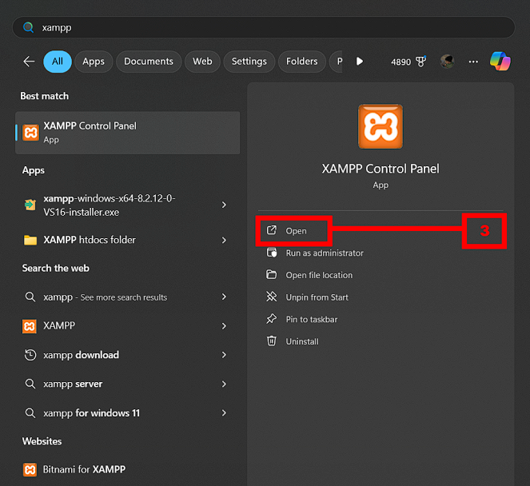
Figure 11. How to install and run the XAMPP
- The Xampp local web server can be downloaded and installed by following the instructions found at https://www.apachefriends.org/download.html
- Press the Windows key on your keyboard and type xampp in the search bar.
- Select the XAMPP Control Panel from the results and open it.
- Click the Start Button next to Apache and MySQL to start the Apache Server and MySQL Database. Ensure both modules are running, as indicated by green highlights in the panel.

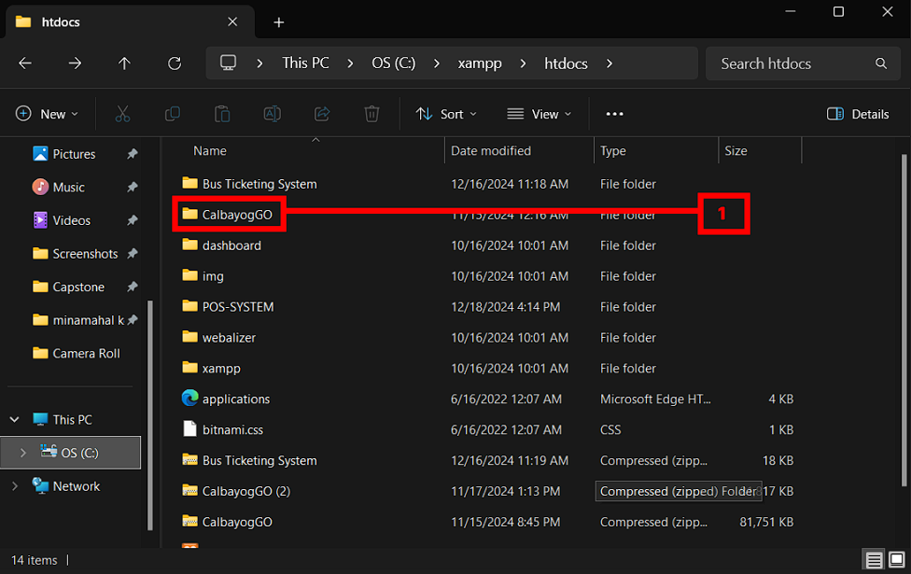

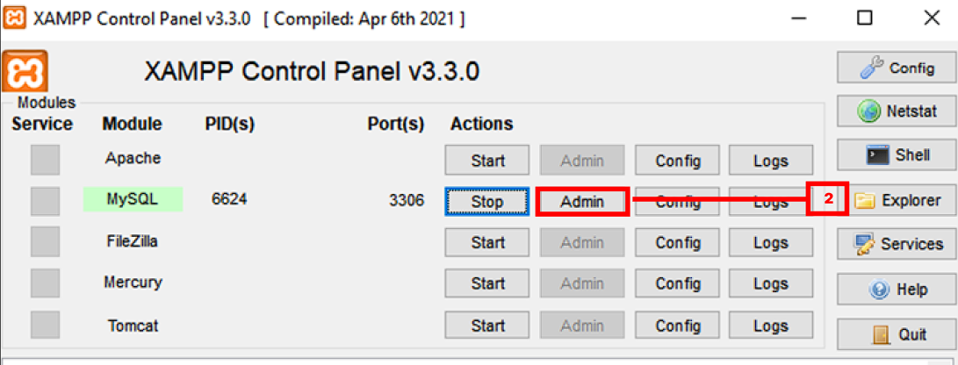

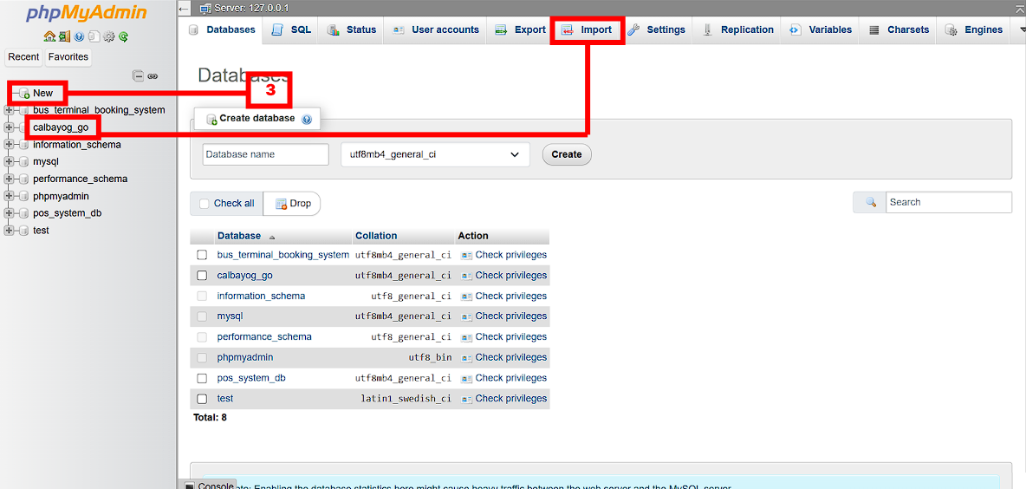

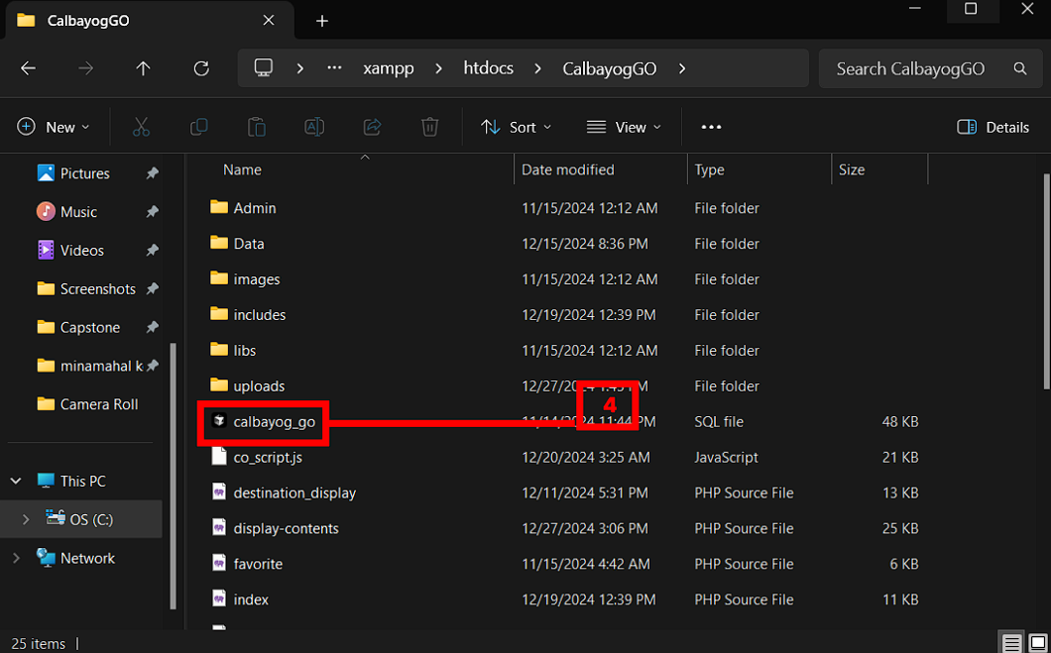

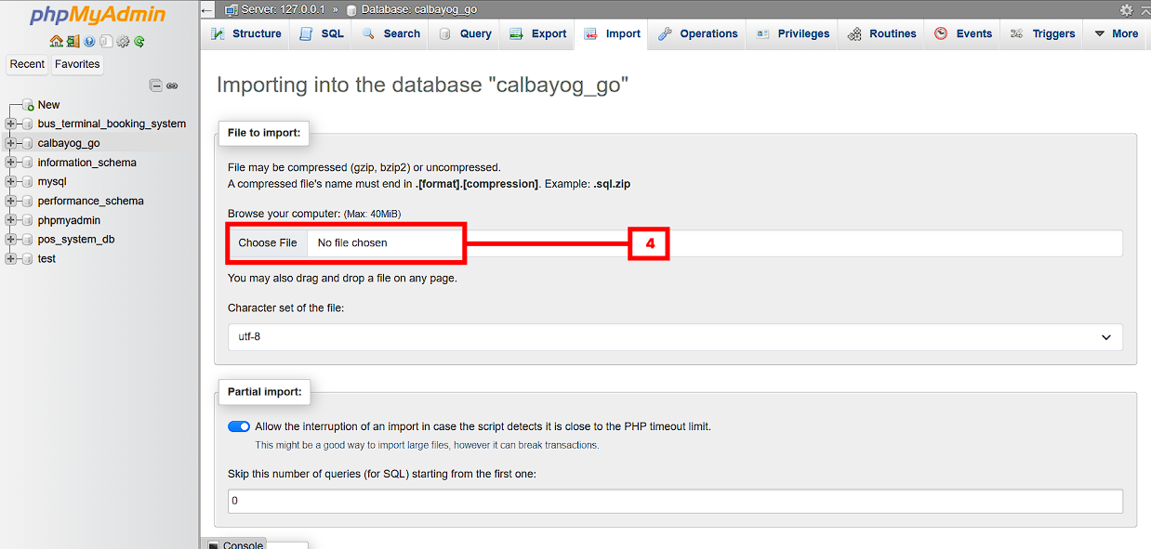

Figure 12. How to set up the Application and Database
- Paste the source code into the “htdocs” folder after opening the “xampp” folder on your drive.
- Click MySQL Module’s “Admin” button in the xampp control panel.
- To create a database, click the “New” button and give it the name “calbayog_go”. Once the creation process is complete, select your database and select “Import”.
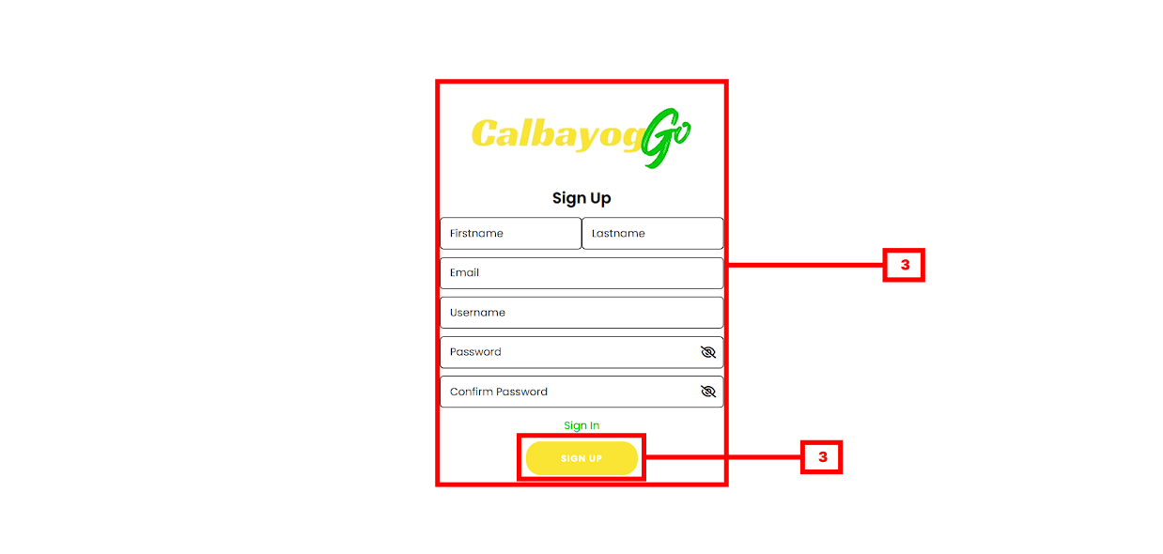
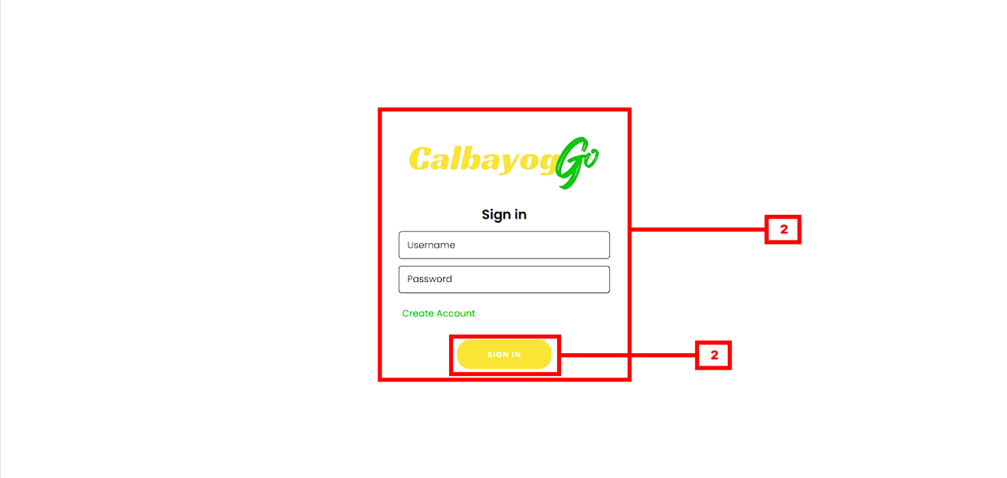
- To choose the “calbayog_go" SQL file, click “choose file” field and look through the folder of CalbayogGO, click the “calbayog_go” SQL file and scroll through the database and click the “Import” button.
Figure 13. Registration and Login of the User
- Go to http://localhost/CalbayogGO/user-signup.php to access and register as student or go to http://localhost/CalbayogGO/user-login.php to use your account.
- To login, fill the necessary input fields, then click the “Sign In” button.
- To register, fill the necessary input fields, then click the “Sign Up” button.
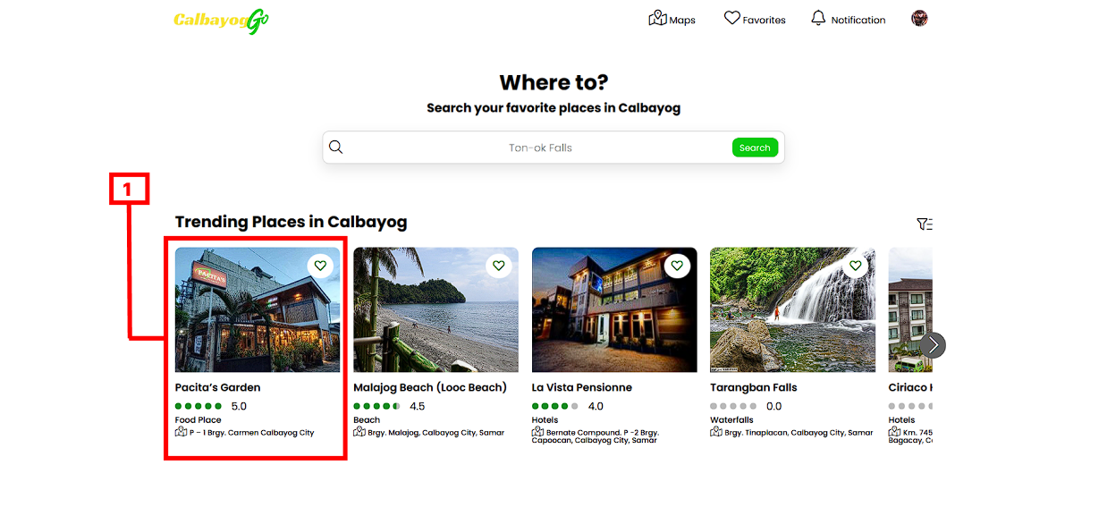
1
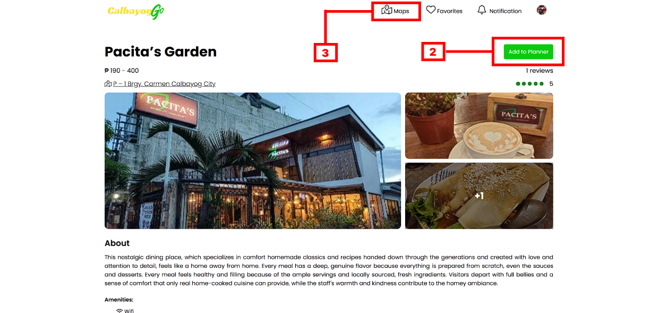
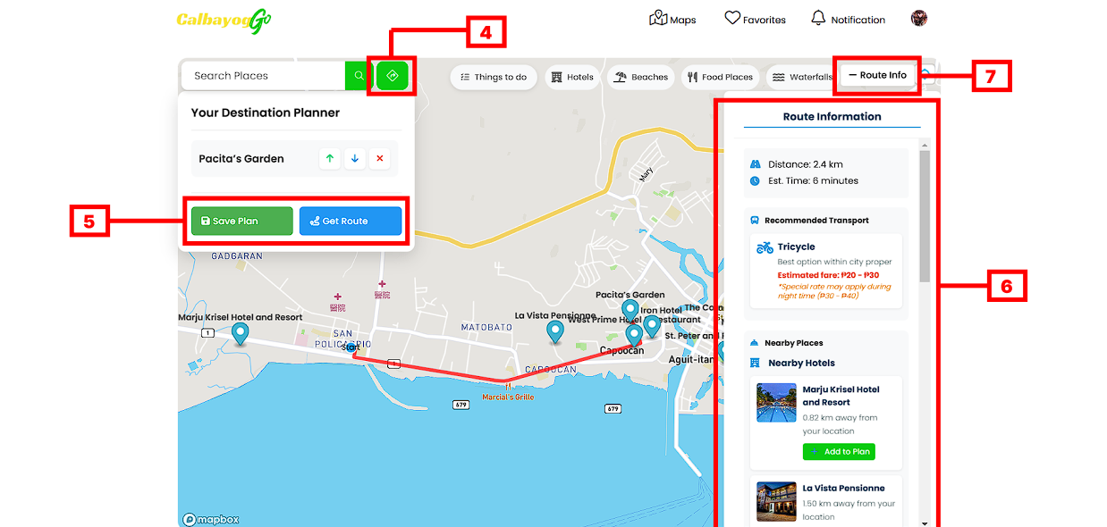
Figure 14. Content Display and Navigation
- Choose any place in the Trending Places section or search for the desired place in the search box.
- Click the "Add to Planner" button to add a place to your planner for navigation.
- Click the "Maps" link to view the location of a place on the map.
- Click the "Destination Planner" to show the places that have been added to the planner.
- Click the 'Save Plan' button to save your travel plan and the 'Get Route' button to get the route to all selected destinations.
- Check the "Route Information" section for details about the route, including distance, estimated time, recommended transport, and nearby places.
- Click the "Route Info" button to show or hide the route details.

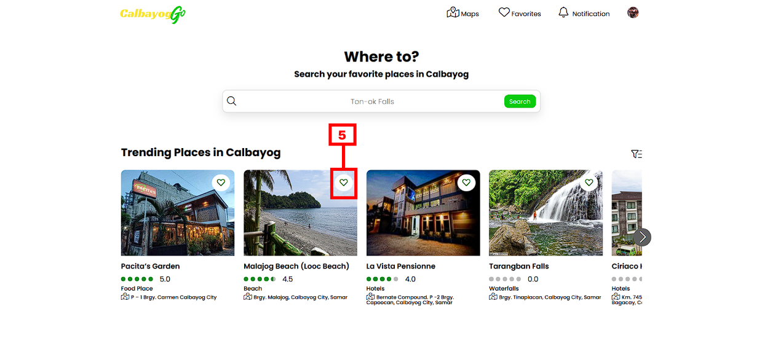
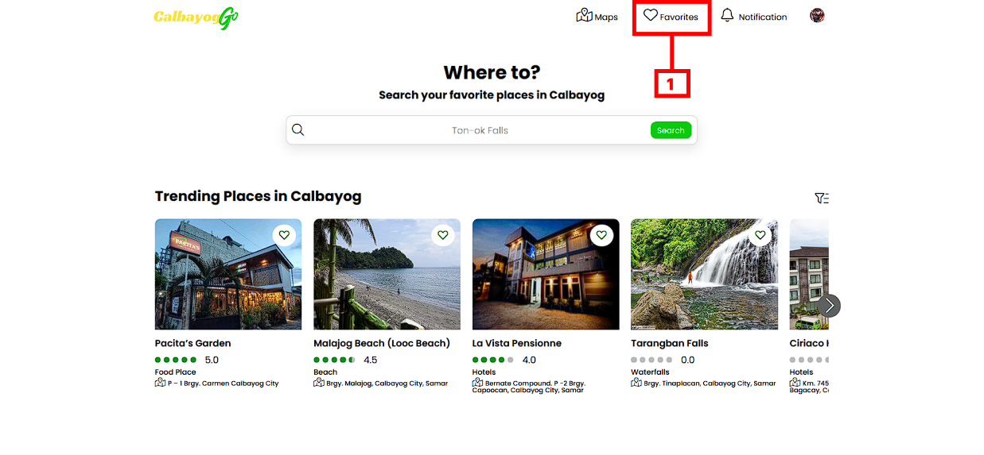
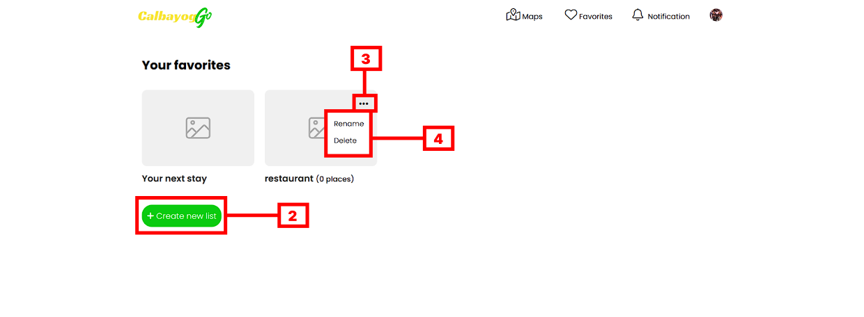

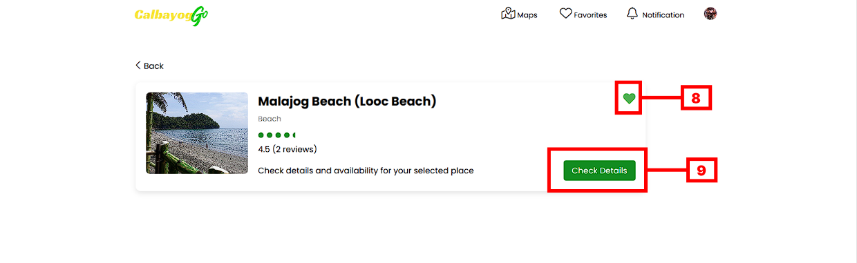
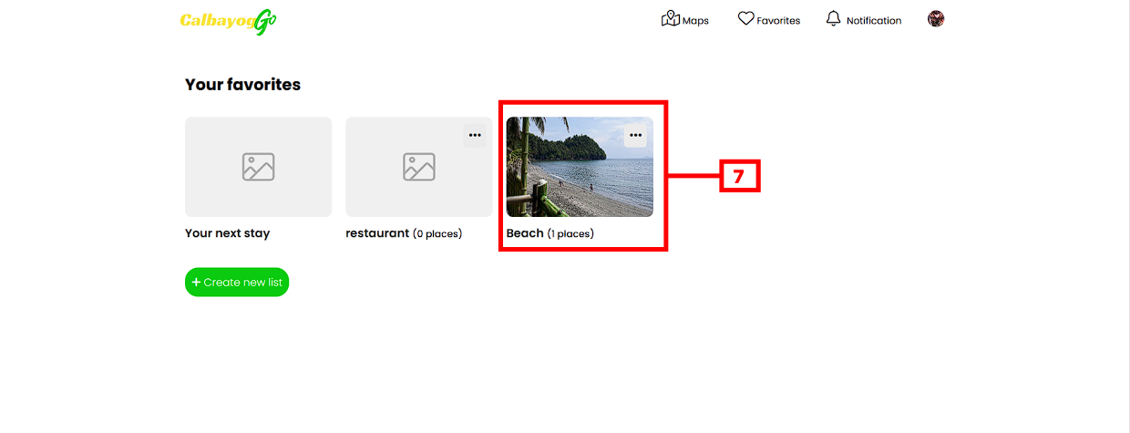
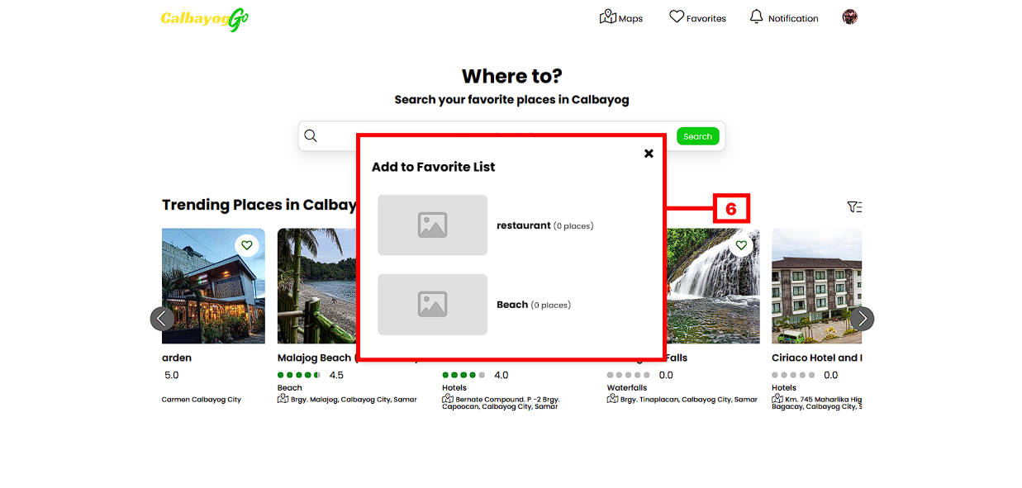
Figure 15. Managing Favorites
- Click 'Favorites' to add and display the places that have been added to favorites.
- Click “Create new list” button to add a new favorite list.
- Click the three-dot menu icon to reveal options for managing the list.
- Click the “Rename” to change the name of the favorite list or click the “Delete” button to remove the list from the favorites.
- Click the heart icon to display the favorite list.
- Choose any of the favorite lists for the place you want to add.
- Click the favorite list to display all the places that have been added to that favorite list.
- Click the hear icon to remove the place on the favorite list.
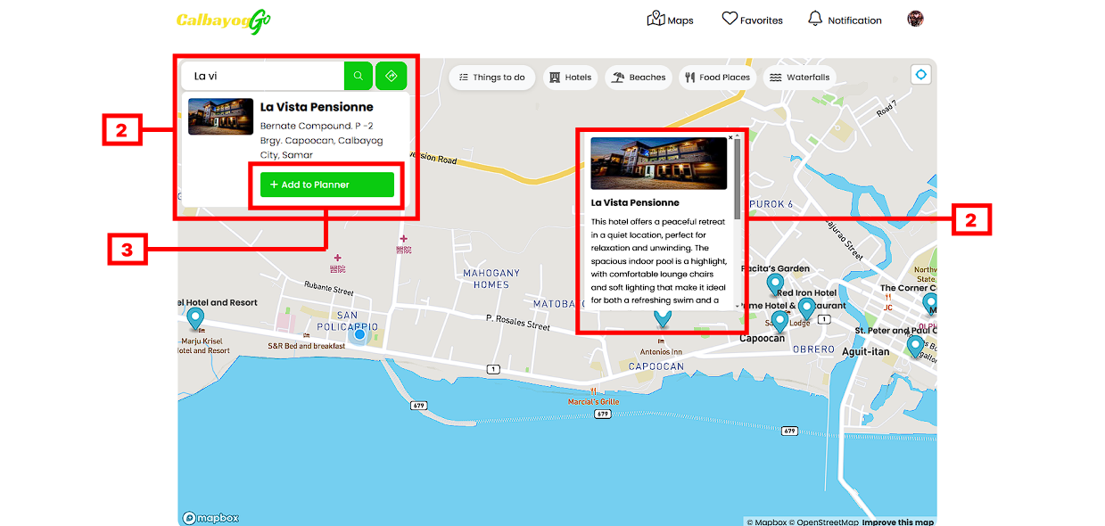
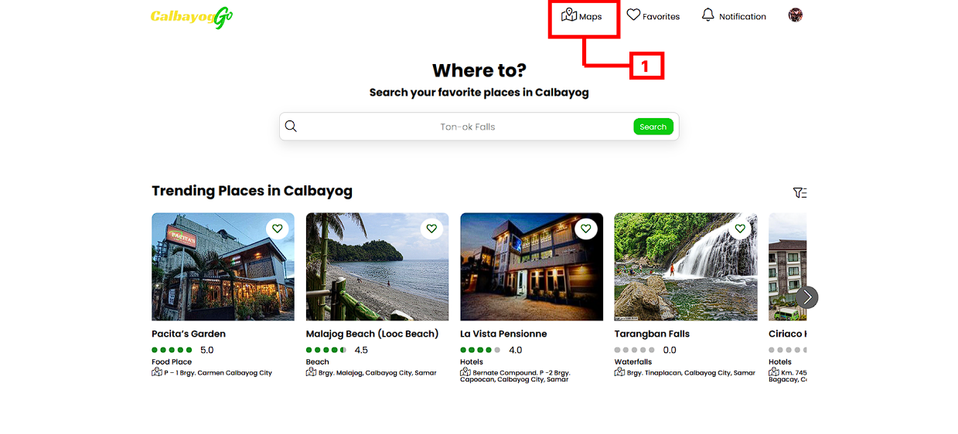
- Click “Check Details” to display the information of the place.
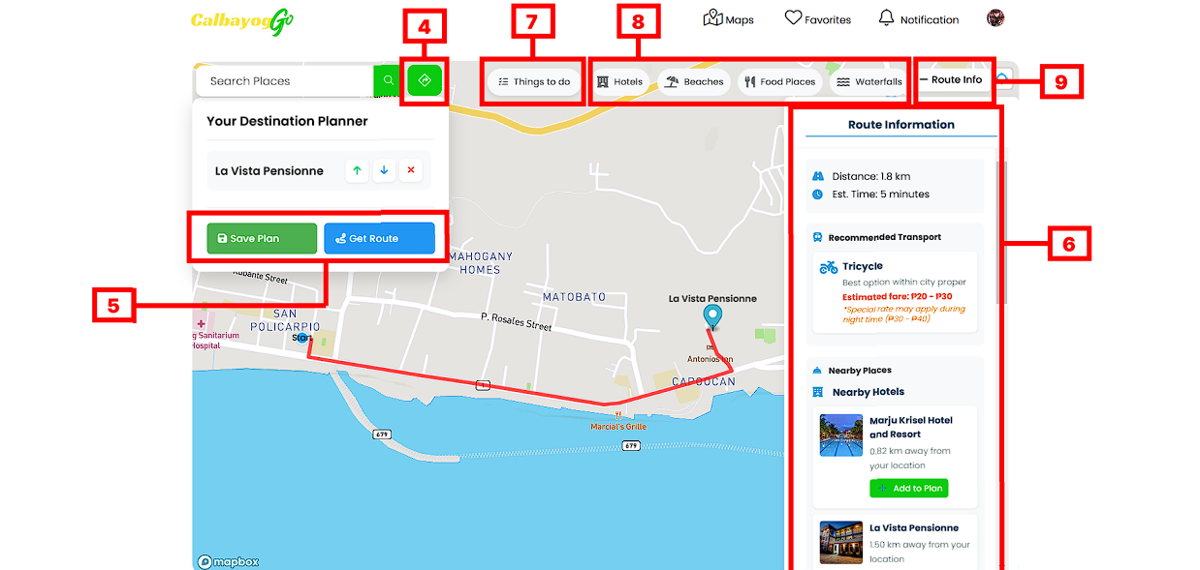
Figure 16. Map Navigation
- Click the "Maps" link to view the location of a place on the map.
- Click the “Search Box” to search for any places you want to visit in Calbayog City, or click any of the place markers to view the information of the place and scroll through to see the “Add to Planner” button.
- Click the "Add to Planner" button to add a place to your planner for navigation.
- Click the "Destination Planner" to show the places that have been added to the planner.
- Click the 'Save Plan' button to save your travel plan and the 'Get Route' button to get the route to all selected destinations.
- Check the "Route Information" section for details about the route, including distance, estimated time, recommended transport, and nearby places.
- Click the "Route Info" button to show or hide the route details.
- Click any specific categories of places to filter out the marks of places on the map.
- Click “Things to Do” to get a recommendation to what based on the reviews and ratings of other users.

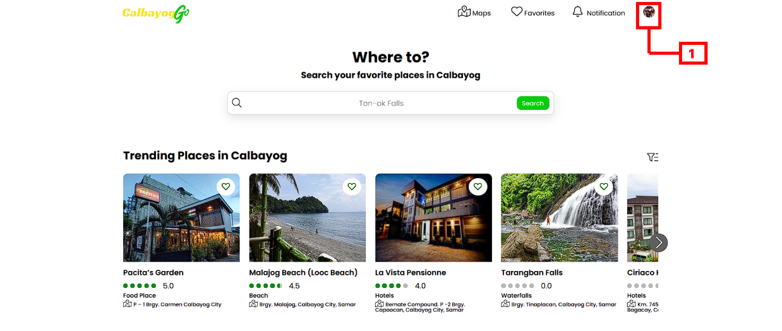

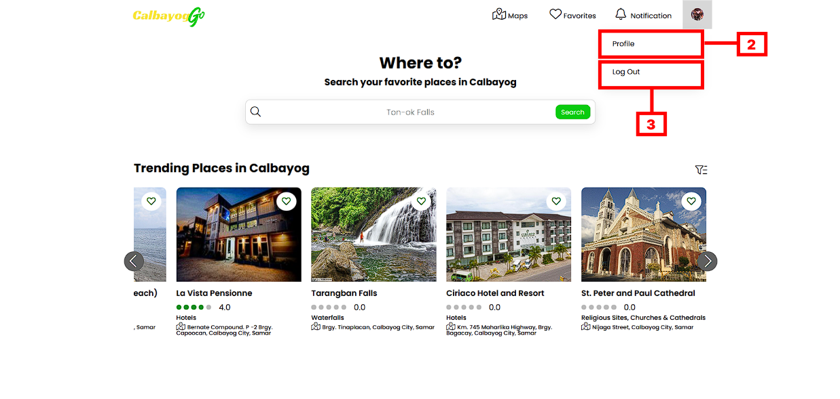
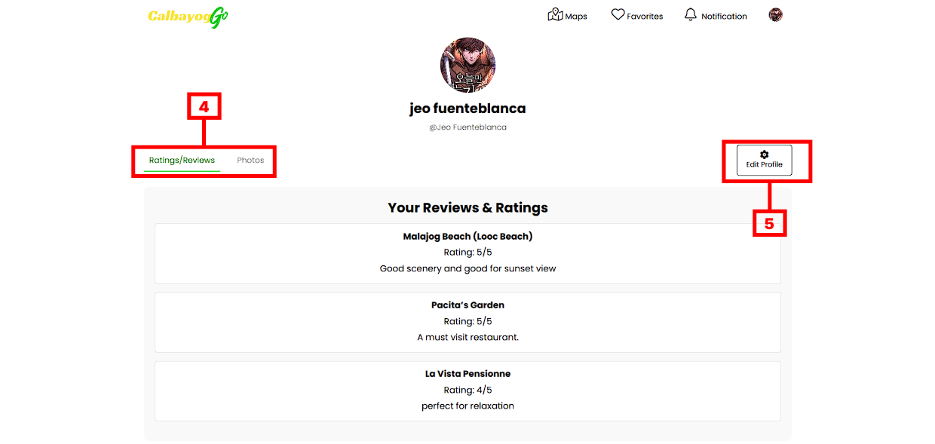
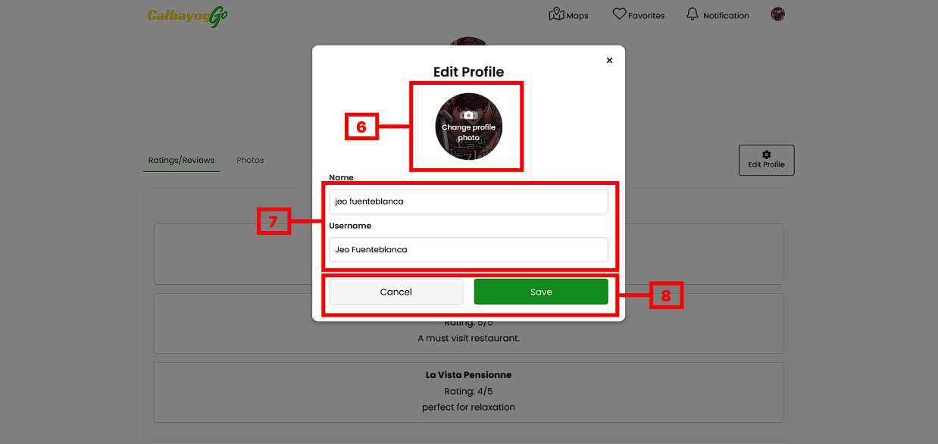
Figure 17. User Profile
- Click the user image to toggle the “Profile” and Logout” options.
- Click “Profile” to see the user reviews & ratings that is been made to the places.
- Click “Logout” to logout the session.
- Choose between the two-tab options "Ratings/Reviews" and "Photos" to display the user's reviews and ratings for various locations, as well as the photos.
- Click “Edit Profile” to update the user information and profile picture.
- Click “Change profile photo” to change the profile picture of the user.
- Click on the "Name" field and type in your full name, then click on the "Username" field and type in your desired username, and finally, click the "Save" button to update your profile information
- Click “Cancel” button to cancel all the changes and click “Save” button to save the changes.
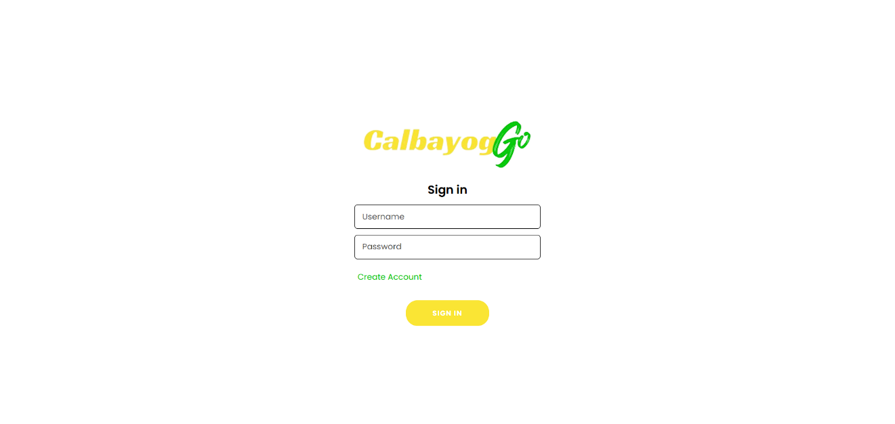
Figure 18. Login Phase of Users and Administrator
- Go to http://localhost/CalbayogGO/user-login.php to access the admin login screen. By giving administrators and users access to a single login page, the system has been developed to improve security while preserving simplicity.
- To login, fill in the necessary fields such as the username and password then click “Sign In” button.

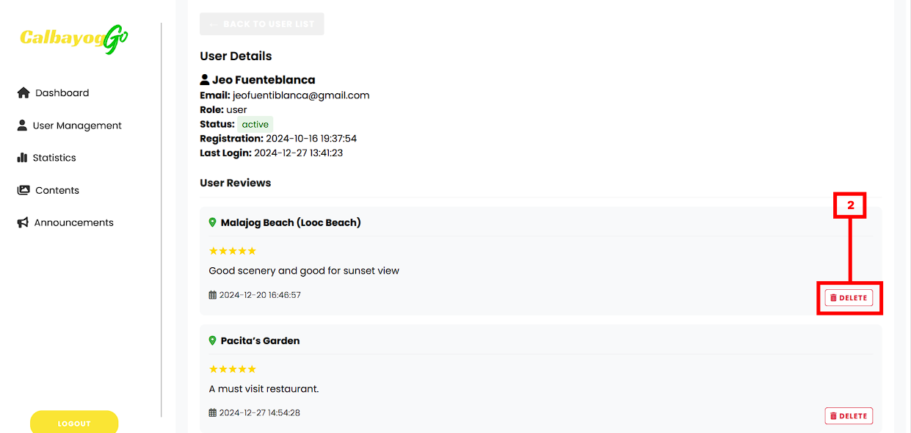
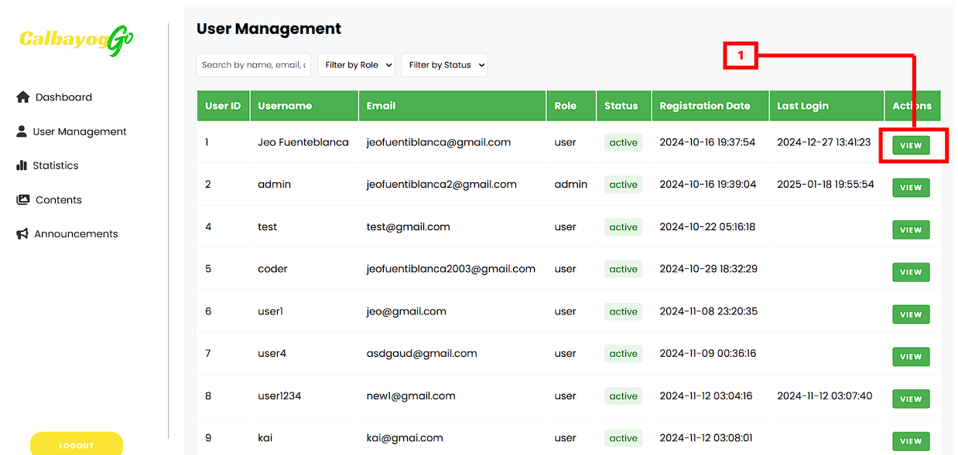
Figure 19. User Management
- Click the “View” button to view user information as well as the user reviews and visited places of the user.
- Click “Delete” button to remove any inappropriate reviews.

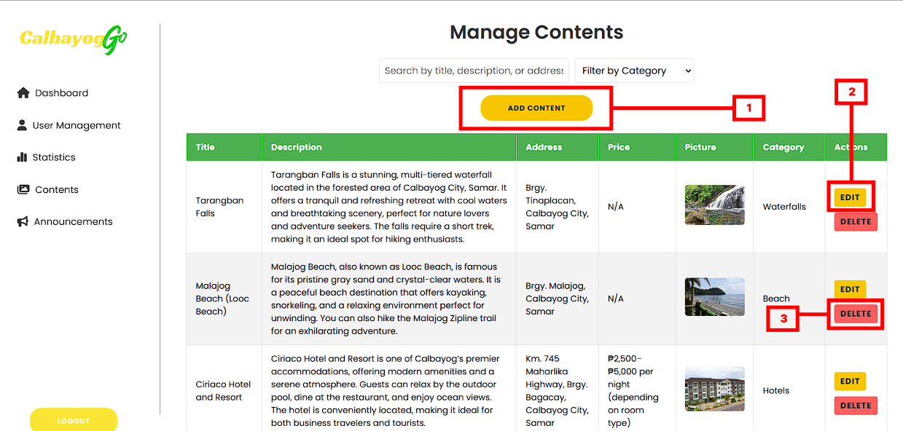
Figure 20. Content Management
- Click the “Add Content” button to add new place.
- Click the 'Edit' button if there is a need to change the information about the place.
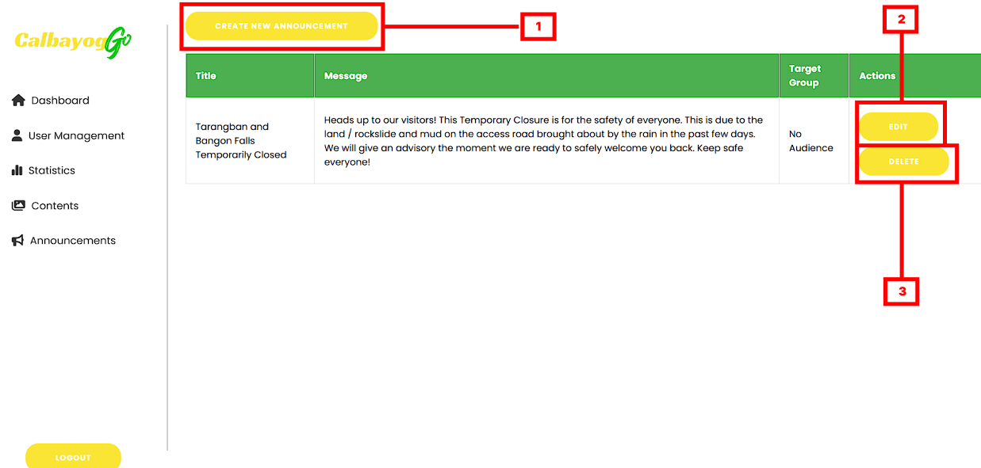
- Click the “Delete” button to remove specific place.
Figure 21. Announcement Management

- Click the “Add Content” button to add announcement.
- Click the 'Edit' button if there is a need to change the information about the announcement.
- Click the “Delete” button to remove specific announcement.
















