NORTHWEST SAMAR STATE UNIVERSITY • COLLEGE OF COMPUTING AND INFORMATION SCIENCES
RESCUE VEHICLE MANAGEMENT SYSTEM (RVMS)
PROBLEM (1st Slide)
Base from our interviews:
•Bureau of Fire Protection (BFP): Relies on physical paper BLOWBAGETS checklists and manual ledger cards, relaying vehicle availability to the LGU via text messages only after maintenance events.
•City Disaster Risk Reduction and Management Office (CDRRMO): Lacks standardized daily inspection forms; vehicle readiness is tracked informally through group chats and physical vehicle labeling.
•City Health Office (CHO): Depends on informal, driver-triggered verbal defect reporting; dispatchers confirm vehicle readiness by sight since all ambulances share the same compound.
•Philippine National Police (PNP): Communicates maintenance concerns strictly through verbal reporting with zero formal fleet documentation at the station level.
Other research studies:
1. Mimbala et al. (2024) • Vinay M. G. et al. (2025):Observed that manual logbook-based vehicle monitoring and paper processes in institutional settings lead to inaccurate records, poor data accessibility, and permanent data loss— leading to agency dispatchers and administrators cannot quickly retrieve reliable vehicle information during critical emergency operations.
2. Crespo del Castillo & Parlikad (2024) • Gallega (2025):Determined that inadequate and disconnected maintenance scheduling severely increases the risk of unexpected vehicle failures and operational downtime— with the consequence that public emergency vehicles face catastrophic roadside breakdowns when preventative maintenance is not tracked systematically.
3. Carlos Bolaños et al. (2022) • Nerona et al. (2025):Reported that emergency fleet operations without centralized dispatch coordination and automated reporting suffer from poor operational visibility, difficulty consolidating records in local government, and reduced accountability— this means agency heads cannot verify fleet readiness or hold personnel accountable for vehicle damage and mission delays.
SOLUTION (2nd Slide)
To resolve documentation gaps and operational risks, the proponents developed the Rescue Vehicle Management System (RVMS), a centralized two-platform digital solution connecting field drivers and agency administrators in real time:
1. Android Mobile Application (For Authorized Drivers):
•Digital BLOWBAGETS Inspections: Standardized pre-trip safety checklist (12 standard items + 2 BFP-specific hydraulic/fire pump items) with required remarks for flagged items.
•Standardized Damage Reporting: Direct mobile submission of defect descriptions, affected parts, and optional photo attachments.
•Push Notifications: Real-time mobile alerts for preventive maintenance schedules and vehicle status changes.
2. Web Administrative Dashboard (For Agency Administrators):
•Centralized Fleet & Driver Management: Secure records for vehicle profiles, driver credentials, and automated driver license expiry monitoring.
•Vehicle Availability Visibility: Standardized tracking across four operational states: Operational, Dispatched, Not Operational, and Under Preventive Maintenance.
•Dispatch Logging: Automatic vehicle status transition to Dispatched upon rollout and return to Operational with chronological odometer progression.
•Preventive Maintenance (PMS) & Repair Tracking: Mileage-based and time-based scheduling with automated Due Soon/Due threshold alerts.
•Multi-Agency Data Isolation: Role-based access separating CHO, CDRRMO, PNP, and BFP records within a shared, secure database.
•One-Click Reporting: Instant filtered, printable reports with visualized summaries for audits and agency accountability.
OBJECTIVES (3rd Slide)
The main objective of this study is to develop a Rescue Vehicle Management System. Specifically:
1. To input vehicle and driver information.
2. To track vehicle maintenance.
3. To provide an admin module for dispatch and vehicle management.
4. To generate relevant reports.
DEMO (4th Slide)
Live System Demonstration • Mobile App & Web Administrative Dashboard
SYSTEM ARCHITECTURE (5th Slide)
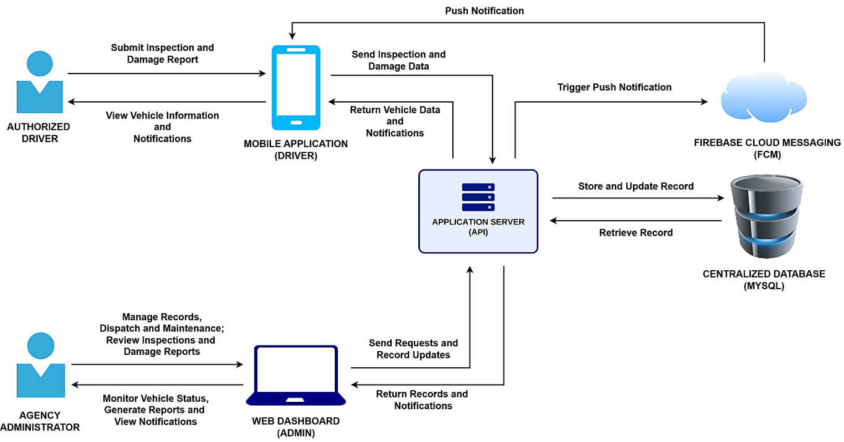
[Image only. Do not add the explanation script to the PPT]
Verbal Defense Pitch Script (What to Say to the Panelists):
“Distinguished members of the panel, Slide 5 illustrates the System Architecture of the Rescue Vehicle Management System. To put it simply: this architecture connects our drivers in the field with office administrators, replacing manual logbooks and group chats so both parties work with the same up-to-date vehicle records.
Structurally, the system is organized into a standard 3-Tier Client-Server Architecture:
1. Client Tier (Presentation Layer): We provide two separate interfaces based on user roles. Emergency drivers use a native Android Mobile Application to submit daily BLOWBAGETS checklists and report vehicle defects on the go. Meanwhile, agency administrators use a Web Dashboard on their computers to oversee vehicle records, coordinate dispatches, schedule preventive maintenance, and review reports.
2. Application Tier (Logic Layer): Both the mobile app and web dashboard communicate with our central Laravel Backend & REST API. This server processes all user requests, enforces data validation, and applies multi-agency data isolation—meaning that CDRRMO, BFP, CHO, and PNP accounts can only access records belonging to their respective agency. It also enforces operational safeguards, such as locking grounded or damaged vehicles from being dispatched.
3. Data Tier (Storage Layer): All data is stored in a centralized MySQL Database. Because both the mobile app and web dashboard connect to this single database through the server, an inspection submitted by a driver or a dispatch closed by an administrator updates the records immediately for everyone.
4. Notification Service: We integrated Firebase Cloud Messaging (FCM) as an external service to handle push notifications. When an administrator updates a vehicle’s status or when a scheduled maintenance date is approaching, the server sends an alert directly to the assigned driver’s phone, even if the app is closed.
In short, this architecture replaces fragmented paper forms with a clean, connected system where daily inspections, repairs, and dispatches are properly recorded and accessible to both drivers and administrators.”
CONTEXT DIAGRAM (6th Slide)
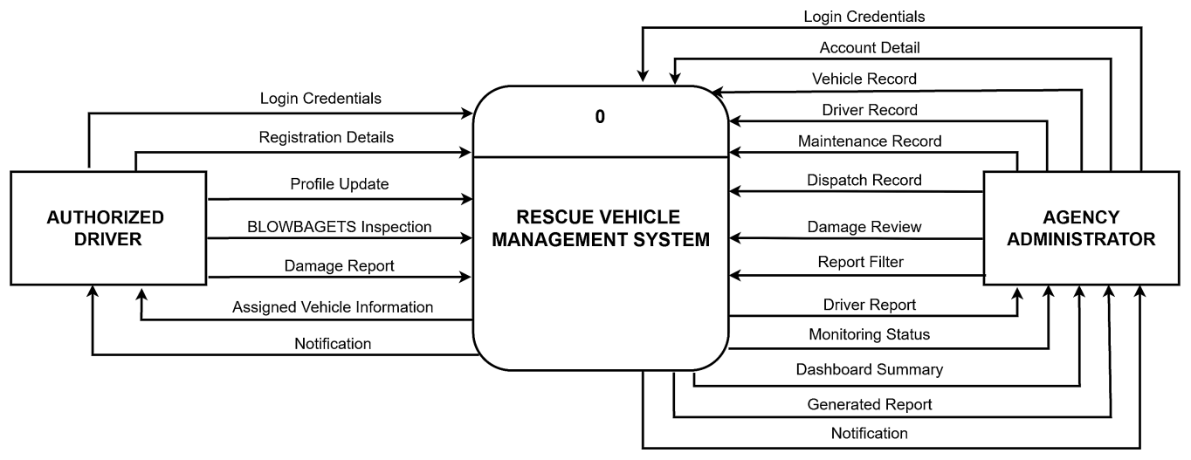
[Image only. Do not add the explanation script to the PPT]
Verbal Defense Pitch Script (What to Say to the Panelists):
“Distinguished members of the panel, Slide 6 presents the Context Diagram (Level 0 DFD) of the Rescue Vehicle Management System. To put this in plain terms: the Context Diagram defines the external boundary of our project—it shows who interacts with the system from the outside and what information flows in and out.
At the center of the diagram is a single process, Process 0: RESCUE VEHICLE MANAGEMENT SYSTEM, representing the entire application as a unified whole. Surrounding it are our two primary external entities: the Authorized Driver on the left and the Agency Administrator on the right. In standard software engineering practice, internal data stores and tables are not shown at this level because database storage happens entirely inside Process 0.
Across this system boundary, exactly twenty data flows govern all operations:
1. Authorized Driver Interactions (7 Data Flows): Through the mobile application, drivers send five inputs into the system—their Login Credentials, Registration Details, Profile Updates, daily BLOWBAGETS Inspections, and Damage Reports. In return, the system provides drivers with two outputs—their Assigned Vehicle Information and automated Notifications regarding maintenance reminders and vehicle status updates.
2. Agency Administrator Interactions (13 Data Flows): Through the web dashboard, administrators provide inputs to configure the system and direct fleet operations, including Login Credentials, Account Details, Maintenance Records, Dispatch Records, Damage Reviews, and Report Filters. Two bidirectional flows—Vehicle Records and Driver Records—allow administrators to both input and retrieve fleet profiles. In return, the system supplies administrators with five outputs: Driver Reports, real-time Monitoring Status for vehicle availability and license alerts, Dashboard Summaries, printable Generated Reports, and system Notifications.
Most importantly for our target clients, while all twenty data flows pass through this single digital platform, the system strictly separates each agency’s operational data, ensuring that CDRRMO, BFP, CHO, and PNP only manage records belonging to their respective office.”
DATA FLOW DIAGRAM — Authorized Driver Operations (7th Slide)
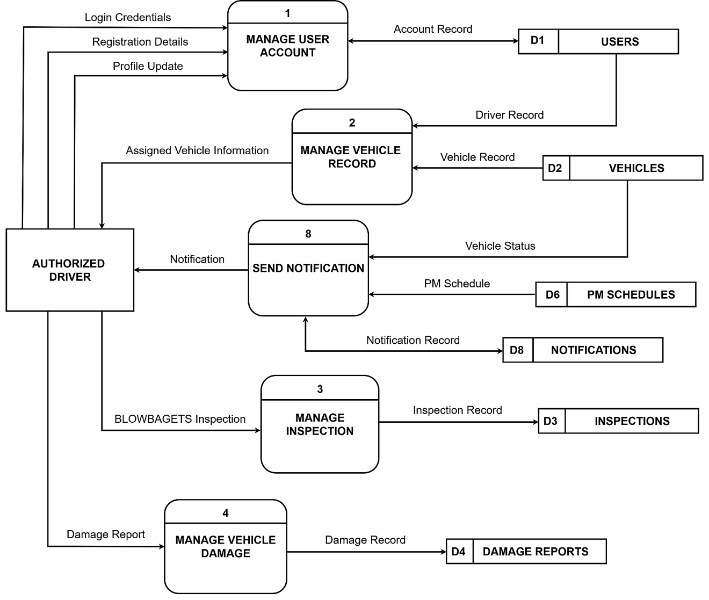
[Image only. Do not add the explanation script to the PPT]
Verbal Defense Pitch Script (What to Say to the Panelists):
“Distinguished members of the panel, Slide 7 presents the Authorized Driver Operations view of our Data Flow Diagram. While the Context Diagram in Slide 6 viewed the system as a single black box, this Level 1 diagram opens up Process 0 to reveal the five specific processes our emergency drivers interact with through the Android mobile app, and the persistent data stores they access.
Across this mobile subsystem, all seven driver data flows from the Context Diagram are strictly conserved across five processes:
1. Process 1 (Manage User Account): Through the mobile application, the driver submits their Login Credentials, Registration Details, and Profile Updates. This process authenticates credentials, manages driver registration status, and securely stores driver profile and device push token details into D1 Users.
2. Process 2 (Manage Vehicle Record): When the driver signs in, this process reads the driver profile from D1 Users and the assigned unit specifications from D2 Vehicles, returning the Assigned Vehicle Information—including plate number, vehicle model, and initial mileage—directly to the driver’s mobile home screen.
3. Process 3 (Manage Inspection): Before taking a rescue vehicle on the road, the driver conducts a mandatory pre-trip check and submits the digital BLOWBAGETS Inspection checklist. The process verifies all items, enforces mandatory remarks on any flagged mechanical defects, and writes the structured record into D3 Inspections.
4. Process 4 (Manage Vehicle Damage): If an emergency unit encounters sudden mechanical failure, collision, or physical wear during field operations, the driver submits a Damage Report with severity details and attached photo evidence, writing an incident record into D4 Damage Reports.
5. Process 8 (Send Notification): To keep drivers informed, this process checks vehicle readiness in D2 Vehicles and upcoming service milestones in D6 PM Schedules, records the alert in D8 Notifications, and delivers real-time push Notifications directly to the driver's phone via Firebase Cloud Messaging.
Crucially for operational safety, drivers are granted read-only visibility into their assigned vehicles and have zero capability to alter fleet availability statuses or view vehicles belonging to other agencies—guaranteeing strict operational integrity and accountability.”
DATA FLOW DIAGRAM — Agency Administrator Operations (8th Slide)
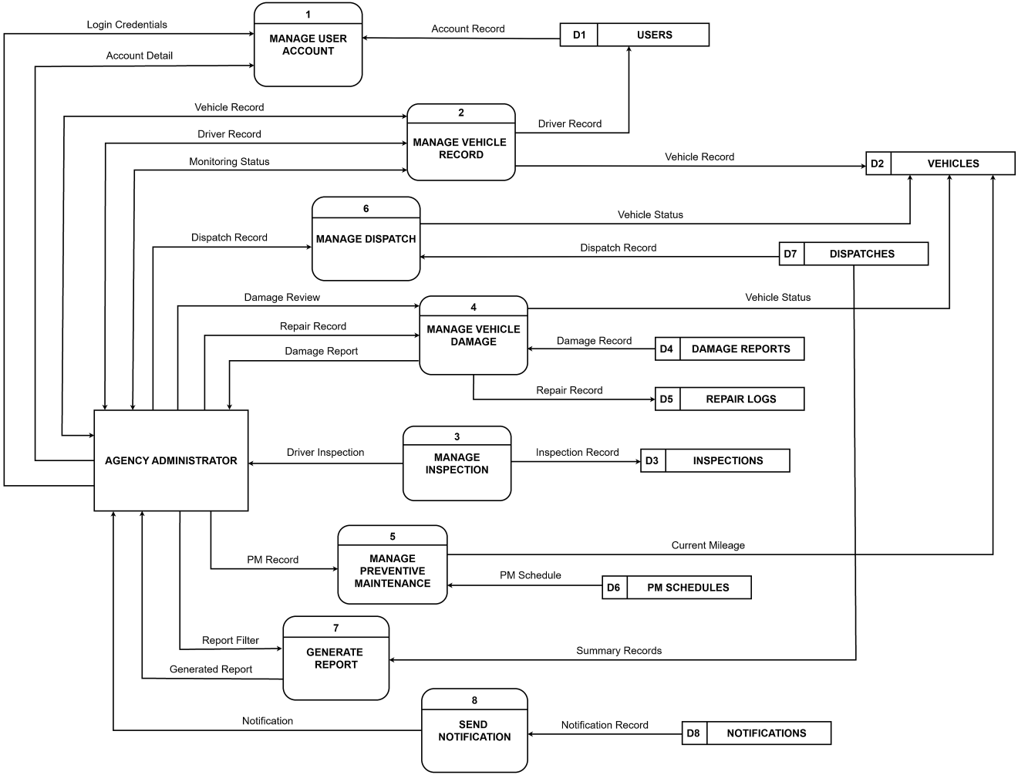
[Image only. Do not add the explanation script to the PPT]
Verbal Defense Pitch Script (What to Say to the Panelists):
“Distinguished members of the panel, Slide 8 illustrates the Agency Administrator Operations view of our Data Flow Diagram. While drivers access five mobile processes, the Agency Administrator sits at the central command desk on the web dashboard, interacting with all eight system processes and governing all eight data stores (D1 through D8).
All thirteen administrative data flows from the Context Diagram are mapped across the eight processes:
1. Process 1 (Manage User Account): The administrator submits Login Credentials and Account Details to authenticate, vet pending driver sign-ups, and update administrative accounts in D1 Users.
2. Process 2 (Manage Vehicle Record): The administrator exchanges Vehicle Records and Driver Records bidirectionally with D1 Users and D2 Vehicles to register vehicles, assign drivers, and monitor fleet readiness. In return, the system feeds the real-time Monitoring Status stream, highlighting vehicle availability states and driver license or TESDA NC II expiration warnings.
3. Process 3 (Manage Inspection): The administrator accesses submitted daily pre-trip records from D3 Inspections through the Driver Report interface, reviewing checklist results and triaging flagged defects.
4. Process 4 (Manage Vehicle Damage): When defects or damages are reported, the administrator conducts a Damage Review on D4 Damage Reports and enters corrective maintenance details via Repair Record into D5 Repair Logs. If severe damage is identified, this process automatically updates the vehicle status in D2 Vehicles to 'Not Operational' to prevent unsafe dispatch.
5. Process 5 (Manage Preventive Maintenance): The administrator logs scheduled servicing policies via PM Record, tracking mileage intervals against Current Mileage readings pulled from D2 Vehicles to manage Upcoming, Due Soon, and Overdue milestones in D6 PM Schedules.
6. Process 6 (Manage Dispatch): The administrator logs emergency and official trips via Dispatch Record into D7 Dispatches, recording trip orders, driver crew, and departure/return odometer readings while automatically toggling vehicle status in D2 Vehicles between 'Operational' and 'Dispatched'.
7. Process 7 (Generate Report): The administrator applies a multi-criteria Report Filter to query records across operational stores D1 through D7, generating the live Dashboard Summary and audit-compliant printable Generated Reports.
8. Process 8 (Send Notification): This process aggregates system events from D8 Notifications and presents administrative in-app Notifications for unreviewed damage reports, flagged inspections, approaching PMS, and expiring licenses.
Together, Slides 7 and 8 prove that every single one of the twenty data flows established in our Context Diagram is fully accounted for without data leakage. Most importantly, all eight processes strictly filter transactions using the administrator's agency_id, guaranteeing complete data isolation among CDRRMO, BFP, CHO, and PNP.”
FUNCTIONAL DECOMPOSITION DIAGRAM (9th Slide)
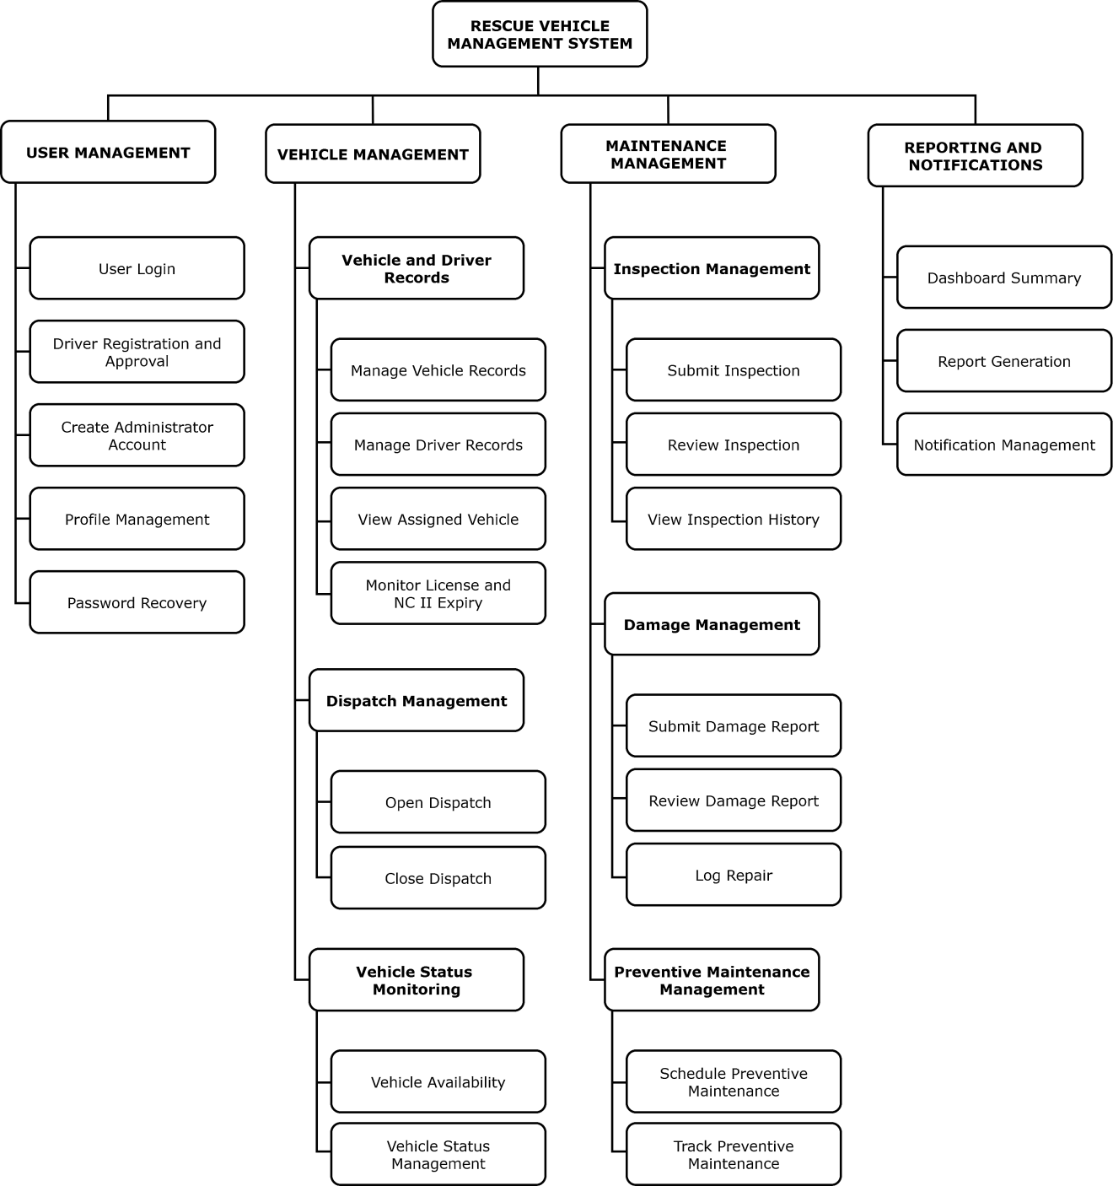
[Image only. Do not add the explanation script to the PPT]
Verbal Defense Pitch Script (What to Say to the Panelists):
“Distinguished members of the panel, Slide 9 presents the Functional Decomposition Diagram (FDD) of the Rescue Vehicle Management System. While our Data Flow Diagrams illustrated the movement and storage of data across time, the FDD provides an architectural, top-down view of the entire system as an organizational structure. It maps out what the system actually does, breaking down our overarching platform into four core operational subsystems and twenty-six granular functional components that served as our development blueprint.
Starting from the Rescue Vehicle Management System at the root, the platform branches into four primary operational pillars:
1. User Management: Governs identity, access control, and credential lifecycles. This module encompasses secure authentication (login and password recovery), driver mobile self-registration, administrative vetting and approval workflows, staff account management, and profile updates.
2. Vehicle Management: Serves as the operational core for fleet logistics. It encompasses vehicle specifications and custom emergency presets, authorized driver and co-driver assignments, driver license and TESDA NC II expiry tracking, dispatch trip logging (travel orders and odometer tracking), and automated vehicle availability state monitoring (Operational, Dispatched, Not Operational, Under Preventive Maintenance).
3. Maintenance Management: Subdivided into three critical maintenance disciplines:
• Inspection Management: Standardized 12-item daily BLOWBAGETS checklists on mobile, mandatory defect remarks, and administrative review triage.
• Damage Management: Immediate incident defect reporting with photographic evidence, severity classification, and administrative corrective repair logging (including parts replaced and repair facility tracking).
• Preventive Maintenance Management: Distance-based and calendar-based service scheduling (Upcoming, Due Soon, Due, Completed), automated mileage comparisons against live odometers, and service history tracking.
4. Reporting and Notifications: Translates operational data into actionable oversight. It provides real-time dashboard analytics, customizable multi-agency report filtering with audit-ready printable tables, and multi-channel notifications (in-app administrative notifications and Android push alerts via Firebase Cloud Messaging).
In summary, this functional breakdown guarantees that every single one of the twenty-six Functional Requirements evaluated by our panel and institutional clients is systematically organized, modularized, and accounted for—ensuring high cohesion, clean separation of concerns, and long-term maintainability for Calbayog City emergency services.”
ENTITY RELATIONSHIP DIAGRAM — Authorized Driver Operations (10th Slide)
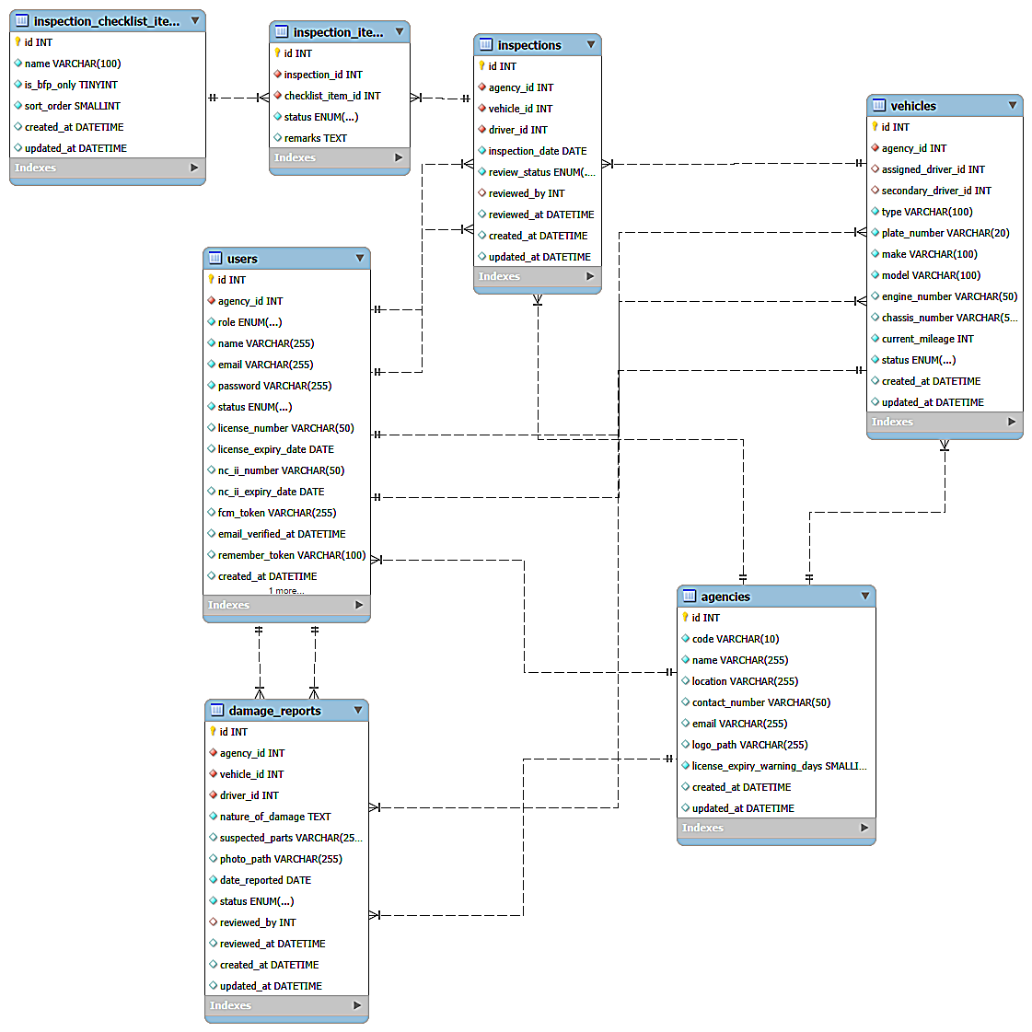
[Image only. Do not add the explanation script to the PPT]
Verbal Defense Pitch Script (What to Say to the Panelists):
“Distinguished members of the panel, Slide 10 presents the Authorized Driver Operations view of our Entity Relationship Diagram (ERD). In any mission-critical municipal system, the database is the foundation of data integrity. To guarantee visual clarity and prevent diagrammatic clutter, we decomposed our database schema into two complementary operational views. This tenth slide focuses specifically on the relational structure powering driver authentication, vehicle assignments, daily pre-trip inspections, and incident reporting across seven interconnected domain entities.
Walking through these seven domain tables using standard Crow’s Foot notation:
1. agencies (Multi-Tenancy Anchor): Every municipal office—CDRRMO, BFP, CHO, and PNP—is defined here. Through its primary key, agencies enforces a strict one-to-many relationship with users and vehicles via their agency_id foreign keys, guaranteeing that drivers and rescue units are permanently isolated by agency.
2. users: Stores driver accounts, verification statuses, and encrypted credentials. Beyond basic contact info, it explicitly stores driver_license_expiry_date and tesda_nc2_expiry_date, which our automated notification engine evaluates to alert administrators well before professional credentials lapse.
3. vehicles: Represents the physical rescue fleet. A one-to-many relationship links users to vehicles through assigned_driver_id for the primary designated operator, alongside secondary_driver_id to accommodate dual-crewed emergency units such as ambulances and fire trucks.
4. inspections: Captures header records for daily pre-trip checks, establishing mandatory foreign key links to the evaluated vehicle (vehicle_id), the inspecting driver (driver_id), and the reviewing administrator (reviewed_by).
5. inspection_checklist_items & inspection_items (Catalog Normalization): Rather than storing checklist criteria as fragile unnormalized text blobs, we normalized inspections into a catalog-driven structure. The inspection_checklist_items catalog stores standard BLOWBAGETS criteria (Battery, Lights, Oil, Water, Brakes, Air, Gas, Engine, Tire, Self, Tools, Documents). When a driver submits a check, inspection_items logs line-item evaluations (OK or Has Issue) and captures mandatory driver remarks for noted defects, linked via checklist_item_id.
6. damage_reports: When collisions or component breakdowns occur in the field outside morning checks, this table logs the incident, establishing foreign key relations with vehicles, users, and the reviewing administrator. It records defect severity, component classification, narrative descriptions, and storage file paths for uploaded photographic evidence.
By anchoring all seven entities to foreign key constraints and enforcing third normal form (3NF), this schema eliminates data redundancy and guarantees that no inspection or damage report can ever become an orphan record.”
ENTITY RELATIONSHIP DIAGRAM — Agency Administrator Operations (11th Slide)
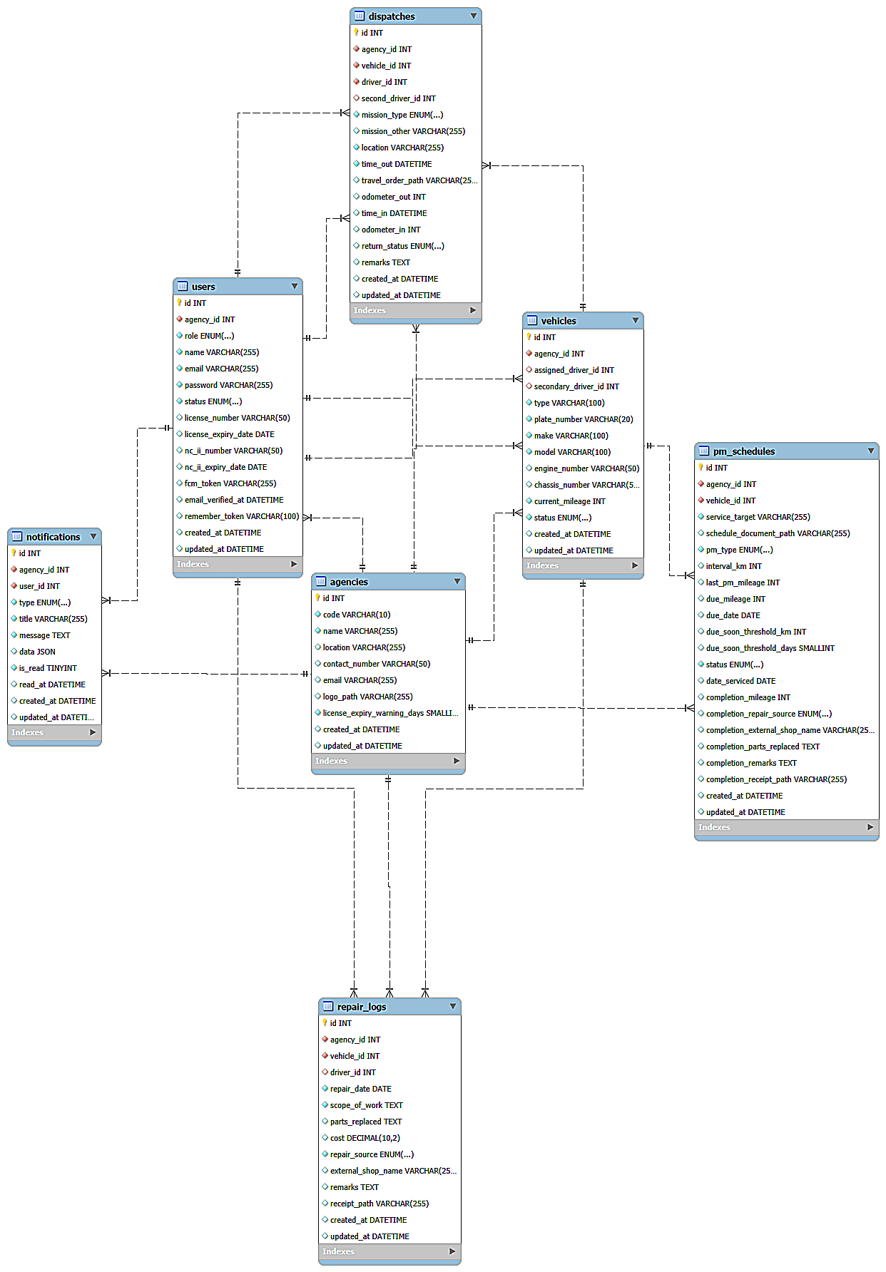
[Image only. Do not add the explanation script to the PPT]
Verbal Defense Pitch Script (What to Say to the Panelists):
“Distinguished members of the panel, Slide 11 presents the Agency Administrator Operations view of our Entity Relationship Diagram. This view details the administrative and fleet governance domain, modeling how our central MySQL database coordinates vehicle dispatches, preventive maintenance schedules, corrective repair logs, and automated notifications across seven domain tables.
Examining the administrative relational model:
1. vehicles (Operational State Core): In this subsystem, vehicles acts as the central source of truth for fleet readiness. It maintains the unified operational availability status—strictly constrained to Operational, Dispatched, Not Operational, and Under Preventive Maintenance—and tracks live cumulative odometer mileage.
2. dispatches: Governs mission rollouts and official travel. Each record establishes foreign key relationships with the deployed unit in vehicles (vehicle_id), the primary driver in users (driver_id), and an optional second driver (second_driver_id). It records official travel order numbers, mission destinations, and departure/return timestamps and odometer readings, automatically toggling the vehicle’s status between Operational and Dispatched.
3. pm_schedules: Powers our proactive maintenance tracking. Each schedule links to a specific vehicle in vehicles and defines either mileage-based thresholds (e.g., every 5,000 km) or calendar time-based intervals (e.g., every 6 months). It dynamically tracks service states across Upcoming, Due Soon, Due, and Completed based on live vehicle odometer updates.
4. repair_logs: Serves as an immutable financial and mechanical ledger for corrective servicing. Linked to vehicles and the requesting driver, it records comprehensive repair scopes, itemized parts replaced, total monetary costs, and external servicing motorpool details (such as the Calbayog City GSO Motorpool or contracted commercial repair shops).
5. notifications: Manages event-driven communication. Every time a damage report is filed, a checklist item is flagged, a driver’s license nears expiration, or PMS falls due, a structured alert is logged here with a foreign key to user_id, driving both web dashboard badge counters and mobile push notifications.
6. agencies & users: Continue to serve as the identity and multi-tenancy foundation, ensuring that dispatch histories, maintenance schedules, and repair expenditures remain strictly private to each operating agency.
Together, Figures 6.1 and 6.2 account for all eleven core domain tables of the Rescue Vehicle Management System. The schema is normalized to Third Normal Form (3NF), preserves strict referential integrity with ON DELETE RESTRICT on audit records, and ensures that Calbayog City emergency agencies maintain a permanent, tamper-resistant digital history of all rescue operations.”
IMPLEMENTATION RESULTS (Slides 12 to 15)
IMPLEMENTATION RESULTS — Objective 1: Input Driver and Vehicle Information (12th Slide)
[Slide Visual Instructions: This slide will only contain screenshot images. Copy and paste Figure 7.1 (Add Driver Input Form Modal), Figure 7.2 (Add Vehicle Input Form Modal), and/or Figure 7.3 (Mobile Driver Sign In and Self-Registration Screen) from Chapter 4 of the manuscript into the PPT slide]
[Image only. Do not add the explanation script to the PPT]
Verbal Defense Pitch Script (What to Say to the Panelists):
“Distinguished members of the panel, Slide 12 presents the implementation results for our First Objective: to input vehicle and driver information. The screenshots displayed on this slide demonstrate how our web dashboard and mobile application replace vulnerable, paper-based logbooks with standardized digital registration across participating rescue agencies.
Key Findings and Operational Results:
• Manual Logbooks with Digital Forms: Agency administrators encode vehicle specifications and personnel profiles through structured web modals with built-in validation, eliminating unreadable, missing, or fragmented paper records.
• Standardizes Vehicle Profiles: Accommodates emergency presets (Ambulance, Fire Truck, Rescue Vehicle, Patrol Car) and dynamic 'Other' custom entries, accurately recording plate numbers, engine/chassis numbers, and starting odometer readings.
• Enforces Driver Crew Assignment & Accountability: Administrators assign designated primary and optional secondary drivers directly from vetted personnel, restricted strictly to active drivers within their own agency to prevent cross-agency errors.
• Monitors Professional Qualifications: The database securely captures driver's license numbers, license expiration dates, and TESDA National Certificate II (NC II, Driving) credentials, feeding automated advance renewal alerts before qualifications lapse.
• Secure Mobile Self-Registration: Emergency drivers can self-register directly through the Android mobile app, but accounts are automatically held in 'Pending' status until vetted and approved by their agency administrator.
In simple terms, Objective 1 establishes a verified, up-to-date digital directory of all emergency vehicles and qualified rescue personnel across CDRRMO, BFP, CHO, and PNP.”
IMPLEMENTATION RESULTS — Objective 2: Track Vehicle Maintenance (13th Slide)
[Slide Visual Instructions: This slide will only contain screenshot images. Copy and paste Figure 8.1 (Submitted Inspection with Flagged Defect), Figure 8.2 (Mobile Damage Report Form), Figure 8.3 (Inspections & Damage Triage Dashboard), and/or Figure 8.4 (Preventive Maintenance Schedules Interface) from Chapter 4 of the manuscript into the PPT slide]
[Image only. Do not add the explanation script to the PPT]
Verbal Defense Pitch Script (What to Say to the Panelists):
“Distinguished members of the panel, Slide 13 showcases the implementation results for our Second Objective: to track vehicle maintenance. The screenshots on this slide illustrate our multi-tiered maintenance pipeline, connecting daily driver checks in the field directly to proactive administrative scheduling.
Key Findings and Operational Results:
• Standardized Daily BLOWBAGETS Inspections: Drivers complete mandatory digital pre-trip checks on mobile covering 12 standard safety items (Battery, Lights, Oil, Water, Brakes, Air, Gas, Engine, Tire, Self, Tools, Documents). Flagged defects mandate detailed explanatory remarks before submission.
• Immediate Field Damage Reporting: When sudden road breakdowns or collision incidents occur outside morning checks, drivers submit structured damage reports with severity classifications, defective component flags, and attached photo evidence taken from the scene.
• Centralized Administrative Triage: Agency administrators review all submitted inspections and incident reports on a single dashboard table, where units with mechanical defects are visually highlighted with warning badges for immediate triage.
• Automated Preventive Maintenance (PMS): Replaces reactive breakdown maintenance with distance-based (e.g., 5,000 km oil changes) and calendar-based service intervals, automatically tracking fleet readiness across Upcoming, Due Soon, Due, and Completed tabs.
• Permanent Repair Ledger & Cost Tracking: Maintains an immutable historical record of all corrective repairs, itemizing parts replaced, servicing motorpools (e.g., City GSO Motorpool or external commercial shops), and cumulative financial expenditures in Philippine Pesos (₱).
In simple terms, Objective 2 shifts rescue fleet maintenance from reactive, last-minute breakdown repairs to structured, daily pre-trip inspections and scheduled preventive care.”
IMPLEMENTATION RESULTS — Objective 3: Admin Module for Dispatch and Vehicle Management (14th Slide)
[Slide Visual Instructions: This slide will only contain screenshot images. Copy and paste Figure 9.1 (Vehicle Management Fleet Inventory Table) and Figure 9.2 (Comprehensive Dispatch Logs Ledger) from Chapter 4 of the manuscript into the PPT slide]
[Image only. Do not add the explanation script to the PPT]
Verbal Defense Pitch Script (What to Say to the Panelists):
“Distinguished members of the panel, Slide 14 presents the implementation results for our Third Objective: to provide an administrative module for dispatch and vehicle management. The screenshots on this slide demonstrate how our web dashboard coordinates emergency deployments and maintains real-time fleet availability.
Key Findings and Operational Results:
• Centralized Fleet Inventory & Monitoring: Administrators monitor their entire vehicle fleet on one interactive table, displaying plate numbers, vehicle models, assigned drivers, cumulative mileage, and standardized operational status badges.
• Unified 4-State Operational Lifecycle: Every rescue vehicle is strictly governed by four standardized states: Operational (available for deployment), Dispatched (active emergency run), Not Operational (grounded/defective), or Under Preventive Maintenance (undergoing servicing).
• Operational Lockout Safeguard: The system enforces strict dispatch controls: vehicles flagged as Not Operational due to severe defects or Under Preventive Maintenance are locked from being selected for emergency dispatches.
• Comprehensive Mission Dispatch Logging: Documents complete trip parameters: official travel orders, primary and secondary driver crew, mission categories (Fire, Medical, Rescue, Patrol, Admin), destination barangays, and departure timestamps and mileage.
• Closed-Loop Odometer Synchronization: Upon vehicle return, the administrator logs the arrival timestamp and return mileage. If the entered odometer exceeds the stored reading, the system automatically updates the vehicle's cumulative mileage in the central database, advancing PMS calculations without duplicate manual re-entry.
In simple terms, Objective 3 gives administrators complete real-time visibility over where vehicles are deployed, guarantees only safe units hit the road, and automatically logs every kilometer traveled.”
IMPLEMENTATION RESULTS — Objective 4: Generate Relevant Reports (15th Slide)
[Slide Visual Instructions: This slide will only contain screenshot images. Copy and paste Figure 10.1 (Centralized Report Generation Filter Configuration) and Figure 10.2 (Generated Inspection Records Report Output with KPI Summary Cards and Signature Lines) from Chapter 4 of the manuscript into the PPT slide]
[Image only. Do not add the explanation script to the PPT]
Verbal Defense Pitch Script (What to Say to the Panelists):
“Distinguished members of the panel, Slide 15 presents the implementation results for our Fourth Objective: to generate relevant reports. The screenshots on this slide show our centralized reporting engine, which replaces tedious manual paperwork with instant, audit-ready operational documentation.
Key Findings and Operational Results:
• Spans 6 Operational Report Categories: Produces structured documentation across Inspection Records, Damage and Defect Reports, Repair and Maintenance History, Preventive Maintenance Schedules, Dispatch Logs, and Vehicle Status Summaries.
• Customizable Multi-Criteria Query Filtering: Administrators can isolate specific operational subsets using preset date ranges (daily, weekly, monthly, quarterly), custom calendar intervals, specific vehicle plate numbers, or individual driver filters before generating outputs.
• Executive Summary KPI Cards: Every generated report opens with analytical summary metrics presenting key performance indicators, including total inspections completed, number of flagged safety defects, and fleet compliance percentages.
• Itemized Chronological Ledgers: Tabulates granular operational data beneath the summary metrics, citing exact event timestamps, vehicle models, operating personnel, component defect remarks, and maintenance costs.
• Institutional Audit Sign-Off Lines: Concludes every printable report with official three-level administrative signature blocks (Prepared By, Verified By, and Approved By), providing formal accountability and compliance with LGU and COA audit standards.
In simple terms, Objective 4 turns raw daily field logs into transparent, professional, and audit-compliant reports with a single click.”

