RESCUE VEHICLE MANAGEMENT SYSTEM

A Capstone Project
Presented to

The Faculty of the College of Computing and Information Sciences
NORTHWEST SAMAR STATE UNIVERSITY
Calbayog City

In Partial Fulfillment
of the Requirements for the Degree
BACHELOR OF SCIENCE IN INFORMATION TECHNOLOGY
and
BACHELOR OF SCIENCE IN INFORMATION SYSTEMS

By
NEIL MAYO C. TORMIS
JENNY ROSE C. MONTICOD
JHON LEX C. MAHAIT
SIM HAROLD J. DOREN
CHRISTIAN JAY F. ABARRO

MAY 2027

CHAPTER 1
INTRODUCTION
Project Context
Government and emergency vehicle fleets in many countries still rely on manual recording systems and disconnected documentation practices that create recurring gaps in vehicle readiness and maintenance accountability. Vinay M. G. et al. (2025) found that manual vehicle information processes produce inconsistent records and poor data accessibility, while Richard Gorham et al. (2025) noted that the absence of centralized vehicle and driver databases weakens long-term monitoring and record validation. Crespo del Castillo and Parlikad (2024) determined that inadequate maintenance scheduling increases the risk of unexpected vehicle failures and operational downtime, and Carlos Bolaños et al. (2022) reported that fleet environments without centralized dispatch coordination suffer from poor operational visibility and reduced accountability. Philippine-based research shows the same problems. Mimbala et al. (2024) observed that manual logbook-based vehicle monitoring in institutional settings leads to inaccurate records and data loss, and Gallega (2025) noted that organized preventive maintenance scheduling is necessary for sustaining vehicle reliability. Nerona et al. (2025) found that manual administrative reporting increases the difficulty of consolidating and retrieving operational records within local government, while Intal et al. (2019) noted that maintenance monitoring deteriorates when agencies rely on paper-based and disconnected workflows.
In Calbayog City, four government agencies (the CDRRMO, BFP, CHO, and PNP) collectively operate ambulances, fire trucks, patrol cars, and other rescue vehicles deployed for emergency response across the city's barangays. Interviews conducted with officers from each agency confirmed that all four rely on manual, paper-based practices with no shared centralized system in place. The BFP documents daily vehicle inspections using a paper-based Motor Vehicle Daily Safety Checklist following the BLOWBAGETS protocol and records defect and maintenance history in a physical Motor Vehicle Ledger Card, while the CDRRMO and CHO depend on informal, driver-triggered defect reporting with no standardized daily inspection form, and the PNP communicates maintenance concerns verbally with no formal documentation at the station level. Fleet availability monitoring is no more systematic: the BFP texts vehicle status to the LGU after each maintenance event, CDRRMO personnel track availability through group chats and manual vehicle labeling, and CHO staff confirm vehicle readiness by sight since all three ambulances share the same compound. All four agencies maintain vehicle records, driver assignments, and license expiration dates in separate paper records that are not consolidated or searchable, and the PNP is the only agency with a digital tool for vehicle management, a Preventive Maintenance System (PMS) that covers only repair record logging, while the CDRRMO separately operates a data management software for emergency response analytics rather than fleet maintenance monitoring. An interview with the City GSO Motorpool further confirmed that damage descriptions submitted by agency officers are sometimes incomplete, as the Motorpool team regularly discovers additional defects during pre-inspection that were not included in the original report. In a setting where vehicle readiness directly affects emergency response outcomes, these documentation gaps and the absence of a centralized monitoring system across all four agencies create operational risk that manual records and informal communication cannot consistently address.
To address these conditions, this study proposes the development of the Rescue Vehicle Management System (RVMS), a two-platform digital solution consisting of an Android mobile application for Authorized Drivers and a web-based administrative dashboard for Agency Administrators. The mobile application allows drivers to view their assigned vehicle's details, submit digital BLOWBAGETS daily inspections, file damage reports with photo attachments, and receive notifications for preventive maintenance schedules and vehicle status changes. The administrative dashboard allows Agency Administrators to manage vehicle and driver records, monitor license expiry, review inspection results and damage reports, log and close dispatch activities, schedule and track preventive maintenance, log repair activities, and generate printable reports for inspections, damage reports, maintenance history, preventive maintenance, dispatch logs, and vehicle status. Each Agency Administrator's access is limited to their own agency's records, keeping vehicle data, inspection submissions, and dispatch logs separated by agency within the same system. The Rescue Vehicle Management System targets the CDRRMO, BFP, CHO, and PNP as participating agencies, with the aim of replacing their current paper forms, verbal reporting, and fragmented monitoring practices with a single digital platform through which vehicle data is consistently recorded and accessible to both drivers and administrators.
Purpose and Description
The Rescue Vehicle Management System is a two-platform digital solution developed to centralize vehicle and driver record management, daily inspection monitoring, defect and damage reporting, repair logging, preventive maintenance scheduling, dispatch logging, and report generation for the CDRRMO, BFP, CHO, and PNP in Calbayog City. The system has two user-facing platforms: an Android mobile application for Authorized Drivers and a web-based administrative dashboard for Agency Administrators, with each Agency Administrator's access limited to records belonging to their own agency. Through the mobile application, Authorized Drivers can view their assigned vehicle's details and current status, submit digital BLOWBAGETS inspections with per-item status entries and remarks for flagged items, file damage reports with descriptions and optional photo attachments, and receive in-app notifications for preventive maintenance schedules and vehicle status updates. Through the web dashboard, Agency Administrators can manage vehicle and driver records, monitor automated license expiry alerts, review submitted inspection results and damage reports, log repair activities, track preventive maintenance schedules, and record and close dispatch activities. A dashboard summary screen displays current counts for vehicle operational statuses, total drivers, total vehicles, expiring licenses, and pending damage reports, together with the most frequently reported issues, while the report generation module allows Agency Administrators to produce filtered, printable records for inspections, damage reports, repair and maintenance history, preventive maintenance, dispatch logs, and vehicle status. Vehicle operational status across both platforms uses four values: Operational, Dispatched, Not Operational, and Under Preventive Maintenance. Agency Administrators receive in-app notifications for newly submitted damage reports, new driver access requests, submitted inspections that report an issue, approaching or expired driver licenses, and preventive maintenance schedules with a Due Soon or Due status, as well as when another administrator is added to their agency, and may mark these notifications as read or clear the ones they have already read from their own notification list.
Objectives
The main objective of this study is to develop a Rescue Vehicle Management System. Specifically:
- To input vehicle and driver information.
- To track vehicle maintenance.
- To provide an admin module for dispatch and vehicle management.
- To generate relevant reports.
Scope and Limitations
The study covers the design and development of the Rescue Vehicle Management System for four government agencies in Calbayog City: the Bureau of Fire Protection, Philippine National Police, City Disaster Risk Reduction and Management Office, and City Health Office. The system consists of an Android mobile application for Authorized Drivers and a web-based administrative dashboard for Agency Administrators, with each Agency Administrator's access limited to records belonging to their own agency. Vehicle and driver record management will store vehicle details including vehicle type (selectable from standard emergency presets or custom-specified via an "Other" option to accommodate specialized agency vehicles), plate number, make, model, engine number, chassis number, current mileage, assigned agency, an assigned primary driver, and an optional secondary driver, alongside driver information covering name, agency, license number, license expiry date, and an optional TESDA National Certificate II (NC II, Driving) number with automated monitoring for approaching and expired driver licenses and NC II certificates using a warning period configured per agency . Authorized Drivers and Agency Administrators will also be able to update their own name, email address, and password without administrator approval. The Digital BLOWBAGETS Inspection module will allow drivers to submit daily vehicle inspections using twelve standard checklist items (Battery, Lights, Oil, Water, Brakes, Air, Gas, Engine, Tires, Power Steering, Horn/Siren, and Directional Signals), with two additional items (Hydraulic System and Fire Pump) applicable to BFP drivers; each item is assigned a status of OK or Has Issue, with remarks required for flagged items, and Agency Administrators can review inspection results and view inspection history per vehicle and per driver. The Damage Report Management module will allow drivers to submit standardized damage reports with the nature of damage, suspected defective parts, and optional photo attachments; each report carries a default status of Pending and is marked Reviewed by the Agency Administrator after assessment, which also includes updating the vehicle's operational status. Repair Logging will document repair activities with scope of work, parts replaced, optional cost, repair source (Internal Office, GSO Motorpool, or External Repair Shop), an optional supporting document that is required when the source is an external repair shop, assigned driver, and remarks, with vehicle operational status updated separately by the Agency Administrator after the repair is logged. Preventive Maintenance Scheduling will support mileage-based and time-based intervals per vehicle, with a configurable Due Soon warning threshold set by the Agency Administrator, and an optional supporting document (such as a pre-inspection checklist) attached when a schedule is created, PM status values of Upcoming, Due Soon, Due, and Completed, and completion fields for date serviced, the odometer reading at the time of service for mileage-based schedules, repair source, an optional supporting document that is required when the source is an external repair shop, parts replaced, and remarks; PM schedules are not auto-renewed and must be manually created for each maintenance cycle. Dispatch Logging will allow Agency Administrators to record vehicle dispatches with vehicle, driver, an optional second driver for missions crewed by two drivers, mission type (Fire Response, Medical Response, Rescue Operation, Patrol, Administrative Travel, or Others), location, date and time out, and an optional odometer reading at time out, and an optional supporting document (travel order) with the selected driver’s license status show when it is approaching expiry or has expired; vehicle status changes automatically to Dispatched when a dispatch is opened, and Agency Administrators are prompted to set the return status (Operational, Not Operational, or Under Preventive Maintenance) and to record an optional odometer reading at time in when the dispatch is closed with date and time in, with the vehicle’s current mileage updated from the recorded time-in odometer reading. A dashboard summary will display current counts for Operational, Dispatched, Not Operational, and Under Preventive Maintenance vehicles, total drivers, total vehicles, expiring licenses, and pending damage reports, together with the most frequently reported inspections issues. Report generation will cover inspection records, damage and defect reports, repair and maintenance history, preventive maintenance records, dispatch logs, and vehicle status summaries, each accessible with date range, vehicle, driver, and other applicable filters, and each presenting summary statistics for the filtered records alongside the detailed listing. In-app notifications for Authorized Drivers will cover preventive maintenance reminders and vehicle status updates, while notifications for Agency Administrators will cover newly submitted damage reports, new driver access requests, submitted inspections in which one or more checklist items are flagged as Has Issue, approaching or expired driver licenses, preventive maintenance schedules with a Due Soon or Due status, and the addition of another administrator to their agency. Agency Administrators will also be able to mark their notifications as read and to clear notifications they have already read from their own notification list; unread notifications are retained, and clearing affects only the notification list of the Agency Administrator who performs it. Agency Administrators will also be able to set a new password for an Authorized Driver of their agency after confirming their own account password, so that an account holder who can no longer sign in can be restored to access.
The proposed system will be limited to rescue vehicle operations and maintenance monitoring for the four participating agencies within Calbayog City, and will support two user roles only: Authorized Drivers and Agency Administrators. GSO personnel, external mechanics, and third-party repair providers will not have direct access to the system. Agency Administrator accounts are provisioned within the system; an existing Agency Administrator may create additional Agency Administrator accounts for their own agency after confirming their own password, and only Authorized Drivers may self-register, and a self-registered driver account remains pending until an Agency Administrator of that agency approves or rejects it. The system will not send electronic mail or text messages, and therefore provides no emailed password reset links or one-time verification codes; password reset is performed within the system, with an Agency Administrator setting a new password only for an Authorized Driver of their own agency after confirming their own account password. An Agency Administrator cannot reset the password of another Agency Administrator; an Agency Administrator who can no longer sign in must be assisted through a recovery command run on the server by the personnel maintaining it. Both platforms require a stable internet connection for data submission, synchronization, notifications, and dashboard access. The mobile application supports Android devices only and will not be available on iOS platforms. The system will not include GPS tracking, GIS mapping, route navigation, route optimization, IoT-based vehicle diagnostics, telematics integration, fuel consumption monitoring, or automated dispatch recommendation features; odometer readings are entered manually by the Agency Administrator from the vehicle's own odometer and are not captured automatically through any device integration. Vehicle inspections, damage reports, repair records, and preventive maintenance data depend on manual user input, and mileage-based preventive maintenance tracking relies on current mileage values that are manually updated by Agency Administrators in the vehicle records or captured from the odometer reading recorded when a dispatch is closed. The dispatch module supports only dispatch logging and fleet availability monitoring and does not include real-time vehicle tracking, emergency communication systems, or automated dispatch assignment; the assignment of vehicles and drivers to missions remains dependent on each participating agency's internal procedures. The system assigns one primary driver per vehicle record and, optionally, one secondary driver, accommodating the two-driver arrangements reported by the CHO and the PNP; broader rotating or shift-based rosters of three or more drivers are not modeled on the vehicle record, and driver attribution in those cases relies on the dispatch record rather than the vehicle assignment. Vehicle condition terminology also varies across agencies; agency-specific status labels such as the BFP’s “Serviceable” and “Unserviceable” classifications are not stored separately and are instead represented by the system’s four standardized operational statuses. Passenger and patient details are not recorded by the system, as these fall outside vehicle management scope and avoid storing sensitive personal information. Although the system supports repair logging and vehicle status monitoring, actual repair validation, mechanical inspections, procurement, and external maintenance processes remain outside the system's scope. Vehicles under manufacturer warranty will be marked as Not Operational when damaged or under repair, with the actual repair process remaining dependent on authorized dealers or external service providers. Generated reports are based solely on encoded data and will not produce officially formatted government forms or legally standardized Commission on Audit documents. The study focuses on system development, workflow implementation, and pilot-level testing within the duration of the capstone project. Vehicle and driver records may be added and updated but not deleted. This is a deliberate constraint rather than an omission: every inspection, damage report, repair log, preventive maintenance schedule, and dispatch refers to a vehicle and a driver, and removing either would break the history that the system exists to preserve. A vehicle that leaves service is recorded through its operational status, and a driver who leaves the agency is recorded by reassigning their vehicles to another driver.

CHAPTER 2
REVIEW OF RELATED LITERATURE/SYSTEMS
This chapter presents the Review of Related Literature (RRL) and Review of Related Systems (RRS) relevant to the proposed Rescue Vehicle Management System. The reviewed studies and existing systems discuss concepts, technologies, workflows, and practices related to vehicle and driver information management, dispatch availability monitoring, vehicle availability monitoring, preventive maintenance monitoring, administrative coordination, maintenance reporting, and centralized fleet management systems. The purpose of this chapter is to examine existing knowledge and technologies that may support the development of the proposed system, identify operational gaps and limitations in current practices, and establish the relevance of the study within the context of rescue vehicle maintenance and management among public safety agencies.
Managing vehicle and driver records through centralized digital systems can reduce the inefficiencies and data risks associated with fragmented, paper-based processes. Vinay M. G. et al. (2025) discussed the OneStop Vehicle Information System, a platform designed to consolidate vehicle registration, driver licensing, and insurance verification into a centralized digital environment. The study emphasized that fragmented manual records often lead to delays, inconsistencies, and operational inefficiencies, while centralized databases with role-based access control provide a more secure and organized approach to information management. Similarly, Richard Gorham et al. (2025) examined a Motor Vehicle Information Management System framework that explored how vehicle and driver data could be stored and validated across multiple countries. Their findings highlighted that centralized databases using verified vehicle identification records and authenticated driver credentials improved record accuracy and strengthened long-term monitoring capabilities. Research conducted by A. M. Mimbala et al. (2024) also explored the use of a QR-code-based vehicle monitoring system intended to replace manual logbook recording practices in institutional settings. The system captured plate numbers, owner details, vehicle categories, and designation records through a centralized database. The researchers noted that manual recording methods frequently resulted in inaccurate entries, delayed reporting, and potential data loss. The reviewed studies consistently highlight the value of centralized information management in improving record accuracy, accessibility, and long-term monitoring. By replacing fragmented and paper-based records with a unified database, organizations can reduce administrative inefficiencies and improve data reliability. These concepts are relevant to the proposed Rescue Vehicle Management System, particularly in supporting vehicle and driver record management, vehicle assignment tracking, and license expiry monitoring.
Vehicle maintenance tracking systems have been implemented across various fleet environments to improve reliability and reduce the operational costs associated with unplanned repairs and maintenance delays. Alejandro Crespo del Castillo and Ajith Kumar Parlikad (2024) explained that dynamic fleet management systems integrating predictive maintenance, preventive scheduling, and workload balancing can minimize operational costs while maintaining fleet availability. Their findings revealed that monitoring asset conditions and adjusting maintenance schedules according to component criticality improved maintenance allocation and reduced the risks associated with unexpected failures. Likewise, G. A. Piña Silva et al. (2025) utilized a discrete event simulation model to analyze corrective maintenance workflows in a government-operated vehicle fleet, focusing on reducing repair delays and workshop bottlenecks. The researchers found that structured maintenance workflow monitoring significantly improved vehicle availability and reduced repair turnaround time. Similarly, Marife M. Gallega (2025) reported that effective vehicle maintenance management relied heavily on preventive maintenance scheduling, utilization monitoring, and organized maintenance planning. The study emphasized that systematic monitoring procedures contributed significantly to efficient institutional vehicle operations. Across the reviewed studies, maintenance activities were shown to be more effective when supported by structured monitoring and preventive servicing procedures. The findings suggest that timely inspections, organized maintenance records, and scheduled maintenance contribute to higher vehicle availability and operational readiness. These principles provide a foundation for the maintenance-related functions of the proposed Rescue Vehicle Management System.
Centralized administrative and dispatch management systems have been developed to improve operational coordination, vehicle monitoring, and fleet availability across organizations. B. R. Lubis and Suendri (2025) developed a web-based fleet management information system that integrated fleet records, maintenance scheduling, driver management, and operational monitoring within a centralized administrative dashboard. Their findings demonstrated that centralized systems improved operational efficiency, monitoring accuracy, and administrative coordination. Similarly, A. Khaliq et al. (2025) designed a web-based Vehicle Management Information System with role-based access control that managed vehicle records, maintenance scheduling, and operational monitoring through a centralized dashboard. The researchers observed that automating administrative processes improved data traceability and operational coordination. In a similar institutional context, Wahyu et al. (2024) designed a web-based vehicle management information system for Widyatama University, further demonstrating that centralized web platforms improve the organization and accessibility of institutional vehicle records. In addition, Carlos Bolaños et al. (2022) developed a Fleet Management and Control System that incorporated vehicle assignment, route monitoring, and enterprise-level operational control for transportation services. Their findings revealed that centralized dispatch and monitoring systems improved accountability, coordination, and real-time operational visibility among fleet administrators. A common theme among the reviewed studies is the importance of centralized administrative oversight in managing fleet operations. Integrating vehicle monitoring, driver management, and dispatch-related activities within a single platform improves coordination and provides administrators with better visibility of operational resources. Such findings reinforce the need for dispatch logging, fleet availability monitoring, and vehicle status management within the proposed system. The reviewed studies also emphasize the importance of maintaining accurate vehicle status information, as dispatch decisions depend heavily on knowing whether vehicles are available, deployed, under maintenance, or otherwise unavailable for operations.
Digital reporting systems have been implemented across fleet and public service operations to reduce manual documentation workloads and improve the accessibility of operational records. Geraldine G. Nerona et al. (2025) developed digital management systems that automated the generation of operational and administrative reports within a local government environment. Their findings demonstrated that automated reporting significantly improved data management efficiency and reduced the burden of manually retrieving and consolidating records. Likewise, Gian Louis D. Intal et al. (2019) developed a computer-based maintenance system that incorporated automated report generation and visual analytics for monitoring maintenance operations. The researchers emphasized that integrating reporting directly into maintenance workflows improved operational monitoring and supported data-driven decision-making. Furthermore, P. B. Jha et al. (2023) explained that a web-based Vehicle Maintenance System incorporated printable and date-filtered reporting features to improve accessibility and organization of maintenance information. The study noted that centralized digital reporting reduced delays associated with manual documentation and improved the retrieval of operational records. The reviewed literature indicates that automated reporting systems improve record accessibility while reducing the effort required to retrieve and consolidate operational information. By generating reports directly from stored records, organizations can strengthen monitoring activities and support more informed administrative decisions. These capabilities are reflected in the reporting functions proposed for the Rescue Vehicle Management System.
Fleetio is a cloud-based fleet management platform developed by Rarestep, Inc. in the United States, designed to centralize vehicle and driver records, automate preventive maintenance scheduling, manage work orders, and generate maintenance and inspection reports for both private and public sector fleets (Fleetio, n.d.). The platform operates through a web-based interface with companion mobile applications for iOS and Android, supporting functions related to vehicle and driver management, maintenance monitoring, dispatch coordination, and report generation. Despite its comprehensive feature set, users have reported that the mobile application provides limited functionality compared to the desktop version, particularly for advanced administrative tasks. The system also relies heavily on third-party telematics integrations for real-time vehicle tracking, which may introduce additional hardware costs and setup complexity for resource-constrained local government units. The Rescue Vehicle Management System addresses these constraints by providing a unified mobile and web platform tailored specifically for LGU rescue vehicle operations, operating entirely without external telematics hardware.
Samsara, developed by Samsara Inc. in the United States, is an Internet of Things-based fleet management platform that combines GPS tracking, AI dashboard cameras, driver behavior monitoring, dispatch visibility, and maintenance alerts through a cloud-hosted dashboard and companion mobile applications (Samsara, 2025). The system has been widely adopted by municipal and government fleets and provides administrators with real-time visibility of vehicle locations, driver activity, and fleet-wide operational metrics relevant to dispatch monitoring and administrative oversight. However, its maintenance module functions mainly as an extension of its telematics capabilities rather than as a dedicated maintenance management system, leaving gaps in preventive maintenance scheduling depth and repair documentation. Its hardware-dependent architecture and subscription-based pricing also make it impractical for smaller LGUs with limited financial resources. The Rescue Vehicle Management System resolves these challenges through an integrated maintenance tracking, dispatch logging, and vehicle status monitoring module that functions reliably without costly IoT equipment or recurring service fees.
Chevin FleetWave, developed by Chevin Fleet Solutions in the United Kingdom, is an enterprise-level fleet information system used by government and public sector organizations to manage vehicle assets, enforce driver compliance, schedule maintenance, and generate regulatory inspection reports (PCMag, 2018). The system is web-based and is particularly recognized for producing compliance and inspection documentation aligned with formal regulatory standards, making it a relevant reference for the report generation objective of the proposed Rescue Vehicle Management System. Despite its strengths, the platform has a steep learning curve, and customizing report templates or data fields often requires significant effort or vendor assistance. This limits its adaptability for LGUs that require localized documentation such as printable defect reports, maintenance records, and operational status reports. The Rescue Vehicle Management System accommodates these municipal realities through simplified, localized reporting modules that generate standardized, audit-ready operational documents without complex configuration.
Verizon Connect, developed by Verizon in the United States, is a Software-as-a-Service fleet management platform that provides administrators with a centralized dashboard for monitoring vehicle locations, managing driver assignments, monitoring dispatch activities, and overseeing fleet operations across organizations of varying sizes (Verizon Connect, 2026). Its centralized command interface serves as a relevant reference for the administrative and dispatch monitoring functions of the proposed Rescue Vehicle Management System by demonstrating how operational data and vehicle status information can be presented within a unified interface. However, the platform has been criticized for creating data silos where maintenance records do not integrate efficiently with other operational modules, leading to fragmented information that weakens informed decision-making. Its relatively slow innovation cycle has also been viewed as a limitation in responding to evolving organizational needs. The Rescue Vehicle Management System eliminates these data silos through a unified database schema where vehicle records, daily inspections, maintenance logs, dispatch activities, and operational statuses operate as one interconnected system under strict multi-agency isolation.
Geotab, developed by Geotab Inc. in Canada, is an open-platform telematics solution that extracts detailed vehicle diagnostic data — including engine health, battery status, and fuel consumption — through its MyGeotab cloud dashboard (Geotab, 2026). The system provides administrators with extensive technical information that can guide maintenance scheduling decisions and fleet monitoring activities. However, users subscribed to Geotab's base plan are restricted from accessing fuel usage data and advanced engine-hour metrics, both of which are essential for mileage-based and time-based preventive maintenance scheduling. This tiered access model limits the ability of lower-budget agencies to fully utilize the platform for maintenance planning without additional subscription costs. The Rescue Vehicle Management System avoids tiered subscription barriers by incorporating built-in preventive maintenance scheduling driven by actual mileage thresholds and calendar intervals identified during municipal data gathering.
TrackMe Suite, developed by Webcast Technologies Inc. in the Philippines, is a locally deployed GPS tracking and fleet management system used by major Philippine corporations and select government agencies to monitor fuel consumption, vehicle location, and driver behavior through web and mobile interfaces (Webcast Technologies Inc., 2026). As a Philippine-developed platform, it demonstrates the feasibility of implementing web-based fleet monitoring systems within the country's infrastructure context. However, the platform is primarily intended for logistics and cargo delivery operations and lacks preventive maintenance scheduling, repair documentation, inspection monitoring, and standardized reporting modules required by government agencies. The Rescue Vehicle Management System directly addresses public sector needs by combining digital BLOWBAGETS inspections, defect ticketing, dispatch tracking, and administrative report generation specifically designed for Philippine emergency response units.
The Pure Force Citizens App and Command Center, developed by Pure Force and Rescue Corp. in the Philippines, is an emergency response platform deployed across several LGUs and agencies including the PNP and BFP (Manila Bulletin, 2022). The system enables citizens to report emergencies while allowing dispatchers to locate and mobilize the nearest rescue units through a mobile application and command dashboard. The platform demonstrates that Philippine government agencies are capable of adopting digital tools for emergency response management and serves as a relevant reference for the dispatch logging and fleet availability monitoring functions of the proposed Rescue Vehicle Management System. However, Pure Force operates primarily as an incident command and dispatch platform and does not provide modules for monitoring vehicle maintenance conditions such as inspection records, repair histories, or preventive maintenance schedules. As a result, agencies using the system cannot effectively determine whether rescue vehicles are mechanically ready before deployment. Unlike Pure Force, the Rescue Vehicle Management System couples dispatch logging directly with vehicle maintenance and operational availability, ensuring that administrators and responders verify physical vehicle readiness before deployment.
PhilTrack, developed by Skyhawk Technology in the Philippines, is a web-based GPS tracking solution intended for small enterprises and personal vehicle owners (PhilTrack, n.d.). The system offers anti-theft monitoring, remote vehicle locking, and basic location tracking through a web interface. In relation to the proposed Rescue Vehicle Management System, PhilTrack demonstrates the local demand for accessible web-based vehicle monitoring tools and supports the feasibility of implementing a web-based administrative platform for LGU vehicle operations. However, the system lacks comprehensive reporting functions, preventive maintenance scheduling, inspection management, and driver record monitoring necessary for rescue vehicle operations. It also does not support dispatch logging or operational vehicle status tracking. The Rescue Vehicle Management System bridges these gaps by combining driver profile management, pre-trip safety checklists, preventive maintenance tracking, and operational dispatch ledgers within a dedicated public safety platform.
The reviewed literature and existing systems consistently demonstrate that centralizing vehicle records, structuring preventive maintenance, and digitizing dispatch logs significantly improve fleet readiness and reduce operational downtime. While commercial platforms such as Fleetio, Samsara, and TrackMe offer extensive fleet monitoring, they depend heavily on expensive telematics hardware, recurring subscriptions, or logistics-oriented workflows that exceed the budget and operational scope of municipal rescue units. Conversely, emergency response applications like Pure Force prioritize incident dispatching but completely lack vehicle inspection checklists, repair histories, and preventive maintenance tracking, leaving agencies unable to verify whether vehicles are mechanically fit prior to deployment. In Calbayog City, where the CDRRMO, BFP, CHO, and PNP manage ambulances, fire trucks, and patrol vehicles through fragmented paper logbooks, ledger cards, and informal messaging, these system limitations create persistent operational risks. The Rescue Vehicle Management System bridges these gaps by providing an accessible, two-platform digital solution that unifies daily BLOWBAGETS inspections, damage reporting, preventive maintenance tracking, dispatch logging, and audit-ready reporting within a single multi-agency platform—without requiring costly OBD telematics or external hardware.

CHAPTER 3
TECHNICAL BACKGROUND
This chapter outlines the software, hardware, and human resources requirements necessary for the successful development and implementation of the proposed system. The specifications listed herein will represent the requirements necessary for each use case to function correctly, and they will guide the entire development and implementation process of the Rescue Vehicle Management System.
The technical background of the study will establish the technological foundation necessary for the development and implementation of the proposed Rescue Vehicle Management System. Since the system will support centralized vehicle monitoring, fleet availability monitoring, maintenance tracking, dispatch logging, and report generation across multiple government agencies, appropriate software tools, hardware resources, and human expertise will be required to ensure system functionality, reliability, and operational efficiency. The identified technical requirements were selected based on the operational workflows gathered from the BFP, PNP, CDRRMO, and City Health Office during the data gathering phase of the study. These requirements will guide the researchers in designing a system capable of supporting digital vehicle inspection, defect reporting, dispatch monitoring, preventive maintenance tracking, dispatch logging, and report generation for rescue vehicle operations across the participating agencies.
Table 1
Technical Requirements for the Development of Rescue Vehicle Management System
Category | Specifications | Description
Software
Android Studio | Android Studio Meerkat (2024.3.1)+ | Used for developing the mobile application.
Kotlin | Kotlin 1.9+ | Main programming language for Android development.
Jetpack Compose | Compose BOM 2024.09.00+ | UI toolkit for creating Android application interfaces.
Laravel | Laravel 11 (PHP 8.2+) | Framework used for backend and web dashboard development.
MySQL | MySQL 8.0+ | Relational database used for storing system records and reports.
Visual Studio Code | Visual Studio Code 1.95+ | Code editor used for backend and web development.
Bootstrap | Bootstrap 5.3+ | Framework used for designing responsive web interfaces.
Firebase Cloud Messaging (FCM) | FCM SDK (Firebase Android SDK 32.0.0+ / Firebase PHP via HTTP v1 API) | Used for mobile push notifications such as preventive maintenance reminders and vehicle status updates.
Hardware
Desktop Computer/Laptop | Intel Core i5 or higher, 8 GB RAM, Windows 10/11 | Used for running development tools and system testing.
Android Device | Android 8.0 (Oreo) or higher | Used for testing the mobile application.
Human Resource
Project Leader | Leadership and Project Management | Oversees project tasks, timeline, and team coordination.
Software Programmer | Programming and System Development | Handles the development of the mobile app, backend API, and web dashboard.
Researcher | Research and Documentation Skills | Conducts research, data gathering, and documentation.
Category | Specification | Description
Hardware
Desktop Computer/Laptop | Intel Core i5 or higher, 8 GB RAM, Windows 10/11 | Used for running development tools and system testing.
Android Device | Android 8.0 (Oreo) or higher | Used for testing the mobile application.
Human Resource
Project Leader | Leadership and Project Management | Oversees project tasks, timeline, and team coordination.
Software Programmer | Programming and System Development | Handles the development of the mobile app, backend API, and web dashboard.
Researcher | Research and Documentation Skills | Conducts research, data gathering, and documentation.
Table 1 presents the technical requirements for developing the Rescue Vehicle Management System. The project utilized both mobile and web technologies to support centralized vehicle monitoring, inspection, and maintenance tracking. For mobile application development, Android Studio Meerkat (2024.3.1)+ served as the primary Integrated Development Environment (IDE), with Kotlin 1.9+ as the programming language for native Android execution. Jetpack Compose was integrated as the UI toolkit to create declarative, responsive user interfaces for drivers in the field. Firebase Cloud Messaging (FCM) was incorporated via the HTTP v1 API to deliver real-time push notifications to drivers' mobile devices for preventive maintenance schedules and vehicle status changes. On the administrative end, the system alerts Agency Administrators to newly submitted damage reports, driver access requests, flagged inspections, approaching or expired licenses, and preventive maintenance due dates.
For backend and web development, Laravel 11 with PHP 8.2+ was used to construct the REST API and administrative dashboard, providing structured routing, middleware security, and Eloquent ORM database isolation. MySQL 8.0+ served as the relational database management system for storing vehicle records, driver profiles, BLOWBAGETS inspection records, damage tickets, repair logs, preventive maintenance schedules, and dispatch ledgers. Visual Studio Code 1.95+ served as the primary code editor for developing backend controllers, API endpoints, and Blade templates. Bootstrap 5.3+ was utilized to design a responsive web dashboard accessible across agency desktop and laptop screens.
The hardware environment required a development workstation equipped with an Intel Core i5 processor, 8 GB RAM, and Windows 10/11 to simultaneously run Android Studio, local database services, and web development servers. Physical Android devices running Android 8.0 (Oreo) or higher were used for hardware testing to evaluate application responsiveness, camera photo uploads, and FCM notification delivery under real-world network conditions.
The development team comprised three primary roles: Project Leader, Software Programmer, and Researcher. The Project Leader directed project milestones, task distribution, and administrative coordination with participating agencies. The Software Programmer handled technical architecture, database schema design, Laravel backend development, and the Android mobile application. The Researcher led literature analysis, field data gathering across the four Calbayog City agencies, and manuscript documentation in compliance with institutional CCIS guidelines.

Table 2
Technical Requirements for the Implementation of Rescue Vehicle Management System
Category | Specifications | Description
Software
Rescue Vehicle Management System (Mobile App) | Android 8.0+ | Mobile application used for vehicle information viewing, digital inspections, defect reporting, preventive maintenance and vehicle status notifications.
Rescue Vehicle Management System (Web Dashboard) | Any modern browser (Chrome, Firefox, Edge) | Web dashboard used for vehicle, driver, dispatch records, maintenance, and report management.
Hardware
Android Device | Android 8.0 or higher, internet-capable | Used by authorized drivers to access the mobile application.
Desktop Computer/Laptop | Any modern desktop or laptop with internet access | Used by Agency Administrators to access the web-based dashboard.
Human Resource
Authorized Driver | Vehicle Inspection and Reporting | Conducts digital inspections, submits defect reports, and monitors vehicle status.
Agency Administrator | Vehicle Management and Monitoring | An authorized account for managing vehicles, maintenance, dispatch, and operational records within an agency.

Table 2 presents the operational requirements for implementing the Rescue Vehicle Management System across the participating municipal offices. The system operates across two platforms: an Android mobile application for Authorized Drivers and a web-based dashboard for Agency Administrators. The mobile application operates on Android devices running Android 8.0 or higher, enabling drivers to complete daily BLOWBAGETS inspections, submit damage reports with photos, review assigned vehicle specifications, and receive push notifications for preventive maintenance and vehicle status updates. The web dashboard runs on modern web browsers (Google Chrome, Mozilla Firefox, Microsoft Edge), providing administrators with agency-scoped tools to log dispatches, track fleet availability, review driver inspections, schedule preventive maintenance, record repairs, and generate audit-ready operational reports.
Field deployment requires internet-capable Android smartphones for Authorized Drivers to submit pre-trip inspections and damage reports on duty. Agency Administrators access the dashboard via existing office desktops or laptops connected to the local network or internet, allowing continuous oversight of vehicle readiness without requiring dedicated high-end computer hardware.
System operation relies on two primary user groups: Authorized Drivers and Agency Administrators. Authorized Drivers perform daily physical inspections and report mechanical anomalies directly through the mobile interface. Agency Administrators oversee driver verification, dispatch clearance, maintenance scheduling, and fleet status governance within their respective agencies, ensuring operational readiness and administrative accountability across Calbayog City's emergency fleet.
Schedule of Activities
A project timeline represented through a Gantt chart guided the development and completion of the Rescue Vehicle Management System. The project activities followed the Prototyping Model of the Software Development Life Cycle (SDLC), consisting of Planning and Data Gathering, Prototype Design, Evaluation, and Refinement, System Development and Implementation, and Testing and Deployment phases spanning May to November 2026.
Activities | 2026
Activities | MAY | JUN | JUL | AUG | SEPT | OCT
Planning & Data Gathering
Prototype Design, Evaluation, and Refinement
System Development and Implementation
Testing and Deployment

Figure 1. Schedule of Activities for the Development and Implementation of Rescue Vehicle Management System
The Planning and Data Gathering phase, conducted in May 2026, focused on preliminary research, workflow analysis, review of existing fleet procedures, and initial scoping. This phase established Chapters 1 through 3, identifying key fleet operational bottlenecks and defining technical specifications. Stakeholder requirements were gathered through structured interviews with personnel from the Philippine National Police, Bureau of Fire Protection, City Disaster Risk Reduction and Management Office, City Health Office, and the City GSO Motorpool across two iterative interview rounds to validate municipal dispatch and maintenance workflows.
The Prototype Design, Evaluation, and Refinement phase, spanning June to July 2026, focused on developing interactive prototypes and validating operational workflows. The proponents created UI/UX mockups and interactive wireframes for both the Android driver app and the web administration dashboard. These prototypes were presented directly to agency representatives and the capstone adviser for evaluation, allowing the team to refine field requirements, input fields, and multi-agency isolation rules before building the production codebase.
The System Development and Implementation phase, conducted from July to September 2026, transformed the validated prototype into a fully operational system. Development covered the Laravel REST API, MySQL database schemas, agency scoping middleware, the Jetpack Compose Android application, daily BLOWBAGETS inspection logic, damage reporting with image uploads, repair tracking, automated preventive maintenance alerts, and printable report generation. Ongoing functional verification and iterative code adjustments ensured close adherence to stakeholder requirements.
The Testing and Deployment phase, conducted from September to October 2026, involved unit testing, integration verification, user acceptance testing with agency stakeholders, defect remediation, pilot deployment, and final thesis documentation. System validation confirmed that all twenty-six functional requirements and five non-functional requirements met institutional and operational benchmarks.

CHAPTER 4
METHODOLOGY
This chapter presents the methodology, results, and discussion of the Rescue Vehicle Management System. It describes the structured approach the proponents followed in determining the needs of the participating agencies, documenting the system requirements, and designing the technical structure of the solution, and it discusses the outputs produced at each stage. The methodology is presented to demonstrate that the development of the Rescue Vehicle Management System was well-planned, credible, and repeatable, and to establish a clear foundation for the design, development, and testing phases of the study.
The development of the Rescue Vehicle Management System followed the Prototyping Model of the Software Development Life Cycle (SDLC). In this model, the proponents first gather requirements, then design and build a working prototype that the intended users evaluate; the feedback gathered is used to refine the requirements and the prototype across successive iterations until the design is validated, after which the actual system is developed, tested, and deployed. The Prototyping Model was selected because the Rescue Vehicle Management System is being built for four government agencies whose common dispatch and vehicle-maintenance processes had to be reconciled into a single centralized platform, a goal that required continuous feedback and validation from the client agencies rather than a one-time, fixed specification. The proponents conducted two rounds of interviews; an initial requirements interview and a follow-up interview that addressed gaps identified in the first, and developed an interactive prototype that simulates the complete set of workflows. The prototype was presented to representatives of the participating agencies for evaluation, and the feedback gathered was used to refine both the prototype and the system requirements before full-scale development. This iterative and feedback-driven approach ensures that the resulting system accurately reflects the shared operational needs of the four participating agencies while reducing the risk of implementing features that do not align with actual agency operations. Following this model, the development of the Rescue Vehicle Management System was organized into the phases reflected in the project's Schedule of Activities presented in Chapter 3. The Planning and Data Gathering phase corresponds to the requirements analysis phase, during which the proponents conducted interviews, reviewed existing records and forms, and analyzed the operational workflows of the participating agencies. The Prototype Design, Evaluation, and Refinement phase corresponds to prototype design and validation, in which the system architecture and an interactive prototype were designed and are being evaluated by the client agencies and the capstone adviser, whose feedback is used to refine the requirements and the prototype before development. The System Development and Implementation phase corresponds to the construction and integration of the system modules, while the Testing and Deployment phase covers unit, integration, and user acceptance testing, pilot testing, and the finalization of the system. The sections that follow present the outputs of the requirements analysis and design phases of this process.
Requirements Analysis
Requirements analysis is the process of determining the needs and expectations of the intended users of the system through close communication with stakeholders, and of resolving conflicts and gaps so that a clear and agreed set of requirements can be established. For the Rescue Vehicle Management System, this phase aimed to identify the operational problems experienced by the four participating rescue agencies in Calbayog City — the Bureau of Fire Protection (BFP), the Philippine National Police (PNP), the City Disaster Risk Reduction and Management Office (CDRRMO), and the City Health Office (CHO) — and to translate those problems into the specific functions the system must perform to meet the objectives set in Chapter 1.
To gather the requirements, the proponents conducted structured interviews with key personnel from each of the four agencies, including drivers, logistics officers, supply officers, and operations officers, as well as personnel from the City General Services Office (GSO) Motorpool. The interviews examined how each agency records vehicle and driver information, performs daily vehicle inspections, reports defects and damage, processes repairs and preventive maintenance, logs dispatches, and monitors vehicle availability. In addition to the interviews, the proponents reviewed existing documentation used by the agencies, such as the BFP Motor Vehicle Daily Safety Checklist, the Motor Vehicle Ledger Card, and other manual logbooks and forms, and observed the current vehicle monitoring practices to understand the actual flow of information across personnel and offices. These techniques were used together so that the requirements would be grounded in the real operational workflows of the participating agencies rather than on assumptions.
The gathered data were then analyzed to identify common practices, recurring problems, and gaps that the proposed system needed to address. The analysis revealed that all four agencies maintain vehicle records, driver assignments, license information, vehicle status, and maintenance activities, but that these are managed almost entirely through paper forms, logbooks, spreadsheets, verbal reporting, phone calls, text messages, and group chats. Because this information is scattered across separate records and offices, the agencies cannot readily determine which vehicles are operational, dispatched, under repair, or due for maintenance, and damage reports submitted to the GSO Motorpool are sometimes incomplete. Differences among the agencies were also identified and reconciled during the analysis: only the BFP uses a formal daily checklist following the BLOWBAGETS protocol with two additional items, the Hydraulic System and Fire Pump, while the other agencies rely on informal checks; the CHO follows a rotating, shift-based driver arrangement; and the PNP and CDRRMO already operate limited digital tools that do not cover full fleet maintenance monitoring. These variations were taken into account so that the system could accommodate a standard workflow common to all agencies while still supporting agency-specific needs.
From this analysis, the proponents determined and categorized both the user and system requirements in line with the four objectives of the study: to input vehicle and driver information, to track vehicle maintenance, to provide an administrative module for dispatch and vehicle management, and to generate relevant reports. The requirements were organized into functional capabilities — such as record management, digital inspection, damage reporting, repair and preventive maintenance tracking, dispatch logging, fleet monitoring, report generation, and notifications — and into quality attributes such as performance, security, usability, reliability, and compatibility. This categorized set of requirements served as the Software Requirements Specification that guided the documentation, design, and development of the Rescue Vehicle Management System, and it is presented in detail in the Requirements Documentation section that follows.
Requirements Documentation
The Requirements Documentation section outlines the essential features, functions, and constraints of the Rescue Vehicle Management System, which serve as the foundation for its design and development. Building on the needs identified in the Requirements Analysis section, this documentation provides an organized record of what the system is expected to achieve so that all stakeholders share a clear and common understanding of its intended behavior. It is presented in two parts: the functional requirements, which describe the specific behaviors and features the system must provide, and the non-functional requirements, which define the quality standards the system must satisfy, including performance, security, usability, reliability, and compatibility. Clearly defining these requirements helps the proponents remain focused during development, avoid misunderstandings, and build a system that is useful, dependable, and appropriate for rescue vehicle operations.
Functional Requirements
The functional requirements define what the Rescue Vehicle Management System is able to do: the specific tasks it performs for Authorized Drivers in the field and for the Agency Administrators who manage each agency's vehicles. These requirements are based on the interviews conducted with officers of the four participating agencies (CDRRMO, BFP, CHO, and PNP) and with the City GSO Motorpool, and they cover maintaining accurate vehicle and driver records, documenting inspections and repairs, monitoring vehicle availability, and keeping users informed of important events. Each requirement is written as a statement of what the system shall do and is presented in Table 3.

Table 3
Functional Requirements for the Rescue Vehicle Management System
Code | Functional Requirement | Description
FR-01 | User Login | The system shall authenticate users via email and password, directing Authorized Drivers to the mobile application and Agency Administrators to the web dashboard based on their verified role.
FR-02 | User Roles and Agency Access | The system shall enforce two user roles (Authorized Driver and Agency Administrator), restricting each administrator's data access and management strictly to their own agency.
FR-03 | Driver Registration and Approval | The system shall allow drivers to self-register into a pending state subject to agency administrator approval or rejection, while enabling administrators to create driver accounts directly.
FR-04 | Create Administrator Account | The system shall allow an Agency Administrator to provision additional administrator accounts for their own agency after password confirmation, notifying other agency administrators upon creation while prohibiting public admin self-registration.
FR-05 | Profile Management | The system shall permit Authorized Drivers and Agency Administrators to update their personal name, email address, and account password without administrative approval.
FR-06 | Password Recovery | The system shall allow an Agency Administrator to reset a driver's password within their agency upon confirming their own admin password, strictly without external email/SMS transmission, while prohibiting admin-to-admin resets.
FR-07 | Vehicle Record Management | The system shall allow administrators to register and update non-deletable vehicle records with classification presets, plate, make, model, engine, chassis, mileage, assigned agency, primary driver, and optional secondary driver.
FR-08 | Driver Record Management | The system shall manage non-deletable driver profiles containing contact details, license number, license expiry date, and optional TESDA NC II certifications, supporting multi-vehicle driver assignments.
FR-09 | View Assigned Vehicle | The system shall display assigned vehicle specifications and real-time operational status to Authorized Drivers within the mobile application.
FR-10 | License Expiry Monitoring | The system shall automatically detect and consolidate driver licenses and NC II certificates approaching expiration or already expired based on agency-configured warning thresholds.
FR-11 | Digital BLOWBAGETS Inspection | The system shall enable Authorized Drivers to submit daily inspections across 12 standard BLOWBAGETS items (plus Hydraulic System and Fire Pump for BFP), recording each as OK or Has Issue with mandatory remarks on flagged defects.
FR-12 | Inspection Monitoring | The system shall allow Agency Administrators to review submitted inspection logs and examine historical pre-trip records filtered by vehicle and driver.
FR-13 | Damage Reporting | The system shall allow Authorized Drivers to submit incident damage tickets detailing defect nature, suspected components, and optional photo evidence under an initial Pending status.
FR-14 | Damage Report Management | The system shall enable Agency Administrators to review pending damage reports, mark them as Reviewed, and adjust the affected vehicle's operational status accordingly.
FR-15 | Repair Logging | The system shall record corrective repairs detailing work scope, parts replaced, financial cost, repair source (Internal, GSO Motorpool, or External Shop with mandatory document upload), driver, and subsequent operational status update.
FR-16 | Preventive Maintenance Scheduling | The system shall allow administrators to create discrete, non-recurring mileage or calendar-based PM schedules with configurable Due Soon thresholds and optional pre-service documentation, setting status to Upcoming, Due Soon, or Due.
FR-17 | Preventive Maintenance Completion | The system shall record PM completion including service date, completion odometer reading, repair facility, replacement parts, remarks, and external invoice upload, marking the schedule as Completed.
FR-18 | Dispatch Logging | The system shall record vehicle departures with primary and optional secondary drivers, mission type, destination, departure time, optional travel order, and departure odometer, displaying driver license warnings and automatically setting vehicle status to Dispatched.
FR-19 | Dispatch Closing | The system shall close dispatches by logging return timestamp, return odometer reading, and designated return status (Operational, Not Operational, or Under Preventive Maintenance), automatically updating cumulative vehicle mileage.
FR-20 | Vehicle Availability Monitoring | The system shall provide administrators with a real-time summary of agency fleet readiness across all four operational statuses to support emergency deployment decisions.
FR-21 | Vehicle Status Management | The system shall maintain a single synchronized status per vehicle (Operational, Dispatched, Not Operational, or Under Preventive Maintenance) updated across modules and mirrored across mobile and web interfaces.
FR-22 | Dashboard Summary | The system shall display agency-level summary metrics on the web dashboard, including fleet status distribution, total vehicles, total drivers, expiring licenses, pending damage reports, and most frequent inspection defects.
FR-23 | Report Generation | The system shall generate filtered, printable operational reports with analytical summary metrics for inspections, damage incidents, repairs, preventive maintenance, dispatches, and fleet status.
FR-24 | Driver Notifications | The system shall deliver in-app and FCM push notifications to Authorized Drivers regarding preventive maintenance reminders and vehicle status adjustments.
FR-25 | Administrator Notifications | The system shall generate in-app alerts for Agency Administrators upon damage submissions, driver access requests, flagged pre-trip defects, approaching license expirations, PM due dates, and new administrator additions.
FR-26 | Notification Management | The system shall allow Agency Administrators to mark alerts as read and clear read items from their personal list without deleting unread alerts or affecting other administrators' feeds.

Table 3 presents the functional requirements of the Rescue Vehicle Management System, arranged to follow how the system is actually used. Access begins with authentication: an Authorized Driver or an Agency Administrator signs in, and the system identifies the user's role, directs them to the appropriate platform, and limits each Agency Administrator to the records of their own agency. New drivers may register and remain pending until their agency's administrator approves them, administrators may create additional administrators, all users may update their own accounts, and administrators may set a new password for a driver who can no longer sign in. Once inside, administrators maintain the agency's vehicle and driver records, while the system automatically monitors licenses and NC II certificates that are approaching or past their expiry. In the field, drivers use the mobile application to submit daily BLOWBAGETS inspections and to report any damage, which administrators then review and act upon. The system further supports vehicle care by logging repairs, scheduling preventive maintenance, and recording its completion. When a vehicle is dispatched, the system records its departure and return and updates its status and mileage, allowing administrators to see which vehicles are available. Finally, the dashboard gives an overview of the fleet, reports can be generated for documentation, and notifications keep drivers and administrators informed of time-sensitive events. Together, these functions replace the agencies' paper-based and fragmented practices with a single connected system, and they serve as the foundation for the system's design, development, and testing.
Non-Functional Requirements
The non-functional requirements describe the quality attributes of the Rescue Vehicle Management System. Unlike the functional requirements, which specify what the system must do, the non-functional requirements define how well the system must perform under different conditions to be effective, secure, and usable for rescue vehicle operations. These attributes were identified from the operational conditions of the participating agencies, particularly the need for accurate and private records and the reality that many users are field personnel rather than technical experts. The non-functional requirements are presented in Table 4.
Table 4
Non-Functional Requirements for the Rescue Vehicle Management System
Code | Non-Functional Requirement | Description
NFR-01 | Performance | The system should respond quickly to user actions, loading dashboards, lists, and reports without noticeable delay, even when several agency users are working at the same time.
NFR-02 | Security | The system should keep data safe through secure logins, hashed passwords, role-based access, separation of each agency's data, and encrypted communication, so every agency's records stay private .
NFR-03 | Usability | The system should be simple and easy to use on both platforms, letting drivers and administrators finish common tasks in as few steps as possible, with large, easy-to-tap buttons on the mobile app .
NFR-04 | Reliability | The system should record information accurately and show the same vehicle status on both platforms, with dependable delivery of notifications for time-sensitive events .
NFR-05 | Compatibility | The mobile app should run on Android 8.0 (Oreo) and later, and the web dashboard should work on common browsers like Google Chrome, Mozilla Firefox, and Microsoft Edge.

Table 4 presents the non-functional requirements, which describe the qualities that make the system dependable in actual use. Performance ensures that pages, record lists, and reports load without noticeable delay, even when several agency users are working at the same time. Security keeps each agency's records private and protected so that only authorized users can access them. Usability provides a simple and consistent interface that allows drivers and administrators to complete common tasks in as few steps as possible, including on mobile devices used in the field. Reliability ensures that information is recorded accurately and that the same vehicle status appears on both platforms, with dependable delivery of time-sensitive notifications. Compatibility ensures that the mobile application runs on ordinary Android devices and that the web dashboard operates on the common browsers the agencies already use. Together with the functional requirements, these quality attributes guided the architectural and design decisions discussed in the following section.
Design of Software, Systems, Product, and/or Processes
This section presents the technical design of the Rescue Vehicle Management System and the structures involved in achieving that design in accordance with the documented requirements. It describes, through diagrams and supporting narrative, how the system was organized so that its components work together to satisfy both the functional and non-functional requirements established in the preceding sections. The design is presented in three parts: the system architecture, which provides the foundational blueprint; the process model, comprising the context diagram, data flow diagram, and functional decomposition diagram; and the data model, comprising the entity-relationship diagram and data dictionary.
System Architecture
The system architecture serves as the overall structure of the Rescue Vehicle Management System, illustrating how users, applications, the application server, the centralized database, and the notification service interact to support vehicle monitoring, inspection, maintenance, and dispatch management. The architecture is composed of two user roles, namely the Authorized Driver and the Agency Administrator, who access the system through their respective platforms: an Android mobile application for drivers and a web dashboard for administrators. An application server receives the requests from both platforms, applies the system's rules, including limiting each Agency Administrator to the records of their own agency, and reads from and writes to a centralized MySQL database that stores all system records. Firebase Cloud Messaging (FCM) is integrated to deliver push notifications to the drivers' mobile devices. This architecture supports centralized data management and allows both platforms to work from the same stored data. The system architecture of the Rescue Vehicle Management System is shown in Figure 2.

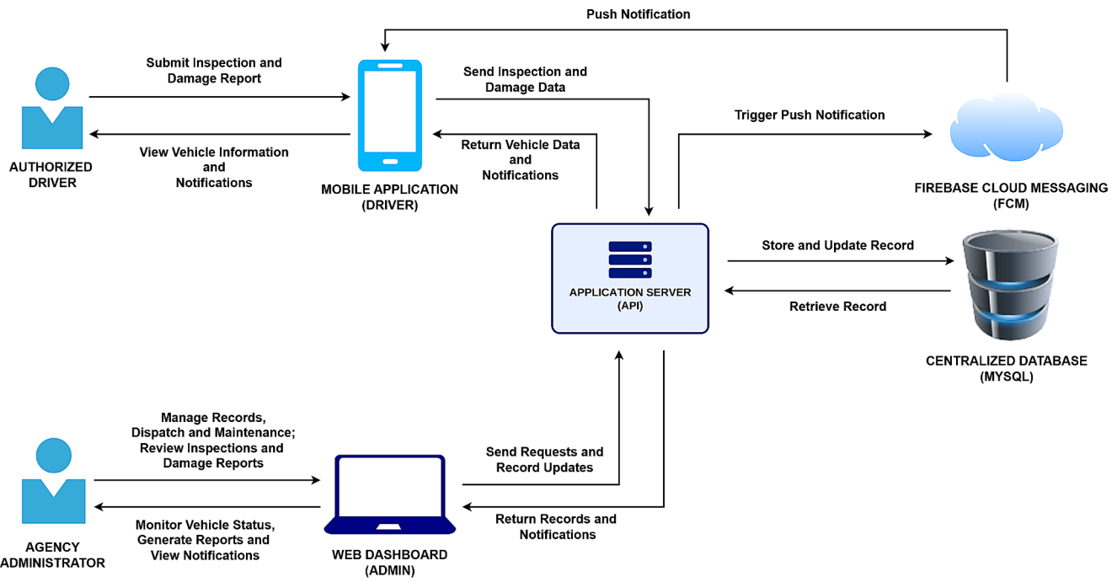
Figure 2. System Architecture of the Rescue Vehicle Management System
As illustrated in Figure 2, the Rescue Vehicle Management System follows a centralized client–server architecture in which two client platforms communicate with a single application server and a shared database. The Authorized Driver interacts with the system through the mobile application, submitting inspections and damage reports and, in return, viewing vehicle information and notifications. The mobile application sends the inspection and damage data to the application server, which returns vehicle data and notifications to the application. The Agency Administrator interacts with the system through the web dashboard, managing records, dispatch, and maintenance, reviewing inspections and damage reports, monitoring vehicle status, generating reports, and viewing notifications. The web dashboard sends requests and record updates to the application server, which returns the requested records and notifications. For both platforms, the application server stores and updates records in the centralized database and retrieves the records it needs, so that the mobile application and the web dashboard work from the same data. When an event requires a driver alert, the application server saves the notification in the database and triggers a push notification through Firebase Cloud Messaging (FCM), which delivers it to the driver's mobile application. Because FCM delivers messages on a best-effort basis and needs the device to be online, each notification also remains in the driver's in-app notification list. Agency Administrators view their notifications on the web dashboard. Through this arrangement, the architecture keeps vehicle records consistent across both platforms and lets drivers receive timely alerts without manually checking the system.
Context Diagram
The context diagram provides the highest-level view of the Rescue Vehicle Management System. It shows the whole system as a single process, numbered 0, together with the outside parties that exchange data with it, and in doing so sets the boundary of the system: what belongs inside it and what lies outside it. The database is part of the system and is therefore not shown at this level; it appears in the more detailed diagrams that break the system down further. The context diagram of the Rescue Vehicle Management System is shown in Figure 3.
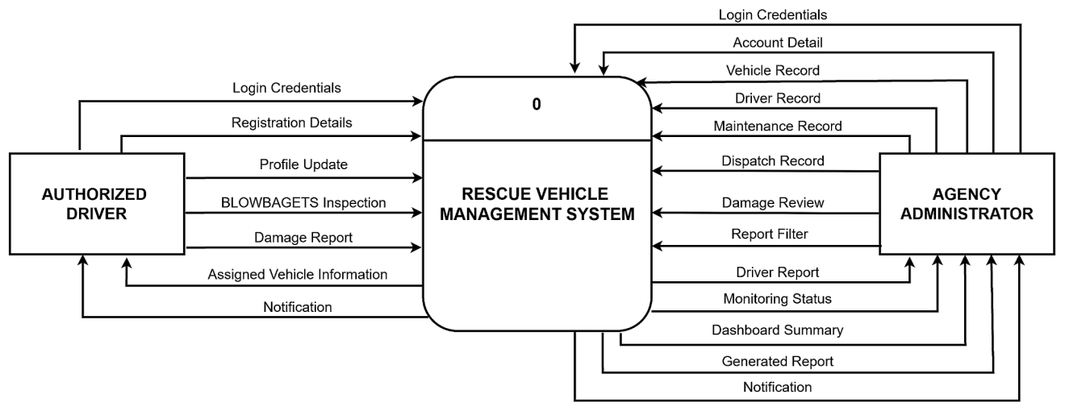
Figure 3. Context Diagram of the Rescue Vehicle Management System
Figure 3 presents the context diagram of the Rescue Vehicle Management System. The RESCUE VEHICLE MANAGEMENT SYSTEM process, labeled 0, is at the center of the diagram, and two external entities are placed around it: the Authorized Driver and the Agency Administrator. The Authorized Driver reaches the system through the mobile application and the Agency Administrator through the web dashboard. The interaction among the central process and the entities involves 20 data flows The Authorized Driver supplies data through the Login Credentials, Registration Details, Profile Update, BLOWBAGETS Inspection, and Damage Report data flows, and receives data through the Assigned Vehicle Information and Notification data flows. The Agency Administrator supplies data through the Login Credentials, Account Detail, Maintenance Record, Dispatch Record, Damage Review, and Report Filter data flows, and exchanges data in both directions through the Vehicle Record and Driver Record data flows. In return, the system provides the Agency Administrator with the Driver Report, Monitoring Status, Dashboard Summary, Generated Report, and Notification data flows. The Notification data flow to the driver includes the push alerts delivered to the driver's mobile device, which are part of the system's notification delivery as shown in Figure 2. As shown in the diagram, all information moves in and out of one central system rather than through separate, disconnected records, while each Agency Administrator's access remains limited to the records of their own agency.
Data Flow Diagram
The Data Flow Diagram (DFD) of the Rescue Vehicle Management System illustrates the logical movement of data between external entities, system processes, and data stores. To maintain readability while clearly representing the operations of the two system users, the DFD is presented through two entity-oriented views: Authorized Driver Operations and Agency Administrator Operations. The diagrams use the Gane and Sarson notation and show how user inputs are processed, stored, retrieved, and returned as system outputs. Together, the two views represent the major internal data flows of the Rescue Vehicle Management System.
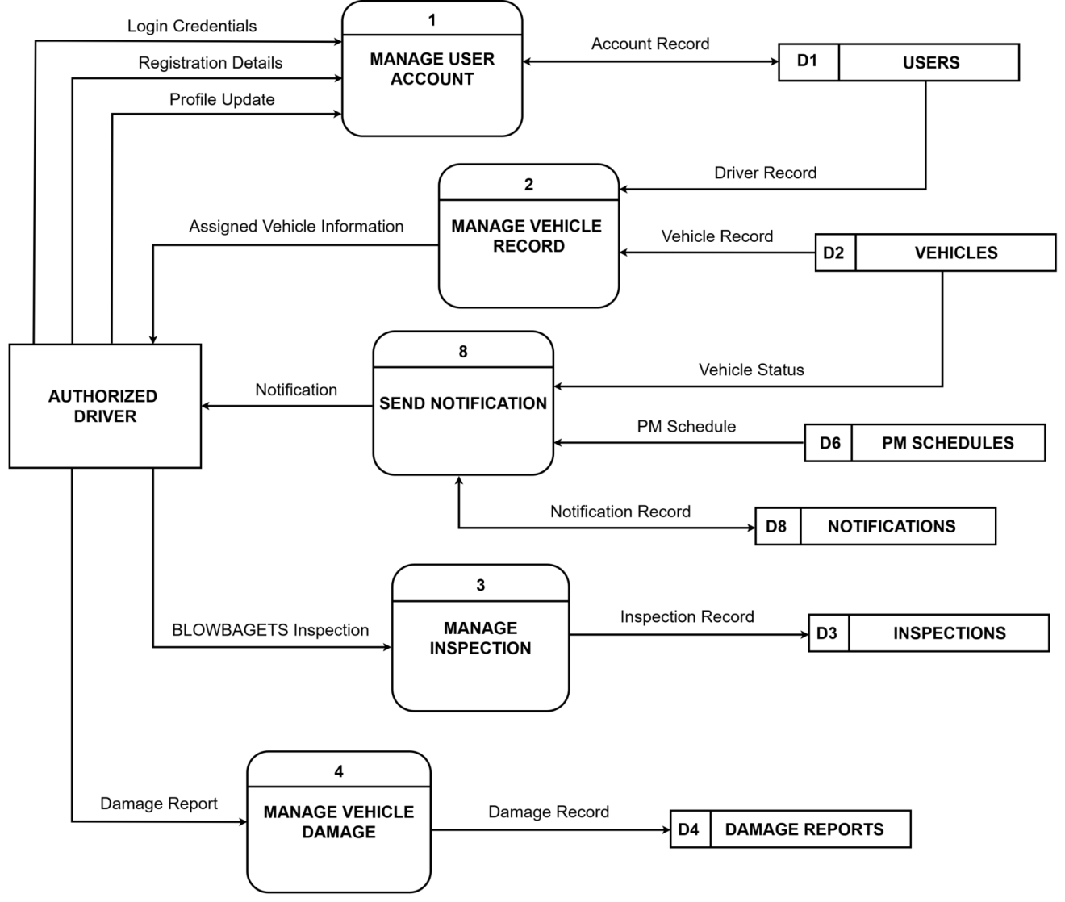

Figure 4.1. Data Flow Diagram of the Rescue Vehicle Management System: Authorized Driver Operations
Figure 4.1 illustrates the Authorized Driver Operations view of the Data Flow Diagram, showing how the mobile application interacts with five system processes and six data stores. Through the Login Credentials, Registration Details, and Profile Update flows, the Authorized Driver sends account data to Manage User Account (1), which validates and updates the Account Record in D1 Users. Manage Vehicle Record (2) reads the Driver Record from D1 Users and the Vehicle Record from D2 Vehicles to return the Assigned Vehicle Information to the driver's mobile screen. For daily safety checks, the driver submits the BLOWBAGETS Inspection to Manage Inspection (3), which saves the Inspection Record into D3 Inspections. When a vehicle defect or incident occurs, the driver submits a Damage Report to Manage Vehicle Damage (4), storing the Damage Record into D4 Damage Reports. Finally, Send Notification (8) checks the Vehicle Status in D2 Vehicles and upcoming maintenance in D6 PM Schedules, records the Notification Record in D8 Notifications, and delivers the Notification alert directly to the driver's mobile device. All administrative operations and remaining data stores are presented in Figure 4.1.
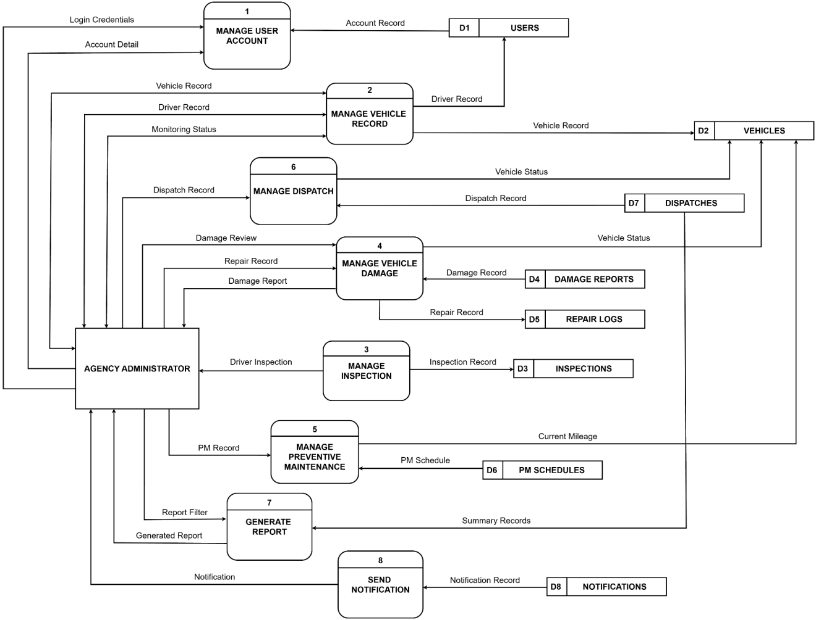
Figure 4.2. Data Flow Diagram of the Rescue Vehicle Management System: Agency Admin Operations
Figure 4.2 illustrates the Agency Administrator Operations view of the Data Flow Diagram, detailing how the web dashboard connects administrative workflows across all eight system processes and eight data stores. Through the Login Credentials and Account Detail flows, the Agency Administrator interacts with Manage User Account (1) to sign in and record user profiles in D1 Users. Through Manage Vehicle Record (2), the administrator exchanges Vehicle Record and Driver Record data with D1 Users and D2 Vehicles to update fleet profiles, receiving the real-time Monitoring Status flow for vehicle readiness and license expiry alerts. Manage Inspection (3) reads saved checklists from D3 Inspections and provides the Driver Report for admin review. When vehicle issues arise, the administrator assesses damage through Damage Review and records repairs through Repair Record under Manage Vehicle Damage (4), updating D4 Damage Reports, D5 Repair Logs, and the vehicle availability status in D2 Vehicles. In maintenance operations, the administrator submits the PM Record to Manage Preventive Maintenance (5), which tracks scheduled servicing against Current Mileage from D2 Vehicles and updates D6 PM Schedules. Manage Dispatch (6) receives the Dispatch Record to deploy and return rescue vehicles, storing trip logs in D7 Dispatches while automatically updating the vehicle status in D2 Vehicles. To support reporting, the administrator applies a Report Filter to Generate Report (7), which gathers summary records across operational tables to output the Dashboard Summary and printable Generated Report. Lastly, Send Notification (8) logs alerts in D8 Notifications and sends in-app Notifications to the administrator for pending registrations, inspection defects, and due maintenance. Together, Figure 4 and Figure 4.1 fully account for all twenty data flows established in the context diagram.

Functional Decomposition Diagram
The Functional Decomposition Diagram provides a top-down view of the Rescue Vehicle Management System, breaking the system into progressively smaller functions in the form of an organization chart. Beginning with the complete system at the top, it is divided into its major functional areas, and each area into the specific operations it performs. This gives a clear, organized picture of what the system does and serves as a blueprint of the modules built during development. The Functional Decomposition Diagram is shown in Figure 5
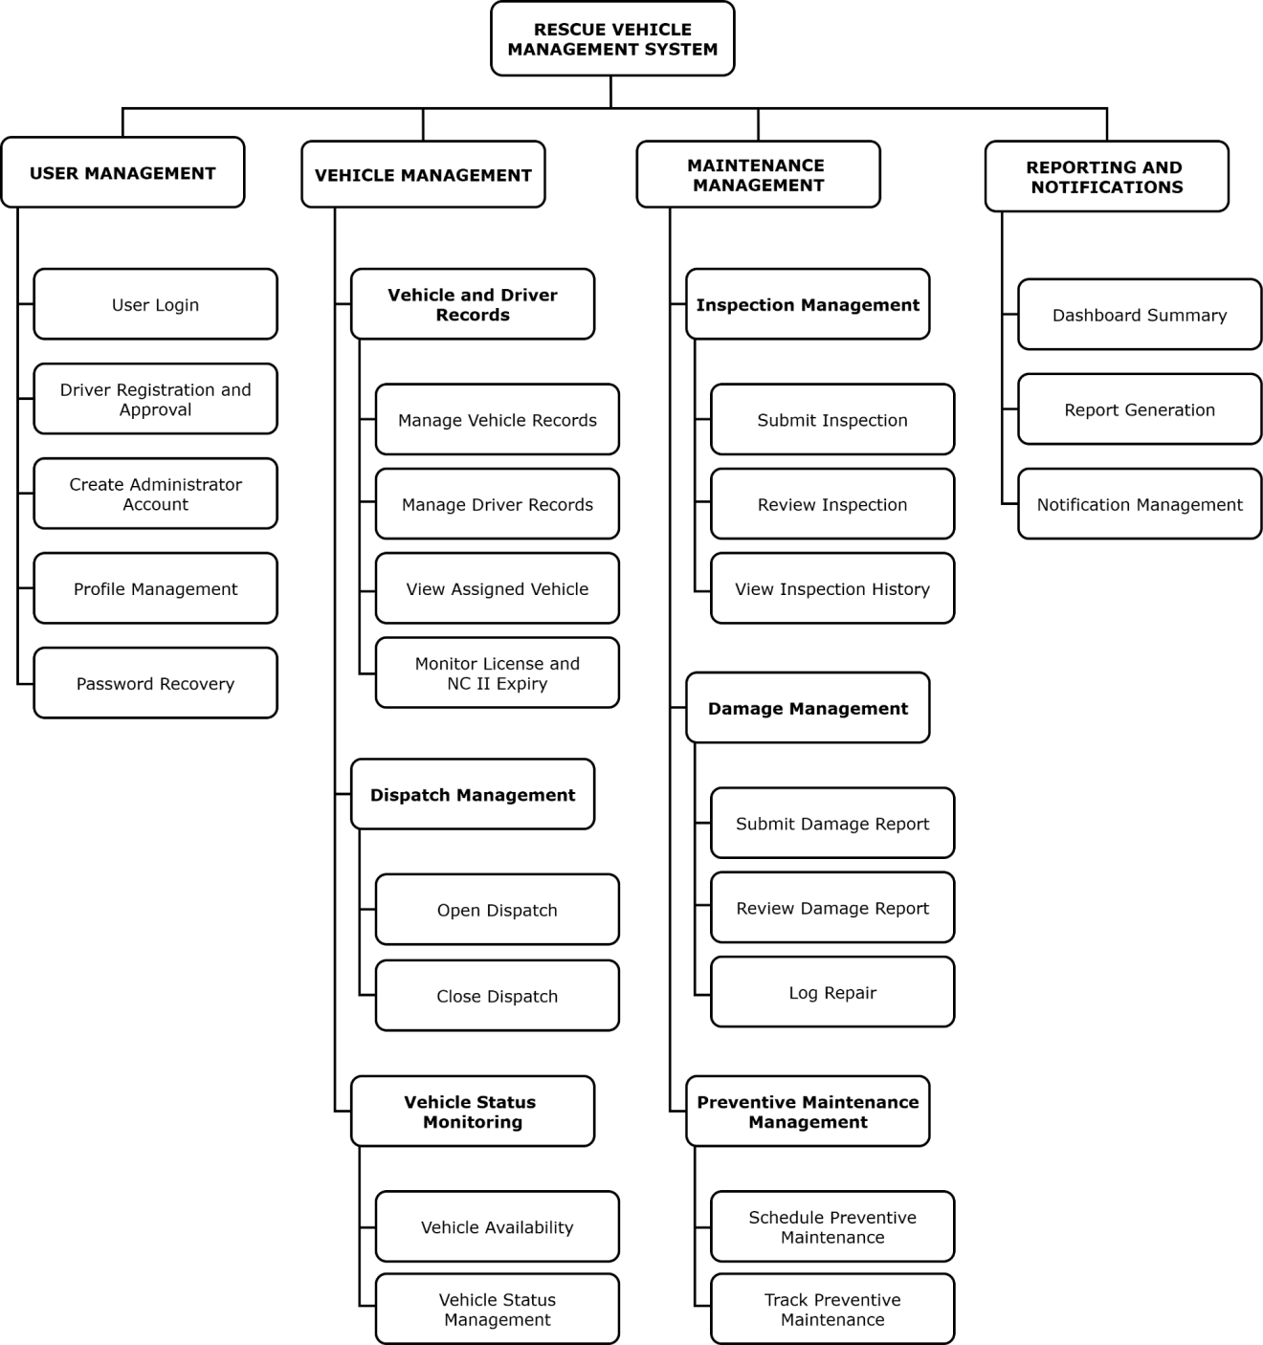
Figure 5. Functional Decomposition Diagram of the Rescue Vehicle Management System
Figure 5 presents the Functional Decomposition Diagram of the Rescue Vehicle Management System. At the top is the complete system, which is decomposed into four major functional areas: User Management, Vehicle Management, Maintenance Management, and Reporting and Notifications. User Management covers user login, driver registration and approval, administrator account creation, profile management, and password recovery. Vehicle Management covers vehicle and driver record management, assigned vehicle viewing, license and NC II expiry monitoring, dispatch management, and vehicle status monitoring. Maintenance Management covers inspection management, damage management, and preventive maintenance management, including inspection submission and review, inspection history, damage reporting and review, repair logging, and preventive maintenance scheduling and tracking. Reporting and Notifications covers the dashboard summary, report generation, and notification management. Each major functional area is further decomposed into specific operations that correspond to the functional requirements of the system, providing a clear and organized representation of the functions and serving as a blueprint for the development of the Rescue Vehicle Management System.

Data Model
Entity Relationship Diagram
An Entity Relationship Diagram (ERD) is a graphical representation of the entities in a database and the relationships among them. It is a fundamental tool in database design used to model real-world concepts as entities and demonstrate how those entities interconnect through primary keys, foreign keys, and cardinalities. To maintain visual clarity while accurately detailing all attributes and relationships, the Entity Relationship Diagram of the Rescue Vehicle Management System is presented through two operational views: the Driver Operations and Inspections Subsystem (Figure 6) and the Vehicle Management, Maintenance, and Dispatch Subsystem (Figure 6.1). Together, these complementary diagrams model the eleven domain tables supporting the system's functional requirements using standard Crow's Foot notation.
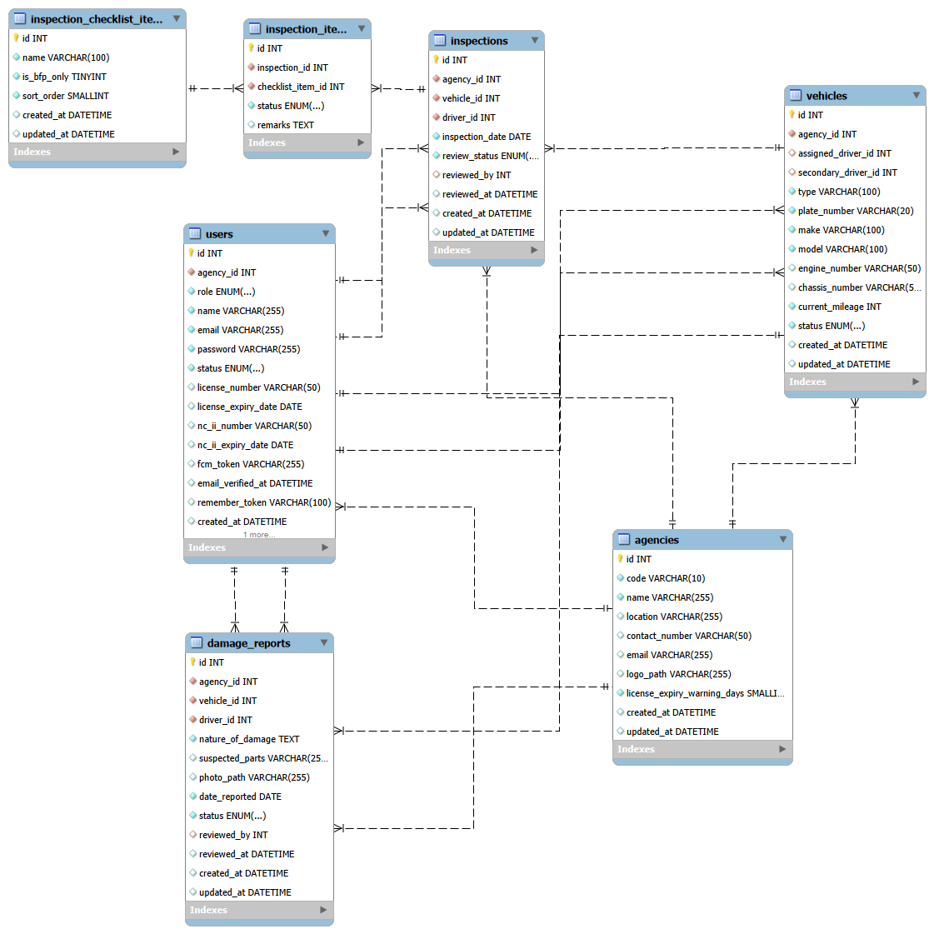
Figure 6.1. Entity Relationship Diagram of the Rescue Vehicle Management System: Authorized Driver Operations
Figure 6.1 illustrates the Authorized Driver Operations view of the Entity Relationship Diagram, capturing the relational database schema supporting driver authentication, fleet assignment, daily pre-trip inspections, and defect reporting. The diagram comprises seven domain tables: agencies, users, vehicles, inspections, inspection_items, inspection_checklist_items, and damage_reports. The agencies table serves as the multi-tenancy anchor, maintaining a one-to-many relationship with users and vehicles through their respective agency_id foreign keys to enforce agency-isolated data access. The users table stores driver credentials, verification states, device push tokens, and professional qualifications including driver license and TESDA NC II expiry dates. A one-to-many relationship links users to vehicles via assigned_driver_id for primary vehicle assignment, as well as secondary_driver_id for dual-crewed operational units. For daily vehicle monitoring, inspections references the evaluated unit in vehicles (vehicle_id), the operating driver in users (driver_id), and the evaluating supervisor in users (reviewed_by). Each inspection record breaks down into multiple granular entries in inspection_items via inspection_id, where each row evaluates a standardized criterion referenced from the inspection_checklist_items catalog (checklist_item_id) and records its functional condition along with mandatory driver remarks for noted defects. In the event of vehicular collision, component failure, or physical wear, damage_reports captures incident details, photographic evidence paths, and suspected defect components, linking the affected unit in vehicles (vehicle_id), the filing driver in users (driver_id), and the assessing Agency Administrator in users (reviewed_by). All relationships follow Crow's Foot notation, with parent tables indicating mandatory single cardinalities and child records representing optional or multiple instances.
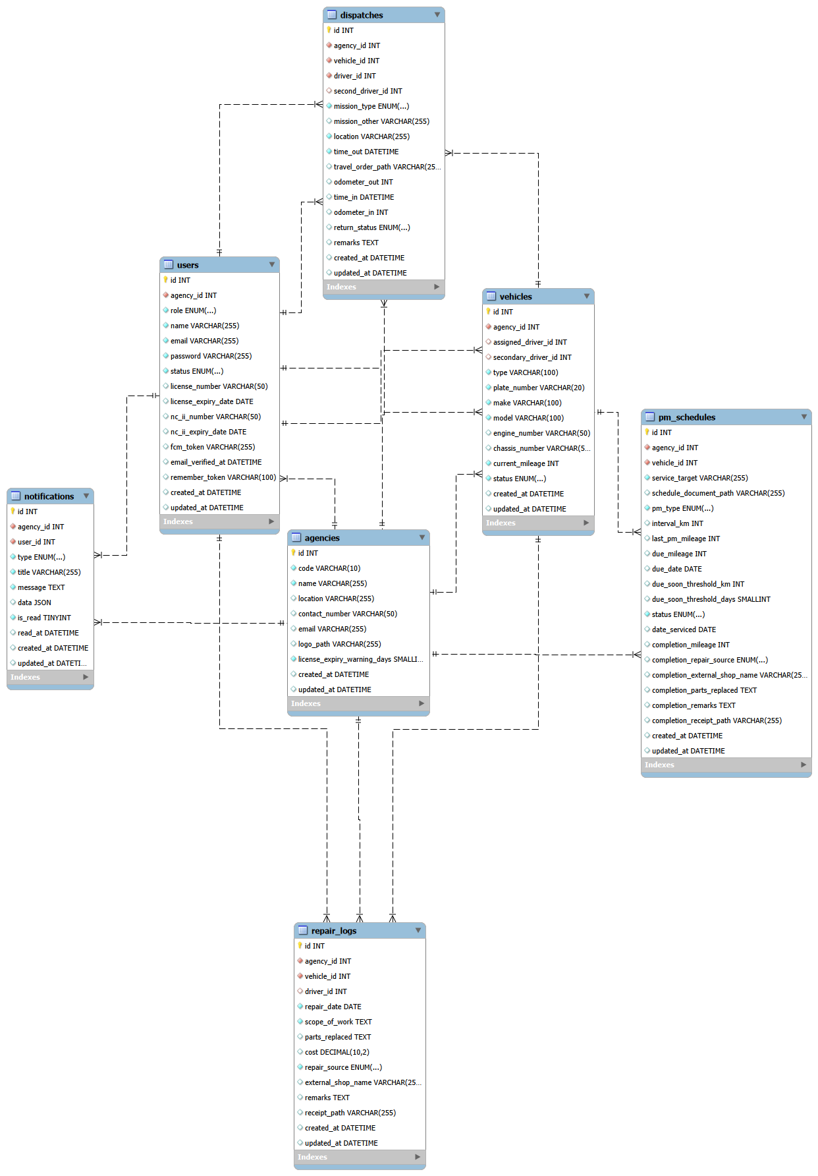
Figure 6.2. Entity Relationship Diagram of the Rescue Vehicle Management System: Agency Administrator Operations
Figure 6.2 illustrates the Agency Administrator Operations view of the Entity Relationship Diagram, modeling the administrative relational database schema governing vehicle deployments, service scheduling, corrective maintenance, and automated system alerts. The diagram consists of seven domain tables: agencies, users, vehicles, dispatches, pm_schedules, repair_logs, and notifications. The agencies table anchors the multi-tenancy architecture, enforcing agency-level data isolation by maintaining one-to-many foreign key relationships with users and vehicles. The vehicles table functions as the operational core across administrative workflows, maintaining the single shared operational status and tracking cumulative odometer mileage. A one-to-many relationship links users to vehicles via assigned_driver_id and secondary_driver_id. For emergency response and administrative travel, the dispatches table logs mission deployments, departure/arrival timestamps, travel orders, and odometer readings, establishing foreign key connections to the deployed unit in vehicles (vehicle_id), the primary driver in users (driver_id), and an optional secondary crew driver in users (second_driver_id). In fleet maintenance operations, pm_schedules defines preventive service plans linked to vehicles (vehicle_id), tracking mileage-based or time-based service intervals, alert thresholds, and post-service completion details. When corrective servicing or parts replacement is required, repair_logs maintains a historical log of repair activities tied to vehicles (vehicle_id) and the assigned driver (driver_id), recording the service scope, parts replaced, financial expenditures, and external repair facility details. Finally, the notifications table manages automated alerts for damage submissions, flagged inspections, license expirations, and overdue maintenance, linking each alert to its targeted recipient in users (user_id). All relationships are rendered using Crow's Foot notation, with parent tables indicating mandatory single cardinalities and child tables representing optional or multiple instances.

Data Dictionary
The Data Dictionary is a centralized document that gives detailed information about the structure, organization, and attributes of the data used in the Rescue Vehicle Management System. It includes clear definitions and descriptions of all the data inside the system, such as tables, fields, and data types. This dictionary is very important for data management because it helps everyone understand the data, maintain its quality, and communicate effectively among developers, agency administrators, and other stakeholders.
Table 5 shows the data dictionary for the agencies table of the Rescue Vehicle Management System.

Table 5
Data Dictionary of agencies Table of the Rescue Vehicle Management System
Field Name | Data Type | Null | Description | Key | Reference Table
id | Int | No | Unique identifier for each agency. | PK | —
code | Varchar(10) | No | Short agency code: BFP, PNP, CDRRMO, or CHO. | — | —
name | Varchar(255) | No | Full name of the agency. | — | —
location | Varchar(255) | Yes | Office location of the agency. | — | —
contact_number | Varchar(50) | Yes | Contact number of the agency. | — | —
email | Varchar(255) | Yes | Contact email address of the agency. | — | —
logo_path | Varchar(255) | Yes | File path of the agency logo shown on the dashboard. | — | —
license_expiry_warning_days | Smallint | No | Number of days before expiry at which a driver license is flagged as expiring soon. Configurable per agency. | — | —
created_at | Datetime | Yes | Date and time the record was created. | — | —
updated_at | Datetime | Yes | Date and time the record was last updated. | — | —

Table 5 – The agencies table stores the profile of each of the four participating agencies — the Bureau of Fire Protection, the Philippine National Police, the City Disaster Risk Reduction and Management Office, and the City Health Office. It holds the agency code, name, location, contact details, and logo, together with the number of days before expiry at which a driver license is flagged as expiring soon. That threshold is stored here rather than fixed in the program so that each agency may set its own warning period. Each record represents one agency and serves as the reference that separates every other record in the system by agency.
Table 6 shows the data dictionary for the users table of the Rescue Vehicle Management System.

Table 6
Data Dictionary of users Table of the Rescue Vehicle Management System
Field Name | Data Type | Null | Description | Key | Reference Table
id | Int | No | Unique identifier for each user account. | PK | —
agency_id | Int | No | Agency the user belongs to. | FK | agencies
role | Enum | No | Role of the user: admin or driver. | — | —
name | Varchar(255) | No | Full name of the Agency Administrator or Authorized Driver. | — | —
email | Varchar(255) | No | Email address used to sign in. Unique across the system. | — | —
password | Varchar(255) | No | Hashed password of the account. | — | —
status | Enum | No | Account state: pending, active, or rejected. | — | —
license_number | Varchar(50) | Yes | Driver license number. Empty for Agency Administrators. | — | —
license_expiry_date | Date | Yes | Expiry date of the driver license. Empty for Agency Administrators. | — | —
nc_ii_number | Varchar(50) | Yes | TESDA National Certificate II (NC II, Driving) number of the driver. Optional; empty for Agency Administrators and for drivers who do not hold an NC II. | — | —
nc_ii_expiry_date | Date | Yes | Expiry date of the driver's NC II certificate. Monitored for a mission crewed by two drivers. Must be different from the dispatched driver. Empty for an ordinary one-driver dispatch. | — | —
travel_order_path | Varchar(50) | Yes | Path to the optional travel order or trip authorization attached when the dispatch is opened. Optional so an emergency response is never delayed. | — | —
fcm_token | Varchar(255) | Yes | Device token used to deliver push notifications to the mobile application. | — | —
email_verified_at | Datetime | Yes | Date and time the email address was verified. | — | —
remember_token | Varchar(100) | Yes | Token used to keep a web session signed in. | — | —
created_at | Datetime | Yes | Date and time the record was created. | — | —
updated_at | Datetime | Yes | Date and time the record was last updated. | — | —

Table 6 – The users table stores every account in the system, both Agency Administrators and Authorized Drivers, distinguished by the role field. Administrators and drivers are kept in one table because both must sign in, and a driver record and a login account are always the same person. The license number and license expiry date are filled in for drivers and left empty for administrators, and the device token is used to deliver push notifications to the mobile application. The status field records whether a self-registered driver is still pending approval, active, or rejected. Each record represents one person who can sign in to the system.
Table 7 shows the data dictionary for the vehicles table of the Rescue Vehicle Management System.

Table 7
Data Dictionary of vehicles Table of the Rescue Vehicle Management System
Field Name | Data Type | Null | Description | Key | Reference Table
id | Int | No | Unique identifier for each vehicle. | PK | —
agency_id | Int | No | Agency that owns the vehicle. | FK | agencies
assigned_driver_id | Int | Yes | Primary Authorized Driver assigned to the vehicle. | FK | users
secondary_id | Int | Yes | Optional secondary or backup Authorized Driver crewing the vehicle. Must be different from the primary driver. Empty for a single-driver vehicle. | FK | users
type | Varchar(100) | No | Type of vehicle, selected from presets (e.g., Fire Truck, Ambulance, Patrol Car) or custom-specified via an "Other" option. | — | —
plate_number | Varchar(20) | No | Plate number of the vehicle. Unique within the agency. | — | —
make | Varchar(100) | No | Manufacturer of the vehicle. | — | —
model | Varchar(100) | No | Model of the vehicle. | — | —
engine_number | Varchar(50) | Yes | Engine number of the vehicle. Unique within the agency. | — | —
chassis_number | Varchar(50) | Yes | Chassis number of the vehicle. Unique within the agency. | — | —
current_mileage | Int | No | Current odometer reading in kilometers. Used for mileage-based preventive maintenance. | — | —
status | Enum | No | Single shared operational status: Operational, Dispatched, Not Operational, or Under Preventive Maintenance. | — | —
created_at | Datetime | Yes | Date and time the record was created. | — | —
updated_at | Datetime | Yes | Date and time the record was last updated. | — | —

Table 7 – The vehicles table stores the fleet of each agency, including the vehicle type (supporting standard emergency presets or custom specification when "Other" is selected), plate number, make, model, engine number, chassis number, and current odometer reading. It also carries the single shared operational status of the vehicle — Operational, Dispatched, Not Operational, or Under Preventive Maintenance — which every module reads and writes so that all screens report the same condition. The assigned driver field names the primary Authorized Driver of the vehicle. Each record represents one physical vehicle belonging to one agency.
Table 8 shows the data dictionary for the inspection_checklist_items table of the Rescue Vehicle Management System.
Table 8
Data Dictionary of inspection_checklist_items Table of the Rescue Vehicle Management System
Field Name | Data Type | Null | Description | Key | Reference Table
id | Int | No | Unique identifier for each checklist item. | PK | —
name | Varchar(100) | No | Name of the checklist item, such as Battery, Brakes, or Fire Pump. | — | —
is_bfp_only | Boolean | No | Marks the two items that apply only to BFP vehicles: Hydraulic System and Fire Pump. | — | —
sort_order | Smallint | No | Order in which the item appears on the checklist. | — | —
created_at | Datetime | Yes | Date and time the record was created. | — | —
updated_at | Datetime | Yes | Date and time the record was last updated. | — | —

Table 8 – The inspection checklist items table stores the standard BLOWBAGETS checklist used for daily inspections. It contains the twelve standard items — Battery, Lights, Oil, Water, Brakes, Air, Gas, Engine, Tires, Power Steering, Horn/Siren, and Directional Signals — and the two additional items that apply only to BFP vehicles, Hydraulic System and Fire Pump. This is a reference list shared by all four agencies rather than an operational record, so it is not scoped to any single agency. Each record represents one item that a driver assesses during an inspection.
Table 9 shows the data dictionary for the inspections table of the Rescue Vehicle Management System.
Table 9
Data Dictionary of inspections Table of the Rescue Vehicle Management System
Field Name | Data Type | Null | Description | Key | Reference Table
id | Int | No | Unique identifier for each inspection. | PK | —
agency_id | Int | No | Agency that owns the inspection record. | FK | agencies
vehicle_id | Int | No | Vehicle that was inspected. | FK | vehicles
driver_id | Int | No | Authorized Driver who performed the inspection. | FK | users
inspection_date | Date | No | The date of daily inspection was performed. | — | —
review_status | Enum | No | Review state of the inspection: Pending or Reviewed. | — | —
reviewed_by | Int | Yes | Agency Administrator who reviewed the inspection. | FK | users
reviewed_at | Datetime | Yes | Date and time the inspection was reviewed. | — | —
created_at | Datetime | Yes | Date and time the inspection was submitted. | — | —
updated_at | Datetime | Yes | Date and time the record was last updated. | — | —

Table 9 – The inspections table stores each daily BLOWBAGETS inspection submitted by an Authorized Driver from the mobile application. It records the vehicle inspected, the driver who performed it, the date of the inspection, and the review state, which begins as Pending and becomes Reviewed once an Agency Administrator has assessed it. When the inspection is reviewed, the administrator who reviewed it and the date and time of the review are also recorded. Each record represents one complete inspection of one vehicle on one occasion.
Table 10 shows the data dictionary for the inspection_items table of the Rescue Vehicle Management System.
Table 10
Data Dictionary of inspection_items Table of the Rescue Vehicle Management System
Field Name | Data Type | Null | Description | Key | Reference Table
id | Int | No | Unique identifier for each inspection item result. | PK | —
inspection_id | Int | No | Inspection this result belongs to. | FK | inspections
checklist_item_id | Int | No | Checklist item that was assessed. | FK | inspection_checklist_items
status | Enum | No | Result for the item: OK or Has Issue. | — | —
remarks | Text | Yes | Explanation of the fault. Required when the status is Has Issue. | — | —

Table 10 – The inspection items table stores the individual results of an inspection. Each row links one inspection to one checklist item and records whether that item was found to be OK or to have an issue, together with the driver's remarks. Remarks are required whenever an item is flagged as having an issue, so that a reported fault is always explained. Each record represents the result of a single checklist item within a single inspection.
Table 11 shows the data dictionary for the damage_reports table of the Rescue Vehicle Management System.
Table 11
Data Dictionary of damage_reports Table of the Rescue Vehicle Management System
Field Name | Data Type | Null | Description | Key | Reference Table
id | Int | No | Unique identifier for each damage report. | PK | —
agency_id | Int | No | Agency that owns the damage report. | FK | agencies
vehicle_id | Int | No | Vehicle that was damaged. | FK | vehicles
driver_id | Int | No | Authorized Driver who submitted the report. | FK | users
nature_of_damage | Text | No | Description of the damage. | — | —
suspected_parts | Varchar(255) | Yes | Parts suspected to be defective. | — | —
photo_path | Varchar(255) | Yes | File path of the optional photo attachment. | — | —
date_reported | Date | No | Date the report was submitted. Set automatically. | — | —
status | Enum | No | Review state of the report: Pending or Reviewed. | — | —
reviewed_by | Int | Yes | Agency Administrator who assessed the report. | FK | users
reviewed_at | Datetime | Yes | Date and time the report was assessed. | — | —
created_at | Datetime | Yes | Date and time the record was created. | — | —
updated_at | Datetime | Yes | Date and time the record was last updated. | — | —

Table 11 – The damage reports table stores the standardized damage reports submitted by Authorized Drivers. It records the vehicle concerned, the driver who filed the report, a description of the nature of the damage, the parts suspected to be defective, and an optional photo attachment. The date reported is set automatically on submission, and the status begins as Pending until an Agency Administrator assesses the report and marks it Reviewed. Each record represents one reported instance of damage to one vehicle.
Table 12 shows the data dictionary for the repair_logs table of the Rescue Vehicle Management System.
Table 12
Data Dictionary of repair_logs Table of the Rescue Vehicle Management System
Field Name | Data Type | Null | Description | Key | Reference Table
id | Int | No | Unique identifier for each repair record. | PK | —
agency_id | Int | No | Agency that owns the repair record. | FK | agencies
vehicle_id | Int | No | Vehicle that was repaired. | FK | vehicles
driver_id | Int | Yes | Authorized Driver assigned to the vehicle at the time of repair. | FK | users
repair_date | Date | No | Date the repair was performed or logged. | — | —
scope_of_work | Text | No | Description of the work performed. | — | —
parts_replaced | Text | Yes | Parts replaced during the repair. | — | —
cost | Decimal(10,2) | Yes | Cost of the repair. | — | —
repair_source | Enum | No | Who performed the repair: Internal Office, GSO Motorpool, or External Repair Shop. | — | —
external_shop_name | Varchar(255) | Yes | Name of the shop when the repair source is External Repair Shop. | — | —
remarks | Text | Yes | Additional notes about the repair. | — | —
created_at | Datetime | Yes | Date and time the record was created. | — | —
receipt_path | Varchar(255) | Yes | Path to the receipt or service document issued by the external repair shop. Required when the repair source is External Repair Shop. | — | —
updated_at | Datetime | Yes | Date and time the record was last updated. | — | —

Table 12 – The repair logs table stores the repair activities carried out on each vehicle. It records the date of the repair, the scope of work performed, the parts replaced, the optional cost, and the source of the repair — Internal Office, GSO Motorpool, or External Repair Shop — with the name of the shop recorded when the repair was performed externally. The driver assigned to the vehicle at the time may also be recorded. Each record represents one repair activity performed on one vehicle.
Table 13 shows the data dictionary for the pm_schedules table of the Rescue Vehicle Management System.
Table 13
Data Dictionary of pm_schedules Table of the Rescue Vehicle Management System
Field Name | Data Type | Null | Description | Key | Reference Table
id | Int | No | Unique identifier for each preventive maintenance schedule. | PK | —
agency_id | Int | No | Agency that owns the schedule. | FK | agencies
vehicle_id | Int | No | Vehicle the schedule applies to. | FK | vehicles
service_target | Varchar(255) | No | Part or service to be maintained, such as Oil Change and Filter. | — | —
schedule_document | Varchar(255) | Yes | Path to the optional supporting document attached when the schedule is created, such as a pre-inspection checklist. Separate from the completion document. | — | —
pm_type | Enum | No | Basis of the schedule: Mileage-Based or Time-Based. | — | —
interval_km | Int | Yes | Distance in kilometers between services. Mileage-based schedules only. | — | —
last_pm_mileage | Int | Yes | Odometer reading at the last service. Mileage-based schedules only. | — | —
due_mileage | Int | Yes | Odometer reading at which the service becomes due. | — | —
due_date | Date | Yes | Date on which the service becomes due. Time-based schedules only. | — | —
due_soon_threshold_km | Int | Yes | Kilometers before the due mileage at which the schedule is flagged Due Soon. Configurable. | — | —
due_soon_threshold_days | Smallint | Yes | Days before the due date at which the schedule is flagged Due Soon. Configurable. | — | —
status | Enum | No | State of the schedule: Upcoming, Due Soon, Due, or Completed. | — | —
date_serviced | Date | Yes | Date the service was carried out. | — | —
completion_mileage | Int | Yes | Odometer reading at the time of service. Mileage-based schedules only. | — | —
completion_repair_source | Enum | Yes | Who carried out the service: Internal Office, GSO Motorpool, or External Repair Shop. | — | —
completion_external_shop_name | Varchar(255) | Yes | Name of the shop when the completion source is External Repair Shop. | — | —
completion_parts_replaced | Text | Yes | Parts replaced during the service. | — | —
completion_remarks | Text | Yes | Notes and findings recorded on completion. | — | —
created_at | Datetime | Yes | Date and time the record was created. | — | —
completion_receipt_path | Varchar(255) | Yes | Path to the receipt or service document issued by the external repair shop when the preventive maintenance was completed externally. | — | —
updated_at | Datetime | Yes | Date and time the record was last updated. | — | —

Table 13 – The preventive maintenance schedules table stores the maintenance plans set for each vehicle. A schedule is either mileage-based, using a kilometre interval and the odometer reading at the last service, or time-based, using a due date. Each schedule carries its own Due Soon threshold, set by the Agency Administrator, so that the warning period may differ from one service to another. The status moves through Upcoming, Due Soon, Due, and Completed, and the completion fields record the date serviced, the odometer reading at the time of service for mileage-based schedules, the source of the service, the shop where it was performed externally, the supporting document issued for the service, the parts replaced, and any remarks. Each record represents one maintenance cycle for one service target on one vehicle.
Table 14 shows the data dictionary for the dispatches table of the Rescue Vehicle Management System.

Table 14
Data Dictionary of dispatches Table of the Rescue Vehicle Management System
Field Name | Data Type | Null | Description | Key | Reference Table
id | Int | No | Unique identifier for each dispatch record. | PK | —
agency_id | Int | No | Agency that owns the dispatch record. | FK | agencies
vehicle_id | Int | No | Vehicle that was dispatched. | FK | vehicles
driver_id | Int | No | Authorized Driver who was dispatched. | FK | users
secondary_driver | Int | Yes | Optional second Authorized Driver same way as the license, using the agency's configurable warning window. Optional. | FK | users
mission_type | Enum | No | Type of mission: Fire Response, Medical Response, Rescue Operation, Patrol, Administrative Travel, or Others. | — | —
mission_other | Varchar(255) | Yes | Description of the mission when the mission type is Others. | — | —
location | Varchar(255) | No | Location the vehicle was dispatched to. | — | —
time_out | Datetime | No | Date and time the vehicle left. Sets the vehicle status to Dispatched. | — | —
odometer_out | Int | Yes | Odometer reading recorded at time out. | — | —
time_in | Datetime | Yes | Date and time the vehicle returned. Empty while the dispatch is active. | — | —
odometer_in | Int | Yes | Odometer reading recorded at time in. Updates the vehicle current mileage when higher. | — | —
return_status | Enum | Yes | Status set on return: Operational, Not Operational, or Under Preventive Maintenance. | — | —
remarks | Text | Yes | Notes recorded when the dispatch was closed. | — | —
created_at | Datetime | Yes | Date and time the record was created. | — | —
updated_at | Datetime | Yes | Date and time the record was last updated. | — | —

Table 14 – The dispatches table stores the record of each vehicle deployment. It records the vehicle and driver dispatched, the mission type and location, and the date and time out, with an optional odometer reading taken as the vehicle leaves. Opening a dispatch automatically sets the vehicle status to Dispatched. When the dispatch is closed, the date and time in, an optional odometer reading on arrival, the return status of the vehicle, and any remarks are recorded; a time-in reading higher than the vehicle's current mileage updates that mileage. A dispatch with no time in is still active. Each record represents one deployment of one vehicle on one mission.
Table 15 shows the data dictionary for the notifications table of the Rescue Vehicle Management System.
Table 15
Data Dictionary of notifications Table of the Rescue Vehicle Management System
Field Name | Data Type | Null | Description | Key | Reference Table
id | Int | No | Unique identifier for each notification. | PK | —
agency_id | Int | No | Agency the notification belongs to. | FK | agencies
user_id | Int | No | User who receives the notification. | FK | users
type | Enum | No | Category of the alert, such as New Damage Report, Inspection Flagged, License Expiring, NC II Expiring, NC II Expired, PM Due, New Administrator, or Password Reset. | — | —
title | Varchar(255) | No | Short headline of the notification. | — | —
message | Text | No | Body text of the notification. | — | —
data | JSON | Yes | Reference details such as the plate number or the record concerned. | — | —
is_read | Boolean | No | Marks whether the recipient has opened the notification. | — | —
read_at | Datetime | Yes | Date and time the notification was opened. | — | —
created_at | Datetime | Yes | Date and time the record was created. | — | —
updated_at | Datetime | Yes | Date and time the record was last updated. | — | —

Table 15 – The notifications table stores the alerts raised by the system for both Authorized Drivers and Agency Administrators. It records the recipient, the category of the alert, the headline and body text, and a reference payload identifying the record the alert concerns. The read flag and the date and time read allow an Agency Administrator to keep their own notification list manageable as alerts accumulate. Each record represents one alert addressed to one user.

Implementation Results
This phase evaluated whether the operational outputs and interfaces of the developed Rescue Vehicle Management System (RVMS) successfully aligned with the specific objectives established in Chapter 1. The primary objective of the study was to input vehicle and driver information. The second objective focused on tracking vehicle maintenance. The third objective aimed to provide an administrative module for dispatch, and the fourth objective was to generate relevant reports. The functional results demonstrating how each of the four objectives was met through the web dashboard and mobile application are presented in the following subsections.
- To input driver and vehicle information.
The first objective focused on replacing informal, paper-based records with standardized digital input mechanisms for capturing emergency vehicle specifications and driver credentials into an agency-isolated database. To achieve this, the system provides dedicated administrative input forms on the web dashboard for encoding vehicle and driver profiles, alongside a mobile registration interface that allows emergency drivers to input their personal and licensing credentials.
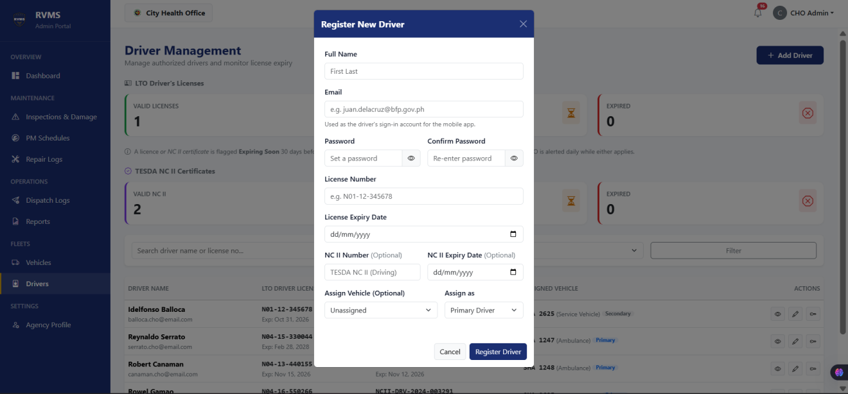
Figure 7.1. Add Driver Input Form (Web Dashboard)
Figure 7.1 displays the modal input form utilized by Agency Administrators to encode new driver profiles into the system. The interface provides structured data fields for capturing the driver's full name, official government email address, mobile contact number, driver’s license number, and license expiration date via an interactive date picker. In addition, the form accommodates professional qualification tracking by providing optional input fields for the driver's Technical Education and Skills Development Authority (TESDA) National Certificate II (NC II, Driving) certification number and its corresponding expiration date. When submitted, the system validates the uniqueness of the license number and stores the expiry dates in the database, enabling the automated notification engine to trigger timely renewal alerts before credentials lapse.
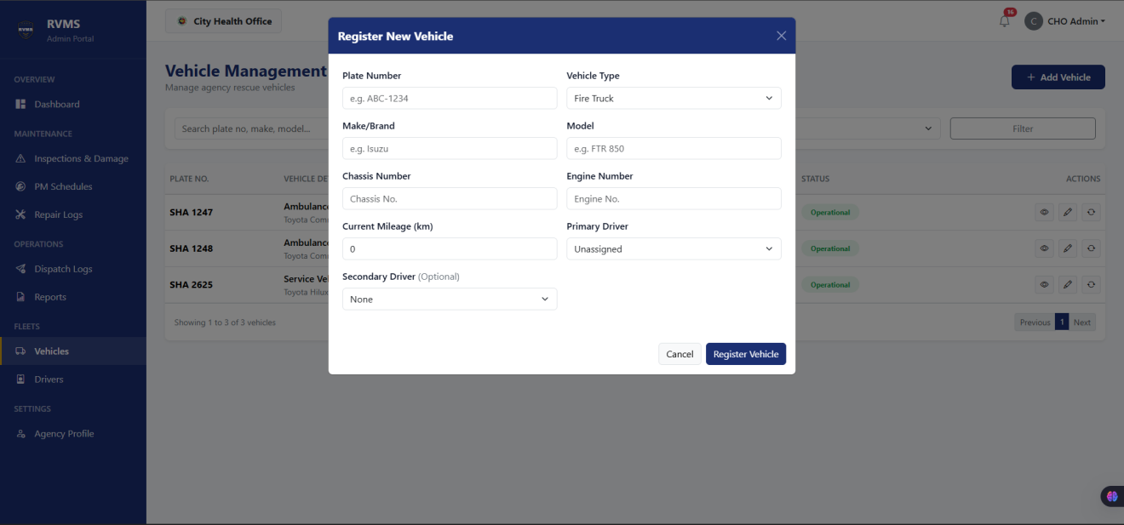
Figure 7.2. Add Vehicle Input Form (Web Dashboard)
Figure 7.2 illustrates the vehicle registration modal used by administrators to input rescue vehicle specifications. The form features a vehicle type selector offering standard emergency presets—Ambulance, Fire Truck, Rescue Vehicle, and Patrol Car—as well as an "Other" classification that dynamically reveals an open text input to accommodate specialized disaster equipment. Additional fields capture the unit's official plate number, make and model, engine number, chassis number, and initial odometer mileage reading. Furthermore, the modal incorporates driver assignment selectors that allow the administrator to designate an authorized primary driver and an optional secondary driver for dual-crewed operational units. These selectors dynamically populate only with approved, active drivers registered under the administrator's agency, preventing cross-agency vehicle assignment errors.
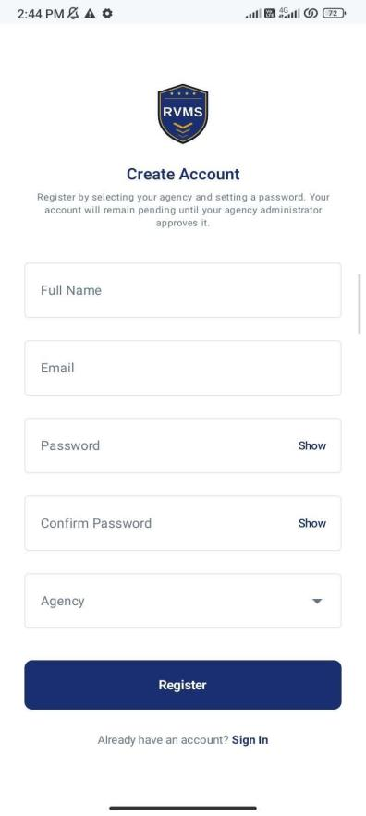
Figure 7.3. Driver Sign In and Registration Screen (Mobile Application)
Figure 7.3 shows the driver registration and authentication interface on the Android mobile application. Unregistered drivers can self-register into the system by inputting their full name, mobile contact number, designated emergency agency (selected from CDRRMO, BFP, CHO, or PNP), government driver’s license number, license expiration date, and account password. Once submitted, the account credentials are stored in the database with a "Pending" approval status, temporarily restricting access to vehicle data. This input workflow guarantees that only legitimately verified personnel are granted mobile access to daily vehicle inspections and assigned rescue units once vetted by their respective Agency Administrator.

- To track vehicle maintenance
The second objective addressed the lack of standardized pre-trip safety checks, verbal defect reporting, and the absence of consolidated maintenance records across the participating rescue agencies. To resolve these challenges, the system provides a multi-tiered tracking mechanism spanning both mobile and web platforms. Authorized drivers utilize the mobile application to review past submitted daily inspections and file detailed damage reports for unexpected vehicular issues. On the web dashboard, Agency Administrators oversee submitted inspections and damage reports through a unified triage module, monitor active preventive maintenance (PMS) schedules to prevent component failures, and maintain a comprehensive historical ledger of corrective repairs with financial cost tracking.
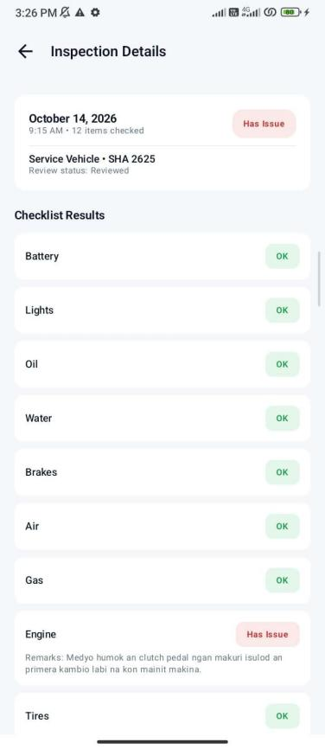
Figure 8.1. Submitted Daily Inspection Details with Flagged Item (Mobile Application)
Figure 8.1 illustrates the inspection review screen on the Android mobile application, displaying a previously submitted digital BLOWBAGETS inspection containing a flagged mechanical concern. The interface presents the unit's plate number, the date and time of inspection, and the driver's name, followed by the itemized checklist covering standard vehicle components. Items in satisfactory condition display a green "OK" status badge, whereas the identified defect—such as an engine, brake, or steering component—is prominently marked with an amber or red "Has Issue" indicator. Directly beneath the flagged item, the screen displays the driver's mandatory explanatory remarks detailing the observed mechanical symptom. This historical view allows drivers to track the operational condition of their assigned rescue vehicle over time and verify that previously documented issues have been officially logged into the system.
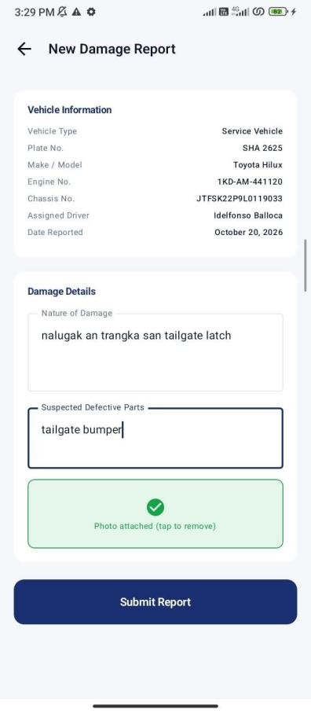
Figure 8.2. Filled Damage and Defect Report Form (Mobile Application)
Figure 8.2 shows the incident reporting interface on the mobile application, depicting a newly authored damage report in a completed state ready for submission. When sudden breakdowns, collisions, or structural defects occur outside routine morning inspections, drivers use this screen to document the incident. The form displays the pre-selected assigned rescue unit, the nature and severity of the defect, and selectable categories identifying suspected defective components. In addition, the driver provides a narrative description of the operational breakdown and attaches photographic evidence captured via the mobile device’s camera or uploaded from local storage. By requiring descriptive details and physical photographic proof before submission, the interface ensures that the administrative office receives comprehensive, actionable defect data directly from the file.
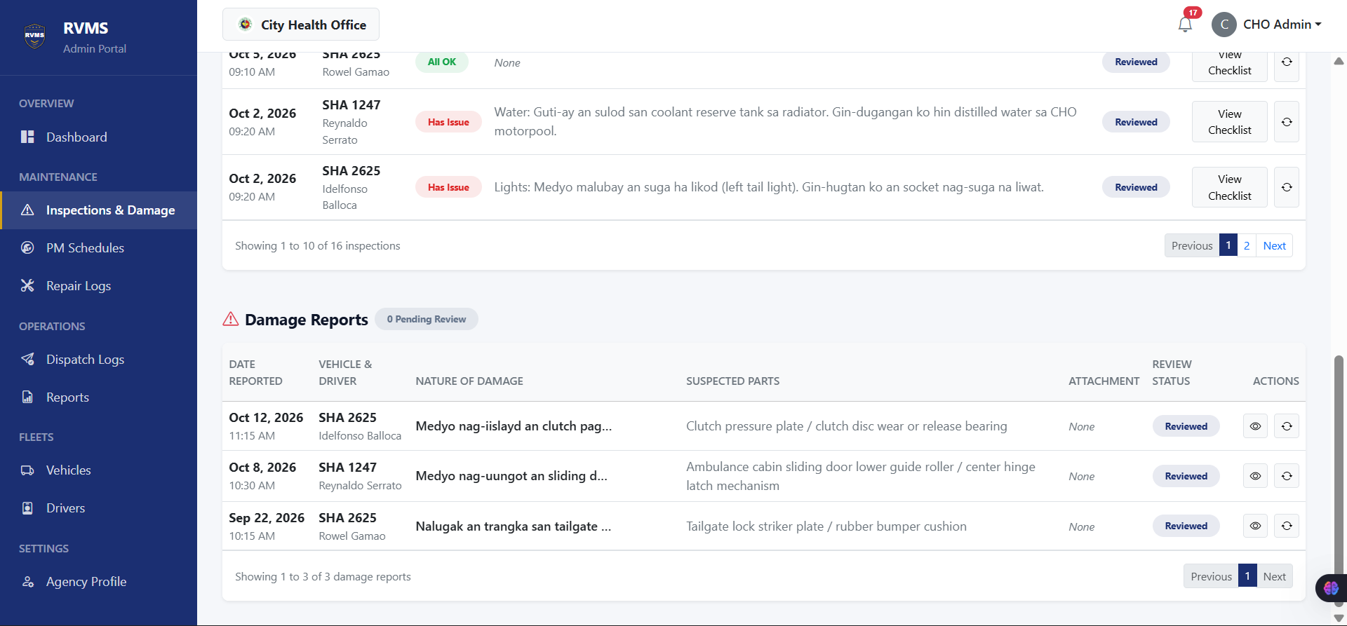
Figure 8.3. Inspections and Damage Reports Management Interface (Web Dashboard)
Figure 8.3 displays the primary landing screen accessed when an administrator navigates to the "Inspections & Damage" module on the web dashboard. This central triage screen consolidates all daily inspection submissions and incident damage reports filed by agency drivers. The interactive table presents the submission date and time, reporting driver, vehicle plate number, report type, summary of flagged checklist items or damages, and current review status (Pending or Reviewed). Flagged inspections with reported defects are visually accentuated with warning indicators to immediately capture administrative attention. From this interface, administrators can filter records by date range, vehicle, or driver, inspect detailed submissions, and initiate administrative reviews to assess mechanical severity and update vehicle availability.
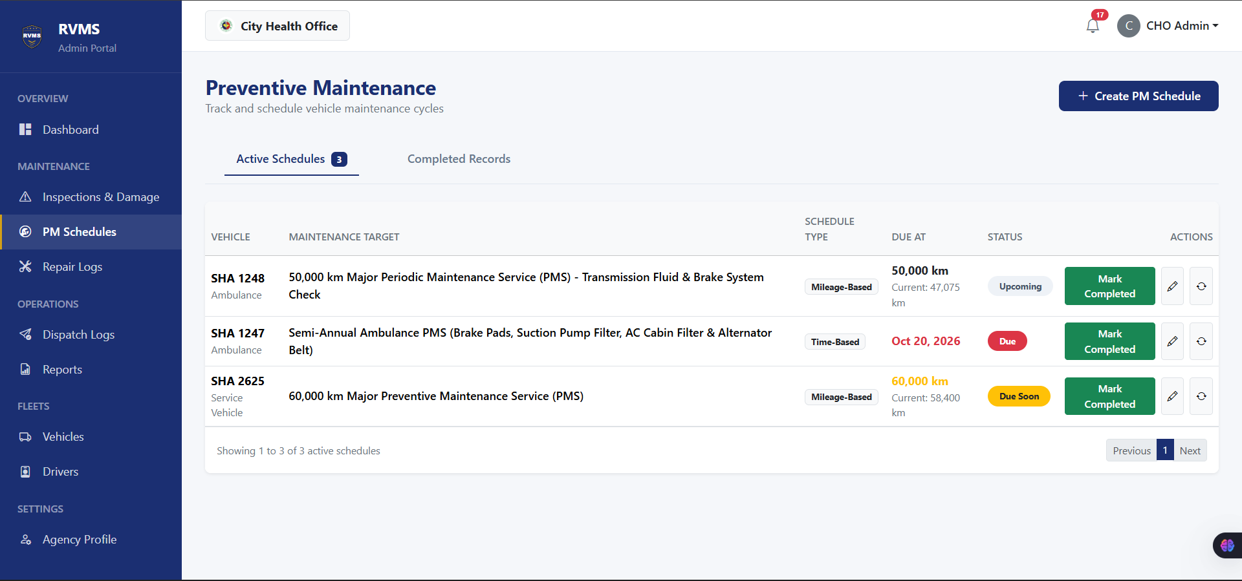
Figure 8.4. Preventive Maintenance Schedule Management Interface (Web Dashboard)
Figure 8.4 illustrates the preventive maintenance (PMS) tracking module on the web dashboard. The interface is organized into distinct lifecycle status tabs—Upcoming, Due Soon, Due, and Completed—allowing administrators to monitor upcoming service milestones across the entire fleet. The active schedule table details each vehicle's plate number, make and model, service target description (such as a 10,000 km periodic maintenance service or bi-annual brake system overhaul), tracking interval type (mileage-based or time-based), target threshold, current vehicle mileage, and automated status indicator. By continuously comparing live vehicle odometer readings and calendar dates against target service thresholds, the system flags vehicles entering the "Due Soon" warning threshold, enabling administrators to schedule routine servicing proactively before severe mechanical failure occurs.
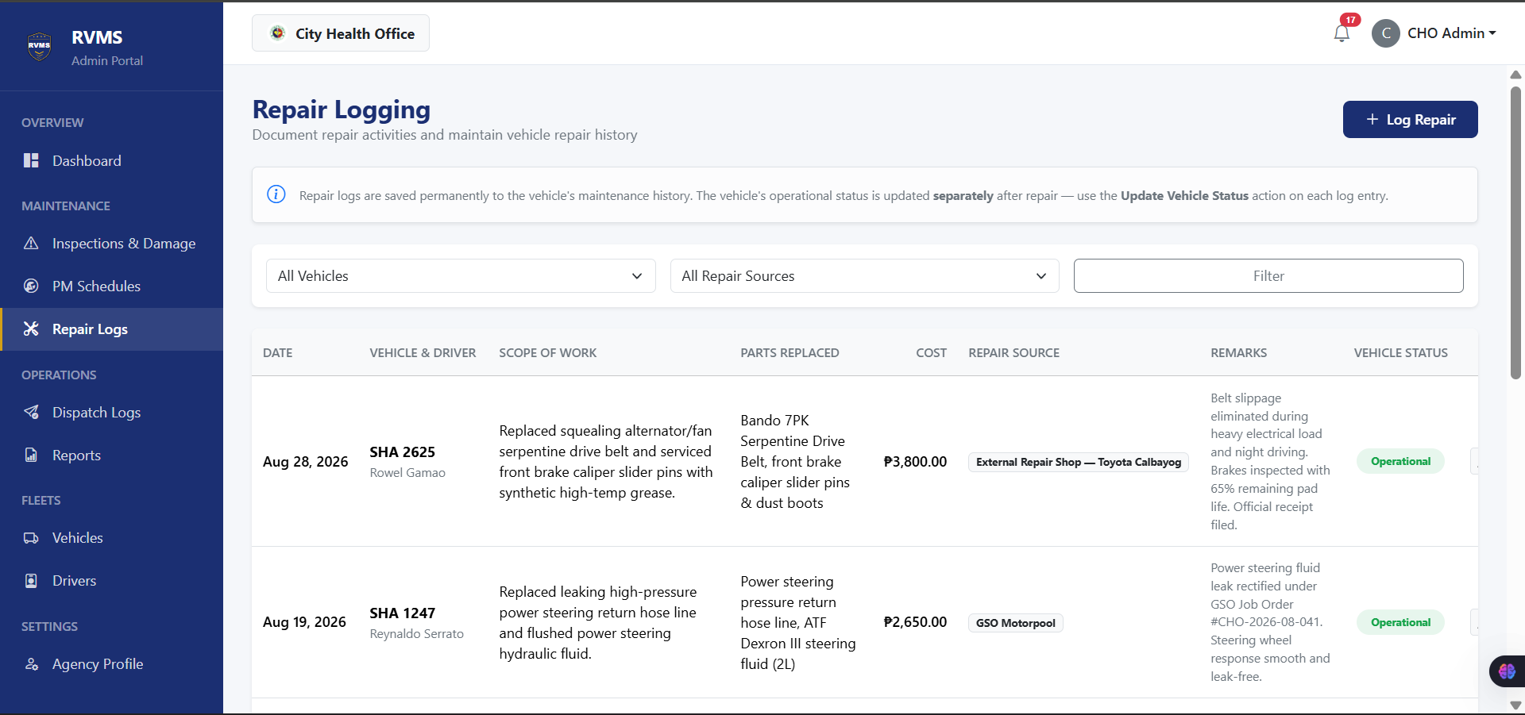
Figure 8.5. Repair Logs Management Interface (Web Dashboard)
Figure 8.5 shows the comprehensive Repair Logs on the web dashboard, presenting all historical corrective repairs recorded for the agency's rescue fleet. Unlike preventive maintenance milestones, this table maintains a permanent chronological record of ad-hoc and corrective repairs resulting from mechanical breakdowns, wear, or damage. The data table displays the repair date, vehicle plate number, scope of work conducted, itemized list of replacement spare parts, total financial expenditure in Philippine Pesos (₱), repair facility source (Internal Office, City GSO Motorpool, or External Repair Shop), and the assigned driver. By aggregating maintenance expenditures and documenting the exact components replaced across all agency units, this interface provides complete operational transparency, establishes an audit-ready maintenance history, and supports informed fleet budgeting.
- To provide an admin module for dispatch and vehicle management
The third objective focused on providing Agency Administrators with a centralized administrative module for overseeing fleet vehicle availability and coordinating emergency dispatches. Prior to the implementation of the system, participating agencies relied on disconnected whiteboards, manual logbooks, and informal messaging group chats to confirm vehicle availability and document deployments. To resolve these operational vulnerabilities, the administrative web platform integrates two core management interfaces: a centralized Vehicle Management module that maintains an active inventory of rescue units, tracks cumulative mileage, and enforces operational status controls; and a comprehensive Dispatch Logs ledger that documents emergency deployments, crew assignments, mission types, and travel distances from initial departure to mission return.
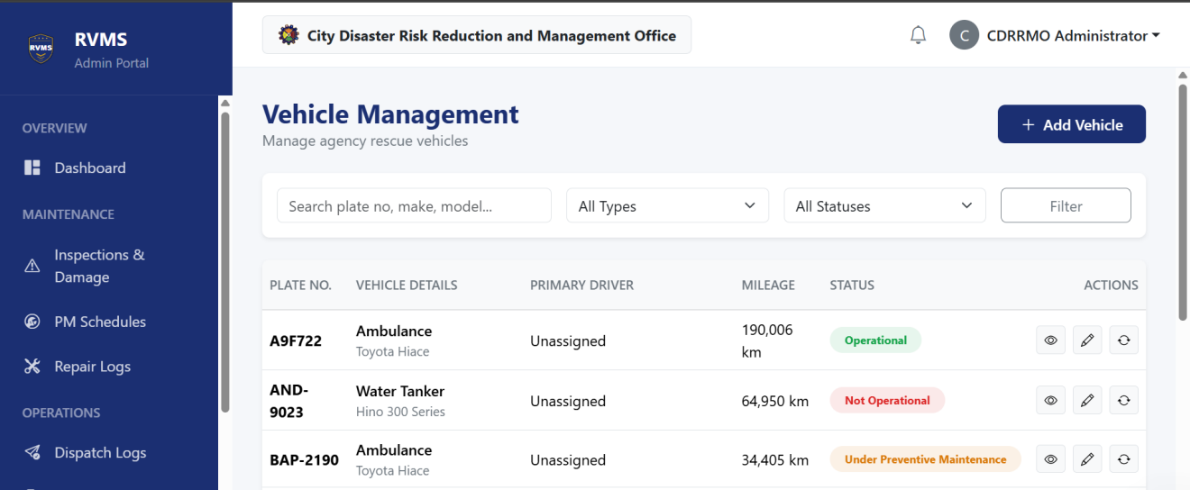
Figure 9.1. Vehicle Management Interface (Web Dashboard)
Figure 9.1 illustrates the Vehicle Management interface on the web dashboard, providing Agency Administrators with an active, centralized registry of all emergency vehicles assigned to their agency. The data table itemizes each unit’s essential operational details, including vehicle classification (e.g., Ambulance, Fire Truck, Rescue Vehicle, Patrol Car), official plate number, make and model, engine number, chassis number, and cumulative odometer mileage. The interface also displays the designated primary driver and optional secondary driver assigned to each unit, establishing clear personnel accountability for vehicle handling. Most crucially, the table prominently displays each vehicle's real-time operational status using standardized badges: Operational (available for active deployment), Dispatched (currently out on an emergency run), Not Operational (grounded due to safety defects or mechanical failure), and Under Preventive Maintenance (undergoing scheduled servicing). This inventory view enables administrators to edit vehicle specifications, reassign drivers, monitor odometer progression, and enforce operational lockout rules that prevent unserviceable or grounded vehicles from being deployed.
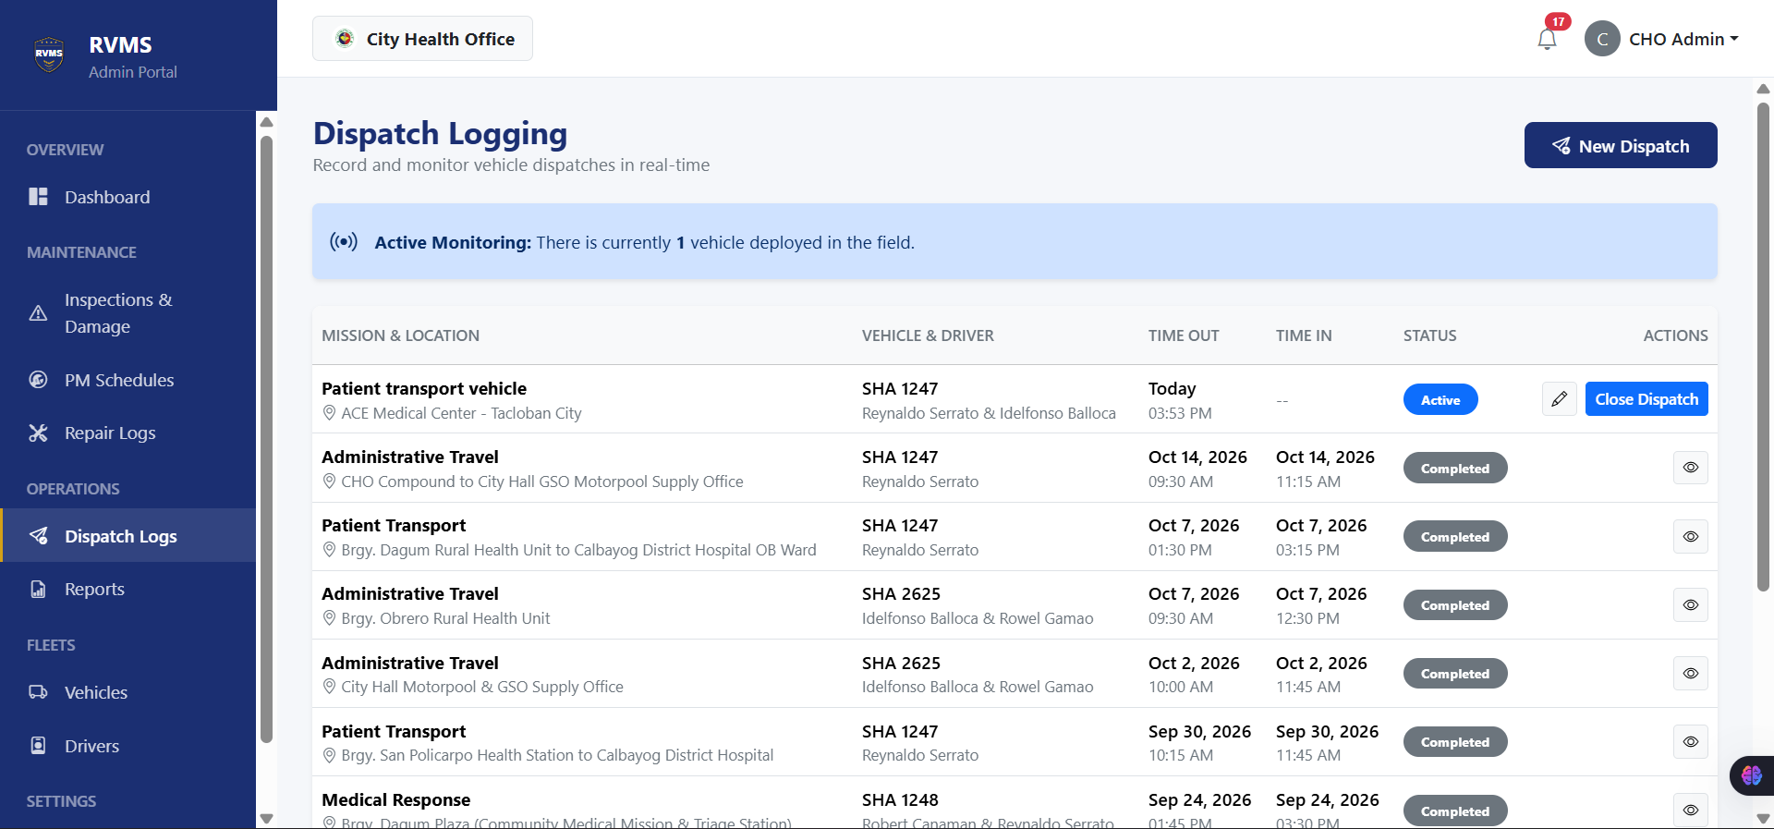
Figure 9.2. Dispatch Logs Interface (Web Dashboard)
Figure 9.2 shows the Dispatch Logs management interface on the web dashboard, presenting the complete operational ledger of all emergency and administrative vehicle dispatches conducted by the agency. The interface records every deployment parameter: the dispatched vehicle plate number, the primary driver, an optional secondary driver for dual-crewed responses, the emergency mission category (Fire Response, Medical Response, Rescue Operation, Patrol, Administrative Travel, or Others), and the target destination barangay or facility. For active deployments, the table records the departure timestamp (Time Out) and departure odometer reading, marking the vehicle status as Dispatched across the entire system. Once the vehicle returns from its mission, the administrator records the arrival timestamp (Time In), the final odometer reading, post-trip administrative remarks, and the designated return status (Operational, Not Operational, or Under Preventive Maintenance). If the entered arrival odometer exceeds the stored mileage, the system automatically updates the vehicle's cumulative odometer reading in the central database, seamlessly advancing mileage-based preventive maintenance tracking without manual re-entry.
- To generate relevant reports
The fourth objective aimed to eliminate manual, paper-based reporting and the time-consuming administrative burden of consolidating physical logbooks and ledger cards across rescue agencies. Administrators can configure tailored queries across six operational categories using flexible date, vehicle, and driver filters, and immediately generate formatted, audit-ready operational reports complete with analytical summary metrics and official sign-off lines.
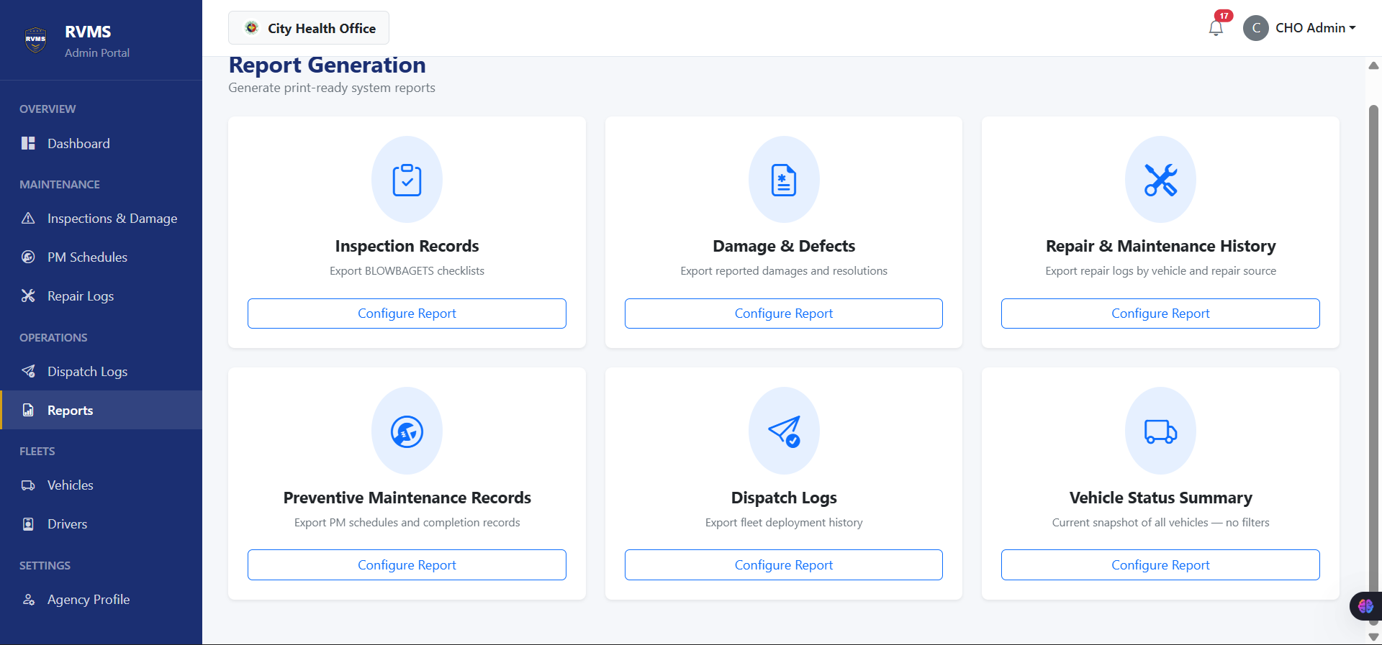
Figure 10.1. Report Generation Interface (Web Dashboard)
Figure 10.1 displays the centralized Report Generation interface on the web dashboard, providing Agency Administrators with a single, unified workspace to produce operational documentation. The interface organizes agency reporting into six dedicated category tabs: Inspection Records, Damage and Defect Reports, Repair and Maintenance History, Preventive Maintenance Schedules, Dispatch Logs, and Vehicle Status Summaries. Within each tab, administrators can customize their data query using intuitive filter parameters, including preset or custom date range selectors (daily, weekly, monthly, or custom quarterly periods), vehicle plate number dropdowns, and individual driver selectors. This structured configuration screen allows administrators to isolate specific operational subsets—such as reviewing all incidents associated with a particular ambulance or auditing dispatches across a holiday weekend—before generating the final consolidated output.
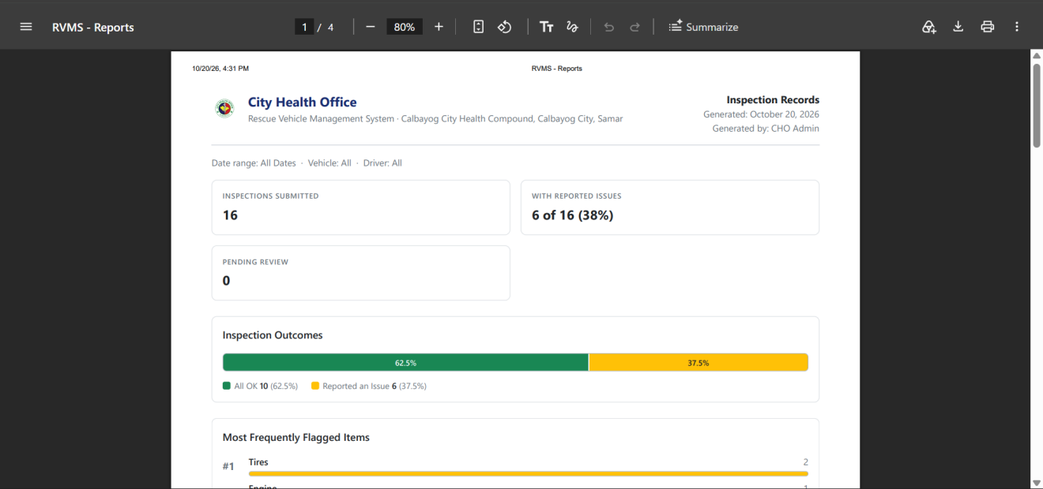
Figure 10.2. Generated Inspection Records Report Output (Web Dashboard)
Figure 10.2 illustrates the generated Inspection Records Report produced by the system's reporting engine. Designed for both on-screen review and official printing, the generated output incorporates formal institutional formatting starting with an official agency header and a clear statement of applied filter criteria. At the top of the report, high-level summary cards provide immediate analytical insights, presenting key performance indicators such as the total volume of daily inspections completed within the specified period, the number of inspections containing flagged safety defects, and the overall fleet pre-trip compliance rate. Below the summary statistics, an itemized tabular ledger chronologically details each inspection event, citing the inspection timestamp, vehicle plate number, inspecting driver, evaluated BLOWBAGETS components, specific flagged defects, and recorded driver remarks. The document concludes with standard administrative signature lines (Prepared By, Verified By, and Approved By), providing formal accountability and making the generated report immediately suitable for administrative audits, fleet performance evaluations, and government oversight compliance.
System Evaluation and Discussion
To evaluate the operational acceptability, technical soundness, and quality of the developed Rescue Vehicle Management System (RVMS), a formal system evaluation was conducted across the four participating municipal emergency response agencies: the City Health Office (CHO), the City Disaster Risk Reduction and Management Office (CDRRMO), the Bureau of Fire Protection (BFP), and the Philippine National Police (PNP).
The evaluation was structured around the ISO/IEC 25010 Software Quality Model, directly aligning with the non-functional requirements (NFRs) and operational criteria established during the initial requirements analysis. A total of eight (8) evaluators participated in the evaluation, representing key operational and administrative roles: Operations and Warning Section Head, Chief of Logistics Unit, Assistant Supply PNCO, Medical Officer III, Dispatcher, Administrative Staff, Emergency Vehicle Drivers.
The evaluation instrument utilized a 5-point Likert scale comprising twelve (12) criteria distributed across six (6) ISO/IEC 25010 quality characteristics: Functional Suitability, Performance Efficiency, Security, Usability, Reliability, and Compatibility & Portability. Table 16 defines the statistical scale and verbal interpretations applied to the evaluation data.
Table 16. Scale and Interpretation for System Evaluation
Rating Scale | Range of Mean | Verbal Interpretation | Description
5 | 4.21 - 5.00 | Strongly Agree (SA) | Highly Acceptable / Excellent
4 | 3.41 - 4.20 | Agree (A) | Acceptable / Very Good
3 | 2.61 - 3.40 | Neutral (N) | Moderately Acceptable / Fair
2 | 1.81 - 2.60 | Disagree (D) | Slightly Acceptable / Poor
1 | 1.00 - 1.80 | Strongly Disagree (SD) | Not Acceptable / Very Poor

Table 17 summarizes the evaluation results across all criteria, including frequency distributions, weighted means per criterion, sub-category means, and the overall mean.
Table 17. Summary of System Evaluation Results Based on ISO/IEC 25010 Quality Standards (N=8)
ISO/IEC 25010 Criteria & Evaluation Statements | 1  (SD) | 2  (D) | 3  (N) | 4  (A) | 5  (SA) | Weighted Mean | Interpretation
A. Functional Suitability
1. The system covers all essential functions for municipal fleet operations (daily BLOWBAGETS checklists, emergency dispatches, damage tickets, and preventive maintenance tracking). | 0 | 0 | 0 | 2 | 6 | 4.75 | Strongly Agree
2. The system workflows and tools directly address and support the day-to-day operational needs of our agency. | 0 | 0 | 0 | 2 | 6 | 4.75 | Strongly Agree
Category Sub-Mean |  |  |  |  |  | 4.75 | Strongly Agree
B. Performance Efficiency
3. The system responds quickly to user actions, loading dashboards, lists, and reports without noticeable delay. | 0 | 0 | 0 | 3 | 5 | 4.63 | Strongly Agree
4. The system maintains fast, responsive performance even when several agency users are working at the same time. | 0 | 0 | 0 | 2 | 6 | 4.75 | Strongly Agree
Category Sub-Mean |  |  |  |  |  | 4.69 | Strongly Agree
C. Security
5. The system keeps data safe through secure logins, hashed passwords, and encrypted communication, ensuring each agency's records stay private. | 0 | 0 | 0 | 2 | 6 | 4.75 | Strongly Agree
6. The system enforces role-based access control, ensuring authorized drivers and administrators access only the features and data appropriate to their role. | 0 | 0 | 0 | 1 | 7 | 4.88 | Strongly Agree
Category Sub-Mean |  |  |  |  |  | 4.81 | Strongly Agree
D. Usability
7. The system is simple and easy to use on both platforms, letting drivers and administrators finish common tasks in as few steps as possible. | 0 | 0 | 0 | 2 | 6 | 4.75 | Strongly Agree
8. The mobile application features large, easy-to-tap buttons and clear layouts that make conducting pre-trip inspections straightforward for drivers. | 0 | 0 | 0 | 3 | 5 | 4.63 | Strongly Agree
Category Sub-Mean |  |  |  |  |  | 4.69 | Strongly Agree
E. Reliability
9. The system records information accurately and consistently shows the exact same vehicle status on both the mobile app and web dashboard. | 0 | 0 | 0 | 2 | 6 | 4.75 | Strongly Agree
10. The system provides dependable and timely delivery of notifications for time-sensitive events (such as dispatch updates, maintenance due dates, and damage reports). | 0 | 0 | 0 | 2 | 6 | 4.75 | Strongly Agree
Category Sub-Mean |  |  |  |  |  | 4.75 | Strongly Agree
F. Compatibility & Portability
11. The mobile application installs and runs reliably on smartphones running Android 8.0 (Oreo) and later versions. | 0 | 0 | 0 | 3 | 5 | 4.63 | Strongly Agree
12. The web administrative dashboard works smoothly on common modern browsers like Google Chrome, Mozilla Firefox, and Microsoft Edge. | 0 | 0 | 0 | 2 | 6 | 4.75 | Strongly Agree
Category Sub-Mean |  |  |  |  |  | 4.69 | Strongly Agree
OVERALL MEAN |  |  |  |  |  | 4.73 | Strongly Agree

The evaluation findings presented in Table 17 demonstrate an exceptionally high level of user acceptance and technical compliance, achieving an overall grand mean of 4.73 with a verbal interpretation of Strongly Agree (Highly Acceptable). Notably, no statement received a rating of Disagree (2), Strongly Disagree (1), or Neutral (3), signifying unanimous approval across all surveyed emergency response units. Overall, the client evaluation results provide empirical evidence that the Rescue Vehicle Management System successfully fulfills its design requirements, satisfies its non-functional parameters under ISO/IEC 25010, and offers a robust, highly acceptable software solution for municipal rescue vehicle operations.

CHAPTER 5
RECOMMENDATIONS
Based on the practical feedback from the participating agencies, the researchers recommend several key enhancements for future development. First, the mobile application should be developed as a cross-platform solution to support iOS devices alongside Android, ensuring all drivers and personnel can access the system regardless of device type. Second, the system should incorporate a damage severity feature that evaluates inspection results and damage reports to provide clear insights into the level of damage, helping administrators prioritize critical mechanical repairs over minor issues. Third, the notification system should implement continuous, recurring alerts for overdue preventive maintenance to ensure that both drivers and administrators are persistently reminded until the vehicle is serviced. Fourth, an administrative confirmation feature should be added to allow administrators to send direct remarks and completion confirmations back to the driver once an assigned vehicle's preventive maintenance is completed. Finally, the mobile app should include a status messaging feature that allows drivers to send quick milestone updates to the dashboard, such as confirming their safe arrival at an emergency destination.

Relevant Source Code
- Vehicle Registration
<?php
namespace App\Http\Requests;
use App\Models\User;
use Illuminate\Foundation\Http\FormRequest;
use Illuminate\Validation\Rule;
class StoreVehicleRequest extends FormRequest
{
public function authorize(): bool
{
return true; // role gating happens in the route middleware
}
protected function prepareForValidation(): void
{
if ($this->input('type') === 'Other') {
$this->merge([
'type' => $this->filled('custom_type') ? trim((string) $this->input('custom_type')) : null,
]);
}
}
public function rules(): array
{
$agencyId = $this->user()->agency_id;
$vehicleId = $this->route('vehicle')?->id;

return [
'type' => ['required', 'string', 'max:100'],
'plate_number' => [
'required', 'string', 'max:20',
Rule::unique('vehicles', 'plate_number')
->where('agency_id', $agencyId)
->ignore($vehicleId),
],
'make' => ['required', 'string', 'max:100'],
'model' => ['required', 'string', 'max:100'],
'engine_number' => [
'nullable', 'string', 'max:50',
Rule::unique('vehicles', 'engine_number')
->where('agency_id', $agencyId)
->ignore($vehicleId),
],
'chassis_number' => [
'nullable', 'string', 'max:50',
Rule::unique('vehicles', 'chassis_number')
->where('agency_id', $agencyId)
->ignore($vehicleId),
],
'current_mileage' => ['required', 'integer', 'min:0'],
'assigned_driver_id' => [
'nullable',
Rule::exists('users', 'id')
->where('agency_id', $agencyId)
->where('role', User::ROLE_DRIVER),
],
'secondary_driver_id' => [
'nullable',
'different:assigned_driver_id',
Rule::exists('users', 'id')
->where('agency_id', $agencyId)
->where('role', User::ROLE_DRIVER),
],
];
}
public function messages(): array
{
return [
'type.required' => 'Please select or specify a vehicle type.',
'plate_number.unique' => 'A vehicle with this plate number already exists in your agency.',
'engine_number.unique' => 'A vehicle with this engine number already exists in your agency.',
'chassis_number.unique' => 'A vehicle with this chassis number already exists in your agency.',
'assigned_driver_id.exists' => 'The assigned driver must be an authorized driver of your agency.',
'secondary_driver_id.exists' => 'The secondary driver must be an authorized driver of your agency.',
'secondary_driver_id.different' => 'The secondary driver must be different from the primary driver.',
];
}
}

- Daily Inspection Submission
<?php
namespace App\Http\Controllers\Api\V1;
use App\Http\Controllers\Controller;
use App\Http\Requests\ReviewInspectionRequest;
use App\Http\Requests\StoreInspectionRequest;
use App\Http\Resources\InspectionResource;
use App\Models\Inspection;
use App\Models\InspectionItem;
use App\Models\Notification;
use App\Models\User;
use App\Services\VehicleStatusWriter;
use App\Services\NotificationDispatcher;
use Illuminate\Http\Request;
use Illuminate\Support\Carbon;
use Illuminate\Support\Facades\DB;
use Symfony\Component\HttpKernel\Exception\NotFoundHttpException;
class InspectionController extends Controller
{
public function store(StoreInspectionRequest $request)
{
$inspection=DB::transaction(function()use($request) {
// agency_id is auto-stamped from the authenticated driver (BelongsToAgency).
$inspection = Inspection::create([
'vehicle_id' => $request->validated('vehicle_id'),
'driver_id' => $request->user()->id,
'inspection_date' => $request->validated('inspection_date') ?? now()->toDateString(),
'review_status' => Inspection::STATUS_PENDING,
]);
foreach ($request->validated('items') as $item) {
$inspection->items()->create([
'checklist_item_id' => $item['checklist_item_id'],
'status' => $item['status'],
'remarks' => $item['status'] === InspectionItem::STATUS_HAS_ISSUE ? $item['remarks'] : null,
]);
}
return $inspection;
});
$this−>notifyIfFlagged($inspection);
return InspectionResource::make($inspection->load(['items.checklistItem', 'vehicle', 'driver']))
->response()
->setStatusCode(201);
}
private function notifyIfFlagged(Inspection $inspection): void
{
$flagged = $inspection->items()
->where('status', InspectionItem::STATUS_HAS_ISSUE)
->with('checklistItem')
->get();
if ($flagged->isEmpty()) {
return;
}
$names = $flagged−>map(fn($item) => $item->checklistItem?->name)->filter()->values();
$dispatcher = app(NotificationDispatcher::class);
$dispatcher->sendToMany(
$dispatcher−>adminsOf($inspection->agency_id),
Notification::TYPE_INSPECTION_FLAGGED,
'Inspection Reported an Issue',
sprintf(
'%s — %d %s flagged: %s.',
$inspection->vehicle?->plate_number ?? 'A vehicle',
$names->count(),
$names->count() === 1 ? 'item' : 'items',
$names->implode(', '),
),
[
'plate' => $inspection->vehicle?->plate_number,
'inspection_id' => $inspection->id,
'flagged_count' => $names->count(),
'flagged_items' => $names->all(),
],
);
}
public function index(Request $request)
{
$user = $request->user();
$query = Inspection::query()
->with(['vehicle', 'driver', 'items.checklistItem']);
if ($user->role === User::ROLE_DRIVER) {
$query->where('driver_id', $user->id);
} else {
$query
->when($request−>filled('vehicle_{i}d'),fn($q) => $q->where('vehicle_id', $request->integer('vehicle_id')))
->when($request−>filled('driver_{i}d'),fn($q) => $q->where('driver_id', $request->integer('driver_id')))
->when($request−>filled('date'),fn($q) => $q->whereDate('inspection_date', $request->date('date')))
->when($request−>filled('review_{s}tatus'),fn($q) => $q->where('review_status', $request->string('review_status')));
}
$inspections = $query
->latest('inspection_date')
->latest('id')
->paginate(10);
return InspectionResource::collection($inspections);
}
public function show(Request $request, Inspection $inspection)
{
$user = $request->user();
if ($user->role === User::ROLE_DRIVER && $inspection->driver_id !== $user->id) {
throw new NotFoundHttpException;
}
return InspectionResource::make(
$inspection->load(['items.checklistItem', 'vehicle', 'driver', 'reviewer'])
);
}
public function frequentIssues(Request $request)
{
$rows = InspectionItem::query()
->join('inspections', 'inspections.id', '=', 'inspection_items.inspection_id')
->join('inspection_checklist_items', 'inspection_checklist_items.id', '=', 'inspection_items.checklist_item_id')
->where('inspections.agency_id', $request->user()->agency_id)
->where('inspection_items.status', InspectionItem::STATUS_HAS_ISSUE)
->groupBy('inspection_items.checklist_item_id', 'inspection_checklist_items.name')
->select([
'inspection_items.checklist_item_id',
'inspection_checklist_items.name',
DB::raw('COUNT(*) as count'),
DB::raw('MAX(inspections.inspection_date) as last_reported'),
])
->orderByDesc('count')
->orderBy('inspection_checklist_items.name')
->get()
->map(fn ($row) => [
'checklist_item_id' => (int) $row->checklist_item_id,
'issue' => $row->name,
'count' => (int) $row->count,
'last_reported' => $row->last_reported
? Carbon::parse($row->last_reported)->toDateString()
: null,
]);
return response()->json(['data' => $rows]);
}
public function review(ReviewInspectionRequest $request, Inspection $inspection)
{
$inspection->update([
'review_status' => Inspection::STATUS_REVIEWED,
'reviewed_by' => $request->user()->id,
'reviewed_at' => now(),
]);
if ($status = $request->validated('vehicle_status')) {
app(VehicleStatusWriter::class)->write(
$inspection->vehicle,
$status,
VehicleStatusWriter::SOURCE_INSPECTION,
);
}
return InspectionResource::make(
$inspection->fresh()->load(['items.checklistItem', 'vehicle', 'driver', 'reviewer'])
);
}
}

- Dispatch Management
<?php
namespace App\Http\Controllers\Web;
use App\Http\Controllers\Controller;
use App\Http\Requests\CloseDispatchRequest;
use App\Http\Requests\StoreDispatchRequest;
use App\Models\Dispatch;
use App\Models\User;
use App\Models\Vehicle;
use App\Services\DispatchGuard;
use App\Services\DispatchReassignment;
use App\Services\VehicleStatusWriter;
use Illuminate\Http\RedirectResponse;
use Illuminate\Http\Request;
use Illuminate\Support\Facades\DB;
use Illuminate\View\View;
class DispatchController extends Controller
{
public function index(Request $request): View
{
$dispatches = Dispatch::query()
->with(['vehicle', 'driver', 'secondDriver'])
->latest('time_out')
->latest('id')
->paginate(10)
->withQueryString();
$activeCount = Dispatch::query()->whereNull('time_in')->count();
$vehicles = Vehicle::query()
->where('status', Vehicle::STATUS_OPERATIONAL)
->orderBy('plate_number')
->get(['id', 'plate_number', 'type', 'status', 'assigned_driver_id']);
$drivers = User::query()
->drivers()
->where('agency_id', $request->user()->agency_id)
->where('status', User::STATUS_ACTIVE)
->with('agency')
->orderBy('name')
->get(['id', 'name', 'agency_id', 'license_number', 'license_expiry_date']);
return view('dispatch', compact('dispatches', 'activeCount', 'vehicles', 'drivers'));
}
public function store(StoreDispatchRequest $request): RedirectResponse
{
DB::transaction(function () use ($request) {
$data = $request->validated();
if ($data['mission_type'] !== Dispatch::MISSION_OTHERS) {
$data['mission_other'] = null;
}
unset($data['travel_order']);
if ($path = $request->storeSupportingDocument('travel_order', 'travel-orders')) {
$data['travel_order_path'] = $path;
}
app(DispatchGuard::class)->assertFree(
(int) $data['vehicle_id'],
(int) $data['driver_id'],
! empty($data['second_driver_id']) ? (int) $data['second_driver_id'] : null,
);
$dispatch=Dispatch::create($data);
app(VehicleStatusWriter::class)->writeFromDispatch(
$dispatch->vehicle,
Vehicle::STATUS_DISPATCHED,
VehicleStatusWriter::SOURCE_DISPATCH_OPEN,
);
});
return redirect()->route('dispatch')->with('status', 'Vehicle dispatched.');
}
public function update(StoreDispatchRequest $request, Dispatch $dispatch): RedirectResponse
{
DB::transaction(function () use ($request, $dispatch) {
$data = $request->validated();
if ($data['mission_type'] !== Dispatch::MISSION_OTHERS) {
$data['mission_other'] = null;
}
unset($data['travel_order']);
if ($path = $request->storeSupportingDocument('travel_order', 'travel-orders')) {
$data['travel_order_path'] = $path;
}
$previousVehicleId = (int) $dispatch->vehicle_id;
if ($dispatch->isActive()) {
app(DispatchGuard::class)->assertFree(
(int) $data['vehicle_id'],
(int) $data['driver_id'],
! empty($data['second_driver_id']) ? (int) $data['second_driver_id'] : null,
$dispatch->id,
);
}
$dispatch−>update($data);
app(DispatchReassignment::class)->handOver($dispatch, $previousVehicleId);
});
return redirect()->route('dispatch')->with('status', 'Dispatch updated.');
}
public function close(CloseDispatchRequest $request, Dispatch $dispatch): RedirectResponse
{
DB::transaction(function () use ($request, $dispatch) {
$odometerIn = $request->validated('odometer_in');
$dispatch->update([
'time_in' => $request->validated('time_in'),
'odometer_in' => $odometerIn,
'return_status' => $request->validated('return_status'),
'remarks' => $request->validated('remarks'),
]);
$vehicle = $dispatch->vehicle;
$extra = [];
if ($odometerIn !== null && $odometerIn > (int) $vehicle->current_mileage) {
$extra['current_mileage'] = $odometerIn;
}
app(VehicleStatusWriter::class)->writeFromDispatch(
$vehicle,
$request->validated('return_status'),
VehicleStatusWriter::SOURCE_DISPATCH_CLOSE,
$extra,
);
});
return redirect()->route('dispatch')->with('status', 'Dispatch closed.');
}
}

- Report Generation
<?php
namespace App\Services;
use App\Models\DamageReport;
use App\Models\Dispatch;
use App\Models\Inspection;
use App\Models\InspectionItem;
use App\Models\PmSchedule;
use App\Models\RepairLog;
use App\Models\Vehicle;
use Carbon\CarbonInterface;
use Illuminate\Database\Eloquent\Builder;
use Illuminate\Support\Collection;
class ReportBuilder
{
public const TYPES = [
'inspections' => 'Inspection Records',
'damage' => 'Damage & Defects',
'repairs-maintenance' => 'Repair & Maintenance History',
'pm' => 'Preventive Maintenance Records',
'dispatch' => 'Dispatch Logs',
'vehicle-status' => 'Vehicle Status Summary',
];
public const RANGES = [
'all' => 'All Dates',
'last-7-days' => 'Last 7 Days',
'this-month' => 'This Month',
];
public const UNFILTERED_TYPES = ['vehicle-status'];
public const NO_DRIVER_FILTER_TYPES = ['pm', 'vehicle-status'];
public function build(string $type, int $agencyId, array $filters = []): array
{
$spec=match($type) {
'inspections' => $this−>inspections($agencyId, $filters),
'damage' => $this−>damage($agencyId, $filters),
'repairs-maintenance' => $this−>repairs($agencyId, $filters),
'pm' => $this−>pm($agencyId, $filters),
'dispatch' => $this−>dispatch($agencyId, $filters),
'vehicle-status' => $this−>vehicleStatus($agencyId),
};
return [
'title' => self::TYPES[$type],
'columns' => $spec['columns'],
'rows' => $spec['rows'],
'filter_summary' => $this−>filterSummary($type, $filters),
'summary' => [
'stats' => $spec['stats'] ?? [],
'composition' => $spec['composition'] ?? null,
'breakdown' => $spec['breakdown'] ?? null,
],
];
}
private function inspections(int $agencyId, array $filters): array
{
$records = $this->scoped(Inspection::query(), $agencyId, $filters, 'inspection_date')
->with(['vehicle', 'driver', 'reviewer', 'items.checklistItem'])
->orderByDesc('inspection_date')
->orderByDesc('id')
->get();
$rows = $records->map(fn (Inspection $i) => [
$this−>dateTime($i->created_at),
$this−>vehicleLabel($i->vehicle),
$i->driver?->name ?? '—',
$i->resultLabel(),
$i->remarksSummary(),
$i->review_status,
$i->reviewer?->name ?? '—',
]);
$flagged = $records->filter(
fn (Inspection $i) => $i−>items−>contains(fn($item) => $item->status === InspectionItem::STATUS_HAS_ISSUE)
);
$issueCounts = $records
->flatMap(fn (Inspection $i) => $i−>items−>filter(fn($item) => $item->status === InspectionItem::STATUS_HAS_ISSUE))
->groupBy(fn ($item) => $item->checklistItem?->name ?? 'Unknown')
->map->count()
->sortDesc();
return [
'columns' => ['Date & Time', 'Vehicle', 'Driver', 'Result', 'Flagged Items / Remarks', 'Review Status', 'Reviewed By'],
'rows' => $rows->all(),
'stats' => [
['label' => 'Total Inspections', 'value' => (string) $records->count()],
['label' => 'Passed (All OK)', 'value' => (string) ($records->count() - $flagged->count())],
['label' => 'Flagged Defects', 'value' => (string) $flagged->count()],
],
'breakdown' => [
'title' => 'Top Flagged Inspection Issues',
'items' => $issueCounts−>take(5)−>map(fn($count, $name) => ['label' => $name, 'count' => $count])->values()->all(),
],
];
}
private function damage(int $agencyId, array $filters): array
{
$records = $this->scoped(DamageReport::query(), $agencyId, $filters, 'created_at')
->with(['vehicle', 'driver', 'reviewer'])
->orderByDesc('created_at')
->get();
$rows = $records->map(fn (DamageReport $d) => [
$this−>dateTime($d->created_at),
$this−>vehicleLabel($d->vehicle),
$d->driver?->name ?? '—',
$d->severity,
$d->nature_of_damage,
$d->suspected_parts,
$d->review_status,
$d->reviewer?->name ?? '—',
]);
return [
'columns' => ['Date & Time', 'Vehicle', 'Driver', 'Severity', 'Nature of Damage', 'Suspected Defect Parts', 'Review Status', 'Assessed By'],
'rows' => $rows->all(),
'stats' => [
['label' => 'Total Damage Reports', 'value' => (string) $records->count()],
['label' => 'Pending Review', 'value' => (string) $records->where('review_status', 'Pending')->count()],
['label' => 'Reviewed', 'value' => (string) $records->where('review_status', 'Reviewed')->count()],
],
];
}
private function repairs(int $agencyId, array $filters): array
{
$records = $this->scoped(RepairLog::query(), $agencyId, $filters, 'repair_date')
->with(['vehicle', 'driver'])
->orderByDesc('repair_date')
->get();
$totalCost = (float) $records->sum('cost');
$rows = $records->map(fn (RepairLog $r) => [
$this−>date($r->repair_date),
$this−>vehicleLabel($r->vehicle),
$r->scope_of_work,
$r->parts_replaced ?? '—',
$r->cost !== null ? '₱'.number_format((float) $r->cost, 2) : '—',
$r->source,
$r->driver?->name ?? '—',
]);
return [
'columns' => ['Date Repaired', 'Vehicle', 'Scope of Work', 'Parts Replaced', 'Cost', 'Facility Source', 'Driver Assigned'],
'rows' => $rows->all(),
'stats' => [
['label' => 'Total Repairs', 'value' => (string) $records->count()],
['label' => 'Total Expenditure', 'value' => '₱'.number_format($totalCost, 2)],
['label' => 'Average Repair Cost', 'value' => $records−>count()>0?'₱'.number_{f}ormat($totalCost / $records->count(), 2) : '₱0.00'],
],
];
}
private function pm(int $agencyId, array $filters): array
{
$records = $this->scoped(PmSchedule::query(), $agencyId, $filters, 'due_date')
->with('vehicle')
->orderBy('due_date')
->get();
$rows = $records->map(fn (PmSchedule $p) => [
$this−>vehicleLabel($p->vehicle),
$p->title,
$p->pm_type,
$this−>pmDueLabel($p),
$p->status,
$p->last_serviced_date ? $this−>date($p->last_serviced_date) : '—',
$p->service_provider ?? '—',
]);
return [
'columns' => ['Vehicle', 'Maintenance Service Milestone', 'Interval Type', 'Target Threshold', 'Status', 'Date Serviced', 'Service Facility'],
'rows' => $rows->all(),
'stats' => [
['label' => 'Total Schedules', 'value' => (string) $records->count()],
['label' => 'Upcoming / Due Soon', 'value' => (string) $records->whereIn('status', ['Upcoming', 'Due Soon'])->count()],
['label' => 'Completed Cycles', 'value' => (string) $records->where('status', 'Completed')->count()],
],
];
}
private function dispatch(int $agencyId, array $filters): array
{
$records = $this->scoped(Dispatch::query(), $agencyId, $filters, 'time_out')
->with(['vehicle', 'driver', 'secondDriver'])
->orderByDesc('time_out')
->get();
$rows = $records->map(fn (Dispatch $d) => [
$this−>vehicleLabel($d->vehicle),
$d->driver?->name ?? '—',
$d->secondDriver?->name ?? '—',
$d−>mission_{t}ype===Dispatch::MISSION_{O}THERS?($d->mission_other ?? 'Others') : $d->mission_type,
$d->location,
$this−>dateTime($d->time_out),
$d->time_in ? $this−>dateTime($d->time_in) : 'Active Mission',
$d−>distanceTraveled()!==null?number_{f}ormat($d->distanceTraveled()).' km' : '—',
$d->return_status ?? 'Dispatched',
]);
return [
'columns' => ['Vehicle', 'Primary Driver', 'Secondary Driver', 'Mission Category', 'Destination', 'Time Out', 'Time In', 'Distance', 'Status'],
'rows' => $rows->all(),
'stats' => [
['label' => 'Total Deployments', 'value' => (string) $records->count()],
['label' => 'Completed Runs', 'value' => (string) $records->whereNotNull('time_in')->count()],
['label' => 'Active Missions', 'value' => (string) $records->whereNull('time_in')->count()],
],
];
}
private function vehicleStatus(int $agencyId): array
{
$vehicles = Vehicle::query()
->where('agency_id', $agencyId)
->with(['assignedDriver', 'secondaryDriver'])
->orderBy('plate_number')
->get();
$rows = $vehicles->map(fn (Vehicle $v) => [
$v->plate_number,
$v->type,
$v−>make.''.$v->model,
number_format($v->current_mileage).' km',
$v->assignedDriver?->name ?? 'Unassigned',
$v->secondaryDriver?->name ?? '—',
$v->status,
]);
return [
'columns' => ['Plate Number', 'Vehicle Type', 'Make & Model', 'Odometer Reading', 'Primary Driver', 'Secondary Driver', 'Operational Status'],
'rows' => $rows->all(),
'stats' => [
['label' => 'Total Fleet Units', 'value' => (string) $vehicles->count()],
['label' => 'Operational', 'value' => (string) $vehicles->where('status', Vehicle::STATUS_OPERATIONAL)->count()],
['label' => 'Dispatched', 'value' => (string) $vehicles->where('status', Vehicle::STATUS_DISPATCHED)->count()],
['label' => 'Grounded / Maintenance', 'value' => (string) $vehicles->whereIn('status', [Vehicle::STATUS_NOT_OPERATIONAL, Vehicle::STATUS_UNDER_PM])->count()],
],
];
}
private function scoped(Builder $query, int $agencyId, array $filters, string $dateColumn): Builder
{
$query->where('agency_id', $agencyId);

if (! empty($filters['vehicle_id'])) {
$query->where('vehicle_id', $filters['vehicle_id']);
}
if (! empty($filters['driver_id'])) {
$query->where('driver_id', $filters['driver_id']);
}
if ($range = $this−>rangeBounds($filters['range'] ?? null)) {
$query−>whereBetween($dateColumn, $range);
}
return $query;
}
private function rangeBounds(?string $range): ?array
{
return match ($range) {
'last-7-days' => [now()->subDays(6)->startOfDay(), now()->endOfDay()],
'this-month' => [now()->startOfMonth(), now()->endOfMonth()],
default => null,
};
}
private function filterSummary(string $type, array $filters): array
{
if (in_array($type, self::UNFILTERED_TYPES, true)) {
return ['Current snapshot of all vehicles'];
}
$bits=['Daterange:'.(self::RANGES[$filters['range'] ?? 'all'] ?? 'All Dates')];
$bits[]='Vehicle:'.($filters['vehicle_label'] ?? 'All');

if (! in_array($type, self::NO_DRIVER_FILTER_TYPES, true)) {
$bits[]='Driver:'.($filters['driver_label'] ?? 'All');
}
return $bits;
}
private function vehicleLabel(?Vehicle $vehicle): string
{
return $vehicle === null ? '—' : $vehicle−>plate_{n}umber.'('.$vehicle->type.')';
}
private function pmDueLabel(PmSchedule $schedule): string
{
if ($schedule->pm_type === PmSchedule::TYPE_MILEAGE && $schedule->due_mileage !== null) {
return number_format($schedule->due_mileage).' km';
}
return $this−>date($schedule->due_date);
}
private function date(?CarbonInterface $value): string
{
return $value?->format('M j, Y') ?? '—';
}
private function dateTime(?CarbonInterface $value): string
{
return $value?->format('M j, Y g:i A') ?? '—';
}
}

REFERENCES
Bolaños, C., Rojas, B., Salazar-Cabrera, R., Ramírez-González, G., Pachón de la Cruz, A., & Madrid Molina, J. M. (2022). Fleet management and control system for developing countries implemented with Intelligent Transportation Systems (ITS) services. Transportation Research Interdisciplinary Perspectives, 16, 100694. https://doi.org/10.1016/j.trip.2022.100694
Crespo del Castillo, A., & Parlikad, A. K. (2024). Dynamic fleet management: Integrating predictive and preventive maintenance with operation workload balance to minimise cost. Reliability Engineering and System Safety, 249, 110243. https://doi.org/10.1016/j.ress.2024.110243
Fleetio. (n.d.). Fleet management software. https://www.fleetio.com
Gallega, M. M. (2025). Vehicle maintenance management practices of the University of Eastern Philippines. International Journal of Advanced Multidisciplinary Studies, 5(6), 225–233.
Geotab. (2026). Fleet management software solutions. https://www.geotab.com
Gorham, R., Ponce de Leon Valdes, M., Small, M., & Gaviria Fajardo, R. (2025). Motor vehicle information management systems: A framework for improvement. World Bank.
Intal, G. L. D., Gomez, T. M. C., Cadorniga, A. V. T., & Kang, J. (2019). Design and development of a decision support system with visual analytics to improve MRT maintenance operations. Proceedings of the International Conference on Industrial Engineering and Operations Management, 3341–3351.
Jha, P. B., Mishra, A. K., & Aithal, P. S. (2023). Operation of vehicle maintenance system in context of developing countries emphasizing Nepal. International Journal of Case Studies in Business, IT, and Education, 7(1), 267–279. https://doi.org/10.5281/zenodo.7790868
Khaliq, A., Arista, R. D., & Arpan. (2025). Analysis and design of web-based vehicle management information systems to support operational efficiency. Journal of Information Technology, Computer Science and Electrical Engineering (JITCSE), 2(2), 74–82. https://doi.org/10.61306/jitcse
Lubis, B. R., & Suendri. (2025). Fleet management information system design PT. Bagus Amelia Jaya uses the user method web-based centered design. Journal of Electrical Engineering and Computer (JEECOM), 7(2), 537–547. https://doi.org/10.33650/jeecom.v4i2
Manila Bulletin. (2022). The re-invention of Jo Soliman. https://mb.com.ph
Mimbala, A. M., Macre, N. U., Maunga, N. C., & Acala, A. C. (2024). Web-based vehicle monitoring system of Mindanao State University Lanao del Norte Agricultural College. Psychology and Education: A Multidisciplinary Journal, 22(7), 863–888. https://doi.org/10.5281/zenodo.13118634
Nerona, G. G., Ortiz, S. J. G., Quizon, L. K. A., Racuya, J. K. I., Abata, P. J. O., Corpuz, J. K. B., Flores, C. N. B., Luna, S. M., Matchoc, H. L. P., & Modesto, N. D. (2025). Improving the data management system of a local government unit in Baguio City, Philippines through information systems solutions: Towards enhanced sustainable public service. Journal of Intelligent Systems and Applied Data Science, 3(2), 72–84. https://doi.org/10.64680/jisads.v3i2.46
PCMag. (2018). Chevin FleetWave review. https://www.pcmag.com/reviews/chevin-fleetwave
PhilTrack. (n.d.). Asset tracking & vehicle fleet management. http://philtrack.com
Piña Silva, G. A., Giovanni, S. M., & Flores De La Mota, I. (2025). Simulation of maintenance process improvements. Procedia Computer Science, 277, 2993–3001.
Samsara. (2025). Connected operations cloud. https://www.samsara.com
Verizon Connect. (2026). Fleet management software. https://www.verizonconnect.com
Vinay, M. G., Mandara, C. J., Nagarathana, B. S., Pavan, H. N., & Pavana Kumara, C. (2025). OneStop vehicle information system. International Journal of Research Publication and Reviews, 6(12), 7943–7948.
Wahyu, A. P., Heryono, H., & Hamdani, D. (2024). Web-based design for vehicle management information system of Widyatama University. Brilliance: Research of Artificial Intelligence, 4(1), 13–18. https://doi.org/10.47709/brilliance.v4i1.3641
Webcast Technologies Inc. (2026). TrackMe Suite. https://webcast-inc.com.ph

