**KnightCrawler**

**Game Design Document**

**Török Tamás** – EDH40K

**Herdics Máté -** CAIQ2C

**Gameplay**

KnightCrawler is a dungeon crawler top-down view videogame. The goal of the player is to get as far in the game as they can, while trying to set up new highscores each run by defeating enemies, clearing rooms and reaching lower floors.

The player must fight **floors** that are procedurally generated and built up of 6+ rooms. Each floor contains one **ladder** down to the next floor. Climbing down a ladder increases the game difficulty each floor as the player progresses through the run.

There are **chests** containing **level ups** hidden on each floor, giving the player the choice to upgrade one of their stats (speed/damage/max health/etc). As the game gets more and more difficult, the player needs to balance which stat they invest in, as the different weapons and enemies require different skills.

**World**

**Floors**

* Procedurally generated layout. The rooms are handmade, but their placement is always different.
* Increasingly more difficult
  + More and more rooms per floor
* One starting and one exit down each floor

**Floor tiles**

There are different types of tile that build up the layout of a room.

**Empty tile**

* Completely empty tile on the ground.
* Does not block anything.
* Has variants and added clutter on the ground for immersion.

**Spike**

* Damages players and non-spectral enemies

**Chest**

* Upgrades one of the player’s stats

**Exit**

* Allows the player to progress to the next level

**Rooms**

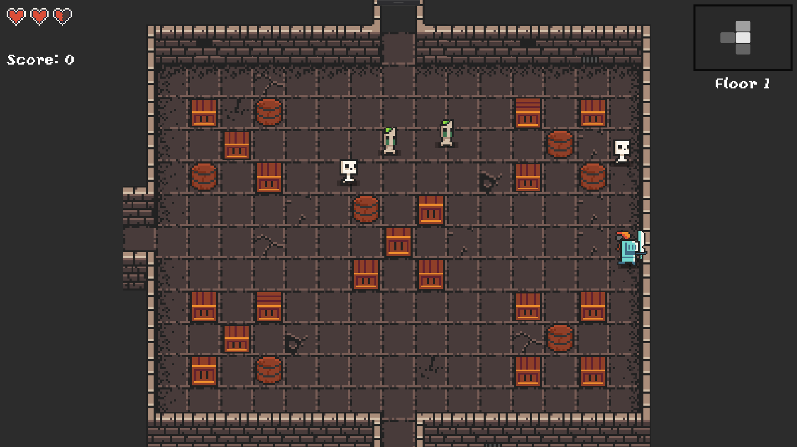

* Dimensions: 11 x 15 tiles
* Only one room is loaded at a time
* Matches the difficulty of the floor
* Loaded from file (made with layout editor)
* Might be clear to leave/enter on all 4 sides
  + If there is no room next to it in one direction, that wall will be solid
  + If the wall is not obstructed, and has a room in any direction, that wall will turn into a corridor allowing transition to the next room.
* If a player clears a room (defeating all enemies) they will not be able to clear it again.

**Special rooms**

* Starting room
  + 1 each floor where the player spawns
  + No enemies
  + Always contains one level up.
* **Exit room**
  + One each floor
  + Has an exit in the middle, which brings the player to the next floor

**Main character**



**Stats**

* Main attributes
  + Speed
  + Max health
* Different weapons
  + Melee attributes
    - Swing delay
    - Swing range
    - Swing damage

**Controls**

* **Movement:** W A S D keys
* **Attack (shoot/swing):** Up/Down/Left/Right keys

**Enemies**

**Movement types**

* A* pathfinding
  + Enemies track the player’s location and try to get close while avoiding obstacles in the room.
  + Enemies do not collide with objects in the room, but they avoid entering tiles with obstacles on them.
* Chasing
  + The enemy mindlessly tries to touch the player, bumping into all obstacles.
* Spectral
  + Enemies fly over obstacles trying to touch the player
  + Spectral enemies will NOT get hurt on spikes

|  |  |
| --- | --- |
| **Goblin** |  |
| Movement type | A* pathfinding |
| Max health | 1.8 HP |
| Speed | 2.4 |

|  |  |
| --- | --- |
| **Skeleton** |  |
| Movement type | A* pathfinding |
| Max health | 5 |
| Speed | 2 |

|  |  |
| --- | --- |
| **Spectre** |  |
| Movement type | Spectral |
| Max health | 4 |
| Speed | 1.6 |

|  |  |
| --- | --- |
| **Ogre** |  |
| Movement type | Chasing |
| Max health | 12 |
| Speed | 1 |

**GUI**

Health indicator Minimap

Current score Floor number



**Health indicator:**

* All hearts are 2 health points. Taking damage always lowers half a heart.

**Minimap:**

* The white rectangle shows the room the player is currently in.
* Light grey rectangles show the rooms the player has already discovered.
* Dark grey rooms show rooms the player has already seen a door to but has not yet entered.
* Rooms that the player has no knowledge of will not show up on the minimap.

**Floor number:**

* The text reminding the player which floor they are on.

**Score**

* The player’s current score

**Use Case**

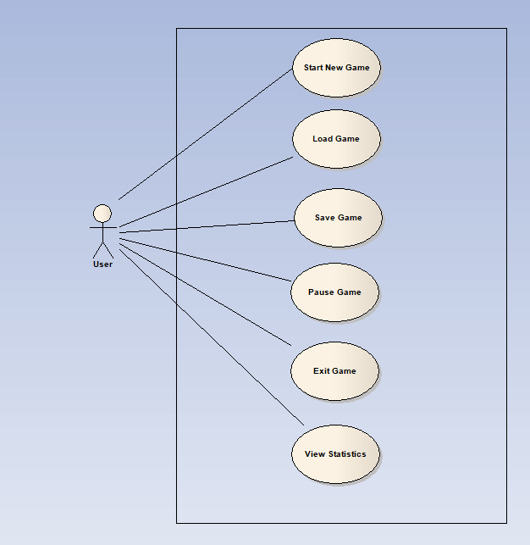

**Wireframe**

**MainMenu**

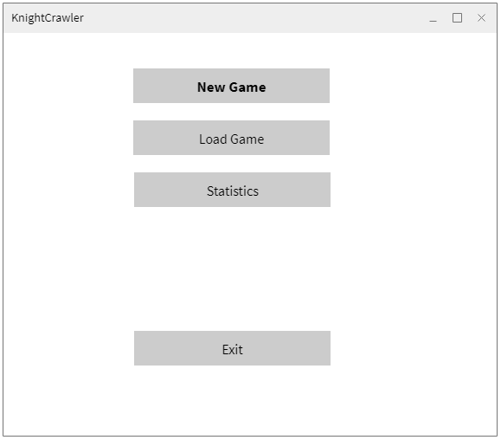

**Ingame Menu**

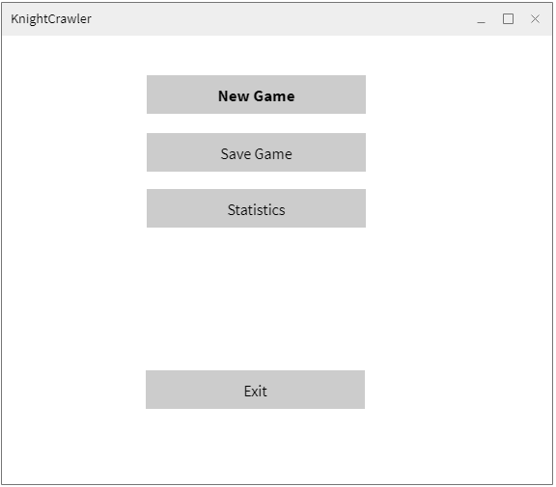

**Load Game (pop-up menu)**

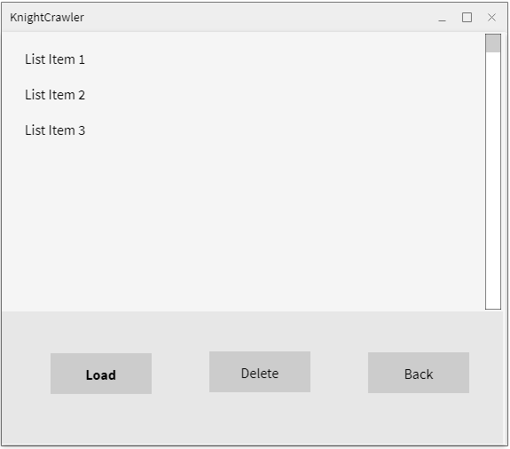

**Save Game (pop-up menu)**

