**MFTech Patient Diagnosis**

**Patient Details:**

**Date:** 25/06/24

**Name:** 2

**Age:** 2

**Pain Level:** 5

**Smoker:** N

**Drinker:** N

**Symptoms Transcript:**

“*my throat hurts my head hurts my mouth is really dry and whenever I have sex I come really early*”

**Model Results:**

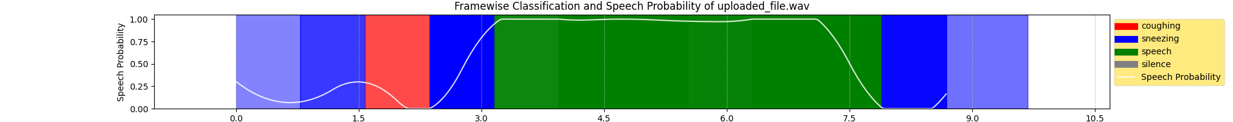

**Speech-Disruption Ratio:** 0.5

**Most-Probable Diseases (Disease: Probability):**

* Allergy: 40.0 %
* Diabetes: 32.7 %
* Drug Reaction: 4.9 %

**Sentiment Score:** 0.308

**Conclusion:**

**Further Consultation Required:** Y

**Treatment Required:** Y

**Treatment Score:** 0.654