**MFTech Patient Diagnosis**

**Patient Details:**

**Date:** 26/06/24

**Name:** some random guy

**Age:** 12

**Pain Level:** 5

**Smoker:** N

**Drinker:** Y

**Symptoms Transcript:**

“*I have trouble breathing in my face and chest are small my eyes are itchy and I have a dry cough*”

**Model Results:**

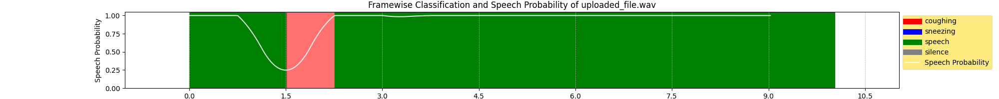

**Speech-Disruption Ratio:** 0.07692307692307693

**Most-Probable Diseases (Disease: Probability):**

* Allergy: 95.8 %
* Bronchial Asthma: 0.7 %
* Diabetes: 0.4 %

**Sentiment Score:** 0.369

**Conclusion:**

**Further Consultation Required:** N

**Treatment Required:** N

**Treatment Score:** 0.6845