**Trello board:** <https://trello.com/b/PAT4nhtZ/cocos-baking>

**User stories:**

1. As a user, I need a simple, visually appealing site interface where I can quickly find what I want so that using the site is easy and enjoyable.

| Task | Corresponding Story # | Duration | Priority (1-10) | Complexity | Lead person |
| --- | --- | --- | --- | --- | --- |
| Design General Home page | 1 | 2 | 7 | 6 | Wyatt |
| Design Customer Profile/Order History page | 1/3 | 1 | 4 | 7 | Torrey |
| Design Order page | 1 | 1 | 7 | 6 | Wyatt |
| Create Footer | 1 | 0.5 | 7 | 4 | Eric |
| Create basic files for the site - index.html, style.css and app.js | 1 | 1 | 7 | 7 | Trent |
| Create sign up/sign in modals | 1 | 0.5 | 7 | 5 | Trent |
| Create sign up/sign in (authentication | 1 | 1 | 8 | 7 | Trent |

1. As a business owner, I need my site to have the most important information readily available to me so that using the site is easy.

| Task | Corresponding Story # | Duration | Priority (1-10) | Complexity | Lead person |
| --- | --- | --- | --- | --- | --- |
| Design Owner's Manage Customer Orders page | 2 | 1 | 7 | 6 | Wyatt |
| Create and connect to Firebase database | 2 | 1 | 6 | 7 | Eric |
| Meet with stakeholder about site style and organization preferences (repeated) | 2/4 | 2.5 | 5 | 4 | Torrey |

1. As a business owner, I need a website to manage orders and items effectively so that I can improve time efficiency and productivity.

| Task | Corresponding Story # | Duration | Priority (1-10) | Complexity | Lead person |
| --- | --- | --- | --- | --- | --- |
| Add owner ability to update site | 3 | 3 | 4 | 8 | Torrey |
| Create a function to update the status of orders | 3 | 2 | 4 | 6 | Trent |

1. As a user/business owner, I want a site that looks well put-together and appropriate to the business so I can enjoy/so customers can enjoy using the site.

| Task | Corresponding Story # | Duration | Priority (1-10) | Complexity | Lead person |
| --- | --- | --- | --- | --- | --- |
| Implement Bulma capabilities | 4 | 1.5 | 5 | 6 | Trent |
| Organize components of the site | 4 | 2 | 5 | 4 | Trent |

**Burndown charts:**

**Day 4**

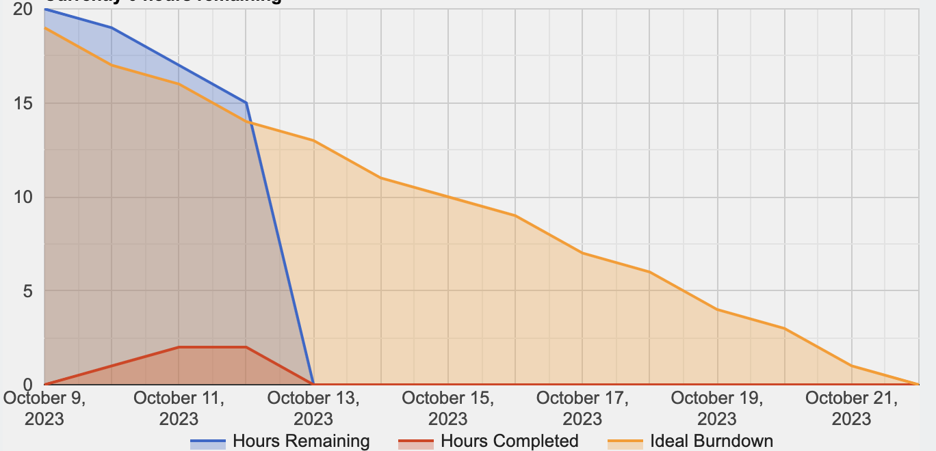

**Day 9**

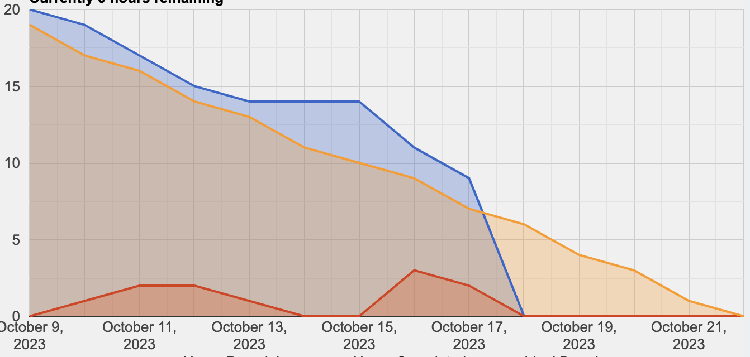

**Day 14**

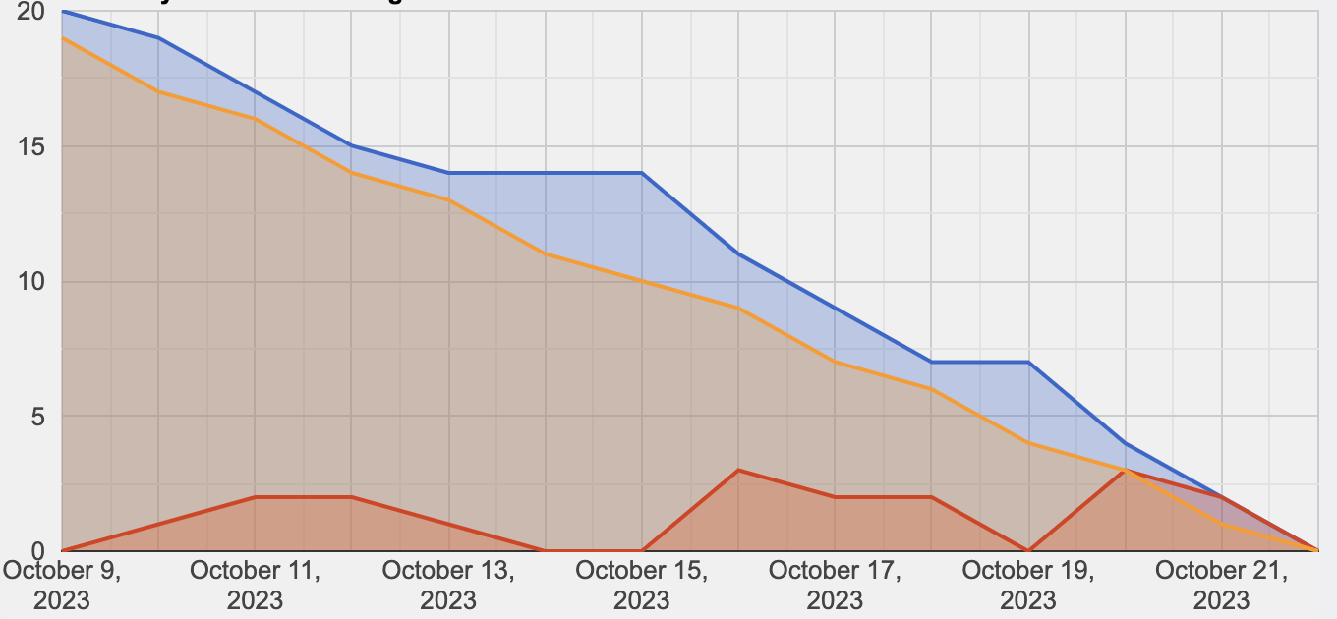

**Github public repo:** <https://github.com/torreycoan/cocosbaking>

**Daily scrum:**

* Daily meeting #1
  + Eric
    - Yesterday I looked at design references
    - Today I will generate a wireframe for the website.
    - Problems I am facing are none
  + Torrey
    - Yesterday I set up the readme document
    - Today I will continue to write and break down user stories into tasks
    - Problems I am facing are none
  + Trent
    - Yesterday I began to set the index.html page
    - Today I will continue adding on to those basics.
    - Problems I am facing are I cannot go too in depth with setting the mainframe for our html page because we are still finalizing our prototype.
  + Wyatt
    - Yesterday I set up the Trello board
    - Today I will make sure the burndown chart is up to date
    - Problems I am facing is not being able to access JustInMind
* Daily meeting #2
  + Eric
    - Yesterday I completed the wireframe for the website
    - Today I will connect and initialize firebase with the website
    - Problems I am facing are none
  + Torrey
    - Yesterday I began the site prototype in Justinmind and tried to share it with you all, to no success
    - Today I will log into your guys’ computers and see if you are able to access my Justinmind project in that instance
    - Problems I am facing are errors in Justinmind - sharing projects
  + Trent
    - Yesterday I added the breakdown of user stories as Trello cards
    - Today I will begin on index.html
    - Problems I am facing are none
  + Wyatt
    - Yesterday I used Eric’s wireframe to design the user interface in JustInMind
    - Today I will connect with everyone and gather opinions on user interface
    - Problems I am facing are letting other team members access JustInMind user interface design
* Daily meeting #3
  + Eric
    - Yesterday I set up Firebase for the project
    - Today I will ensure every groupmate can access it
    - Problems I am facing are none
  + Torrey
    - Yesterday I had another conversation with Joey about style preferences
    - Today I will communicate that info through our group chat and shared document
    - Problems I am facing are none
  + Trent
    - Yesterday I began working on the authentication aspect of the system
    - Today I will continue working on the authentication
    - Problems I am facing are that this can be a complex tax and will require some outside research
  + Wyatt
    - Yesterday I created elements in photoshop to be used in the website design
    - Today I will communicate with Torrey about style preferences and adjust the HTML and CSS code accordingly
    - Problems I am facing are none

**Sprint review:**

1. What did you learn from doing our first sprint?

**We learned a constant cycle of communication is essential. With people working on the same files, merges, and the need for overall organization, communication is a necessity. Additionally, when addressing the “what problems are in your way” part of the Daily Scrum, communication can help create a collaborative environment to help one another solve problems and make progress.**

**Related to the part of the Daily Scrum just mentioned, problems are going to be a part of any project. Some of the specific problems and issues encountered can be found in the Daily Scrum section above. Any project won’t progress smoothly; problems are a natural part of the process and will come up periodically.**

**Finally, we learned the importance of client feedback. Without client feedback, there can be a bit of misdirection in a project. Client feedback provides a track for teams to follow with relative goals of what is to be achieved. At the end of the day, the number one priority is customer satisfaction. Customer satisfaction will guide a project team and break up goals into iterations.**

1. What did go well? Why?

**One thing that went well was the development of our prototype; we feel it closely meets the client’s expectations. Obviously, adjustments will be made to meet exact expectations. This part of the project went well because we closely understood client expectations. Our communication with the client allowed us to develop this understanding and develop the appropriate prototype based off of it.**

**Then, based on the prototype, an overall mainframe for the actual site was created. Although nowhere close to complete, it still portrays a good look. This phase was successful due to close collaboration among team members**

1. What didn’t go well? Why not?

**User story breakdowns could have been more specific to more closely guide our development. This will require better communication as a team. We will need to have closer conversations to create a better user requirement definition and therefore break it up into applicable user stories.**

**Another aspect that didn’t go as desired was the authentication development process. There is still a lot of work to be done there. This didn’t go well because of the limited knowledge with authentication within firebase. This will be further developed in the next sprint and the professor’s help will be utilized.**

1. How can you make things better next time?

**We will be revisiting our user stories and breakdowns as we continue into the next sprint. Using the Checklist feature in Trello can be useful so that there are not too many cards (overwhelming visually) but the work to be done is still detailed.**

**Also, to address the trouble with authentication, as mentioned before, professor help will be seeked out and outside research will be done.**

1. Are you satisfied with what you already completed?

**Overall, we are satisfied with what we completed. Considering it was the first sprint, communication and progress was satisfactory.**

**There are things we have pinpointed in this sprint review that we will improve on. Our biggest need for improvement lies within the actual coding aspect. To make for a more satisfactory outcome in the next sprint, we could have closer conversations regarding coding to make sure everybody is on the same page.**

1. Which group was invited? What are your observations/notes? Everybody was present?

**No group remaining to partner with for the sprint review. Joey (client) was invited instead. All present. Joey noted no notes currently but will be coming back with notes as she comes up with them.**