**!!!!UPLOAD THIS AS README.DOC!!!**

**USER STORIES AND TASKS TO BE COMPLETED THIS SPRINT**

1. As a customer, I want my orders to be displayed in a visually appealing way with the most important information most obvious to me so that checking on my orders is easy and enjoyable.

| Task | Corresponding Story # | Duration | Priority (1-10) | Complexity | Lead person |
| --- | --- | --- | --- | --- | --- |
| Load only the customer’s orders on their My Orders page | 1 | 2 | 8 | 6 | Torrey |
| Load the customer’s orders in a visually appealing way using bulma. | 1 | 3 | 8 | 7 | Wyatt |
| Design the look for the customer’s order filters on the My Orders page | 1 | 1 | 5 | 6 | Trent |

1. As a customer, I want a page to clearly display available products in an appealing, organized way with the necessary information immediately available so I can understand what goods are being offered.

| Task | Corresponding Story # | Duration | Priority (1-10) | Complexity | Lead person |
| --- | --- | --- | --- | --- | --- |
| Obtain product information from owner, discuss product information needed | 2 | 1.5 | 7 | 2 | Torrey |
| Photoshop product images to reflect site style and be visually appealing | 2 | 2 | 7 | 6 | Wyatt |
| Add images to home page | 2 | 0.5 | 4 | 4 | Wyatt |
| Create “products” collection with necessary fields | 2 | 0.25 | 5 | 3 | Eric |
| Add product information to the “products” collection | 2 | 0.25 | 5 | 3 | Torrey |
| Create prototype for the stylistically appealing and well-organized display of products in the Products page using HTML | 2 | 1 | 7 | 6 | Eric |
| Load all products from the products collection into the products page, matching the prototype and taking into account the future additions/removals of products - HTML, JS, CSS | 2 | 5.5 | 7 | 7 | Torrey |
| Allow for product photos to be displayed directly on the “my orders” page. | 2 | 2 | 6 | 7 | Wyatt |

1. As a customer, I want the site’s appearance to change as my screen size changes so the site is enjoyable and easy to use.

| Task | Corresponding Story # | Duration | Priority (1-10) | Complexity | Lead person |
| --- | --- | --- | --- | --- | --- |
| Navbar disappears into the hamburger when the screen is small | 3 | 3 | 6 | 7 | Eric |
| Site contents compress appealingly when the screen is small | 3 | 2 | 6 | 7 | Eric |

1. As a customer, I want to be able to create an account and sign in/out so that I can see user-only information, keep track of my orders, and place orders that trace back to me.

| Task | Corresponding Story # | Duration | Priority (1-10) | Complexity | Lead person |
| --- | --- | --- | --- | --- | --- |
| Complete Firebase authentication | 4 | 6 | 9 | 9 | Eric |
| Complete authentication status check | 4 | 1.5 | 7 | 7 | Eric |
| Troubleshooting: sign up, sign in, sign out | 4 | 1.5 | 7 | 7 | Eric |

**PUBLIC TRELLO BOARD WITH STORIES *AND* TASKS:** <https://trello.com/b/PAT4nhtZ/cocos-baking>

**BURNDOWN CHART**

Day 4

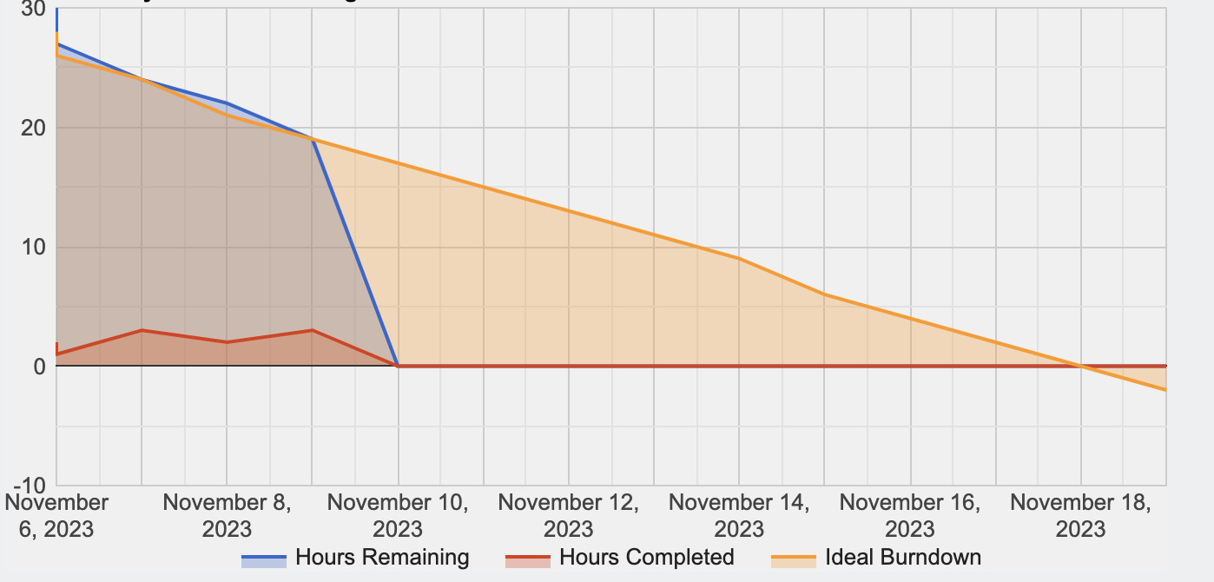

Day 9

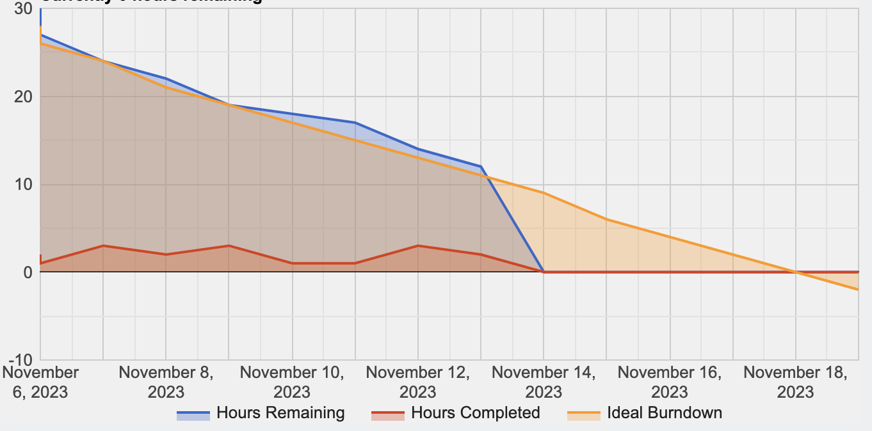

Day 14

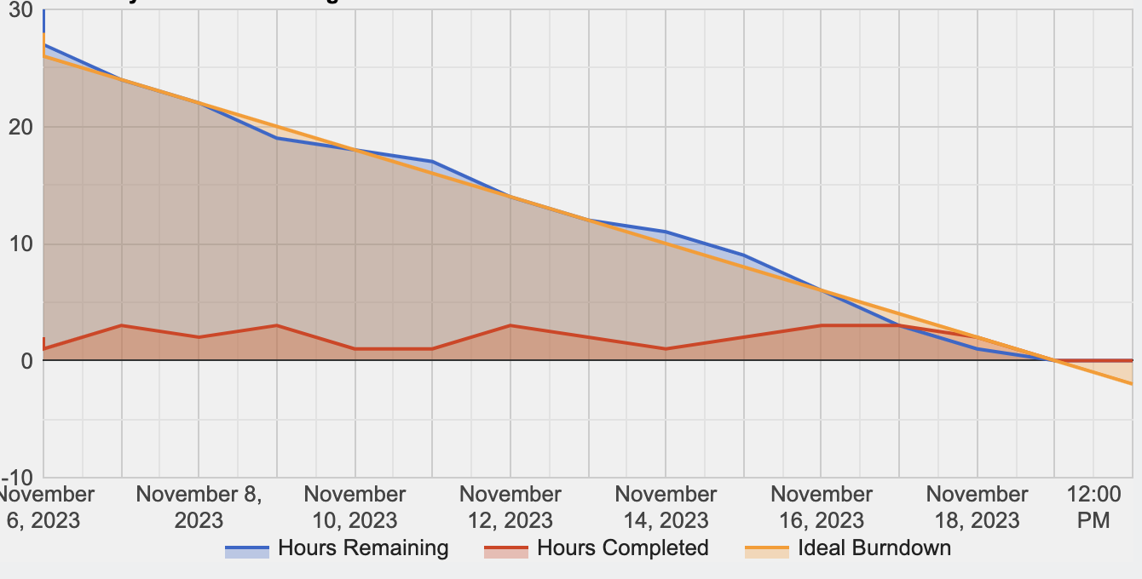

**DAILY SCRUM**

Meeting #1

* Torrey
  + Yesterday I updated the order form page to include all relevant fields
  + Today I will gather and organize product details from Joey
  + Problems I am facing are lack of photos from Joey/Joey is busy
* Trent
  + Yesterday I cleaned up some of the formatting on the site
  + Today I will work on trying to implement different site views based on if a user is signed in and signed out (can’t view the “Order Now” page or “My Orders” page if not signed in
  + Problems I am facing are none
* Wyatt
* Eric
  + Yesterday I fixed errors in sign in & out buttons
  + Today I will implement Firebase authentication
  + Problems I am facing are nothing

Meeting #2

* Torrey
  + Yesterday I created a version of the My Orders page
  + Today I will fix page bugs
  + Problems I am facing are none
* Trent
  + Yesterday I implemented different site views
  + Today I will begin laying the foundation for users to be able to filter their orders based on order status and payment status
  + Problems I am facing are conceptual difficulties in completing this task
* Wyatt
* Eric
  + Yesterday I implemented Firebase authentication
  + Today I will implement a reset function when signing in & out modals are closed or after processing and will edit the footer.
  + Problems I am facing are nothing

Meeting #3

* Torrey
  + Yesterday I pseudocoded how the products would be loaded into the products page
  + Today I will add the code for adding the products to the product page in a visually appealing fashion
  + Problems I am facing are none.
* Trent
  + Yesterday I worked on the filtering aspect of the page
  + Today I will finalize the formatting and overall look of the filtering section of the page
  + Problems I am facing are I’m not exactly sure what Joey will like most with this aspect of the site.
* Wyatt
* Eric
  + Yesterday I completed reset function and edited footer
  + Today I will implement Authentication status check, make navigation bar responsive by putting burger button when compressed
  + Problems I am facing are nothing

**EVIDENCE WORK WAS COMPLETED/GITHUB REPO**: <https://github.com/torreycoan/cocosbaking> . Example: see Eric Eoh’s commit “product page updated”, index.html, lines 253-307 for an example of work: design/prototype of the Products page.

**SPRINT REVIEW**

1. What did you learn from doing our second sprint?

**We learned the importance of receiving information from the client. Scrum implementation and agile frameworks not only require consistent communication with the client, but some information may be required from them too. This was the case with this sprint and our need for photos of products, product information, and product pricing. Additionally, hearing client feedback on the overall look of the site boosts development efficiency and further progresses the sprint’s progress.**

**Similar to the last sprint, we also learned about the importance of communication within the team. This sprint requires a lot more development in the app.js. Smaller tasks that aren’t listed in our task list and appear all over the files in small areas (e.g. code from troubleshooting, changing an id, tweaking page layout for another purpose) had to be clearly communicated. Additionally, this is important for merges and the issues that may arise from doing so.**

1. What did go well? Why?

**One aspect of this sprint that did go well was the development related to our collections. We feel as a group we have solidified definitions of the collections we have and the elements inside each document within the collection. This part of the sprint doesn’t go well without accurate and quality sprint planning along with daily scrums of the same standard. We communicated well as a team and defined specifically what we want to do with our collections, how they will affect our development, and where they will be utilized on the site.**

**Our overall organization of who is doing what task was of a high quality. We communicated early to define our tasks and also throughout the sprint to update each other on our progress and where we each may need assistance. Definitive jobs are the key to an organized process which is something we achieved.**

1. What didn’t go well? Why not?

**One thing that didn’t go well was some delays associated with needing information from our client, as previously mentioned. It was difficult to fully develop our “Order Now” page and “My Orders” page without knowing specific product information or pricing.**

**Another piece that didn’t go as well as we had hoped it would was balancing the daily obligations of the sprint with our daily lives. This sprint’s duration was in a busy part of our semester where each of us was busy in other courses we are taking. Balancing this sprint with our other courses’ work was difficult but we managed to make it work.**

1. How can you make things better next time?

**We can make things better next time by setting out in the sprint planning meeting what is specifically needed from the client. If we can gather the necessary information and materials from our client at the beginning of the sprint, our efficiency will be boosted and we can develop more quickly.**

**Additionally, each of us does a good job of this already, but looking ahead on our calendars, identifying times when we can work on the project, and setting aside this time to manage daily life with this project will be essential. This will be especially important as we begin to finish the project. There may be a lot of work required in putting the finishing touches on the project. We need to make sure we allocate enough time to complete it.**

1. Are you satisfied with what you already completed?

**We are satisfied with what we have completed. We have a lot of accomplished javascript and the overall look of our site is appealing and organized. This satisfaction wouldn’t be possible without our clear communication at the beginning of the sprint in defining our tasks. We feel our progress is adequate for a second sprint and we are in a good position to go into the final sprint and complete this project and in a high quality manner for our client.**

1. Which group was invited? What are your observations/notes? Everybody was present?

**Group 2**

**Observations:**

* **They had good communication in their meetings, texting. Client communication was good as well, client is very involved**
* **Our clients are pretty different - theirs is very involved and has strong and frequent ideas that she is bringing up to them, ours provides information slowly and has fewer strong opinions and is more deferential to our judgment, probably due to her inexperience.**
* **Time management is also an issue for their group**

**All present.**