EPA Environmental Dataset Gateway (EDG)


For More Information
Lee Kyle
EPA/OEI/OIC
kyle.lee@epa.gov
Phone: 202-564-4622
http://edg.epa.gov

Includes login for EPA personnel and contractors

The EDG is a geospatial metadata portal that provides a single point of access to EPA's geospatial resources. The EDG contains metadata records contributed by EPA's organizations and links to geospatial resources (e.g., data, services, or applications) described by those metadata records. Unrestricted information that is contributed to the EDG is shared with interagency data sharing portals, including Data.gov and Geospatial One-Stop (GOS).
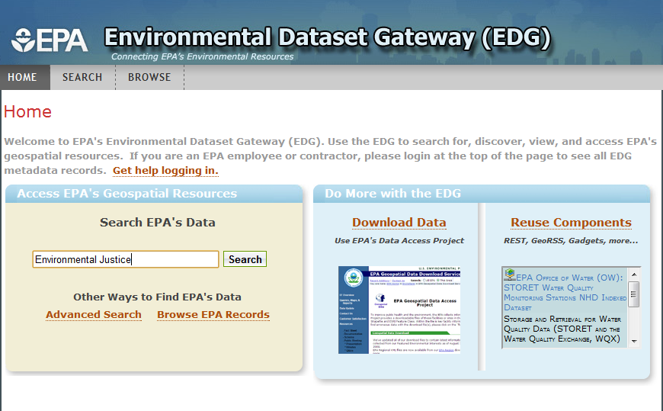

Content provided to the EDG is managed using a defined governance structure. Each EPA organization assigns one or more EDG Stewards that is responsible for contributing to and managing geospatial metadata at the EDG on behalf of their organization. EDG Stewards organize metadata for their organizations and then contribute it to the EDG by uploading it manually or using an automated process called harvesting. Metadata contributed to the EDG is reviewed and approved by the EDG Administrator. Once it is approved, the information is available for others to discover.
Key Features
The EDG offers users a number of options for accessing geospatial metadata and data. Some of the key features the EDG offers include:
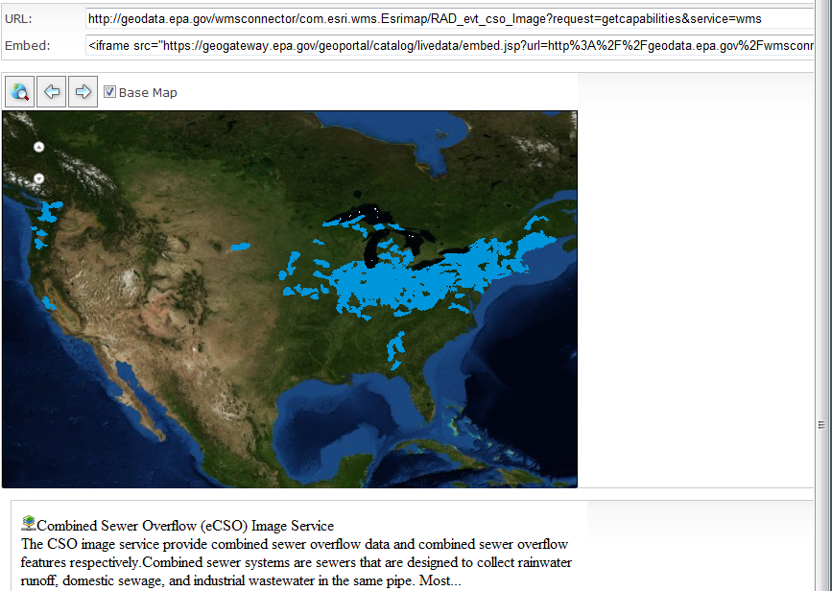
- Search and Discovery
  - Simple, advanced, and targeted search

- Metadata Browse Capabilities
  - Desktop and web-based

- Data Access and Download
  - Downloadable Data Sets
  - Live Data Services
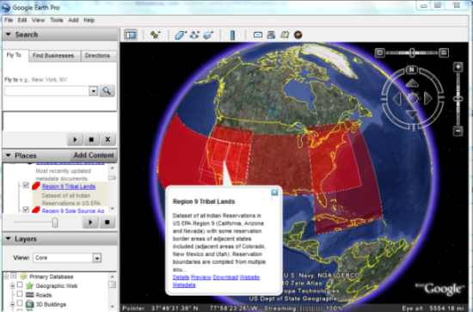
  - Interactive Clip N Ship

- Web-based Map Viewer
  - Preview data using EDG map viewer

- Reusable Components
  - EDG REST outputs (GeoRSS, KML, HTML)
  - EDG Search Widget Plug-in
  - Catalog Service for the Web interface
Benefits
The EDG provides the following key benefits:
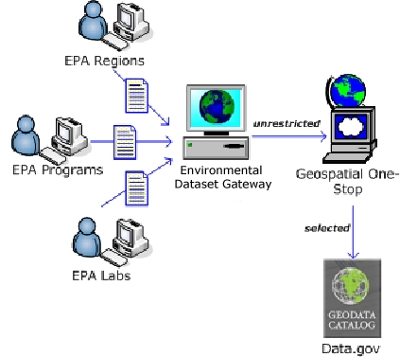
- The EDG connects people with resources that support EPA’s key priorities– Key data sets, such as climate change, air quality, or environmental justice are available through the EDG.

- The EDG allows contributors to reuse content to support their mission goals– The EDG’s REST and Search Widget are two tools organizations can use to link to live feeds from the EDG and embed the content directly into their applications. This not only saves time and money but also provides better consistency across the agency.

- The EDG streamlines EPA’s contributions to external metadata sharing portals– The EDG acts as a single source for EPA’s contributions to Data.gov and GOS. Content derived from EDG is consistently managed and updated at these external resources.

- The EDG supports EPA’s Open Government Plan– The EDG assists in implementing the principles of transparency, participation, and collaboration by helping EPA identify and publish high-value resources.

