**Putting the Environmental Dataset Gateway (EDG) to Use**

**Why Use EDG Outputs?**

**Detailed Instructions**

Link to the [Reuse Components](https://geogateway.epa.gov/geoportal/catalog/components/components.page) page from the EDG Home Page, or visit the [EDG Help](https://geogateway.epa.gov/geoportal/webhelp/en/geoportal_931/index.htm#using_rest.htm)

The EDG’s reusable outputs allow you to easily promote your resources without a significant investment of time. For example, by copying and pasting simple EDG REST URLs into your web pages, you can:

* Embed **custom views** of your metadata in your websites
* Access your metadata from any web page
  + 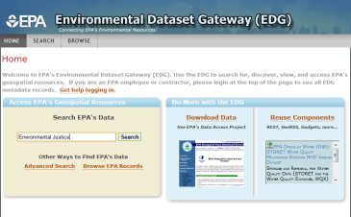Apply your own **styles** and customizations
* Allow users to **subscribe** to dynamic **feeds** that link to your records

Access the EDG

<http://edg.epa.gov>

Includes login for EPA personnel and contractors

* Visualize your data and metadata in new and exciting ways

**How to Embed EDG REST Outputs in Your Website**

1. Perform a search at the EDG
2. Scroll to the bottom of the results list and open a REST link in your web browser (**GEORSS, HTML, HTML FRAGMENT, or KML)**
3. Paste the URL into a web page as <href> or <iframe>. You can use additional parameters to customize your REST URLs. For example:

*<a href="https://edg.epa.gov/geoportal/rest/find/document*

*?searchText=ecoregions&f=html&xs1=fgdc">*

For more information, please see the [EDG Help](https://geogateway.epa.gov/geoportal/webhelp/en/geoportal_931/index.htm#using_rest.htm).

OFFICE OF INFORMATION COLLECTION

ORGANIZATION NAME HERE

**How to Include Stylesheets**

You can stylize EDG HTML output to match your organization’s look and feel. To specify do this, use the &style parameter to link to a stylesheet in css format. For example:

*<a href="https://edg.epa.gov/geoportal/rest/find/document?*

*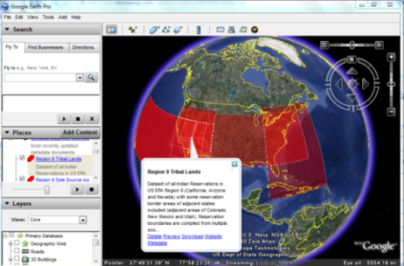searchText=eco&f=html&xs1=fgdc&style=[your.css]">*

To specify a stylesheet for a metadata record, use the &xsl parameter to the URL and specify a particular stylesheet (fgdc, fgdc_classic, fgdc_faq, fgdc_esri, iso, iso_geography_network, fgdc_geography_network, fgdc_plus).

For example, the fgdc_faq stylesheet would be specified as:

*http://edg.epa.gov/geoportal/rest/document?id={Your Record’s ID}****&xsl=fgdc_faq***

**How to Embed EDG KML Output in a Map**

To embed KML output in a web map on your website, copy the EDG REST Output (in KML format) from your search results and paste the link into your website’s map as a KML Layer.

For More Information

Lee Kyle

EPA/OEI/OIC

[kyle.lee@epa.gov](mailto:kyle.lee@epa.gov)

Phone: 202-564-4622

<http://edg.epa.gov>

**How to Embed the EDG Search Widget**

To embed the EDG Search Widget in your site, include the following two lines in the <script> section of your web page:

[*http://serverapi.arcgisonline.com/jsapi/arcgis/?v=1.3*](http://serverapi.arcgisonline.com/jsapi/arcgis/?v=1.3)

[*http://edg.epa.gov/geoportal/widgets/searchjs.jsp*](http://edg.epa.gov/geoportal/widgets/searchjs.jsp)

**Putting the Environmental Dataset Gateway (EDG) to Use**

**About EDG REST Outputs**

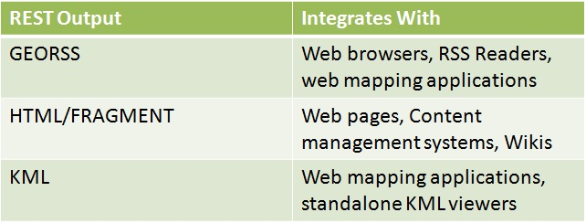The EDG's REST (Representational State Transfer) API (Application Programming Interface) provides you with a powerful way to access and embed EDG content directly and dynamically in other web applications or pages. When you search the EDG, links to internet and intranet REST results are displayed below the search results. The intranet URL provides access to the full set of EPA records (restricted and unrestricted) without requiring that users login, while the internet URL only provides those users who are logged into the EDG with access to restricted records. Only the internet URL should be used for public websites.

**Embed Outputs in Your Website**

It is easy to embed REST outputs into your website. Simply search the EDG for your records, copy the REST link at the bottom of the Search Results page (internet or intranet), and paste the link as <href> or <iframe> in your HTML file. The following example would link your website to a EDG metadata record :

*<A href=https://edg.epa.gov/geoportal/rest/document?id=[Your Record’s UUID]&xsl=fgdc>Your Record’s Title</A>*

**Choose a Stylesheet**

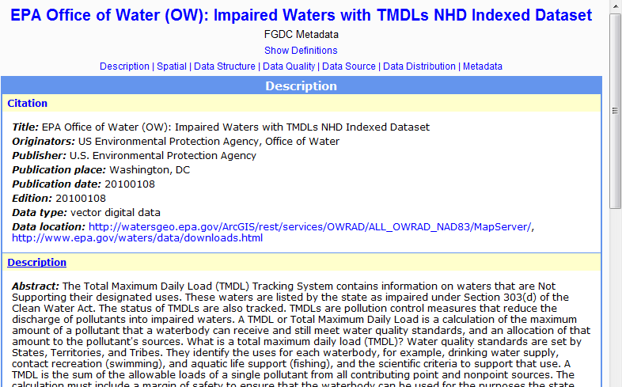The EDG allows you to apply custom stylesheets to the REST interface HTML output and to individual metadata records. Stylesheets allow you to format the look and feel of EDG outputs to meet your needs. To apply the stylesheet of your choice, edit the URL of your EDG record so that the **&xsl=** parameter is followed by one of the following options: **fgdc_geography_network, fgdc, fgdc_classic, fgdc_ faq, fgdc_esri, fgdc_plus, iso, iso_geography_network.** You can also create your own custom stylesheet and have it hosted at the EDG.

**Embed KML Output In a Map**

For web users without access to GIS software, web-based maps (such as Google or Bing) provide a convenient way to view geospatial data. Overlaying the EDG’s KML output on a web-based map can provide your users with a unique view of your metadata and data. To embed a KML Output in a Google or Bing map on your website, copy the REST Output (KML) from your search results and paste the link into your website’s map as a KML Layer.

**Embed the EDG Search Widget in Your Website**



The EDG Search Widget makes it possible to search the EDG from another web page or application. The search widget can be included on your website by simply inserting two lines of code. Users can type a search term or lucene search query in the search field and retrieve a pop-up list of records that match that search.

**For more help, follow the** [**Reuse Components**](https://geogateway.epa.gov/geoportal/catalog/components/components.page) **link on the EDG Homepage.**