Torry Brelsford

Include an explanation of the asymptotic analysis of the function, and state your reason based on the algorithm that you have implemented.
- I have a few issues with the time complexity of my function. I am calling compute_in_degrees after every node I delete with a zero indegree and recomputing each nodes indegrees. The function compute_in_degrees has a n^2 complexity as does my own compute_tps for a n^4 which is fine for smaller values but as n gets to 2500+ the time it takes to complete is really terrible. Although it works correctly, it does not run with the desired speed. Some things I could have done to improve the time complexity would be to decrement the in-degree dictionary when the node I am deleting has an edge to those nodes. This would take away the need to run compute_in_degrees after every deleted node from the graph.

Time | Nodes
0.00093 | 5 | 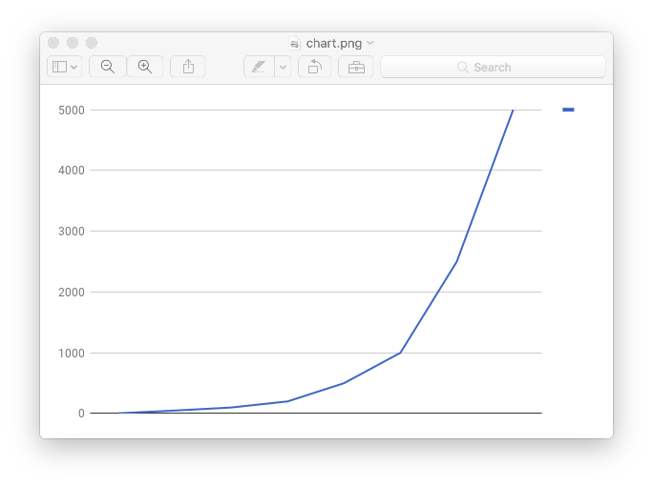
0.0097 | 50
0.03589 | 100
0.17738 | 200
2.11182 | 500
21.2845 | 1000
388.59651 | 2500
3883.20198 | 5000

