moments_PL_loop

# Run test image in loop and show center line

[1]:

**from**

**PIL**

**import**

Image, ImageDraw

**import**

**numpy**

**as**

**np**

**from**

**IPython**

**.**

**display**

**import**

display

**from**

**pynq**

**import**

Xlnk

**from**

**pynq**

**import**

Overlay

**import**

**math**

*# for atan2*

## Download the Moments IP bitstream

[2]:

moments_design

=

Overlay(

"

../bitstream/moments.bit

"

)

*#moments_design?*

dma

=

moments_design

.

axi_dma_0

moments

=

moments_design

.

moments_0

## Load image and prepare buffer

[11]: image_path = "simu_img/eye1.jpg"

original_image = Image.open(image_path) original_image.load() display(original_image)

old_width, old_height = original_image.size

print("Image size: **{}**x**{}** pixels.".format(old_width, old_height))

new_width = int(old_width/2)

new_height = int(old_height/2)

xlnk = Xlnk()

in_buffer = xlnk.cma_array(shape=(old_height, old_width, 3), dtype=np.uint8, cacheable=1)

out_buffer = xlnk.cma_array(shape=(new_height, new_width, 3), dtype=np.uint8, cacheable=1)

[11]:

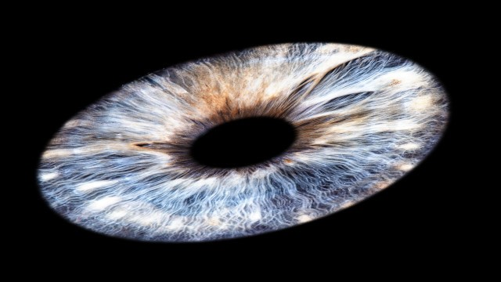

Image size: 640x360 pixels.

Loop over all image in folder: Size 640x360 color or gray (jpg, png)

[12]:

**import**

**glob**

*# run loop to load images*

**for**

img

**in**

glob

.

glob(

"

simu_img/*

"

):

original_image

=

Image

.

open(img)

original_image

.

load()

input_array

=

np

.

array(original_image)

**if**

(

len

(

input_array

.

shape)

==

2

):

*# if single channel create rgb image 3channels*

h,w

=

input_array

.

shape

rgbArray

=

np

.

zeros((h,w,

3

)

,

'

uint8

'

)

rgbArray[:,:,

0

]

=

input_array

rgbArray[:,:,

1

]

=

input_array

rgbArray[:,:,

2

]

=

input_array

in_buffer[

0

:

640

*

360

*

3

]

=

rgbArray

**else**

:

in_buffer[

0

:

640

*

360

*

3

]

=

input_array

buf_image

=

Image

.

fromarray(in_buffer)

**for**

i

**in**

range

(

2

):

moments

.

write(

0

x

10

,

13

)

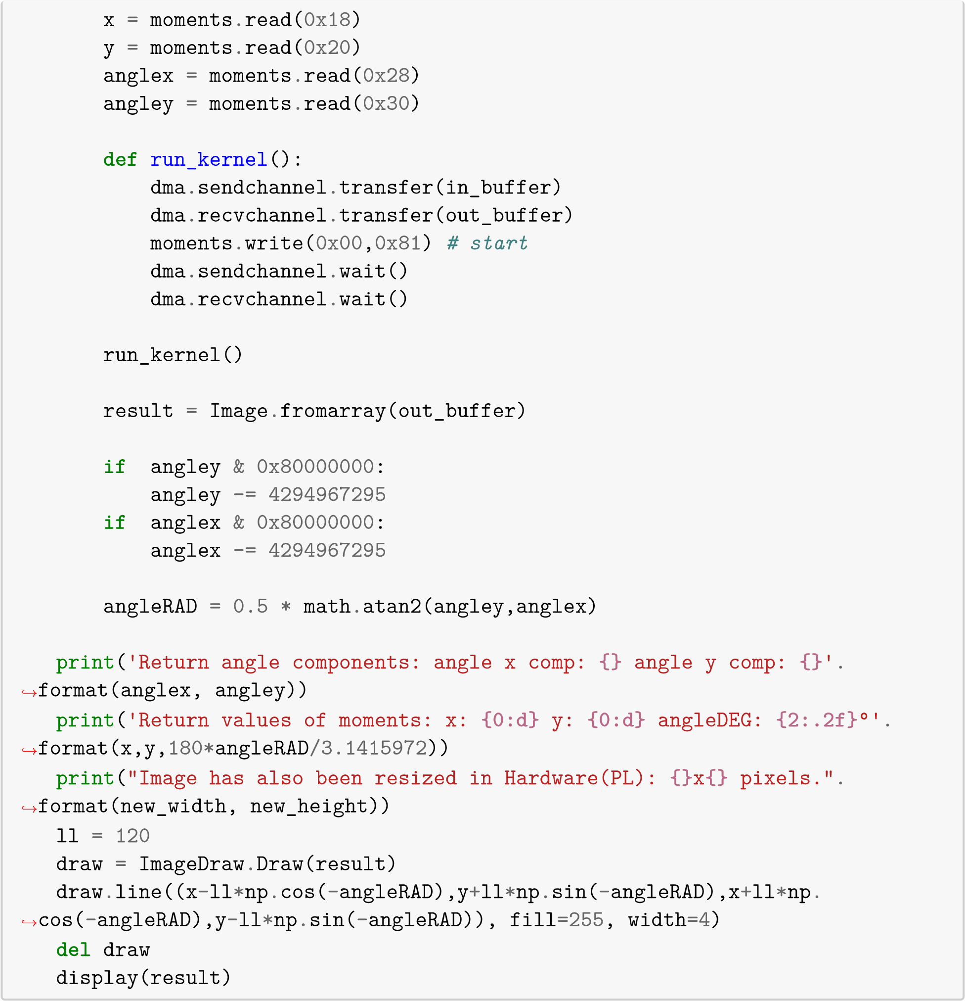

Return angle components: angle x comp: 1899 angle y comp: -1177   
Return values of moments: x: 176 y: 176 angleDEG: -15.90°   
Image has also been resized in Hardware (PL): 320x180 pixels.

[12]:

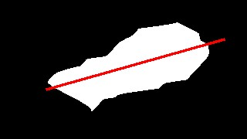

Return angle components: angle x comp: 2419 angle y comp: -513   
Return values of moments: x: 165 y: 165 angleDEG: -5.99°   
Image has also been resized in Hardware(PL): 320x180 pixels.

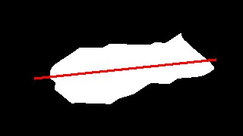[12]:

Return angle components: angle x comp: 2807 angle y comp: 940   
Return values of moments: x: 164 y: 164 angleDEG: 9.26°   
Image has also been resized in Hardware (PL): 320x180 pixels.

[12]:

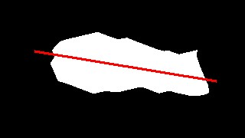

Return angle components: angle x comp: 6278 angle y comp: 6208   
Return values of moments: x: 159 y: 159 angleDEG: 22.34°   
Image has also been resized in Hardware (PL): 320x180 pixels.

[12]:

Return angle components: angle x comp: 2921 angle y comp: 2794   
Return values of moments: x: 155 y: 155 angleDEG: 21.86°   
Image has also been resized in Hardware(PL): 320x180 pixels.

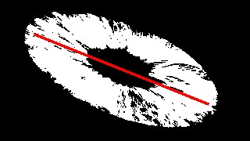[12]:

Return angle components: angle x comp: -543 angle y comp: -1039   
Return values of moments: x: 138 y: 138 angleDEG: -58.80°   
Image has also been resized in Hardware (PL): 320x180 pixels.

[12]:

Return angle components: angle x comp: 3008 angle y comp: -145   
Return values of moments: x: 177 y: 177 angleDEG: -1.38°   
Image has also been resized in Hardware(PL): 320x180 pixels.

[12]:

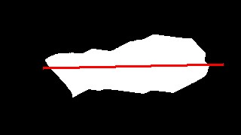

Return angle components: angle x comp: 2617 angle y comp: 422   
Return values of moments: x: 164 y: 164 angleDEG: 4.58°   
Image has also been resized in Hardware(PL): 320x180 pixels.

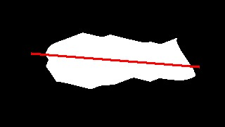[12]:

Return angle components: angle x comp: 2621 angle y comp: 1000   
Return values of moments: x: 177 y: 177 angleDEG: 10.44°   
Image has also been resized in Hardware(PL): 320x180 pixels.

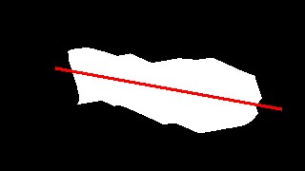[12]:

Return angle components: angle x comp: 1926 angle y comp: 1760   
Return values of moments: x: 175 y: 175 angleDEG: 21.21°   
Image has also been resized in Hardware(PL): 320x180 pixels.

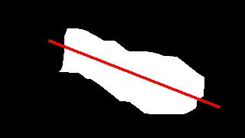[12]:

Return angle components: angle x comp: -54 angle y comp: -1443   
Return values of moments: x: 170 y: 170 angleDEG: -46.07°   
Image has also been resized in Hardware(PL): 320x180 pixels.

[12]:

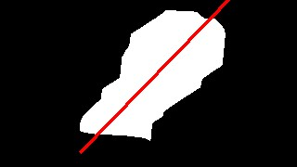

Return angle components: angle x comp: 6227 angle y comp: -5641   
Return values of moments: x: 161 y: 161 angleDEG: -21.09°   
Image has also been resized in Hardware(PL): 320x180 pixels.

[12]:

Return angle components: angle x comp: 1310 angle y comp: -3725   
Return values of moments: x: 215 y: 215 angleDEG: -35.31°

Image has also been resized in Hardware(PL): 320x180 pixels.

[12]:

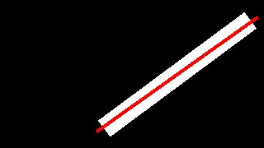

Return angle components: angle x comp: 3893 angle y comp: 3644   
Return values of moments: x: 149 y: 149 angleDEG: 21.55°   
Image has also been resized in Hardware(PL): 320x180 pixels.

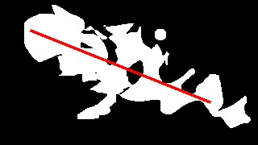[12]:

Return angle components: angle x comp: 3564 angle y comp: -1509   
Return values of moments: x: 155 y: 155 angleDEG: -11.47°

Image has also been resized in Hardware(PL): 320x180 pixels.

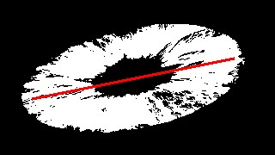[12]:

Return angle components: angle x comp: 1883 angle y comp: 1584   
Return values of moments: x: 145 y: 145 angleDEG: 20.04°   
Image has also been resized in Hardware(PL): 320x180 pixels.

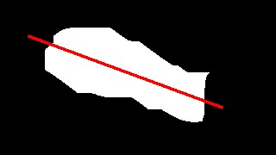[12]:

Return angle components: angle x comp: 187 angle y comp: 2084

Return values of moments: x: 171 y: 171 angleDEG: 42.44°

Image has also been resized in Hardware(PL): 320x180 pixels.

[12]:

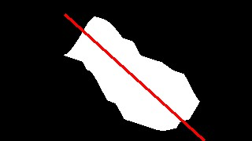

Return angle components: angle x comp: -898 angle y comp: -101   
Return values of moments: x: 162 y: 162 angleDEG: -86.79°   
Image has also been resized in Hardware(PL): 320x180 pixels.

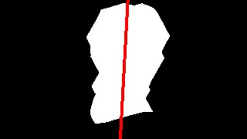[12]:

Return angle components: angle x comp: 4497 angle y comp: 2472

Return values of moments: x: 182 y: 182 angleDEG: 14.40°   
Image has also been resized in Hardware(PL): 320x180 pixels.

[12]:

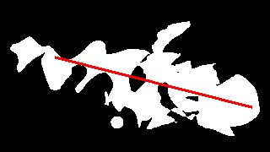

Return angle components: angle x comp: -232 angle y comp: 1874   
Return values of moments: x: 152 y: 152 angleDEG: 48.53°   
Image has also been resized in Hardware(PL): 320x180 pixels.

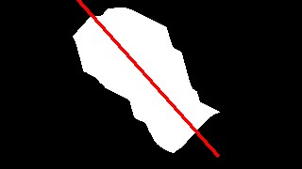[12]:

Return angle components: angle x comp: -538 angle y comp: 1218   
Return values of moments: x: 149 y: 149 angleDEG: 56.92°

Image has also been resized in Hardware(PL): 320x180 pixels.

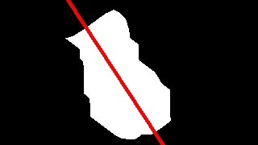[12]:

Return angle components: angle x comp: 1639 angle y comp: -1377   
Return values of moments: x: 167 y: 167 angleDEG: -20.02°   
Image has also been resized in Hardware(PL): 320x180 pixels.

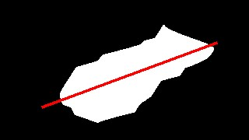[12]:

Return angle components: angle x comp: 772 angle y comp: 2212

Return values of moments: x: 148 y: 148 angleDEG: 35.38°

Image has also been resized in Hardware(PL): 320x180 pixels.

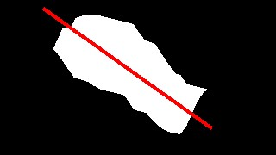[12]:

[0]:

[13]:

xlnk

.

xlnk_reset()