Each group defines:
- Goal increase the add-to-cart rate by comparing the existing PDP (Variant A) to two other PDPs (B = social proof/user ratings and testimonials, C = AI generated)
- Primary KPI = Add-to-cart rate
- Hypothesis (If we change X, then Y will improve because Z) : A and B/C have the same add-to-cart-rate (Null Hypothesis).
- Variants do A/B, A/C OR do B/C and have a look at A as comparison. Problem : hard to compare to A then since environment could have changed.
Maybe better : do A/B and A/C.
- Randomization strategy = a method for assigning participants to different groups in a study to prevent selection bias and ensure groups are comparable.
Make two different product descriptions and load one of the variants (have them evenly shown).

- Sample size estimate (https://cxl.com/ab-test-calculator/)
Sample Size per Group: | 3623
Total Sample Size: | 10869
Estimated Duration (weeks): | 11

- Stopping conditions : reaching a predetermined sample size ( 10900), a maximum time period (11 weeks), and achieving statistical significance.
- Assumptions & risks:
No special time of year (Christmas / black Friday / other peak seasons). Outage due to change. Loss of customers. Bad reviews for bad descriptions.
Assumption : User behavior is independent, user does not notice that he is tested.

4. Analyze the Results – A/B
Control Conversion Rate | 8.22%
Variant Conversion Rate | 10.85%
Lift (%) | 32.08%
Absolute differences
Absolute difference | 2.64%
Confidence Interval (Difference, %) | 1.31% to 3.96%
Right-Sided Interval (%) | 1.52% to ∞%
Left-Sided Interval (%) | -∞% to 3.75%
Value ± SE (%) | 32.08 ± 1.33 %
P-Value (One-sided) | 0.000037
P-value (Two-sided) | 0.000075
Z-Score | 3.96
Significance (One-sided) | Significant

A/C

Results
Control Conversion Rate | 8.22%
Variant Conversion Rate | 12.49%
Lift (%) | 51.98%
Absolute differences
Absolute difference | 4.27%
Confidence Interval (Difference, %) | 2.87% to 5.67%
Right-Sided Interval (%) | 3.09% to ∞%
Left-Sided Interval (%) | -∞% to 5.45%
Value ± SE (%) | 51.98 ± 1.40 %
P-Value (One-sided) | 0.000000
P-value (Two-sided) | 0.000000
Z-Score | 6.14
Significance (One-sided) | Significant
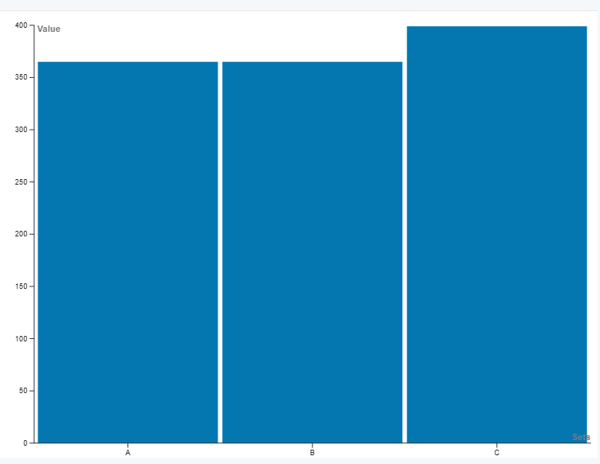

Significance was given,
B performed better than A, but C performed even better than B. So we would recommend using C (AI generated content).
Risks :
+ bad timing could have messed up result
+ slight possibility for making errors, even though p is very small (< 0.05)
Next steps :
Roll out change for Variant C (present recommendation to upper management). Uplift speaks for Variant C.

