Mobile Micro Homes Concept:

This project was born from a simple fact: Many people are one step away from homelessness.

Every person experiencing homelessness deserves dignity, safety, and a path toward stability.

The mobile micro-home concept aims to provide immediate, an affordable livable micro home for currently un-sheltered individuals in communities.

Unlike traditional shelter systems that require people to navigate complex bureaucracies or leave their belongings and pets behind, these units offer autonomous, portable homes that preserves dignity, provides a way to keep their pets and belongings while protecting them from the elements.

How this idea came into being and why it’s needed:

I have always had an interest in affordable practical innovative housing, I'm trying to create the absolute most affordable, accessible, maintainable home that's possible to create, with the goal of helping un-housed people who are having to sleep in tents, and on the ground in all types of weather, having to feel insecure, having to worry and carry their possessions in bags.

I have been working over several months on an idea that could help, a practical affordable easy to build and maintain mobile micro-home.

I’ve had several friends that have experienced homelessness over their life times. I’ve seen people sleeping on sidewalks, in doorways, and on the ground in parking lots. Walking, alone, carrying their only worldly possessions in bags.

We live in a prosperous land of unimaginable riches, in a time of unparalleled wealth, knowledge, and technology.

It should not have to be this way.

Many people are in this situation because of a couple of bad breaks; many of us could easily be in the same situation and find ourselves homeless and alone with a bit of bad luck.

We are all responsible for the world we are creating through our actions, thoughts, efforts, choices, decisions, and in-actions.

Small decisions and actions add up over time to collectively create the world in which we currently find ourselves—like a thousand hands each taking one cup of water from a shared well. Each person thinks, "It's just one cup," but when everyone takes without giving back, the well runs dry and we all go thirsty together.

Now imagine a better world, the one we wanted to live in before we became hardened and jaded, when we were idealistic and hopeful.

With reason, compassion, solidarity, and effort, I believe that we can make the world a better place if we all work together and follow the example of the peace teachers of the world: Buddha, Jesus, Gandhi, MLK

If we can find the courage, the strength, and the resolve, we are gifted with the possibility of creating a world where everyone is fed, has a safe place to live, and can live with purpose and dignity.

Please join me in taking a first step: helping provide safe, secure shelter to people who need it. One micro-home at a time, we can start building the world we all deserve.

Core Ideas:

- Ownership: Individual owns the micro-home.
- Livable: As home-like and comfortable as possible in a small space
- Portability: Individuals may need to move quickly to find a new safe location
- Dignity: Private space that respects individual autonomy
- Security: A safe place to sleep and store personal belongings
- Simple Maintainability: Built for real-world conditions, to be fixable and durable and maintainable.
- Affordable: Low enough cost ($1,500-2,000 per unit) to deploy large-scale

What happens if someone transitions into a larger space?

- They own the unit, the can sell it for move in funds to their new place
- They can donate it to a friend

Why This Size and Design Choices?

This size is similar to 2 large shopping carts, people are regularly seen making a mobile shelter from 2 large shopping carts strapped end to end together, with a tarp on top.

The design principals:

- Keep the cost as low as possible so cost is not a barrier to building these, and we can give as many people as possible
- Make it small and portable so if people need to move they can easily
- A bit of extra space for a pet, many people on the street have dogs, and many homeless shelters require surrender of their pets.
- Secure for the home owner, and their stuff, un-housed people have limited things they need
- A safe place to sleep
- Simple as possible so it’s easy to fix and maintain
- Comfortable

Lightweight & Portable:

- Lightest smallest home practical
- Can be moved as needed
- Doesn't require permanent site development
- Allows users to stay near work, services, or support networks

Affordable:

- Target cost: $1,500-2,000 per unit (with surplus materials)
- Uses readily available construction materials
- Can be built by one person with basic carpentry skills
- Designed for volunteer labor or small-scale production

Actually Livable:

- Insulation makes it habitable in extreme weather
- Solar power provides lighting and ventilation
- Secure storage protects belongings
- Secure sleeping helps safety and peace of mind
- Private space reduces trauma and stress
- Heating and Cooling systems
- Windows
- Sitting area
- Desk
- Mini cabinets for personal organization

What about cold weather?

Initial Concept:

- Use enough insulation that this acts like an igloo in cold weather and body heat will warm up the space.
- Use an extreme cold weather sleeping bag.
- Paint mostly cold weather units in darker colors

What about heating options?

- Candle heaters --> pose a carbon-monoxide and fire risk
- Wood-Stoves --> pose a carbon-monoxide and fire risk
- Other heat sources --> require access to funds and fuel
- Electric blanket --> requires access to a decent amount of power
- Electric heat --> requires access to a decent amount of power

Possible Heating Solution: PCM (Phase Change Material) Thermal Battery

What Is It?

A PCM thermal battery is essentially a "heat storage device" that works like a rechargeable battery—but for warmth instead of electricity. During the day, solar panels power a small heater that melts paraffin wax inside sealed containers. As the wax melts, it absorbs and stores large amounts of heat energy. At night, when temperatures drop, the wax slowly solidifies and releases that stored heat into the living space—providing warmth for 6-8 hours without using any electricity.

Think of it like a hot water bottle that stays warm all night, but much more efficient because the phase change (solid to liquid and back) stores far more energy than just heating water.

How would this work?:

This work by using solar panels on the roof of the micro-home to heat submerged 12v heating elements in 3 gallons of paraffin wax in the main sleeping area during daylight hours, and then slowly releasing that heat into the main sleeping area at night.

The Heating system could be switched off during summer months.

PCM Heating System Coverage:

- What it is and why paraffin wax works (phase change explanation)
- Heat storage capacity and practical temperature improvements
- Solar panel sizing for sunny vs. overcast climates (100W-300W requirements)
- Energy calculations for melting 3 gallons of wax
- Daily operation cycle from morning charging to overnight heat release
- Component costs ($125-185 for the heating system)
- Safety features and maintenance requirements
- Realistic expectations (survival warmth, not luxury heating)

Why Paraffin Wax?

Paraffin wax is ideal for this application because:

- Perfect Temperature Range: Melts at 130-150°F (depending on the specific type), which is:
- Hot enough to store significant heat
- Cool enough to be safe (won't cause burns if touched)
- Matches well with what solar heating can achieve

High Energy Storage: When 1 pound of paraffin wax melts, it stores about 80-100 BTUs of heat. That's 3-4 times more energy than heating the same weight of water by the same temperature difference.

Safe and Stable: Non-toxic, won't degrade over thousands of heating cycles, doesn't expand dangerously when freezing, and is fire-resistant in its solid and liquid states (though flammable if vaporized at high temps—but our system never gets that hot).

Cheap and Available: Gulf Wax (canning paraffin) costs $8-12 for 4 pounds at any grocery store. Total cost for 3 gallons (about 20-24 pounds): $40-60.

How Much Heat Does It Provide?

3 gallons of paraffin wax:
- Weight: approximately 20-24 pounds
- Heat storage capacity when fully melted: 1,600-2,400 BTUs
- Heat release duration: 6-8 hours of gradual warmth

What does that mean in practical terms?**

In a well insulated (3” foam board) 39 cubic feet heated volume
- 25-40°F temperature rise
- 40°F outside → 70-75°F inside (comfortable)
- 20°F outside → 50-55°F inside (pleasant)
- 0°F outside → 35-40°F inside (livable)
- -20°F outside → 15-20°F inside (survival warmth)

It keeps the interior significantly warmer than outside, prevents moisture condensation, and makes sleep possible with a good sleeping bag.

What about hot weather?

- Strong venting and fans
- Excellent insulation to keep heat out
- Swamper air-conditioning
- Paint mostly hot weather units in lighter colors.

COOLING SOLUTION: DIY Swamp Cooler (Evaporative Cooling)

What Is It?

A swamp cooler (evaporative cooler) is a simple device that cools air by evaporating water. Hot, dry outside air is pulled through a water-soaked pad by a fan. As the air passes through the wet pad, water evaporates into the air—and evaporation absorbs heat, cooling the air by 20-30°F. The cooled, slightly more humid air then flows into the living space.

This is ancient technology—it's how humans stayed cool for thousands of years before air conditioning. It works incredibly well in hot, dry climates and uses 90% less electricity than traditional air conditioning.

Why It Works (and Why It Doesn't In all situations)

Science: When liquid water evaporates into water vapor, it absorbs approximately 1,000 BTUs per pound of water. This massive energy absorption cools the surrounding air dramatically.

Requirements for Effectiveness:
- Low humidity (<30% ideal, works up to 40-50%)
- Hot temperatures (90°F+ outside)
- Good airflow (fan pulls air through wet pad, exhaust fan pushes warm air out)

Where It Works GREAT:
- Southwest deserts: Phoenix, Tucson, Las Vegas, Albuquerque, Palm Springs
- High plains: Denver, Wyoming, western Texas
- Central California valleys
- Anywhere hot AND dry

Where It DOESN'T Work:
- Humid climates: Florida, Gulf Coast, Southeast
- Coastal areas with high humidity
- Pacific Northwest (not hot enough)
- Already-humid summer days anywhere

Performance Chart:

Outside Temp | Outside Humidity | Temp Drop | Interior Result | Feels Like
115°F | 10.00% | 30°F | 85°F | Survivable
110°F | 15.00% | 28°F | 82°F | Tolerable
105°F | 20.00% | 25°F | 80°F | Uncomfortable but safe
100°F | 25.00% | 22°F | 78°F | Relatively comfortable
95°F | 30.00% | 18°F | 77°F | Comfortable

Specifications:

Dimensions:

- Length: 7 feet long
- Width: 3 feet
- Height: 4 feet

Construction Method:

- Sandwich panel design (plywood-foam-plywood)
- 1/4 inch plywood exterior
- 1/8” inch plywood interior
- 2"-3” EPS foam insulation (R-7.5 to R-8 value)
- Lightweight but weather-resistant
- Estimated weight: TBD

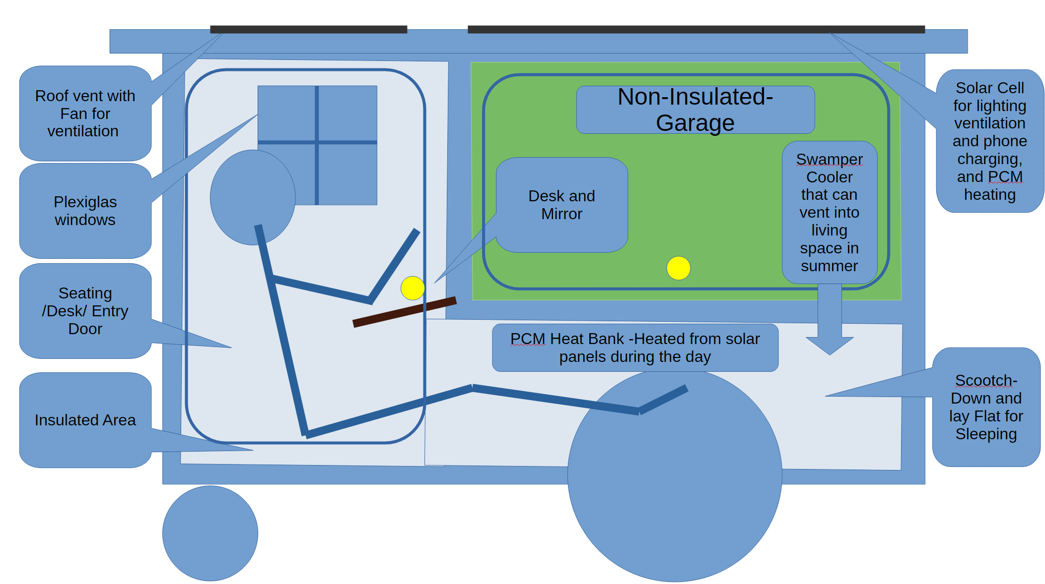
Mobility Features:

- Large wagon cart-style wheels (20-24" diameter)
- Can be moved by hand
- Can be towed by bicycle
- Castors on non-wagon wheel side.

Weather Proofing Features:

- Exterior Plywood coated with UV and water proof boat epoxy
- Then painted with epoxy comparable paint
- Openings Sealed with weather stripping
- Roof overhangs home to prevent direct water on door, window, and garage openings

Security Features:

- Deadbolt Lock
- Garage Lock
- Bicycle chain to lock in home in place
- Exterior Solar Motion detecting Lights
- Plexiglas windows to prevent break-ins
Climate Control:

- 12V solar Ventilation fans for air circulation
- Roof vent with fan
- Windows
- Insulation for cold weather
- Extreme Weather Sleeping bag
- Evaproative cooling system
- PCM heating

Features:

- Weatherproof exterior with proper sealing
- Windows for light and ventilation
- Secure door with lock
- Interior lighting
- Storage garage area for belongings
- Insulated for both heat and cold
- Solar Lighting
- Solar phone charger
- Vent fan
- Desk and seating area
- Mirror
- Medicine cabinet

Proven Construction Concepts:

- Sandwich panel construction used in RV and tiny home industry
- Solar/battery systems well-established technology
- Evaporative cooling proven in desert climates
- PCM heating system
- Not experimental just applied differently

Current Status: Where We Are Now

What's Been Done

Planning & Research:

- Initial design documentation completed
- Materials sourcing research
- Initial Cost estimates developed
- Climate-specific adaptations researched (desert cooling system)

What We Know:

- Construction method is straightforward
- Budget seems realistic ($1,500-2,000 per unit achievable)
- Build time: TBD
- Solar system --> highly viable
- Desert deployment with cooling system --> highly viable

What Success Looks Like

Immediate Impact (1-2 years):

- 5-10 people have safe, dignified shelter who otherwise wouldn't
- Proof that low-cost, mobile shelter is viable
- Data showing health, safety, or housing outcomes improvements
- Model that other communities can study and adapt

Medium-Term Impact (3-5 years):

- If nonprofit model: 50-100 units deployed in one or more cities
- If open-source model: Multiple communities building their own versions
- Recognition as viable emergency shelter option by service providers
- Integration with housing-first and rapid rehousing programs

Long-Term Legacy:

- Contribution to solving homelessness crisis, even if small
- Proven model others can build upon
- Documentation and knowledge freely available
- Lives saved from exposure to extreme weather

Realistic Expectations:

- This won't solve homelessness (systemic problem requiring policy changes)
- This is a minimal safe housing solution
- Success means helping dozens to hundreds of people, not thousands
- Impact is measured in individual lives improved, not statistics

What This Project Represents

For Homeless Individuals:

This isn't about solving all their problems it's about removing one very specific barrier: exposure to dangerous weather while trying to survive and stabilize their lives.

A secure, weatherproof space provides:

- Safety from extreme heat, cold, rain, and wind
- Protection for belongings (critical for maintaining employment)
- Privacy and dignity that shelters often can't provide
- Autonomy to come and go as needed
- A possible bridge to a better tomorrow

For the Community

This demonstrates that communities can address homelessness without massive budgets or perfect solutions. At $1,500-2,000 per unit:

- Honoring humanity: Recognizing that homeless individuals deserved better.
- Action over sentiment: Doing something concrete rather than just feeling bad
- Practical compassion: Creating real solutions, not just symbolic gestures
- Lasting impact: Building something that continues helping people after we're unable to continue

- Churches, civic groups, or individuals could fund single units
- Small grants could fund 5-10 units
- Deploy-able immediately while permanent housing develops
- Complements (doesn't replace) comprehensive homeless services

Closing Thoughts and Notes:

All people matter; this project is one attempt to respond to that truth with action rather than just words.

Whether we personally build these shelters or not, the underlying principle remains: people experiencing homelessness deserve dignity, safety, and practical solutions. This design is just one small piece of a much larger puzzle.

Thank you for taking the time to read this.

Notes:

This is exploratory: We're simply sharing what we're thinking about and why it matters to us.

Realistic Approach: We don't know when or if this can happen, but the intention is to see if there is something that we can do to improve lives of people experiencing homelessness.

