**SOUTH CAROLINA HEAT**

**TRAVEL BASKETBALL**

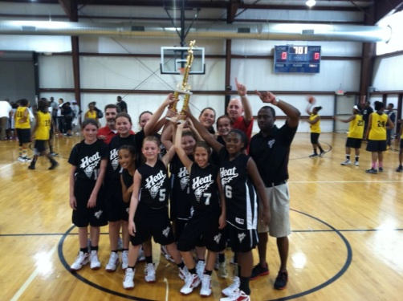  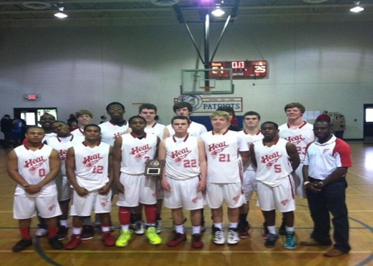

 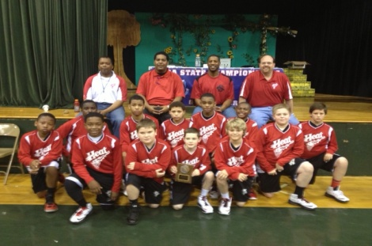 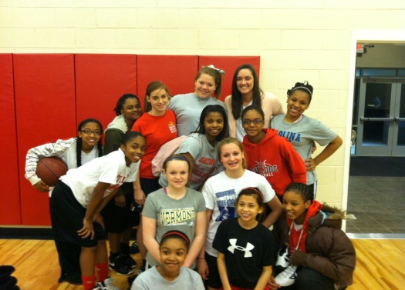

**SOUTH CAROLINA HEAT TEAM TRYOUTS**

WILL BE HELD FEBRUARY 15TH AT NEW BEGINNINGS UNITED METHODIST CHURCH

TRYOUTS WILL ALSO BE HELD FEBRUARY 22ND LOCATION TBA

9TH-12TH GRADE BOYS & GIRLS: 1pm-2:30pm; 6TH-8TH GRADE BOYS & GIRLS: 2:30pm-4pm 4TH -5TH GRADE BOYS & GIRLS: 4pm-5:30pm;

**$10 TRYOUT FEE (Non-refundable)**

**Athlete’s Name___________________________________________________________**

**Birthdate_____/_____/_____Current Age_________Current Grade_________________**

**Address____________________________________________ City_______________Zip_________**

**Email *(must have for updated practice/schedule info)__________________________***

**Parent/Guardian Contact Phone # ______________ Other Phone #_________________**

By signing below, I claim that my son/daughter has had a physical and is cleared to play basketball which is an intense activity. I am the parent/legal guardian and have the authority to release South Carolina Heat and New Beginnings UMC from any charges related to an injury occurring at this volunteered activity.

**NAME OF PARENT/LEGAL GUARDIAN (please print) __________________________________________________________________________________**

**SIGNATURE________________________________________________________________________DATE__________________________**