
May 3, 2024
Company
Address Line 1
Address Line 2
City, State, Zip
Cover Letter
Lorem ipsum dolor sit amet, consectetur adipiscing elit. Maecenas facilisis sollicitudin magna at condimentum. Vestibulum at aliquam lorem. Aliquam ut nibh pretium, volutpat metus eu, fermentum velit. Cras dapibus placerat viverra. Etiam faucibus lectus ac neque scelerisque fringilla. Nunc mi velit, tristique ac placerat gravida, porttitor at ante. Phasellus vehicula.
Best Regards,
Eric Foerster CGCS, MG
TORV, LLC
970.409.9874
eric@torv.me



Green
- The average total available Nitrogen is 8.7 ppm. This is optimal and is within the ideal range of 5 ppm - 10 ppm for soil nitrogen.
- No deficits were noted in the values tied to MLSN values. [TODO: Add custom comment.]
- No other anomalies were highlighted in the analysis. [TODO: Add custom comment.]

Organic Matter
The mean OM measurements can be summarised as follows:
- The APPROACH samples taken on April 7th, 2021 were as follows:
  - At a depth of 0-2 cm, the OM content was 16.45%.
  - At a depth of 2-4 cm, the OM content was 6.84%.
  - At a depth of 4-6 cm, the OM content was 6.08%.
- Comparing the FAIRWAY samples taken on April 30th, 2024 to their most recent previous samples (October 18th, 2023)
  - At a depth of 0-2 cm, the OM content decreased from 26.24% to 15.88%
  - At a depth of 2-4 cm, the OM content decreased from 12.26% to 8.54%
  - At a depth of 4-6 cm, the OM content decreased from 8.71% to 6.57%
- Comparing the GREEN samples taken on April 30th, 2024 to their most recent previous samples (October 18th, 2023)
  - At a depth of 0-2 cm, the OM content decreased from 16.39% to 14.87%
  - At a depth of 2-4 cm, the OM content decreased from 4.97% to 4.39%
  - At a depth of 4-6 cm, the OM content decreased from 3.53% to 3.52%
Like calibrating a TDR measurement for soil moisture content based on subjective observations, the OM246 test should be thought of in the same context. Playability and overall green performance should be considered.
Using a known amount of topdressing applied, we can estimate/calculate the Amount of topdressing needed to maintain, increase, or decrease the organic matter.
- Consider obtaining an accurate topdressing rate per year to make this calculation possible. What is the estimated depth of all topdressing applications applied this year?
- This video from the USGA shows how to calculate the depth along with the required conversion equations.
- Cultural decisions such as aerification, verticutting, topdressing amounts/frequency can be influenced by tracking organic matter over time and established goals for organic matter targets.
[TODO: Additional comments]


The temperature data is provided by NOAA using 30-year climate normals and is site-specific to your location. Pace Turf, LLC (Gelernter and Stowell, 2005) developed the growth potential model to explain the myriad of ways in which weather impacts turf growth. The model considers turf growth to be good when the GP is between 50% and 100% (the best possible growth occurs at a GP of 100%). However, when weather conditions are either too hot or too cold for optimal turf growth, the GP falls below 50%, and turf becomes progressively more stressed. When the GP falls to 10% or lower, growth is extremely limited. Appearing below is your model specific to Sonnenalp Golf Club.
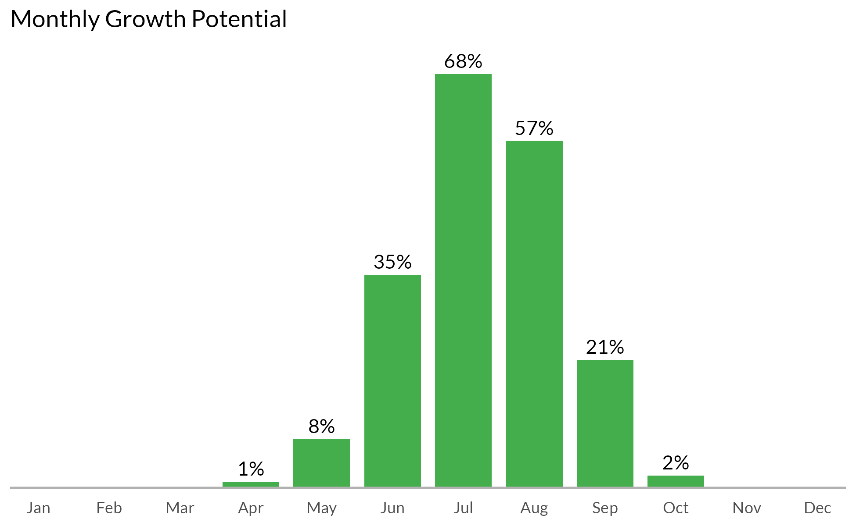



Measurement results and MLSN values
The following graph shows how the samples taken from each GREEN compare to the calculated MLSN values and required elemental inputs based on the provided nitrogen input and the Turf Growth Potential Model.
- Red dots highlight samples where a deficit was found
- Orange dots represent samples which are within 1% of the desired MLSN value
- Green dots indicate that the samples met the MLSN requirements

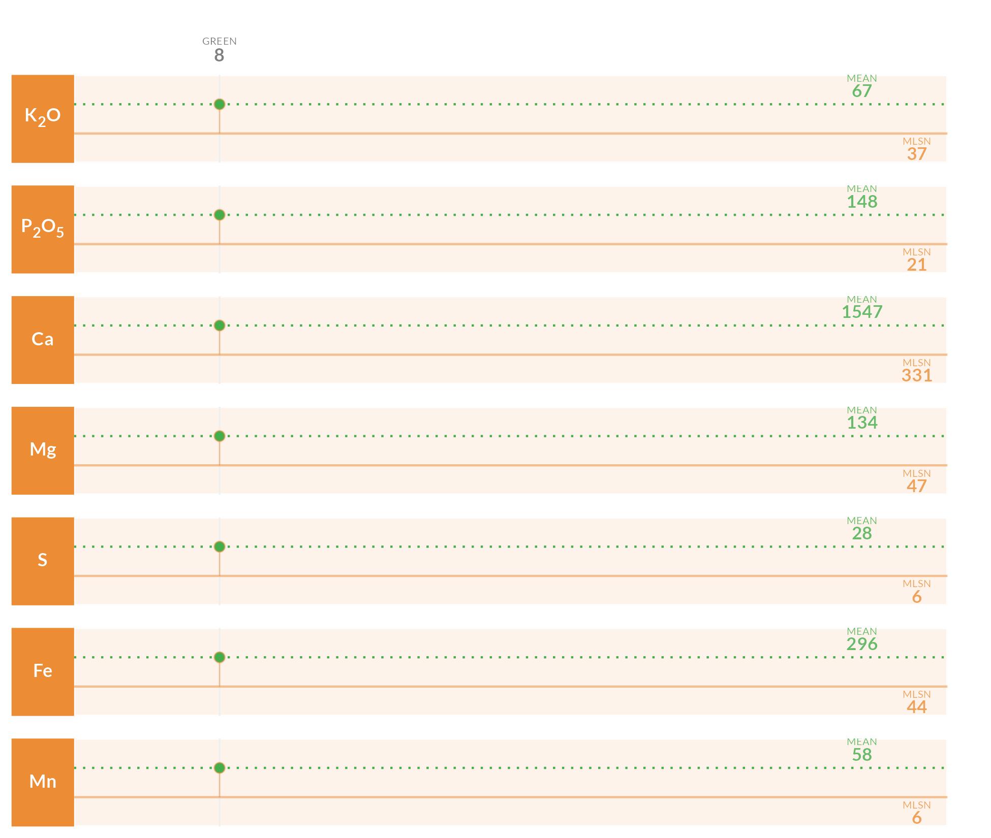

Required element per area (lbs. per 1000 sq.ft.)
This table specifies the amount of fertilizer required to remedy the deficits highlighted by the analysis.

Area | K₂O | P₂O₅ | Ca | Mg | S | Fe | Mn
8 | - | - | - | - | - | - | -
Average
Note: The symbol " - " means no deficit was found; an empty cell means no data was provided. The Average values are the means across all areas where a deficit was found.

Mean measurements and recommendations


pH
The average pH is 7.2. This is within the optimum range for soil microbial activity and soil nutrient availability. With the pH is this range, there is a chance of seeing some iron chlorosis. If this does occur, you can fix it by making foliar applications of ferrous sulfate.

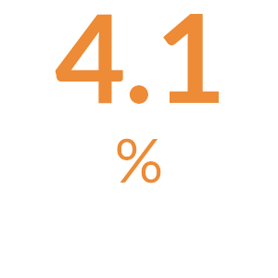
Organic Matter
The average Organic Matter is 4.1%. This is normal and indicates that your current maintenance practices are keeping the organic matter percentage in an ideal range.

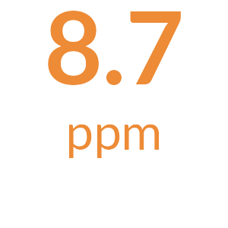
Total Nitrogen
The total available Nitrogen measurement is the sum of the Ammonium (NH₄-N) and Nitrate (NO₃-N) measurements. The average total available Nitrogen is 8.7 ppm. This is optimal and is within the ideal range of 5 ppm - 10 ppm for soil nitrogen.

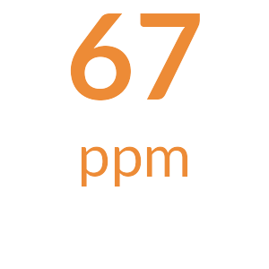
Potassium
The mean Potassium (ppm) measurement is 67 ppm and is above the MLSN value of 37 ppm for all the samples. [TODO: Add something along the lines of all is well.]

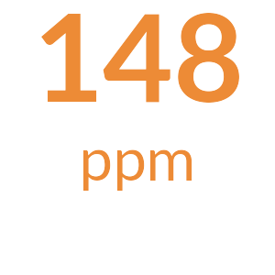
Phosphorus
The mean Phosphorus (ppm) measurement is 148 ppm and is above the MLSN value of 21 ppm for all the samples. [TODO: Add something along the lines of all is well.]

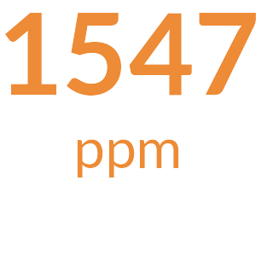
Calcium
The mean Calcium (ppm) measurement is 1547 ppm and is above the MLSN value of 331 ppm for all the samples. [TODO: Add something along the lines of all is well.]

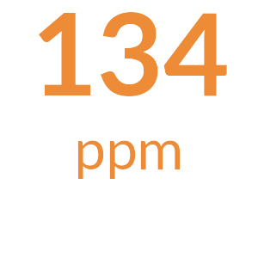
Magnesium
The mean Magnesium (ppm) measurement is 134 ppm and is above the MLSN value of 47 ppm for all the samples. [TODO: Add something along the lines of all is well.]

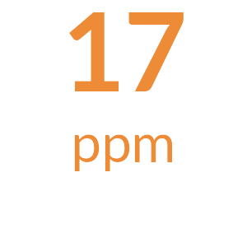
Sodium
The average Sodium is 17 ppm. This is below 110 ppm, the beginning threshold for negative effects of sodium on turfgrass.

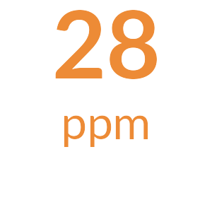
Sulfur
The mean Sulfur (ppm) measurement is 28 ppm and is above the MLSN value of 6 ppm for all the samples. [TODO: Add something along the lines of all is well.]

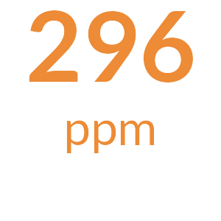
Iron
The mean Iron (ppm) measurement is 296 ppm and is above the MLSN value of 44 ppm for all the samples. [TODO: Add something along the lines of all is well.]

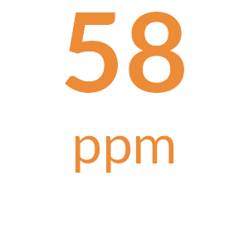
Manganese
The mean Manganese (ppm) measurement is 58 ppm and is above the MLSN value of 6 ppm for all the samples. [TODO: Add something along the lines of all is well.]


Micronutrients
All Micronutrients are present and there are no recommendations for additional applications.


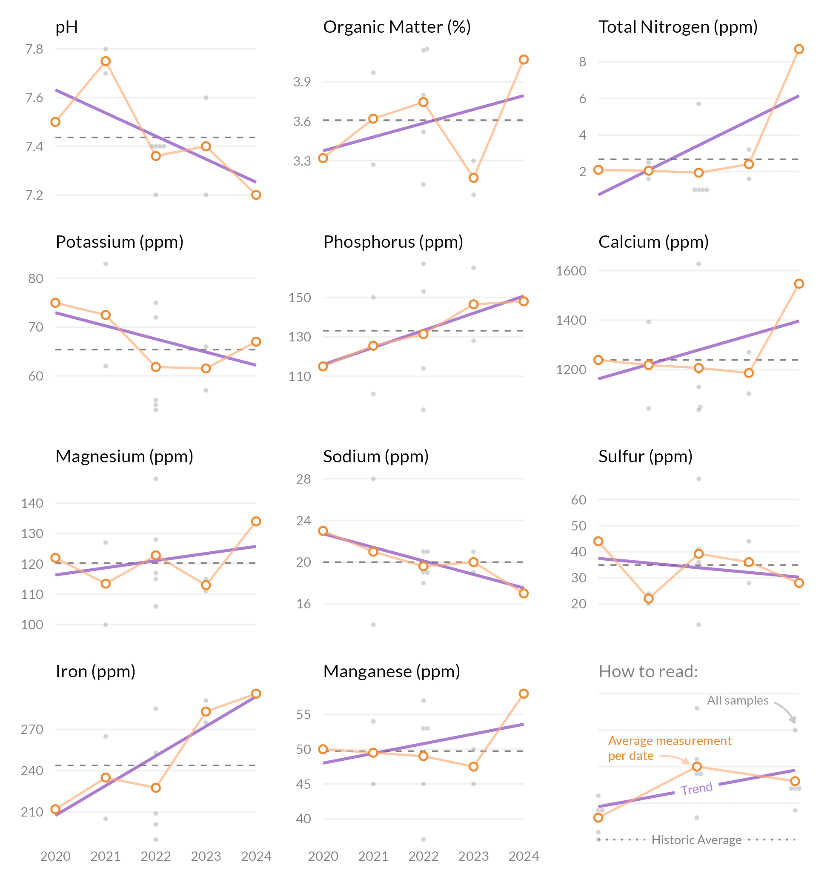


These measurements are neither good nor bad. Information such as fertilizer applied, cultural practices, sand applied, verti-cutting, aerification, etc. can be used to see how these practices have changed the OM% by depth. Ideally, once a desired OM% has been identified based on playability and turf performance, fertility and cultural practices can be adjusted to maintain the desired OM%.
The S325 test package includes the entire sample submitted. This includes leaves, stems, and roots. This differs from the standard soil test which filters out most of the components. This is the reason why the percentages appear higher than that on a standard soil test.
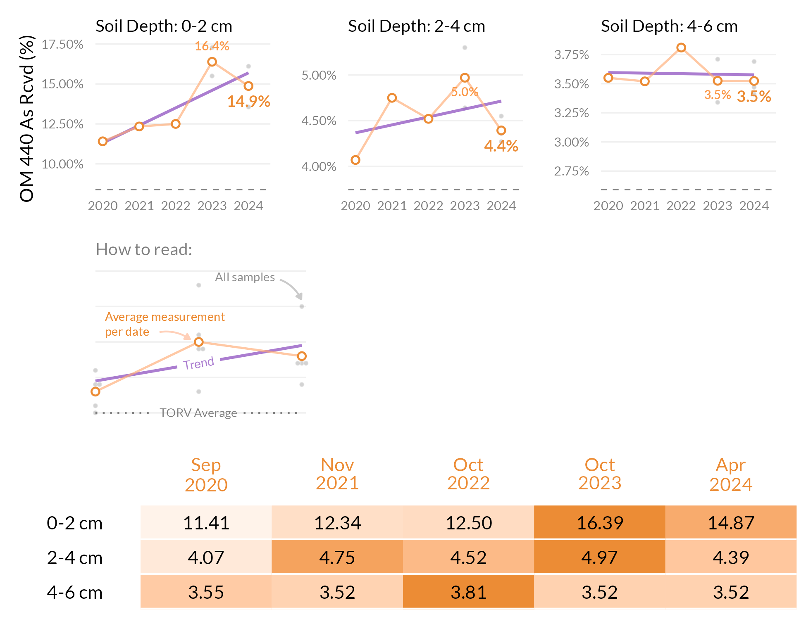


These measurements are neither good nor bad. Information such as fertilizer applied, cultural practices, sand applied, verti-cutting, aerification, etc. can be used to see how these practices have changed the OM% by depth. Ideally, once a desired OM% has been identified based on playability and turf performance, fertility and cultural practices can be adjusted to maintain the desired OM%.
The S325 test package includes the entire sample submitted. This includes leaves, stems, and roots. This differs from the standard soil test which filters out most of the components. This is the reason why the percentages appear higher than that on a standard soil test.
