

May 5, 2024

Company  
Address Line 1  
Address Line 2  
City, State, Zip

Cover Letter

**Lorem ipsum dolor sit amet, consectetur adipiscing elit. Maecenas facilisis sollicitudin magna at condimentum. Vestibulum at aliquam lorem. Aliquam ut nibh pretium, volutpat metus eu, fermentum velit. Cras dapibus placerat viverra. Etiam faucibus lectus ac neque scelerisque fringilla. Nunc mi velit, tristique ac placerat gravida, porttitor at ante. Phasellus vehicula.**

Best Regards,

Eric Foerster's Signature

Eric Foerster CGCS, MG  
TORV, LLC  
970.409.9874  
eric@torv.me



## Fairway

* The average total available Nitrogen is 4.8 ppm. This is below the optimal range of 5 ppm - 10 ppm for soil nitrogen. Consider additional applications of nitrate or ammonium based fertilizers to increase soil nitrogen levels.
* No deficits were noted in the values tied to MLSN values. **[TODO: Add custom comment.]**
* The average Organic Matter (%) measurement is above 4.5%. **[TODO: Add custom comment]**

## Water

* **Lorem ipsum dolor sit amet, consectetur adipiscing elit. Maecenas facilisis sollicitudin magna at condimentum. Vestibulum at aliquam lorem. Aliquam ut nibh pretium, volutpat metus eu, fermentum velit.**



The temperature data is provided by NOAA using 30-year climate normals and is site-specific to your location. Pace Turf, LLC (Gelernter and Stowell, 2005) developed the growth potential model to explain the myriad of ways in which weather impacts turf growth. The model considers turf growth to be good when the GP is between 50% and 100% (the best possible growth occurs at a GP of 100%). However, when weather conditions are either too hot or too cold for optimal turf growth, the GP falls below 50%, and turf becomes progressively more stressed. When the GP falls to 10% or lower, growth is extremely limited. Appearing below is your model specific to Snowmass Club.

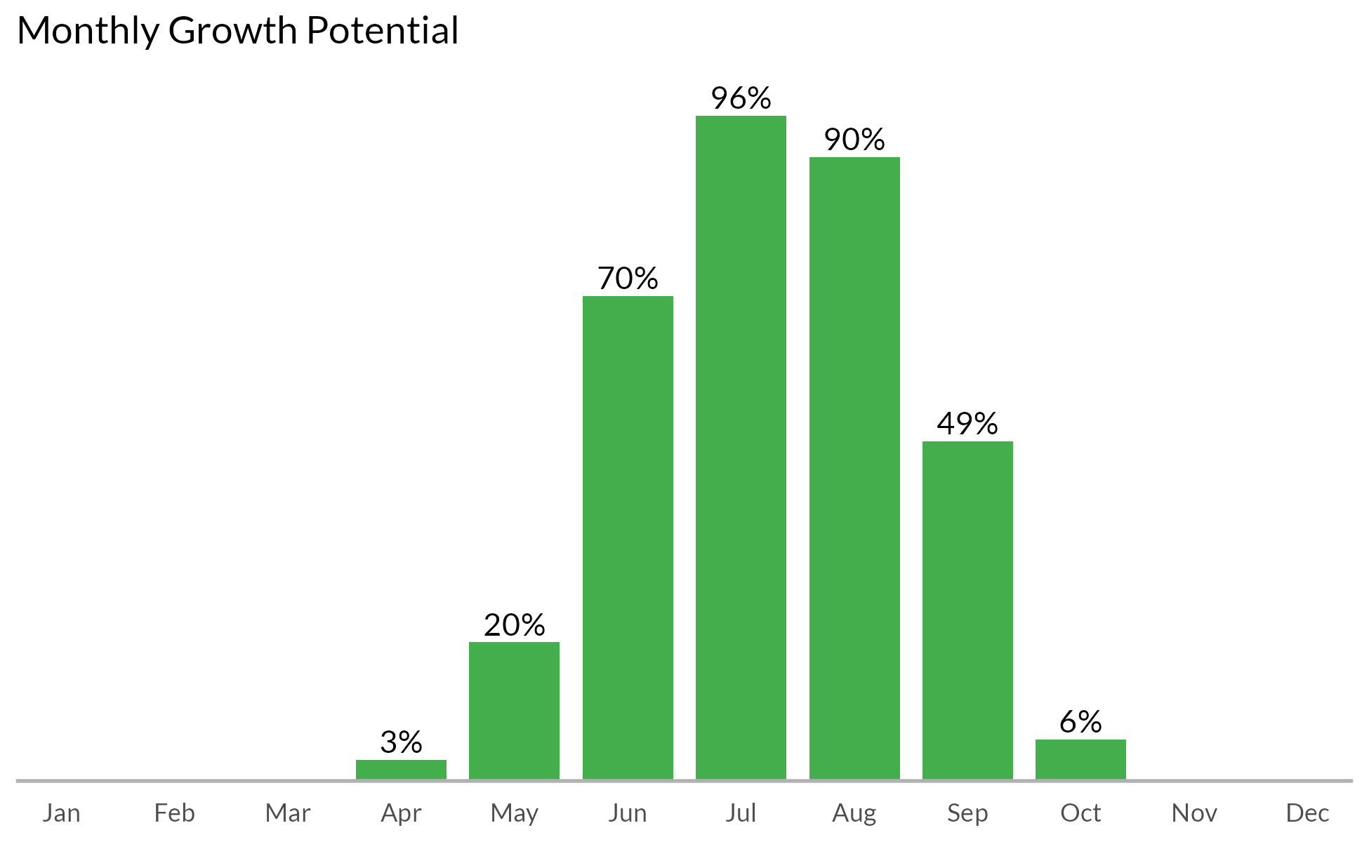



## Measurement results and MLSN values

The following graph shows how the samples taken from each FAIRWAY compare to the calculated MLSN values and required elemental inputs based on the provided nitrogen input and the Turf Growth Potential Model.

* **Red** dots highlight samples where a deficit was found
* **Orange** dots represent samples which are within 1% of the desired MLSN value
* **Green** dots indicate that the samples met the MLSN requirements

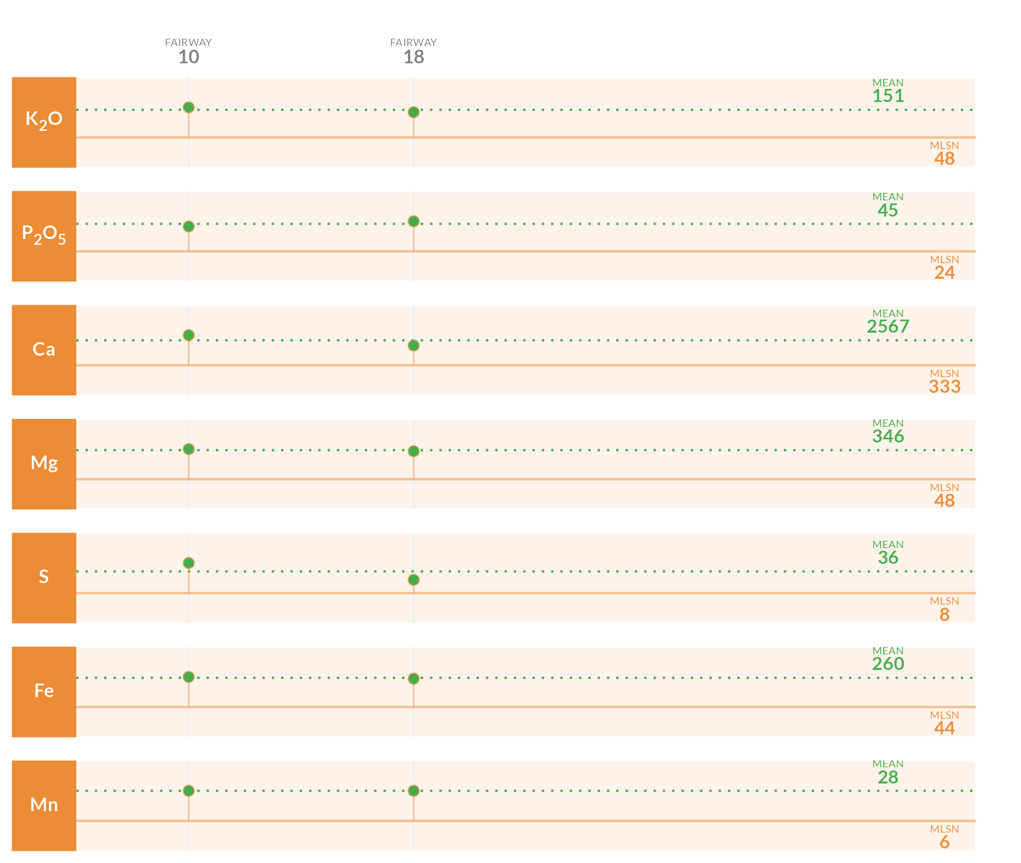

## Required element per area (lbs. per 1000 sq.ft.)

This table specifies the amount of fertilizer required to remedy the deficits highlighted by the analysis.

| **Area** | **K2O** | **P2O5** | **Ca** | **Mg** | **S** | **Fe** | **Mn** |
| --- | --- | --- | --- | --- | --- | --- | --- |
| **10** | - | - | - | - | - | - | - |
| **18** | - | - | - | - | - | - | - |
| **Average** |  |  |  |  |  |  |  |
| Note: The symbol " - " means no deficit was found; an empty cell means no data was provided. The Average values are the means across all areas where a deficit was found. | | | | | | | |

## Mean measurements and recommendations



**pH**

The average pH is 7.5. This is within the optimum range for soil microbial activity and soil nutrient availability. With the pH is this range, there is a chance of seeing some iron chlorosis. If this does occur, you can fix it by making foliar applications of ferrous sulfate.

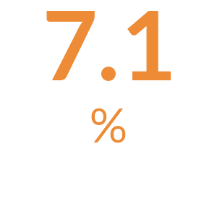

**Organic Matter**

The average Organic Matter (%) measurement is above 4.5%. **[TODO: Add custom comment]**

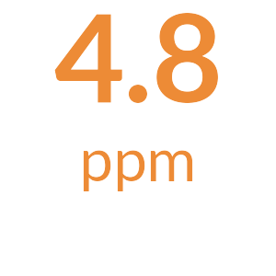

**Total Nitrogen**

The total available Nitrogen measurement is the sum of the Ammonium (NH4-N) and Nitrate (NO3-N) measurements. The average total available Nitrogen is 4.8 ppm. This is below the optimal range of 5 ppm - 10 ppm for soil nitrogen. Consider additional applications of nitrate or ammonium based fertilizers to increase soil nitrogen levels.

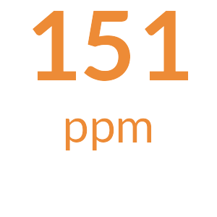

**Potassium**

The mean Potassium (ppm) measurement is 151 ppm and is above the MLSN value of 48 ppm for all the samples. **[TODO: Add something along the lines of all is well.]**

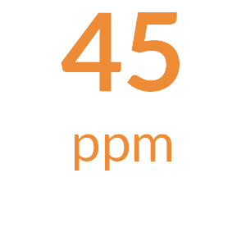

**Phosphorus**

The mean Phosphorus (ppm) measurement is 45 ppm and is above the MLSN value of 24 ppm for all the samples. **[TODO: Add something along the lines of all is well.]**

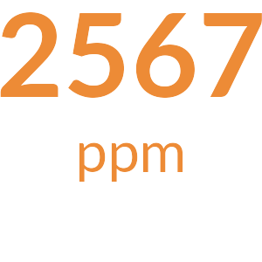

**Calcium**

The mean Calcium (ppm) measurement is 2567 ppm and is above the MLSN value of 333 ppm for all the samples. **[TODO: Add something along the lines of all is well.]**

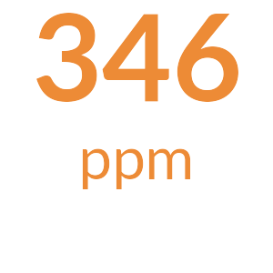

**Magnesium**

The mean Magnesium (ppm) measurement is 346 ppm and is above the MLSN value of 48 ppm for all the samples. **[TODO: Add something along the lines of all is well.]**

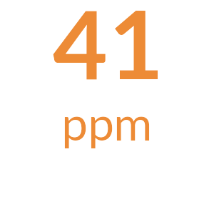

**Sodium**

The average Sodium is 41 ppm. This is below 110 ppm, the beginning threshold for negative effects of sodium on turfgrass.

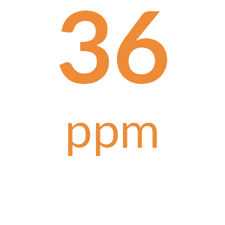

**Sulfur**

The mean Sulfur (ppm) measurement is 36 ppm and is above the MLSN value of 7.6 ppm for all the samples. **[TODO: Add something along the lines of all is well.]**

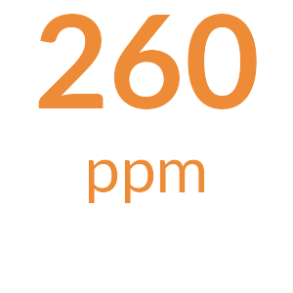

**Iron**

The mean Iron (ppm) measurement is 260 ppm and is above the MLSN value of 44 ppm for all the samples. **[TODO: Add something along the lines of all is well.]**

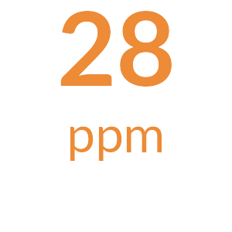

**Manganese**

The mean Manganese (ppm) measurement is 28 ppm and is above the MLSN value of 6 ppm for all the samples. **[TODO: Add something along the lines of all is well.]**



**Micronutrients**

All Micronutrients are present and there are no recommendations for additional applications.



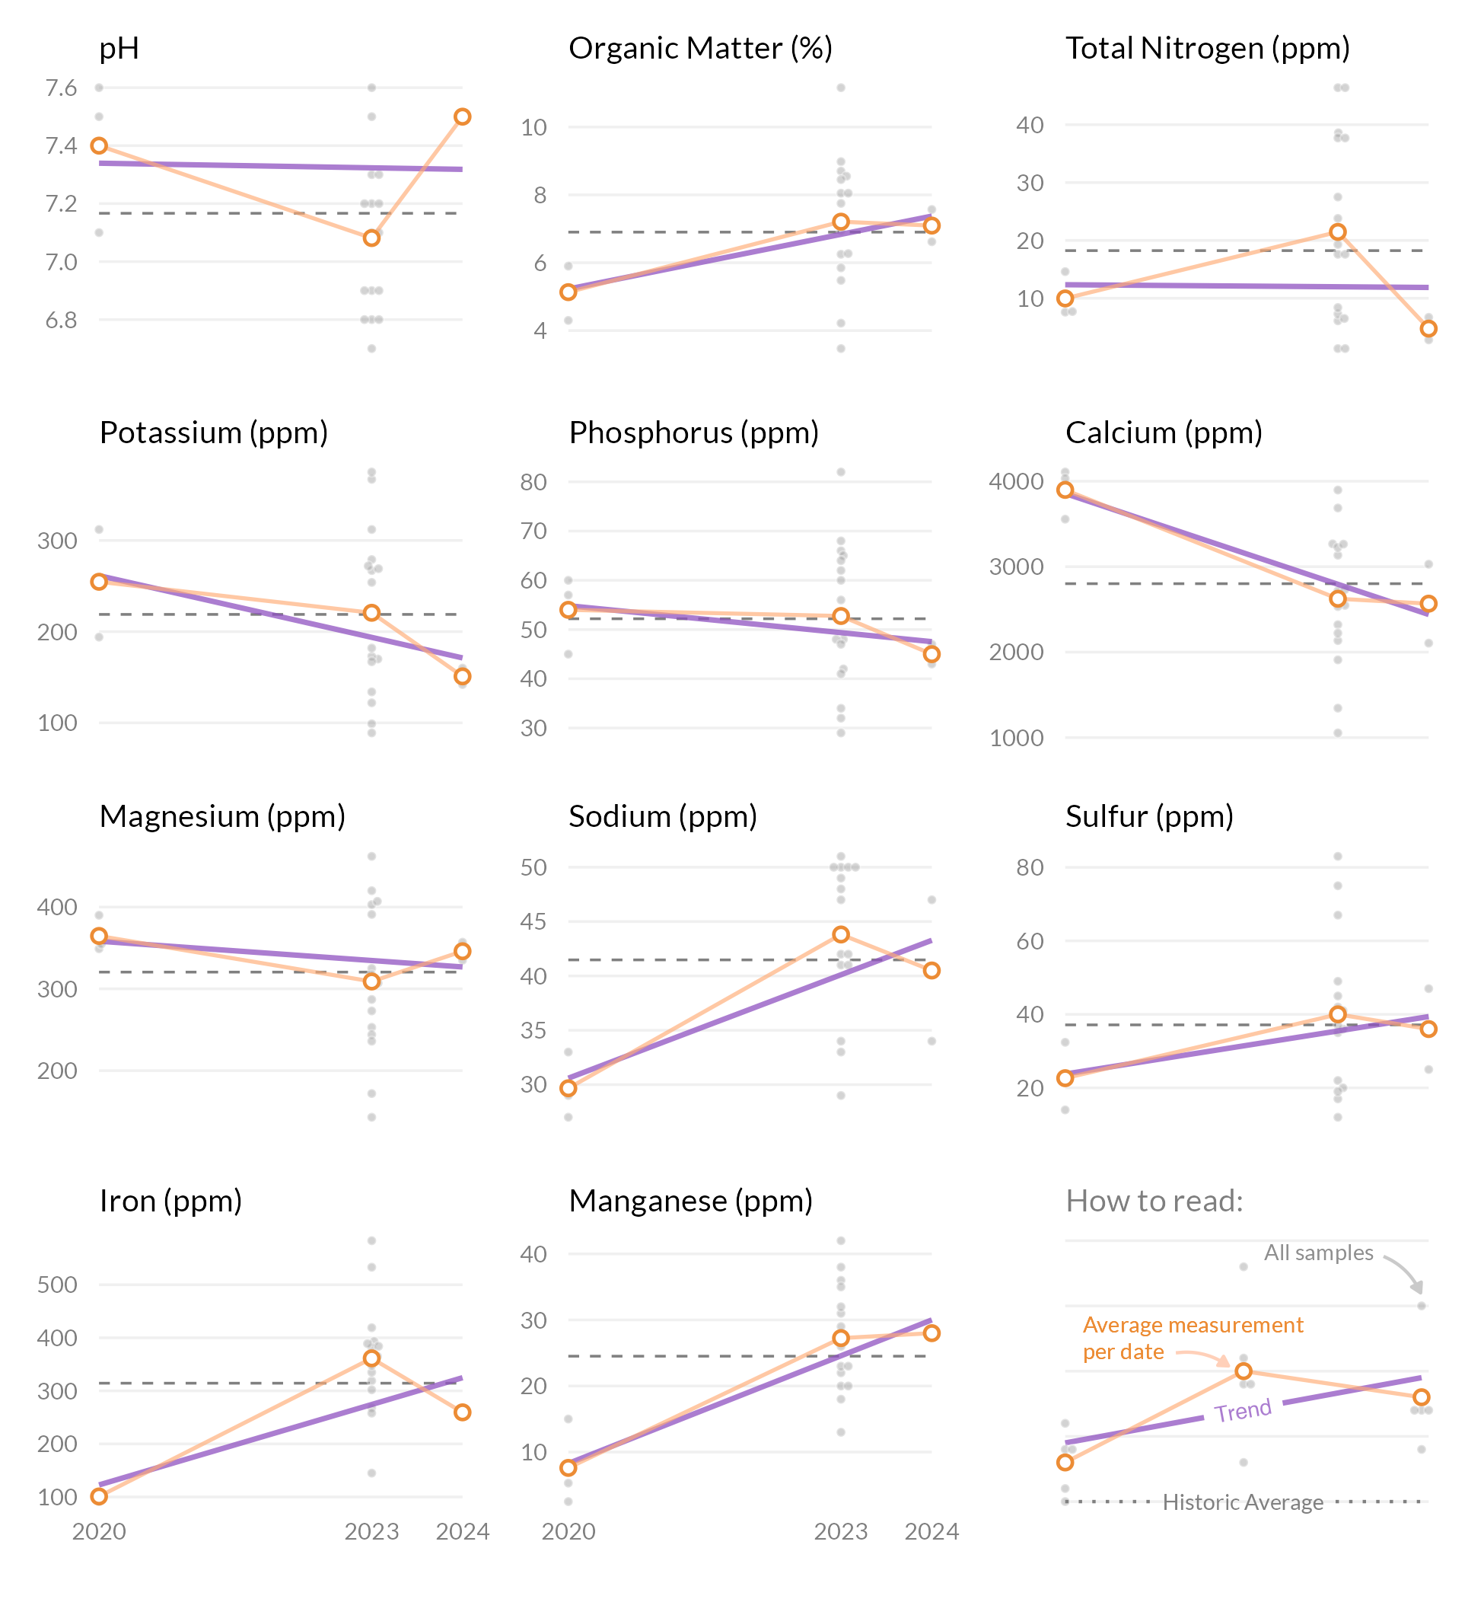



FAO Handbook 29 is the Food and Agricultural Organization of the United Nations and widely is recognized as the leading source for irrigation water quality guidelines. Below are the water sample results as shown in comparison to the FAO guidelines for likelihood of soil problems.

1: Yes 2: No

