

November 17, 2021

Company  
Address Line 1  
Address Line 2  
City, State, Zip

Cover Letter

Lorem ipsum dolor sit amet, consectetur adipiscing elit. Maecenas facilisis sollicitudin magna at condimentum. Vestibulum at aliquam lorem. Aliquam ut nibh pretium, volutpat metus eu, fermentum velit. Cras dapibus placerat viverra. Etiam faucibus lectus ac neque scelerisque fringilla. Nunc mi velit, tristique ac placerat gravida, porttitor at ante. Phasellus vehicula.

Eric Foerster's Signature





## Green

* Lorem ipsum dolor sit amet, consectetur adipiscing elit. Maecenas facilisis sollicitudin magna at condimentum. Vestibulum at aliquam lorem. Aliquam ut nibh pretium, volutpat metus eu, fermentum velit.

## Fairway

* Lorem ipsum dolor sit amet, consectetur adipiscing elit. Maecenas facilisis sollicitudin magna at condimentum. Vestibulum at aliquam lorem. Aliquam ut nibh pretium, volutpat metus eu, fermentum velit.

## Water

* Lorem ipsum dolor sit amet, consectetur adipiscing elit. Maecenas facilisis sollicitudin magna at condimentum. Vestibulum at aliquam lorem. Aliquam ut nibh pretium, volutpat metus eu, fermentum velit.



The temperature data is provided by NOAA using 30-year climate normals and is site-specific to your location. Pace Turf, LLC (Gelernter and Stowell, 2005) developed the growth potential model to explain the myriad of ways in which weather impacts turf growth. The model considers turf growth to be good when the GP is between 50% and 100% (the best possible growth occurs at a GP of 100%). However, when weather conditions are either too hot or too cold for optimal turf growth, the GP falls below 50%, and turf becomes progressively more stressed. When the GP falls to 10% or lower, growth is extremely limited. Appearing below is your model specific to Saratoga Lake Golf Club.

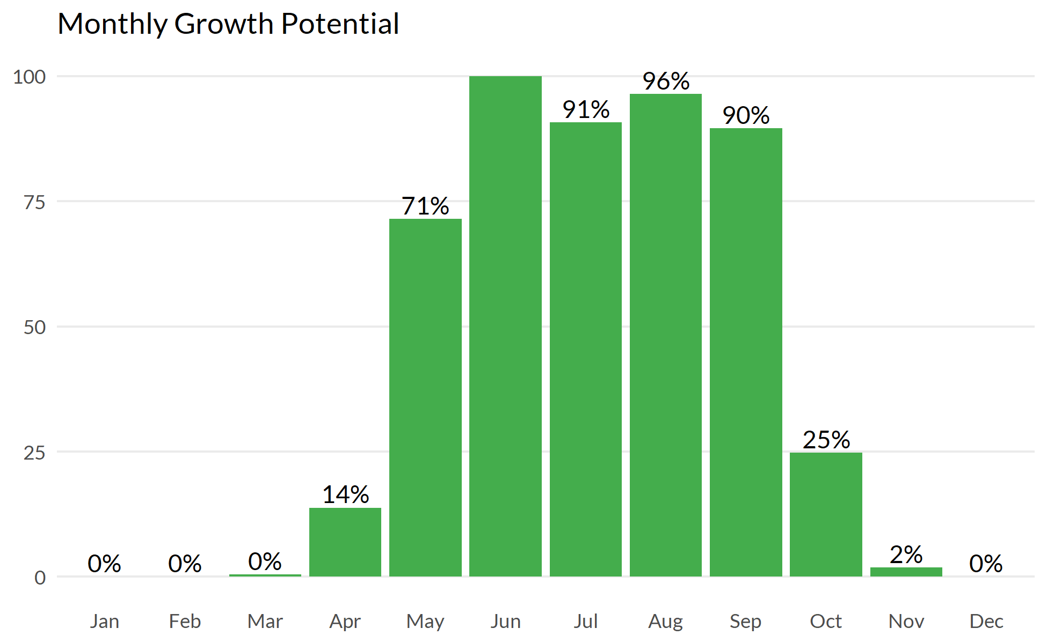



The following tables represent the calculated MLSN values and required elemental inputs based on the provided nitrogen input and the Turf Growth Potential Model.

## MLSN Values (ppm)

| **K** | **P** | **Ca** | **Mg** | **S** | **Fe** | **Mn** |
| --- | --- | --- | --- | --- | --- | --- |
| 77 | 16 | 339 | 52 | 12 | 44 | 6 |

## Required element per area (lbs. per 1000 sq.ft.)

| **Area** | **K2O** | **P2O5** | **Ca** | **Mg** | **S** | **Fe** | **Mn** |
| --- | --- | --- | --- | --- | --- | --- | --- |
| **5** | 2.14 | 0.69 | - | - | 0.18 | - | - |
| **14** | 2.22 | 0.42 | - | - | 0.18 | - | - |
| **Average** | **2.18** | **0.55** |  |  | **0.18** |  |  |
| Note: - means no deficit was found; an empty cell means no data was provided. The Average values are the means across all areas where a deficit was found. | | | | | | | |



**pH**

Lorem ipsum dolor sit amet, consectetur adipiscing elit. Nulla eu pulvinar arcu, quis aliquam dui. In at cursus ante.

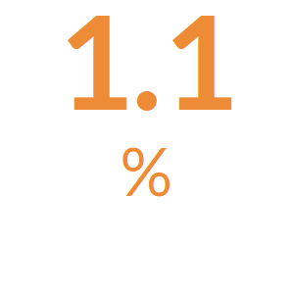

**Organic Matter**

Lorem ipsum dolor sit amet, consectetur adipiscing elit. Nulla eu pulvinar arcu, quis aliquam dui. In at cursus ante.

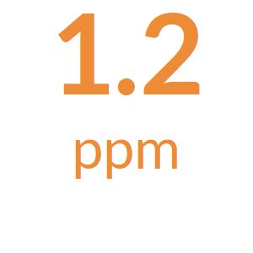

**Total Nitrogen**

The total available Nitrogen measurement is the sum of the Ammonium (NH4-N) and Nitrate (NO3-N) measurements.

Lorem ipsum dolor sit amet, consectetur adipiscing elit. Nulla eu pulvinar arcu, quis aliquam dui. In at cursus ante.

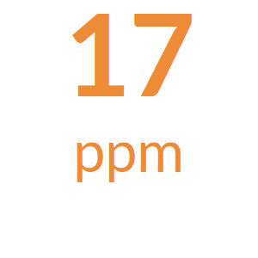

**Potassium**

Lorem ipsum dolor sit amet, consectetur adipiscing elit. Nulla eu pulvinar arcu, quis aliquam dui. In at cursus ante.

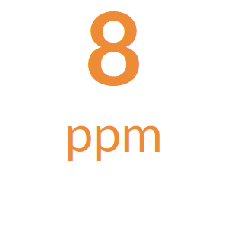

**Phosphorus**

Lorem ipsum dolor sit amet, consectetur adipiscing elit. Nulla eu pulvinar arcu, quis aliquam dui. In at cursus ante.

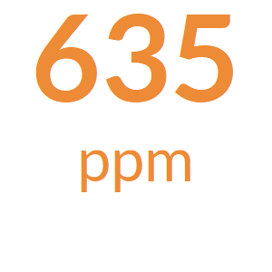

**Calcium**

Lorem ipsum dolor sit amet, consectetur adipiscing elit. Nulla eu pulvinar arcu, quis aliquam dui. In at cursus ante.

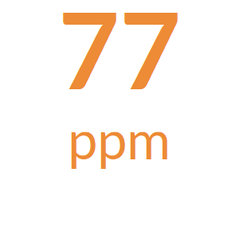

**Magnesium**

Lorem ipsum dolor sit amet, consectetur adipiscing elit. Nulla eu pulvinar arcu, quis aliquam dui. In at cursus ante.

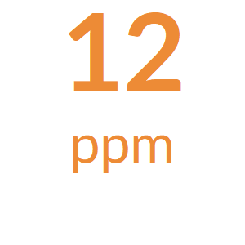

**Sodium**

Lorem ipsum dolor sit amet, consectetur adipiscing elit. Nulla eu pulvinar arcu, quis aliquam dui. In at cursus ante.

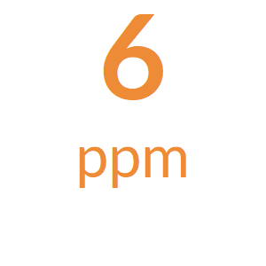

**Sulfur**

Lorem ipsum dolor sit amet, consectetur adipiscing elit. Nulla eu pulvinar arcu, quis aliquam dui. In at cursus ante.

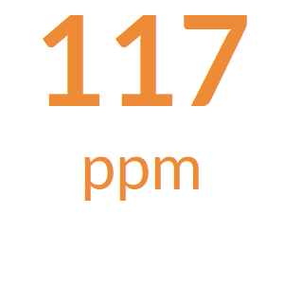

**Iron**

Lorem ipsum dolor sit amet, consectetur adipiscing elit. Nulla eu pulvinar arcu, quis aliquam dui. In at cursus ante.

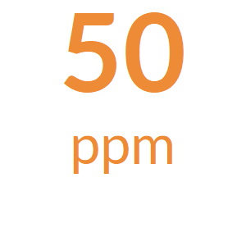

**Manganese**

Lorem ipsum dolor sit amet, consectetur adipiscing elit. Nulla eu pulvinar arcu, quis aliquam dui. In at cursus ante.



**Micronutrients**

Lorem ipsum dolor sit amet, consectetur adipiscing elit. Nulla eu pulvinar arcu, quis aliquam dui. In at cursus ante.



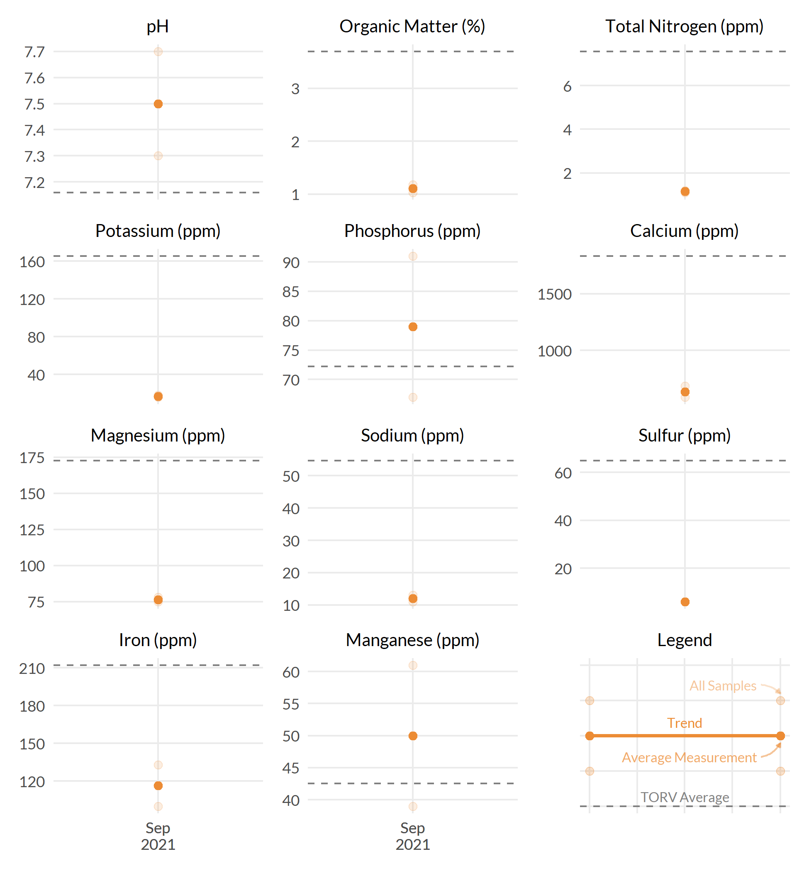



The following tables represent the calculated MLSN values and required elemental inputs based on the provided nitrogen input and the Turf Growth Potential Model.

## MLSN Values (ppm)

| **K** | **P** | **Ca** | **Mg** | **S** | **Fe** | **Mn** |
| --- | --- | --- | --- | --- | --- | --- |
| 77 | 16 | 339 | 52 | 12 | 44 | 6 |

## Required element per area (lbs. per 1000 sq.ft.)

| **Area** | **K2O** | **P2O5** | **Ca** | **Mg** | **S** | **Fe** | **Mn** |
| --- | --- | --- | --- | --- | --- | --- | --- |
| **2** | 1.82 | 0.28 | - | - | 0.18 | - | - |
| **13** | 1.45 | - | - | - | 0.06 | - | - |
| **18** | 1.53 | 0.97 | - | - | 0.03 | - | - |
| **Average** | **1.60** | **0.62** |  |  | **0.09** |  |  |
| Note: - means no deficit was found; an empty cell means no data was provided. The Average values are the means across all areas where a deficit was found. | | | | | | | |



**pH**

Lorem ipsum dolor sit amet, consectetur adipiscing elit. Nulla eu pulvinar arcu, quis aliquam dui. In at cursus ante.

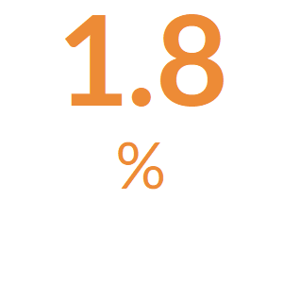

**Organic Matter**

Lorem ipsum dolor sit amet, consectetur adipiscing elit. Nulla eu pulvinar arcu, quis aliquam dui. In at cursus ante.

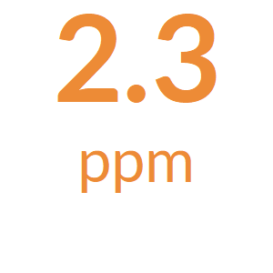

**Total Nitrogen**

The total available Nitrogen measurement is the sum of the Ammonium (NH4-N) and Nitrate (NO3-N) measurements.

Lorem ipsum dolor sit amet, consectetur adipiscing elit. Nulla eu pulvinar arcu, quis aliquam dui. In at cursus ante.

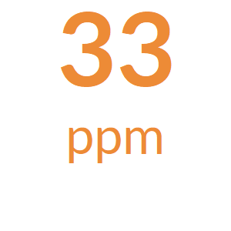

**Potassium**

Lorem ipsum dolor sit amet, consectetur adipiscing elit. Nulla eu pulvinar arcu, quis aliquam dui. In at cursus ante.

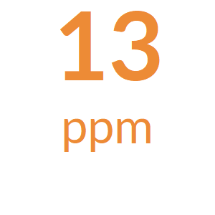

**Phosphorus**

Lorem ipsum dolor sit amet, consectetur adipiscing elit. Nulla eu pulvinar arcu, quis aliquam dui. In at cursus ante.

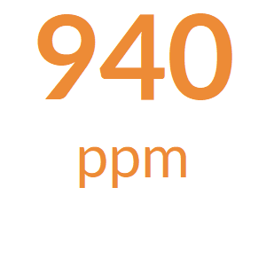

**Calcium**

Lorem ipsum dolor sit amet, consectetur adipiscing elit. Nulla eu pulvinar arcu, quis aliquam dui. In at cursus ante.

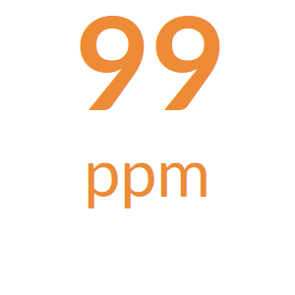

**Magnesium**

Lorem ipsum dolor sit amet, consectetur adipiscing elit. Nulla eu pulvinar arcu, quis aliquam dui. In at cursus ante.

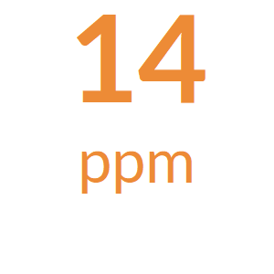

**Sodium**

Lorem ipsum dolor sit amet, consectetur adipiscing elit. Nulla eu pulvinar arcu, quis aliquam dui. In at cursus ante.

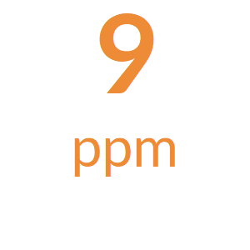

**Sulfur**

Lorem ipsum dolor sit amet, consectetur adipiscing elit. Nulla eu pulvinar arcu, quis aliquam dui. In at cursus ante.

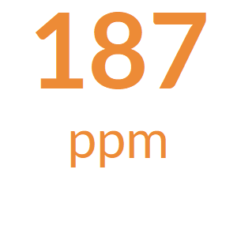

**Iron**

Lorem ipsum dolor sit amet, consectetur adipiscing elit. Nulla eu pulvinar arcu, quis aliquam dui. In at cursus ante.

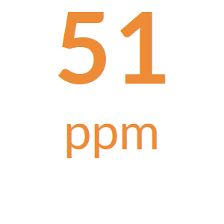

**Manganese**

Lorem ipsum dolor sit amet, consectetur adipiscing elit. Nulla eu pulvinar arcu, quis aliquam dui. In at cursus ante.



**Micronutrients**

Lorem ipsum dolor sit amet, consectetur adipiscing elit. Nulla eu pulvinar arcu, quis aliquam dui. In at cursus ante.



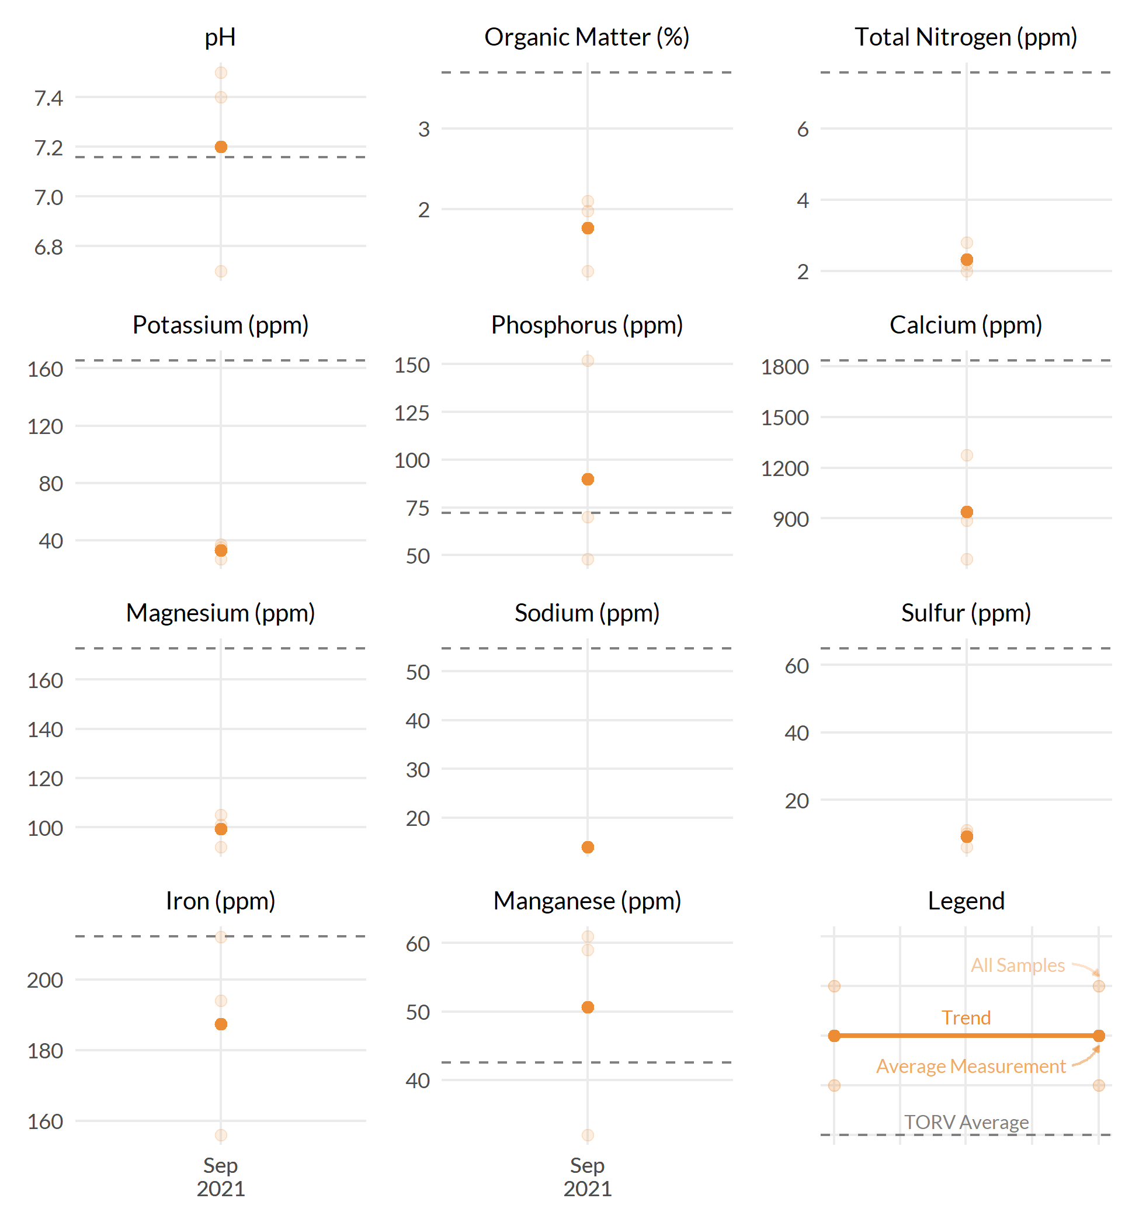



FAO Handbook 29 is the Food and Agricultural Organization of the United Nations and widely is recognized as the leading source for irrigation water quality guidelines. Below are the water sample results as shown in comparison to the FAO guidelines for likelihood of soil problems.

