

November 22, 2023

Company  
Address Line 1  
Address Line 2  
City, State, Zip

Cover Letter

Lorem ipsum dolor sit amet, consectetur adipiscing elit. Maecenas facilisis sollicitudin magna at condimentum. Vestibulum at aliquam lorem. Aliquam ut nibh pretium, volutpat metus eu, fermentum velit. Cras dapibus placerat viverra. Etiam faucibus lectus ac neque scelerisque fringilla. Nunc mi velit, tristique ac placerat gravida, porttitor at ante. Phasellus vehicula.

Best Regards,

Eric Foerster's Signature

Eric Foerster CGCS, MG  
TORV, LLC  
970.409.9874  
eric@torv.me



## Green

* The average total available Nitrogen is 2.5 ppm. This is below the optimal range of 5 ppm - 10 ppm for soil nitrogen. Consider additional applications of nitrate or ammonium based fertilizers to increase soil nitrogen levels.
* No deficits were noted in the values tied to MLSN values. [TODO: Add custom comment.]
* No other anomalies were highlighted in the analysis. [TODO: Add custom comment.]

## Organic Matter

The mean OM measurements can be summarised as follows:

* The **APPROACH** samples taken on April 7th, 2021 were as follows:
  + At a depth of **0-2 cm**, the OM content was **16.45%**.
  + At a depth of **2-4 cm**, the OM content was **6.84%**.
  + At a depth of **4-6 cm**, the OM content was **6.08%**.
* Comparing the **GREEN** samples taken on November 4th, 2021 to their most recent previous samples (September 21st, 2020)
  + At a depth of **0-2 cm**, the OM content increased from 11.41% to 12.34%
  + At a depth of **2-4 cm**, the OM content increased from 4.07% to 4.75%
  + At a depth of **4-6 cm**, the OM content decreased from 3.55% to 3.52%

Like calibrating a TDR measurement for soil moisture content based on subjective observations, the OM246 test should be thought of in the same context. Playability and overall green performance should be considered.

Using a known amount of topdressing applied, we can estimate/calculate the Amount of topdressing needed to maintain, increase, or decrease the organic matter.

* Consider obtaining an accurate topdressing rate per year to make this calculation possible. What is the estimated depth of all topdressing applications applied this year?
* [This video from the USGA](https://www.asianturfgrass.com/post/sand-topdressing-by-depth/) shows how to calculate the depth along with the required conversion equations.
* Cultural decisions such as aerification, verticutting, topdressing amounts/frequency can be influenced by tracking organic matter over time and established goals for organic matter targets.

[TODO: Additional comments]



The temperature data is provided by NOAA using 30-year climate normals and is site-specific to your location. Pace Turf, LLC (Gelernter and Stowell, 2005) developed the growth potential model to explain the myriad of ways in which weather impacts turf growth. The model considers turf growth to be good when the GP is between 50% and 100% (the best possible growth occurs at a GP of 100%). However, when weather conditions are either too hot or too cold for optimal turf growth, the GP falls below 50%, and turf becomes progressively more stressed. When the GP falls to 10% or lower, growth is extremely limited. Appearing below is your model specific to Sonnenalp Golf Club.

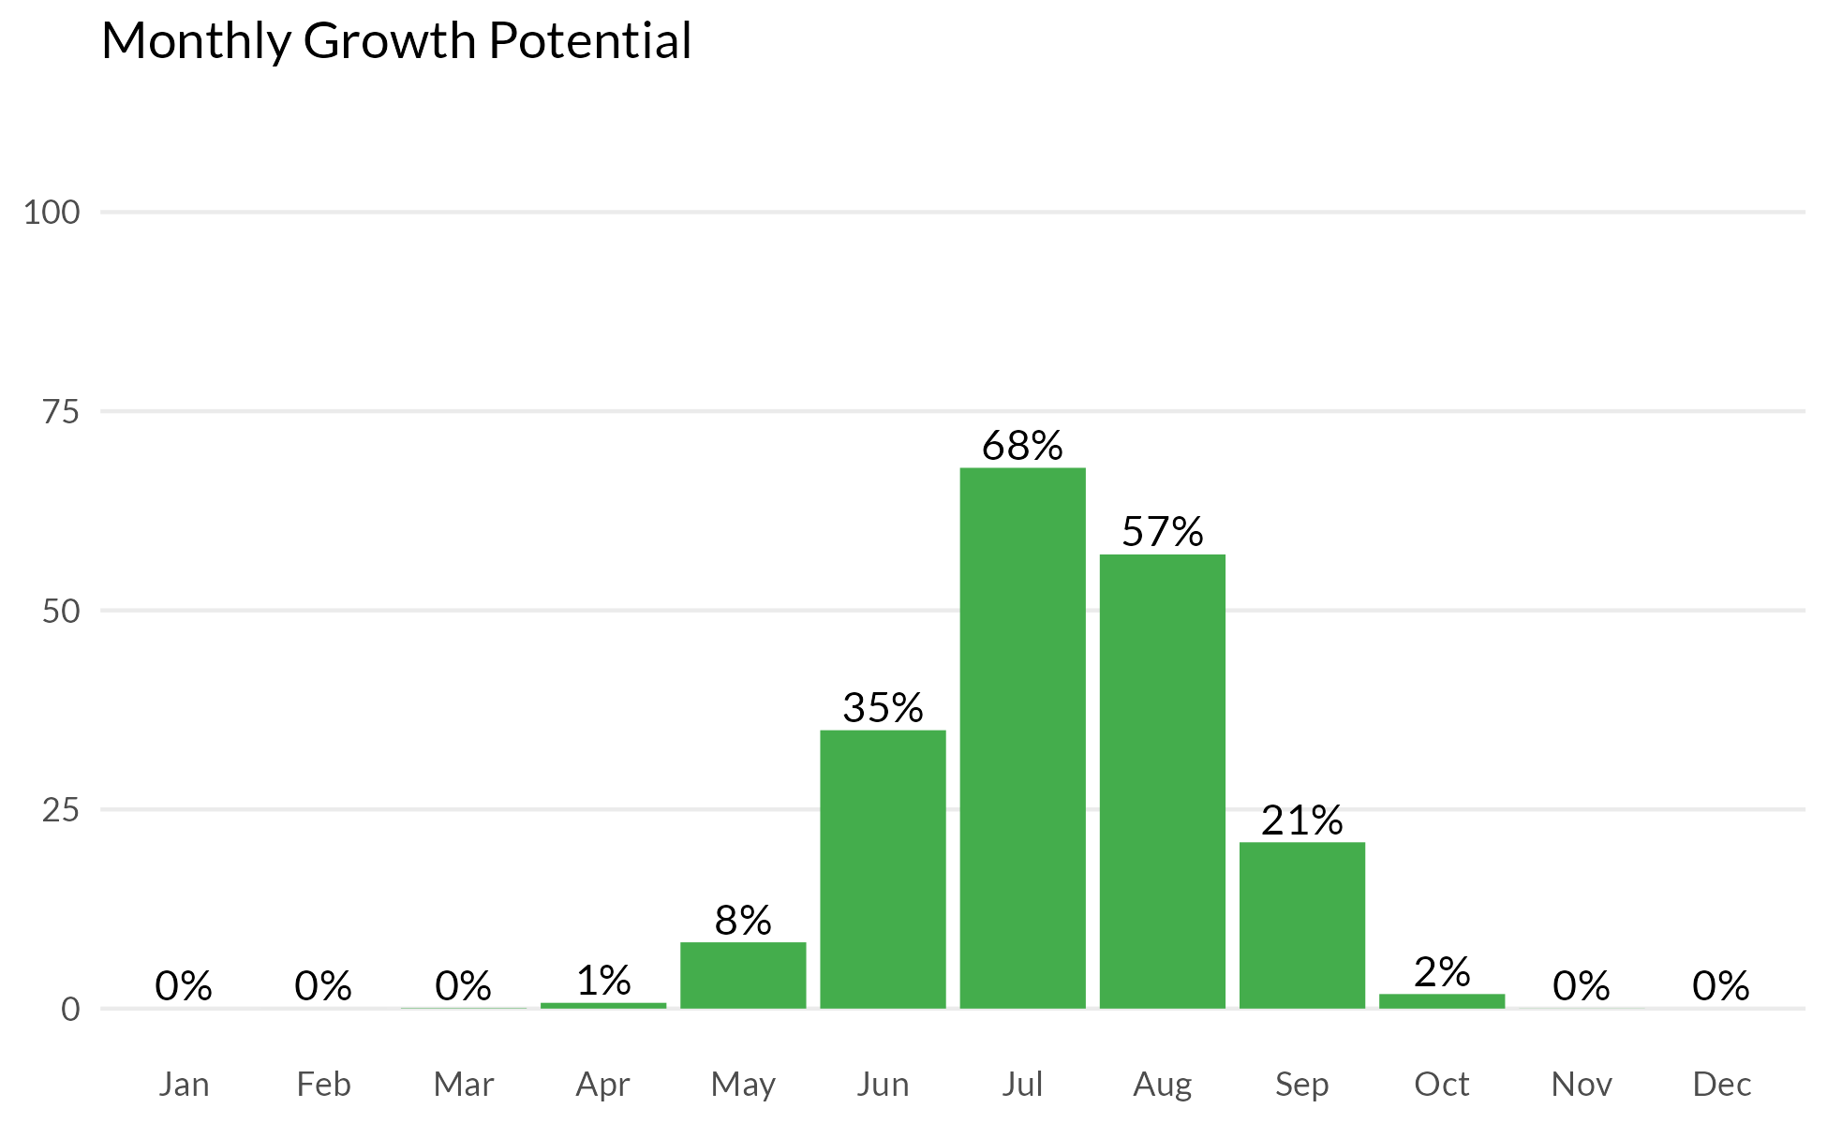



## Measurement results and MLSN values

The following graph shows how the samples taken from each GREEN compare to the calculated MLSN values and required elemental inputs based on the provided nitrogen input and the Turf Growth Potential Model.

* **Red** dots highlight samples where a deficit was found
* **Orange** dots represent samples which are within 1% of the desired MLSN value
* **Green** dots indicate that the samples met the MLSN requirements

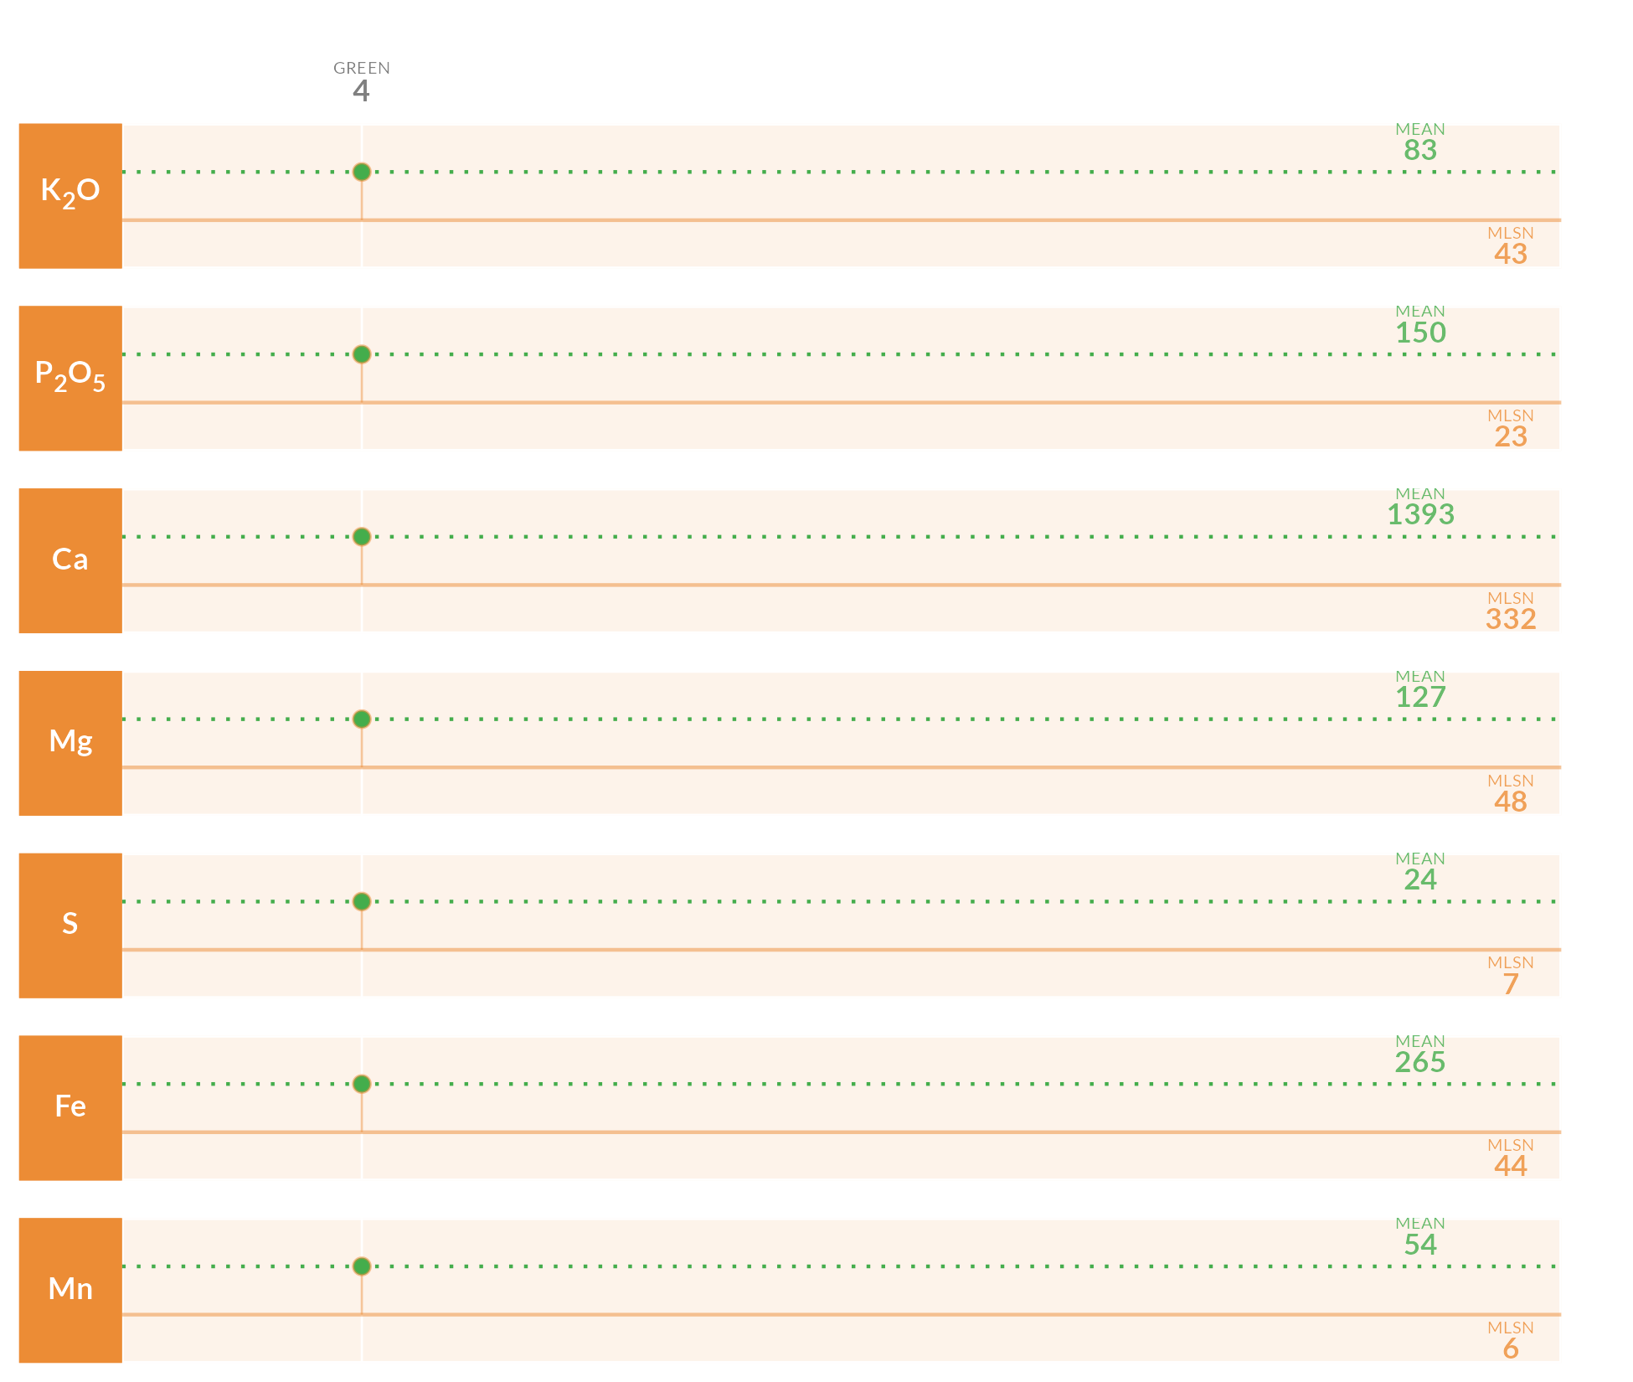

## Required element per area (lbs. per 1000 sq.ft.)

This table specifies the amount of fertilizer required to remedy the deficits highlighted by the analysis.

| **Area** | **K2O** | **P2O5** | **Ca** | **Mg** | **S** | **Fe** | **Mn** |
| --- | --- | --- | --- | --- | --- | --- | --- |
| **4** | - | - | - | - | - | - | - |
| **Average** |  |  |  |  |  |  |  |
| Note: The symbol " - " means no deficit was found; an empty cell means no data was provided. The Average values are the means across all areas where a deficit was found. | | | | | | | |

## Mean measurements and recommendations



**pH**

The average pH is 7.7. This is within the optimum range for soil microbial activity and soil nutrient availability. With the pH is this range, there is a chance of seeing some iron chlorosis. If this does occur, you can fix it by making foliar applications of ferrous sulfate.

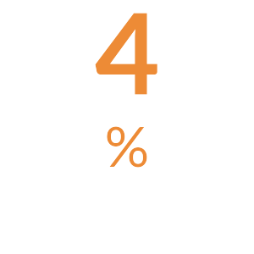

**Organic Matter**

The average Organic Matter is 4%. This is normal and indicates that your current maintenance practices are keeping the organic matter percentage in an ideal range.

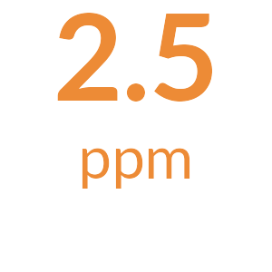

**Total Nitrogen**

The total available Nitrogen measurement is the sum of the Ammonium (NH4-N) and Nitrate (NO3-N) measurements. The average total available Nitrogen is 2.5 ppm. This is below the optimal range of 5 ppm - 10 ppm for soil nitrogen. Consider additional applications of nitrate or ammonium based fertilizers to increase soil nitrogen levels.

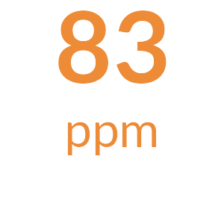

**Potassium**

The mean Potassium (ppm) measurement is 83 ppm and is above the MLSN value of 43 ppm for all the samples. [Something along the lines of all is well.]

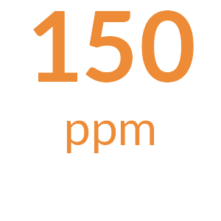

**Phosphorus**

The mean Phosphorus (ppm) measurement is 150 ppm and is above the MLSN value of 23 ppm for all the samples. [Something along the lines of all is well.]

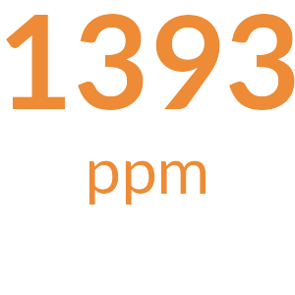

**Calcium**

The mean Calcium (ppm) measurement is 1393 ppm and is above the MLSN value of 332 ppm for all the samples. [Something along the lines of all is well.]

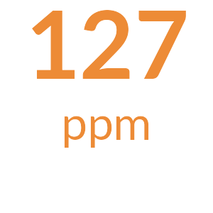

**Magnesium**

The mean Magnesium (ppm) measurement is 127 ppm and is above the MLSN value of 48 ppm for all the samples. [Something along the lines of all is well.]

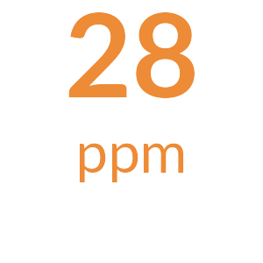

**Sodium**

The average Sodium is 28 ppm. This is below 110 ppm, the beginning threshold for negative effects of sodium on turfgrass.

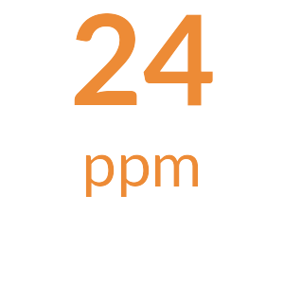

**Sulfur**

The mean Sulfur (ppm) measurement is 24 ppm and is above the MLSN value of 6.9 ppm for all the samples. [Something along the lines of all is well.]

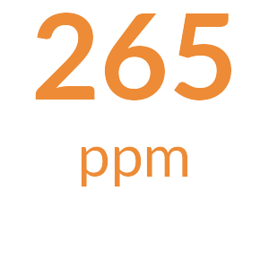

**Iron**

The mean Iron (ppm) measurement is 265 ppm and is above the MLSN value of 44 ppm for all the samples. [Something along the lines of all is well.]

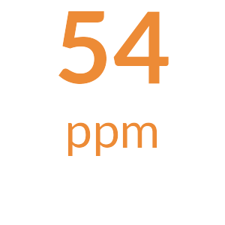

**Manganese**

The mean Manganese (ppm) measurement is 54 ppm and is above the MLSN value of 6 ppm for all the samples. [Something along the lines of all is well.]



**Micronutrients**

All Micronutrients are present and there are no recommendations for additional applications.



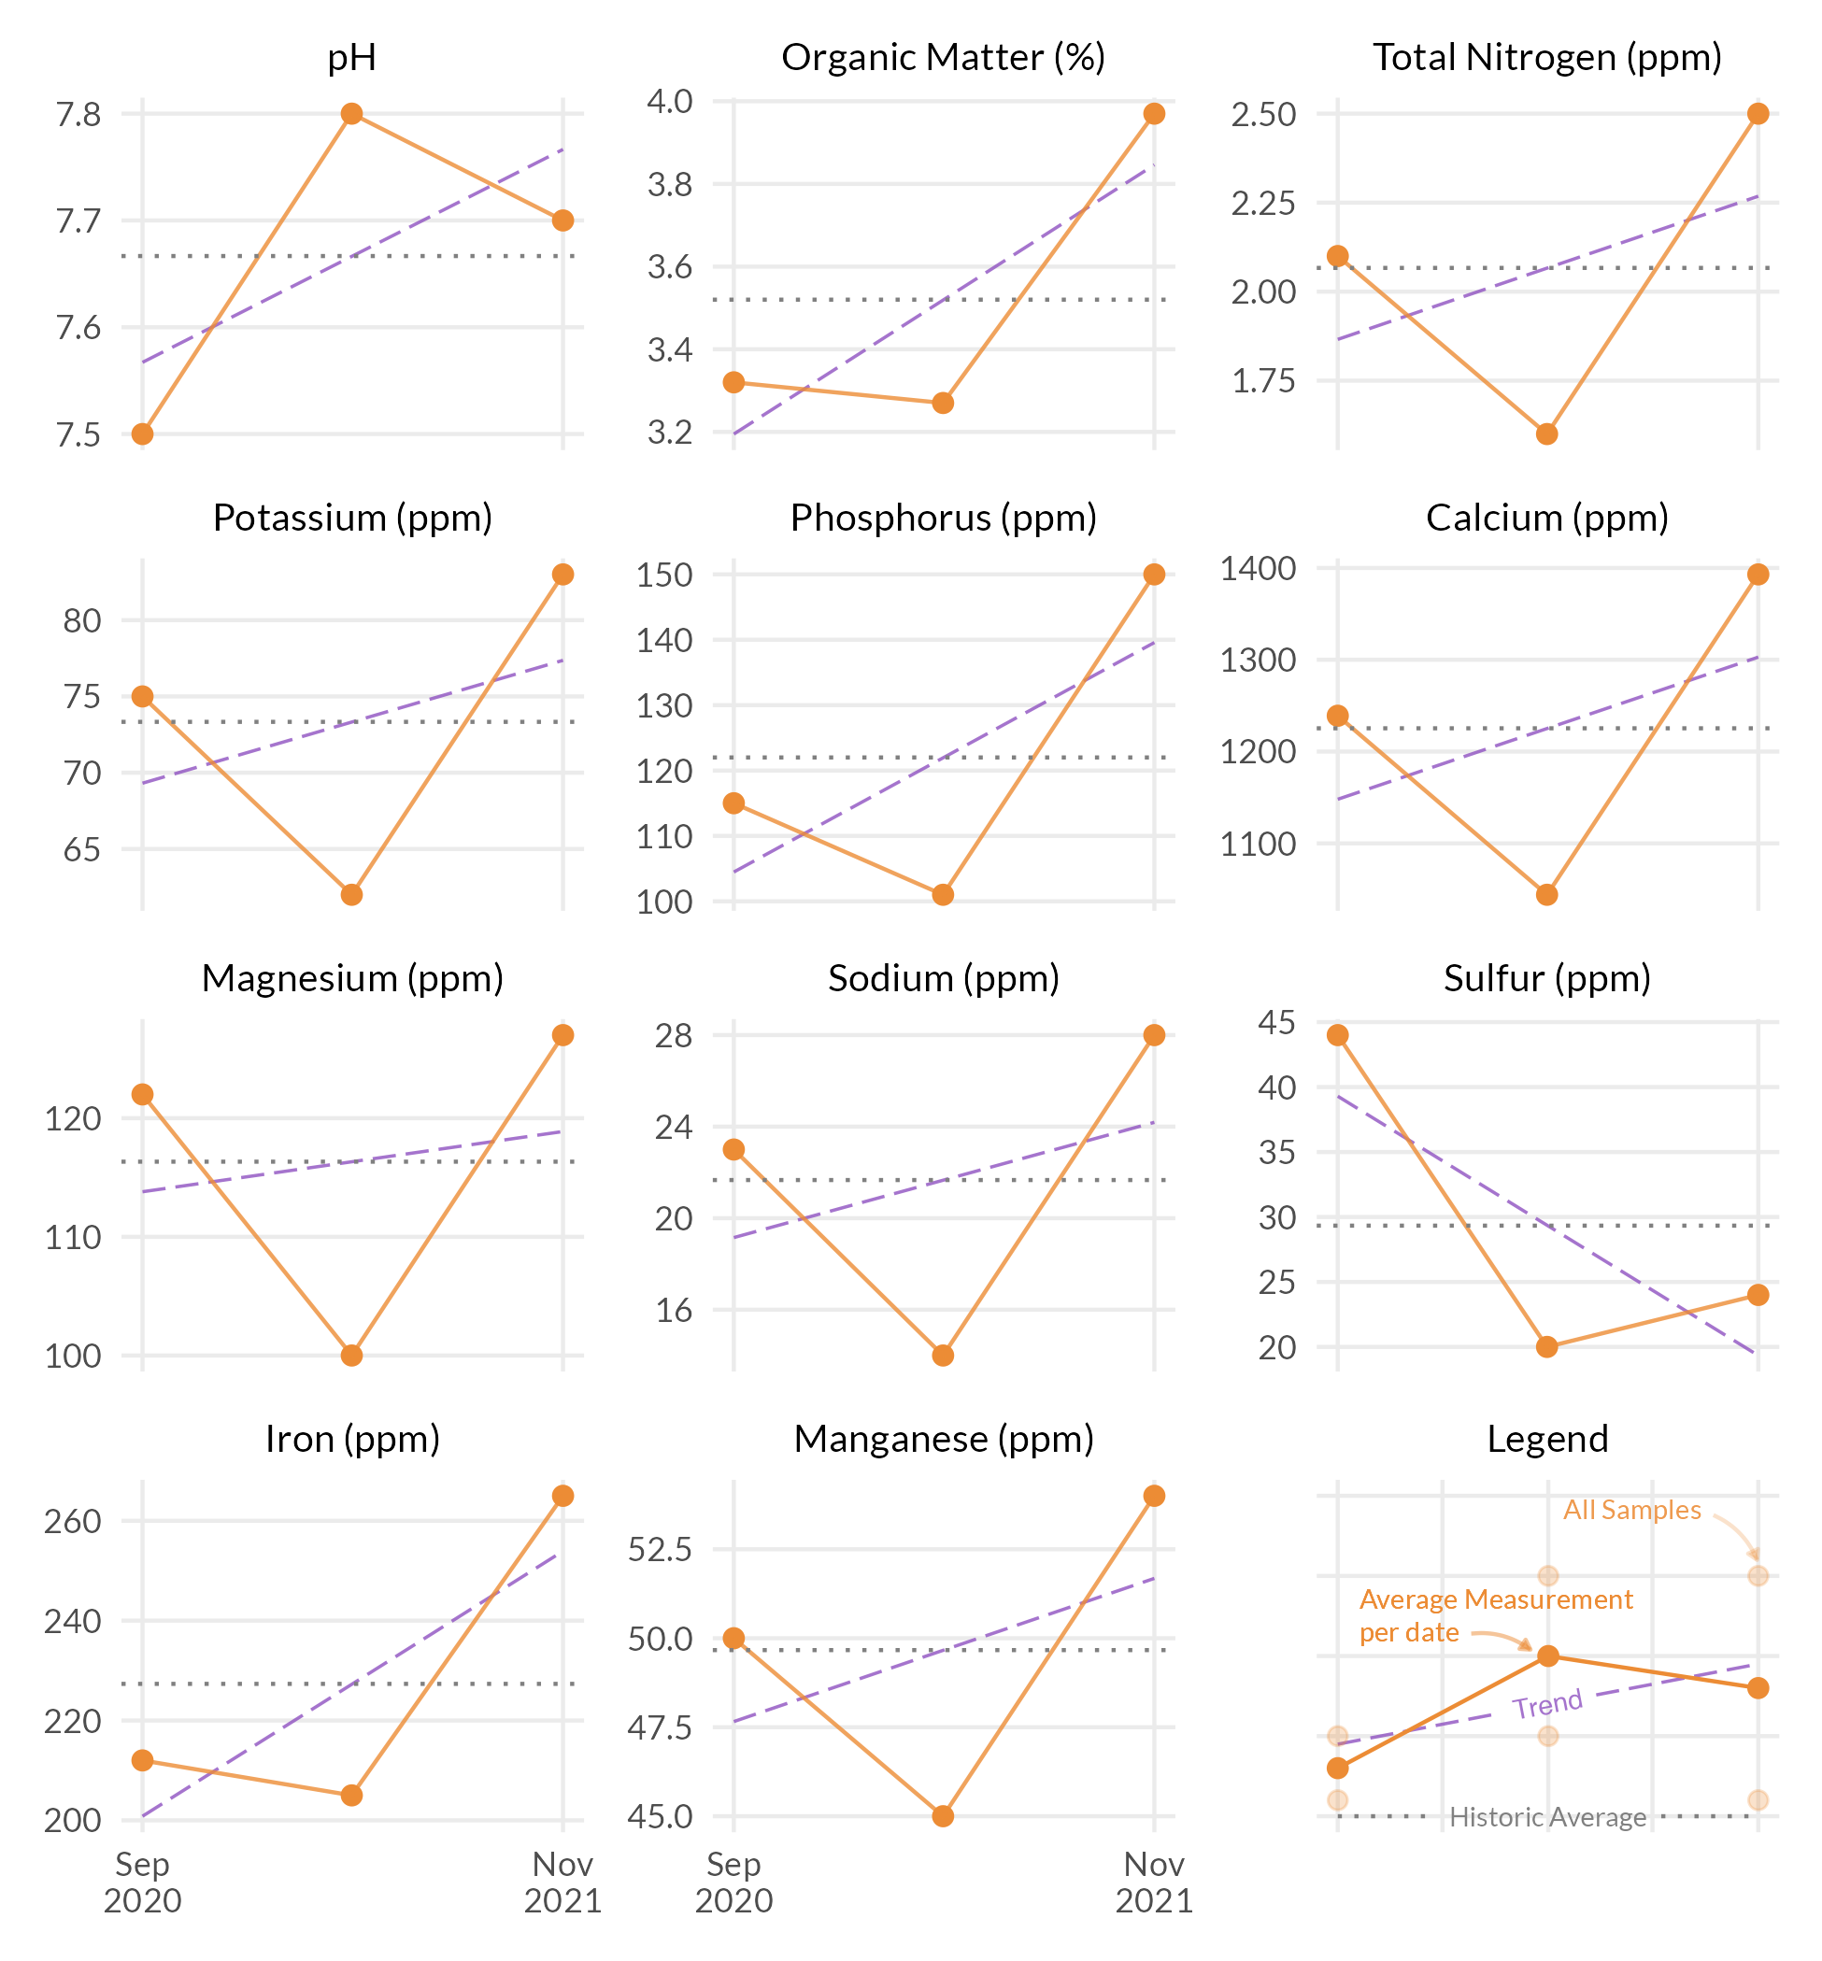



These measurements are neither good nor bad. Information such as fertilizer applied, cultural practices, sand applied, verti-cutting, aerification, etc. can be used to see how these practices have changed the OM% by depth. Ideally, once a desired OM% has been identified based on playability and turf performance, fertility and cultural practices can be adjusted to maintain the desired OM%.

The S325 test package includes the entire sample submitted. This includes leaves, stems, and roots. This differs from the standard soil test which filters out most of the components. This is the reason why the percentages appear higher than that on a standard soil test.

