Script_1.R

toryf

2023-02-09

#Alumno: Luis Miguel Toribio Ferrer  
#Fecha: 09/02/2022  
#sesion01: Estadisticas descriptivas  
  
  
# primera sesion ---------------------------------------------------------  
  
dbh <- 15  
h <- 8  
  
#multiplicaciones   
  
dbh*h

## [1] 120

dbh^2

## [1] 225

log(dbh)

## [1] 2.70805

dbh <- c(12, 8, 7, 5, 11, 13, 16, 21, 8, 16)  
  
  
dbh*h

## [1] 96 64 56 40 88 104 128 168 64 128

h <- c(5, 3, 2.5, 2, 4.7, 5.8, 7, 11, 2.4, 7.2)  
  
dbh*h

## [1] 60.0 24.0 17.5 10.0 51.7 75.4 112.0 231.0 19.2 115.2

# Graficas ----------------------------------------------------------------  
  
  
#boxplot   
  
boxplot(dbh)

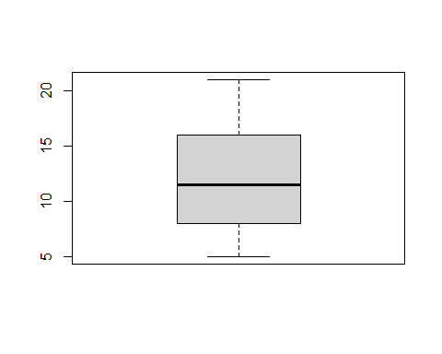

boxplot(h)

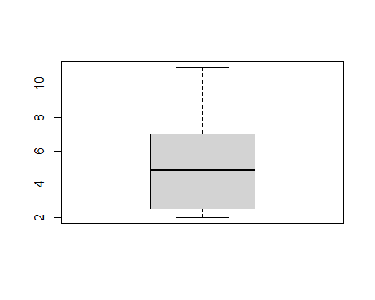

plot(dbh, h)

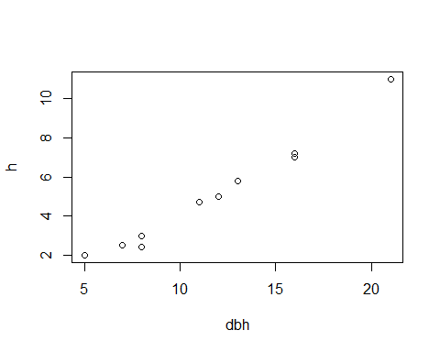

hist(dbh)

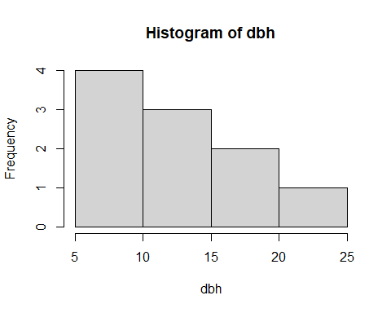

set.seed(13)  
obs.50 <- rnorm(50, mean =3)  
obs.50

## [1] 3.5543269 2.7197281 4.7751634 3.1873201 4.1425261 3.4155261 4.2295066  
## [8] 3.2366797 2.6346172 4.1051443 1.9064060 3.4618709 1.6390155 1.1439728  
## [15] 2.5601446 2.8060531 4.3964315 3.1006632 2.8855612 3.7022252 3.2625427  
## [22] 4.8361633 3.3574024 1.9545899 3.6201841 3.1493545 1.5406831 0.9729562  
## [29] 1.9430422 2.2718563 2.9917893 3.8477974 2.6165085 2.4734885 2.7267740  
## [36] 2.3942584 2.6671327 2.7584625 2.1372246 2.1530292 3.1003403 4.5900335  
## [43] 3.5664949 4.6144795 2.5313498 2.2738986 1.9766610 1.0621845 3.2771473  
## [50] 4.4083537

hist(obs.50)

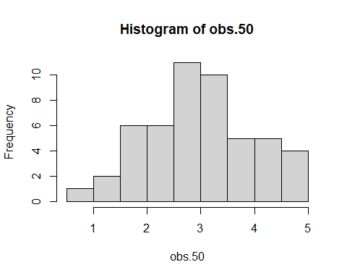

set.seed(13)  
if.50 <- runif(50, min=10, max=40)  
hist(if.50)

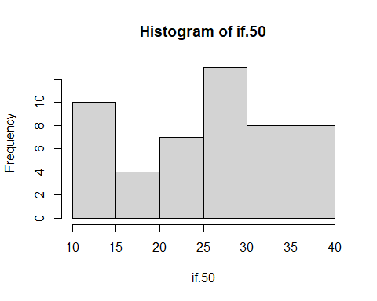

if.100 <- runif(100, min=10, max=40)  
hist(if.100)

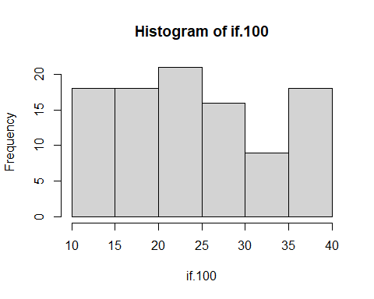

if.500 <- runif(500, min=10, max=40)  
hist(if.500)

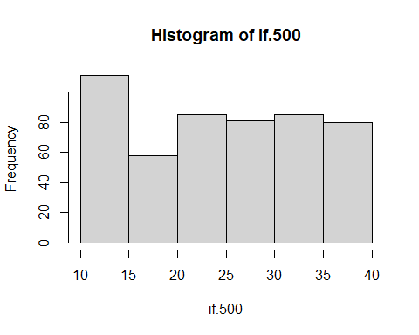

if.1000 <- runif(1000, min=10, max=40)  
hist(if.1000)

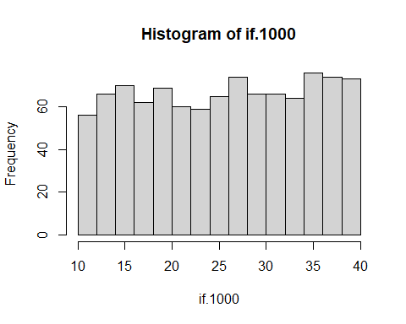

stem(if.50)

##   
## The decimal point is 1 digit(s) to the right of the |  
##   
## 1 | 0112333344  
## 1 | 77  
## 2 | 001122344  
## 2 | 666778888999  
## 3 | 000012334  
## 3 | 66678899

hist(if.50)



# Restricciones -----------------------------------------------------------  
  
#Trabajar con datos del objeto if. 50  
  
mean(if.50)

## [1] 25.3432

fivenum(if.50)

## [1] 10.32800 19.87381 27.10863 31.30967 39.00500

boxplot(if.50)

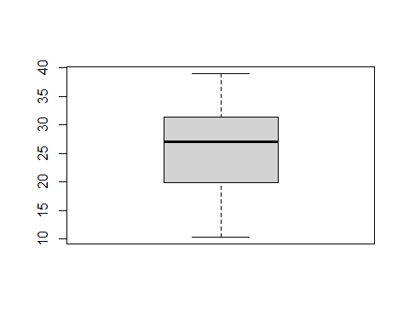

#igual a ==  
#diferente a !=  
#igual o mayor >=  
#igual o menor <=  
#mayor que >  
#menor que <  
  
if.50 <= median(if.50)

## [1] FALSE TRUE TRUE TRUE FALSE TRUE FALSE FALSE FALSE TRUE FALSE FALSE  
## [13] FALSE TRUE FALSE TRUE TRUE FALSE FALSE FALSE TRUE TRUE FALSE TRUE  
## [25] TRUE FALSE TRUE TRUE TRUE FALSE TRUE TRUE FALSE FALSE TRUE TRUE  
## [37] TRUE TRUE FALSE TRUE FALSE TRUE FALSE FALSE FALSE FALSE TRUE TRUE  
## [49] FALSE FALSE

#subset es igual a un subconjunto de datos  
  
dbh.50 <- subset(if.50, if.50<= median(if.50))  
  
dbh.up50 <- subset(if.50, if.50 >= median(if.50))  
  
dbh.up30 <- subset(if.50, if.50> 30)  
dbh.up30

## [1] 31.30967 38.86194 32.93194 36.20147 36.35113 36.71677 35.96354 30.41571  
## [9] 30.33739 37.56123 34.26281 32.76192 39.00500 37.56994 31.97295 30.41875

mean(dbh.up30)

## [1] 34.54013

sd(dbh.up30)

## [1] 3.100909

# Importar datos ----------------------------------------------------------  
  
#funcion read.csv  
  
  
fert <- read.csv("vivero.csv", header= TRUE)  
  
#ingresarlos como factor  
  
#direccion de los ejes de la graficas =las  
  
fert$Tratamiento <- as.factor(fert$Tratamiento)  
  
  
boxplot(fert$IE ~ fert$Tratamiento,  
 xlab= "Tratamientos",  
 ylab= "Indice de Esbeltez",  
 col= "red",  
 main= "vivero bosque escuela",  
 las= 1,  
 ylim= c(0.4, 1.4))

