数据库设计

如下是iOrder服务器端数据库设计E-R图。

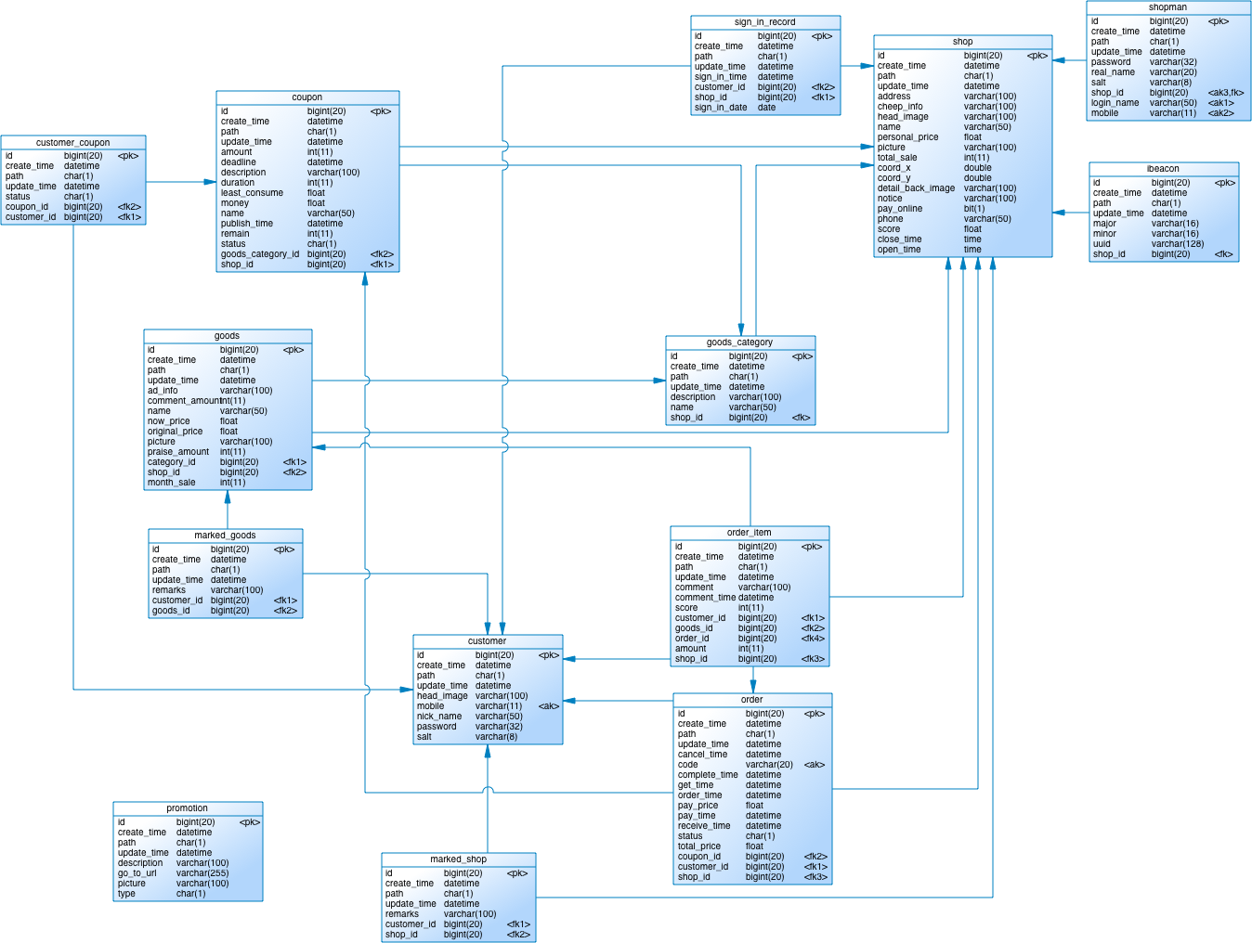

图‑1数据库E-R图

## 优惠券信息coupon表

优惠券信息表设计

|  |  |  |  |  |
| --- | --- | --- | --- | --- |
| **名称** | **数据类型** | **长度** | **身份** | **外来键** |
| id | bigint(20) | 20 | TRUE | FALSE |
| create_time | datetime |  | FALSE | FALSE |
| path | char(1) | 1 | FALSE | FALSE |
| update_time | datetime |  | FALSE | FALSE |
| amount | int(11) | 11 | FALSE | FALSE |
| deadline | datetime |  | FALSE | FALSE |
| description | varchar(100) | 100 | FALSE | FALSE |
| duration | int(11) | 11 | FALSE | FALSE |
| least_consume | float |  | FALSE | FALSE |
| money | float |  | FALSE | FALSE |
| name | varchar(50) | 50 | FALSE | FALSE |
| publish_time | datetime |  | FALSE | FALSE |
| remain | int(11) | 11 | FALSE | FALSE |
| status | char(1) | 1 | FALSE | FALSE |
| goods_category_id | bigint(20) | 20 | FALSE | TRUE |
| shop_id | bigint(20) | 20 | FALSE | TRUE |

表格‑1 coupon表

## 顾客信息customer表

顾客信息表设计

|  |  |  |  |  |
| --- | --- | --- | --- | --- |
| **名称** | **数据类型** | **长度** | **身份** | **外来键** |
| id | bigint(20) | 20 | TRUE | FALSE |
| create_time | datetime |  | FALSE | FALSE |
| path | char(1) | 1 | FALSE | FALSE |
| update_time | datetime |  | FALSE | FALSE |
| head_image | varchar(100) | 100 | FALSE | FALSE |
| mobile | varchar(11) | 11 | FALSE | FALSE |
| nick_name | varchar(50) | 50 | FALSE | FALSE |
| password | varchar(32) | 32 | FALSE | FALSE |
| salt | varchar(8) | 8 | FALSE | FALSE |

表格‑2 customer表

## 优惠券关联customer_coupon表

优惠券与顾客关联信息表设计

|  |  |  |  |  |
| --- | --- | --- | --- | --- |
| **名称** | **数据类型** | **长度** | **身份** | **外来键** |
| id | bigint(20) | 20 | TRUE | FALSE |
| create_time | datetime |  | FALSE | FALSE |
| path | char(1) | 1 | FALSE | FALSE |
| update_time | datetime |  | FALSE | FALSE |
| status | char(1) | 1 | FALSE | FALSE |
| coupon_id | bigint(20) | 20 | FALSE | TRUE |
| customer_id | bigint(20) | 20 | FALSE | TRUE |

表格‑3 customer_coupon表

## 菜品信息goods表

菜品信息表设计

|  |  |  |  |  |
| --- | --- | --- | --- | --- |
| **名称** | **数据类型** | **长度** | **身份** | **外来键** |
| id | bigint(20) | 20 | TRUE | FALSE |
| create_time | datetime |  | FALSE | FALSE |
| path | char(1) | 1 | FALSE | FALSE |
| update_time | datetime |  | FALSE | FALSE |
| ad_info | varchar(100) | 100 | FALSE | FALSE |
| comment_amount | int(11) | 11 | FALSE | FALSE |
| name | varchar(50) | 50 | FALSE | FALSE |
| now_price | float |  | FALSE | FALSE |
| original_price | float |  | FALSE | FALSE |
| picture | varchar(100) | 100 | FALSE | FALSE |
| praise_amount | int(11) | 11 | FALSE | FALSE |
| category_id | bigint(20) | 20 | FALSE | TRUE |
| shop_id | bigint(20) | 20 | FALSE | TRUE |
| month_sale | int(11) | 11 | FALSE | FALSE |

表格‑4 goods表

## 菜品分类goods_category表

菜品分类信息表设计

|  |  |  |  |  |
| --- | --- | --- | --- | --- |
| **名称** | **数据类型** | **长度** | **身份** | **外来键** |
| id | bigint(20) | 20 | TRUE | FALSE |
| create_time | datetime |  | FALSE | FALSE |
| path | char(1) | 1 | FALSE | FALSE |
| update_time | datetime |  | FALSE | FALSE |
| description | varchar(100) | 100 | FALSE | FALSE |
| name | varchar(50) | 50 | FALSE | FALSE |
| shop_id | bigint(20) | 20 | FALSE | TRUE |

表格‑5 goods_category表

## iBeacon信息ibeacon表

iBeacon信息表设计

|  |  |  |  |  |
| --- | --- | --- | --- | --- |
| **名称** | **数据类型** | **长度** | **身份** | **外来键** |
| id | bigint(20) | 20 | TRUE | FALSE |
| create_time | datetime |  | FALSE | FALSE |
| path | char(1) | 1 | FALSE | FALSE |
| update_time | datetime |  | FALSE | FALSE |
| major | varchar(16) | 16 | FALSE | FALSE |
| minor | varchar(16) | 16 | FALSE | FALSE |
| uuid | varchar(128) | 128 | FALSE | FALSE |
| shop_id | bigint(20) | 20 | FALSE | TRUE |

表格‑6 ibeacon表

## 收藏菜品信息marked_goods表

顾客收藏的菜品信息表设计

|  |  |  |  |  |
| --- | --- | --- | --- | --- |
| **名称** | **数据类型** | **长度** | **身份** | **外来键** |
| id | bigint(20) | 20 | TRUE | FALSE |
| create_time | datetime |  | FALSE | FALSE |
| path | char(1) | 1 | FALSE | FALSE |
| update_time | datetime |  | FALSE | FALSE |
| remarks | varchar(100) | 100 | FALSE | FALSE |
| customer_id | bigint(20) | 20 | FALSE | TRUE |
| goods_id | bigint(20) | 20 | FALSE | TRUE |

表格‑7 marked_goods表

## 收藏店铺信息marked_shop表

顾客收藏的店铺信息表设计

|  |  |  |  |  |
| --- | --- | --- | --- | --- |
| **名称** | **数据类型** | **长度** | **身份** | **外来键** |
| id | bigint(20) | 20 | TRUE | FALSE |
| create_time | datetime |  | FALSE | FALSE |
| path | char(1) | 1 | FALSE | FALSE |
| update_time | datetime |  | FALSE | FALSE |
| remarks | varchar(100) | 100 | FALSE | FALSE |
| customer_id | bigint(20) | 20 | FALSE | TRUE |
| shop_id | bigint(20) | 20 | FALSE | TRUE |

表格‑8 marked_shop表

## 订单信息order表

订单信息表设计

|  |  |  |  |  |
| --- | --- | --- | --- | --- |
| **名称** | **数据类型** | **长度** | **身份** | **外来键** |
| id | bigint(20) | 20 | TRUE | FALSE |
| create_time | datetime |  | FALSE | FALSE |
| path | char(1) | 1 | FALSE | FALSE |
| update_time | datetime |  | FALSE | FALSE |
| cancel_time | datetime |  | FALSE | FALSE |
| code | varchar(20) | 20 | FALSE | FALSE |
| complete_time | datetime |  | FALSE | FALSE |
| get_time | datetime |  | FALSE | FALSE |
| order_time | datetime |  | FALSE | FALSE |
| pay_price | float |  | FALSE | FALSE |
| pay_time | datetime |  | FALSE | FALSE |
| receive_time | datetime |  | FALSE | FALSE |
| status | char(1) | 1 | FALSE | FALSE |
| total_price | float |  | FALSE | FALSE |
| coupon_id | bigint(20) | 20 | FALSE | TRUE |
| customer_id | bigint(20) | 20 | FALSE | TRUE |
| shop_id | bigint(20) | 20 | FALSE | TRUE |

表格‑9 order表

## 订单项信息order_item表

订单项信息表设计

|  |  |  |  |  |
| --- | --- | --- | --- | --- |
| **名称** | **数据类型** | **长度** | **身份** | **外来键** |
| id | bigint(20) | 20 | TRUE | FALSE |
| create_time | datetime |  | FALSE | FALSE |
| path | char(1) | 1 | FALSE | FALSE |
| update_time | datetime |  | FALSE | FALSE |
| comment | varchar(100) | 100 | FALSE | FALSE |
| comment_time | datetime |  | FALSE | FALSE |
| score | int(11) | 11 | FALSE | FALSE |
| customer_id | bigint(20) | 20 | FALSE | TRUE |
| goods_id | bigint(20) | 20 | FALSE | TRUE |
| order_id | bigint(20) | 20 | FALSE | TRUE |
| amount | int(11) | 11 | FALSE | FALSE |
| shop_id | bigint(20) | 20 | FALSE | TRUE |

表格‑10 order_item表

## 推广信息promotion表

首页推广信息表设计

|  |  |  |  |  |
| --- | --- | --- | --- | --- |
| **名称** | **数据类型** | **长度** | **身份** | **外来键** |
| id | bigint(20) | 20 | TRUE | FALSE |
| create_time | datetime |  | FALSE | FALSE |
| path | char(1) | 1 | FALSE | FALSE |
| update_time | datetime |  | FALSE | FALSE |
| description | varchar(100) | 100 | FALSE | FALSE |
| go_to_url | varchar(255) | 255 | FALSE | FALSE |
| picture | varchar(100) | 100 | FALSE | FALSE |
| type | char(1) | 1 | FALSE | FALSE |

表格‑11 promotion表

## 店铺信息shop表

店铺信息表设计

|  |  |  |  |  |
| --- | --- | --- | --- | --- |
| **名称** | **数据类型** | **长度** | **身份** | **外来键** |
| id | bigint(20) | 20 | TRUE | FALSE |
| create_time | datetime |  | FALSE | FALSE |
| path | char(1) | 1 | FALSE | FALSE |
| update_time | datetime |  | FALSE | FALSE |
| address | varchar(100) | 100 | FALSE | FALSE |
| cheep_info | varchar(100) | 100 | FALSE | FALSE |
| head_image | varchar(100) | 100 | FALSE | FALSE |
| name | varchar(50) | 50 | FALSE | FALSE |
| personal_price | float |  | FALSE | FALSE |
| picture | varchar(100) | 100 | FALSE | FALSE |
| total_sale | int(11) | 11 | FALSE | FALSE |
| coord_x | double |  | FALSE | FALSE |
| coord_y | double |  | FALSE | FALSE |
| detail_back_image | varchar(100) | 100 | FALSE | FALSE |
| notice | varchar(100) | 100 | FALSE | FALSE |
| pay_online | bit(1) | 1 | FALSE | FALSE |
| phone | varchar(50) | 50 | FALSE | FALSE |
| score | float |  | FALSE | FALSE |
| close_time | time |  | FALSE | FALSE |
| open_time | time |  | FALSE | FALSE |

表格‑12 shop表

## 店主账号信息shopman表

店主账号信息表设计

|  |  |  |  |  |
| --- | --- | --- | --- | --- |
| **名称** | **数据类型** | **长度** | **身份** | **外来键** |
| id | bigint(20) | 20 | TRUE | FALSE |
| create_time | datetime |  | FALSE | FALSE |
| path | char(1) | 1 | FALSE | FALSE |
| update_time | datetime |  | FALSE | FALSE |
| password | varchar(32) | 32 | FALSE | FALSE |
| real_name | varchar(20) | 20 | FALSE | FALSE |
| salt | varchar(8) | 8 | FALSE | FALSE |
| shop_id | bigint(20) | 20 | FALSE | TRUE |
| login_name | varchar(50) | 50 | FALSE | FALSE |
| mobile | varchar(11) | 11 | FALSE | FALSE |

表格‑13 shopman表

## 签到信息sign_in_record表

顾客签到记录信息表设计

|  |  |  |  |  |
| --- | --- | --- | --- | --- |
| **名称** | **数据类型** | **长度** | **身份** | **外来键** |
| id | bigint(20) | 20 | TRUE | FALSE |
| create_time | datetime |  | FALSE | FALSE |
| path | char(1) | 1 | FALSE | FALSE |
| update_time | datetime |  | FALSE | FALSE |
| sign_in_time | datetime |  | FALSE | FALSE |
| customer_id | bigint(20) | 20 | FALSE | TRUE |
| shop_id | bigint(20) | 20 | FALSE | TRUE |
| sign_in_date | date |  | FALSE | FALSE |

表格‑14 sign_in_resord表