*Edward Handy-Clinical Program Development*

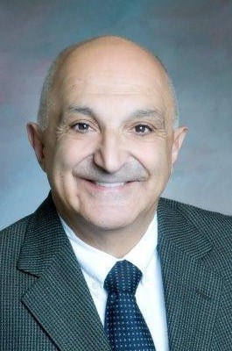Edward Handy’s background includes over thirty years of Healthcare clinical, operational and program development experience. He spent twenty-nine years with the University of Vermont’s College of Medicine Department of Psychiatry (Assistant Professor of Clinical Psychiatry, with specialty in Community Psychiatry). He possesses clinical and operational expertise in designing and developing integrated behavioral health programs, inclusive of in-patient/outpatient program design, Partial Hospital Programs, Intensive Outpatient programs, Outpatient clinics, Faculty Practice development, and Comprehensive Evidence Based Clinical Continuums of Care, as well as clinical architectural design of Psychiatric/NeuroBehavioral units with coordinated outpatient components.

He was the principle Clinical Program design person for the building and opening of the Park Royal Hospital in Fort Myers, FL—a free-standing Psychiatric hospital which opened with 76 beds and has expanded to 104 beds. He was the clinical point on Curriculum designs (inpatient and outpatient units), Medical Attending Staff development (Psychiatrists and Hospitalist: recruitment/contracting and By-law composition), and regulatory compliance (state, federal and hospital accreditation).

His vast Community Psychiatry skill sets have been utilized by national healthcare organizations, colleges/universities, state departments of Mental Health, profit/non-profit hospital/medical systems, community mental health agencies, Nursing Homes and Assisted Living facilities alike. Currently, Edward works in Clinical Program Development with Christian Companies, LLC.

Edward’s military service history consists of an Honorable discharge (Captain) United States Air Force. MOS: Management Analysts Officer (Behavioral Services focus: clinical program design on Post Traumatic Stress Disorder and Anger Management).