MLOps Assignment I: Heart Disease Risk Prediction
End-to-End ML Development, CI/CD, Containerization, Deployment, and Monitoring
Course | MLOps (S2-25_AMLCSZG523)
Dataset | Heart Disease UCI - Cleveland processed dataset
Problem | Binary classification for heart disease risk prediction
Repository | https://github.com/tosenthu/bits-mlops
Date | 2026-05-23

This report documents a reproducible machine learning system with automated data preparation, experiment tracking, model packaging, API serving, CI/CD, containerization, Kubernetes deployment artifacts, and monitoring hooks.

1. Executive Summary
The project implements a complete MLOps workflow for predicting heart disease risk from the UCI Cleveland dataset. The solution includes dataset acquisition, EDA, preprocessing, model training, experiment tracking, model persistence, API serving, Docker packaging, Kubernetes deployment manifests, CI/CD, logging, and metrics.
- Problem type: supervised binary classification.
- Primary models: Logistic Regression and Random Forest.
- Serving pattern: FastAPI application with /predict, /health, and /metrics endpoints.
- Deployment pattern: Docker container deployed through Kubernetes manifests.

2. Dataset and Data Acquisition
The dataset is the processed Cleveland Heart Disease dataset from the UCI Machine Learning Repository. The repository includes scripts/download_data.py, which downloads the source CSV, applies column names, converts '?' values to missing values, converts columns to numeric types, and binarizes the target.
Field group | Columns | Treatment
Demographic | age, sex | Age is scaled; sex is one-hot encoded.
Clinical | trestbps, chol, fbs, thalach | Numeric values are imputed and scaled.
ECG and symptoms | cp, restecg, exang, oldpeak, slope | Mixed numeric and categorical preprocessing.
Diagnostic | ca, thal | Missing values are imputed inside the pipeline.
Target | target | Converted to 0 for absence and 1 for presence of disease.

3. Exploratory Data Analysis
EDA focuses on target balance, feature distributions, and numeric correlations. The figures are generated by scripts/run_eda.py and saved under reports/figures.
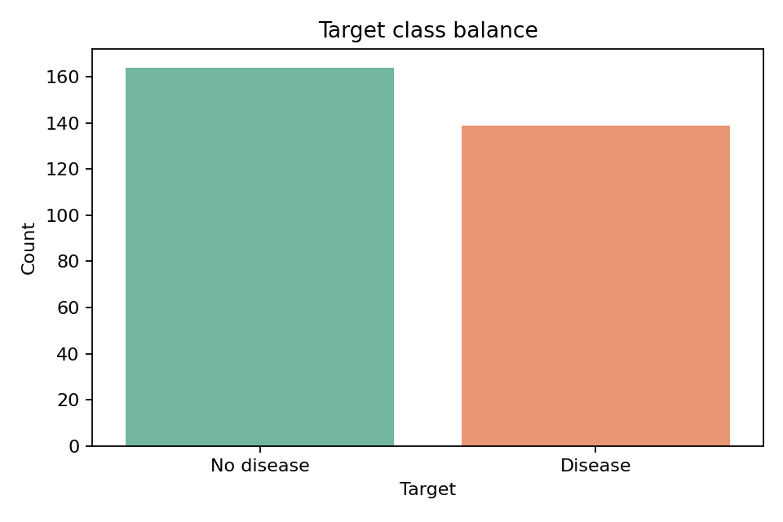
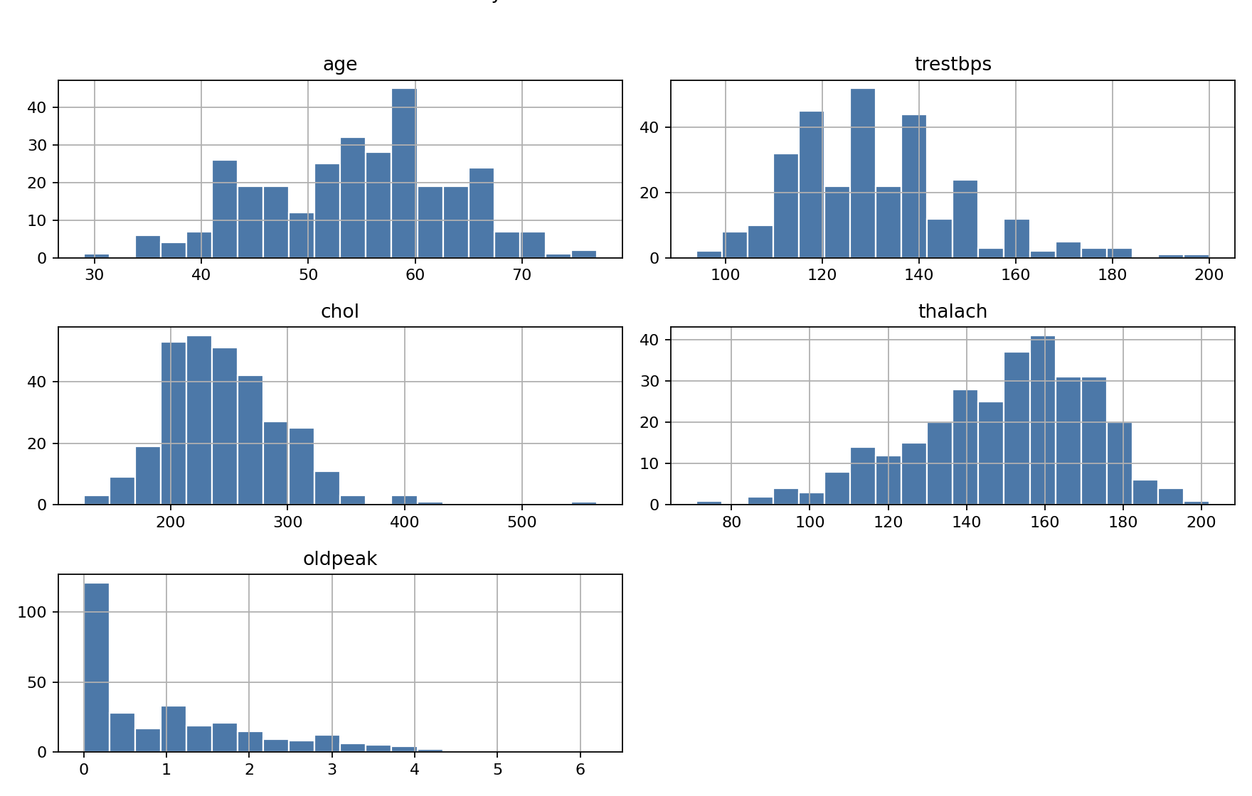
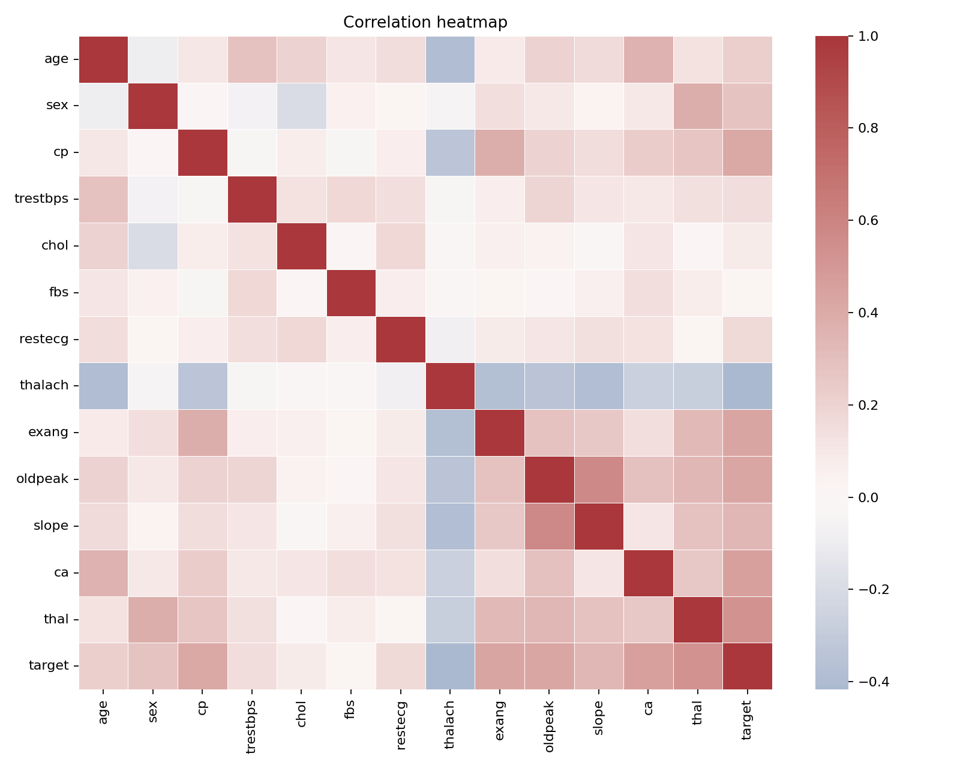

4. Feature Engineering and Model Development
The repository uses a scikit-learn Pipeline and ColumnTransformer so the exact same preprocessing steps are used in training and inference. Numeric fields are imputed with the median and standardized. Categorical fields are imputed with the most frequent value and one-hot encoded.
Model | Tuning parameters | Selection reason
Logistic Regression | C over 0.1, 1.0, 10.0 | Interpretable linear baseline with class weighting.
Random Forest | n_estimators, max_depth, min_samples_leaf | Nonlinear ensemble baseline with robust tabular performance.
Model | Accuracy | Precision | Recall | ROC-AUC
logistic_regression | 0.869 | 0.812 | 0.929 | 0.966
random_forest | 0.869 | 0.812 | 0.929 | 0.943
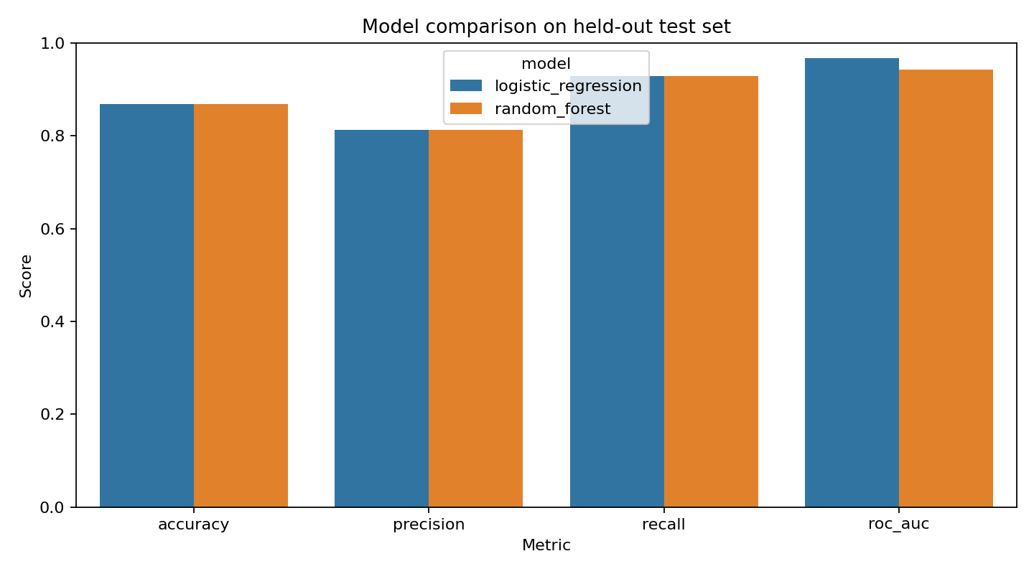
Selected model: logistic_regression

5. Experiment Tracking
MLflow is integrated in the training entry point. Each candidate model run logs model name, hyperparameters, cross-validation ROC-AUC, held-out test metrics, the sklearn model artifact, metrics JSON, model metadata, and model comparison plot.
- Run `python -m heart_disease_mlops.train --fast` for a smoke training run.
- Run `mlflow ui --backend-store-uri mlruns` to inspect local experiments.
- Capture screenshots of run metrics and artifacts into reports/screenshots.

6. Packaging and Reproducibility
The final model is saved as a joblib artifact containing the full preprocessing and classification pipeline. requirements.txt and pyproject.toml define the runtime and test environment. The sample_input/patient_high_risk.json file can be used for a repeatable API check.
- models/heart_disease_model.joblib: trained pipeline.
- models/model_metadata.json: feature order, selected model, parameters, and metrics.
- data/processed/heart_disease_clean.csv: cleaned dataset generated from source.

7. CI/CD and Automated Testing
The GitHub Actions workflow in .github/workflows/ci.yml installs dependencies, runs Ruff linting, executes pytest, performs a fast model training smoke test, and uploads model, metrics, and report artifacts.
Stage | Purpose | Failure behavior
Lint | Runs ruff against source, scripts, and tests. | Fails on style or code-quality issues.
Unit tests | Validates data cleaning, feature preprocessing, and API behavior. | Fails on regression or schema mismatch.
Training smoke | Runs a reduced hyperparameter grid. | Fails if data, MLflow, or model persistence breaks.
Artifacts | Uploads models, metrics, figures, and report outputs. | Provides audit trail for each workflow run.

8. API, Containerization, and Local Serving
The serving layer is implemented with FastAPI. Dockerfile builds a lightweight image, trains or uses the packaged model, exposes port 8000, and serves the API through uvicorn.
- Build: `docker build -t bits-mlops-heart .`
- Run: `docker run --rm -p 8000:8000 bits-mlops-heart`
- Predict: `curl -X POST http://localhost:8000/predict -H 'Content-Type: application/json' -d @sample_input/patient_high_risk.json`

9. Production Deployment and Monitoring
The deployment/k8s folder contains Kubernetes Deployment, Service, and optional Ingress manifests. The API exposes /metrics using prometheus-client. Request counts and latency histograms can be scraped by Prometheus and visualized in Grafana.
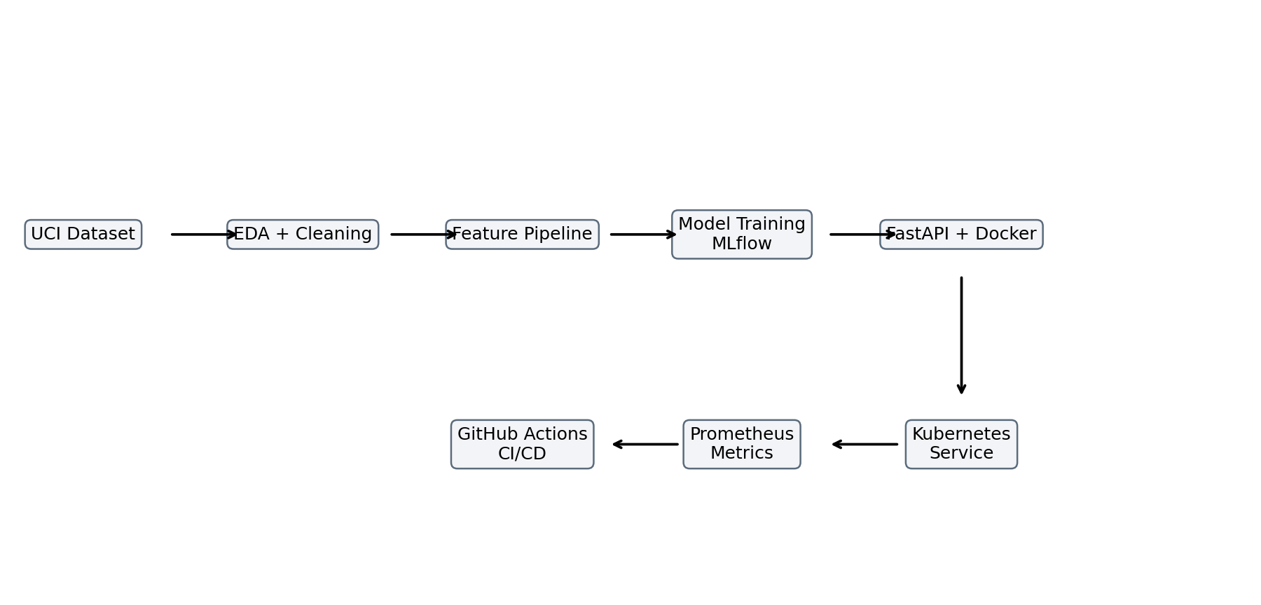
- Build and tag the Docker image.
- Load the image into Minikube or push it to a registry.
- Apply deployment/k8s/*.yaml.
- Use kubectl port-forward or the configured service URL to verify /health and /predict.
- Add Prometheus scrape configuration for /metrics.

10. Submission Evidence Checklist
Evidence item | Repository location | Status
Code repository | https://github.com/tosenthu/bits-mlops | Included
Dataset scripts | scripts/download_data.py | Included
EDA figures | reports/figures | Generated by script
Unit tests | tests/ | Included
CI/CD workflow | .github/workflows/ci.yml | Included
Dockerfile | Dockerfile | Included
Kubernetes manifests | deployment/k8s | Included
Screenshots | reports/screenshots | Add after running workflow/deployment
Demo video | External short recording | Record final run-through

Appendix A. Commands
python -m pip install -r requirements.txt
python scripts/download_data.py
python scripts/run_eda.py
python -m heart_disease_mlops.train --fast
pytest -q
uvicorn heart_disease_mlops.api:app --host 0.0.0.0 --port 8000
docker build -t bits-mlops-heart .
kubectl apply -f deployment/k8s/

