Scholarship Platform
Entity–Relationship Diagram & UML Documentation
Reverse-engineered from the PHP / MySQL backend (scholarship_2 project)
Contents
1. Entity–Relationship Diagram (ERD)
2. UML Class Diagram
3. Sequence Diagram — Sign Up & Login
4. Sequence Diagram — Browse & Apply to a Scholarship
5. Sequence Diagram — Post & Approve a Scholarship
6. Use Case Diagram
7. Notes & Assumptions

1. Entity–Relationship Diagram (ERD)
Derived from every INSERT, SELECT...JOIN, and ON DUPLICATE KEY clause across /backend/*.php. No .sql schema file was included in the project, so column types are inferred from bind_param type strings (i = int, s = string, d = double).
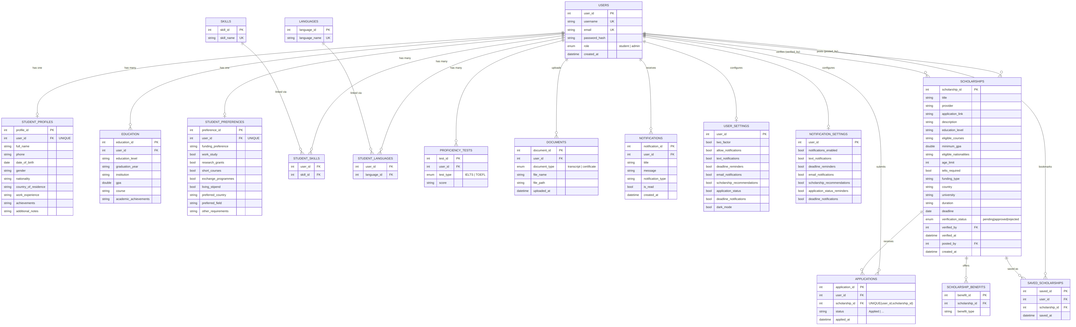
Figure 1 — Entity–Relationship Diagram (18 tables)

2. UML Class Diagram
A conceptual domain model implied by the procedural PHP endpoints. The codebase itself has no classes (plain mysqli procedural PHP) — this groups the data and operations into the classes an OOP refactor would naturally produce.
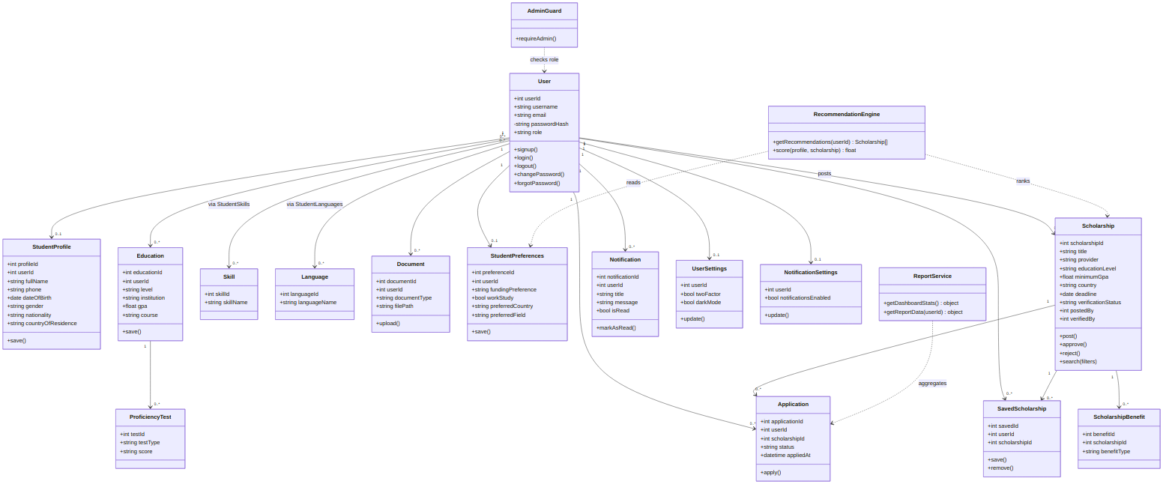
Figure 2 — UML Class Diagram

3. Sequence Diagram — Sign Up & Login
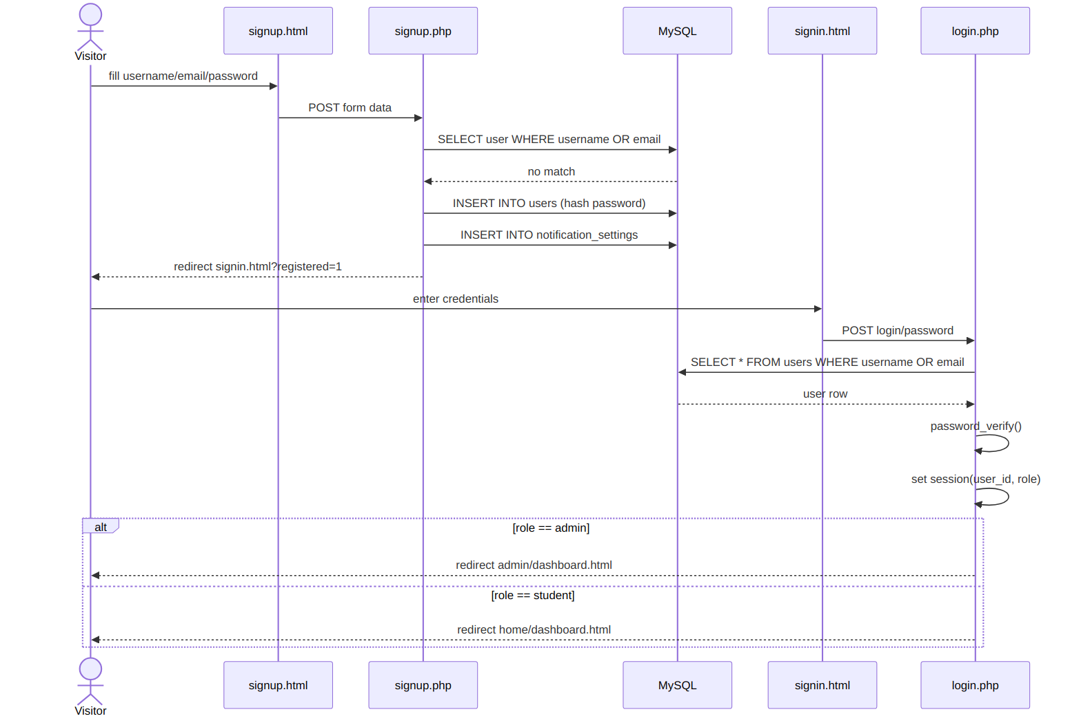
Figure 3 — Sign Up & Login sequence

4. Sequence Diagram — Browse & Apply to a Scholarship
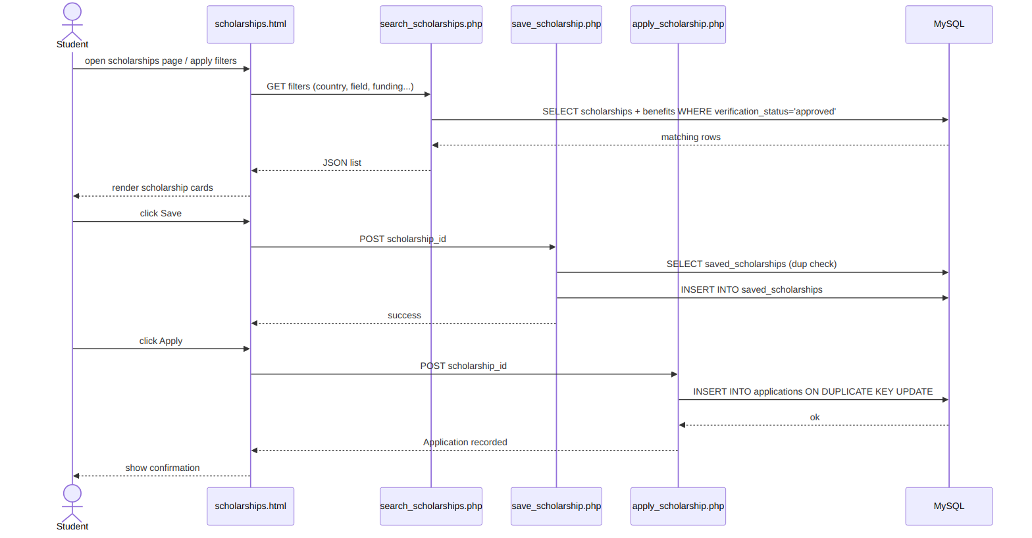
Figure 4 — Browse & Apply sequence

5. Sequence Diagram — Post & Approve a Scholarship
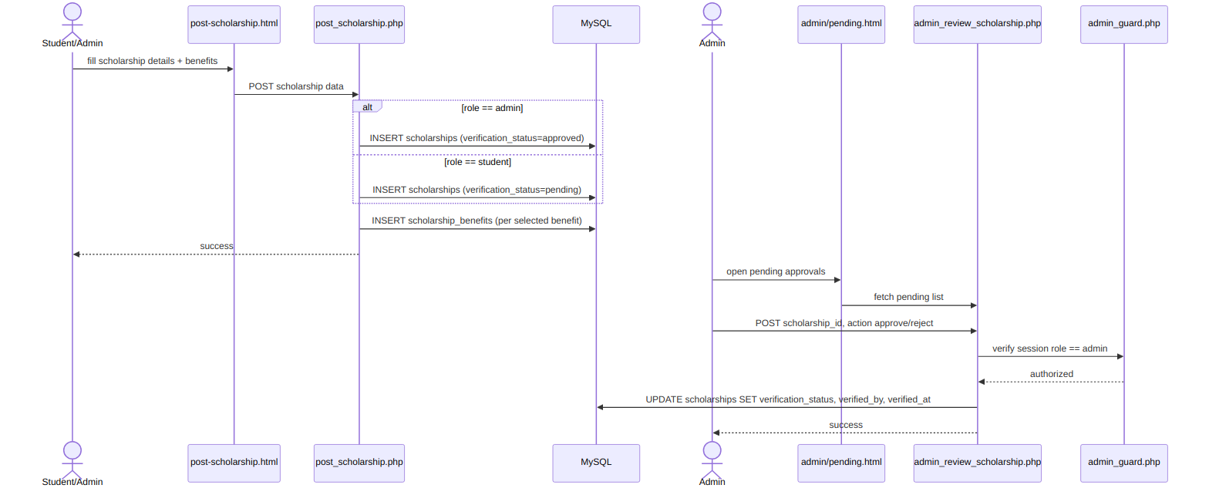
Figure 5 — Post & Approve sequence

6. Use Case Diagram
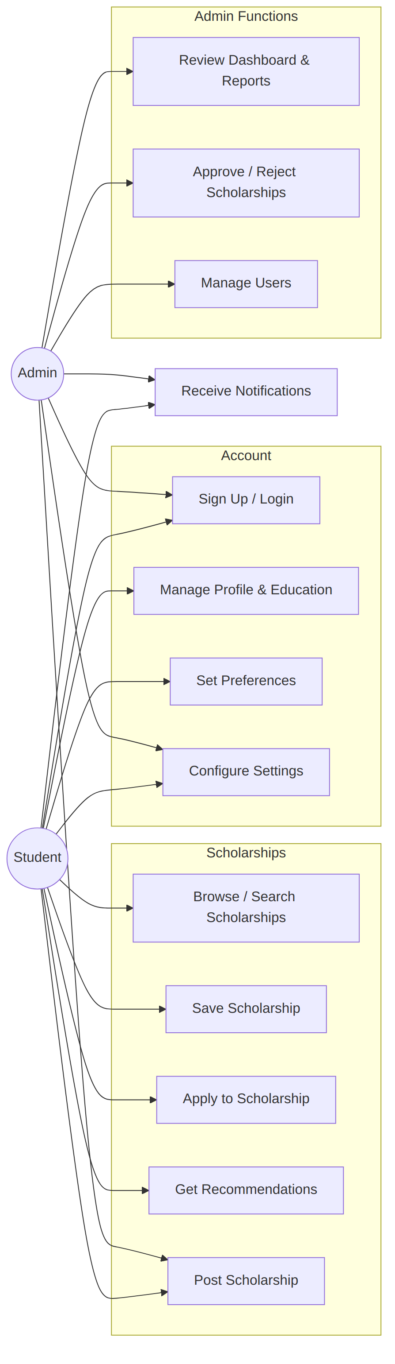
Figure 6 — Use Case Diagram (Student vs Admin)

7. Notes & Assumptions
Item | Detail
Source | No .sql schema file was in the archive - schema reconstructed purely from mysqli prepared statements in /backend/*.php (INSERT/UPDATE/SELECT column lists and bind_param type strings).
1:1 relations | student_profiles, student_preferences, user_settings, notification_settings all use user_id as a unique key with ON DUPLICATE KEY UPDATE, implying one row per user.
M:N relations | student_skills and student_languages are pure junction tables (INSERT IGNORE) linking users to shared lookup tables skills / languages.
Redundancy | user_settings and notification_settings overlap heavily (both store notification toggles) - likely leftover from iterative development (save_settings.php vs update_settings.php).
Self-referencing FK | scholarships.posted_by and scholarships.verified_by both reference users.user_id.
Architecture | Plain procedural PHP + mysqli, session-based auth, no framework/ORM/classes - the class diagram is a conceptual OOP view, not literal code structure.

