Scholarship Platform
System Analysis & Design — Context, DFD, ERD & UML Documentation
Reverse-engineered from the PHP / MySQL backend (scholarship_2 project)
Contents
4.0 Context Diagram
4.1 Data Flow Diagram (DFD) — Level 1 Overview
4.1.1 Detailed DFD — Student-Facing Processes
4.1.2 Detailed DFD — Admin-Facing Processes
4.2 Entity–Relationship Diagram (ERD)
4.3 UML Class Diagram
4.4 Sequence Diagram — Sign Up & Login
4.5 Sequence Diagram — Browse & Apply to a Scholarship
4.6 Sequence Diagram — Post & Approve a Scholarship
4.7 Use Case Diagram
4.8 Notes & Assumptions

4.0 Context Diagram
Level-0 DFD: the entire platform is shown as a single process, with the two external entities that interact with it — the Student/Applicant and the Administrator — and the data that flows between them. No external payment or third-party system is called anywhere in the backend, so only these two human actors appear.
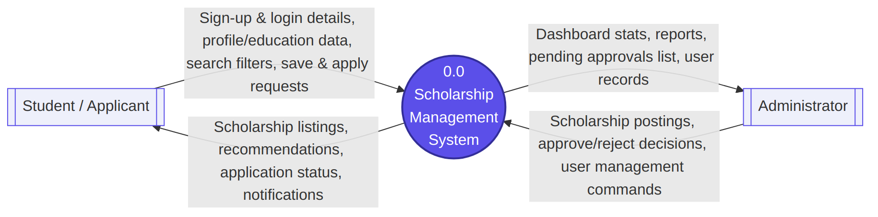
Figure 1 — Context Diagram (Level 0 DFD)

4.1 Data Flow Diagram (DFD) — Level 1 Overview
The single process from the context diagram is decomposed into its seven major functional processes, each reading from and writing to the data stores derived from the database schema (Section 4.2).
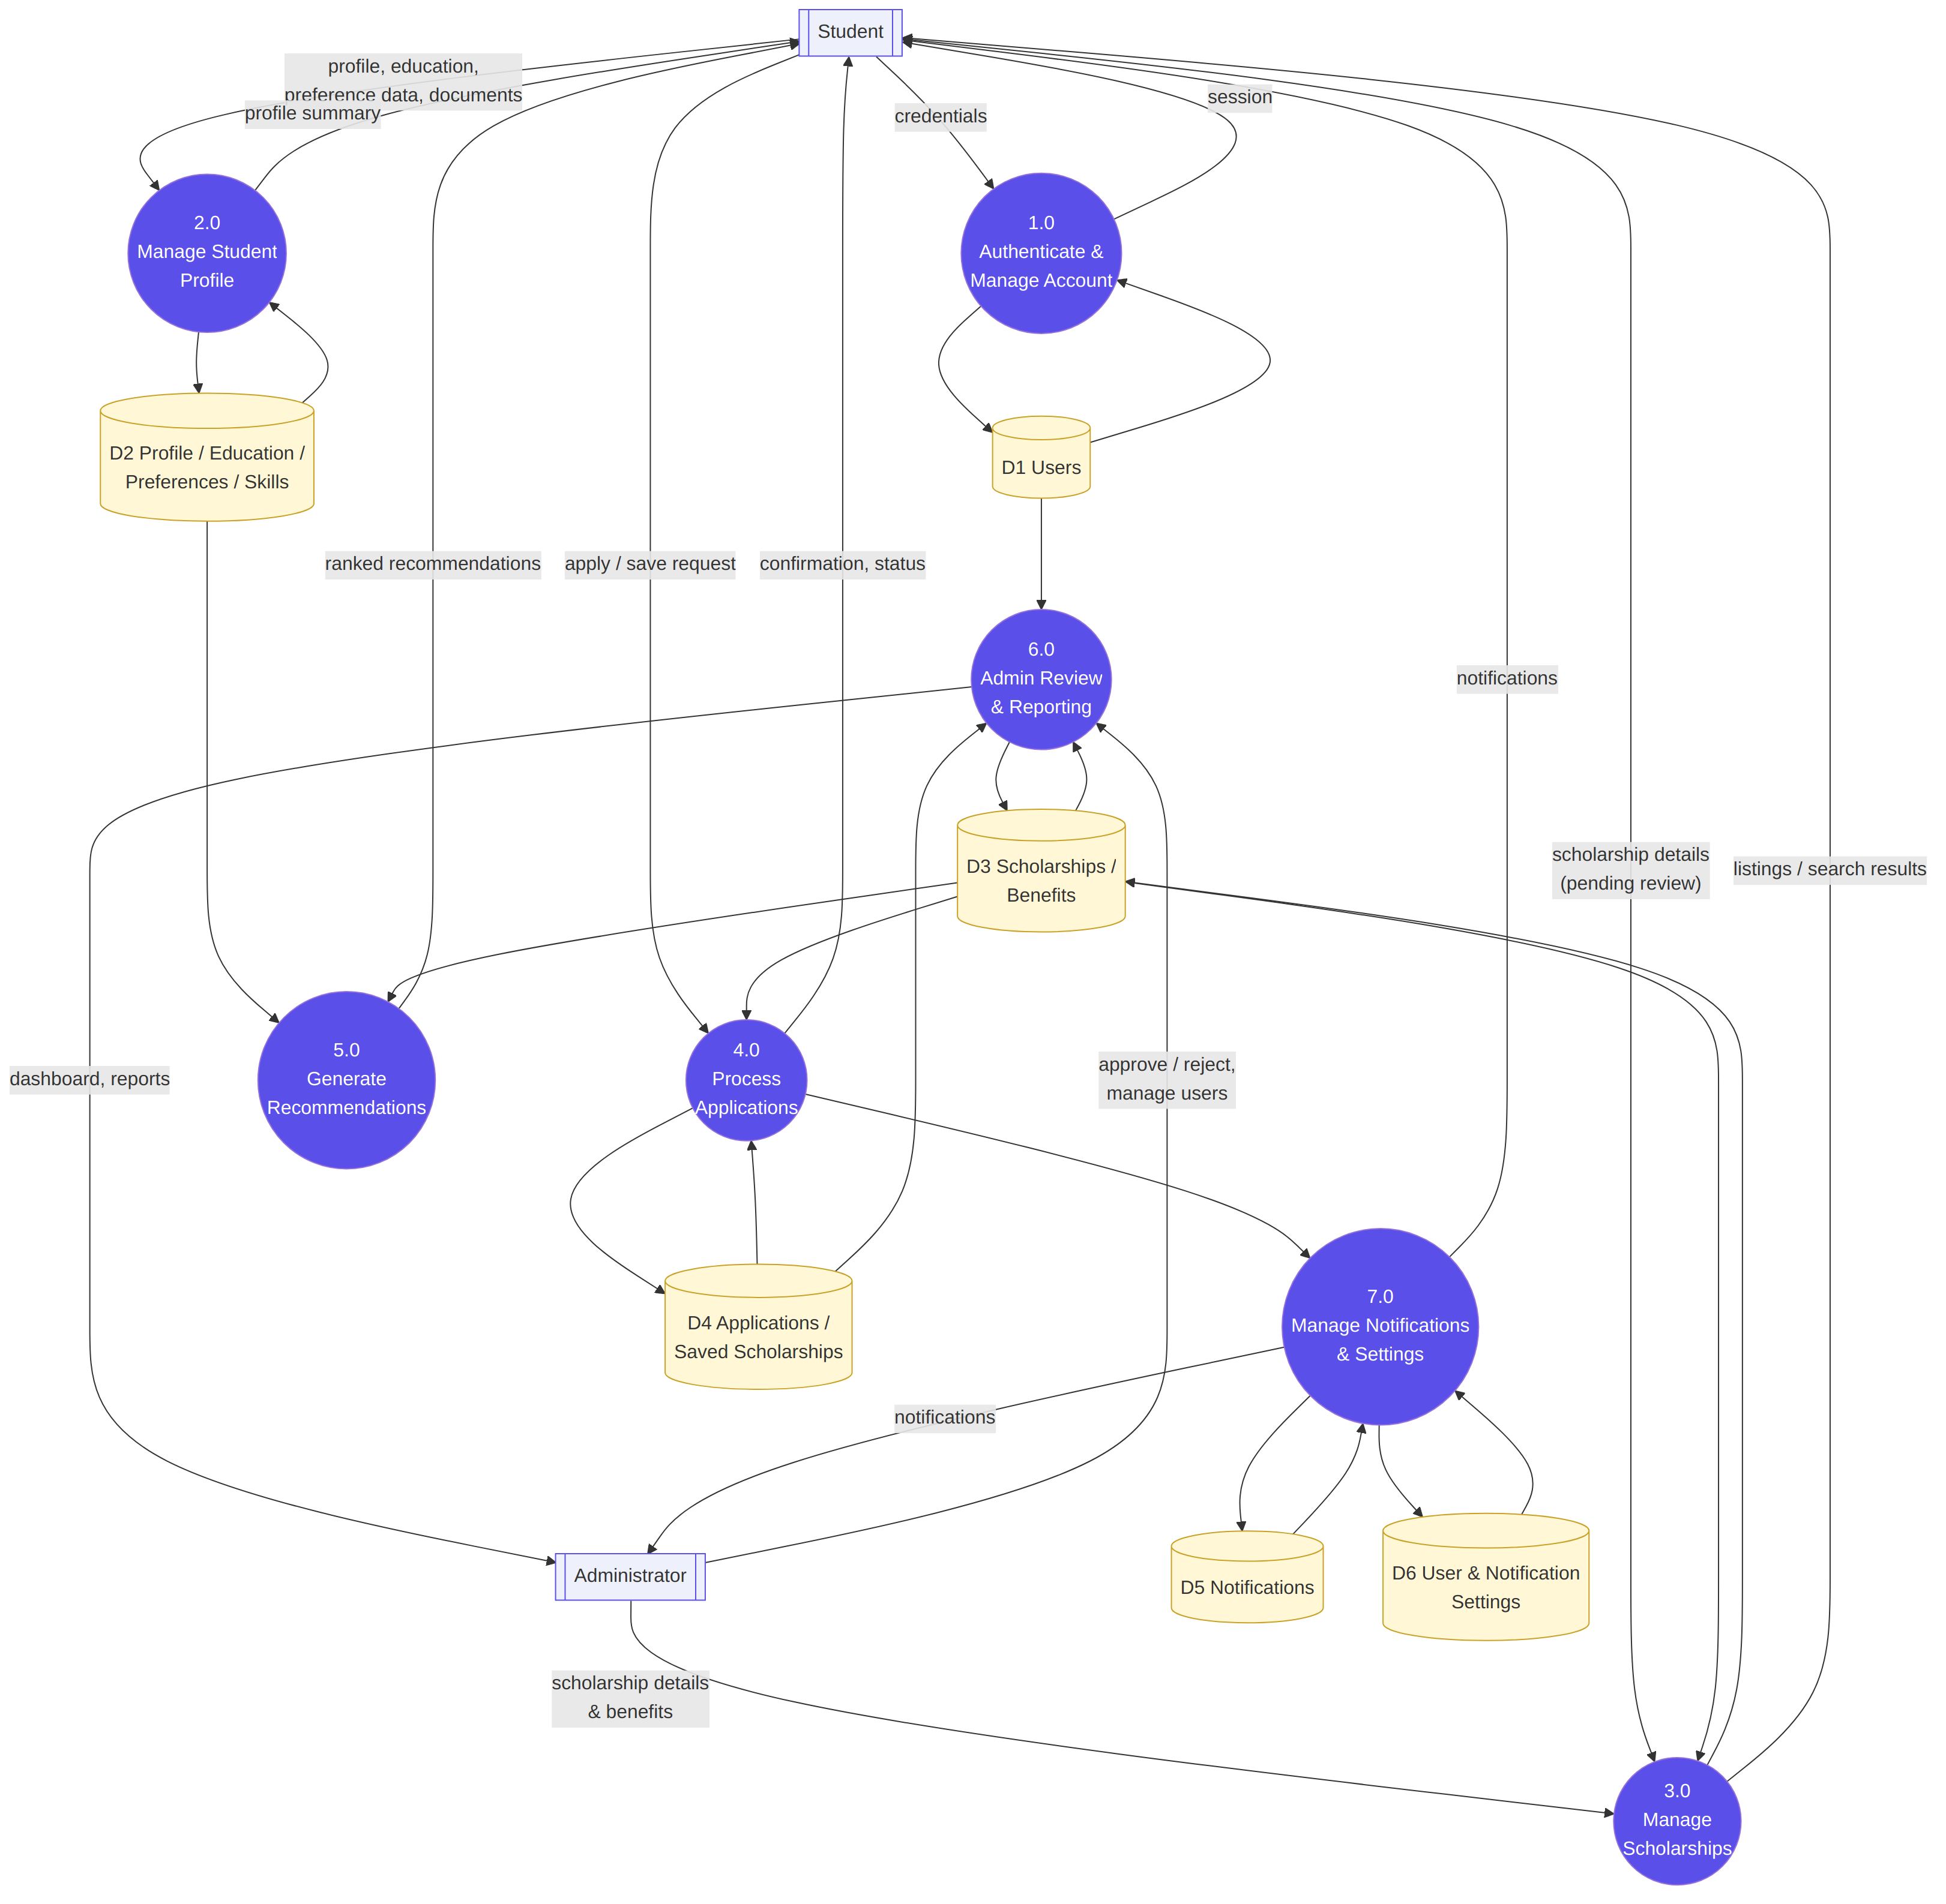
Figure 2 — Level 1 Data Flow Diagram (Overview)

4.1.1 Detailed DFD — Student-Facing Processes
Each Level-1 process is expanded into the individual backend endpoints that implement it, mapped against every table it reads from or writes to. This traces directly to the 24 student-facing PHP scripts in /backend (signup.php, login.php, save_profile.php, save_education.php, save_preferences.php, post_scholarship.php, search_scholarships.php, get_scholarships.php, save_scholarship.php, get_saved_scholarships.php, remove_saved_scholarship.php, apply_scholarship.php, get_applications.php, get_updates.php, get_recommendations.php, get_notifications.php, mark_notification_read.php, get_settings.php, save_settings.php, update_settings.php, change_password.php, forgot_password.php, get_profile_details.php, check_profile_status.php).
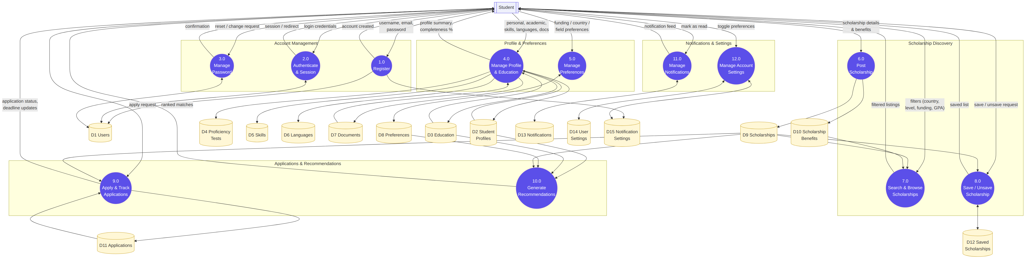
Figure 3 — Detailed DFD: Student-Facing Processes (Processes 1.0–12.0)

4.1.2 Detailed DFD — Admin-Facing Processes
The administrative half of the system, covering scholarship governance, user oversight and reporting — implemented by admin_review_scholarship.php, admin_delete_scholarship.php, admin_get_scholarships.php, admin_get_users.php, admin_get_dashboard.php, get_dashboard.php, admin_get_reports.php and get_report_data.php, all gated by admin_guard.php / admin_check.php.
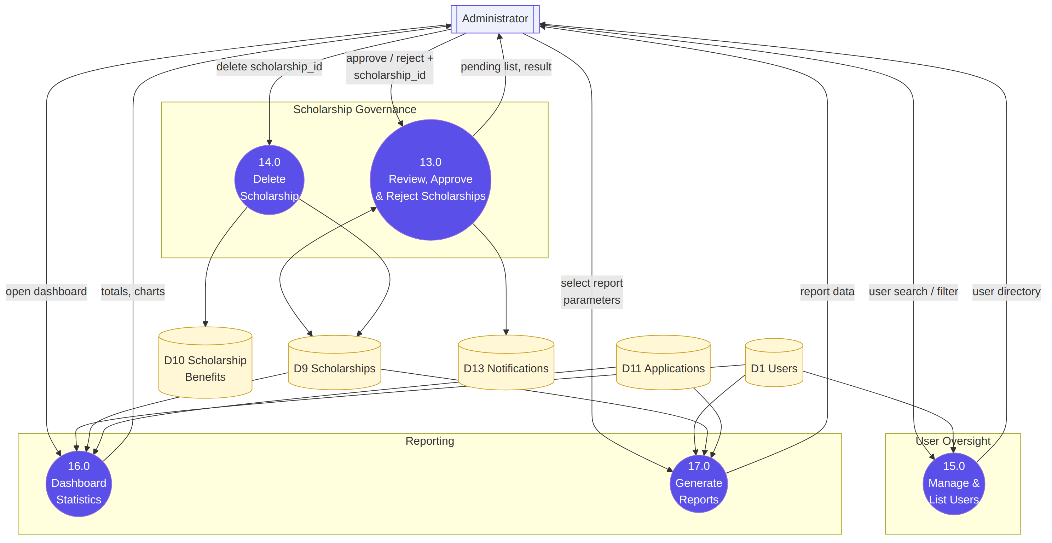
Figure 4 — Detailed DFD: Admin-Facing Processes (Processes 13.0–17.0)

4.2 Entity–Relationship Diagram (ERD)
Derived from every INSERT, SELECT...JOIN, and ON DUPLICATE KEY clause across /backend/*.php. No .sql schema file was included in the project, so column types are inferred from bind_param type strings (i = int, s = string, d = double).
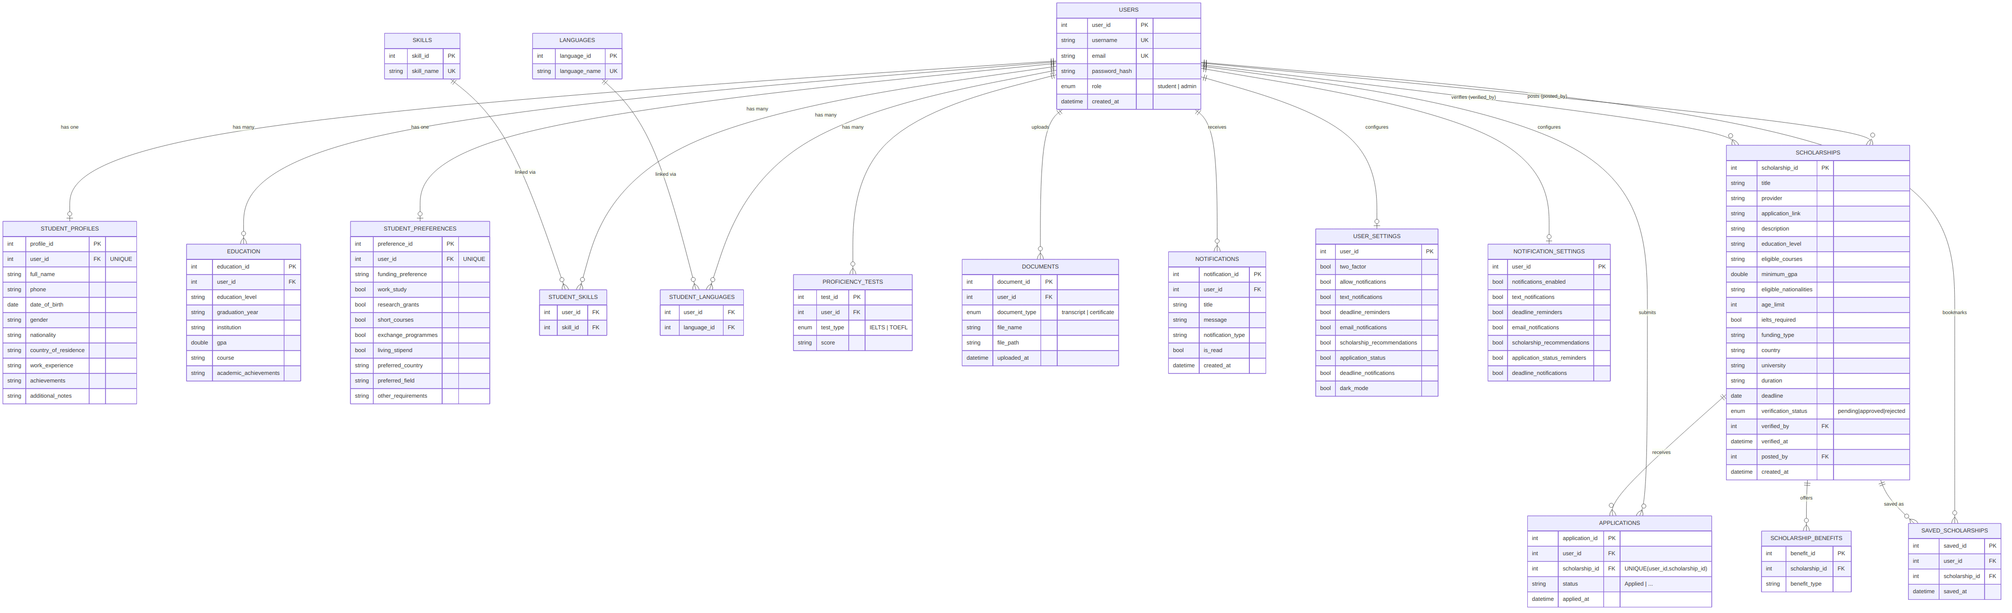
Figure 5 — Entity–Relationship Diagram (18 tables)

4.3 UML Class Diagram
A conceptual domain model implied by the procedural PHP endpoints. The codebase itself has no classes (plain mysqli procedural PHP) — this groups the data and operations into the classes an OOP refactor would naturally produce.
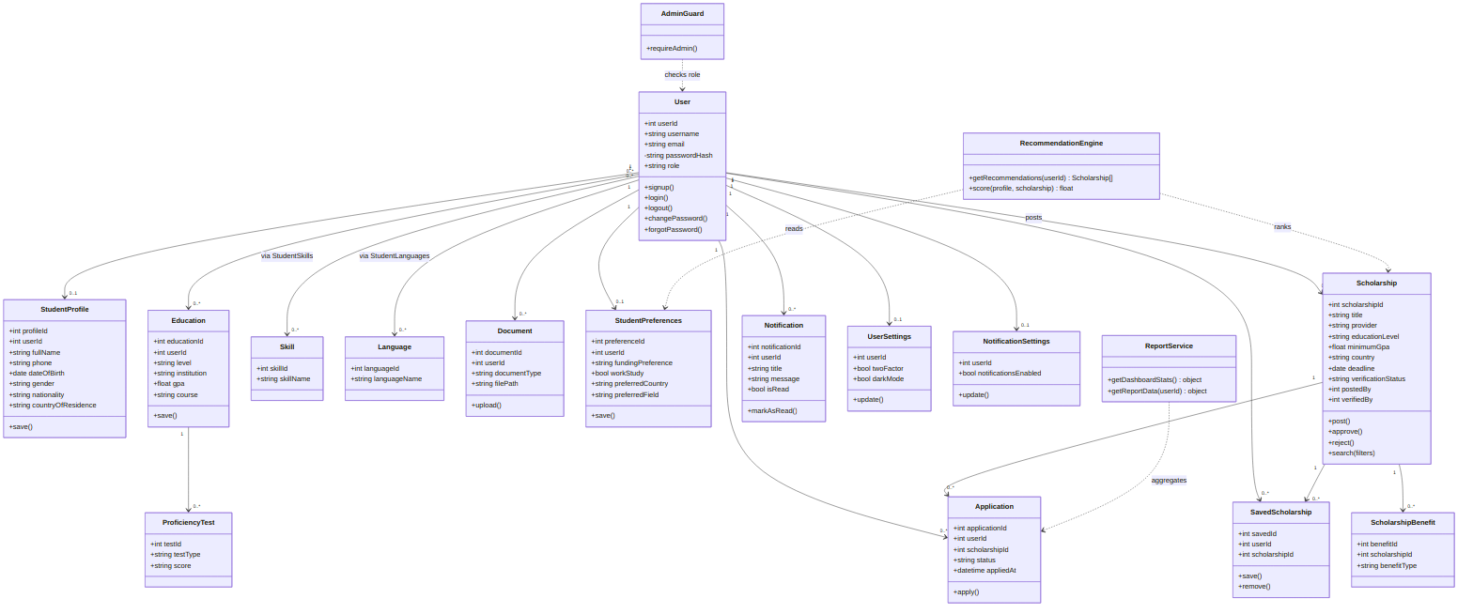
Figure 6 — UML Class Diagram

4.4 Sequence Diagram — Sign Up & Login
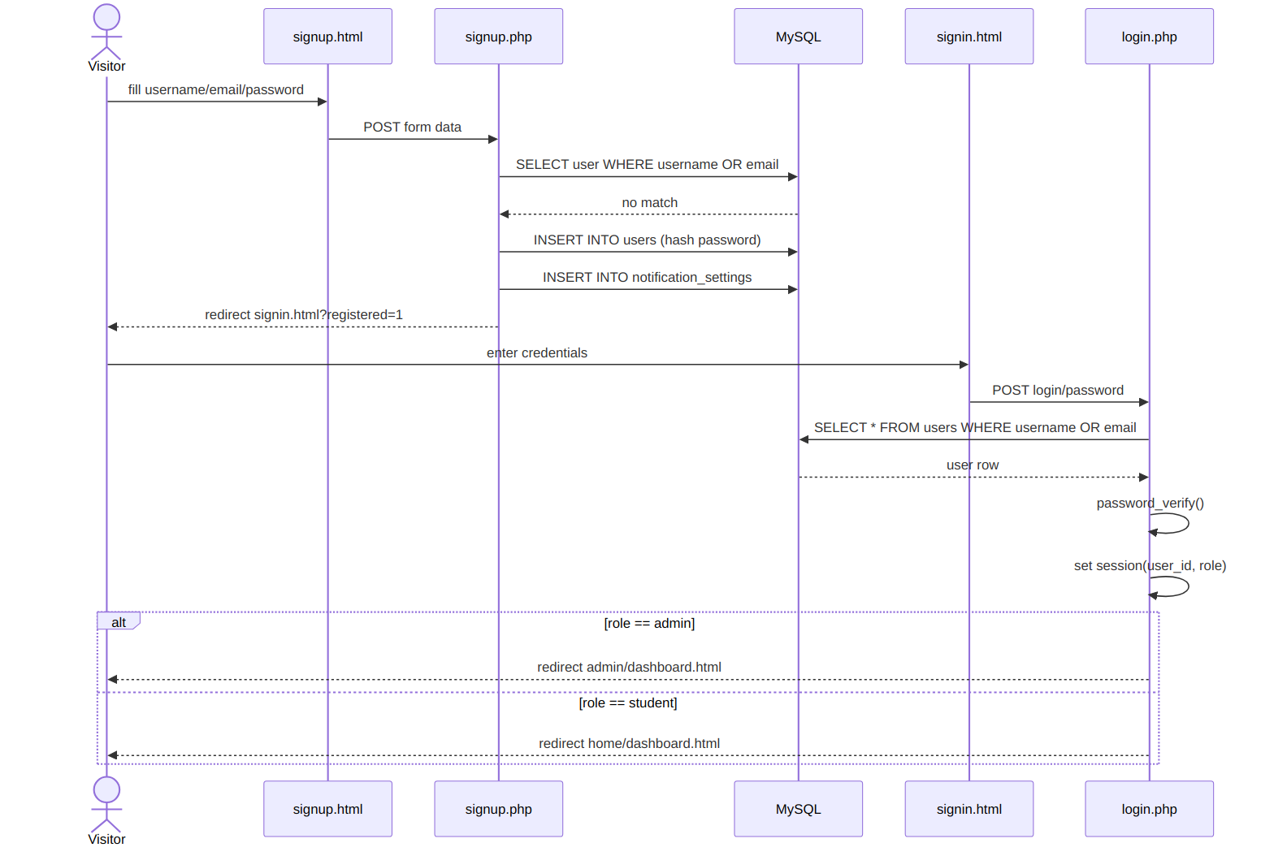
Figure 7 — Sign Up & Login sequence

4.5 Sequence Diagram — Browse & Apply to a Scholarship
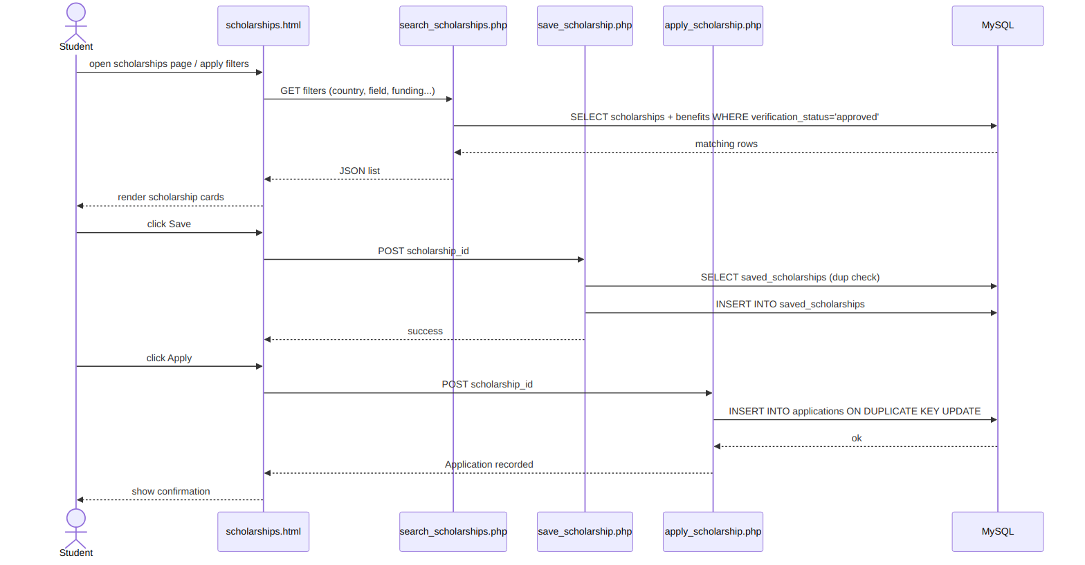
Figure 8 — Browse & Apply sequence

4.6 Sequence Diagram — Post & Approve a Scholarship
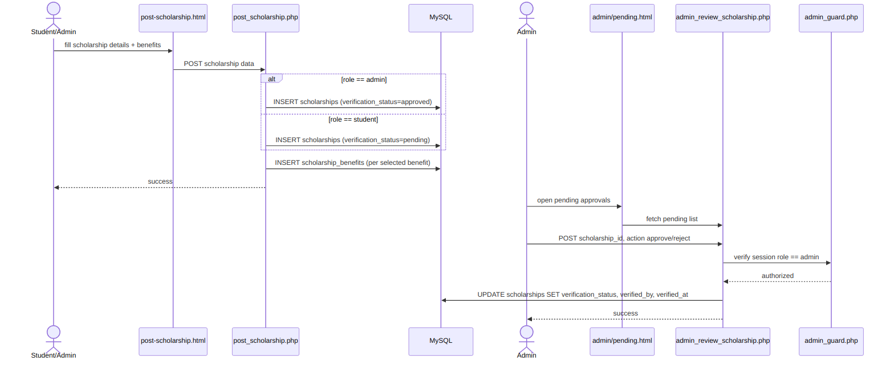
Figure 9 — Post & Approve sequence

4.7 Use Case Diagram
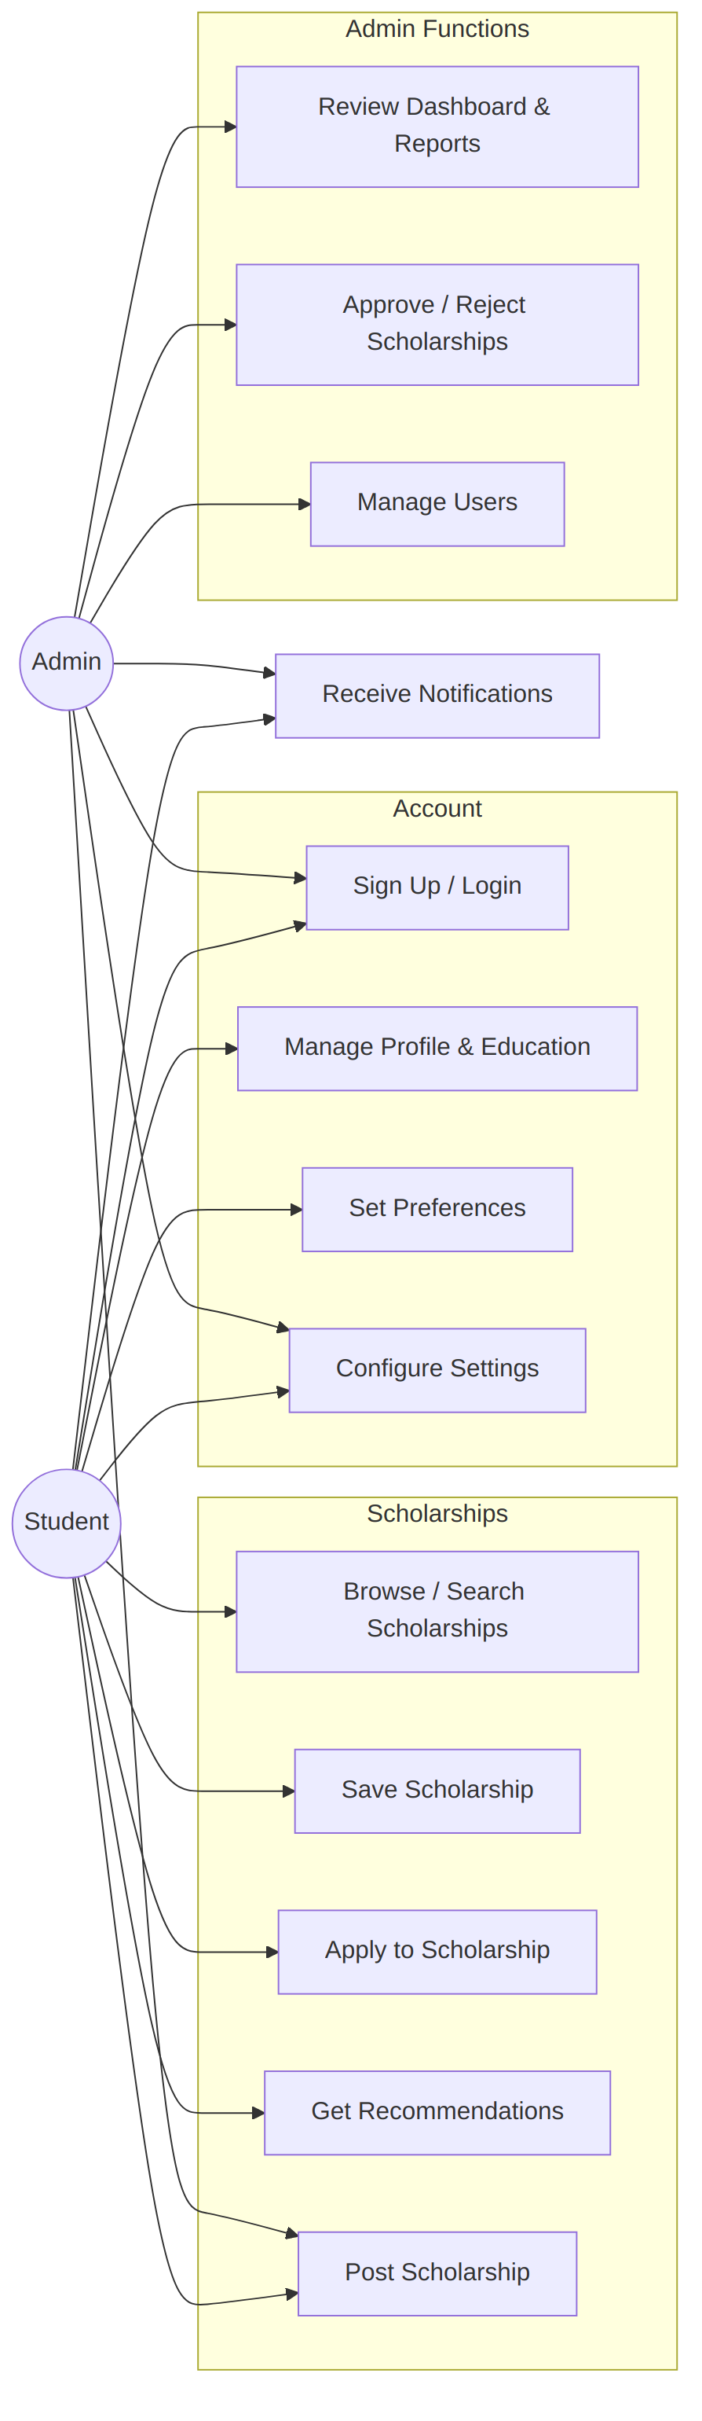
Figure 10 — Use Case Diagram (Student vs Admin)

4.8 Notes & Assumptions
Item | Detail
Source | No .sql schema file was in the archive - schema reconstructed purely from mysqli prepared statements in /backend/*.php (INSERT/UPDATE/SELECT column lists and bind_param type strings).
1:1 relations | student_profiles, student_preferences, user_settings, notification_settings all use user_id as a unique key with ON DUPLICATE KEY UPDATE, implying one row per user.
M:N relations | student_skills and student_languages are pure junction tables (INSERT IGNORE) linking users to shared lookup tables skills / languages.
Redundancy | user_settings and notification_settings overlap heavily (both store notification toggles) - likely leftover from iterative development (save_settings.php vs update_settings.php).
Self-referencing FK | scholarships.posted_by and scholarships.verified_by both reference users.user_id.
Architecture | Plain procedural PHP + mysqli, session-based auth, no framework/ORM/classes - the class diagram is a conceptual OOP view, not literal code structure.
Context / DFD scope | No payment gateway, email/SMS gateway, or other third-party system is called anywhere in the backend, so the context diagram shows only two external entities: Student and Administrator. Notification delivery (email/SMS) is modelled by settings flags only, not an outbound integration.

