**Traversable Surface Perception Report**

1. **Data and Preprocessing**

The data consists of a *rosbag* collected from a d435i camera mounted over a robot vehicle being driven around campus (JHU) - hence the traversable surface primarily consists of (red) brickway (alongwith road, marble and if needed, grass lawns). The data consists of color and depth images which are by design of the camera unable to be perfectly aligned since they are not taken at the same time, but given the velocity that the vehicle can achieve

1. **Algorithm Implemented**

Figure 1 provides a basic understanding of the traversable path detection (TPD) algorithm.

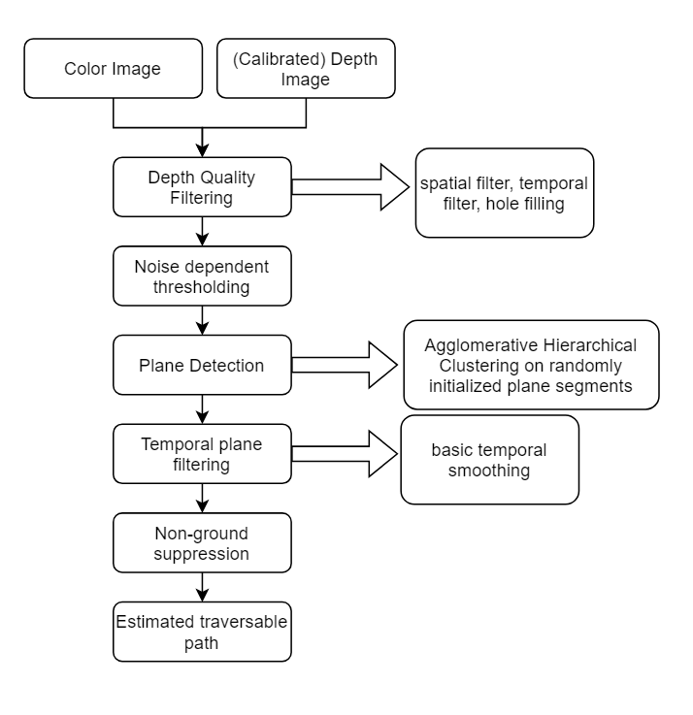

**Figure 1. TPD Algorithm**

1. **Plane Detection**

The plane detection has two major parts.

1. Over segmented texture
2. **Ground Plane Validation**