“Improvement of power using direct current control method of STATCOM”

Sanjyot Ramteke Toshik Ghormare Tushar Giripunje Pankaj Dhongale

Dept of Electrical Engineering Dept of Electrical Engineering Dept of Electrical Engineering Dept of Electrical Engineering

Rajiv Gandhi College of Rajiv Gandhi College of Rajiv Gandhi College of Rajiv Gandhi College of

Engineering and Research Engineering and Research Engineering and Research Engineering and Research

Nagpur, India Nagpur, India Nagpur, India Nagpur, India

[rsanjyot@gmail.com](mailto:rsanjyot@gmail.com) [toshik.ghormare@gmail.com](mailto:toshik.ghormare@gmail.com) [tussuu28@gmail.com](mailto:tussuu28@gmail.com) dhongalepankaj[@gmail.com](mailto:tussuu28@gmail.com)

Takshak Raul Tinkesh Bhanarkar Piyush Ganorkar

Dept of Electrical Engineering Dept of Electrical Engineering Dept of Electrical Engineering

Rajiv Gandhi College of Rajiv Gandhi College of Rajiv Gandhi College of

Engineering and Research Engineering and Research Engineering and Research

Nagpur, India Nagpur, India Nagpur, India

[takshakraul@gmail.com](mailto:takshakraul@gmail.com) [tinkeshbhanarkar06@gmail.com](mailto:tinkeshbhanarkar06@gmail.com) piyush.ganorkar290797@gmail.com

***Abstract* -** This project introduced the working principle of STATCOM by using direct current control method of triangle carrier waves to detect both the harmonics and reactive power also reduces the switching noises and pulsating current and improve the reliability, controllability and power factor. With the help of MATLAB to build the model of STATCOM and the simulation result verified the feasibility and effectiveness of this method and accurate, fast and steady compensation effect.

**Keywords-** direct current control; STATCOM; instantaneous reactive power;

**Introduction**

With the rapid development of industry, the requirements of electric power quality are becoming stricter. Improvement in the reliability, controllability and rapidity of modern power system has become a urgent problem to be solved. Reactive power and voltage regulation are the major issues in power system operation. Power quality mainly deals with, Continuity of power supply, Quality of the voltage. Various power quality problems may leads to another undesirable problems like voltage variations, harmonics, flickers. So, in order to mitigate this problems, Flexible Alternating Current Transmission System (FACTS) is used to enhance controllability and increase power transfer capability of the network.

Series Devices - SSSC,TCSC

Shunt Devices - STATCOM,SVC

Series-series devices - IPFC,UPFC

Series-shunt devices - HVDC link

So, in order to improve power quality by reducing all such problems STATCOM is used. In this project, we generally focued on STATCOM and it’s working in transmission line. This Research also focuses on the detailed study of STATCOM using Direct Current Control(DCC) Method to indicate the system's healthy performance and reliability. This strategy is highly recommended for harmonic elimination and reactive power control. Plus we can also mitigate the switching frequency with the help of triangular carrier waves. As a result, the control precision and response speed of Direct Current Control is high with respect to Indirect Current Control Method. So, we adopt this method. We use the MATLAB/SIMULINK to build the STATCOM and its controller and also to check the compensation effect. As a result, we get overall Power Factor and Total Harmonic Distortion(THD) improved. Thus Power is Improved.

**PROJECT METHODOLOGY**

This project focuses on the Improvement of Power Quality in Transmission using STATCOM by using direct current control method.by using triangle carrier direct current control method .

**Operation of STATCOM:**

In this mode, the STATCOM reactive power output is kept constant independent of other system parameter.

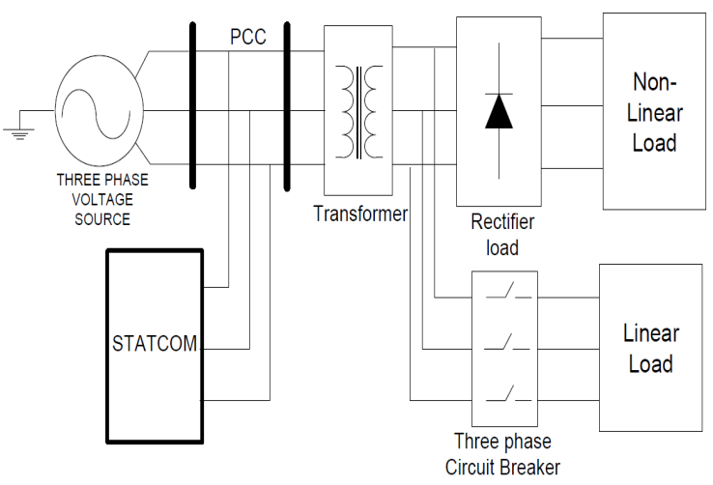

**Fig. Schematic diagram of STATCOM connected power system with Linear and Non-Linear load**

Using MATLAB Simulink simulate the uncompensated system of the transmission line with linear and non linear load then observe the voltage,current,power and harmonics of the system. Then STATCOM is connected between source and load (this is compensated system) by using direct current control method. Tracking PWM control technology can use the hysteresis comparison method, it also can be used triangle wave comparison. In the link of modulation, switch frequency varies with the compensation current in the hysteresis modulation, which causes the great pulsating current and switching noise, while using the triangle wave modulation method, switching frequency is equal to the triangular carrier frequency, pulse current is small, and the output voltage of less harmonic content. Based on the above advantages, this paper adopts the triangular wave comparison. .

**SIMULATION RESULT**

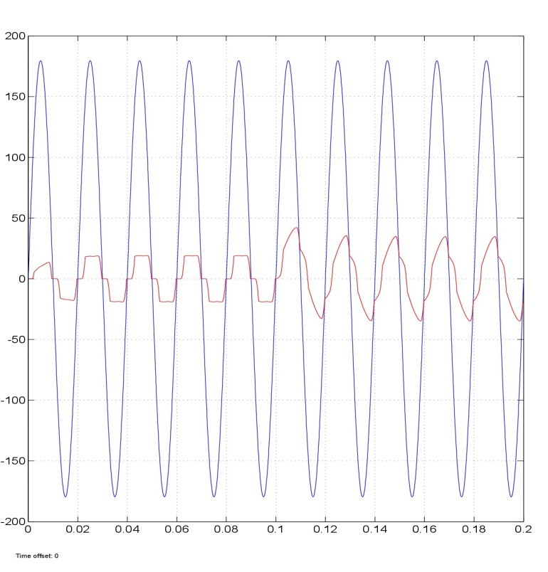

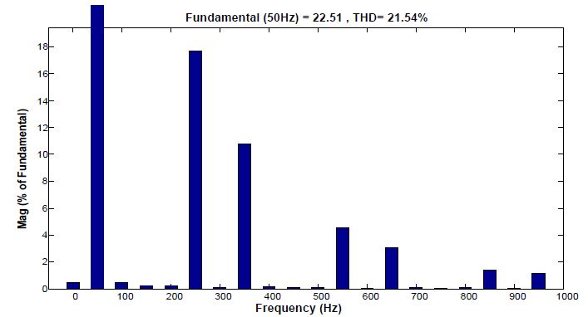

**CONCLUSION**

This paper mainly demonstrates the basic operating

principle of STATCOM with direct current control scheme

under linear and non-linear load conditions. It is observed

that this method is complex in implementation as compared

to indirect current control method but due to fast response

and precise nature of direct current control method,

STATCOM acts as a highly proficient device for power

factor improvement and harmonic reduction.

**References**

1. The Direct Current Control Method of STATCOM and its simulation.2013 Third International Conference on Intelligent System Design and Engineering Applications.
2. Nagrani G. Hingorani , Laszio Gyugyi. Understanding of FACTS Concepts and Technology of Flexible AC Transmission System . IEEE Press 1999.
3. Using STATCOM Interfacing of Renewable Energy Sources to Grid and Power Quality Improvement. 2015 International Conference on Energy System and Applications.
4. P.S. Bhimra , Power Electronics.
5. Improvement of Voltage Quality in AC Network by use of STATCOM -2005Mazurov M.I.,Nikolaev A.V.,Lozinova N.G