RAJIV GANDHI COLLEGE OF ENGINEERING AND RESEARCH, NAGPUR
DEPARTMENT OF ELECTRICAL ENGINEERING
2018-19


“Improvement of Power using Direct Current Control method using STATCOM”
A synopsis submitted in Partial Fulfillment of the requirements for the Degree of

BACHELOR OF ENGINEERING
IN
ELECTRICAL ENGINEERING

RASHTRASANT TUKADOJI MAHARAJ NAGPUR UNIVERSITY, NAGPUR
BY
Name of Student
Pankaj Dhongale
Piyush Ganorkar
Sanjyot Ramteke
Takshak Raul
Tinkesh Bhanarkar

Toshik Ghormare
Tushar Giripunje

Name of Guide/Co-Guide
Prof. Tripti Rai

ABSTRACT:

This project introduced the working principle of STATCOM by using direct current control method of triangle carrier waves to detect both the harmonics and reactive power also reduces the switching noises and pulsating current and improve the reliability, controllability and power factor. With the help of MATLAB to build the model of STATCOM and the simulation result verified the feasibility and effectiveness of this method and accurate, fast and steady compensation effect.

INTRODUCTION OF PROJECT:
With the rapid development of industry, the requirements of electric power quality are becoming stricter. Improvement in the reliability, controllability and rapidity of modern power system has become a urgent problem to be solved. Reactive power and voltage regulation are the major issues in power system operation. Power quality mainly deals with, Continuity of power supply, Quality of the voltage. Various power quality problems may leads to another undesirable problems like voltage variations, harmonics, flickers. So, in order to mitigate this problems, Flexible Alternating Current Transmission System (FACTS) is used to enhance controllability and increase power transfer capability of the network.
Series Devices - SSSC,TCSC
Shunt Devices - STATCOM,SVC
Series-series devices - IPFC,UPFC
Series-shunt devices - HVDC link
So, in order to improve power quality by reducing all such problems STATCOM is used. In this project, we generally focued on STATCOM and it’s working in transmission line. This Research also focuses on the detailed study of STATCOM using Direct Current Control(DCC) Method to indicate the system's healthy performance and reliability. This strategy is highly recommended for harmonic elimination and reactive power control. Plus we can also mitigate the switching frequency with the help of triangular carrier waves. As a result, the control precision and response speed of Direct Current Control is high with respect to Indirect Current Control Method. So, we adopt this method. We use the MATLAB/SIMULINK to build the STATCOM and its controller and also to check the compensation effect. As a result, we get overall Power Factor and Total Harmonic Distortion(THD) improved. Thus Power is Improved.

PROJECT METHODOLOGY
This project focuses on the Improvement of Power Quality in Transmission using STATCOM by using direct current control method.by using triangle carrier direct current control method .

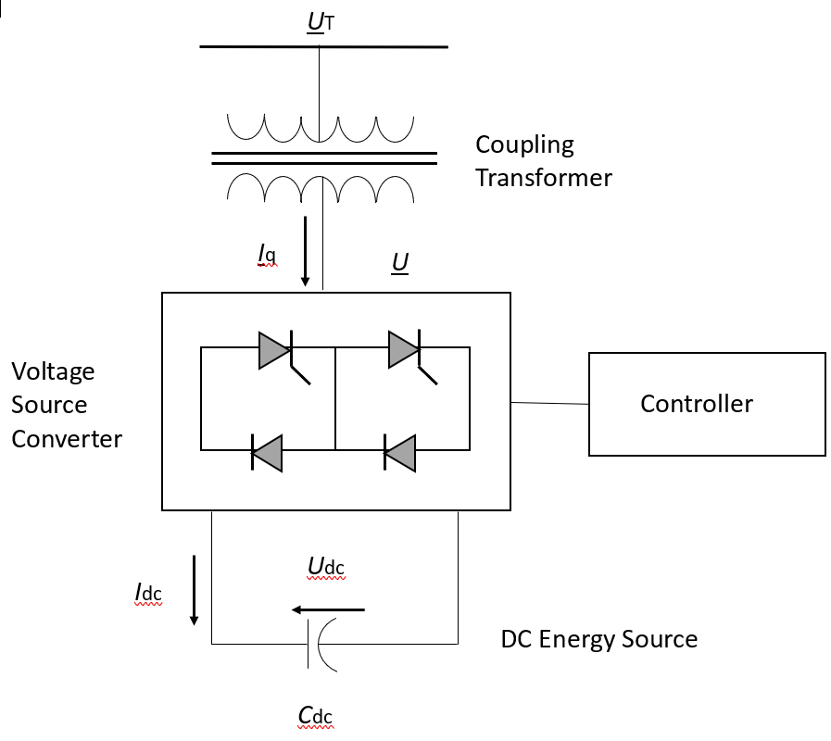

Operation of STATCOM:

In this mode, the STATCOM reactive power output is kept constant independent of other system parameter.
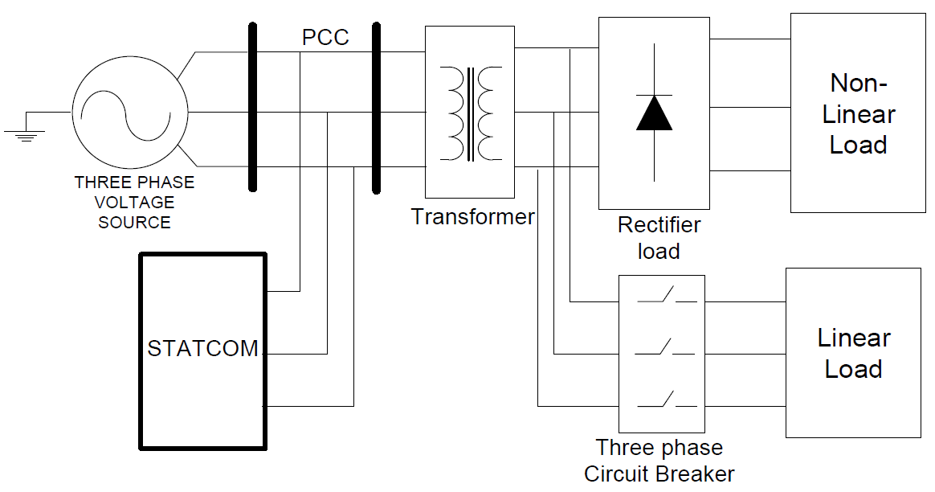

Fig. Schematic diagram of STATCOM connected power system with Linear and Non-Linear load

Using MATLAB Simulink simulate the uncompensated system of the transmission line with linear and non linear load then observe the voltage,current,power and harmonics of the system. Then STATCOM is connected between source and load (this is compensated system) by using direct current control method. Tracking PWM control technology can use the hysteresis comparison method, it also can be used triangle wave comparison. In the link of modulation, switch frequency varies with the compensation current in the hysteresis modulation, which causes the great pulsating current and switching noise, while using the triangle wave modulation method, switching frequency is equal to the triangular carrier frequency, pulse current is small, and the output voltage of less harmonic content. Based on the above advantages, this paper adopts the triangular wave comparison.

Proposed PLAN OF WORK:
Phase-I: [7th Semester]
(i)Literature Analysis
(ii)Study Of STATCOM
(iii)Simulation before Compensation
Phase-II: [8th Semester]
(i)Simulation after Compensation
(ii)Paper presentation
(iii)Thesis submission

Literature Survey:
(1)The Direct Current Control Method Of STATCOM And It’s Simulation- Static synchronous compensator (STATCOM) is a central device of modern flexible AC transmission system compared with the traditional reactive power compensation device. STATCOM has a advantages of fast response, absorb reactive continuous harmonic current, low loss, small size etc. STATCOM has become an important development direction of reactive power and harmonic compensation[1].
(2)Using STATCOM Interfacing Of Renewable Energy Source To Grid And Power Quality Improvement- We use novel idea using Facts devices and interface source to grid propose system Facts device use as STATCOM[2]
(3)Improvement Of Voltage Quality In AC Network By Use Of STATCOM- As the STATCOM control by PWM controls current of the phase reactor, the problem of compensation of high harmonic by use of STATCOM can be solve by forming the current containing compensatory components of high harmonic in phase of reactor and in phase of network transformer.[3]

REFERENCES:
1) Li Shengqing, Li Weizhou, Xu Wenxiang, Zeng Huanyue, “The Direct Current Control Method of
STATCOM and It’s Simulation”, Third International conference ISDEA, Jan-2013.
2) Narain G. Hingorani, Laszlo Gyugyi, "Understanding FACTS concept and technology of Flexible AC
Transmission System", IEEE Press 2000.
3) Prashant M. Chavan, Girish R. Walke, "Using STATCOM Interfacing of Renewable Energy Source to
Grid and Power Quality Improvement", International Conference on Energy Systems and Applications,
2015.
4) P S Bhimra, "Power Electronics", 2004
5) K R Padiyar, "Facts Controllers In Power Transmission And Distribution", New Age International
Limited, 2007
6) Mazurov M I, Nikolaev A V, Lozinova N G, "Improvement of Voltage Quality in AC Network by Use of
STATCOM", IEEE Russia Power Technology, 2005

Asst. Prof. Tripti Rai Asst. Prof. Mrs Sarika Patil
(Project Guide) (Head EE )

