<https://blog.logrocket.com/real-time-chat-app-rust-react/>

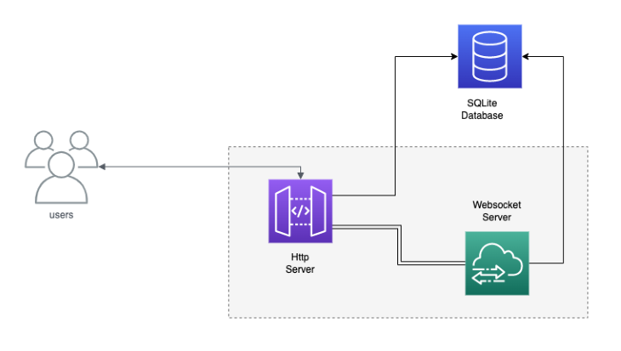

* Websocket server: handle communication betwedn clinets and rooms
* Room manager: create update delete rooms, on http server
* User manager:create update delete users, also on hyyyp server
* Message manager: create update delete messages

Diiesel is out object relational mapping ORM

* Actix_cors will be used to debug UI, post and get request from 3000 and 8080
* Actix_files for embedding static files to one of our routes

GONATIVE

<https://gist.github.com/zeljic/d8b542788b225b1bcb5fce169ee28c55>

build sqlirte3lib ^

<https://github.com/diesel-rs/diesel/issues/487#issuecomment-415752856>

<https://stackoverflow.com/questions/4041114/what-is-database-pooling>

UUID is a universally unique identifier that is generated using a timestamp and the MAC address of the computer on which it was generated.

<https://stackoverflow.com/questions/58296263/how-do-i-create-a-new-database-using-diesel>

<https://stackoverflow.com/questions/70410103/how-to-make-diesel-auto-generate-model>

I FUCKING FORGOT

Misspelled link + frgot to compile + using dabase browser so it was locked + forgot to add service +