<https://atcoder.jp/contests/abc172/tasks/abc172_e>

count the pairs of length $n$ sequences consisting of integers from 1 to $m$ such that each sequence consists of distinct integers and $a_{i}≠b_{i}$ for all $i$. (can share integers, cannot have same integer multiple times in one sequence)

First thought: enumerate the number of overlapping integers

$$\sum_{i=0}^{n}{\left({m \atop i}\right)×\left({m-i \atop n-i}\right)×\left({m-n \atop n-i}\right)×\#sequences with those numbers}$$

choose $i$ overlapping integers, choose $n-i$ other integers out of $m-i$ remaining integers for the first sequence, choose $n-i$ other integers out of $m-n$ remaining integers for the second one.

I cant think, maybe enumerate again can simplify stuff? enumerate the number of overlapping positions of the overlapping integers

$$\sum_{i=0}^{n}{\left(\left({m \atop i}\right)×\left({m-i \atop n-i}\right)×\left({m-n \atop n-i}\right)×\sum_{j=0}^{i}{\left({i \atop j}\right)×\frac{\left(i-1\right)!}{\left(i-j-1\right)!}×\frac{\left(n-i\right)!}{\left(n-2i+j\right)!}×\left(n-i\right)!}\right)}$$

(too lazy to explain probably wrong anyways)

cant find any simplifications, will $O\left(n^{2}\right)$, this is so sad

editorial: inclusion-exclusion principle!! (what?)

By inclusion-exclusion principle, #(all not equal) is equal to #(0 def equal) - #(1 def equal) + #(2 def equal) - … +/- #(n def equal)

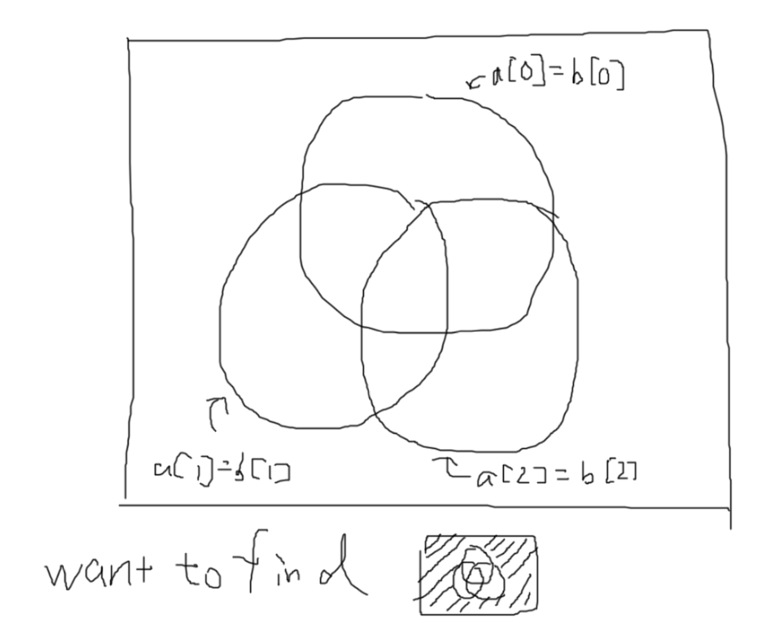(i def equal means i of the a[j] and b[j] are equal rest is unsure so can be both)

If still don’t get, heres an example lets say n = 3

therefore, formula is

$$\sum_{i=0}^{n}{{\left(-1\right)}^{i}×C_{i}^{n}×P_{i}^{m}×{\left(P_{n-i}^{m-i}\right)}^{2}}$$

$i$ is number of def equal elements

$C_{i}^{n}$ choose i a[j] = b[j] positions

$P_{i}^{m}$ choose the i same integers (with order as they are sequences)

${\left(P_{n-i}^{m-i}\right)}^{2}$ choose the $n-i$ remaining integers, they may be the same but it is ok.

Wow never really thought of inclusion exclusion when doing combinatorics problem hope I will know how to do when this thing shows up again