overfitting

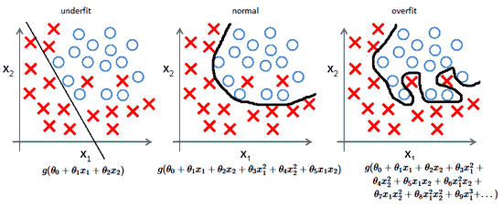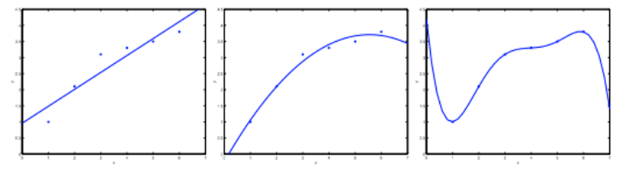

underfitting / high bias ok fit overfitting / high variance

Underfitting happens when the form of our hypothesis function maps poorly to the trend of the data. It is usually caused by a function that is too simple or uses too few features.

Overfitting is caused by a hypothesis function that fits the available data but does not generalize well to predict new data. It is usually caused by a complicated function that creates a lot of unnecessary curves and angles unrelated to the data.

To solve the problem of underfitting:

* Add more features with higher degrees.

To solve the problem of overfitting:

* Manually select which features to keep.
* Implement a model selection algorithm.
* Implement regularization

regularization

$$J\left(θ\right)=\frac{1}{2m}\sum_{i=1}^{m}{cost(h_{θ}\left(x\right),y)}+\frac{λ}{2m}\sum_{j=1}^{n}{θ_{j}^{2}}$$

To minimize the effects of all the parameters except the bias term, we will set lambda to a large number and multiply it the the sum of squared parameters, so if the parameters are large, which will lead to overfitting, the regularization term will penalize it and the cost function will be very large. We want to minimize the cost function, so in the end, the function will smoothen out. Note that we do not regularize the bias term, or the first parameter.

$$\frac{∂J\left(θ\right)}{∂θ_{j}}=\frac{1}{m}\sum_{i=1}^{m}{\left(h_{θ}\left(x\right)-y\right)x_{j}}+\frac{λ}{m}θ_{j}$$

$$θ_{j}≔θ_{j}-α\frac{∂J\left(θ\right)}{∂θ_{j}}$$

$$θ_{j}≔θ_{j}-\frac{α}{m}\sum_{i=1}^{m}{\left(h_{θ}\left(x\right)-y\right)x_{j}}-\frac{αλ}{m}θ_{j}$$

$$θ_{j}≔{\left(1-\frac{αλ}{m}\right)θ}_{j}-\frac{α}{m}\sum_{i=1}^{m}{\left(h_{θ}\left(x\right)-y\right)x_{j}}$$

vectorized implementation:

$$θ≔\left(1-\frac{αλ}{m}\right)θ-\frac{α}{m}X^{T}(h_{θ}\left(X\right)-y)$$

regularized normal equation

$$θ={\left(X^{T}X+λL\right)}^{-1}X^{T}y$$

$$L=\left[\begin{matrix}0 & & & \\ & 1 & & \\ & & ⋱ & \\ & & & 1\end{matrix} \right] \left(n+1\right)×\left(n+1\right) square matrix$$