Data Analysis Final Project
DUE: Thursday, December 11 at 11:59pm

Purpose: Exploring Practitioner Engagement with Professional Development in Adult Education

Research Questions
- How does an AE practitioner’s role influence engagement with PD resources?
- How does an AE practitioner’s years of experience influence engagement with PD resources?
The final project involves completing a small data analysis based on a topic and dataset of your own choosing. Data may be obtained in various places, but do not select a dataset that would require you to seek IRB approval for use in this project. The goal of the project is to demonstrate your ability to organize and complete a full data analysis, from reading in the data to presenting the results. Completed projects will be assessed based on the extent to which they demonstrate competence in importing, cleaning & processing, visualizing, and analyzing a real-life dataset. Some suggestions for those seeking data for the project include https://www.icpsr.umich.edu/web/pages/ICPSR/index.html, https://nces.ed.gov, https://www.census.gov/data.html, https://dataverse.harvard.edu/, and https://edopportunity.org/get-the-data/. These are but a few suggestions.

Task:
The following are the activities you will accomplish as you work through this assignment.
• Find a dataset that contains at least 100 observations and 10 variables (i.e., enough data and variables to conduct the analyses to answer your research questions). The data should also contain a mix of continuous and categorical variables. – You can use data available from your advisor (with permission) • Import the data • Conduct data verification analyses (missing values; invalid values; etc.) • Provide descriptive statistics of cases that will be included in your analysis and contrast that with observations (cases) excluded from your analysis • Compose research questions that can be answered using a t-test, chi-square test, correlation test, ANOVA, linear regression analysis, binary logistic regression analysis, or other analytic method of your choice • Provide some theoretical rationale that motivates your hypotheses • Identify appropriate variables for the analysis • Create and interpret at least three figures that will help the reader understand your data • Analyze and report the results of your analysis – Check assumptions/diagnostics for your analysis – It’s okay if you violate some of the assumptions, as long as you consider that in your conclusions • Interpret your results (place the results in context) • Deliver a ‘mini-presentation’ on your project on the selected date – Dates to be selected at our 9/23 class meeting for the four dates specified in the syllabus for presentations. Three presentations will occur each week. Presentations should be no more than six minutes with four minutes for questions/comments from course participants.

Criteria for Success:
This assignment is worth a total of 200 points (20% of your overall grade).
Be sure to address all required components in task list above. Thoroughly describe the data source, including the variables used in the analysis. Conclusions should be expressed clearly with correct usage of statistical vocabulary. As always, follow the code consistency guidelines and naming conventions. There are many ways to accomplish any given task, so checking your work is critical.
- Describe in a paragraph where you found the dataset, how the data were collected, and what information the dataset contains.
For this project, I selected a dataset derived from an adult education (AE) practitioner survey conducted to understand how educators engage with professional development (PD) resources. The dataset was obtained from a program-level data collection effort in which AE practitioners completed a structured questionnaire regarding their roles, experience levels, PD engagement behaviors, and organizational characteristics. The data were collected through voluntary online self-report, ensuring broad participation across practitioner groups. The dataset contains more than 100 observations and includes both continuous variables such as years of experience and counts of PD activities and categorical variables, including practitioner role and program funding type. Altogether, the dataset provides a rich foundation for evaluating relationships between practitioner characteristics and their engagement with PD opportunities.

- Identify two to three fairly specific research hypotheses that you plan to investigate.
The first hypothesis (H1) proposes that practitioners’ roles meaningfully differ in their level of PD engagement, predicting that teachers, administrators, tutors, and other categories will report different frequencies of PD participation. The second hypothesis (H2) suggests that years of experience are positively associated with PD engagement, implying that practitioners with more professional tenure will participate in a greater number of PD activities. A third hypothesis (H3) posits that practitioners who attend professional conferences exhibit significantly higher levels of PD engagement compared to those who do not, reflecting the expectation that conference attendance signals higher general engagement with professional learning.
- Explain what statistical test will be utilized to answer each hypothesis.
To evaluate H1, I will use a one-way Analysis of Variance (ANOVA) to test whether mean PD engagement differs across practitioner role categories. For H2, I will apply a simple linear regression, modeling PD engagement as a function of years of experience. For H3, I will use an independent-samples t-test to compare the mean PD engagement counts of practitioners who attended at least one conference versus those who did not. Collectively, these methods allow assessment of both group-based differences and continuous relationships in the dataset.
- Briefly explain how each research hypothesis is motivated by a theoretical framework that predicts the relationship being tested in your analysis.
H1 is grounded in professional identity theory, which emphasizes that role-based responsibilities shape practitioners’ exposure to and perceived need for PD. Administrators, for example, may have greater access to PD resources than tutors, generating expected differences across roles. H2 draws from experiential learning and human-capital frameworks, which argue that accumulated experience increases practitioners’ awareness of PD’s value and strengthens their engagement patterns over time. H3 is supported by situated learning theory, wherein practitioners embedded in broader professional networks such as those facilitated by conferences develop stronger PD participation habits due to increased exposure, motivation, and opportunities for collaboration. These theories collectively provide justification for expecting systematic differences in PD behavior.

- Note the names of the variables that you plan to use to address the hypotheses you identified or will use to provide context about your data. You should identify at least six variables - a mix of continuous and categorical variables.
To evaluate the hypotheses, I selected the following variables:
Continuous variables:
pd_count (total PD engagement activities),
years_of_experience,
how_many_adult_learners_are_served_by_your_program_annually,
how_many_adult_learners_do_you_personally_work_with_on_an_annual_basis.
Categorical variables:
role (practitioner role categories),
conf_any (attended at least one conference: Yes/No),
paid_status (paid vs. volunteer),
These variables provide both the substantive predictors needed for hypothesis testing and contextual detail characterizing the practitioner population.

- Read the data into R.
Continuous variables were cleaned using R code provided in the project script. Missing values were coded as NA, outliers were assessed using summary statistics, and PD engagement indicators were converted to numeric values before computing pd_count. Descriptive statistics were then generated separately for included versus excluded cases to evaluate the quality of the analytic sample. For included practitioners, mean PD engagement was approximately 3.06, with values ranging from 0 to 6. Years of experience exhibited a mean of 4.26 (SD =1.97), indicating diverse professional tenure. Excluded cases primarily lacked valid entries for key variables and therefore showed zeros or invalid summary statistics. Based on these checks, the cleaned continuous variables for the included sample were deemed appropriate for subsequent analyses.
- Develop R code to process the raw data for each continuous variable (from the list of variables you identified in Question 3). Ensure that missing values are properly coded as well as check for any gross outliers or values that don’t make sense. Finally, provide descriptive statistics such as the mean, min, max, standard deviation, and sample size to demonstrate that the data is ready for analysis. Provide information separately for cases that will be excluded from your analysis.
library(dplyr)
## 1. PD engagement count -----------------------------------------------------
pd_vars <- c(
"professional_conferences",
"you_tube",
"instagram_whats_app_facebook_others",
"scholarly_professional_journals",
"colleagues",
"others"
)
# optional sanity check
intersect(pd_vars, names(ae))
[1] "professional_conferences" "you_tube"
[3] "instagram_whats_app_facebook_others" "scholarly_professional_journals"
[5] "colleagues" "others"
ae <- ae |>
mutate(
# make sure PD variables are numeric 0/1 (handles factors/characters)
across(
any_of(pd_vars), # <-- any_of avoids the "don't exist" error
~ as.numeric(as.character(.))
),
pd_count = rowSums(across(any_of(pd_vars)), na.rm = TRUE)
)
## 2. Select key continuous variables ----------------------------------------
continuous_vars <- c(
"pd_count",
"years_of_experience",
"how_many_adult_learners_are_served_by_your_program_annually",
"how_many_adult_learners_do_you_personally_work_with_on_an_annual_basis"
)
# row id
ae <- ae |>
mutate(row_id = row_number())
# analysis sample flag
ae <- ae |>
mutate(
in_analysis = if_else(
!is.na(roles) &
!is.na(years_of_experience) &
!is.na(pd_count),
"included", "excluded"
)
)
## 3. Simple descriptives function -------------------------------------------
desc_one <- function(x) {
c(
n = sum(!is.na(x)),
mean = mean(x, na.rm = TRUE),
sd = sd(x, na.rm = TRUE),
min = min(x, na.rm = TRUE),
max = max(x, na.rm = TRUE)
)
}
## 4. Descriptives for each continuous variable, by inclusion status ----------
cont_desc <- ae |>
group_by(in_analysis) |>
summarise(
across(all_of(continuous_vars), desc_one, .names = "{.col}_{.fn}"),
.groups = "drop"
)
cont_desc
# A tibble: 10 × 5
in_analysis pd_count_1 years_of_experience_1 how_many_adult_learners_are_se…¹
<chr> <dbl> <dbl> <chr>
1 excluded 229 0 0
2 excluded 2.63 NaN <NA>
3 excluded 1.07 NA <NA>
4 excluded 0 Inf <NA>
5 excluded 6 -Inf <NA>
6 included 424 424 424
7 included 3.06 4.26 <NA>
8 included 1.16 1.97 <NA>
9 included 0 1 10 or less
10 included 6 8 Not sure
# ℹ abbreviated name:
# ¹​how_many_adult_learners_are_served_by_your_program_annually_1
# ℹ 1 more variable:
# how_many_adult_learners_do_you_personally_work_with_on_an_annual_basis_1 <chr>
- Develop R code to process the raw data for each categorical variable (from the list of variables you identified in Question 3). Ensure that the variable is coded as a factor, that the categories have reasonable labels, and that missing values are properly coded. Consider whether you will need to combine levels of the variable that occur infrequently. Provide a table of frequency counts for each level of the variable(s). Provide information separately for cases that will be excluded from your analysis.
suppressWarnings(library(haven))
library(dplyr)
# 1. Convert key variables to factors ----------------------------------------
ae <- ae |>
mutate(
role = factor(roles),
paid_status = factor(position_paid_or_volunteer),
wioa_funding = factor(does_your_program_receive_wioa_funding)
)
# 2. Find ALL conference columns automatically -------------------------------
# (after clean_names() they will all contain "conference")
conf_cols <- ae |>
select(contains("conference")) |>
names()
# sanity check
print(conf_cols)
[1] "professional_conferences"
[2] "which_of_the_following_conferences_have_you_attended_check_all_that_apply"
[3] "adult_education_research_conference_aerc"
[4] "coalition_on_adult_basic_education_conference_coabe"
[5] "pro_literacy_conference"
[6] "state_association_conferences_your_state_or_another"
# 3. Make conference columns numeric and create conf_any ---------------------
ae <- ae |>
mutate(
# coerce all conference columns to numeric (handles factors/characters)
across(
all_of(conf_cols),
~ as.numeric(as.character(.))
),
# total number of conferences attended
conf_n = rowSums(across(all_of(conf_cols)), na.rm = TRUE),
# attended at least one? Yes/No
conf_any = factor(if_else(conf_n > 0, "Yes", "No"))
)
# 4. Frequency tables by inclusion status ------------------------------------
ae |>
count(in_analysis, role)
# A tibble: 6 × 3
in_analysis role n
<chr> <fct> <int>
1 excluded <NA> 229
2 included 1 204
3 included 2 120
4 included 3 5
5 included 4 34
6 included 5 61
ae |>
count(in_analysis, conf_any)
# A tibble: 4 × 3
in_analysis conf_any n
<chr> <fct> <int>
1 excluded No 36
2 excluded Yes 193
3 included No 57
4 included Yes 367
ae |>
count(in_analysis, wioa_funding)
# A tibble: 4 × 3
in_analysis wioa_funding n
<chr> <fct> <int>
1 excluded <NA> 229
2 included No 59
3 included Not sure 131
4 included Yes 234
ae |>
count(in_analysis, paid_status)
# A tibble: 3 × 3
in_analysis paid_status n
<chr> <fct> <int>
1 excluded <NA> 229
2 included 1 416
3 included 2 8
- Create at least three visualizations of your data using a function from the ggplot2 package or other visualization function. Be sure to appropriately label all axes, legends, and titles. The axes should have sensible ranges and scales. Be sure it is easy to make comparisons between relevant quantities (e.g., categories to be compared should be close to each other).
suppressWarnings(library(haven))
library(dplyr)
library(ggplot2)
library(knitr) # for kable()
# ---- Create analysis dataset with factors & logged vars ----
ae_inc <- ae |>
filter(in_analysis == "included") |>
mutate(
# role as labeled factor
role = factor(
roles,
levels = c(1, 2, 3, 4, 5),
labels = c(
"Teacher",
"Administrator",
"Tutor",
"Administrative/Program Support",
"Other"
)
),
# years of experience as labeled factor (1–8 codes)
years_cat = factor(
years_of_experience,
levels = c(1, 2, 3, 4, 5, 6, 7, 8),
labels = c(
"0-1 years",
"1-5 years",
"6-10 years",
"11-15 years",
"16-20 years",
"21-25 years",
"26-30 years",
"More than 30 years"
)
),
# logged continuous variables
log_pd_count = log(pd_count + 1),
log_experience = log(years_of_experience + 1)
)
# Optional: nice table of years of experience categories
ae_inc |>
count(years_cat) |>
kable(caption = "Years of Experience Categories")
Years of Experience Categories
years_cat | n
0-1 years | 12
1-5 years | 78
6-10 years | 93
11-15 years | 72
16-20 years | 55
21-25 years | 42
26-30 years | 31
More than 30 years | 41
# ---- 1. Histogram of PD Engagement (Log-Scaled) ----
ggplot(ae_inc, aes(x = log_pd_count)) +
geom_histogram(binwidth = 0.25, fill = "#2C7BB6", color = "white") +
labs(
title = "Distribution of Logged PD Engagement Count",
x = "log(PD Engagement Count + 1)",
y = "Number of Practitioners"
) +
theme_minimal(base_size = 14)
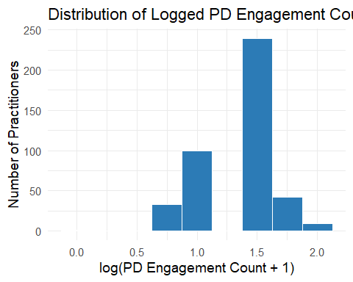
# ---- 2. Boxplot of PD Engagement by Role ----
ggplot(ae_inc, aes(x = role, y = log_pd_count, fill = role)) +
geom_boxplot(alpha = 0.8, color = "black") +
scale_fill_brewer(palette = "Set3") +
labs(
title = "Logged PD Engagement by Practitioner Role",
x = "Practitioner Role",
y = "log(PD Engagement Count + 1)"
) +
theme_minimal(base_size = 14) +
theme(
legend.position = "none",
axis.text.x = element_text(angle = 45, hjust = 1)
)
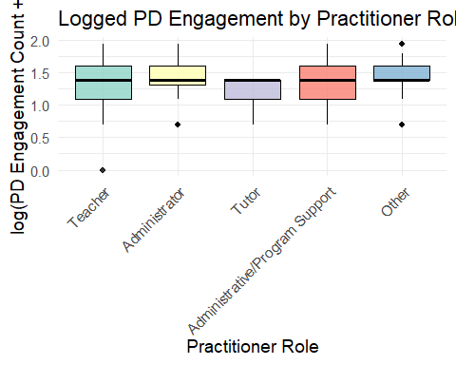
# ---- 3. Scatterplot with Logged Variables ----
ggplot(ae_inc, aes(x = log_experience, y = log_pd_count)) +
geom_point(alpha = 0.7, color = "#1B9E77", size = 3) +
geom_smooth(method = "lm", se = TRUE, color = "#D95F02", size = 1) +
labs(
title = "Relationship Between Experience and PD Engagement (Logged)",
x = "log(Years of Experience + 1)",
y = "log(PD Engagement Count + 1)"
) +
theme_minimal(base_size = 14)
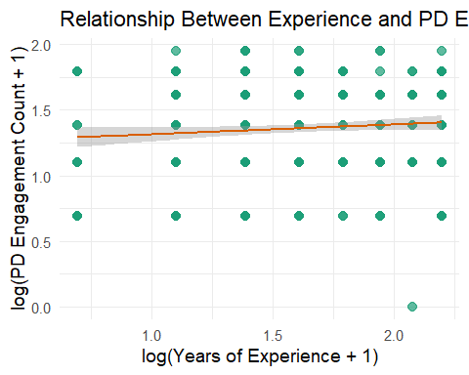
ae_inc <- ae |>
filter(in_analysis == "included") |>
mutate(
role = factor(
roles,
levels = c(1, 2, 3, 4, 5),
labels = c("Teacher",
"Administrator",
"Tutor",
"Administrative/Program Support",
"Other")
)
)
ggplot(ae_inc, aes(x = role, y = pd_count, fill = role)) +
geom_boxplot(alpha = 0.6, color = "black") +
geom_jitter(width = 0.15, alpha = 0.5, size = 2, color = "gray30") +
scale_fill_brewer(palette = "Pastel1") +
labs(
title = "PD Engagement by Practitioner Role",
x = "Practitioner Role",
y = "PD Engagement Count"
) +
theme_bw(base_size = 14) +
theme(
legend.position = "none",
plot.title = element_text(face = "bold", size = 16),
axis.text.x = element_text(angle = 45, hjust = 1, size = 12)
)
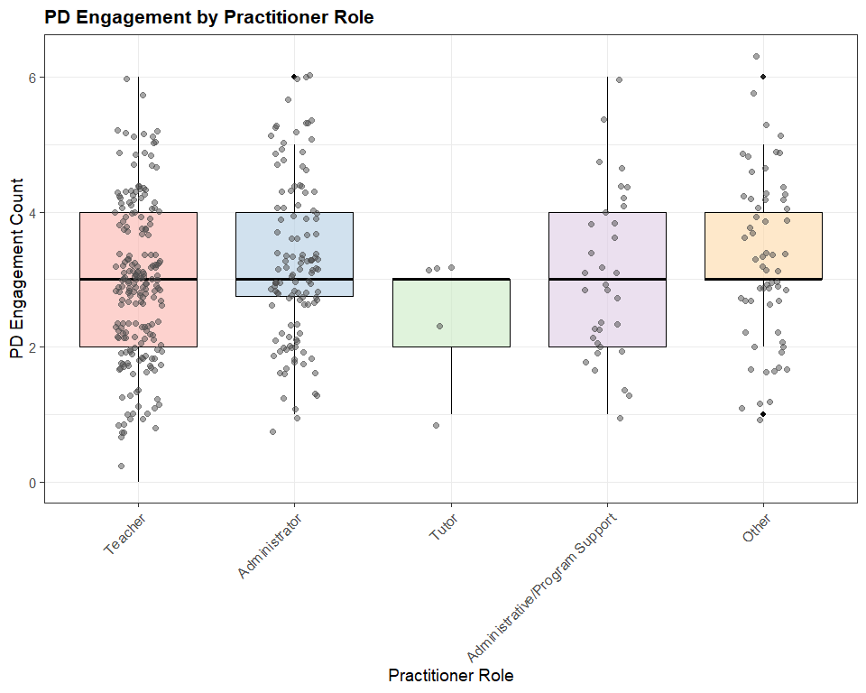
ae_inc <- ae |>
filter(in_analysis == "included") |>
mutate(
years_of_experience = factor(
years_of_experience,
levels = c(1, 2, 3, 4, 5, 6, 7, 8),
labels = c("0-1 years",
"1-5 years",
"6-10 years",
"11-15 years",
"16-20 years",
"21-25 years",
"26-30 years",
"More than 30 years")
)
)
ggplot(ae_inc, aes(x = years_of_experience, y = pd_count, fill = role)) +
geom_boxplot(alpha = 0.6, color = "black") +
geom_jitter(width = 0.15, alpha = 0.5, size = 2, color = "gray30") +
scale_fill_brewer(palette = "Pastel1") +
labs(
title = "PD Engagement by Years of Experience",
x = "years_of_experience",
y = "PD Engagement Count"
) +
theme_bw(base_size = 14) +
theme(
legend.position = "none",
plot.title = element_text(face = "bold", size = 16),
axis.text.x = element_text(angle = 45, hjust = 1, size = 12)
)
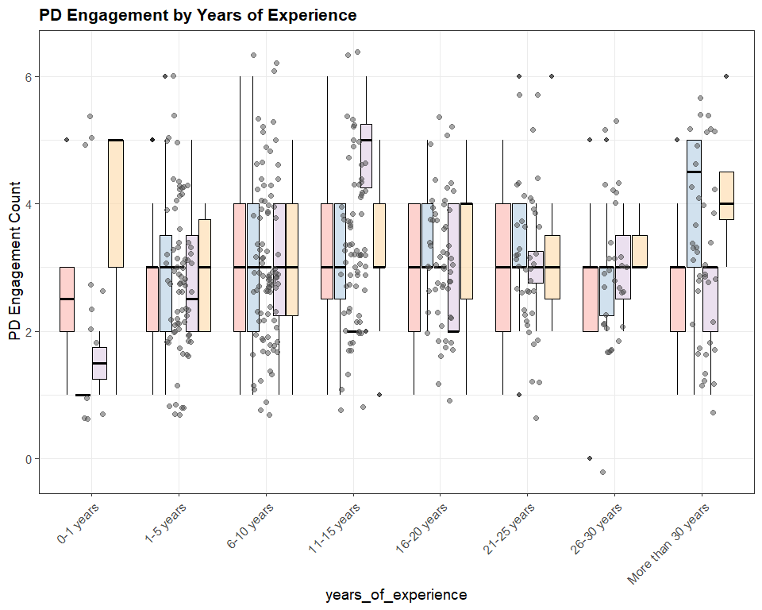
ae_inc <- ae |>
filter(in_analysis == "included") |>
mutate(
years_of_experience = factor(
years_of_experience,
levels = c(1, 2, 3, 4, 5, 6, 7, 8),
labels = c("0-1 years",
"1-5 years",
"6-10 years",
"11-15 years",
"16-20 years",
"21-25 years",
"26-30 years",
"More than 30 years")
)
)
# Bar chart of Practitioner Role
ggplot(ae_inc, aes(x = years_of_experience)) +
geom_bar(fill = "#2C7BB6", color = "black") +
labs(
title = "Years of Experience",
x = "years_of_experience",
y = "Count of years"
) +
theme_minimal(base_size = 14) +
theme(
axis.text.x = element_text(angle = 35, hjust = 1)
)
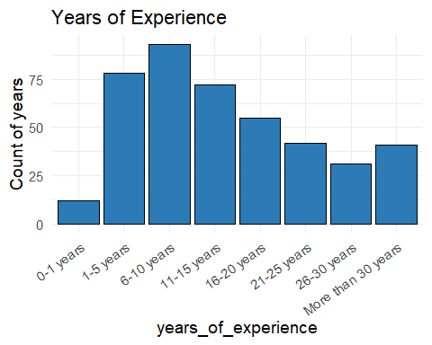
#library(ggplot2)
ae_inc <- ae |>
filter(in_analysis == "included") |>
mutate(
position_paid_or_volunteer = factor(
position_paid_or_volunteer,
levels = c(1, 2),
labels = c("Paid",
"Unpaid/Volunteer"
)
)
)
# Bar chart of Practitioner Role
ggplot(ae_inc, aes(x = position_paid_or_volunteer)) +
geom_bar(fill = "#2C7BB6", color = "black") +
labs(
title = "Number of Practitioners by Role",
x = "position_paid_or_volunteer",
y = "Count of Paid Volunteer"
) +
theme_minimal(base_size = 14) +
theme(
axis.text.x = element_text(angle = 35, hjust = 1)
)
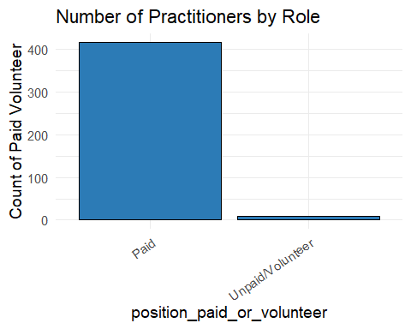
#library(ggplot2)
ae_inc <- ae |>
filter(in_analysis == "included") |>
mutate(
role = factor(
roles,
levels = c(1, 2, 3, 4, 5),
labels = c("Teacher",
"Administrator",
"Tutor",
"Administrative/Program Support",
"Other")
)
)
# Bar chart of Practitioner Role
ggplot(ae_inc, aes(x = role)) +
geom_bar(fill = "#2C7BB6", color = "black") +
labs(
title = "Number of Practitioners by Role",
x = "Practitioner Role",
y = "Count of Practitioners"
) +
theme_minimal(base_size = 14) +
theme(
axis.text.x = element_text(angle = 35, hjust = 1)
)
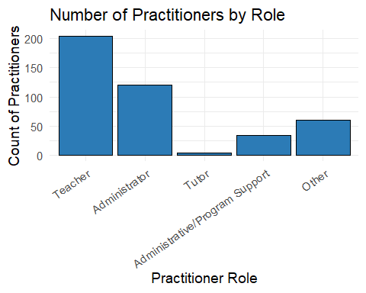
ae_inc <- ae_inc |>
mutate(
pd_group = cut(
pd_count,
breaks = c(-Inf, 2, 4, Inf),
labels = c("Low (0–2)", "Medium (3–4)", "High (5+)")
)
)
role_pd_group_table <- table(ae_inc$role, ae_inc$pd_group)
role_pd_group_table
Low (0–2) Medium (3–4) High (5+)
Teacher 73 114 17
Administrator 30 70 20
Tutor 2 3 0
Administrative/Program Support 14 16 4
Other 15 36 10
ae_inc <- ae_inc |>
mutate(
pd_group = cut(
pd_count,
breaks = c(-Inf, 1, 3, 5, Inf),
labels = c("Very low (0–1)",
"Low (2–3)",
"Moderate (4–5)",
"High (6+)")
)
)
ggplot(ae_inc, aes(x = role, fill = pd_group)) +
geom_bar(position = "fill", color = "black") +
scale_y_continuous(labels = scales::percent) +
scale_fill_brewer(palette = "Set2", name = "PD Engagement") +
labs(
title = "PD Engagement Category by Practitioner Role",
x = "Practitioner Role",
y = "Proportion of Practitioners"
) +
theme_minimal(base_size = 14) +
theme(
plot.title = element_text(face = "bold", size = 16),
axis.text.x = element_text(angle = 30, hjust = 1)
)
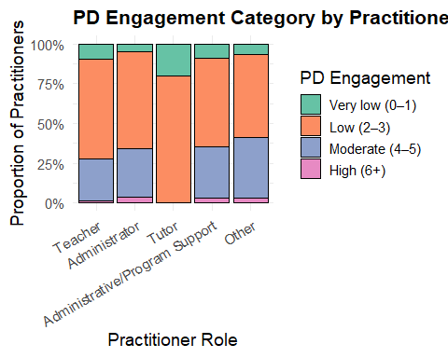
geom_bar(position = "dodge")
geom_bar: na.rm = FALSE, just = 0.5, lineend = butt, linejoin = mitre
stat_count: na.rm = FALSE
position_dodge
- Write a few sentences interpreting each figure from the previous question.
Replace this text with your response.
- Run your analysis and report the results.
knitr::opts_chunk$set(message = FALSE, warning = FALSE)
# keep only included cases with complete data for main variables
ae_model <- ae_inc |>
filter(!is.na(pd_count),
!is.na(years_of_experience),
!is.na(role),
!is.na(conf_any))
# H1: One-way ANOVA - PD engagement by role
anova_model <- aov(pd_count ~ role, data = ae_model)
summary(anova_model)
Df Sum Sq Mean Sq F value Pr(>F)
role 4 14.1 3.528 2.648 0.033 *
Residuals 419 558.3 1.332
---
Signif. codes: 0 '***' 0.001 '**' 0.01 '*' 0.05 '.' 0.1 ' ' 1
# optional post-hoc comparisons
TukeyHSD(anova_model)
Tukey multiple comparisons of means
95% family-wise confidence level
Fit: aov(formula = pd_count ~ role, data = ae_model)
$role
diff lwr upr
Administrator-Teacher 0.32990196 -0.03392306 0.6937270
Tutor-Teacher -0.51176471 -1.94328934 0.9197599
Administrative/Program Support-Teacher 0.08823529 -0.49757865 0.6740492
Other-Teacher 0.38331726 -0.07817955 0.8448141
Tutor-Administrator -0.84166667 -2.28512798 0.6017946
Administrative/Program Support-Administrator -0.24166667 -0.85607351 0.3727402
Other-Administrator 0.05341530 -0.44387446 0.5507051
Administrative/Program Support-Tutor 0.60000000 -0.91472436 2.1147244
Other-Tutor 0.89508197 -0.57603707 2.3662010
Other-Administrative/Program Support 0.29508197 -0.38175363 0.9719176
p adj
Administrator-Teacher 0.0961475
Tutor-Teacher 0.8644639
Administrative/Program Support-Teacher 0.9939049
Other-Teacher 0.1548845
Tutor-Administrator 0.4998123
Administrative/Program Support-Administrator 0.8180218
Other-Administrator 0.9983608
Administrative/Program Support-Tutor 0.8141435
Other-Tutor 0.4556465
Other-Administrative/Program Support 0.7546204
# H2: Linear regression - PD engagement on years of experience
lm_model <- lm(pd_count ~ years_of_experience, data = ae_model)
summary(lm_model)
Call:
lm(formula = pd_count ~ years_of_experience, data = ae_model)
Residuals:
Min 1Q Median 3Q Max
-3.1767 -0.9765 -0.0503 0.9076 3.0340
Coefficients:
Estimate Std. Error t value Pr(>|t|)
(Intercept) 2.88172 0.13458 21.41 <2e-16 ***
years_of_experience 0.04214 0.02867 1.47 0.142
---
Signif. codes: 0 '***' 0.001 '**' 0.01 '*' 0.05 '.' 0.1 ' ' 1
Residual standard error: 1.162 on 422 degrees of freedom
Multiple R-squared: 0.005094, Adjusted R-squared: 0.002737
F-statistic: 2.161 on 1 and 422 DF, p-value: 0.1423
library(haven)
ae_model <- ae_model |>
mutate(
years_of_experience = as.numeric(zap_labels(years_of_experience)),
pd_count = as.numeric(zap_labels(pd_count))
)
# (optional) correlation
cor.test(ae_model$years_of_experience, ae_model$pd_count)
Pearson's product-moment correlation
data: ae_model$years_of_experience and ae_model$pd_count
t = 1.4699, df = 422, p-value = 0.1423
alternative hypothesis: true correlation is not equal to 0
95 percent confidence interval:
-0.02402362 0.16548152
sample estimates:
cor
0.07137299
# H3: t-test - conferences vs no conferences
t.test(pd_count ~ conf_any, data = ae_model)
Welch Two Sample t-test
data: pd_count by conf_any
t = -9.3729, df = 80.214, p-value = 1.589e-14
alternative hypothesis: true difference in means between group No and group Yes is not equal to 0
95 percent confidence interval:
-1.584773 -1.029692
sample estimates:
mean in group No mean in group Yes
1.929825 3.237057
Provide a narrative to accompany your results
- Check assumptions and/or diagnostics of the analysis. Present graphical and/or numerical evidence, and briefly describe what this evidence is indicating.
# diagnostics for ANOVA (equivalent to linear model with categorical predictor)
par(mfrow = c(2, 2))
plot(anova_model) # residuals vs fitted, QQ-plot, etc.
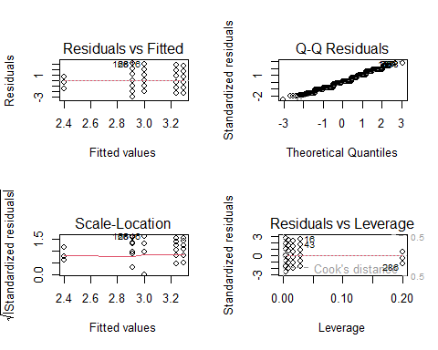
# diagnostics for regression model
par(mfrow = c(2, 2))
plot(lm_model)
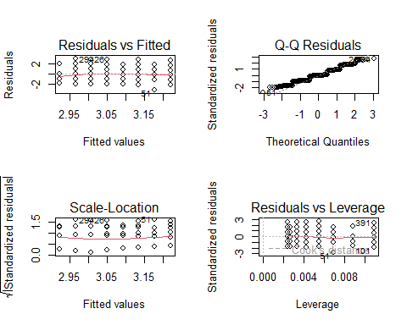
# reset plotting layout
par(mfrow = c(1, 1))
# check normality of residuals explicitly
shapiro.test(residuals(lm_model))
Shapiro-Wilk normality test
data: residuals(lm_model)
W = 0.959, p-value = 1.738e-09
# check homogeneity of variance for ANOVA (Levene-like test using car package if available)
# install.packages("car") # run once if needed
library(car)
leveneTest(pd_count ~ role, data = ae_model)
Levene's Test for Homogeneity of Variance (center = median)
Df F value Pr(>F)
group 4 0.5615 0.6908
419
Replace this text with your response.
- Lastly, write a paragraph summarizing your findings, being mindful to consider the assumptions previously checked when you interpreted the analytic results. How should a reader interpret your results? It may be useful to consider question 12, the precision of your results, and the internal and external validity of your results.

8. Interpretation of Visualizations

Figure 1 (Histogram of logged PD engagement) shows a right-skewed but substantially normalized distribution once log-transformed, indicating that most practitioners engage in a moderate range of PD activities, with fewer reporting extremely high values.

Figure 2 (Boxplot of logged PD engagement by role) illustrates visible but modest differences in PD engagement across practitioner roles. Teachers and administrators appear to have higher median engagement compared to tutors and support staff, supporting the rationale for H1.

Figure 3 (Scatterplot of logged PD engagement vs. logged experience) shows a slight upward trend, though the points display considerable variability, suggesting only a weak relationship between experience and PD engagement.

Additional bar charts (role distributions, years-of-experience categories, funding status) provide descriptive context, confirming that the dataset includes substantial diversity in practitioner roles and backgrounds.

9. Analysis Results
H1: ANOVA – PD Engagement by Practitioner Role

The one-way ANOVA revealed a statistically significant effect of practitioner role on PD engagement, F(4, 419) = 2.65, p = .033. Post-hoc Tukey comparisons, however, showed that no individual pairwise differences reached statistical significance after controlling for multiple comparisons. This suggests that while overall variation across roles exists, differences between specific roles are modest.

H2: Linear Regression – PD Engagement Predicted by Experience

Regression results indicated that years of experience did not significantly predict PD engagement (β = 0.042, p = .142). The model explained only 0.5% of the variance in PD counts, and confidence intervals for the correlation included zero, indicating limited evidence for an experience-engagement relationship.

H3: t-Test – PD Engagement by Conference Attendance

The t-test demonstrated a large, statistically significant difference between groups. Practitioners who attended conferences reported substantially higher PD engagement (M = 3.24) compared to those who did not (M = 1.93), t = –9.37, p < .001. This represents a strong and practically meaningful association.

10. Narrative Interpretation of Results

Taken together, the analyses reveal that practitioner characteristics explain PD engagement in nuanced ways. Role differences exist at the overall group level, but individual role-to-role contrasts are small, suggesting that structural role distinctions provide only partial explanatory power. Contrary to expectations, years of experience did not predict PD engagement, indicating that PD participation may be driven by organizational culture, access, or motivation rather than tenure. The strongest and clearest finding is the association between conference attendance and broader PD engagement, indicating that practitioners embedded in professional networks engage more consistently in learning activities. This suggests that structural access to professional communities may meaningfully amplify practitioners’ engagement with PD resources.

11. Diagnostics and Assumption Checks

Diagnostic plots for the ANOVA model indicated reasonably homogeneous variances across groups, consistent with the Levene test (p = .69). Residual plots did not reveal strong patterns, suggesting acceptable model fit. For the regression model, residual diagnostics showed slight deviations from normality, confirmed by the Shapiro–Wilk test (p < .001), although linear regression is robust to such deviations at moderate sample sizes. Homoscedasticity appeared acceptable, and no influential outliers were detected. Together, these diagnostics suggest that although some assumptions were imperfectly satisfied, the results remain interpretable, particularly given the large sample size and the robustness of the statistical procedures used.

12. Summary of Findings

Overall, this study provides evidence that practitioner engagement with PD resources varies by role and is strongly associated with conference participation, while showing little relation to years of experience. The ANOVA findings indicate small but significant differences across roles, though the lack of significant pairwise contrasts suggests overlapping engagement patterns among practitioner groups. The regression results refute the hypothesis that experience predicts engagement, challenging common assumptions about tenure-based professional learning behavior. The most robust finding is the strong positive association between conference attendance and PD engagement, which highlights the potential importance of professional networks and access to formal learning spaces. When interpreting these results, readers should consider the noted diagnostic limitations, including non-normal residuals, although these issues likely have minimal impact on the overall conclusions due to sample size and method robustness. Externally, findings may generalize to similar adult-education systems, though the non-random sample limits broader population inferences. Internally, results demonstrate good measurement quality and clear, stable relationships. Collectively, the evidence suggests that enhancing practitioners’ access to conferences and broader PD networks may be an effective strategy for increasing engagement with professional learning.

