**ESE-2014 Lab 3**

**Submitted By**

**Bibin Babu – C0749104**

**Joyal Raju -C0749019**

Generate the following sequences using the basic Octave signal functions and the basic Octave signal operations discussed in this chapter. Plot signal samples using the stem function.

1.

Impulse Sequence function:

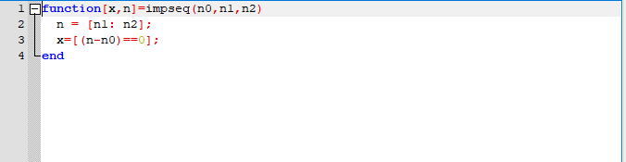

x1 = 3*impseq(-2,-5,15) + 2*impseq(0,-5,15) - impseq(3,-5,15) ...

+ 5*impseq(7,-5,15);

stem(x1);

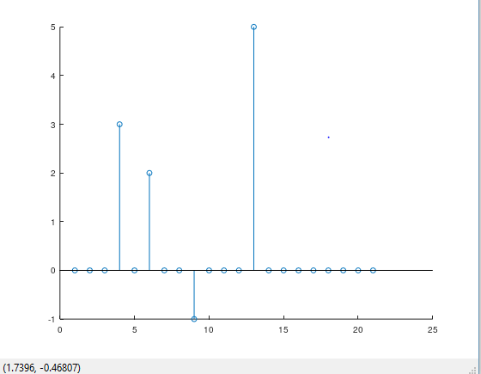

2.

n2 = [-10:10]; x2 = zeros(1,length(n2));

for k = -5:5

x2 = x2 + exp(-abs(k))*impseq(2*k ,-10,10);

end

disp(x2);

stem(x2);

Observation:  
  
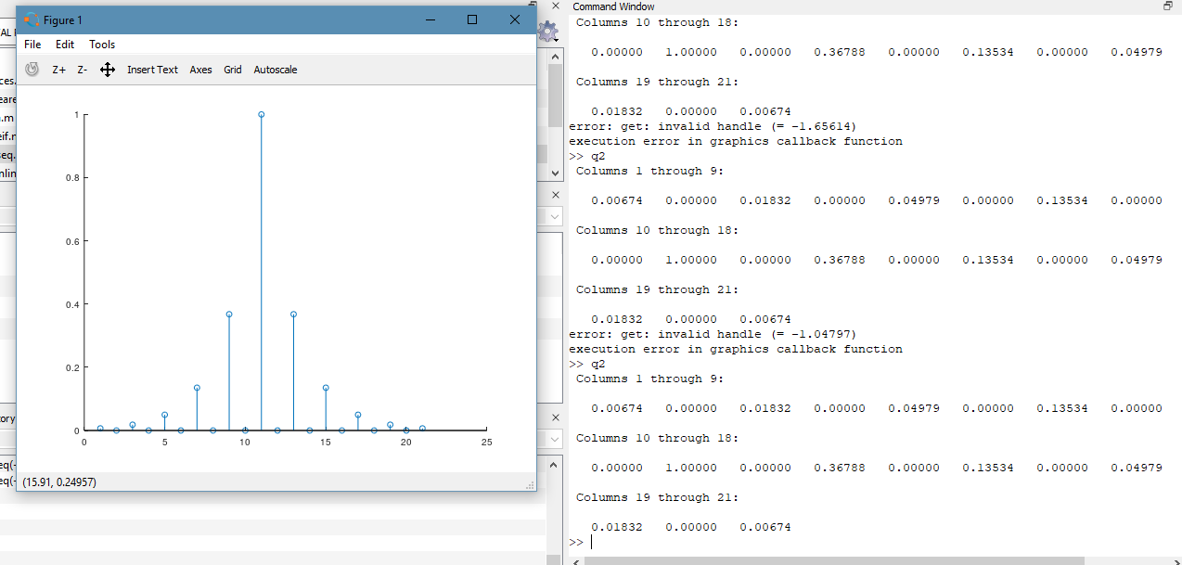

3.

Step Sequence function:

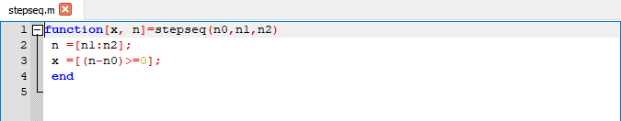  
  
x3=10*stepseq(0,0,20)- 5*stepseq(5,0,20) - 10*stepseq(10,0,20) ...

+ 5*stepseq(15,0,20);

n3=[0:20];

disp(x3);

stem(x3);

Observation:

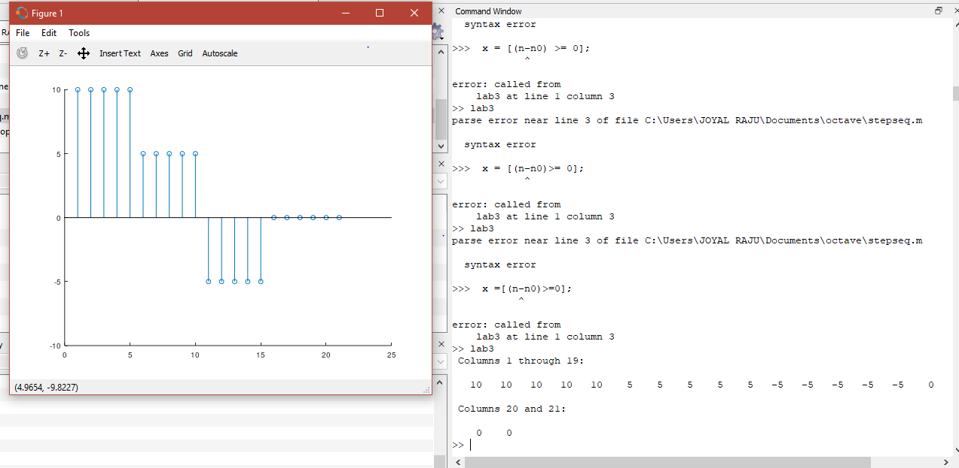

4.

n4 = [-25:15];

x4 = exp(0.1*n4).*(stepseq(-20,-25,15) - stepseq(10,-25,15));

disp(x4);

stem(x4);

Observation:

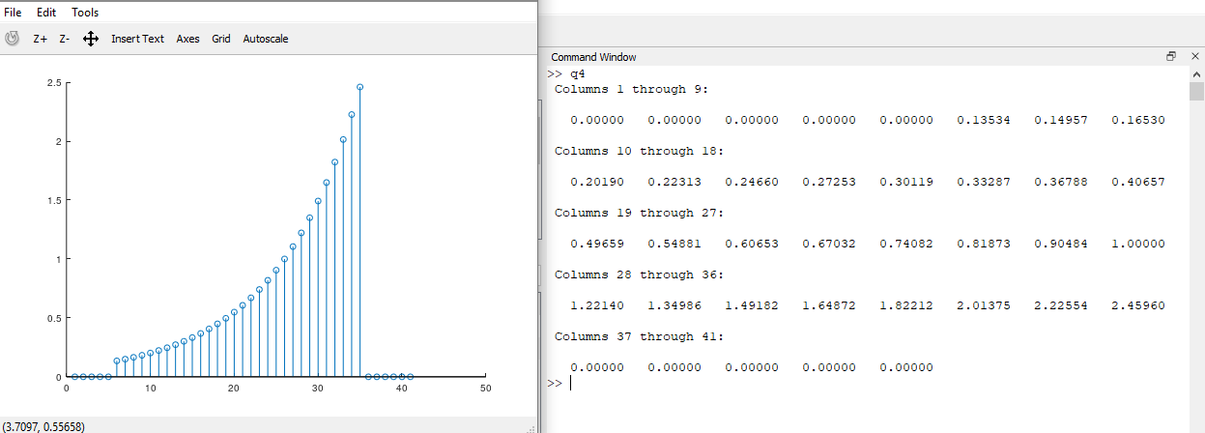

2. Let x(n)={2, 4, -3, 1, -5, 4, 7}. Generate and plot the samples (use the stem function) of the

following sequences.

1.

Signal Shifting Function:

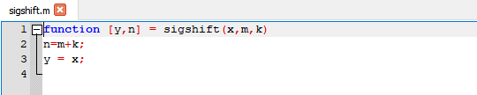

Signal Adding Function:

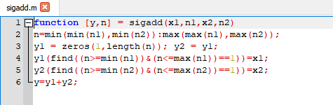

Code:

m=[-3:3];

x=[2, 4, -3, 1, -5, 4, 7];

[x1,n1]=sigshift(x,m,3);

[x2,n2]=sigshift(x,m,-4);

[x3,n3]=sigadd(2*x1,m1,3*x2,m2);

[x4,n4]=sigadd(x3,n3,-x,m)

stem(n4,x4);

Observation:

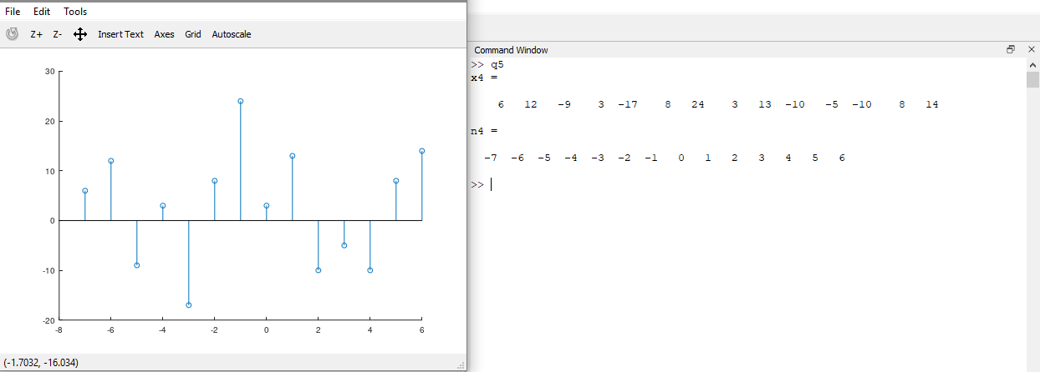

2.

Signal Folding Function:

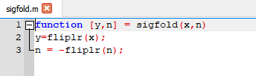

Code:

m=[-3:3];

x=[2, 4, -3, 1, -5, 4, 7];

[x1,n1]=sigfold(x,m);

[x1,n1]=sigshift(x1,n1,-4);

[x2,n2]=sigshift(x,m,-5);

[x3,n3]=sigadd(4*x1,n1,5*x2,n2);

[x4,n4]=sigadd(x3,n3,2*x,m)

stem(n4,x4);

Observation:

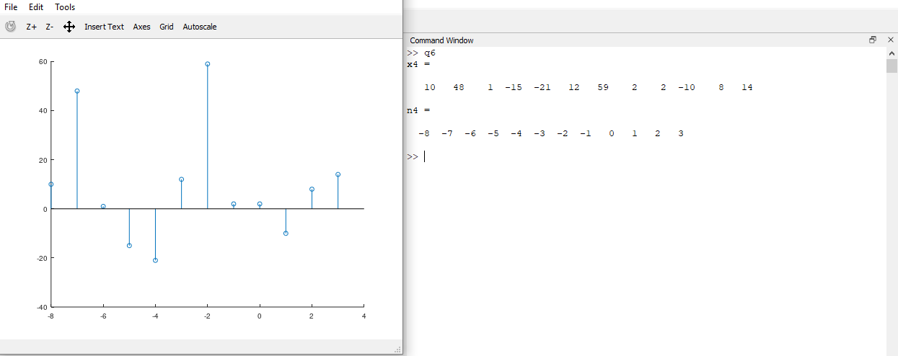

3.

Signal Multiplying Function:

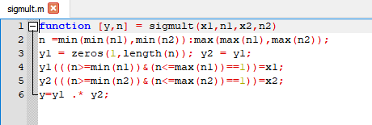

Code:

m=[-3:3];

x=[2, 4, -3, 1, -5, 4, 7];

[x1,n1]=sigshift(x,m,-3);

[x2,n2]=sigshift(x,m,2);

[x3,n3]=sigmult(x1,n1,x2,n2);

[x4,n4]=sigfold(x,m);

[x4,n4]=sigfold(x,m);

[x5,n5]=sigshift(x,m,-1);

[x6,n6]=sigmult(x4,n4,x5,n5);

[x7,n7]=sigadd(x3,n3,x6,n6);

stem(n7,x7);

Observation:

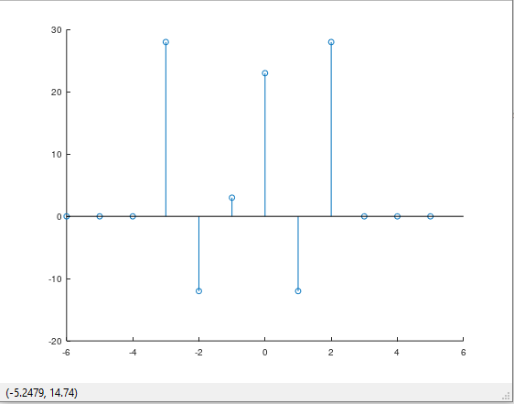

4.

Code:

m= [-3:3]; x = [2,4,-3,1,-5,4,7];

m4 = [-10:10];

x41 = 2*exp(0.5*m4);

x412 = cos(0.1*pi*m4);

[x42,n42] = sigmult(x41,m4,x,m);

[x43,n43] = sigshift(x,m,-2);

[x44,n44] = sigmult(x412,n42,x43,n43);

[x4,n4] = sigadd(x42,n42,x44,n44);

stem(n4,x4);

Observation:

